Supplementary Information for

“Topological dislocation modes in three-dimensional acoustic topological insulators”

Liping Ye,¹ Chunyin Qiu,^{1*} Meng Xiao,^{1*} Tianzi Li, Juan Du, Manzhu Ke,¹ and Zhengyou Liu^{1,3*}

¹Key Laboratory of Artificial Micro- and Nano-structures of Ministry of Education and School of Physics and Technology, Wuhan University, Wuhan 430072, China
²Institute for Advanced Studies, Wuhan University, Wuhan 430072, China

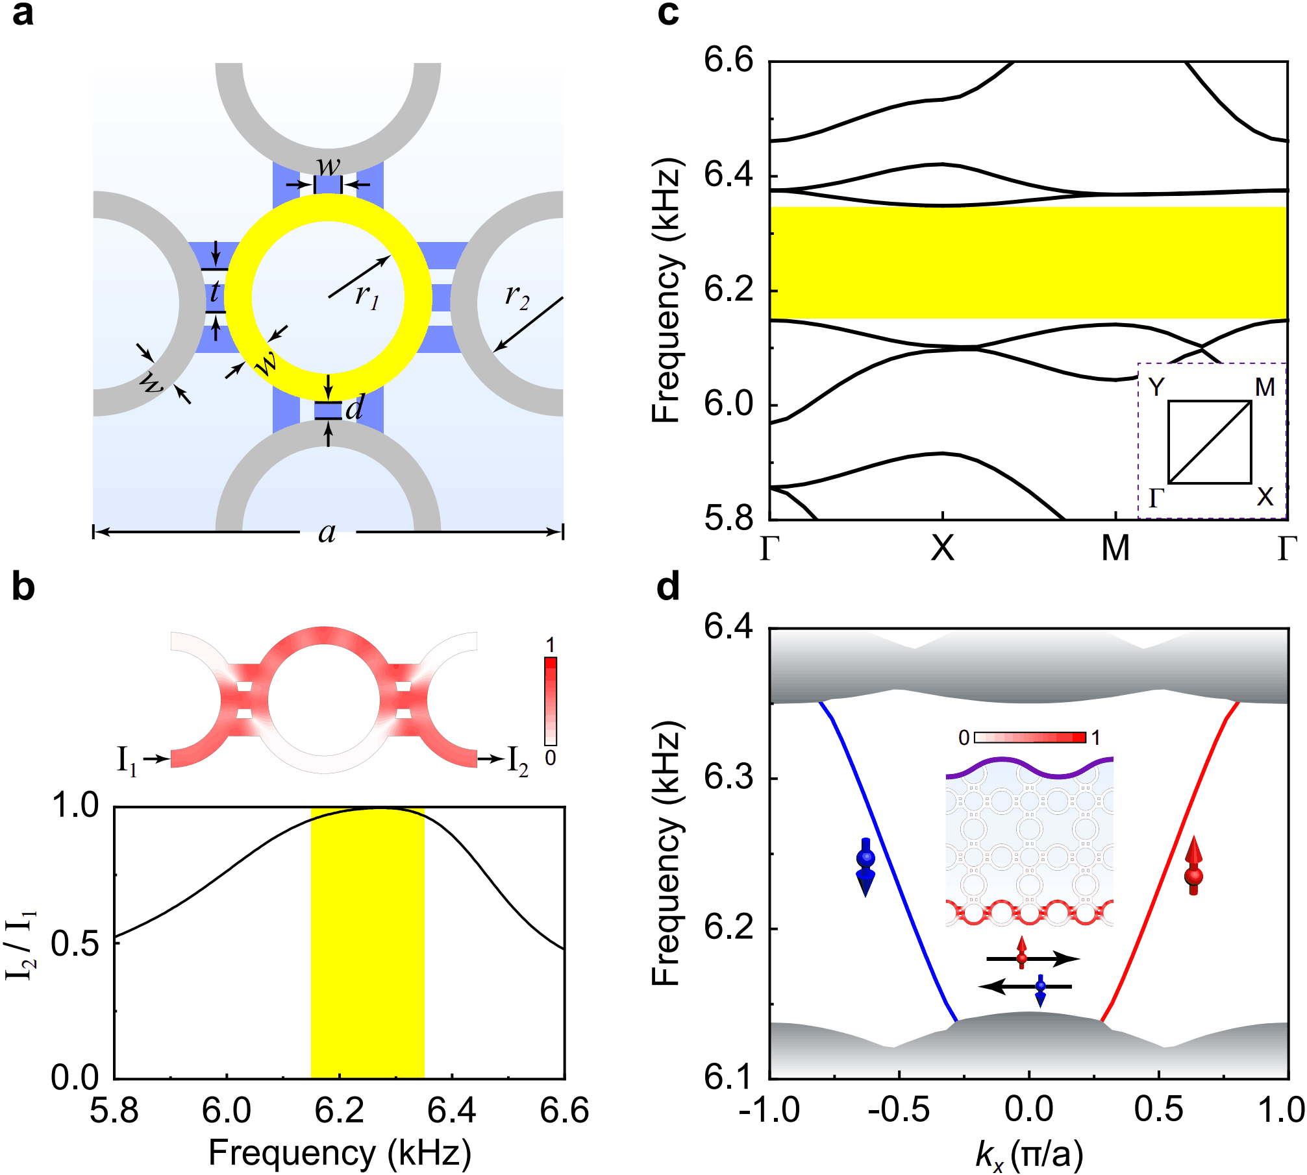

Figure S1 | Construction of the 2D acoustic QSH insulator. a, Geometry of the unit cell. For a square array of the unit cells, the site ring-waveguides (yellow) are coupled through equidistant straight tubes (blue) and coupler ring-waveguides (gray). The structure parameters are: $a=208 mm$, $r_{1}=34 mm$, $r_{2}=38 mm$, $w=12 mm$, $d=8 mm$, and $t=18.5 mm$. The straight tubes and coupled ring-waveguides (collectively dubbed as in-plane couplers) are optimized to attain strong coupling but negligible pseudospin flip. All the waveguides have a constant thickness $h=10 mm$ for the experiments below. b, Top panel: Numerical setup used for analyzing the coupling strength of the in-plane coupler, where the lateral half rings correspond to site ring-waveguides and the middle ring represents a coupler ring-waveguide. In the case of strong coupling, the sound signal correlated with pseudospin-up will excite a pressure amplitude concentrating at the upper half coupler ring-waveguide, as exemplified at by the simulation at 6.27 kHz (color). Bottom panel: Power transmission spectrum that characterizes the coupling strength induced by the in-plane coupler. Specifically, the power transmission $I_{2}/I_{1}>0.95$ spans over the interested nontrivial band gap in c, indicating that almost all of the incident waves reach the desired outlet without flipping the pseudospin. c, Bulk band structure of the acoustic QSH insulator. The nontrivial band gap (ranging from 6.15 kHz to 6.35 kHz) is highlighted by yellow. d, Band structure simulated for a ribbon periodic in the x direction and finite in the y direction. For clarity, here we provide only the spin-momentum locked edge modes localized at the lower boundary (color lines), where the gray shadows are projected bulk bands. Inset: Eigenfield distribution exemplified at 6.27 kHz, which is the same for both pseudospins since they are related by time-reversal symmetry.

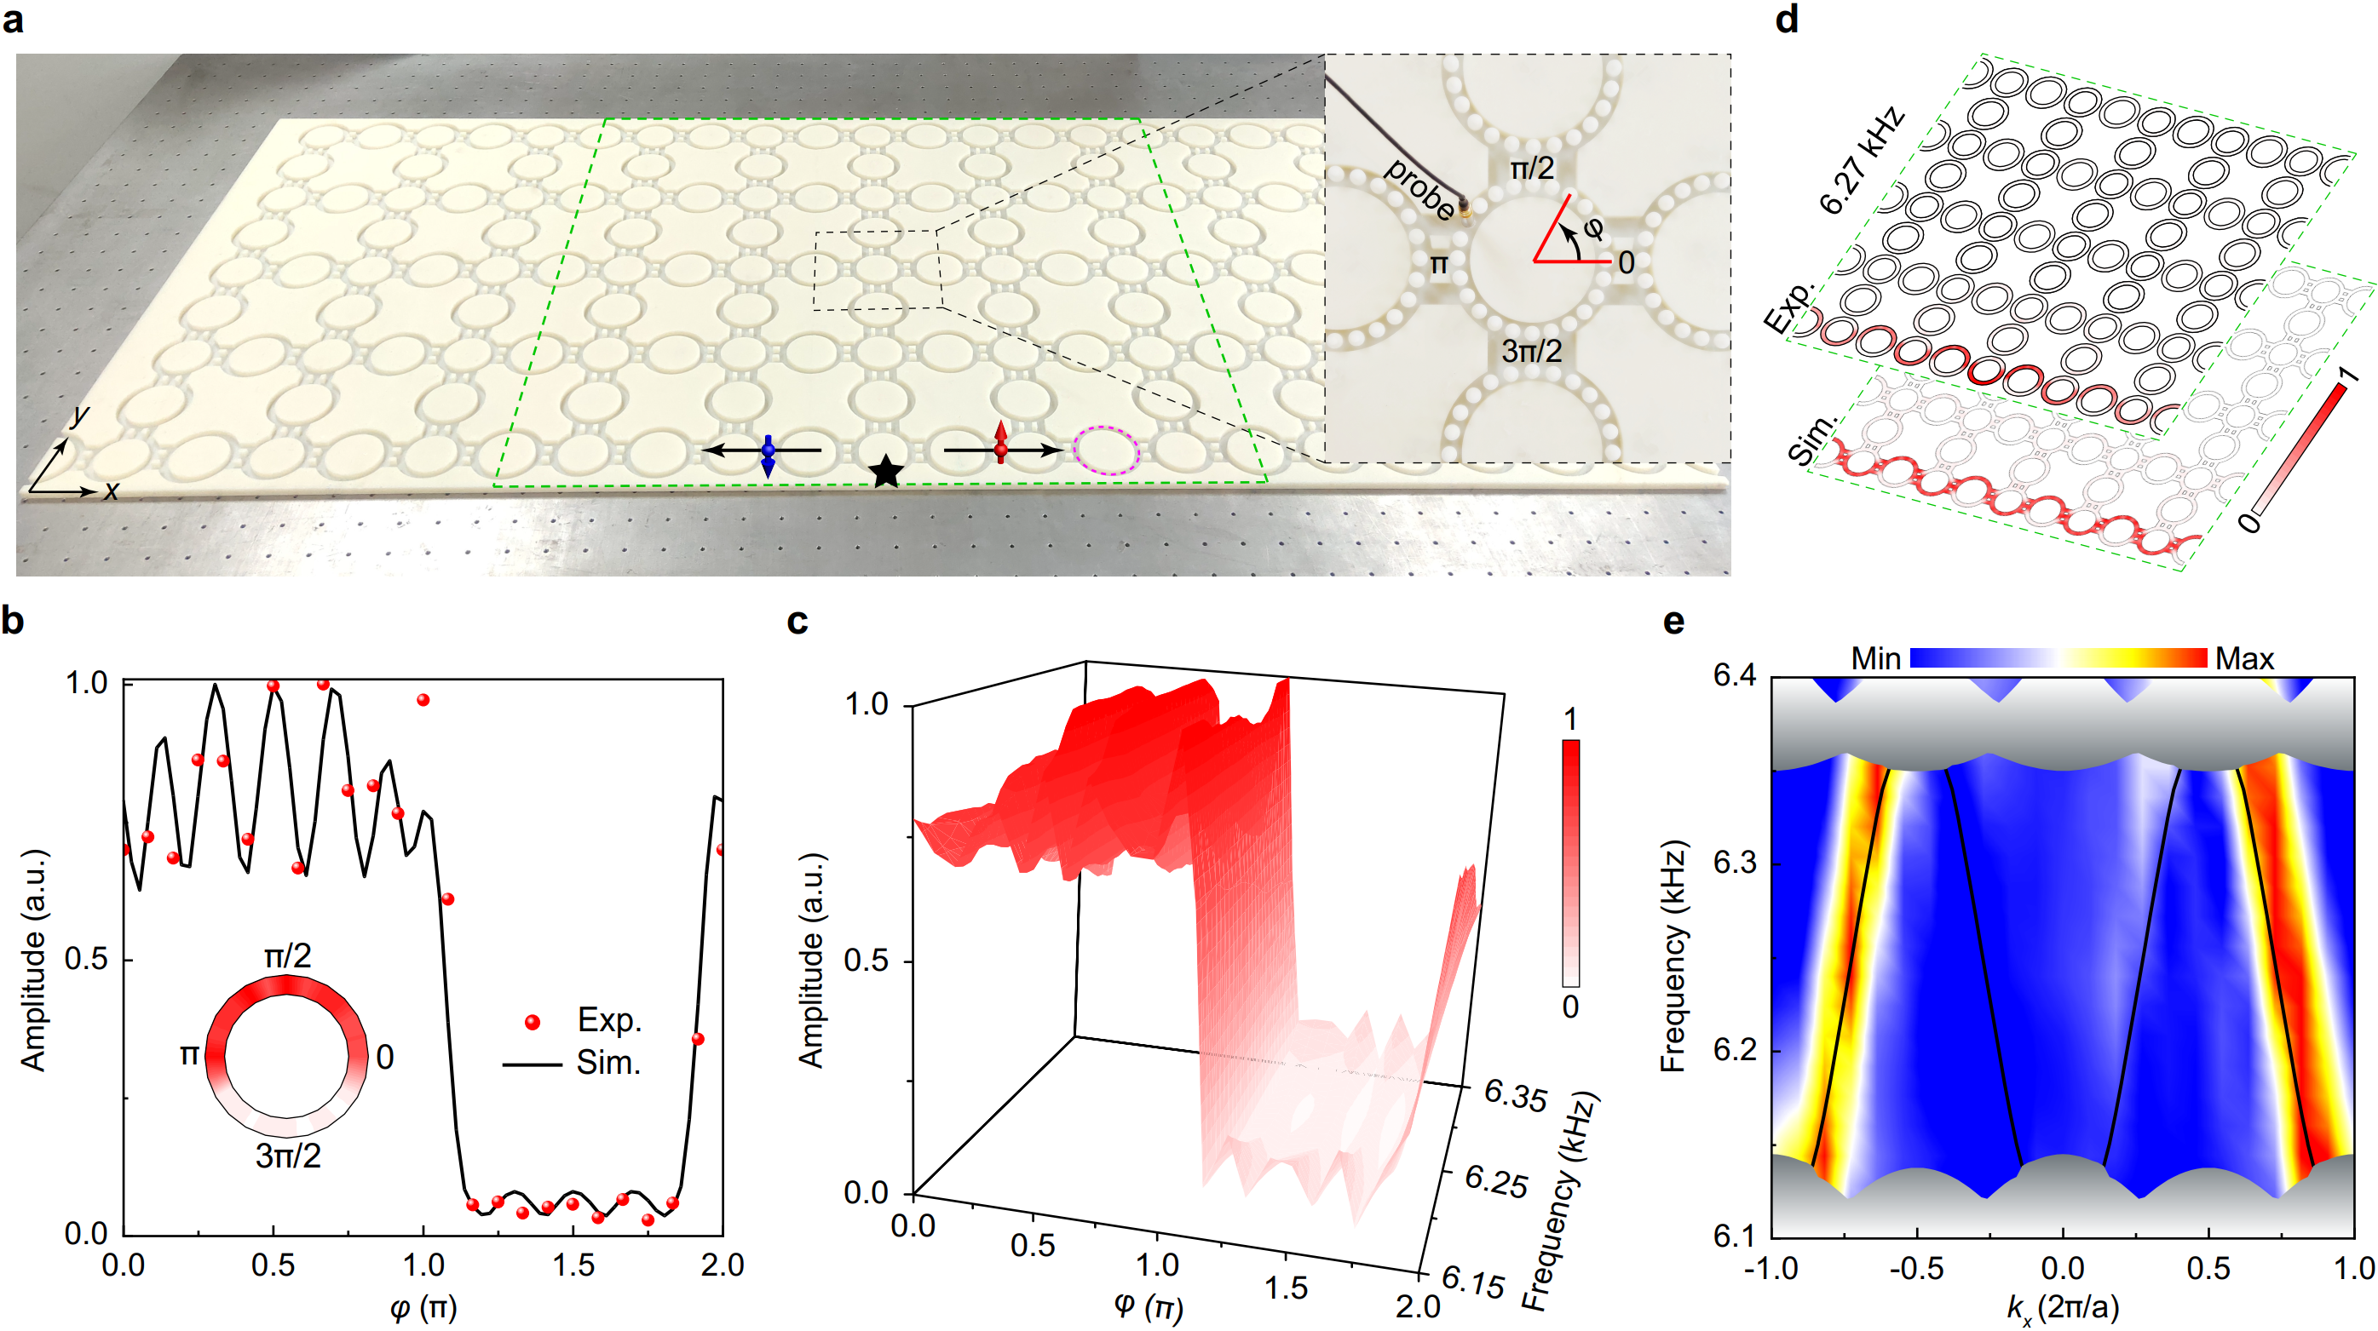
Figure S2 | Experimental characterizations for our 2D QSH insulator. a, Experimental setup. The black star labels the position of the point-like sound source. During the measurements, the sample is covered with a transparent acrylic plate, which is perforated with small holes for inserting the sound source and probe. Inset: Zoom-in photograph that demonstrates the sound detection, where $φ$ labels the azimuthal angle in the ring-waveguide. b, $φ$-dependent pressure amplitude distribution measured in a coupler ring-waveguide (highlighted in a with the magenta dashed circle) at 6.27 kHz. The experimental data (red spheres) capture well the simulation (black line). Inset: A direct visualization of the experimental data inside the ring. Consistent with the top panel in Fig. S1b, the sound energy for the rightward-moving (pseudospin-up) mode concentrates in the upper half coupler ring-waveguide, which is a direct evidence for the strong coupling induced by the in-plane coupler. c, Similar to b, but plotted from 6.15 kHz to 6.35 kHz, which confirms the strong coupling over the nontrivial bulk gap. d, Experimental field pattern (top layer) scanned at 6.27 kHz inside the green dashed box sketched in a, comparing with the associated simulation result (bottom layer). The experimental result agrees well with the simulation, except for the attenuation induced by the unavoidable loss. e, Measured dispersion of the topological edge modes (bright color), which reproduces excellently the simulation result (black lines). Again, the gray shadows represent the numerical bulk-band projections. Note that the Fourier component of the measured edge modes in the second Brillouin zone is much stronger than that exhibited in the first Brillouin zone.

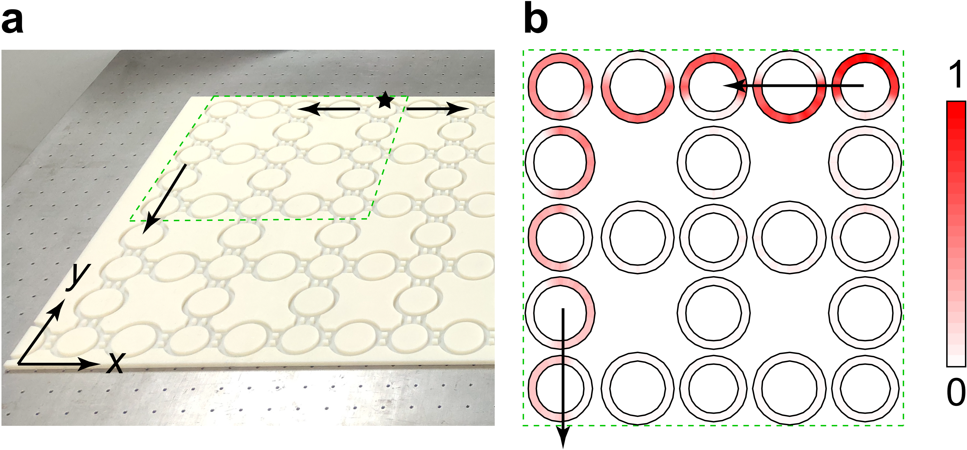

Figure S3 | Testing topological robustness of the helical edge modes in the 2D QSH insulator. a, Photograph of the experimental setup. The black star marks the position of the sound source and the black arrows indicate the propagating directions of the excited topological edge modes. b, Pressure amplitude distribution scanned in the region highlighted by the green dashed box in a. Again, the field profile is exemplified at 6.27 kHz. It shows that the topological edge modes bypass the $90°$ bending corner smoothly without visible scattering into the bulk, as an evidence of the topological robustness against the boundary deformation.

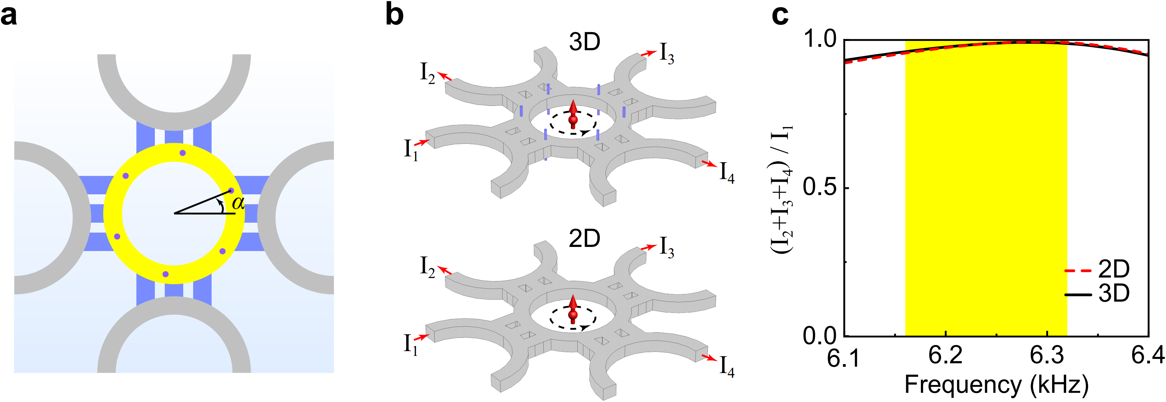
Figure S4 | Design of our 3D ATI. a, Top view of the unit cell. Its in-plane geometry inherits that of the 2D system in Fig. S1, associated with a constant thickness $h=10 mm$ for 3D realization. The equally-spaced purple dots represent narrow tubes (of radii $r_{0}=1 mm$) that couple the site ring-waveguides in the z direction, where the angle $α={22}^{o}$ is optimized to reduce pseudospin flip. The out-of-plane lattice constant of the 3D ATI is $H=27.5 mm$. b, Numerical setups for analyzing the coupling ratio of the same pseudospin. Comparing with that of the 2D case (bottom panel), additional periodic boundary condition in the z direction is applied to our 3D ATI (top panel). To evaluate the pseudospin preservation, the sound signal is injected from the port 1 of the structure. As such, pseudospin-up modes will be excited dominantly, which leave the structure from the ports 2, 3, 4. The coupling ratio (of the pseudospin-up) is defined as ${(I}_{2}+I_{3}+I_{4})/I_{1}$, where $I_{1}$-$I_{4}$ are sound energies flowing through the ports 1-4. c, Coupling ratio spectra of the 2D and 3D systems. It shows that the coupling ratio of the 3D ATI is almost the same as the 2D system, and approaches 1 within the nontrivial band gap (yellow shadow). In other words, a negligible inter-pseudospin scattering is incurred by the interlayer couplers (i.e., vertical tubes).

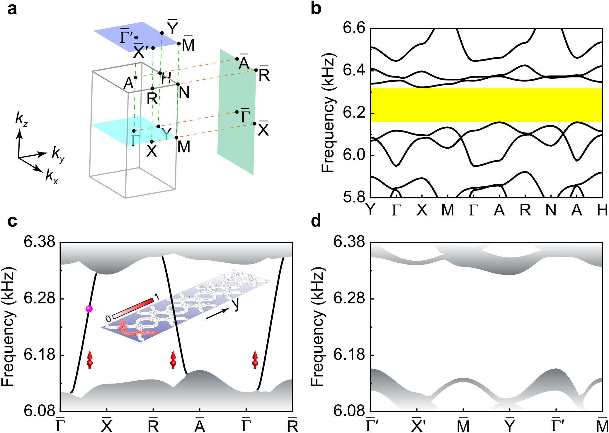
Figure S5 | Bulk topology of the 3D ATI manifested as its surface signatures. a, Bulk Brillouin zone and its surface projections along the $k_{y}$ and $k_{z}$ directions. b, Bulk band structure simulated along some high-symmetry directions. It exhibits a nontrivial gap ranging from 6.16 to 6.32 kHz (yellow shadow), very close to that of the 2D QSH insulator since the interlayer coupling is weak. c, Surface-projected band structure, simulated for a ribbon structure periodic in the x-z plane but finite along the y direction. The black lines indicate gapless topological surface states (plotted only for the surface involved in the inset), and the gray shadows correspond to the projected bulk states. Inset: pressure amplitude distribution exemplified for the surface state labeled with the pink sphere. Similarly, gapless topological surface states emerge on the y-z surfaces of the 3D ATI. d, Surface-projected dispersion simulated for a ribbon periodic in the x-y plane but finite along the z direction, which exhibits no topological surface states on the x-y surfaces. The simulations in c and d are consistent with the weak topological indices $\left(v_{1}v_{2}v_{3}\right)=(001)$. Physically, the nontrivial topology is inherited from the 2D QSH system since there is no gap closing if one increases gradually the strength of the interlayer coupling from zero to the weak coupling in our system¹.

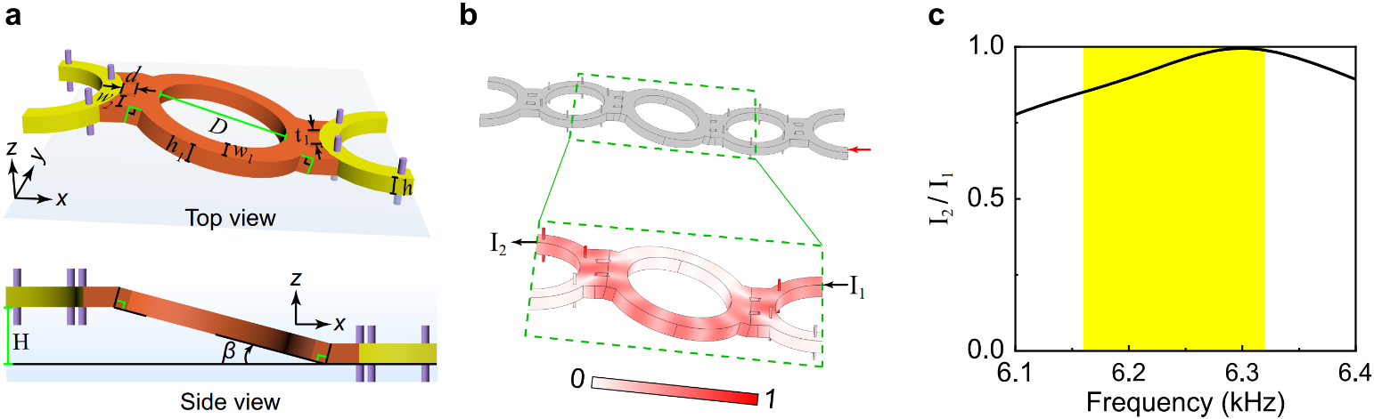

Figure S6 | Design of the tilted interlayer coupler. a, Top and side views of the tilted interlayer coupler (orange), which serves as an extra but crucial component for constructing the dislocation. The structural parameters, $t_{1}=19.3 mm$, $w_{1}=14.5 mm$,$w_{2}=14.7 mm$, $d=8 mm$, $D=77.3 mm$, $h=10 mm$, $h_{1}=h/cosβ$, and $β={15}^{o}$, are optimized to attain a strong coupling but negligible pseudospin flip. b, Numerical setup used for analyzing the coupling strength induced by the tilted interlayer coupler, imposed with a periodic boundary condition in the z direction. The red arrow indicates the input of the sound signal associated to pseudospin-up. The coupling strength of the tilted interlayer coupler can be characterized by the power transmission $I_{2}/I_{1}$. Inset: Pressure amplitude distribution exemplified at 6.27 kHz, exhibiting a signature of strong coupling. c, Spectrum of the coupling strength, which is larger than $0.85$ over the nontrivial gap (yellow shadow).

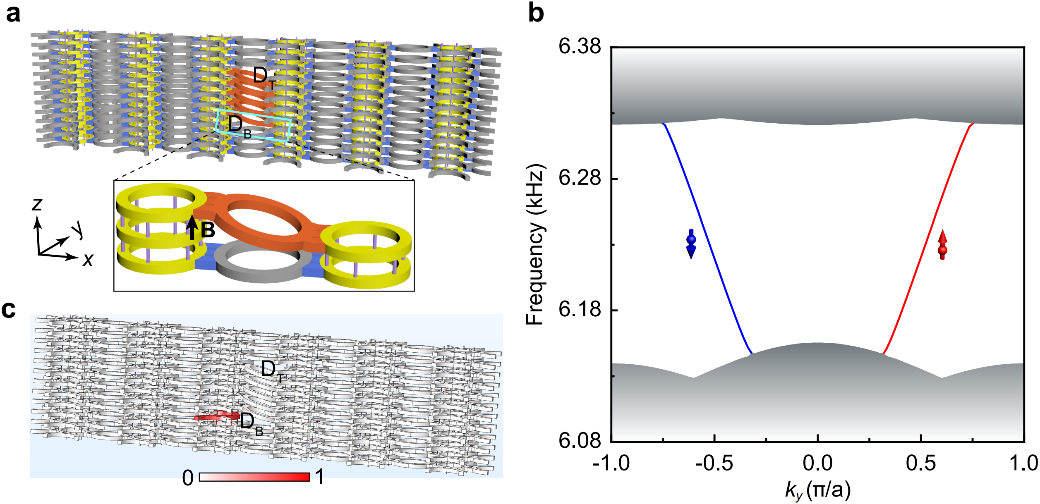

Figure S7 | 1D gapless TDMs trapped by edge dislocations. a, Supercell structure that contains a pair of edge dislocations with $B=\left(0,0,±H\right)$. The supercell has a total size of $6×1×12$ lattice sites in the x, y, and z directions, respectively. By removing 1 interlayer coupler and tilting 5 interlayer couplers (orange), we create two edge dislocations of opposite Burgers vectors, labeled respectively with D_{T} and D_{B}. Inset: Zoom-in around the edge dislocation D_{B}. b, Dislocation-projected band structure simulated for the supercell, imposing with Bloch boundary condition in the y direction and periodic boundary conditions in the x-z plane. As expected from the bulk-dislocation correspondence, each edge dislocation supports one pair of helical TDMs. (For clarity, here we plot only the TDMs trapped at the edge dislocation D_{B}.) c, Typical eigenfield distribution (exemplified at 6.27 kHz) for the TDM trapped at D_{B}.

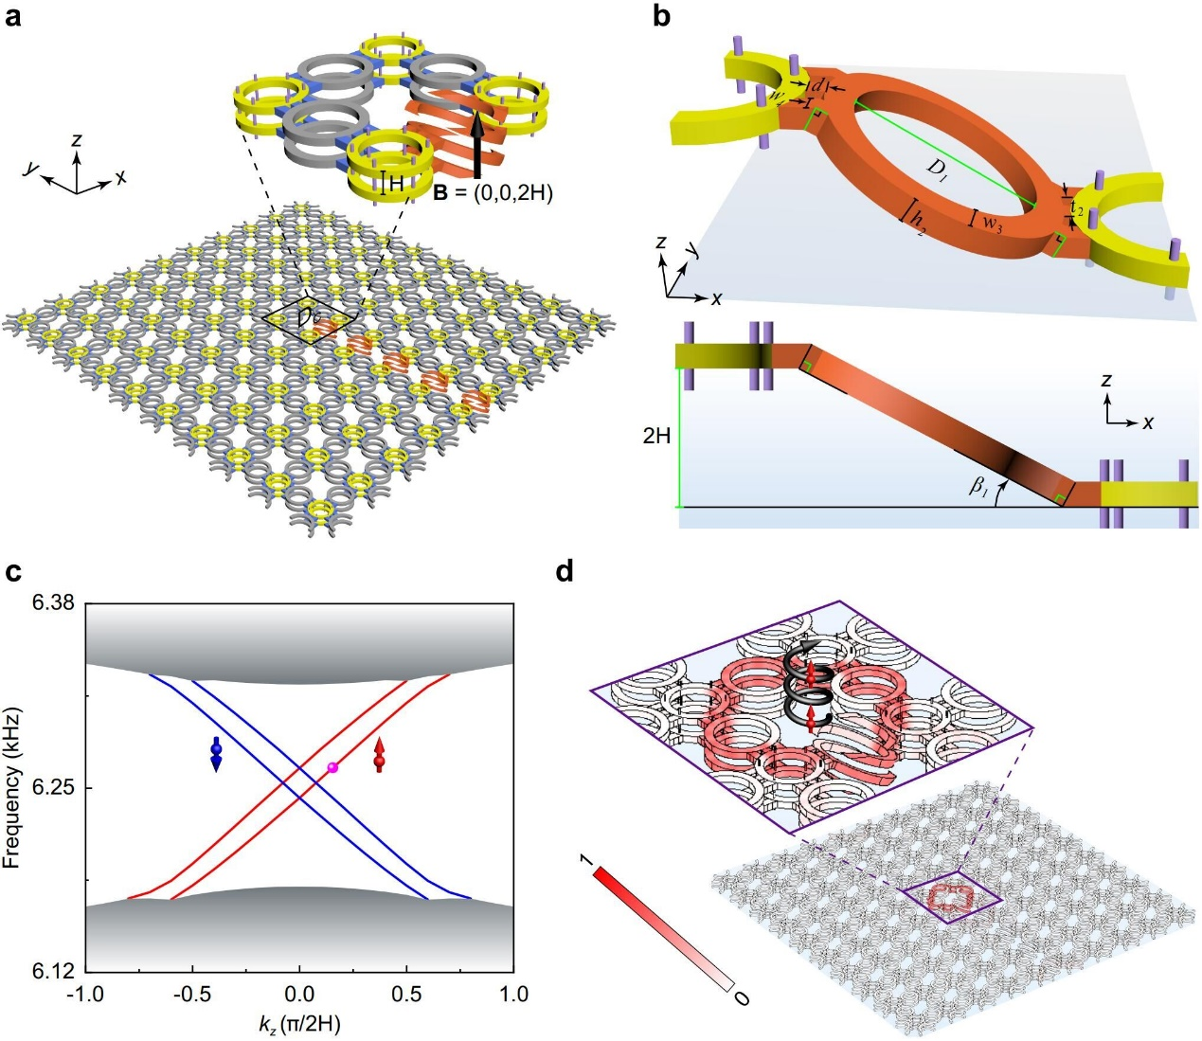

Figure S8 | TDMs trapped by the screw dislocation with a larger Burgers vector. a, Supercell structure that contains a pair of screw dislocations with $B=(0,0,±2H)$, one at the center and the other at the boundary. The inset shows the fine features around the dislocation in the center (labeled with D_{C}). b, Top and side views of the tilted interlayer coupler (orange), associated with structure parameters: $D_{1}=96.3 mm$, $t_{2}=19.5 mm$,$w_{3}=11.2 mm$, $d=8.0 mm$, $w_{4}=11.0 mm$, $β_{1}={27.6}^{o}$, and $h_{2}=h/cosβ_{1}$. c, Dislocation-projected band structure simulated for the supercell in a, imposing with Bloch boundary condition in the z direction while periodic boundary conditions in the x-y plane. (Here we plot only the TDMs trapped at the supercell center.) As expected from the bulk-dislocation correspondence, each screw dislocation hosts two pairs of helical TDMs (color lines). d, Pressure amplitude distribution exemplified for the TDM highlighted by the pink sphere in c, where the inset enlarges the region around the dislocation.

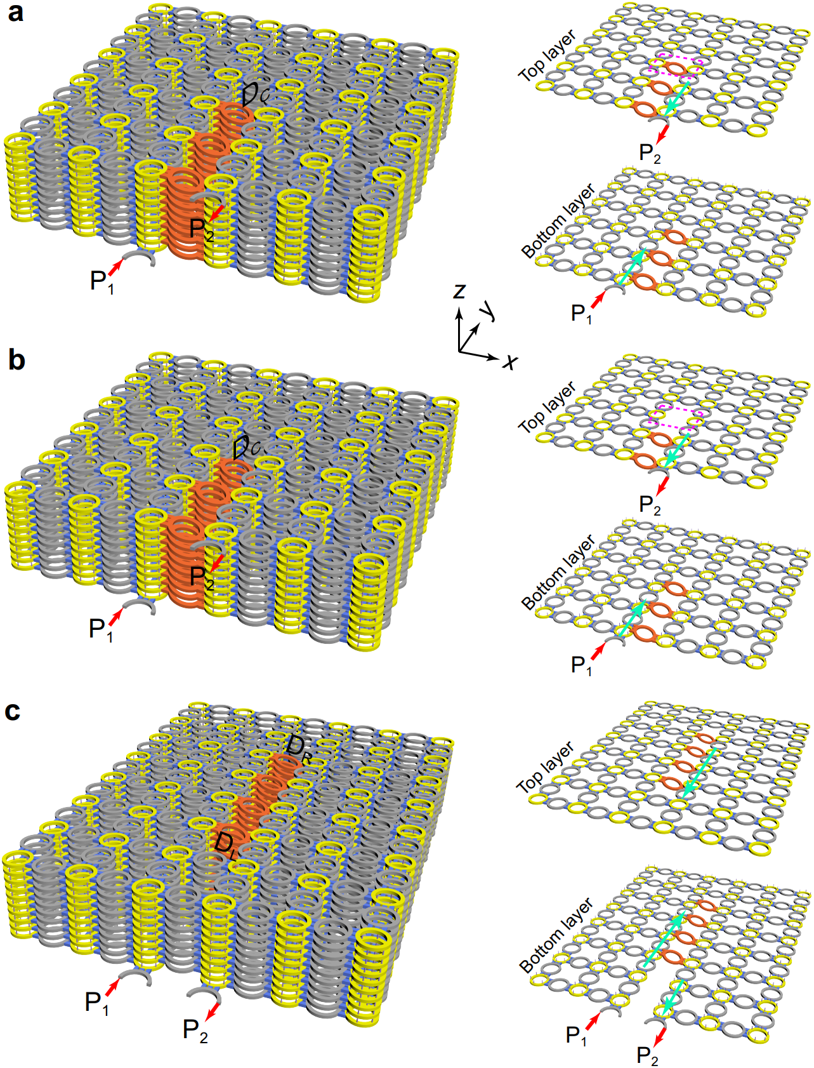

Figure S9 | Structure details of the three dislocation systems discussed in Fig. 3. a, The system considered in Fig. 2e, which hosts a screw dislocation (labeled with D_{C}) in its interior and two edge dislocations on the top and bottom layers. For clarity, here we provide the structure details for the top and bottom layers. The ports P₁ and P₂, which connect respectively the edge dislocations in the bottom and top layers, are used to import and export sound signals, respectively. The cyan arrows indicate the propagations of the excited TDMs along the edge dislocations on the boundary layers. b, The system considered in Fig. 2f. Comparing with a, a tilted interlayer coupler on the top layer (see the magenta dashed box) is removed to create a defect in the dislocation path. c, The system considered in Fig. 2g. It features a dislocation loop connected with two screw dislocations (labeled with D_{R} and D_{L}) in the interior of the sample and two edge dislocations on the top and bottom layers.

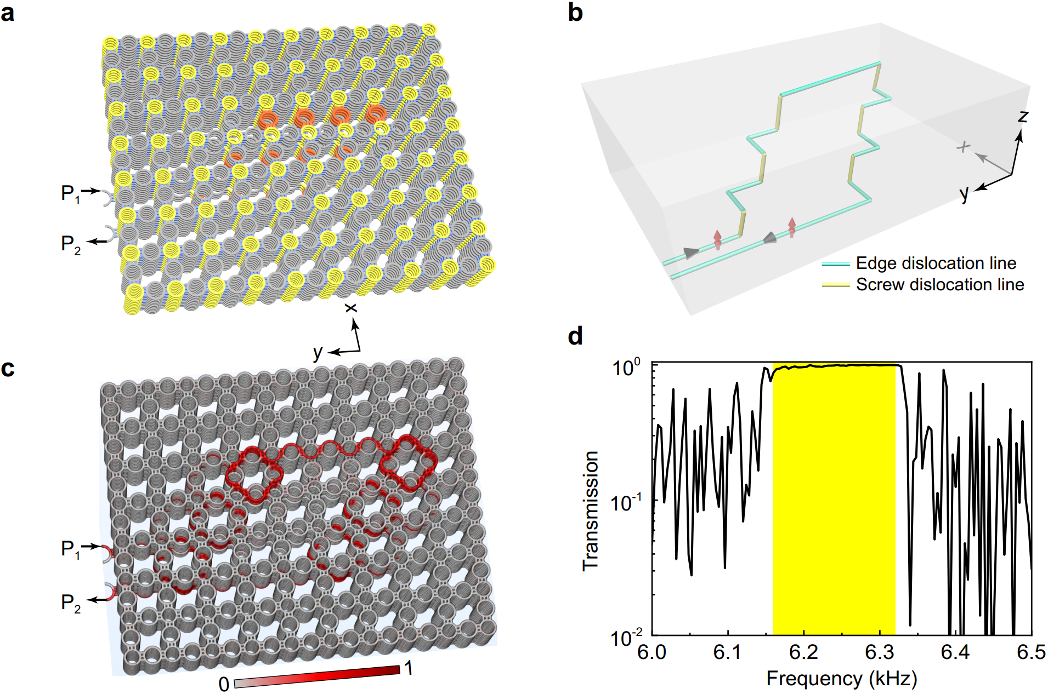

Figure S10 | Unidirectional propagation of the spin-locked TDMs in an arbitrary dislocation path. a, A 10-layer 3D ATI with a dislocation path of irregular shape. The sound signal is injected from the port P₁ and exported from the port P₂. b, Sketch of the dislocation lines in a. c, Pressure amplitude distribution simulated at 6.27 kHz. It shows that the (pseudospin-up) TDM propagates smoothly along the prescribed route without visible scattering into the bulk. d, Transmission spectrum of the system, which characterizes quantitatively the topological robustness of the TDMs traveling in this complex dislocation path. It shows that nearly perfect transmission occurs within the nontrivial band gap (yellow), while suffering striking reflection beyond that frequency range.

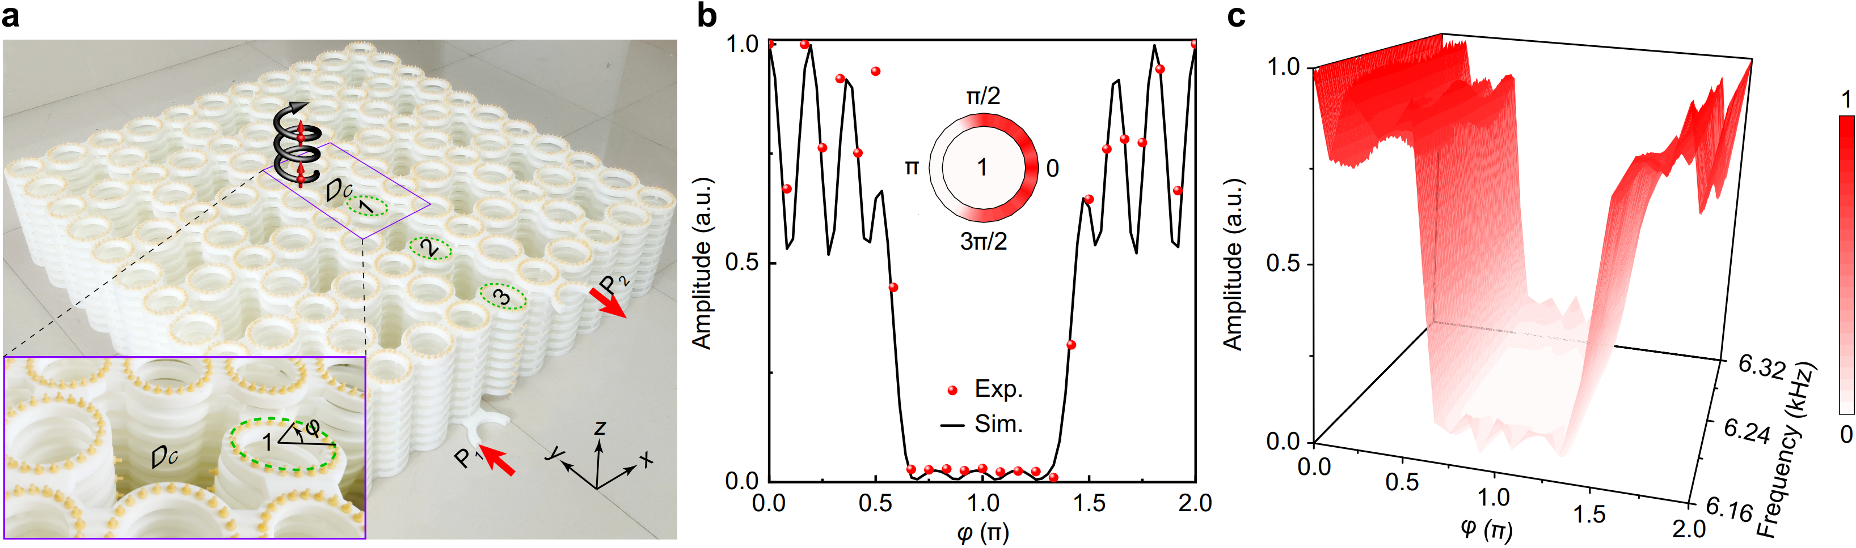

Figure S11 | Experimental evidence for the strong coupling induced by the tilted interlayer coupler. a, A photograph of the experimental sample. As mentioned in our main text, pseudospin-up TDMs will be excited for the sound signal injected from the port P₁. The inset amplifies the tilted ring-waveguide 1 around the dislocation D_{C}, where the angular dependent field profile will be detected hole-by-hole. b, Experimentally measured pressure amplitude distribution at 6.27 kHz (red spheres), which reproduces well the simulation result (black line). Inset: A direct visualization of the experimental data inside the ring. The sound energy concentrated in the right half ring shows a direct evidence of the strong coupling induced by the tilted interlayer coupler. (Please pay attention to the coordinate systems defined for Fig. S6 and Fig. S11.) c, Similar to b, but plotted from 6.16 kHz to 6.32 kHz, which confirms the strong coupling over the nontrivial bulk gap.

Reference:
- Fu, L. & Kane, C. L. Topological insulators with inversion symmetry. Phys. Rev. B 76, 045302 (2007).

