Supplemantary Meterial for
Predicting hosts based on early SARS-CoV-2 Samples and Analyzing later World-wide Pandemic in 2020
Qian Guo^{1,2,3#}, Mo Li^{4#}, Chunhui Wang^{4#}, Jinyuan Guo^{1,3#}, Xiaoqing Jiang^{1,2,5#}, Jie Tan¹, Shufang Wu^{1,2}, Peihong Wang¹, Tingting Xiao⁶, Man Zhou^{1,2}, Zhencheng Fang^{1,2}, Yonghong Xiao^{6*} & Huaiqiu Zhu^{1,2,3,5*}
¹ State Key Laboratory for Turbulence and Complex Systems, Department of Biomedical Engineering, College of Engineering, Peking University, Beijing 100871, China.
² Center for Quantitative Biology, Peking University, Beijing 100871, China.
³ Department of Biomedical Engineering, Georgia Institute of Technology and Emory University, Georgia 30332, USA.
⁴ Peking University-Tsinghua University-National Institute of Biological Sciences (PTN) joint PhD program, School of Life Sciences, Peking University, Beijing 100871, China.
⁵ Institute of Medical Technology, Peking University Health Science Center, Beijing 100191, China.
⁶ State Key Laboratory for Diagnosis and Treatment of Infectious Diseases, National Clinical Research Center for Infectious Diseases, Collaborative Innovation Center for Diagnosis and Treatment of Infectious Diseases, The First Affiliated Hospital, College of Medicine, Zhejiang University, Hangzhou 310006, China.
# These authors contributed equally.
* Corresponding authors: hqzhu@pku.edu.cn(Zhu H) & xiao-yonghong@163.com (Xiao Y)

The following sections include:
Supplementary Methods
Supplementary Tables 1, 3 and 6
Supplementary Figs. 1 to 6

Other Supplementary Material for this manuscript includes the following:
Supplementary Table S2 Metadata and host likelihood scores of genes for SARS-CoV, MERS-CoV and SARS-COV-2 isolates
Supplementary Table S4 Contributions of 11 genes in the determination of hosts for SARS-CoV-2
Supplementary Table S5 Metadata, host likelihood score profiles, and high frequency SNPs on 53759 SARS-CoV-2 isolates
Supplementary Table S7 Host information of the viral genomes in training and test sets of DeepHoF
Supplementary Table S8 Acknowledge of sequence data of SARS-CoV-2 in GISAID

Supplementary Methods
Host prediction using BLAST
As there are no bioinformatics tools for comparison, we compare evaluation metrics of BLAST and DeepHoF. The host prediction using BLAST are divided into the following steps:
(1) Make BLAST database with the viral whole genomes used in the training dataset of DeepHoF. Besides, all the viral genomes are annotated with the corresponding host types.
Command: makeBLASTdb -in input_file -dbtype nucl -out database_name
(2) Align the whole genome sequences in test dataset of DeepHoF to the BLAST database made at the step (1).
Command: BLASTn -query input_file -task BLASTn -db database_name -out output_file -evalue 1e-1 -outfmt 6 -qcov_hsp_perc 0.5 -num_threads 30 -max_target_seqs 1
(3) Assign host prediction result for each query sequence. For example, for query sequence A, if virus B, which is annotated with host type “human, invertebrate”, is the best hit for it, then the hosts of virus B (human and invertebrate) will be regarded as the predicted host types of viral sequence A. Meanwhile, the identity between sequence A and virus B is assigned as the prediction scores on both “human” and “invertebrate” host types, while the scores on other host types are assigned with zero. Besides, if there are no hit for viral sequence A, then the prediction scores are assigned with the difference between [1,1,1,1,1] and the true label vector. For example, if the viral A has host types of plant and germ, its label vector is [1, 1, 0, 0, 0], and if there are no hit for viral sequence A, the predicted score vector will be provided with [0, 0, 1, 1, 1] by BLAST. (Note: the five labels in the label vector are corresponding to plants, germs, invertebrates, vertebrates except human, and human, respectively)
The details of each layer of DeepHoF
Input: BOH(COH)
Layer b1(c1): 1D convolutional layer, including 512 convolution kernels with the length of six. Activation function: ReLU (Rectified Linear Unit, y = max(0, x)).
Layer b2(c2): global average pooling layer.
Layer 3: the concatenation layer, combining the output of the “base path” and “codon path”.
Layer 4: batch normalization layers with the dropout operation, used to facilitate the convergence and prevent the overfitting.
Layers 5a-5e, 6a-6e and 7a-7e: full connection layers, followed by batch normalization layers with the dropout operation. After the dropout operation, five sigmoid layers calculate five prediction scores, each corresponding to host likelihood scores on plants, germs, invertebrates, vertebrates and human, respectively.
Commands of software used in phylogenetic analysis and protein annotation
Clustalo: clustalo --full -force -i Multiple_sequence_input_file --distmat-out=name.mat --guidetree-out name.guide.nwk -o name.aln --threads 30 --outfmt=a2m
RAxML: raxmlHPC-HYBRID -s multi-alignmentfile -w outputdir -n coronavirus -m GTRGAMMA -T 40 -N 100 -p 20170808 -f a -x 20170808
Snippy: snippy --outdir outidr --ctgs fastafile –ref NC_045512.gbk --cpus 50
Supplementary Tables
Supplementary Table S1 Comparison of performance of DeepHoF and BLAST on each host type classification
Metrics | Plant |  |  | Germ |  | Invertebrate
Metrics | BLAST | DeepHoF |  | BLAST | DeepHoF | BLAST | DeepHoF
TPR | 0.72807 |  | 0.412281 | 0.901219 | 0.904577 | 0.808696 | 0.913043
FPR | 0.101413 |  | 0.002748 | 0.12494 | 0.011922 | 0.112158 | 0.020024
AUC | 0.776833 |  | 0.973326 | 0.833512 | 0.994894 | 0.809932 | 0.993924
Precision | 0.096737 |  | 0.691176 | 0.951138 | 0.99514 | 0.097895 | 0.406977
Accuracy | 0.89608 |  | 0.988654 | 0.894146 | 0.927153 | 0.886668 | 0.978984

Metrics | Vertebrate |  | Human |  | Average
Metrics | BLAST | DeepHoF | BLAST | DeepHoF | BLAST | DeepHoF
TPR | 0.840225 | 0.808065 | 0.95873 | 0.75873 | 0.887814 | 0.864929
FPR | 0.096774 | 0.003623 | 0.109599 | 0.003087 | 0.106788 | 0.007986
AUC | 0.832527 | 0.976409 | 0.873414 | 0.996917 | 0.832533 | 0.987131
Precision | 0.745809 | 0.986908 | 0.436101 | 0.956 | 0.699312 | 0.968049
Accuracy | 0.887313 | 0.948814 | 0.895952 | 0.977566 | 0.892032 | 0.964234

Supplementary Table S3 Top 20 hosts predicted by DeepHoF on SARS-CoV-2
Rank | Host name | Euclidean distance
1 | Neovison vison/ Mustela lutreola | 0.01886
2 | Rhinolophus sinicus | 0.02647
3 | Canis lupus familiaris | 0.03508
4 | Hipposideros pomona | 0.03878
5 | Rhinolophus affinis | 0.04301
6 | Feliformia/ Felidae | 0.05125
7 | Ailuropoda melanoleuca | 0.05456
8 | Meleagris gallopavo | 0.06631
9 | Homo sapiens/ Paguma larvata | 0.07209
10 | Sus scrofa | 0.07290
11 | Plecotus auritus | 0.07410
12 | Enhydra lutris kenyoni | 0.07444
13 | Gorilla gorilla | 0.07839
14 | Galliformes/ Gallus gallus | 0.07906
15 | Canis lupus signatus | 0.08073
16 | Pan troglodytes | 0.08151
17 | Gallus gallus | 0.08597
18 | Pipistrellus | 0.08734
19 | Chelonia mydas | 0.08987
20 | Zosteropidae | 0.09105

Supplementary Table S6 Subtypes in five host types
Host type | Host subtypes
plant | algae, diatom, plant
germ | Archaea, bacteria, fungi, protozoa
invertebrate | invertebrate
vertebrate | vertebrates except human
human | human

Supplementary Figures
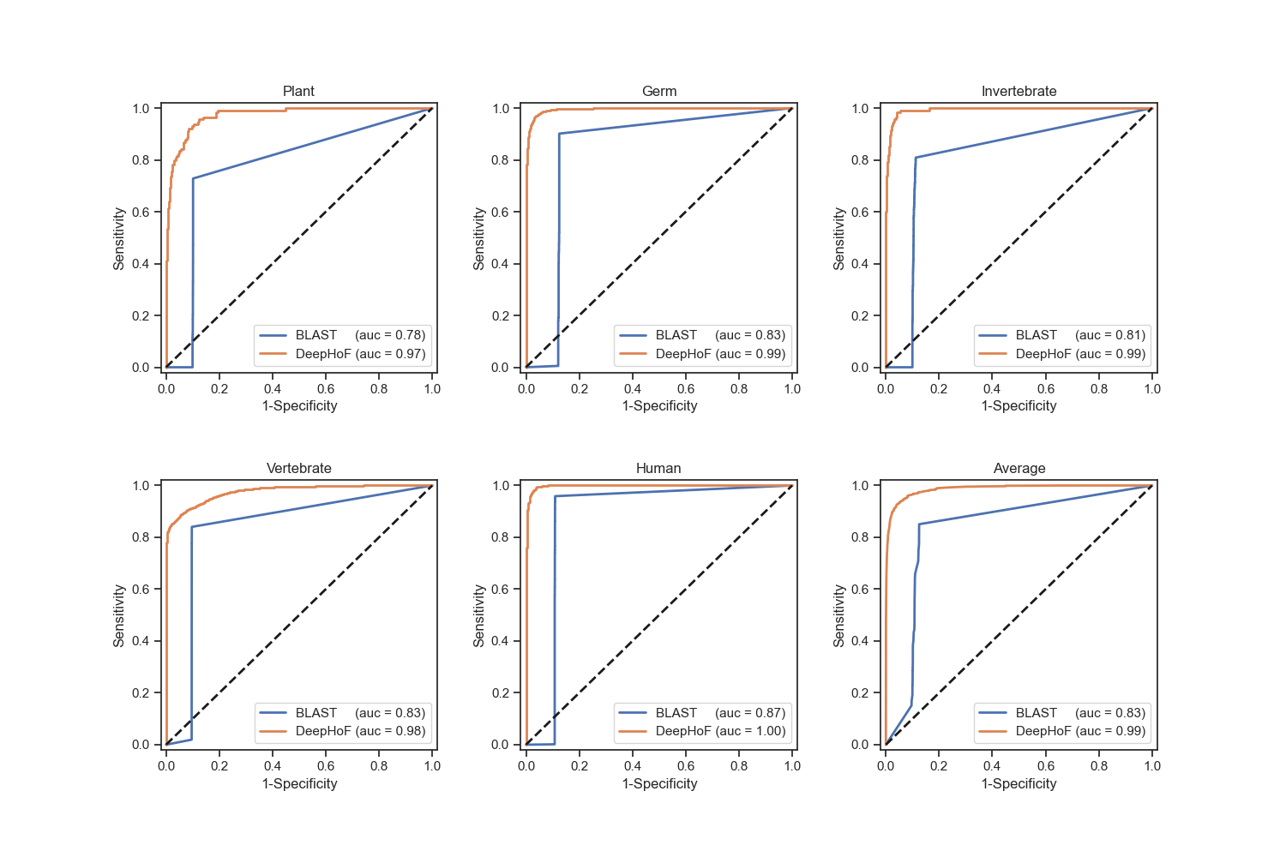
Supplementary Figure 1 ROC curves and AUC values of DeepHoF and BLAST on five host types
DeepHoF performs better than BLAST on AUC of each host type.

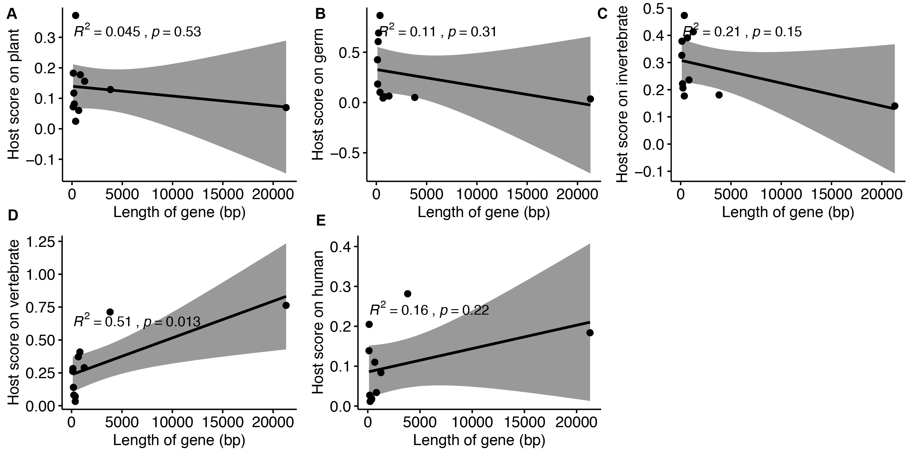
Supplementary Figure S2 The untenable linear correlations between the lengths and the host likelihood scores for genes of SARS-CoV-2
For the genes of SARS-CoV-2, there is no statistical significance in the linear correlations between the lengths and the host likelihood scores on plant (A), germ (B), invertebrate (C), vertebrate (D) and human (E).

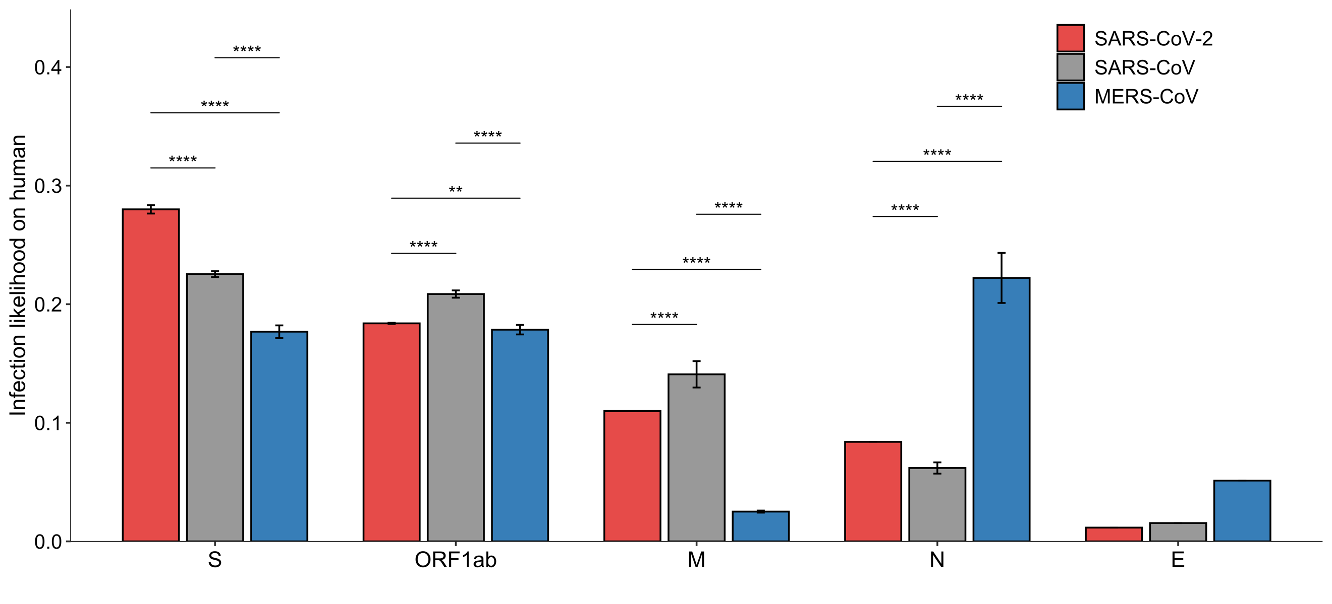
Supplementary Figure 3 Human host likelihood scores of 5 genes of SARS-CoV-2, SARS-CoV and MERS-CoV
Although all the three coronaviruses possess ORF1ab and four structural genes (S, M, N, E), these genes made different contributions on human host likelihood scores in these three viruses (two-sided unpaired Welch Two Sample t-test, p-value $<$ 0.05). S gene and M gene contributed more in SARS-CoV-2 and SARS-CoV, while N gene and E gene were more significant in MERS-CoV.

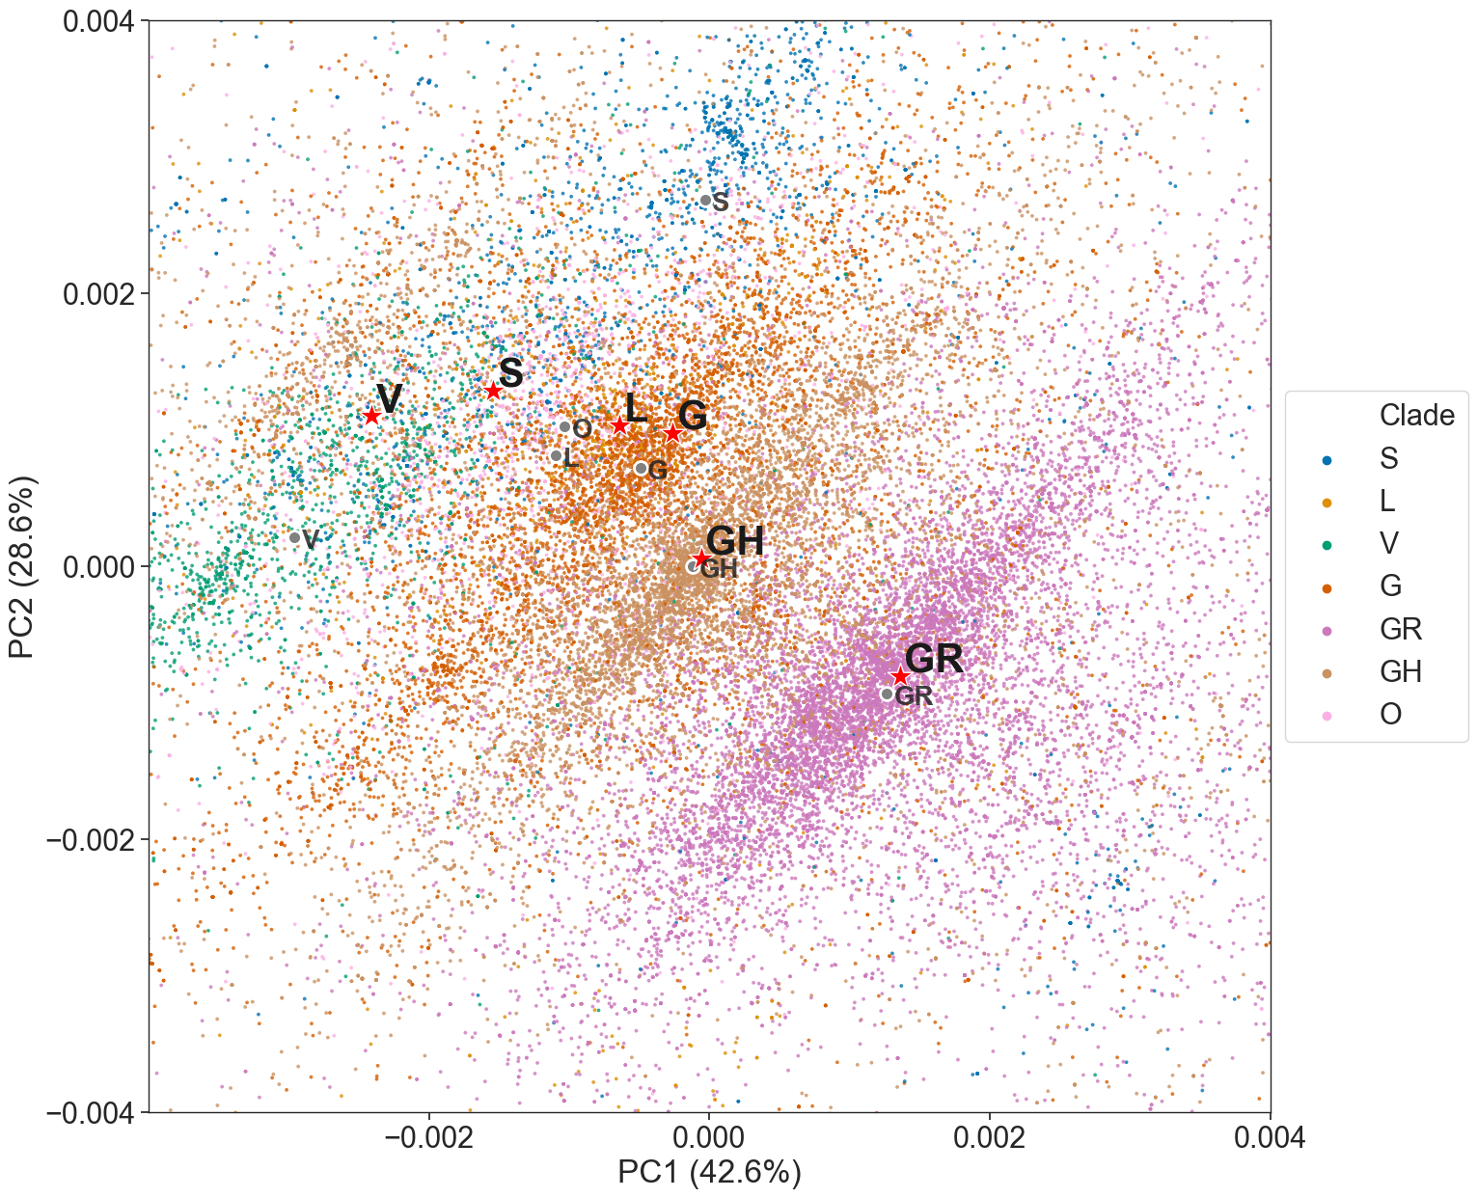
Supplementary Figure S4 Visualization of the host likelihood score profiles of SARS-CoV-2 isolates from different GISAID clades and the manually mutated SARS-CoV-2 isolates on two-dimensional PCA
SARS-CoV-2 isolates fall into several clear fusiform clusters with different colors according to their clades. Manually mutated with specific marker variants, the 17 earliest sequenced isolates move to the corresponding fusiform cluster of the clade that is represented by the specific marker variants.

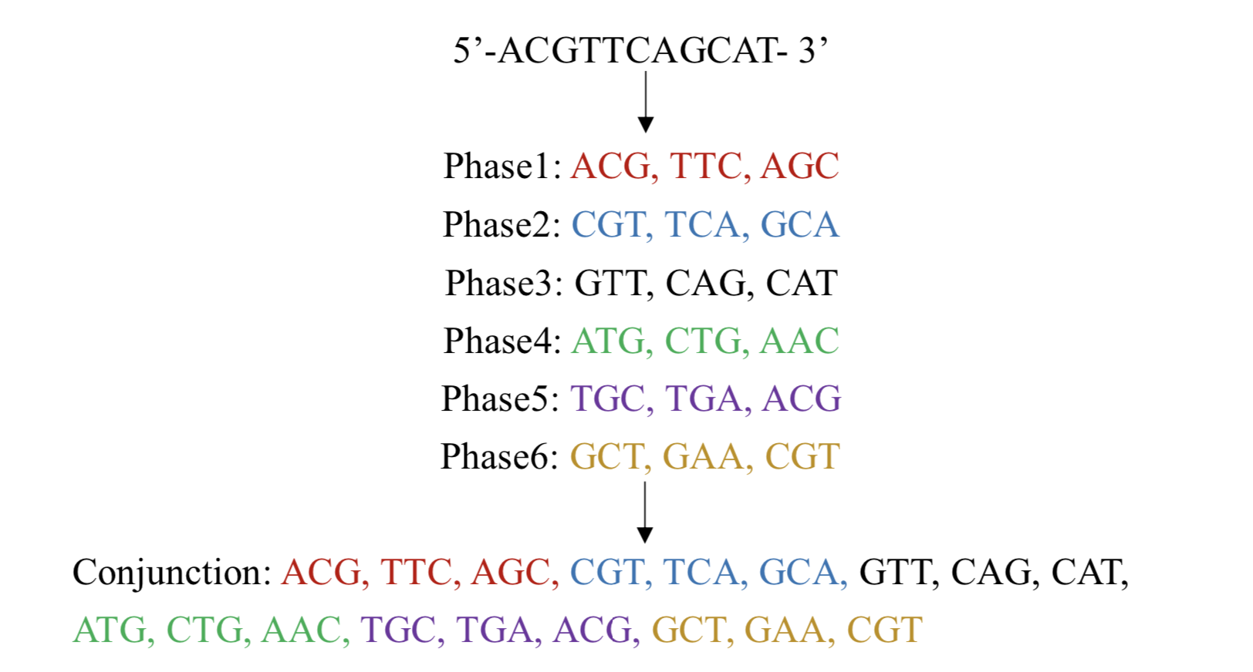
Supplementary Figure 5 Six phases of an input sequence
For coding the COH matrix of a given sequence, we represented it with the direct conjunction of its six phases, generated from its complementary strand and itself.

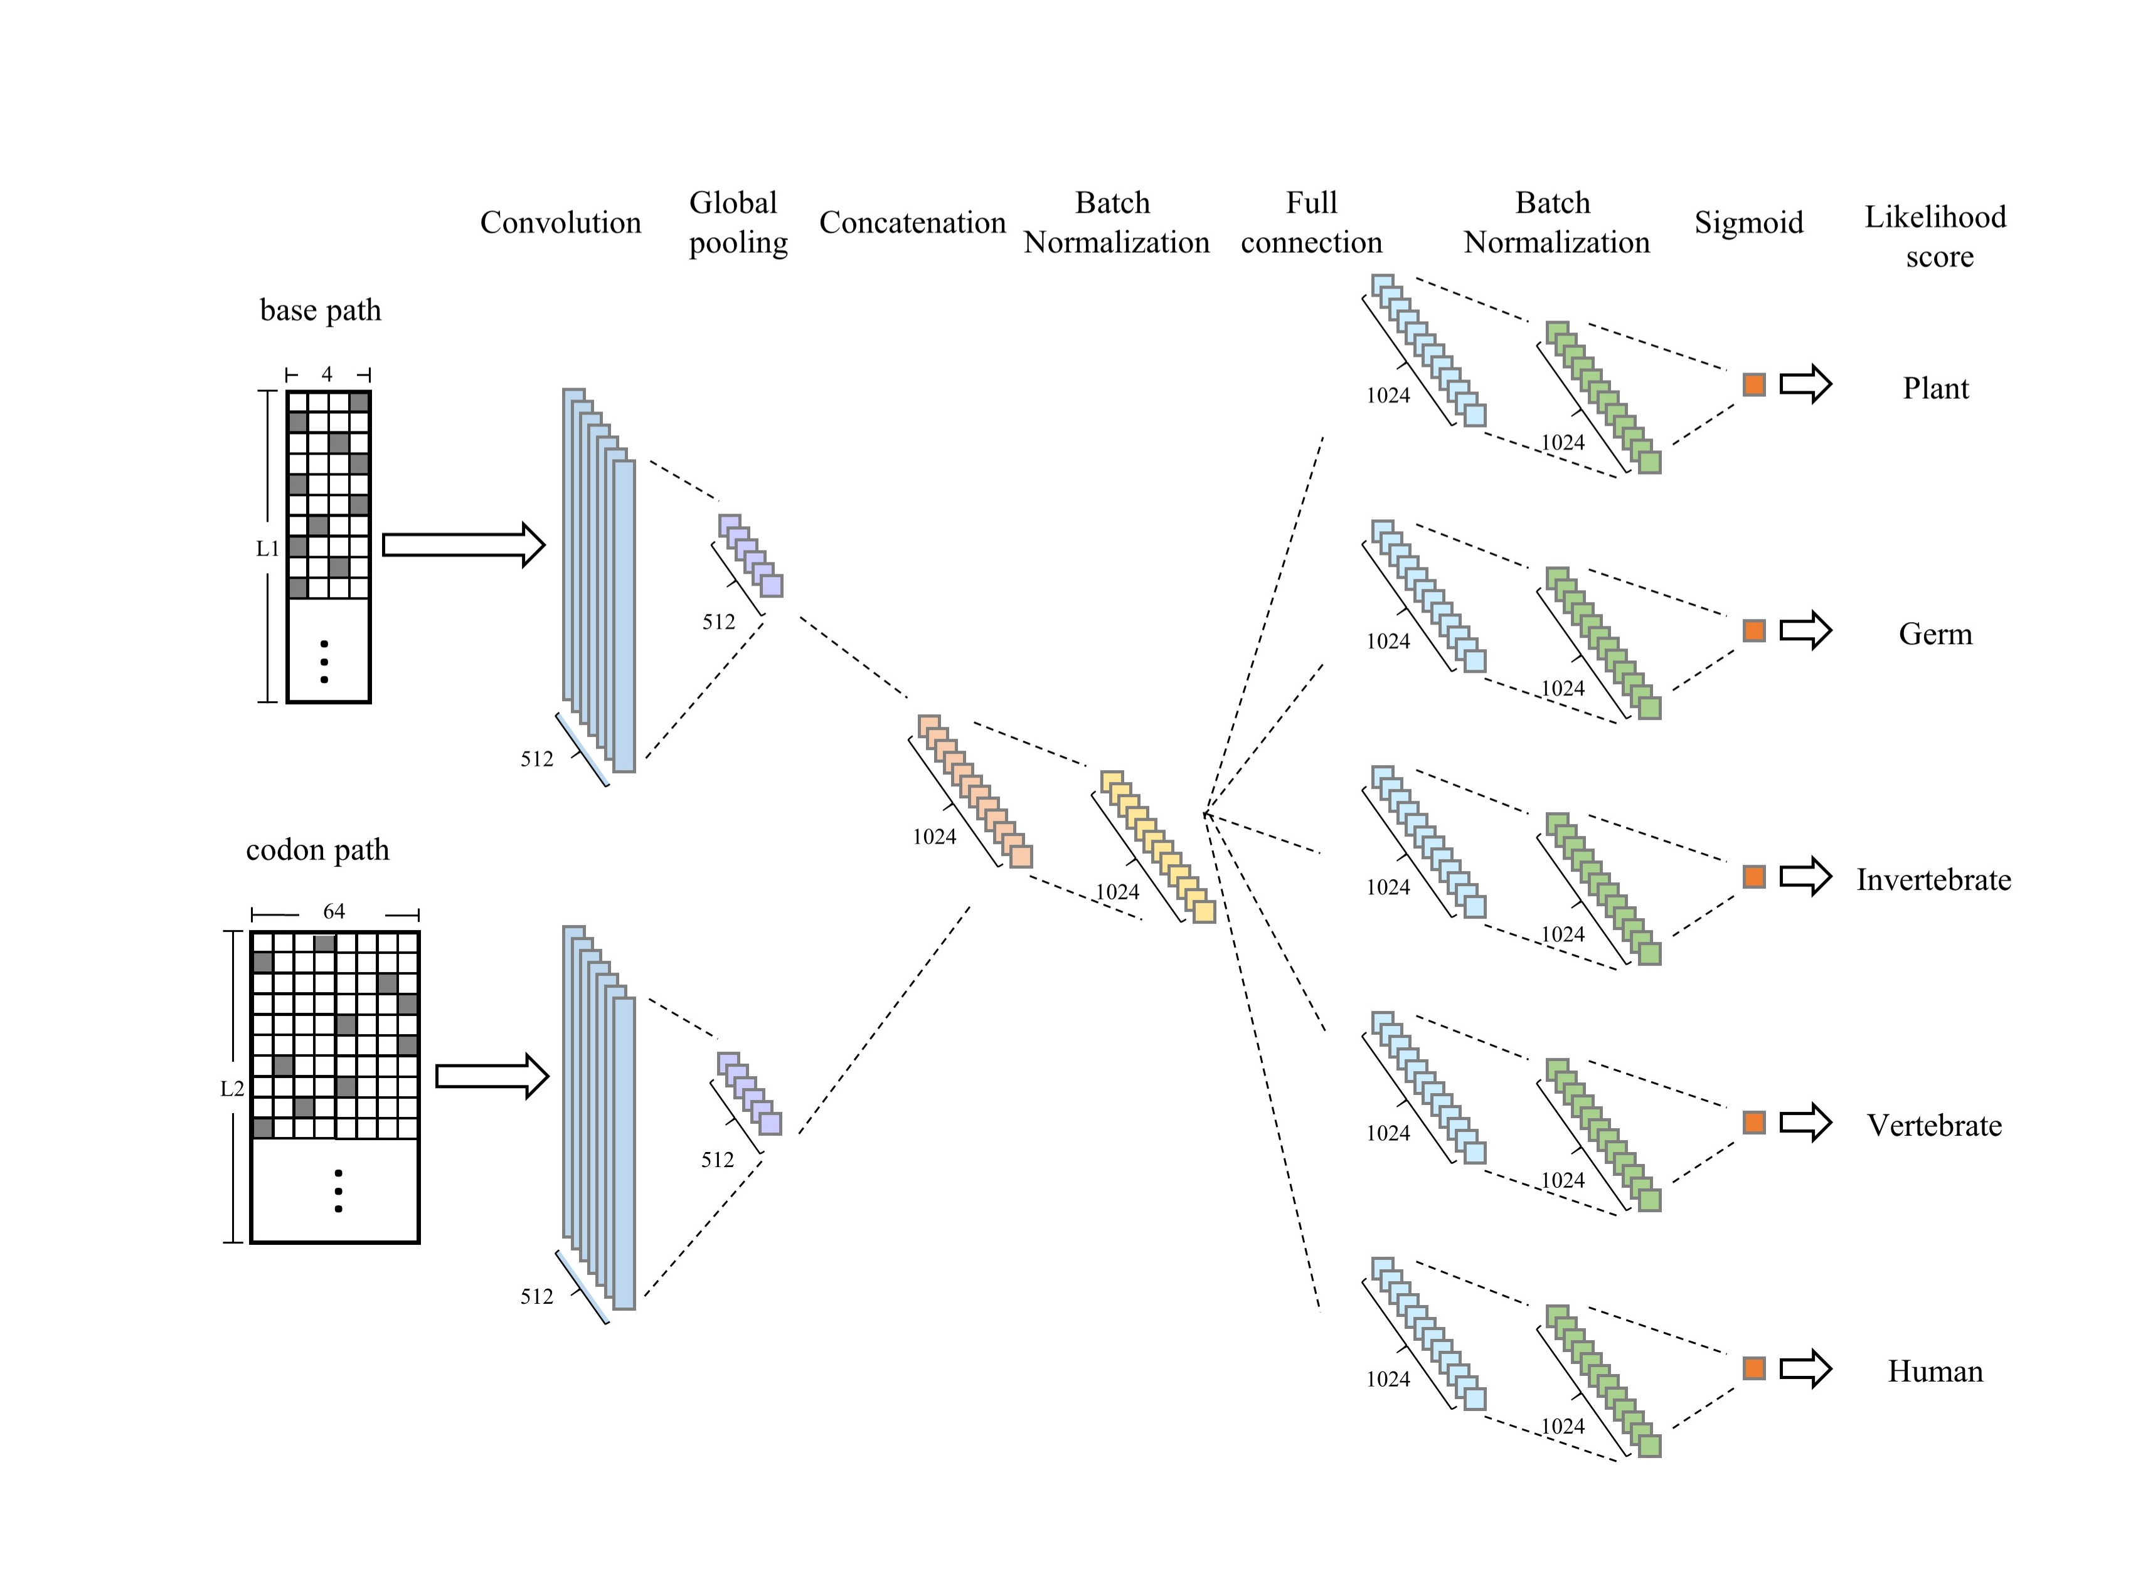
Supplementary Figure S6 Structure of BiPathCNN in DeepHoF
BOH matrix and COH matrix are input into two paths independently and transformed by the convolution and pooling layers at the beginning. A concatenation layer and a normalization layer combine the output of the two paths. Five sub-paths process the combined intermediate output individually. Each sub-path contains a full connection layer, a normalization layer and an output layer with sigmoid activation and binary cross-entropy loss function. The five sub-paths output the host likelihood scores on five host types respectively.

