Table 5 Comparison of binding energy of molecular docking Vina, LeDock, and DS
Compound | Structure | Target(Ligand) | Binding Energy
Compound | Structure | Target(Ligand) | Vina  (kcal·mol-1) | LeDock  (kcal·mol-1) | DS  (LibDockScore)
quercetin | 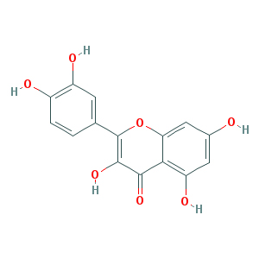 | VEGFA(5T89) | -6.00 | -5.09 | -
quercetin |  | CCND1(2W96) | -6.30 | -5.59 | 90.3571
quercetin |  | MYC(5I42) | -8.00 | -7.70 | -
quercetin |  | JUN(3V3V) | -8.80 | -6.00 | 99.4514
quercetin |  | MMP9(6ESM) | -9.90 | -6.86 | 145.044
quercetin |  | MMP2(4WK7) | -9.50 | -6.82 | 138.262
Stigmasterol | 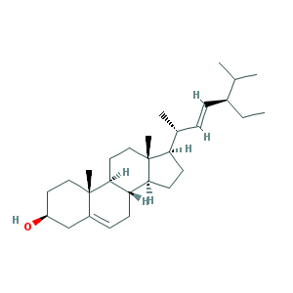 | VEGFA(5T89) | -4.90 | -4.08 | -
Stigmasterol |  | CCND1(2W96) | -6.50 | -4.00 | 87.8871
Stigmasterol |  | MYC(5I42) | -6.40 | -5.38 | -
Stigmasterol |  | JUN(3V3V) | -7.20 | -4.86 | 107.282
Stigmasterol |  | MMP9(6ESM) | -8.50 | -5.12 | -
Stigmasterol |  | MMP2(4WK7) | -5.80 | -4.98 | 117.641
beta-sitosterol | 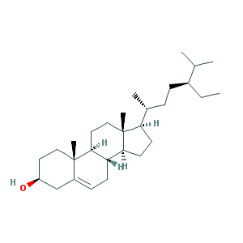 | VEGFA(5T89) | -5.70 | -4.25 | -
beta-sitosterol |  | CCND1(2W96) | -6.40 | -4.27 | -
beta-sitosterol |  | MYC(5I42) | -6.30 | -5.53 | -
beta-sitosterol |  | JUN(3V3V) | -9.50 | -5.23 | 109.886
beta-sitosterol |  | MMP9(6ESM) | -8.80 | -5.57 | -
beta-sitosterol |  | MMP2(4WK7) | -7.40 | -5.14 | 124.419
Izoteolin | 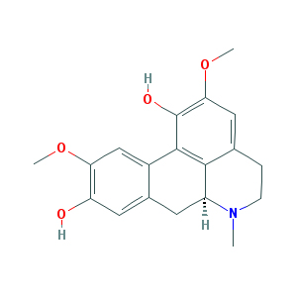 | VEGFA(5T89) | -5.50 | -4.02 | -
Izoteolin |  | CCND1(2W96) | -5.70 | -4.70 | -
Izoteolin |  | MYC(5I42) | -6.10 | -5.95 | -
Izoteolin |  | JUN(3V3V) | -8.80 | -5.89 | 96.172
Izoteolin |  | MMP9(6ESM) | -7.70 | -5.27 | 117.762
Izoteolin |  | MMP2(4WK7) | -8.30 | -5.86 | 118.482
ellagic acid | 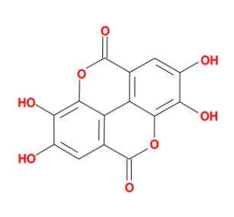 | VEGFA(5T89) | -6.10 | -4.38 | -
ellagic acid |  | CCND1(2W96) | -6.30 | -4.92 | -
ellagic acid |  | MYC(5I42) | -6.30 | -6.44 | -
ellagic acid |  | JUN(3V3V) | -9.50 | -6.40 | 100.529
ellagic acid |  | MMP9(6ESM) | -7.70 | -5.47 | 132.727
ellagic acid |  | MMP2(4WK7) | -8.60 | -5.80 | 120.031

