TABLE I
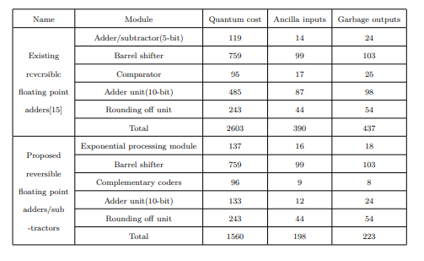
Comparison between existing design and proposeda

