Evolving trajectories of COVID-19 curves in India: Prediction using autoregressive integrated moving average modeling.
Sudhir Bhandari¹, Amit Tak^{*2}, Jitendra Gupta², Bhoopendra Patel³, Jyotsna Shukla² , Ajit Singh Shaktawat¹, Sanjay Singhal², Abhishek Saini², Shivankan Kakkar⁴, Amitabh Dube², Sunita Dia⁵, Mahendra Dia⁶, Todd C. Wehner⁶
Affiliations
¹Department of Medicine, SMS Medical College and Hospitals, Jaipur, Rajasthan, India
²Department of Physiology, SMS Medical College and Hospitals, Jaipur, Rajasthan, India
³ Department of Physiology, Government Medical College, Barmer, Rajasthan, India
⁴Department of Pharmacology, SMS Medical College and Hospitals, Jaipur, Rajasthan, India
⁵ Department of Rheumatology, Medstar Washington Hospital Center, Washington DC-20010, USA.
⁶ Department of Horticultural Science, North Carolina State University, Raleigh, NC 27695-7609, USA.
*Corresponding author : dramittak@gmail.com

Supplemental Material Description
There are four supplemental figures provide correlograms of times series of cumulative cases and death cases of COVID-19 and residual diagnostics of selected ARIMA models.
Two supplemental tables provide estimates of parameters of ARIMA model.

Supplemental Figure S1. Correlograms of time series of cumulative cases of COVID-19 (a) sample autocorrelation function (b) sample partial autocorrelaton function.

Supplemental Figure S2. Correlograms of time series of death cases of COVID-19 (a) sample autocorrelation function (b) sample partial autocorrelaton function.

Supplemental Figure S3. Line plots, QQ plots and correlograms of residual diagnostic of differenced logarithmic transformed time series of cumulative cases of COVID-19. Line plots showing random distribution of standardized residuals and QQ plot showing straight line in the mid portion and the autocorrelation and partial autocorrelation functions are within random limits , represent normality of residuals.

Supplemental Figure S4. Line plots, QQ plots and correlograms of residual diagnostic of differenced logarithmic transformed time series of death cases of COVID-19. Line plots showing random distribution of standardized residuals and QQ plot showing straight line in the mid portion and the autocorrelation and partial autocorrelation functions are within random limits , represent normality of residuals.

Supplemental Table Legends
Supplemental Table S1. Parameters, errors and statistics of ARIMA (1,3,2) model, fitted from training dataset of cumulative cases of COVID-19.
Supplemental Table S2. Parameters, errors and statistics of ARIMA (3,3,1) model, fitted from training dataset of death cases of COVID-19.
Supplemental Figure S1. Correlograms of time series of cumulative cases of COVID-19 (a) sample autocorrelation function (b) sample partial autocorrelaton function.
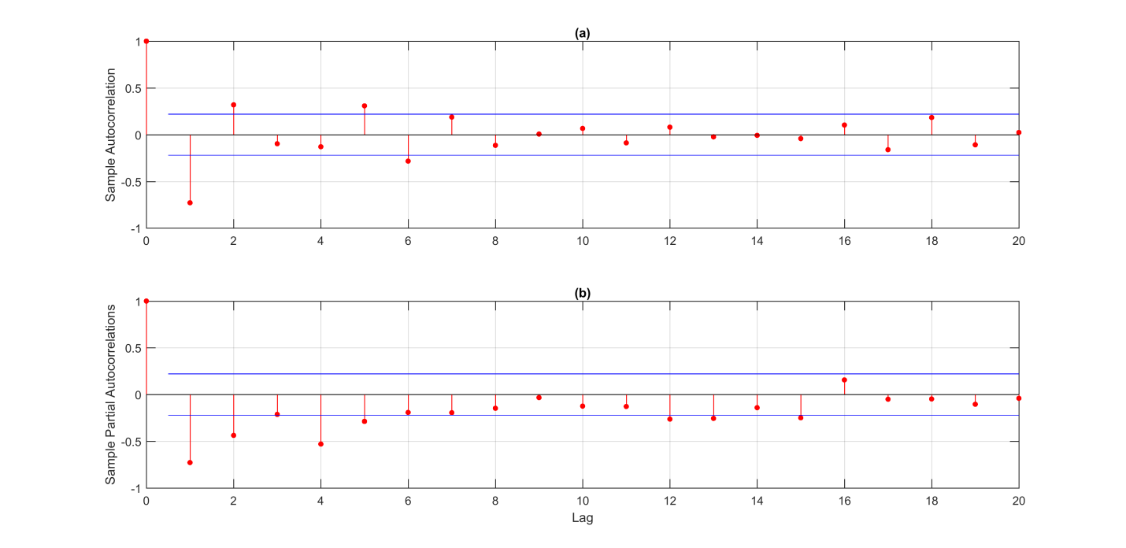

Supplemental Figure S2. Correlograms of time series of death cases of COVID-19 (a) sample autocorrelation function (b) sample partial autocorrelaton function.
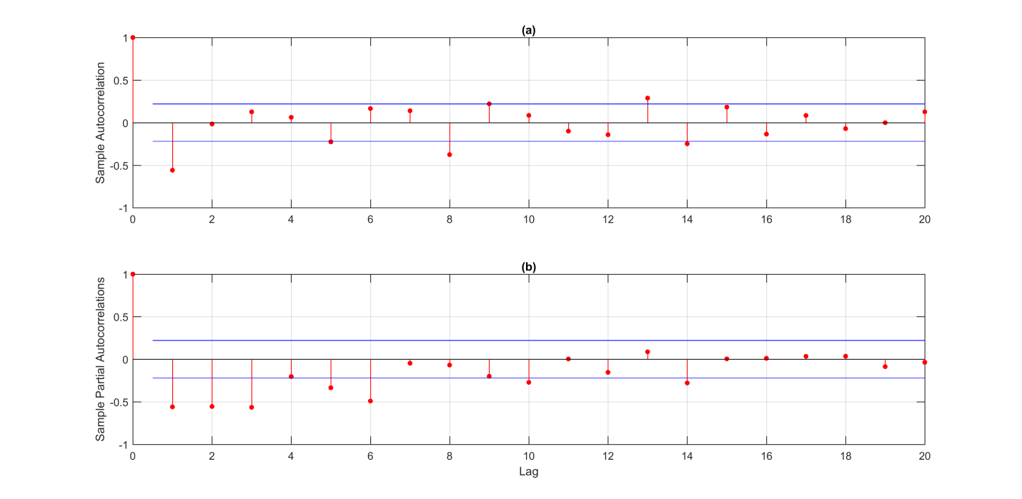

Supplemental Figure S3. Line plots, QQ plots and correlograms of residual diagnostic of differenced logarithmic transformed time series of cumulative cases of COVID-19. Line plots showing random distribution of standardized residuals and QQ plot showing straight line in the mid portion and the autocorrelation and partial autocorrelation functions are within random limits , represent normality of residuals.
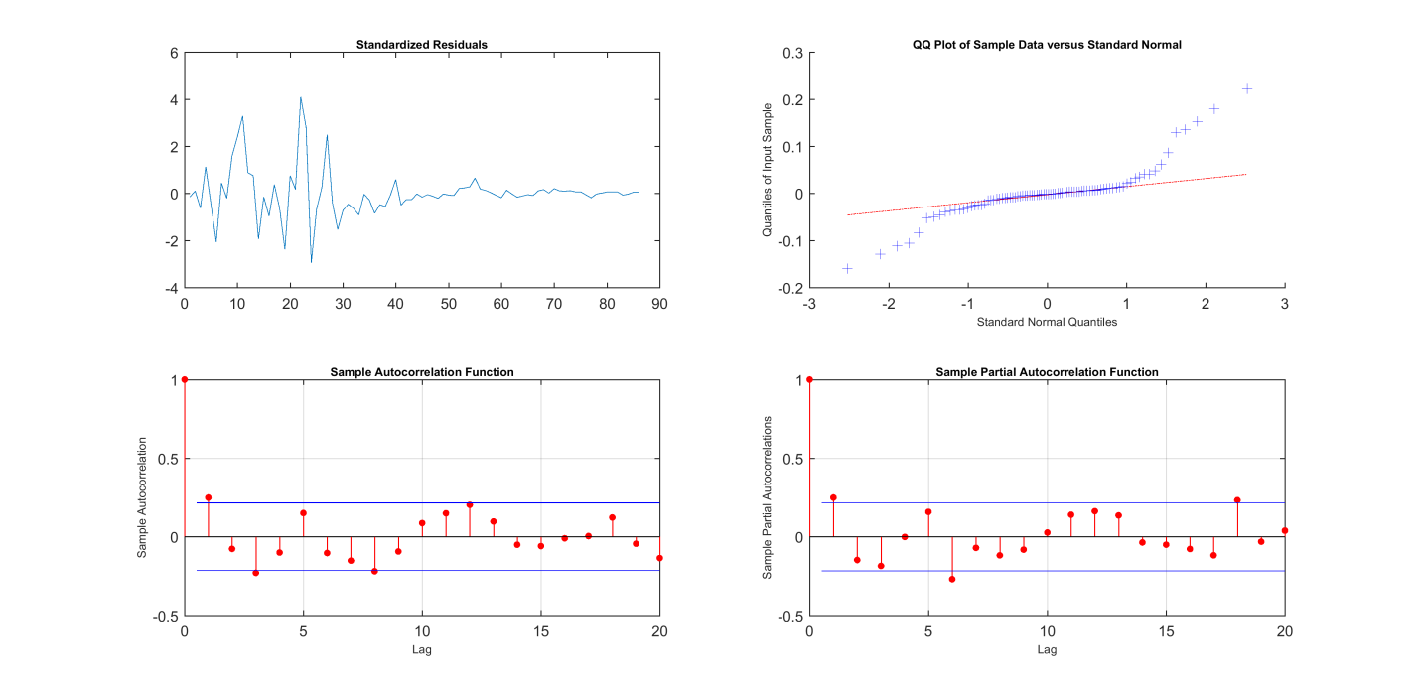

Supplemental Figure S4. Line plots, QQ plots and correlograms of residual diagnostic of differenced logarithmic transformed time series of death cases of COVID-19. Line plots showing random distribution of standardized residuals and QQ plot showing straight line in the mid portion and the autocorrelation and partial autocorrelation functions are within random limits , represent normality of residuals.
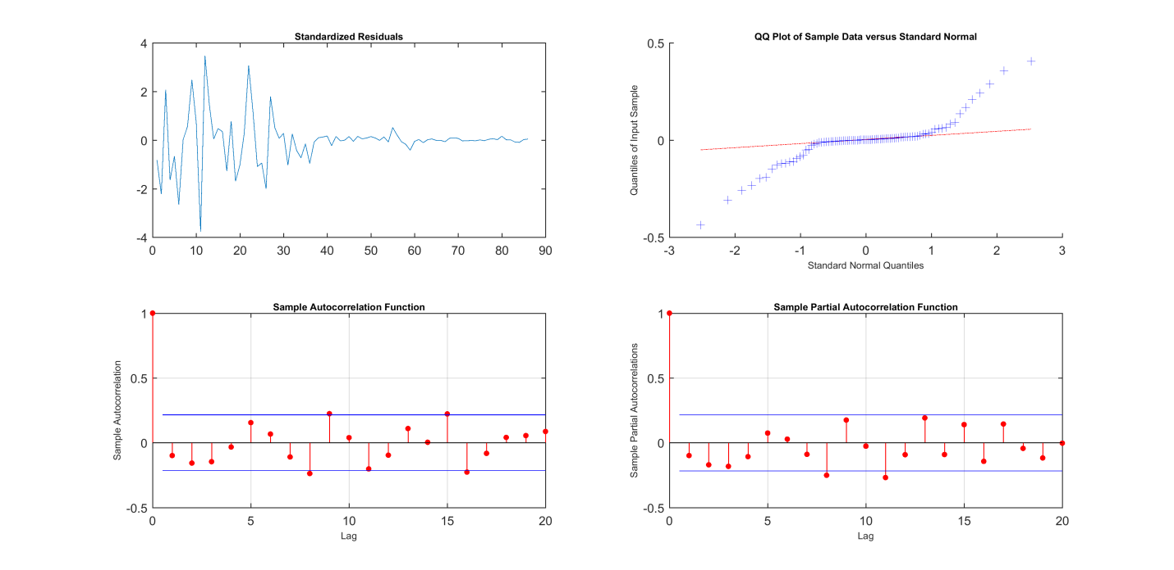

Supplemental Table S1. Parameters, errors and statistics of ARIMA (1,3,2) model, fitted from training dataset of cumulative cases of COVID-19.
Parameter | Value | Error | Statistics
Constant | 0.000 | 0.0002 | 0.171
AR{1} | -0.398 | 0.036 | -10.923
MA{1} | -1.756 | 0.048 | -36.406
MA{2} | 0.756 | 0.047 | 16.092
Variance | 0.003 | 0.0002 | 10.190

Supplemental Table S2. Parameters, errors and statistics of ARIMA (3,3,1) model, fitted from training dataset of death cases of COVID-19.
Parameter | Value | Error | Statistics
Constant | 0.0002 | 0.001 | 0.158
AR{1} | -1.118 | 0.0520 | -21.502
AR{2} | -1.078 | 0.058 | -18.482
AR{3} | -0.606 | 0.053 | -11.430
MA{1} | -1 | 0.064 | -15.525
Variance | 0.013 | 0.001 | 9.700

