Deciphering omics atlases to aid stony corals in response to global change

Chunpeng He^{1, 2, 6 *}, Tingyu Han^{1, 6}, Wanlong Huang^{3, 6}, Bing Wang^{3, 6}, Xin Liao⁴, J.-Y. Chen⁵, and Zuhong Lu^{1, *}

¹State Key Laboratory of Bioelectronics, School of Biological Science and Medical Engineering, Southeast University, Nanjing 210096, China.
²National Graduate College for Elite Engineers, Southeast University, Nanjing 210096, China.
³Novogene Bioinformatics Institute, Beijing, 100083, China.
⁴Guangxi Mangrove Research Center, Beihai, Guangxi, 536000, China.
⁵Nanjing Institute of Paleontology and Geology, Nanjing 210008, China.
⁶These authors contributed equally.
*e-mail: cphe@seu.edu.cn; zhlu@seu.edu.cn
EDF_1
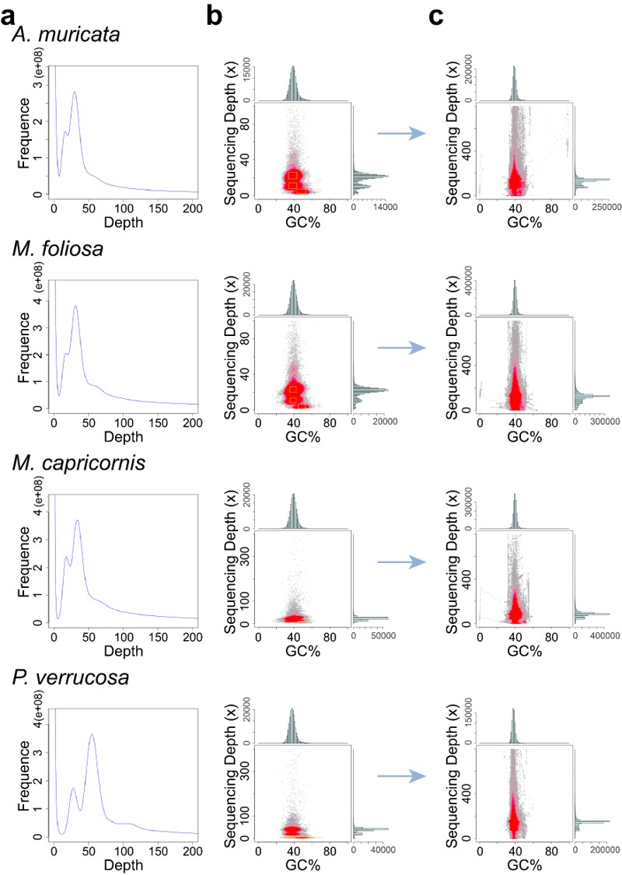
Extended Data Fig. 1 | Genome survey and the effect of removing exogenous sequence contamination. a. K-mer analysis using next-generation sequencing (NGS) data. K-mer (K = 17) analysis was applied to estimate genome size and heterozygote frequency of the studied stony corals (Extended Data Table 1). The presence of a heterozygous peak (preceding the highest homozygous peak) in the K-mer curves suggests that the genomes of the four samples belong to the high-heterozygosity diploid type. The x-axis is depth (×); the y-axis is the proportion that represents the frequency at that depth divided by the total frequency of all depths. b. Depth (×)-related guanine plus cytosine (GC) content analysis. Contigs extracted from the yellow boxes were selected for nucleotide (NT) alignment analysis. The results showed that there were obvious GC separations in the four surveyed genomes, indicating the presence of exogenous sequence contaminations, notably endosymbiotic Symbiodiniaceae, symbiotic algae, and microorganisms. The x-axis represents the GC content and the y-axis is the sequencing depth. c. The effect of removing exogenous sequence contamination. After removing the exogenous sequence contaminations, the GC contents are within the normal range (Extended Data Table 1) and the scatter plot shows no distinct GC separation, indicating that there are no significant exogenous contaminations in the genomes.
EDF_2
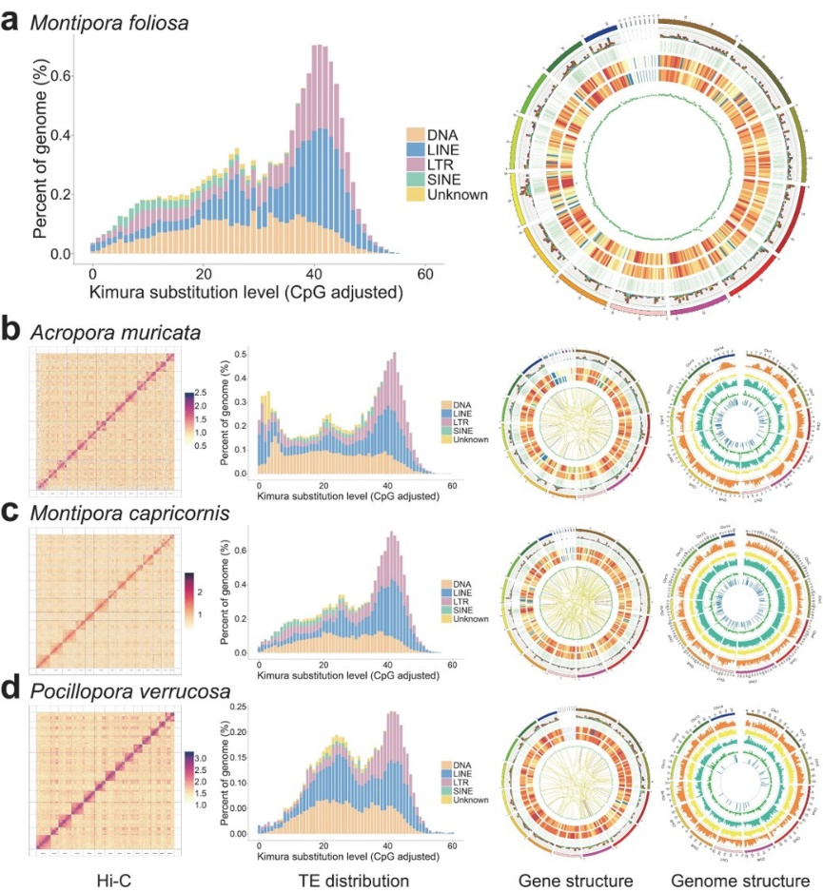
Extended Data Fig. 2 | The results of Hi-C map, TE distribution, gene structure and genome structure. a. TE distribution and gene structure of the M. foliosa genome. b-d. The Hi-C maps, TE distributions, gene structures and gene structures of A. muricata, M. capricornis, and P. verrucosa genomes. In gene structure, the circos plot from outer to inner represents: 1) chromosome sequence; 2) alternative splicing sites (stacked bar chart, different colors represent different types of alternative splicing—light blue for RI, green for A3, yellow for A5, purple for SE, red for MX, brown for AF, dark blue for AL); 3) alternative polyadenylation (APA) sites; 4) distribution of novel transcripts, where the color closer to red indicates higher density; 5) distribution of novel genes, where the color closer to red indicates higher density; 6) density distribution of lncRNA; 7) fusion genes, indicated by purple lines (same chromosome) and yellow lines (different chromosomes) showing gene fusion events. In genome structure, the tracks from outer to inner (I-VI) of genome structures are seen in Fig. 1. All full-length transcriptomes used in gene structure analyses reached saturation (Methods), indicating that no fusion genes were detected in the full-length transcriptome of M. foliosa (a).

EDF_3
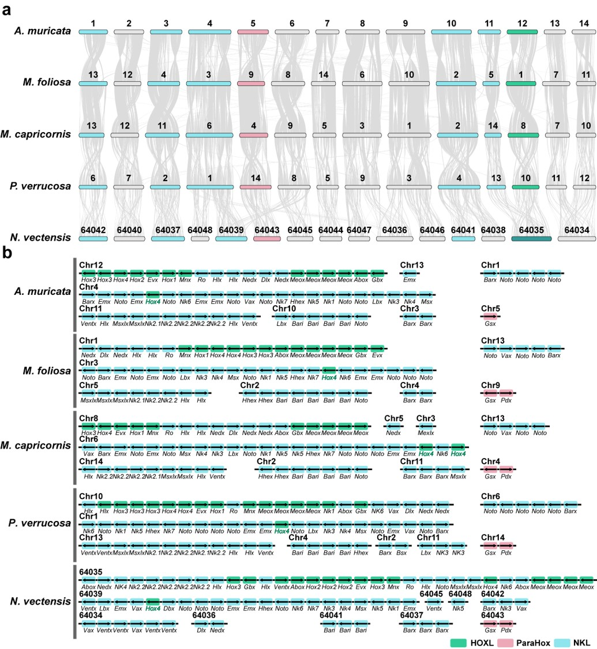
Extended Data Fig. 3 | Microsynteny analysis of the ANTP-class Homeobox genes. a. Genomic loci distribution of ANTP-class homeobox genes in the genomes of the studied stony corals and N. vectensis. b. ANTP-class homeobox gene groups of the studied stony corals and N. vectensis. Includes all the gene models containing homeodomains identified in the genomes of four studied stony corals and N. vectensis (Methods, Supplementary Table 6). The genomic loci distribution of Homeobox genes in the genomes of four studied corals and N. vectensis is highly conserved and remarkably consistent (a), and these genes can be divided into seven across-chromosome corresponding groups (b): 1) Hox group (Chr. 12, 1, 8, 10, and 64035 in the genomes of A. muricata, M. foliosa, M. capricornis, P. verrucosa, and N. vectensis), 2) ParaHox group (Chr. 5, 9, 4, 14, and 64043, corresponding order as above), 3) NKL group 1 (Chr. 4, 3, 6, 1, and 64039, as above), 4) NKL group 2 (Chr. 11, 5, 14, 13, and 64035, as above), 5) NKL group 3 (Chr. 10, 2, 2, 4, and 64041, as above), 6) NKL group 4 (Chr. 1, 13, 13, 6, and 64034, as above), and 7) NKL group 5 (Chr. 3, 4, 11, 2, and 64037, as above). Within the Hox and NKL groups, there are tandemly duplicated genes (TDG), such as the Meox genes observed in the Hox groups of five genomes. Interestingly, across the five genomes, all the Hox genes (green) are located on a single chromosome, except for a satellite Hox4 gene (bold and green) found within NKL group 1, indicating an ancestral trait of Hexacorallia genome. Chr.: Chromosome.

EDF_4
Extended Data Fig. 4 | The HOXL (Hox and ParaHox) subclass in stony corals. Genome distribution of the HOXL subclass in all selected Scleractinia stony corals (Extended Data Table 2) is conserved, including aspects such as gene arrangement order, with a tandemly duplicated gene (TDG) of Meox genes, a satellite Hox4 gene, and the loss of Cdx (or Pdx).

EDF_5
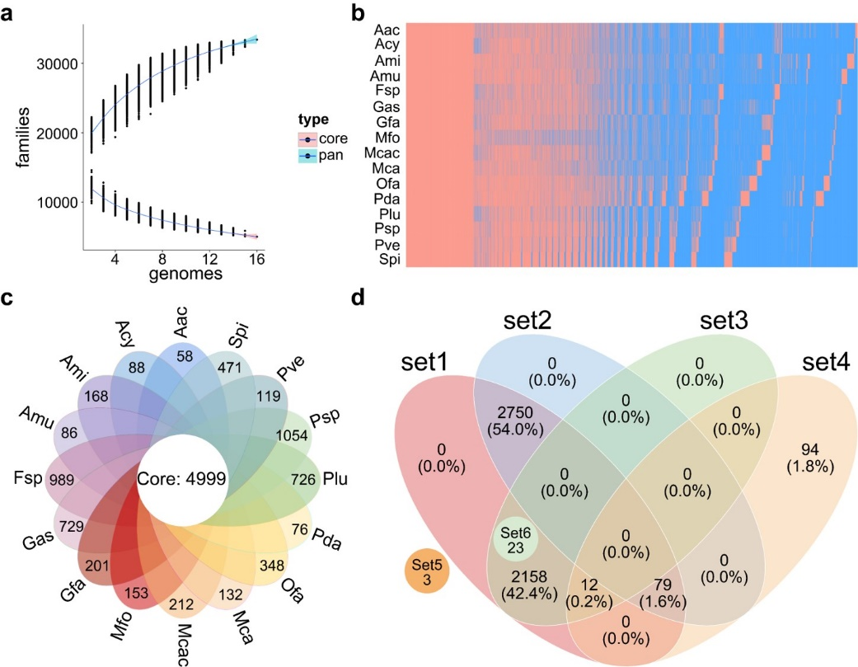
Extended Data Fig. 5 | The pan-genomic analysis of Scleractinian stony corals. a. Pan-genome model of Scleractinian stony corals. The x-axis represents the sample size, and the y-axis represents the number of gene families. The gene families in the pan-genome and core genome were counted. As the sample size increased, the core gene set decreased, and the pan-genome expanded. b. Distribution map of the presence and absence of species gene families. The presence (red) and absence (blue) of all species gene families were counted. Each row represents a species, and each column represents a gene family, displaying the presence and absence of each species in each gene family. c. Venn diagram of gene family distribution. Based on the clustering results of gene families, the number of core gene families and unique gene families in all species was counted. d. Venn diagram of core genes. Set1: The core gene families identified in Scleractinian stony corals; Set2: Exclusive core gene families identified in Scleractinian stony corals; Set3: Core gene families shared with other cnidarians identified in Scleractinian stony corals; Set4: Gene family expansion in Scleractinia stony corals; Set5: Gene family contraction in Scleractinia stony corals; Set6: Positively selected gene families in Scleractinia stony corals (Supplementary Table 7). Set1 equates to Set2 plus Set3. Abbreviations are listed in Extended Data Table 2.

EDF_6
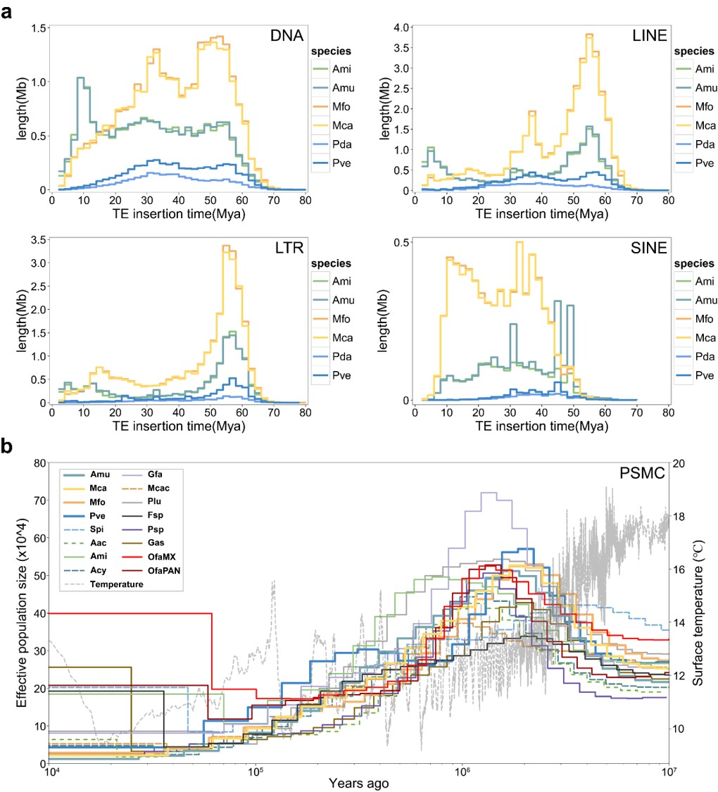
Extended Data Fig. 6 | Transposable elements (TE) and Pairwise Sequentially Markovian Coalescent (PSMC) analysis in the Cenozoic era. a. Insertion times of TE to aid the understanding of the temporal dynamics of TE activities during the evolution of Scleractinian stony corals. b. PSMC analysis. Effective population sizes inferred from sixteen sequenced stony coral genomes⁴⁰. Parameter settings: u (per base pair per generation) = 4 × 10⁻⁹, and y (a generation time) = 3 years⁹. The PSMC analysis provides limited information on the recent past (less than 10⁴ generations)⁹. Abbreviations listed in Supplementary Table 7.

EDF_7
Extended Data Fig. 7 | scRNA-seq analysis suggesting a potential supportive role of alga-hosting cells in the calcification process of calicoblastic cells. a. T-distributed stochastic neighbor embedding (t-SNE) map in A. muricata. High-quality transcriptomes of 17,277 individual cells obtained by scRNA-seq grouped into 24 clusters and presented in t-SNE space. Cell numbers in cell clusters C0-C23 were 5,242, 1,384, 1,313, 1,117, 1,010, 908, 653, 562, 513, 508, 506, 477, 473, 455, 403, 360, 248, 244, 233, 203, 185, 119, 107, and 54, respectively (Supplementary Table 8). b. Bubble plot of cell marker genes and specific high-expression genes visualizing the twelve types divided into 24 cell clusters in adult A. muricata. c. Violin plot visualizing that all cell clusters were overwhelmingly expressed CEBPG gene (set3). d. Bubble plot visualizing the expression patterns of genes involved in the calcification process. e. Schematic diagram illustrating the biomineralization mechanism in Scleractinian stony corals. Sym: Symbiodiniaceae. ACC: Amorphous calcium carbonate.

EDF_8
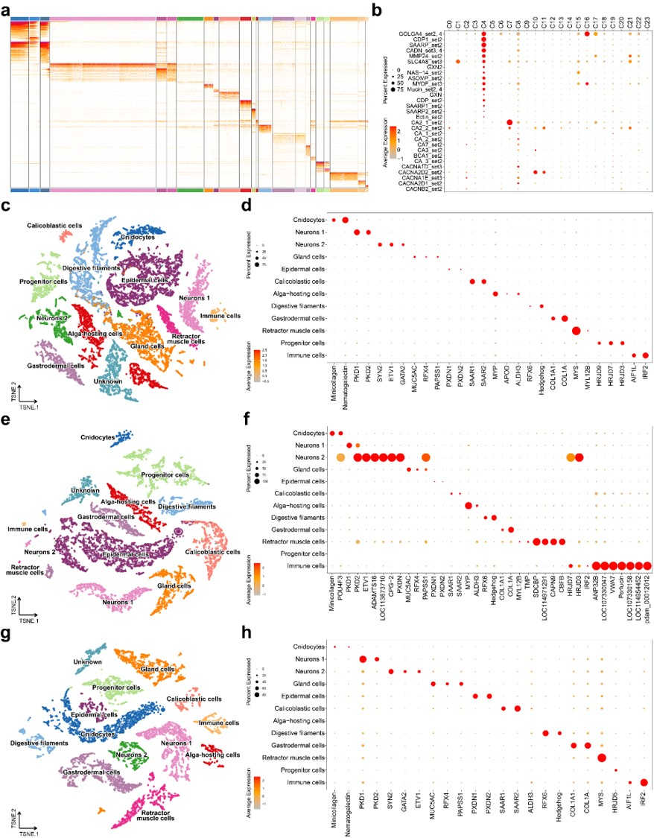
Extended Data Fig. 8 | scRNA-seq analysis for the four studied stony corals. a. Heat map displaying gene expression patterns of all 24 cell clusters in A. muricata encompassing all cells. Each column represents a cell cluster, while each row represents a gene. The gene expression matrix of heat map can be found in Supplementary Table 8. b. Bubble plot visualizing that in adult colonies, the calicoblastic cells exhibit lower levels of gene expression for carbonic anhydrase and calcium channels. c., e., g., t-SNE maps demonstrating that the transcriptomes of individual cells obtained through scRNA-seq can be classified into 12 basic cell clusters in adult M. foliosa, M. capricornis, and P. verrucosa. d., f., h., Bubble plot illustrating the expression of cell marker genes in the 12 basic cell clusters of adult M. foliosa, M. capricornis, and P. verrucosa.

Extended Data Table 1 | Core parameter statistics

 | A. muricata | M. foliosa | M. capricornis | P. verrucosa
Genome survey
Genome size survey (Mb) | 486.36 | 801.80 | 751.77 | 371.70
Heterozygosity | 1.46% | 1.24% | 1.40% | 1.25%
Genome sequencing
Total sequencing data (Gb) | 469.47 | 506.77 | 389.10 | 202.18
Illumina reads (Gb) | 80.36 | 114.56 | 44.14 | 63.68
PacBio reads (Gb) | 99.69 | 159.88 | 128.02 | 52.30
10X Genomics linked-reads (Gb) | 53.25 | 89.44 | 69.91 | 51.48
Hi-C reads (Gb) | 236.17 | 142.89 | 147.03 | 34.72
Illumina coverage (×) | 165.23 | 142.88 | 58.71 | 171.32
PacBio coverage (×) | 204.97 | 199.40 | 170.29 | 140.70
10X Genomics coverage (×) | 109.49 | 111.55 | 93.00 | 138.50
Hi-C coverage (×) | 485.59 | 178.21 | 195.58 | 93.41
Genome assembly
Hi-C anchored rate | 92.88% | 96.46% | 93.28% | 99.36%
Hi-C id | Chromosome length (bp)
Chr1 | 40,898,739 | 54,083,217 | 73,212,188 | 36,587,346
Chr2 | 27,410,703 | 67,801,410 | 65,996,636 | 20,324,702
Chr3 | 31,222,512 | 76,858,509 | 71,223,241 | 32,318,388
Chr4 | 35,922,707 | 56,417,652 | 49,170,247 | 31,444,709
Chr5 | 33,923,508 | 32,770,628 | 48,216,838 | 28,751,197
Chr6 | 29,594,457 | 74,628,471 | 74,049,392 | 26,436,911
Chr7 | 31,529,664 | 51,956,490 | 43,345,697 | 25,771,138
Chr8 | 30,331,324 | 55,284,781 | 52,848,797 | 23,872,040
Chr9 | 32,555,205 | 51,776,225 | 50,183,484 | 23,312,843
Chr10 | 38,714,998 | 72,646,732 | 38,654,671 | 21,697,480
Chr11 | 30,713,501 | 42,566,026 | 54,656,406 | 21,541,678
Chr12 | 31,901,382 | 42,127,947 | 42,395,612 | 21,183,137
Chr13 | 33,929,392 | 50,195,517 | 44,065,140 | 17,735,002
Chr14 | 27,219,173 | 49,990,958 | 25,845,834 | 22,489,030
GC rate | 39.19% | 39.66% | 39.67% | 38.06%
Contig N50 (bp) | 1,515,440 | 826,490 | 1,033,442 | 2,212,633
Contig (bp) | 491,313,022 | 806,404,854 | 786,647,181 | 353,892,550
Scaffold N50 (bp) | 30,774,878 | 54,133,718 | 50,228,684 | 25,718,899
Scaffold (bp) | 492,088,061 | 810,204,524 | 789,625,352 | 354,866,308
Genome annotation
Repeat sequence | Rate in Genome
Repeat sequence rate | 58.87% | 62.17% | 62.28% | 48.46%
DNA (Transposable element, TE) | 15.35% | 12.18% | 12.50% | 11.03%
LINE (TE) | 20.03% | 25.83% | 25.22% | 16.14%
LTR (TE) | 16.32% | 20.12% | 20.76% | 10.88%
Predicted gene | 19,493 | 22,816 | 21,533 | 19,633
Functional gene rate | 99.7% | 99.6% | 99.7% | 99.8%
miRNA loci | 2,042 | 3,610 | 3,844 | 457
Full-length transcriptome (UniGene) | 30,482 | 26,881 | 26,603 | 16,632
Alternative splicing (AS) (gene loci) | 5,137 | 4,095 | 4,133 | 1,541
Fusion gene (Under saturation) | 126 | 0 | 192 | 83
Identified LncRNA | 452 | 661 | 346 | 1,004
Identified miRNA | 110 | 101 | 181 | 27
scRNA-seq (Illumina reads) | 767.27Gb | 4,539.17Gb | 2,261.36Gb | 1,016.08Gb

Extended Data Table 2 | BUSCO assessment on applied genomes in phylogenetic analysis

Species | Abbr. | Genes  (No.) | BUSCO | Contig N50  (k bp)
Acropora millepora | Ami | 23,024 | C: 93.8% [S: 92.9%, D: 0.9%], F: 1.9%, M: 4.3%, n: 954 | 1,091.36
Acropora muricata | Amu | 19,493 | C: 91.9% [S: 88.9%, D: 3.0%], F: 2.8%, M: 5.3%, n: 954 | 1,515.44
Acropora cytherea | Acy | 23,170 | C: 84.0% [S: 81.8%, D: 2.2%], F: 6.9%, M: 9.1%, n: 954 | 48.47
Acropora acuminata | Aac | 22,126 | C: 85.6% [S: 84.8%, D: 0.8%], F: 6.4%, M: 8.0%, n: 954 | 49.97
Montipora cactus | Mcac | 21,447 | C: 85.5% [S: 84.7%, D: 0.8%], F: 5.2%, M: 9.3%, n: 954 | 25.33
Montipora capricornis | Mca | 21,533 | C:93.8% [S: 89.6%, D: 4.2%], F:2.8%, M: 3.4%, n: 954 | 1,033.44
Montipora foliosa | Mfo | 22,816 | C:93.6% [S: 88.6%, D: 5.0%], F:2.7%, M: 3.7%, n: 954 | 826.49
Pachyseris speciosa | Psp | 39,160 | C: 86.0% [S: 83.5%, D: 2.5%], F: 6.4%, M: 7.6%, n: 954 | 776.65
Galaxea fascicularis | Gfa | 22,221 | C: 82.7% [S: 82.2%, D: 0.5%], F: 9.1%, M: 8.2%, n: 954 | 21.37
Porites lutea | Plu | 30,714 | C: 91.3% [S: 89.2%, D: 2.1%], F: 4.2%, M: 4.5%, n: 954 | 19.55
Orbicella faveolata | Ofa | 24,856 | C: 82.7% [S: 79.5%, D: 3.2%], F: 7.2%, M: 10.1%, n: 954 | 7.44
Goniastrea aspera | Gas | 35,640 | C: 85.3% [S: 84.3%, D: 1.0%], F: 8.0%, M: 6.7%, n: 954 | 19.66
Fungia spp. | Fsp | 37,843 | C: 83.9% [S: 82.6%, D: 1.3%], F: 9.6%, M: 6.5%, n: 954 | 17.35
Stylophora pistillata | Spi | 23,484 | C: 87.3% [S: 86.6%, D: 0.7%], F: 3.4%, M: 9.3%, n: 954 | 14.89
Pocillopora verrucosa | Pve | 19,633 | C: 93.5% [S: 91.8%, D:1.7%], F: 3.1%, M: 3.4%, n: 954 | 2,212.63
Pocillopora damicornis | Pda | 19,040 | C: 88.0% [S: 87.6%, D: 0.4%], F: 4.3%, M: 7.7%, n: 954 | 25.94
Exaiptasia pallida | Epa | 20,613 | C: 88.6% [S: 85.5%, D: 3.1%], F: 3.1%, M: 8.3%, n: 954 | 11.72
Nematostella vectensis | Nve | 24,655 | C: 89.6% [S: 87.8%, D: 1.8%], F: 4.8%, M: 5.6%, n: 954 | 2,927.19
Xenia sp. | Xsp | 27,157 | C: 86.9% [S: 83.9%, D: 3.0%], F: 4.8%, M: 8.3%, n: 954 | 1,411.98
Dendronephthya gigantea | Dgi | 21,948 | C: 94.1% [S: 84.6%, D: 9.5%], F: 0.8%, M: 5.1%, n: 954 | 1,445.52
Hydra vulgaris | Hvu | 19,261 | C: 83.0% [S: 81.1%, D: 1.9%], F: 9.0%, M: 8.0%, n: 954 | 10.11
Hydra viridissima | Hvi | 21,121 | C: 88.7% [S: 87.5%, D: 1.2%], F: 3.9%, M: 7.4%, n: 954 | 14.09
Morbakka virulenta | Mvi | 23,658 | C: 83.6% [S: 83.1%, D: 0.5%], F: 8.5%, M: 7.9%, n: 954 | 14.63
Rhopilema esculentum | Res | 17,219 | C: 92.4% [S: 88.9%, D: 3.5%], F: 2.2%, M: 5.4%, n: 954 | 1,126.89
Amphimedon queenslandica | Aqu | 20,633 | C: 90.4% [S: 84.0%, D: 6.4%], F: 2.7%, M: 6.9%, n: 954 | 11.71

In the Benchmarking Universal Single-Copy Orthologs (BUSCO) assessment, the following abbreviations are used: C for Complete BUSCOs, S for Complete and single-copy BUSCOs, D for Complete Duplicated BUSCOs, F for Fragmented BUSCOs, M for Missing BUSCOs, and n for Total BUSCO groups searched. The bold Latin names represent the genomes assembled in this study. In phylogenetic analysis, we selected cnidarian and poriferan genomes based on rigorous BUSCO assessment by searching against the lineage dataset of metazoa_odb10 (version 5.1.2) under meeting the following parameters: C ≥80.0% [S ≥79.5%, D ≤10.0%], F ≤10.0%, M ≤10.0%, n: 954.

