
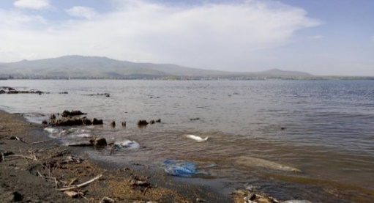
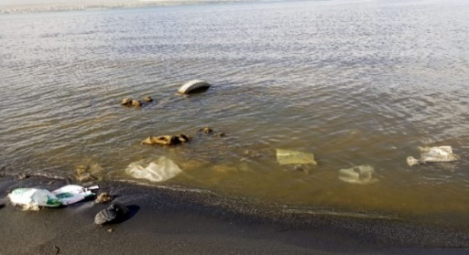
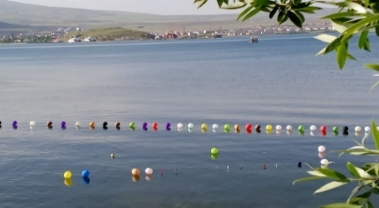

Supplementary Figure 1. Visible plastic pollution

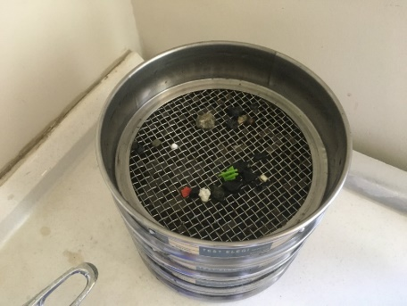
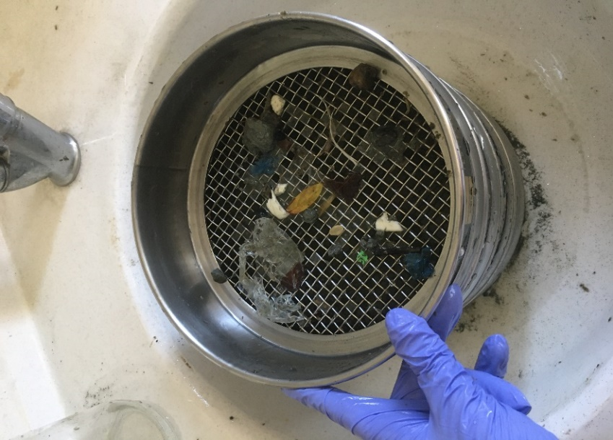
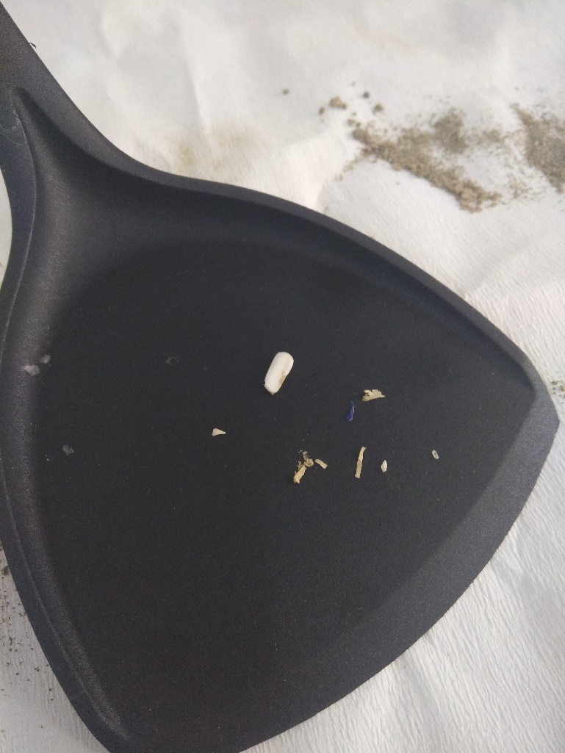

Supplementary Figure 2. Microplastics isolated from some sediment samples

Supplementary Figure 3. Proportional data on the forms of microplastics by stations. A) Van, B) Tatvan, C) Gevaş, E) Erciş

Supplementary Figure 4. Proportional data of microplastic colors according to stations A) Van, B) Tatvan, C) Gevaş, E) Erciş
Suplementary Table 1. Presence and similarity rates of LDPE because of FTIR analysis of sediment samples
LDPE | Van1 | Van2 | Van3 | Tatvan1 | Tatvan2 | Tatvan3 | Gevaş1 | Gevaş2 | Gevaş3 | Erciş1 | Erciş2 | Erciş3
2917 | + | + | + | + | + | + | + | + | + | + | + | -
2852 | + | + | + | + | + | + | - | - | - | + | + | +
1377 | + | - | + | - | + | + | + | + | + | + | + | +
718 | + | + | + | + | + | + | + | + | + | - | + | +
Benzerlik | 100% | 75% | 100% | 75% | 100% | 100% | 75% | 75% | 75% | 75% | 100% | 75%

Suplementary Table 2. Presence and similarity rates of PP because of FTIR analysis of sediment samples
PP | Van1 | Van2 | Van3 | Tatvan1 | Tatvan2 | Tatvan3 | Gevaş1 | Gevaş2 | Gevaş3 | Erciş1 | Erciş2 | Erciş3
2956, 2875 | + | + | + | + | + | + | + | + | + | + | + | -
2921, 2840 | + | + | + | + | + | + | - | + | - | + | + | -
1377 | + | + | + | + | + | + | + | + | + | + | + | +
Benzerlik | 100% | 100% | 100% | 100% | 100% | 100% | 67% | 100% | 67% | 100% | 100% | 34%

Suplementary Table 3. Presence and similarity rates of PET because of FTIR analysis of sediment samples
PET | Van1 | Van2 | Van3 | Tatvan1 | Tatvan2 | Tatvan3 | Gevaş1 | Gevaş2 | Gevaş3 | Erciş1 | Erciş2 | Erciş3
1721 | + | + | + | + | + | + | + | + | + | + | + | +
1245 | + | + | + | + | + | + | - | - | + | + | - | +
1100 | - | + | + | - | - | - | + | + | + | - | - | -
Benzerlik | 67% | 100% | 100% | 67% | 67% | 67% | 67% | 67% | 100% | 67% | 34% | 67%

Suplementary Table 4. Presence and similarity rates of PS because of FTIR analysis of sediment samples
PS | Van1 | Van2 | Van3 | Tatvan1 | Tatvan2 | Tatvan3 | Gevaş1 | Gevaş2 | Gevaş3 | Erciş1 | Erciş2 | Erciş3
3081, 3059,3025 | + | + | + | + | + | - | + | + | + | + | + | -
2923, 2850 | + | - | + | + | + | + | - | + | + | + | + | -
1600, 1492 | + | + | - | + | + | + | + | + | + | + | + | +
756 | + | + | + | + | + | + | + | + | + | + | + | +
698 | + | + | + | + | + | + | - | + | + | - | + | +
Benzerlik | %100 | %80 | %80 | %100 | %100 | %80 | %60 | %100 | %100 | %80 | %100 | %60

