Supplementary Information

Exploring multiple reaction pathways in the proteolysis of SARS-CoV-2 main protease through large-scale quantum molecular dynamics

Junichi Ono,¹ Uika Koshimizu,² Yoshifumi Fukunishi,³ and Hiromi Nakai^{1,2*}

¹ Waseda Research Institute for Science and Engineering (WISE), Waseda University, 3-4-1 Okubo, Shinjuku, Tokyo 169-8555, Japan
² Department of Chemistry and Biochemistry, School of Advanced Science and Engineering, Waseda University, 3-4-1 Okubo, Shinjuku, Tokyo 169-8555, Japan
³ Cellular and Molecular Biotechnology Research Institute, National Institute of Advanced Industrial Science and Technology (AIST), 2-3-26 Aomi, Koto-ku, Tokyo, 135-0064, Japan
*Correspondence: nakai@waseda.jp

The structural changes along the reaction pathways were analyzed in more details in terms of the conditional expectations with respect to PC1 and PC3, i.e., the statistical averages given that PC1 and PC3 have the specific values, for the distances related to the nucleophilic acyl substitution. Figure S7 shows the conditional expectations for the distances associated with OP1-OP4, i.e., S_{γ}(Cys145)-H_{γ}(Cys145), S_{γ}(Cys145)-C(P1), C(P1)-N(P1’), and H_{γ}(Cys145)-N(P1’), calculated from the DC-DFTB-MetaD simulations for the wild-type dimer, wild-type monomer, and L50F/E166 nirmatrelvir-resistance mutant. From R to I1, the S_{γ}(Cys145)-H_{γ}(Cys145) distance is lengthened due to dissociating the S_{γ}-H_{γ} covalent bond of Cys145 and forming the salt bridge between Cys145-S_{γ}⁻ and His41-H_{γ}⁺. Along this reaction process, the S_{γ}(Cys145)-C(P1) distance is slightly shortened by the contact of the resulting highly nucleophilic S_{γ}⁻(Cys145) with electrophilic C(P1) of the substrate. From I1 to I2 on path 1, the S_{γ}(Cys145)-H_{γ}(Cys145) distance is elongated by breaking the salt bridge, and the S_{γ}(Cys145)-C(P1) distance is shrunk by the nucleophilic attack. The C(P1)-N(P1’) peptide bond is already elongated up to ~2.0 Å in the thiohemiketal structure (I2). The H_{γ}(Cys145)-N(P1’) distance is contracted due to forming the hydrogen bond, His41-H_{γ}⁺...N(P1’), after breaking the salt bridge, which is relevant to the subsequent second proton transfer. From I2 to P on path 1, the H_{γ}(Cys145)-N(P1’) distance is further shortened via the second proton transfer, followed by the elongation of the C(P1)-N(P1’) distance due to the complete cleavage of the peptide bond, finalizing the nucleophilic acyl substitution. From I1 to P on path 2, the H_{γ}(Cys145)-N(P1’) distance is shrunk from ~3.0 Å to ~1.0 Å, resulting in the second proton transfer via the hydrogen bond, N_{ε}(His41)-H_{γ}(Cys145)...N(P1’), prior to the change of the S_{γ}(Cys145)-C(P1) and C(P1)-N(P1’) distances corresponding to the nucleophilic substitution. Through the comparison of the wild-type dimer and monomer, clear differences were found in the S_{γ}(Cys145)-H_{γ}(Cys145) and H_{γ}(Cys145)-N(P1’) distances, whereas only small discrepancy was obtained in the S_{γ}(Cys145)-C(P1) and C(P1)-N(P1’) distances. The result indicates that compared with the wild-type dimer, the wild-type monomer involves larger structural changes in the S_{γ}(Cys145)-H_{γ}(Cys145) and H_{γ}(Cys145)-N(P1’) distances associated with the proton transfers, which is responsible for the higher free energy barriers in the wild-type monomer.

Table S1. Four order parameters (OPs) describing the acylation process in enzymatic reaction of M^{pro}.
Entry | Name | Function ª | Atom pair | Protomer | r₀ (Å) | Reaction
#1 | OP1 | 1 – n(r) | S_{γ}(C145)−H_{γ}(C145) | A | 1.6 | Proton transfer
#2 | OP2 | n(r) | S_{γ}(C145)−C(P1) | A | 2.3 | Nucleophilic substitution
#3 | OP3 | 1 – n(r) | C(P1)−N(P1’) | A | 1.6 | Nucleophilic substitution
#4 | OP4 | n(r) | H_{γ}(C145)−N(P1’) | A | 1.8 | Proton transfer
ª Effective coordination number: n(r) = [1−(r/r₀)¹²] / [1−(r/r₀)²⁴]．

Table S2. Eigenvectors of the nth principal component (PCn), i.e., the linear combination coefficients for OP1-OP4, obtained from principal component analysis (PCA) applied to the DC-DFTB-MetaD trajectories for the wild-type M^{pro} dimer system.
Component | OP1 | OP2 | OP3 | OP4
PC1 | 0.51 | 0.44 | 0.43 | 0.60
PC2 | −0.81 | −0.04 | 0.41 | 0.41
PC3 | 0.17 | −0.70 | −0.34 | 0.16
PC4 | 0.24 | −0.56 | 0.73 | −0.31

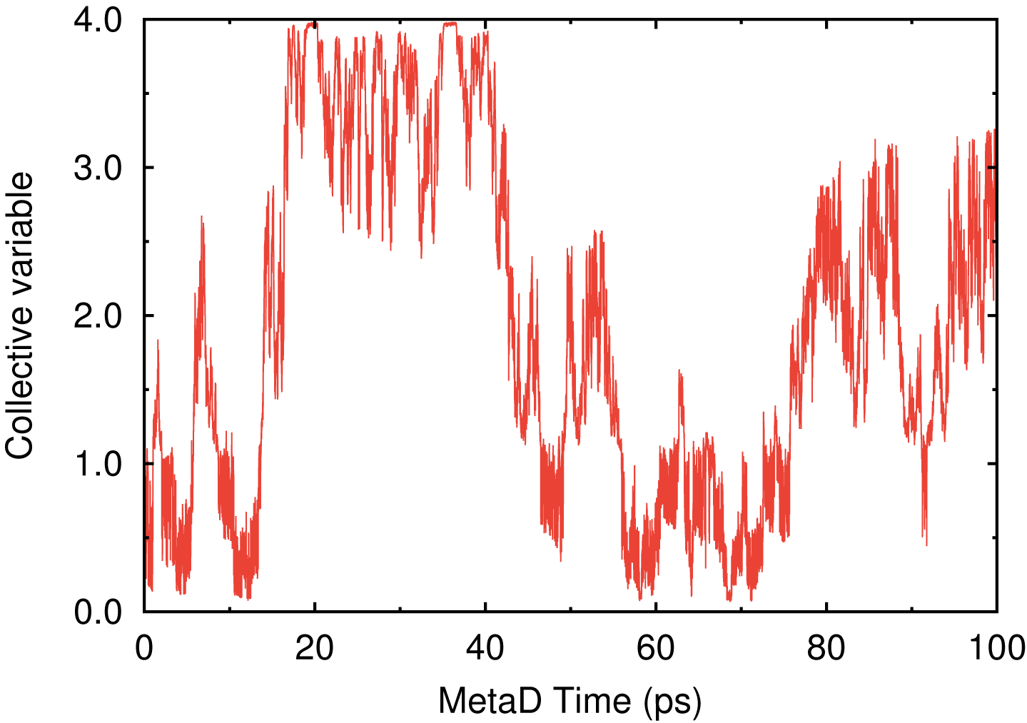 | 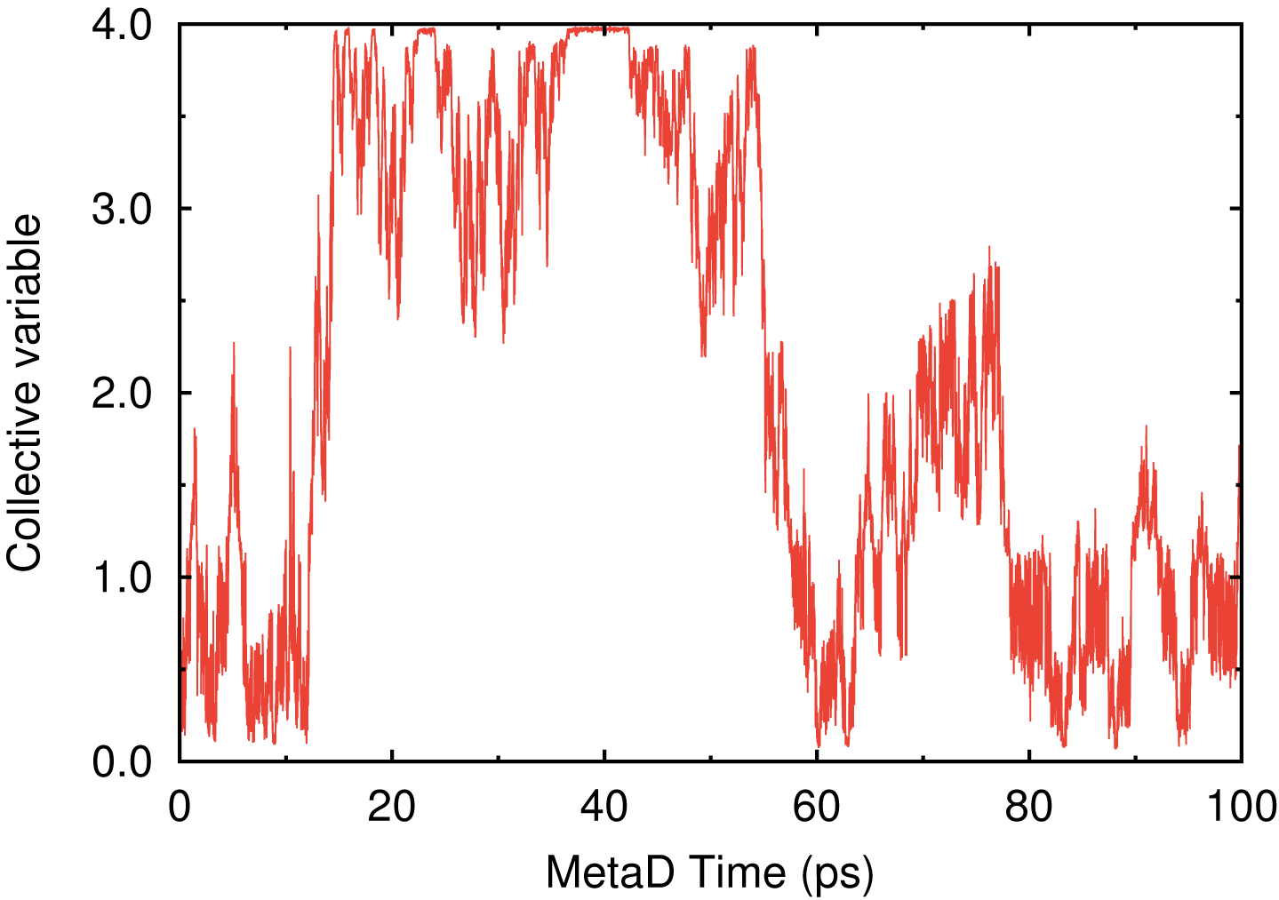
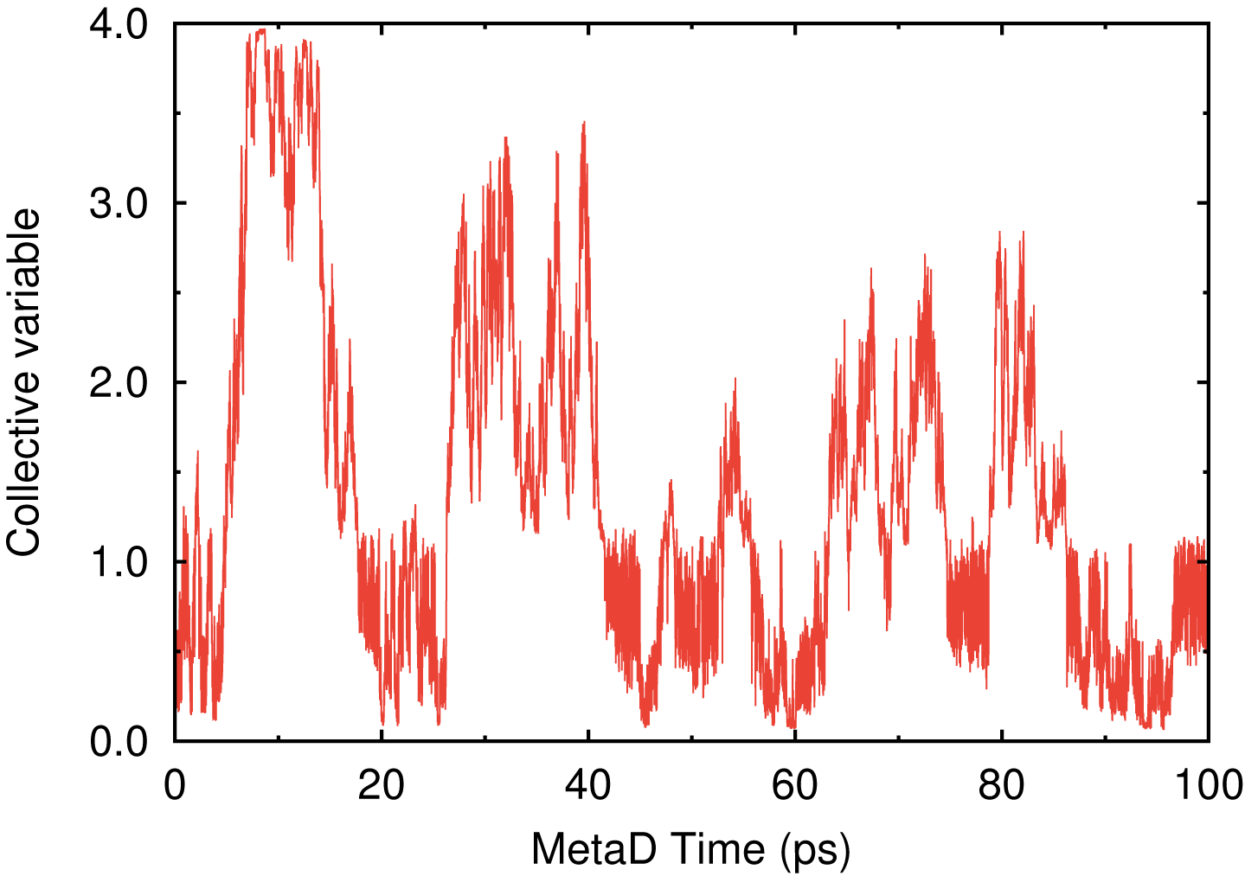 | 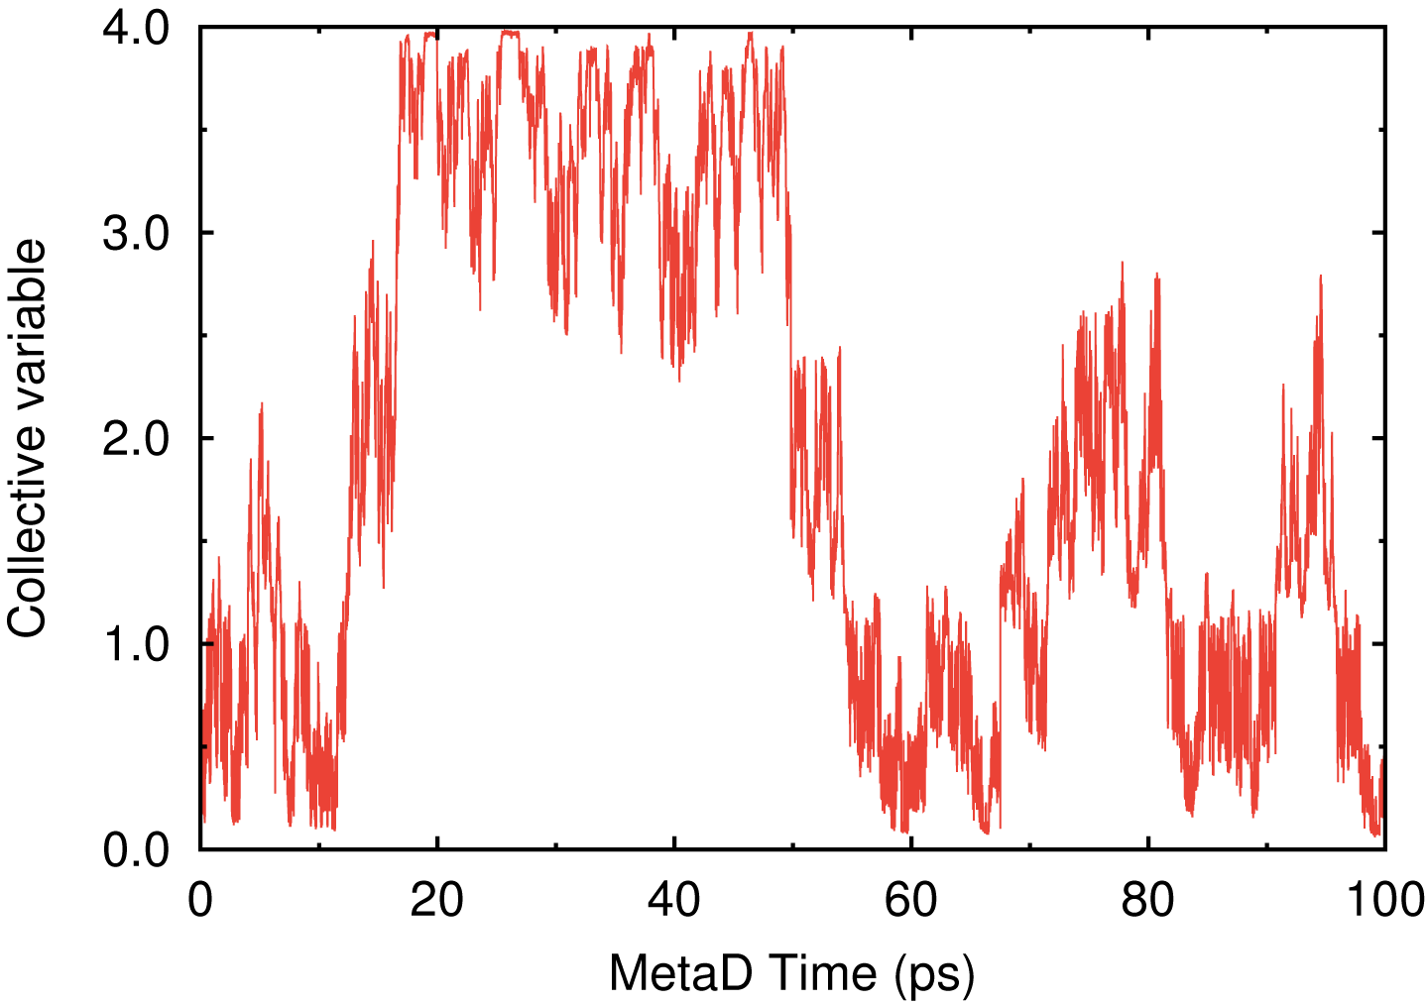
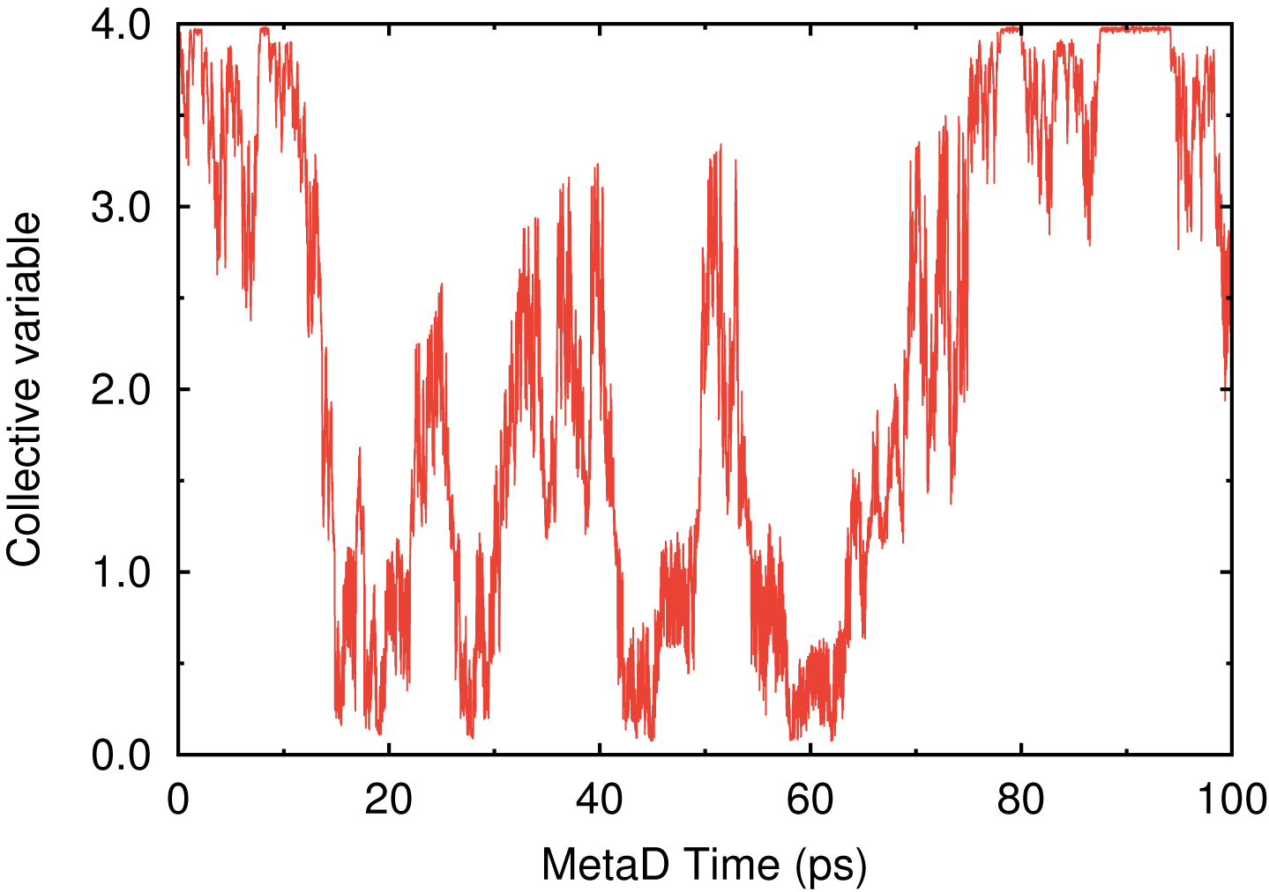 | 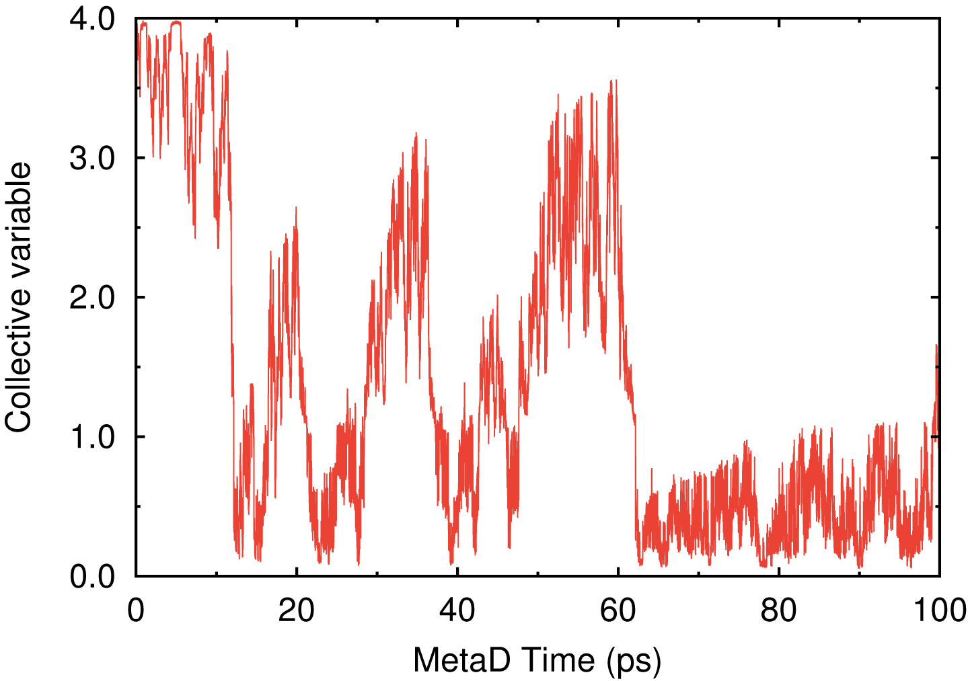
Figure S1. Time series of the CV obtained from the six independent 100-ps DC-DFTB-MetaD simulations for the wild-type M^{pro} dimer system (PDB ID: 6LU7).

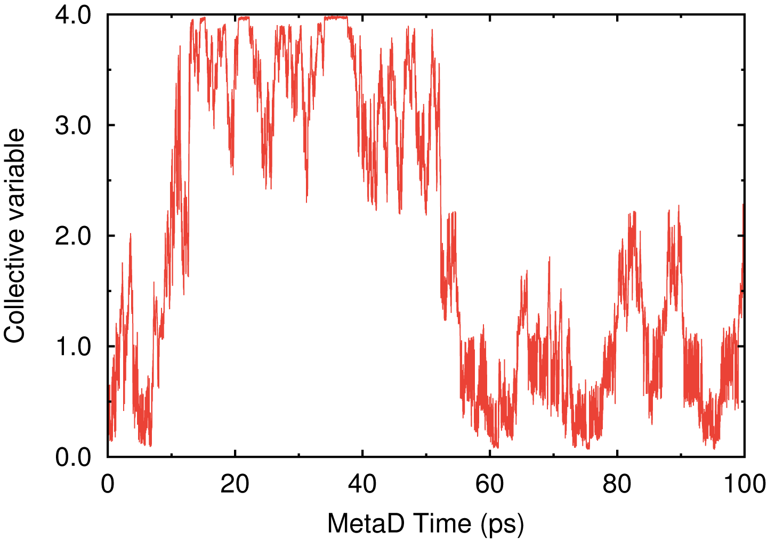 | 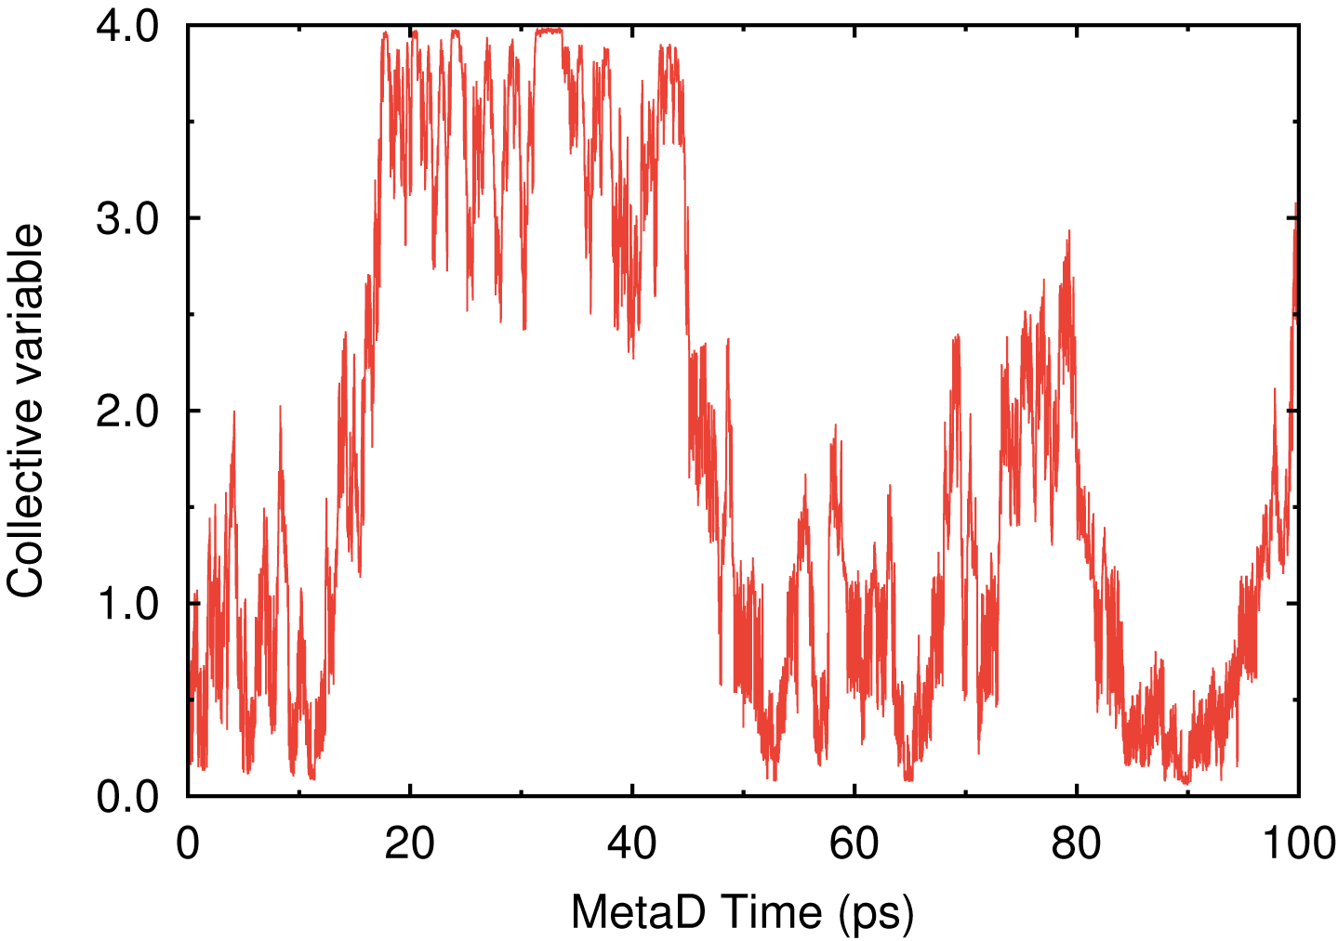
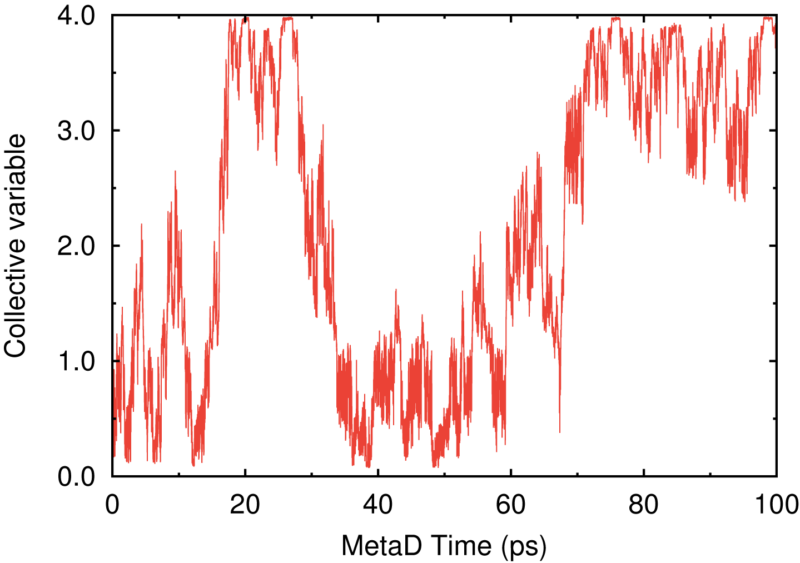 | 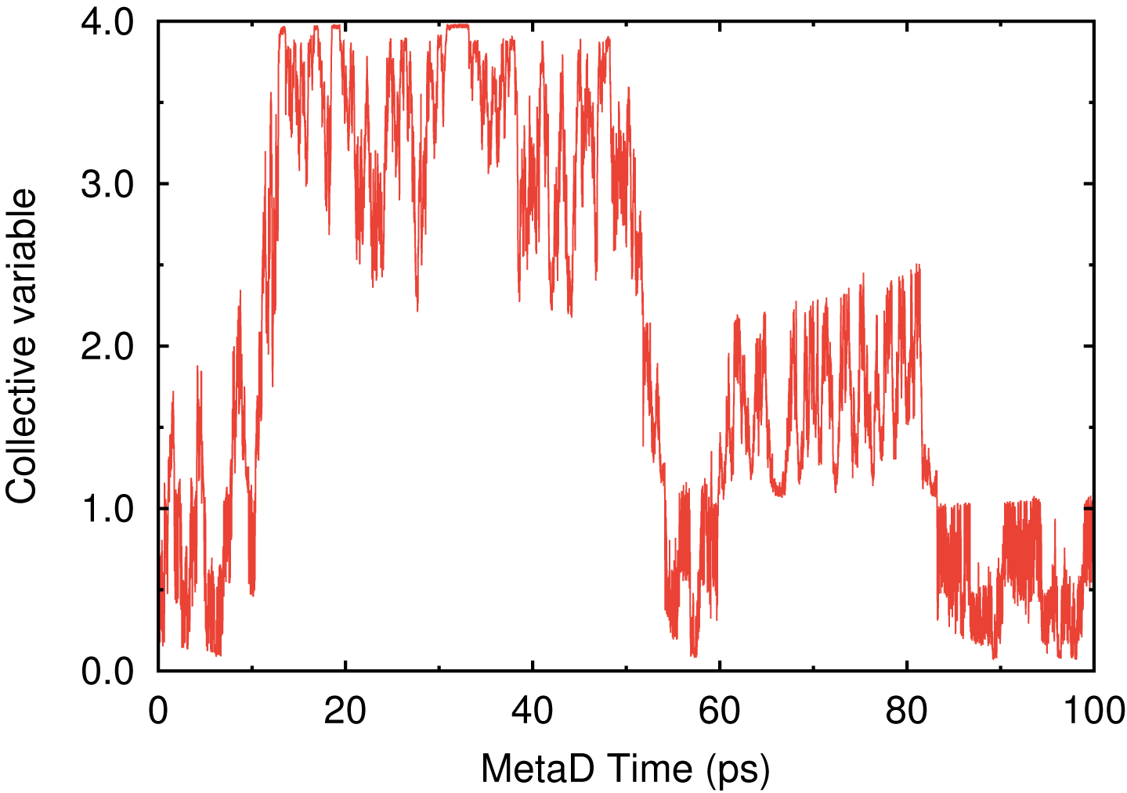
Figure S2. Time series of the CV obtained from the four independent 100-ps DC-DFTB-MetaD simulations for the wild-type M^{pro} monomer system (PDB ID: 6LU7).

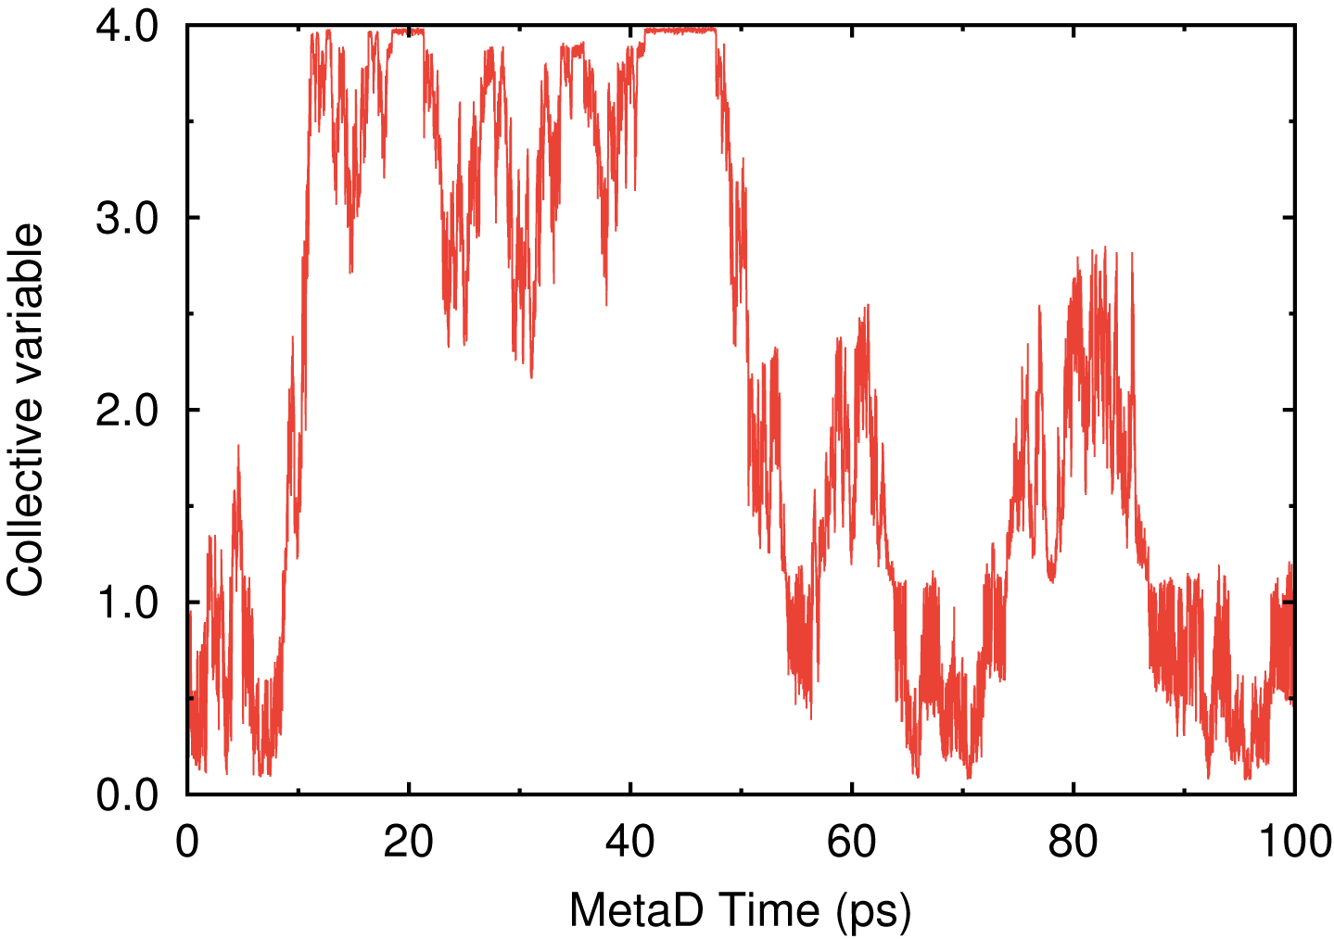 | 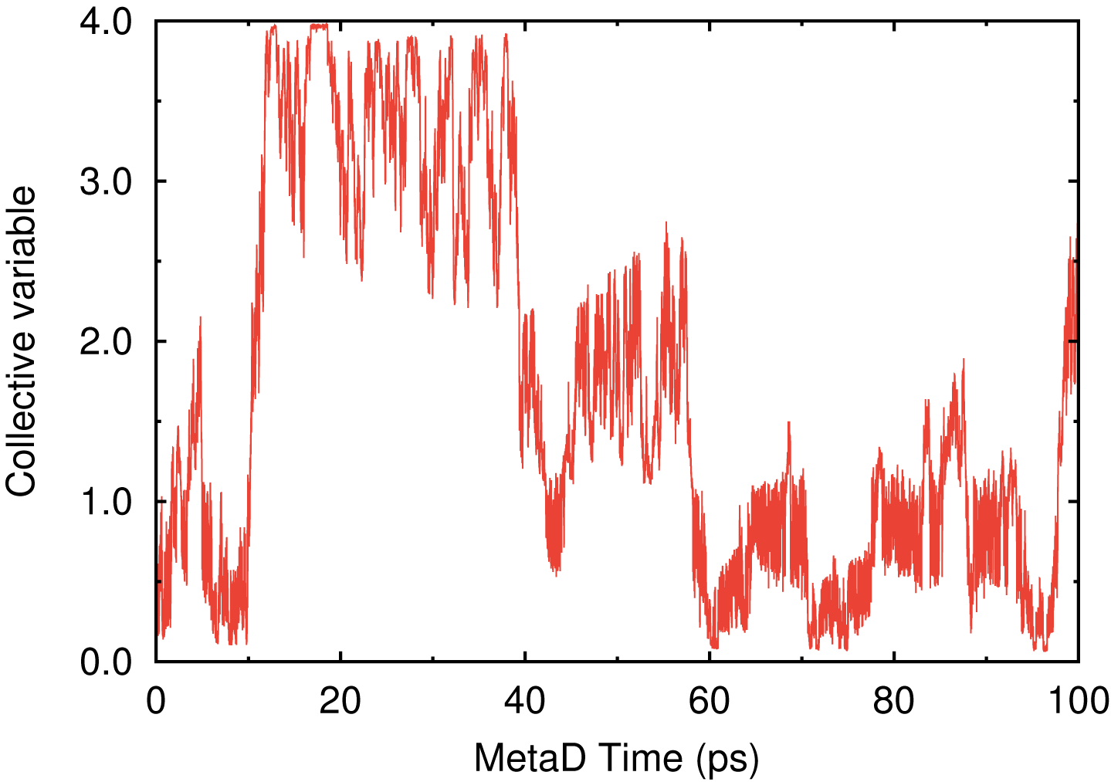
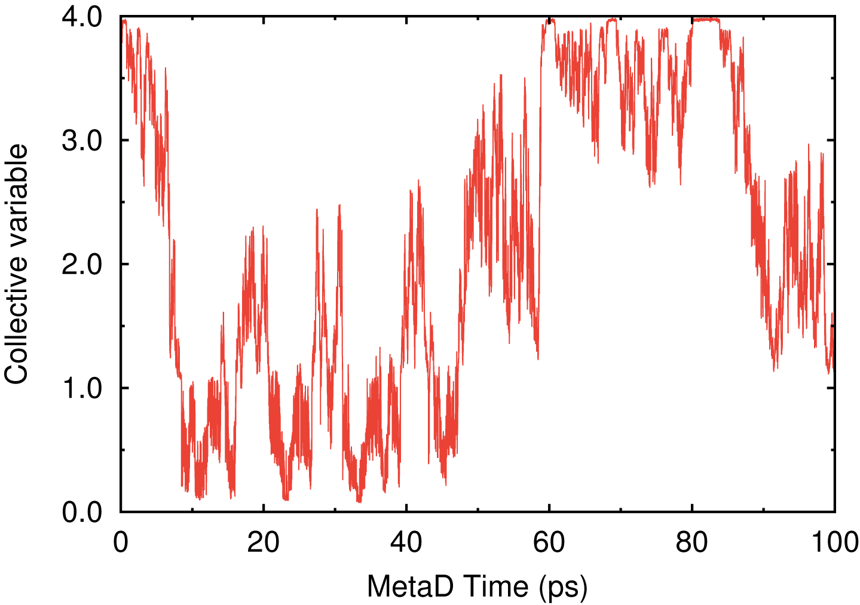 | 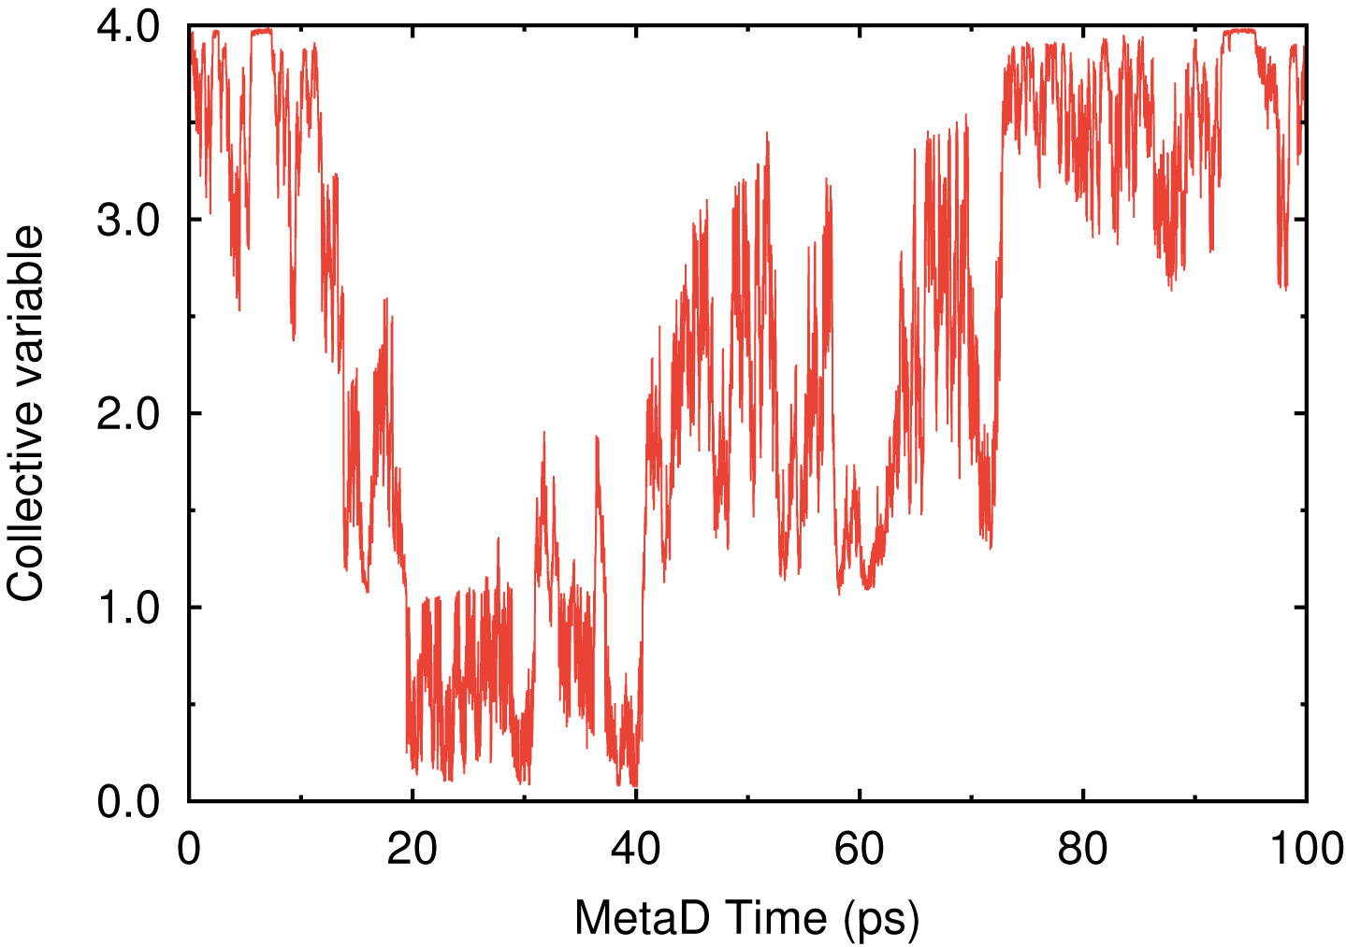
Figure S3. Time series of the CV obtained from the four independent 100-ps DC-DFTB-MetaD simulations for the system with nirmatrelvir-resistant L50F/E166V mutant of M^{pro} dimer (PDB ID: 6LU7).

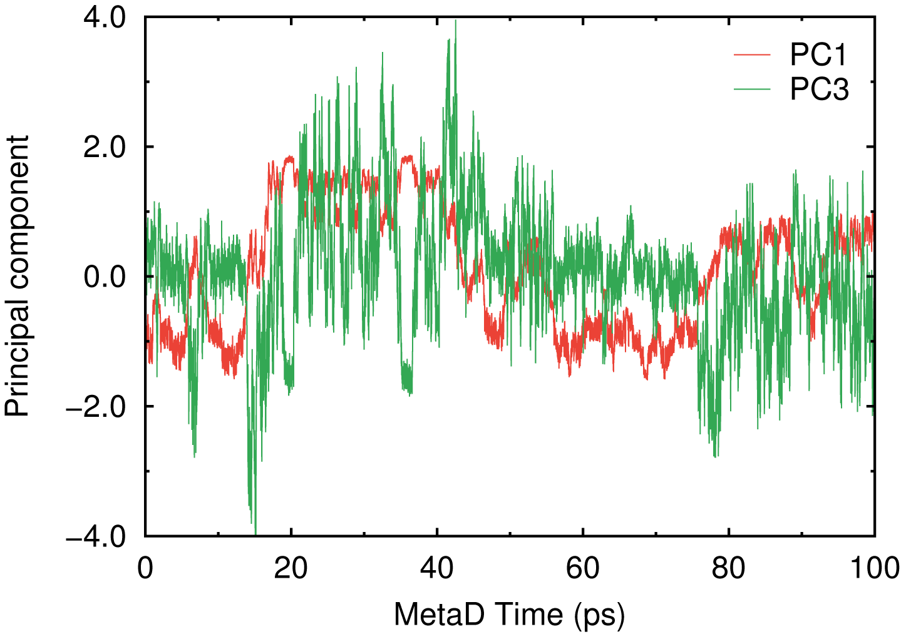 | 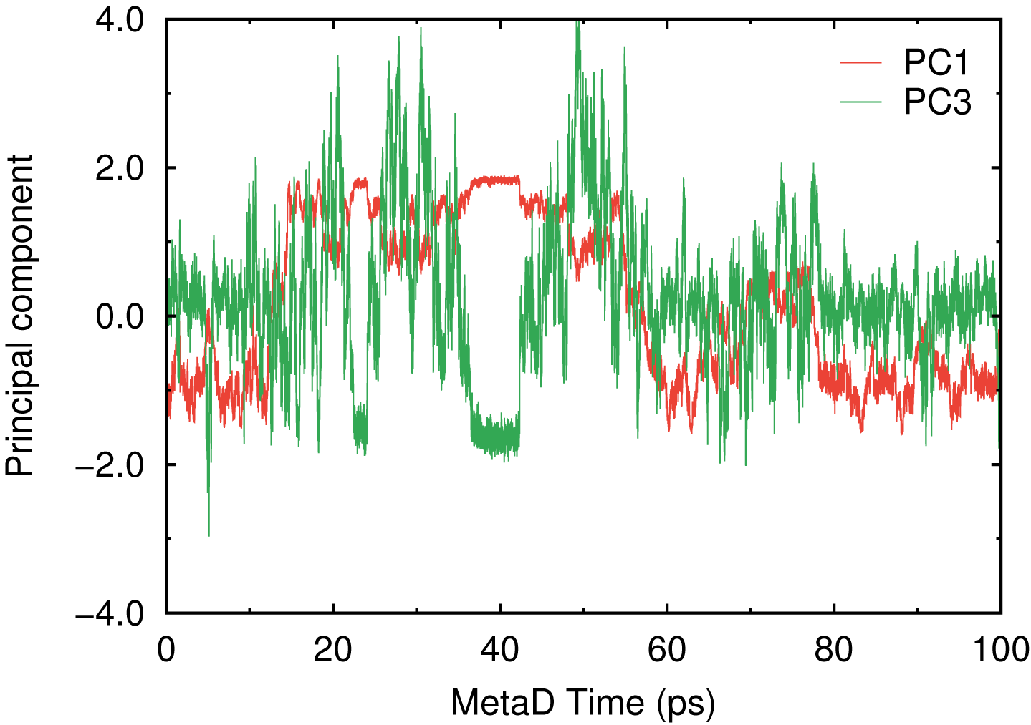
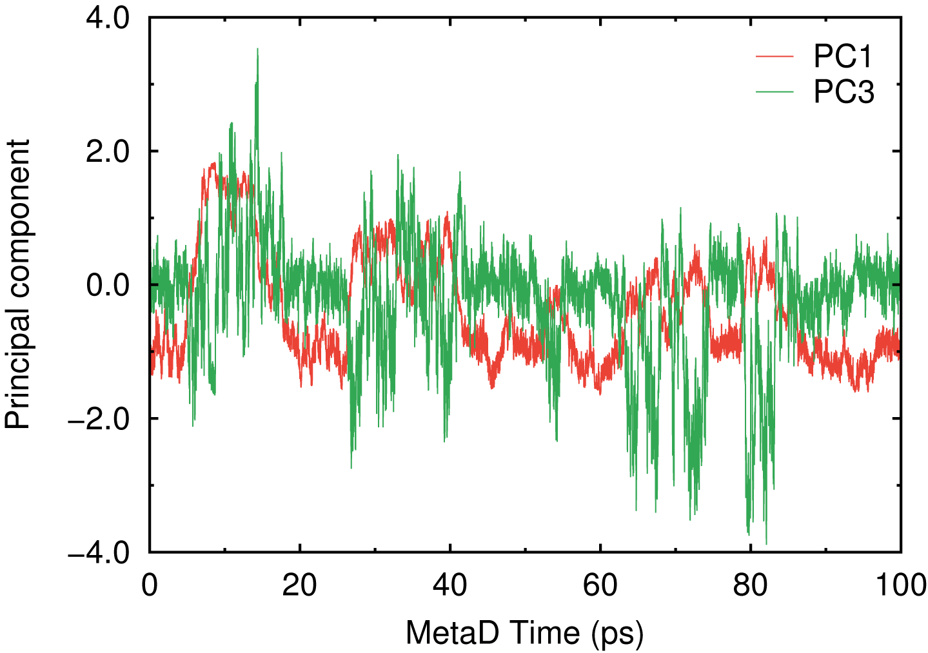 | 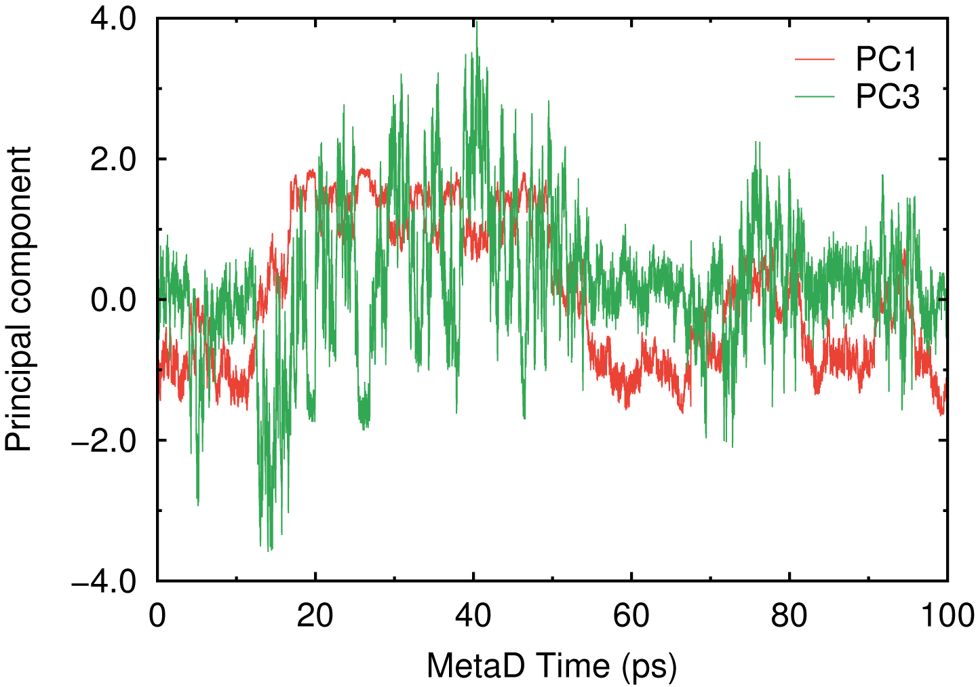
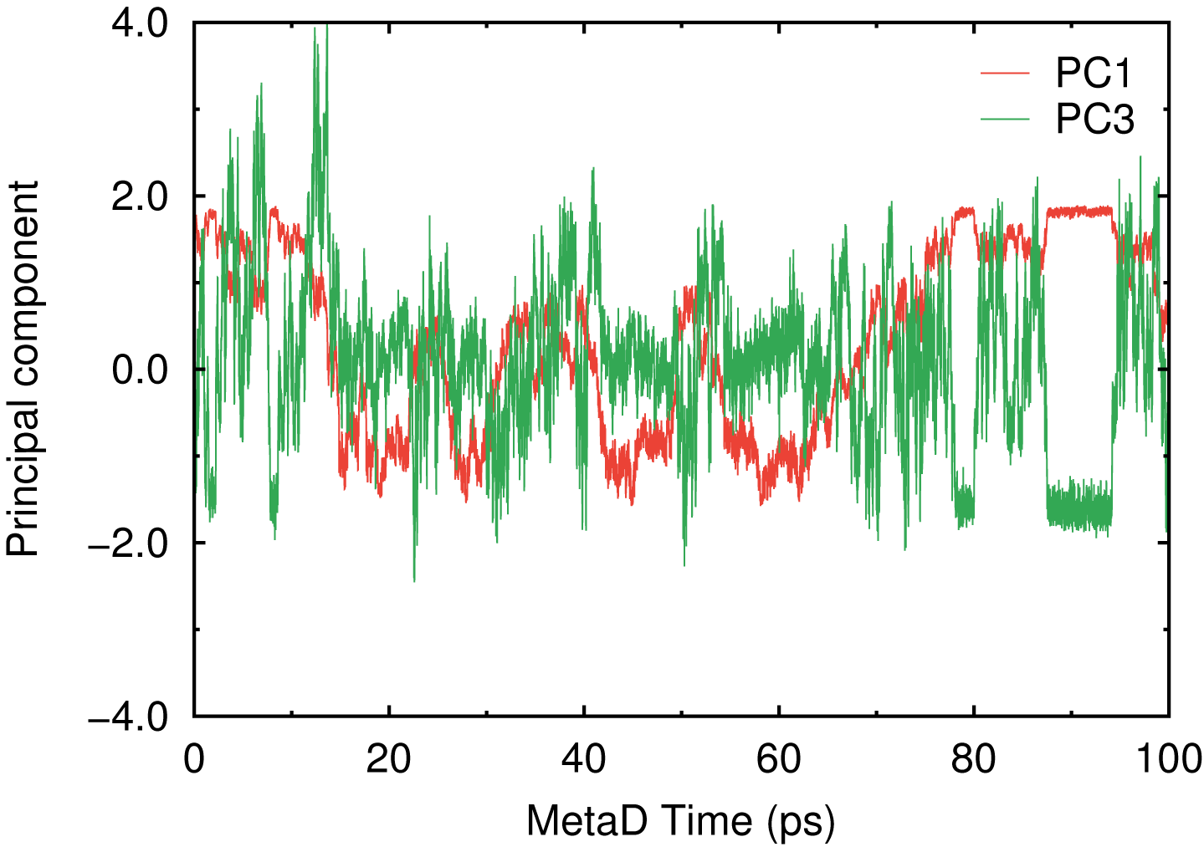 | 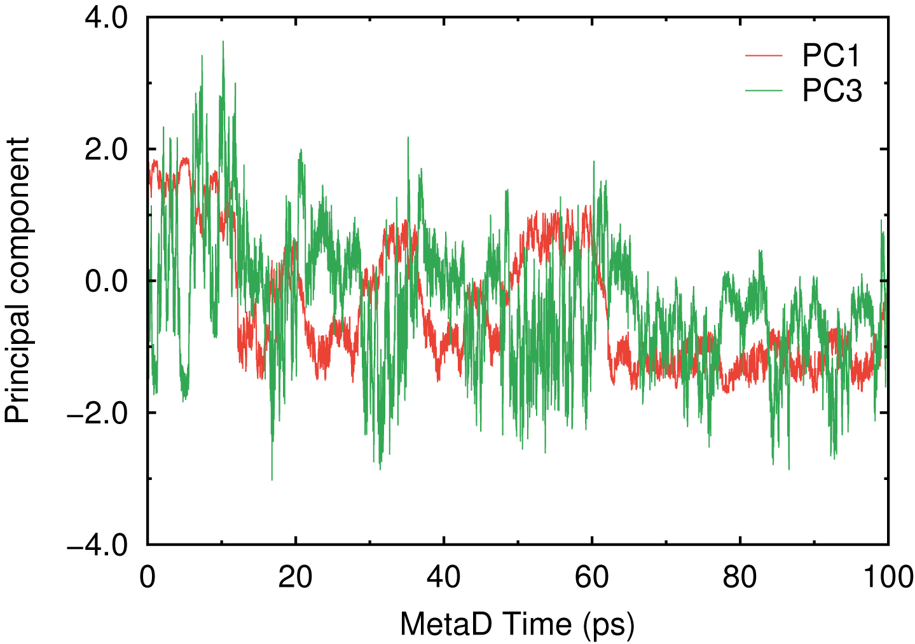
Figure S4. Time series of the PC1 and PC3 obtained from the six independent 100-ps DC-DFTB-MetaD simulations for the wild-type M^{pro} dimer system (PDB ID: 6LU7).

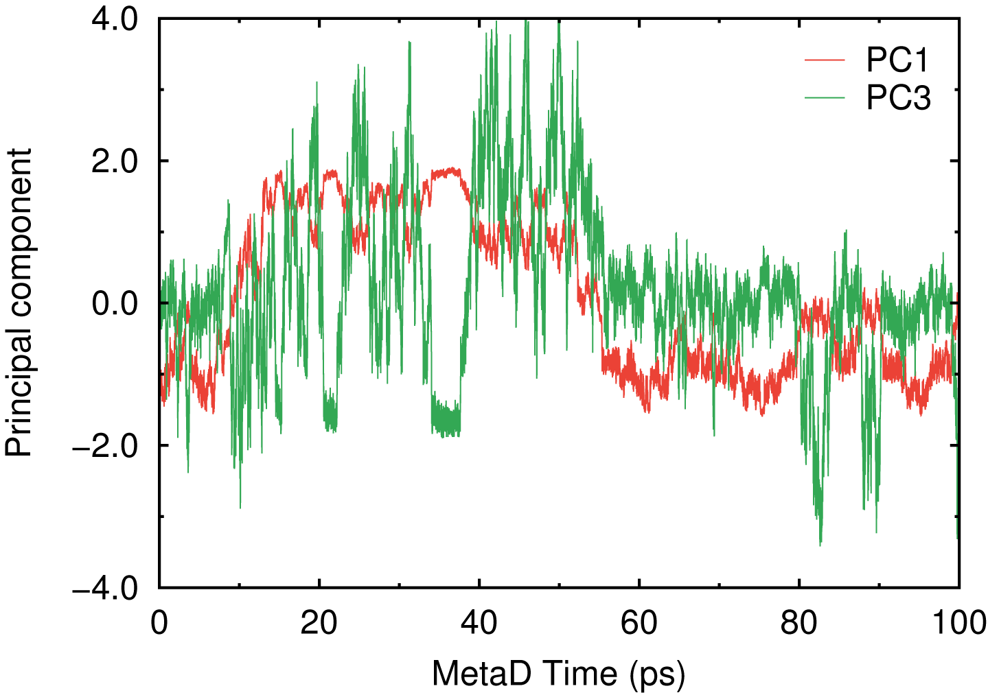 | 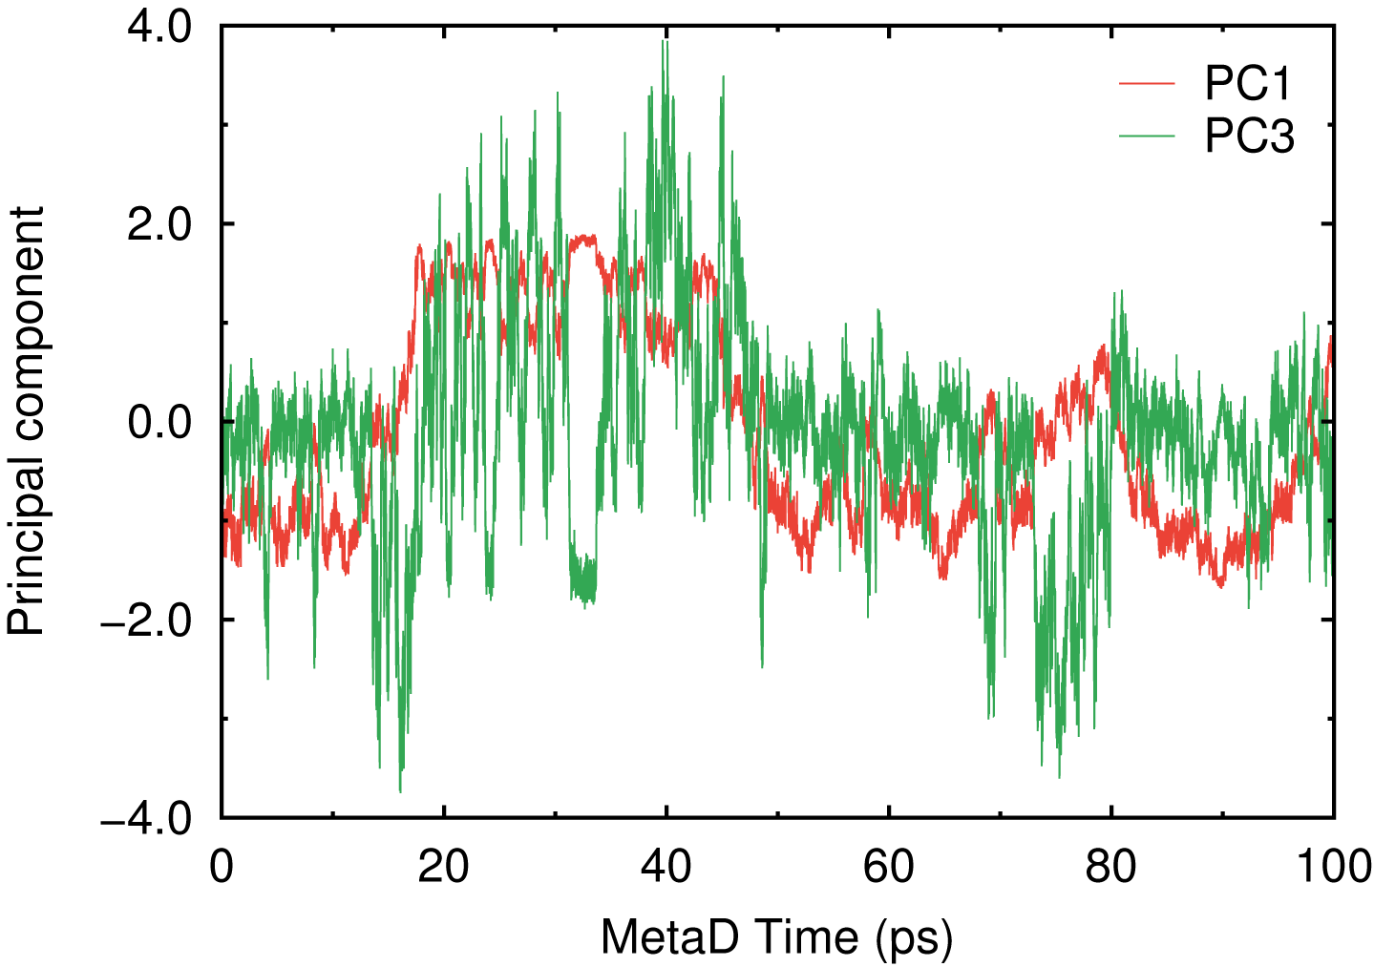
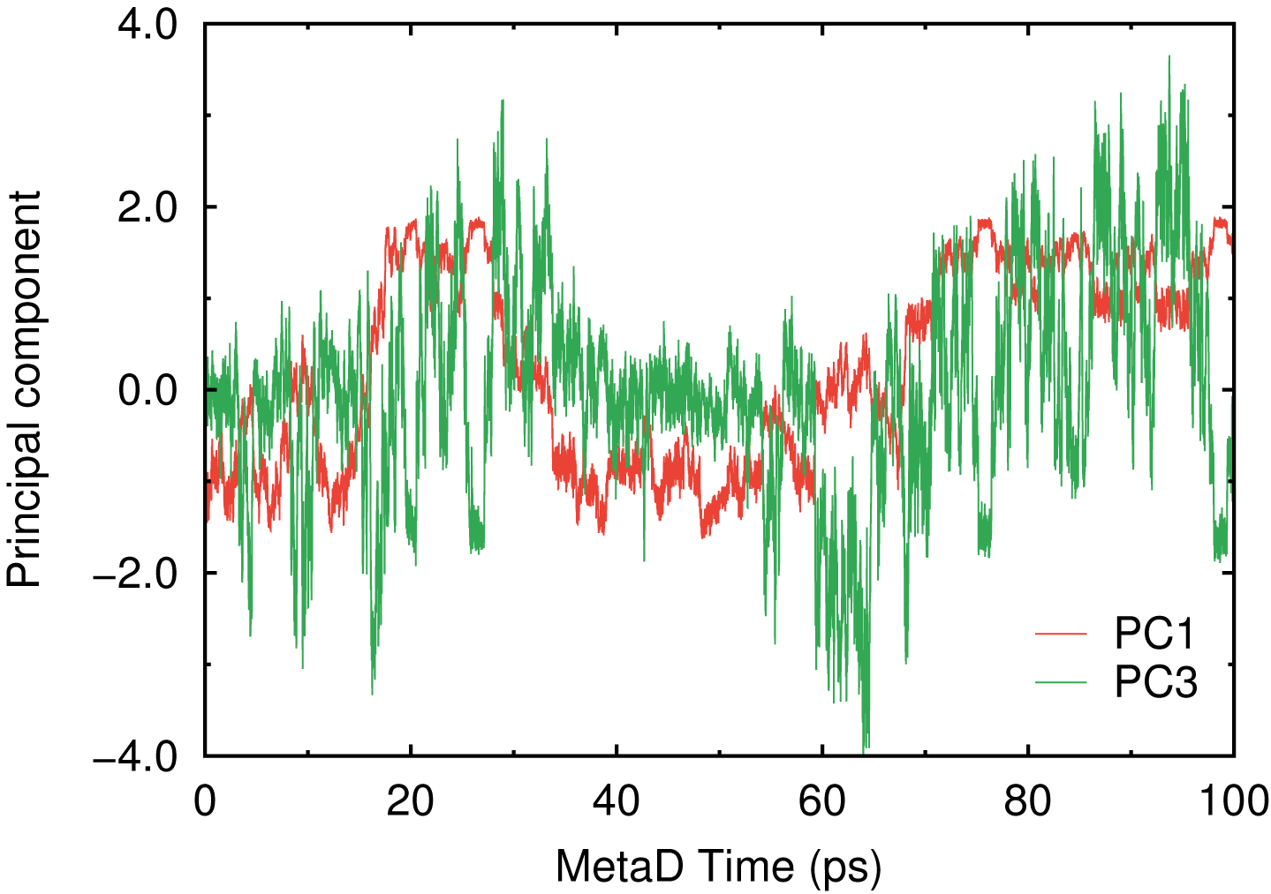 | 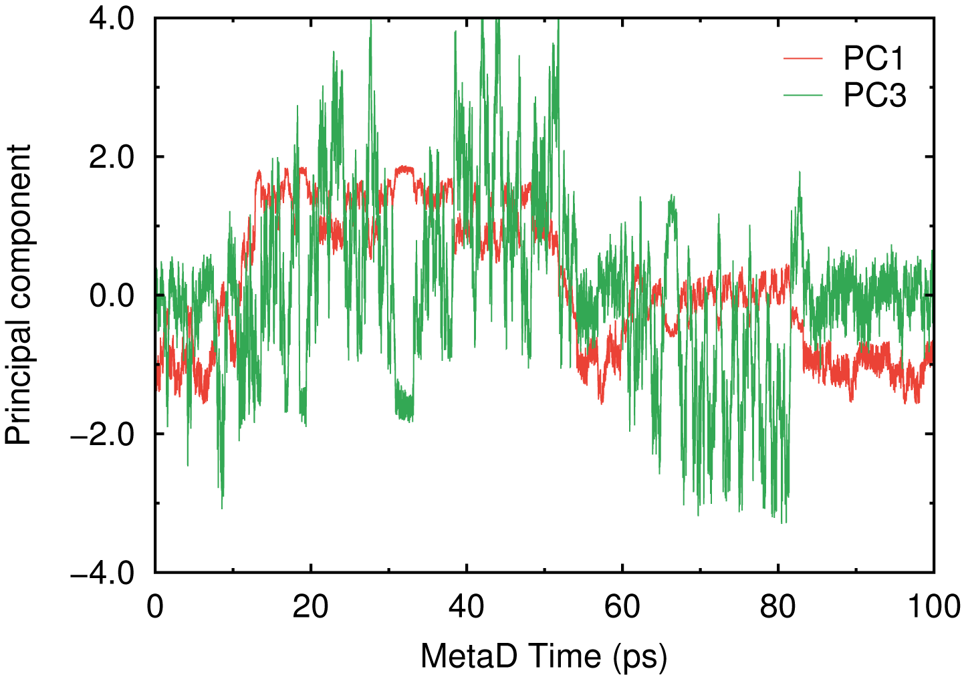
Figure S5. Time series of the PC1 and PC3 obtained from the four independent 100-ps DC-DFTB-MetaD simulations for the wild-type M^{pro} monomer system (PDB ID: 6LU7).

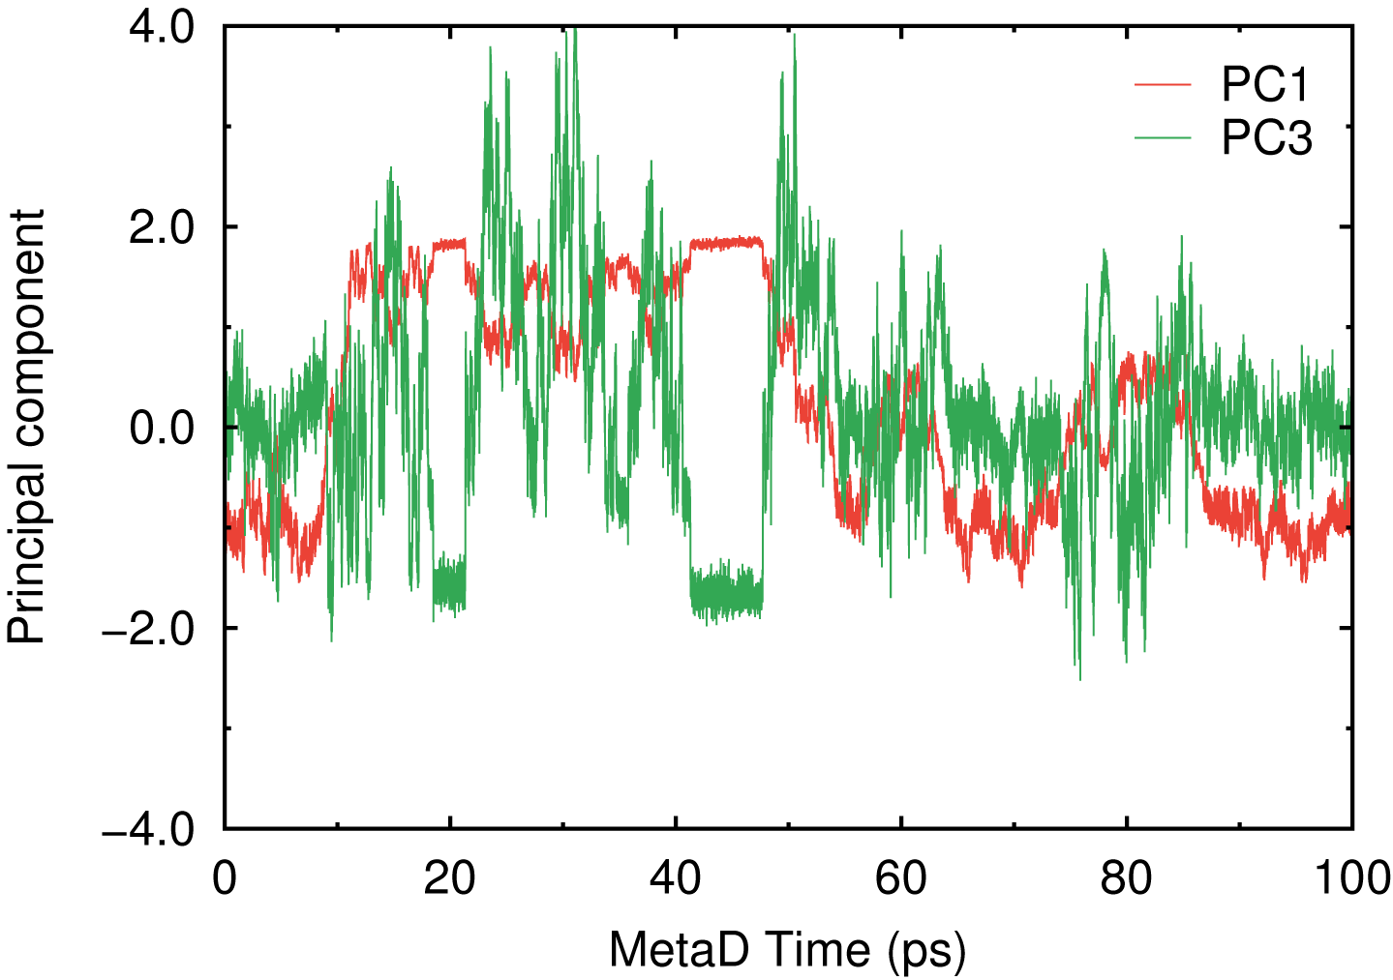 | 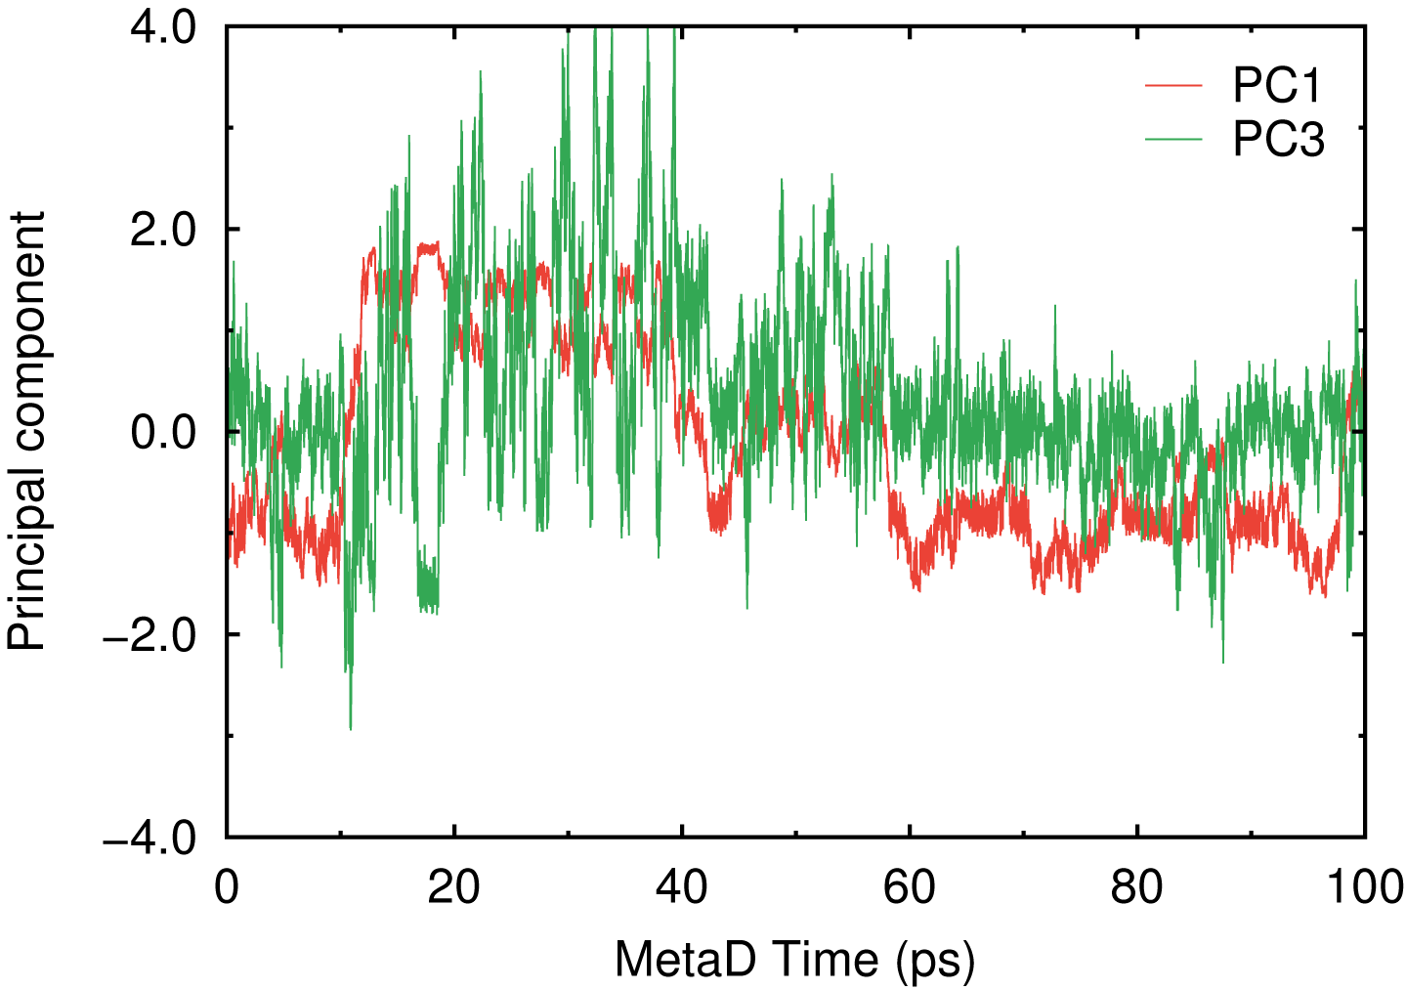
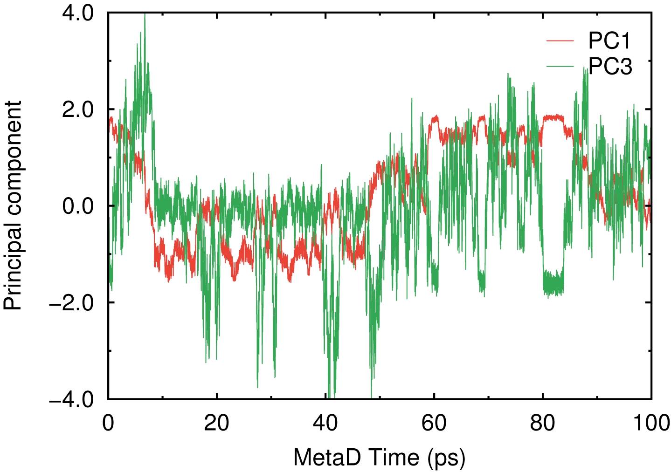 | 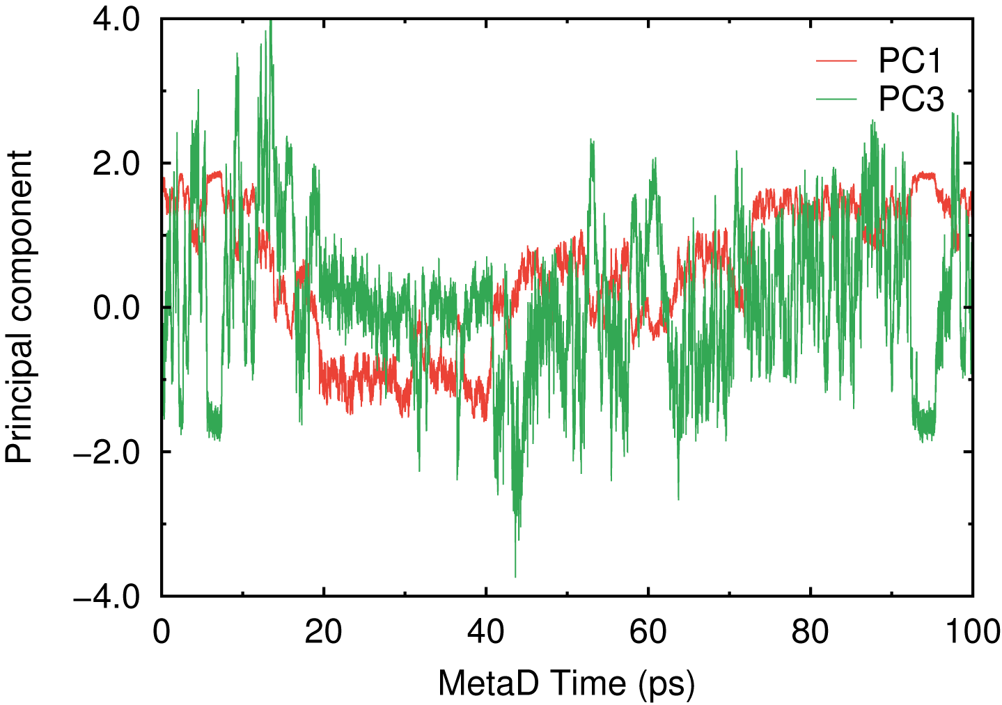
Figure S6. Time series of the PC1 and PC3 obtained from the four independent 100-ps DC-DFTB-MetaD simulations for the nirmatrelvir-resistant L50F/E166V mutant of M^{pro} dimer (PDB ID: 6LU7).

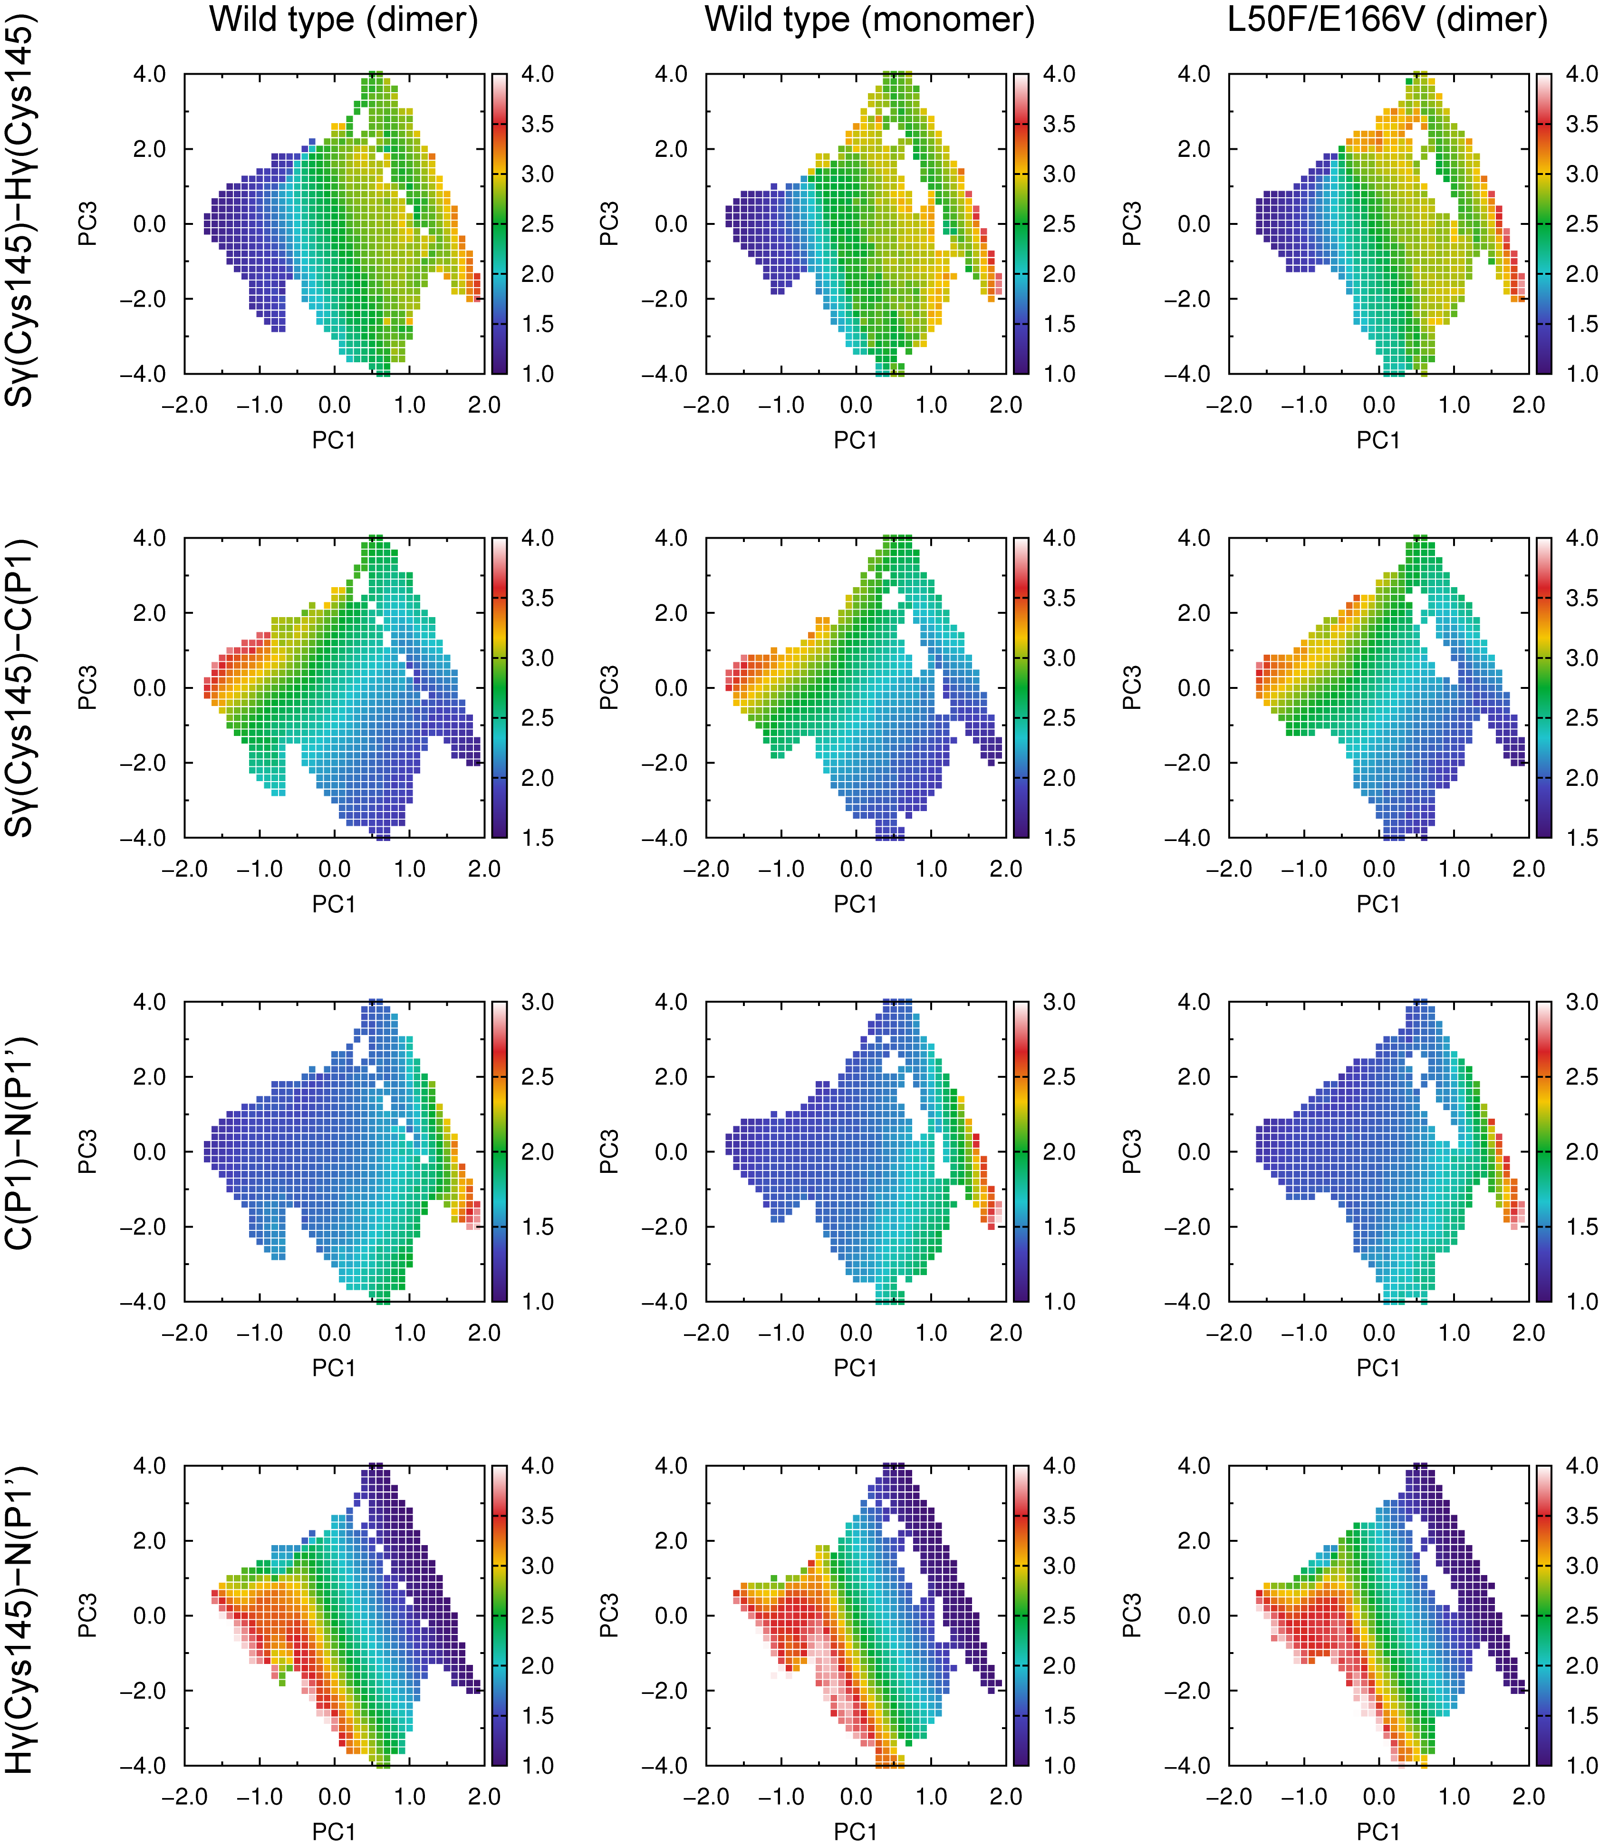

Figure S7. Conditional expectations with respect to PC1 and PC3 for the distance related to OP1-OP4 in the DC-DFTB-MetaD simulations for the nucleophilic acyl substitution: S_{γ}(Cys145)-H_{γ}(Cys145), S_{γ}(Cys145)-C(P1), C(P1)-N(P1’), and H_{γ}(Cys145)-N(P1).

