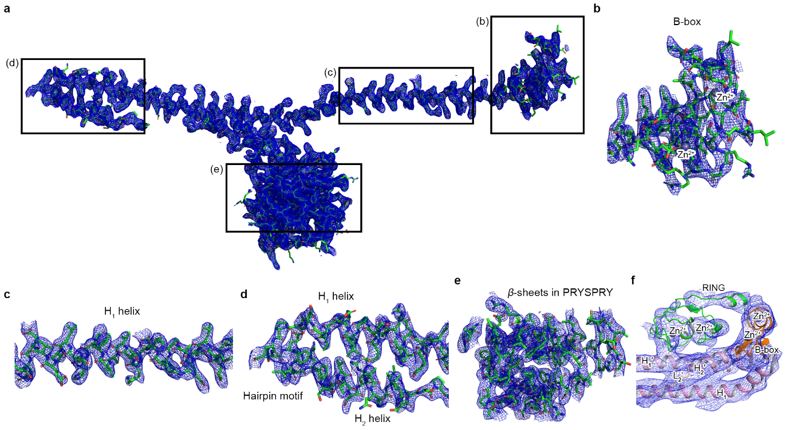

Supplementary Fig. 1| Electron density map of TRIM72 ΔRING.
a, Overall electron density map of the TRIM72 ΔRING monomer containing four representative boxed regions (b), (c), (d), and (e). b-e, Electron density maps of the B-box (b), H₁ helix (c), H₁ helix-hairpin motif-H₂ helix (d), and β-sheets in the PRYSPRY domain (e). The models and electron density maps were derived from the crystal structure of TRIM72 ΔRING (2.75 Å). f, Electron density map of the RING domain in the bent conformation of TRIM72 FL (4.6 Å). The 2Fo-Fc maps are contoured at 1.0 σ. The models are shown as sticks with carbon (green), nitrogen (blue), oxygen (red), and sulfur (yellow) in Panels a-e and a ribbon diagram in Panel f. Zinc atoms are represented as gray spheres.

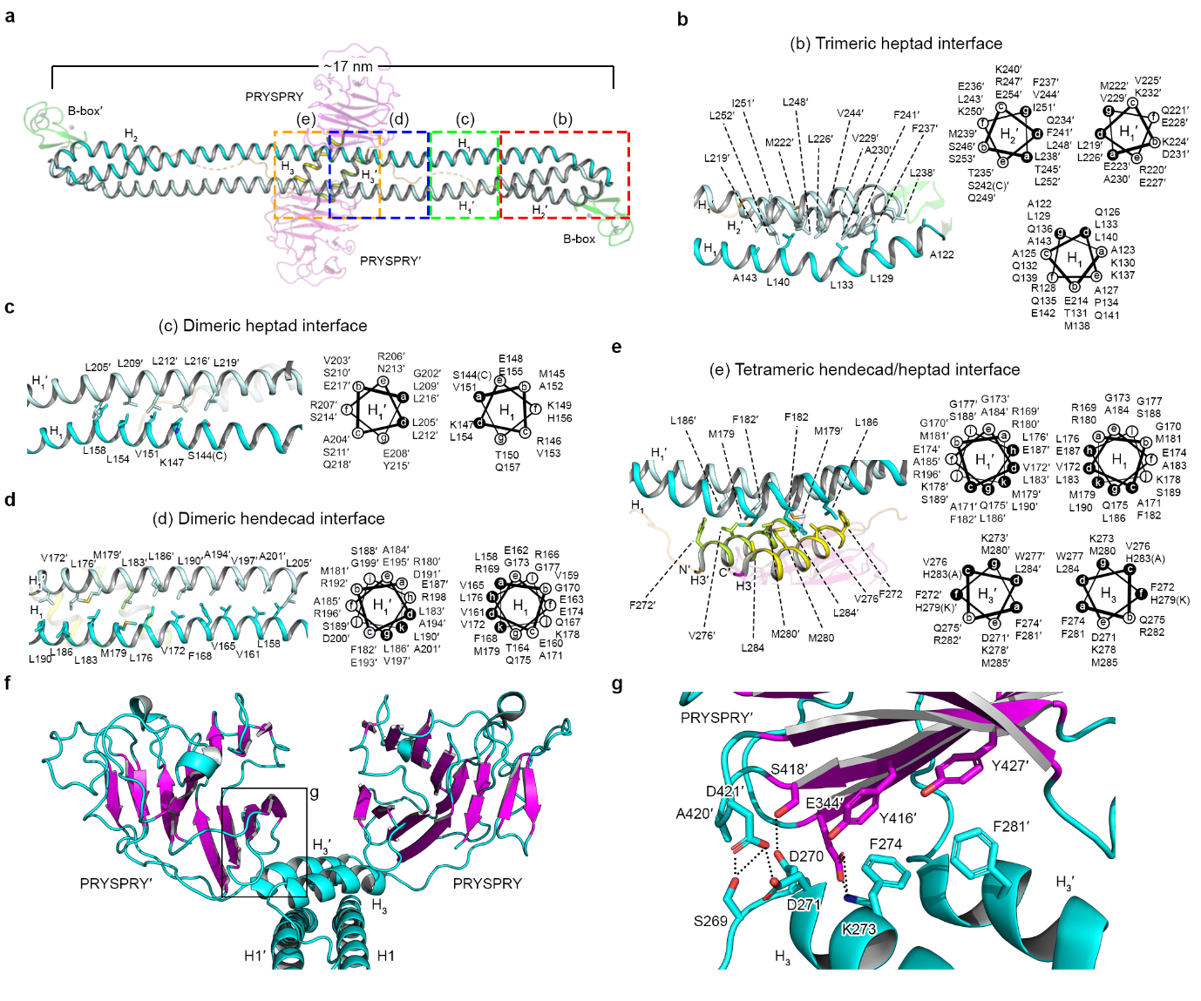Supplementary Fig. 2| Structural analysis of the interface between CCDs.
a, Overall structure of the TRIM72 CCD shown as a ribbon diagram. CCD interactions are categorized as belonging to four regions: b (red), c (green), d (blue) and e (orange). The other protomer is labeled with prime (’) symbols. b-e, CCD interfaces in the trimeric heptad interface (b), dimeric heptad interface (b), dimeric hendecad interface, (d) and four helical bundles of the heptad/hendecad interface (e). Each region is represented by ribbon (left) and helical wheel (right) diagrams (b-e). The black circled positions in the wheels are hydrophobic repeats buried in the interface. The amino acid residues of mouse TRIM72 WT are labeled in both the ribbon and helical wheel diagrams. The mutated residues for crystallization are indicated in S144 (C), S242 (C), H279 (K) and H283 (A). The WT residues are described in parentheses. f, Orientation of two PRYSPRY domains maintained by interactions of the H₃ helices. g, Interface between the H₃ helices and PRYSPRY domain. Panel g shows a close-up view of the black box in f. All models were derived from the crystal structure of TRIM72 ΔRING (2.75 Å).



Supplementary Fig. 3| Membrane fractionation assay in C2C12 myoblast cells.
Subcellular fractionation of human TRIM72 in C2C12 myoblasts. The membrane (Mem) and cytosol (Cyto) fractions are indicated at the top. Strep-tagged TRIM72 was detected with an HRP-conjugated strep monoclonal antibody. A subcellular localization marker and loading control were detected with specific antibodies. Independent experiments were performed in triplicate. The quantified results are shown in Fig. 2e.

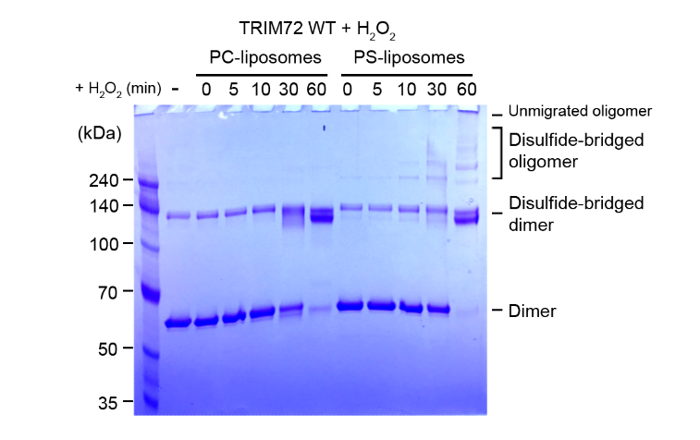

Supplementary Fig. 4| The oxidation of TRIM72 depends on the negatively charged membrane.
Time-dependent protein oxidation analysis of TRIM72. Hydrogen peroxide (H₂O₂) was used as an oxidizing reagent to detect the formation of disulfide bonds in the presence of PC- or PS-liposomes. Note that the oligomerized bands are increased progressively only in lanes with PS-liposomes. Boiled samples were loaded onto 4-12% SDS‒PAGE gels under nonreducing conditions.
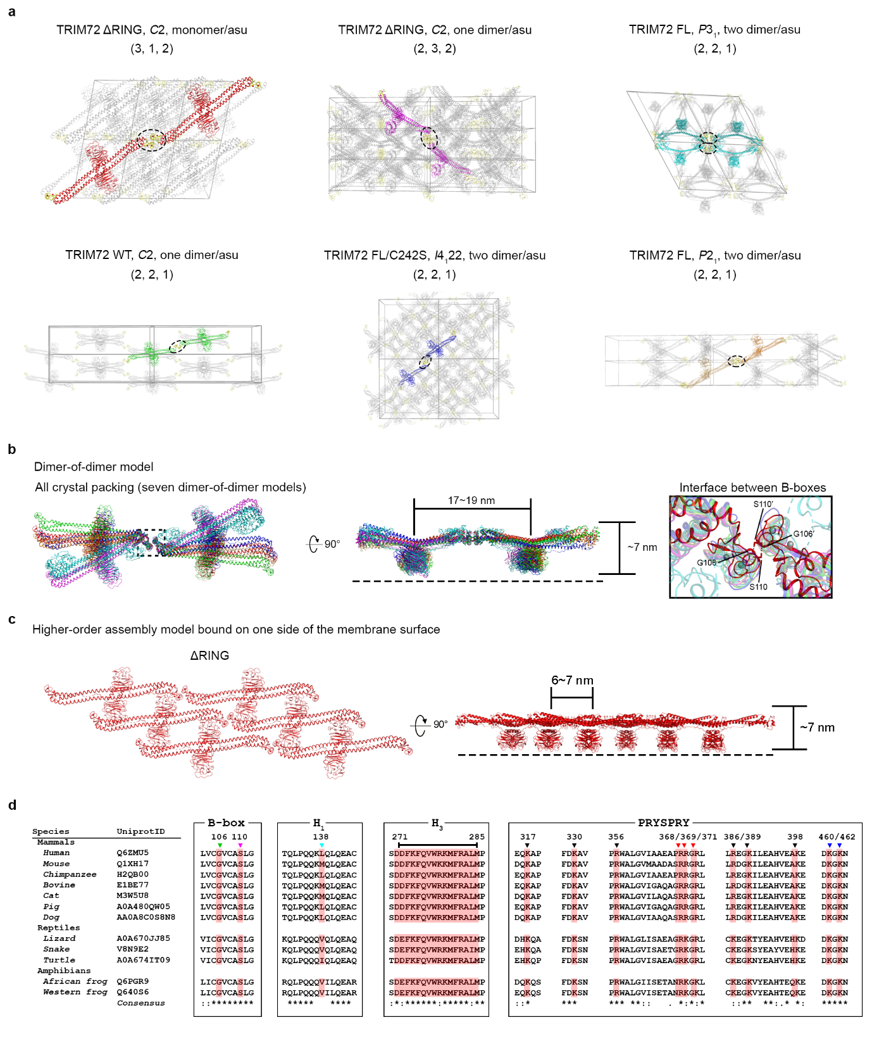

Supplementary Fig. 5| Structural analysis of the TRIM72 assembly in crystal packing.
a, Crystal packing of TRIM72. The constructs, space groups, and the number of molecules per asymmetric unit are shown at the top of each panel. The number of expanded unit cells is indicated in parentheses. The dimer-of-dimer model is highlighted with color in the crystal lattice. B-boxes are marked in yellow. Note that the B-boxes interacted with each other in all crystal packings. The dashed ellipses indicate contacted B-boxes in dimer-of-dimer models. b, Superimposition of dimer-of-dimer models shows that PRYSPRY domains adopt the same orientation. The top view (left) and side view (middle) rotated by 90° are shown. The interfaces between B-boxes are also shown (right). The right panel is an enlarged dotted box. c, Symmetry expansion of the crystal packing of TRIM72 ΔRING (2.75 Å). The top view (left) and side view (right) rotated by 90° are shown. d, Sequence alignment of TRIM72 proteins from various species. Conserved residues for membrane binding and higher-order assembly in mammals, reptiles, and amphibians are shown as inverted triangles (top) and shaded in red. The number of residues corresponds to the sequence of mouse TRIM72. The TRIM72 sequences were aligned using Clustal Ω¹.

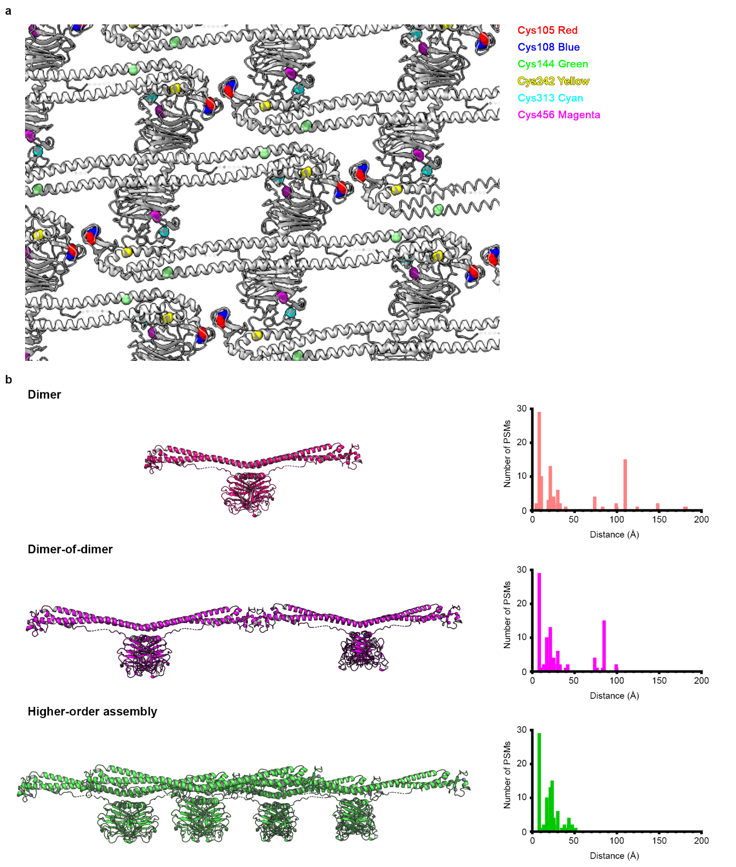
Supplementary Fig. 6| Crosslinking analysis of the higher-order TRIM72 assembly.
a, Coordinates of cysteine residues in the higher-order TRIM72 assembly. Each cysteine is represented with a colored ball (Cys105, red; Cys108, blue; Cys144, green; Cys242, yellow; Cys313, cyan; Cys456, magenta). b, Distances between crosslinked cysteines in each TRIM72 model. Compared to the dimer or the dimer-of-dimer model, the higher-order assembly model shows an optimal range of the distance between crosslinked cysteines within 50 Å. The CLMS data are summarized in Supplementary Data S2. The experimental procedure is detailed in the Methods.
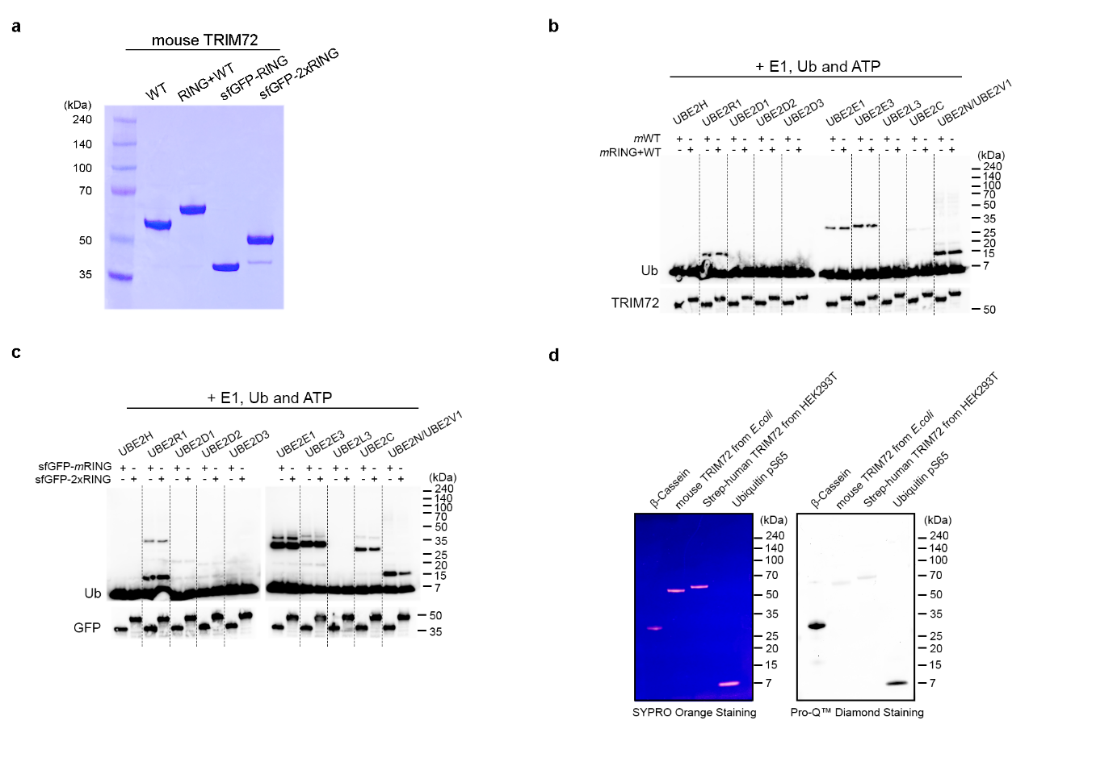
Supplementary Fig. 7| In vitro ubiquitination assay with TRIM72 RING constructs.
a, SDS‒PAGE analysis of TRIM72 constructs containing the RING domain. The details of the constructs are described in Supplementary Table 1. b-c, In vitro E2 screening with various TRIM72 constructs: WT and RING+WT (b), RING and 2×RING (c). d, SDS‒PAGE analysis with phosphorylation-specific staining. Note that TRIM72 proteins purified from both bacterial and mammalian cells were not stained with phosphorylation-specific dyes. The total quantities of proteins were shown by staining with SYPRO Orange Protein Gel Stain (left). The phosphorylated proteins were shown by staining with ProQTM Diamond Phosphoprotein Gel Stain (right). β-Catenin (Lane 1) and phosphorylated Ub at Ser65 (Lane 4) were the positive controls for detection of phosphate groups.

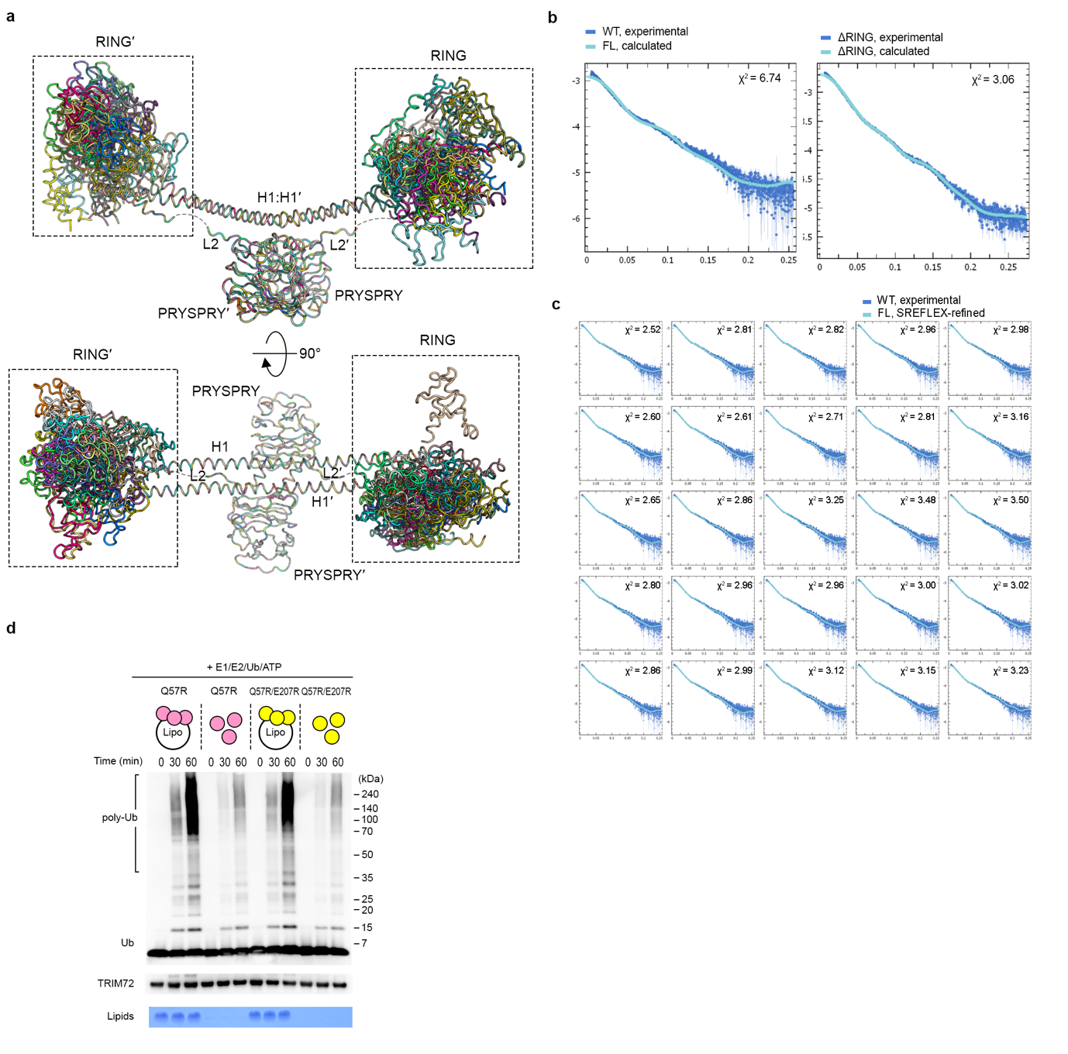
Supplementary Fig. 8| The RING domain is highly flexible.
a, Dynamic conformations of the RING domains. A total of 25 ensemble models were created based on the SREFLEX analysis. b, Comparison of the experimental (blue) and calculated (cyan) intensity plots for TRIM72 WT (left) and ΔRING (right). Theoretical SAXS profiles were calculated from the crystal structures of TRIM72 FL and ΔRING by CRYSOL software². c, SREFLEX-derived SAXS profiles of TRIM72 WT corresponding to the ensemble models (a). d, In vitro ubiquitination assay of TRIM72 Q57R and Q57R/E207R in the presence or absence of PS-liposomes. Polyubiquitination is shown as poly-Ub. Ub was detected with an anti-Ub antibody. TRIM72 was detected using an anti-TRIM72 antibody. Phospholipids were stained with Sudan black B. Schematic diagrams are shown in each panel for better communication of the results (Q57R, pink; Q57R/E207R, yellow).

Supplementary References
1 Sievers, F. et al. Fast, scalable generation of high-quality protein multiple sequence alignments using Clustal Omega. Mol Syst Biol 7, 539 (2011).
2 Svergun, D., Barberato, C. & Koch, M. H. J. CRYSOL - A program to evaluate x-ray solution scattering of biological macromolecules from atomic coordinates. J Appl Crystallogr 28, 768-773 (1995).

