Supplementary materials
Supplementary Figure S1. The elbow method for the optimal number of clusters
Supplementary Figure S2. Prevalence of each disease and results of clustering analysis as a validation study in Sammu City
Supplementary Figure S3. Obtained survey data for care-need certification, medical claims data and insurance registration data in Tsukuba City
Supplementary Table S1. The Xie-Beni index of each condition in a fuzzy c-means clustering algorithm
Supplementary Table S2. Definition of 22 diseases based on the International Classification of Diseases 10th Revision (ICD-10) codes

Supplementary Figure S1. The elbow method for the optimal number of clusters
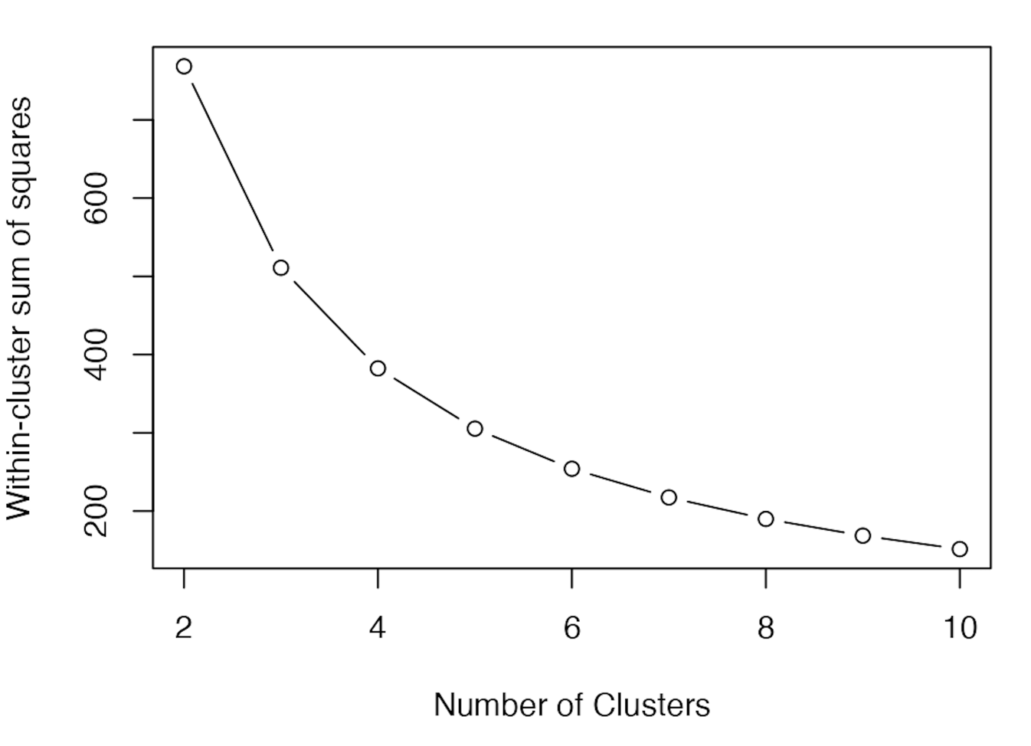

Supplementary Figure S2. Prevalence of each disease and results of clustering analysis as a validation study in Sammu City
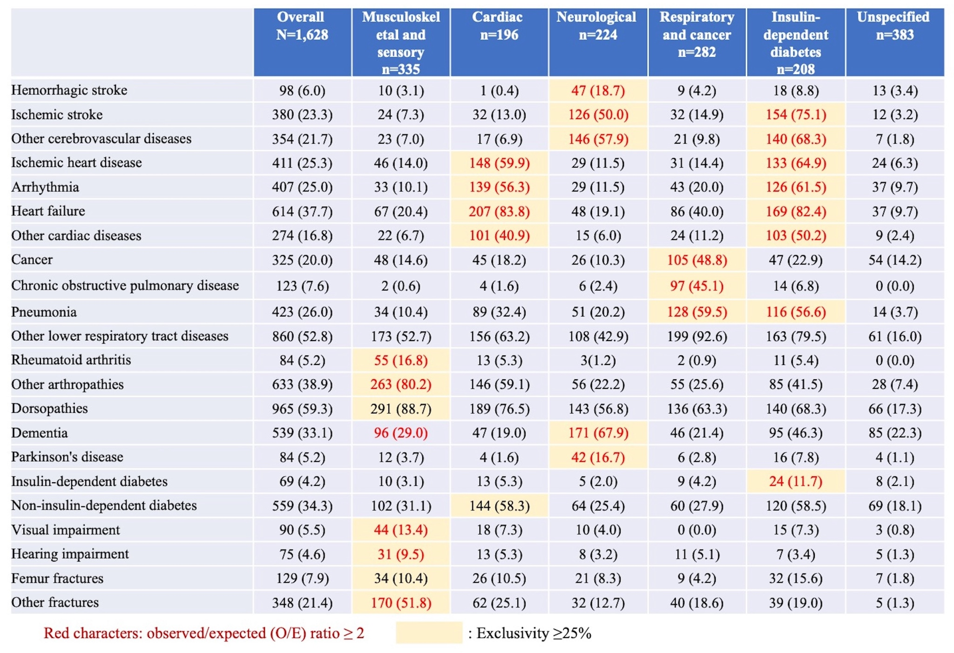
Supplementary Figure S3. Obtained survey data for care-need certification, medical claims data and insurance registration data in Tsukuba City
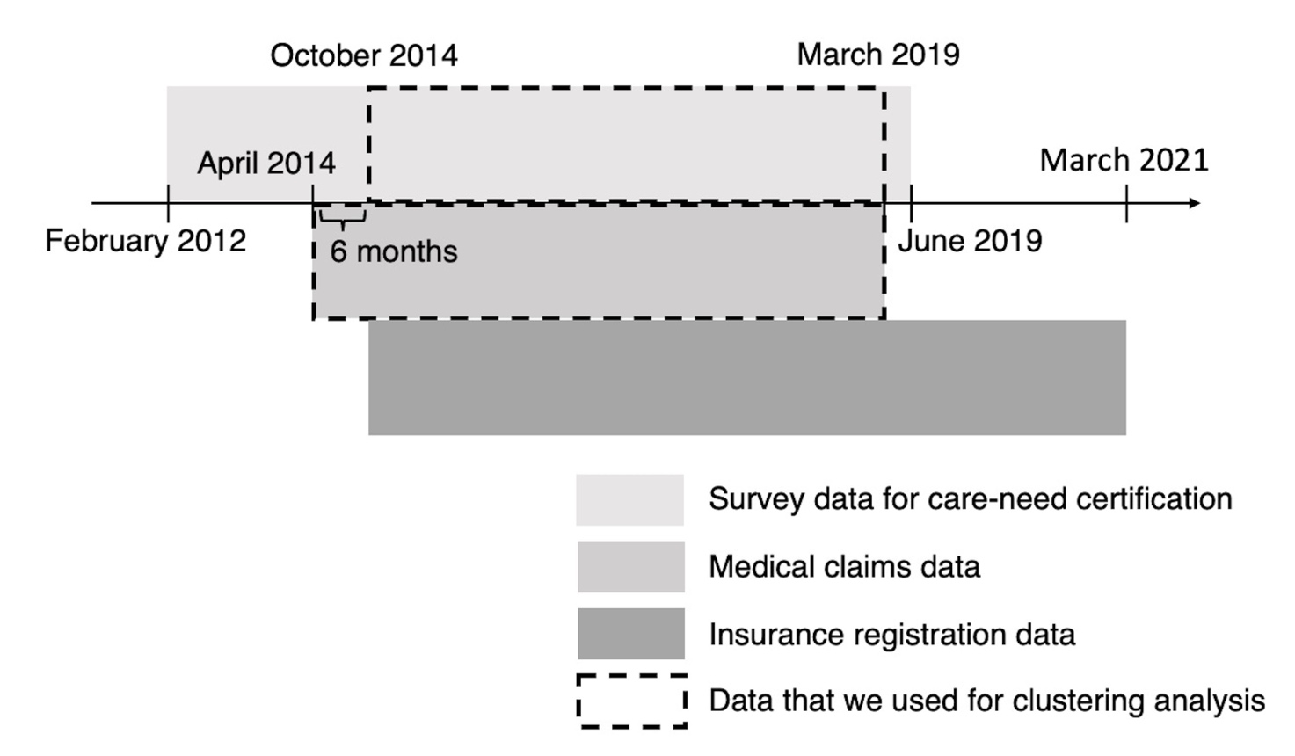

Supplementary Table S1. The Xie-Beni index of each condition in a fuzzy c-means clustering algorithm
Number of clusters | m parameter
Number of clusters | m=1.1 | m=1.5
2 | 0.0001898194 | 0.0002364669
3 | 0.0002419844 | 0.0002338178
4 | 0.0001900166 | 0.0001791536
5 | 0.0001594791 | 0.0001383843
6 | 0.0001364424 | 0.0002164881
7 | 0.0001865748 | 0.000201598
8 | 0.0001731017 | 0.0002095857
Footnote: Xie-Beni index indicates the optimal number of clusters when the value is the lowest.

Supplementary Table S2. Definition of 22 diseases based on the International Classification of Diseases 10th Revision (ICD-10) codes
Medical diagnosis category | ICD-10 codes
Cerebrovascular diseases:
- Hemorrhagic stroke | I60–I62
- Ischemic stroke | I63
- Other cerebrovascular diseases* | I64–I69
Cardiac diseases:
- Ischemic heart disease | I20–I25
- Arrhythmia | I44, I45, I47–I49
- Heart failure | I50
- Other cardiac diseases | I01, I05–I09, I11, I13, I30–I43, I51, I52
- Cancer | C00–C097
Lower respiratory tract diseases
- Chronic obstructive pulmonary disease | J43, J44
- Pneumonia | J12–18, J69
- Other lower respiratory tract diseases | A15, A16, J20–J22, J40–J42, J45–J47, J60–J68, J70, J80–J86, J90–J94
Joint diseases
- Rheumatoid arthritis | M05, M06
- Other arthropathies | M00–03, M07, M10–M25
- Dorsopathies (disorders of the back or spine) | M40–M54
- Dementia | F00–F03, G30
- Parkinson’s disease | G20
Diabetes
- Insulin-dependent diabetes | E10–E14 with prescription records of insulin products**
- Non-insulin-dependent diabetes | E10–E14 with prescription records of oral antidiabetic drugs*** (without insulin products)
Visual or hearing impairment
- Visual impairment | H53, H54
- Hearing impairment | H90, H91
Fractures
- Femur fractures | S72
- Other fractures | S02, S12, S22, S32, S42, S52, S62, S82, S92, T02, T08, T10, T12

ICD-10 = International Classification of Diseases 10th Revision.
*Including unspecified stroke and sequelae of cerebrovascular disease.
**Prescription records (WHO Anatomical Therapeutic Chemical classification ‘A10A’) were additionally used to define insulin-dependent diabetes.
***Prescription records (WHO Anatomical Therapeutic Chemical classification ‘A10B’) were additionally used to define Non-insulin-dependent diabetes.

