Table 1. Predicted toxicities and toxicity risk for 90 compounds performed by ADMET predictor software. ADMET predictor identifier of each toxicity is mentioned in the parenthesis (See abbreviation list). In particular, Tox_hERG_Filter is a qualitative estimation of the affinity to the hERG potassium channel in human and Tox_hERG is the affinity to the hERG potassium channel in human expressed as pIC50 in mol/L. Compounds with an IC50 less than or equal to 10μmol/L were labeled Toxic (T, red), while those greater than 10μmol/L are considered (NT, green). Human liver adverse effect (the likelihood of causing elevation in the levels of AlkPhos, GGT, LDH, AST amd ALT enzymes) is also summarized in hepatotoxicity section and color coded as EL (Elevated, red), NL (Normal, green). Other toxicity assessments are mentioned in Skin sensitivity, Respiratory sensitivity, Reproductive toxicity, Phospholipidosis, Chromosome aberration, Estrogen and AndrogenToxicity and Max_RTD (Maximum Recommended Therapeutic Dose). The abbreviations used are Nonsensitive (NS, green), Sensitive (S, red), EL(Elevated, red), NL(Normal, green), T(Toxic) and NT(Nontoxic). Toxicity risk (possible range 0-7) is the risk connected with predicted toxicity problems a compound might have. Toxicity risk less than 2 is considered as safe (green). Check rules and abbreviations for TOX_Risk and ToX_Code in risk section for the codes. MV stands for MISSING_VALUE in ADMET predictor and color coded in yellow. 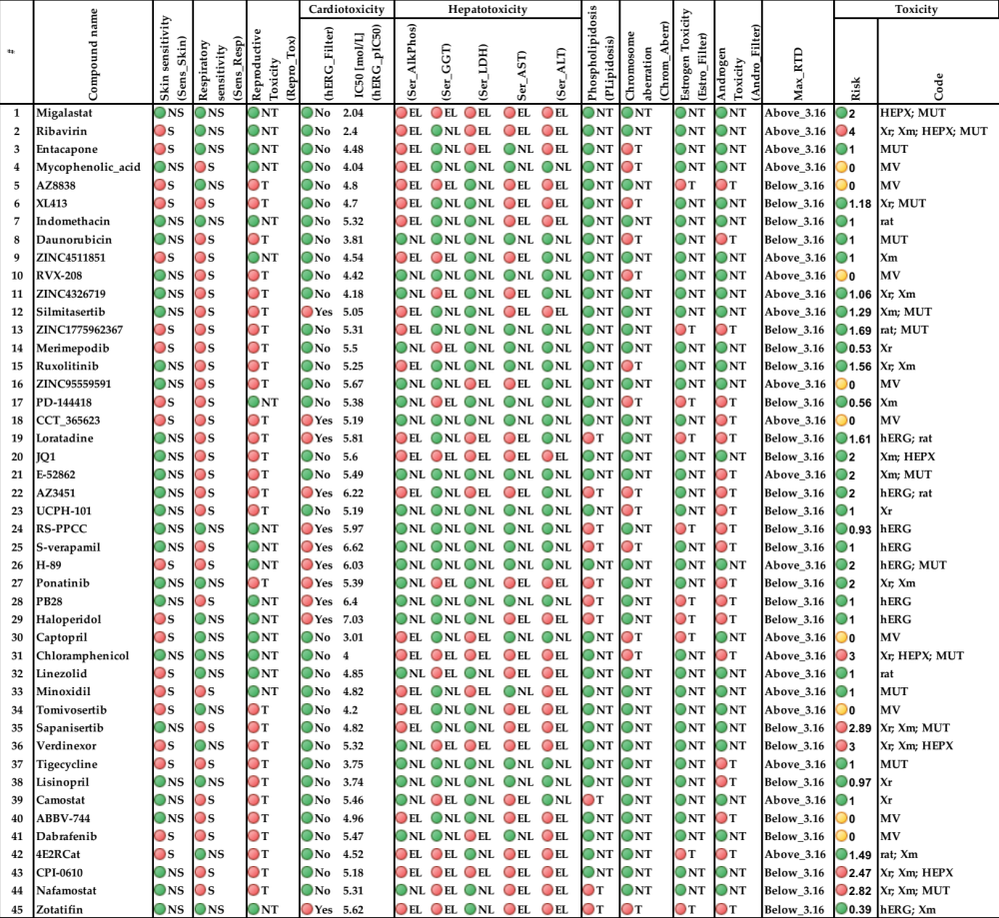

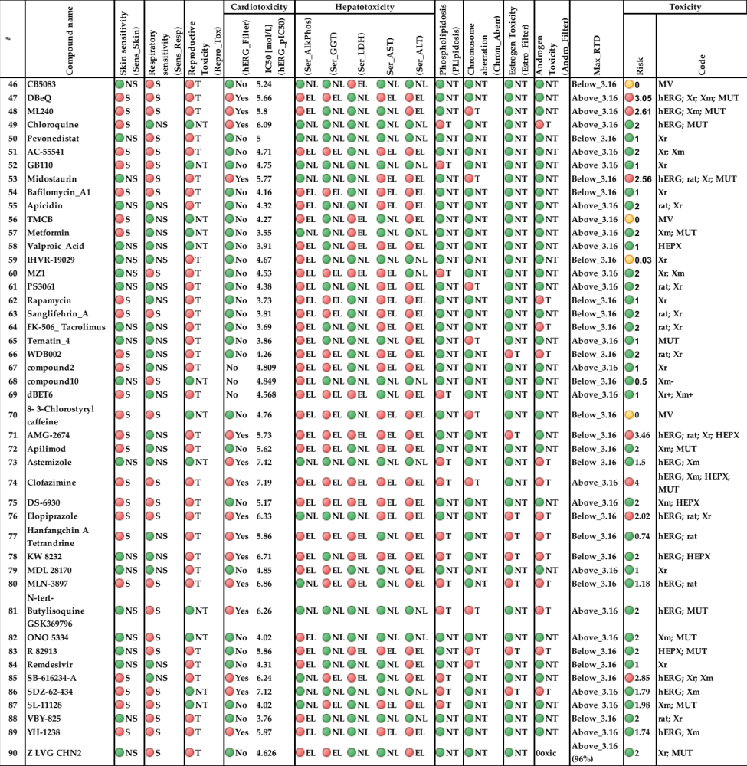

Table 2. ADMET Risk and ADMET Code for toxic liability, mutagenicity in S. typhimurium liability, metabolic liability, and the global ADMET Risk and ADMET Code summarizing all other ADMET Risk/Code models. TOX_Risk (possible range 0-7) and TOX_MUT_Risk (possible range 0-11). Check codes, rules and abbreviations for in risk section. The high risk values were highlighted with red (TOX_Risk> 2, CYP_Risk > 2, MUT_Risk > 2 and ADMET_Risk > 3), while the acceptable values are highlighted with green. MV stands for MISSING_VALUE in ADMET predictor and color coded with yellow.

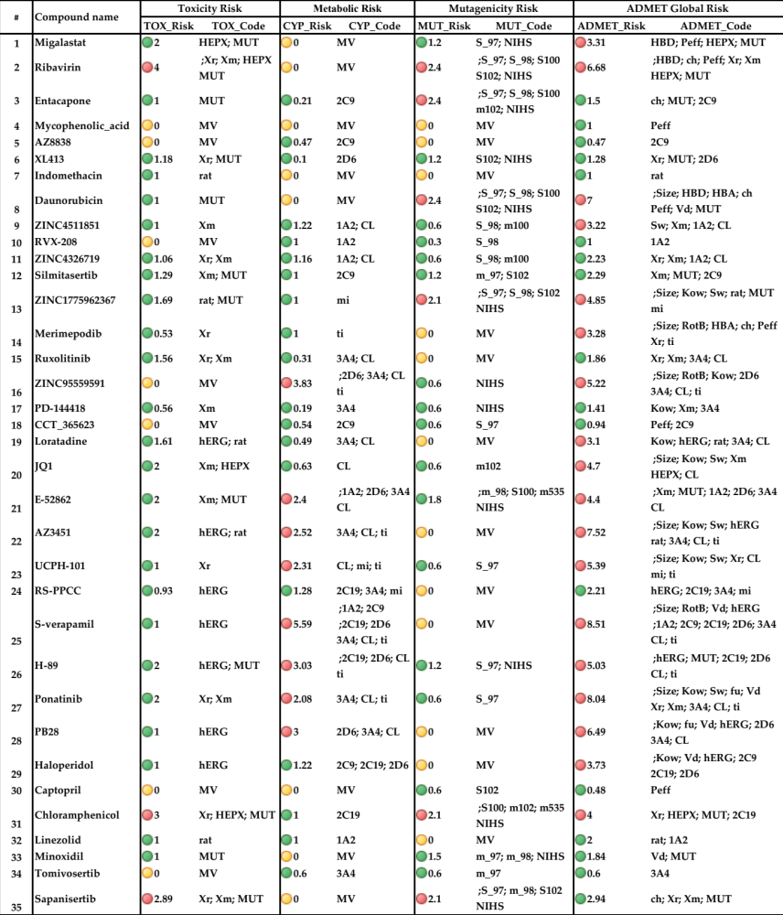

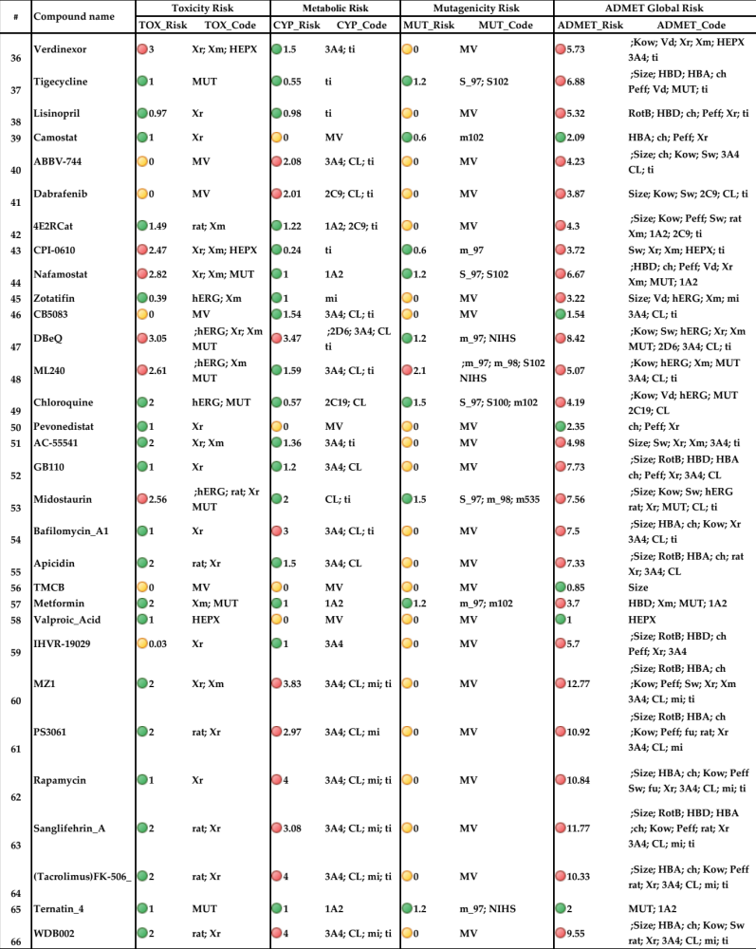

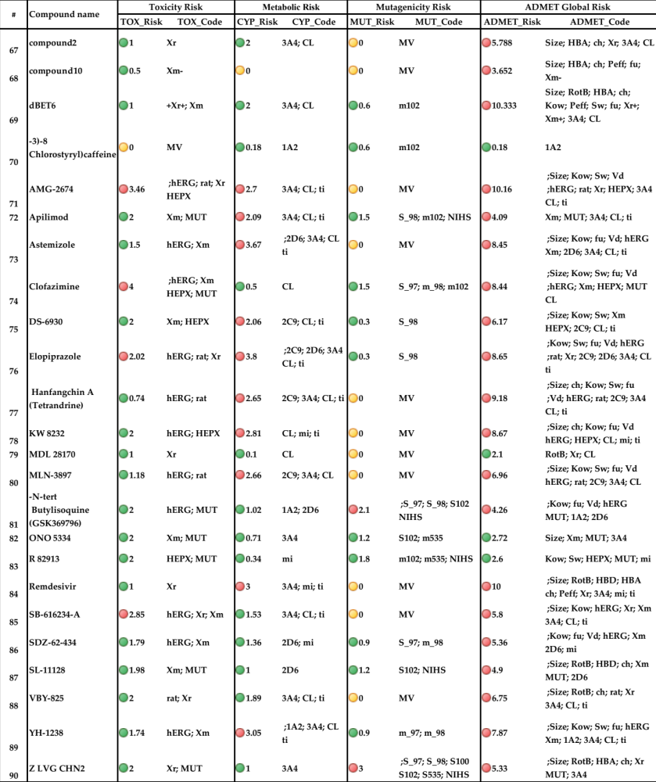

Table 3. Block1: Substrate Classification Models for Cytochrome P450 1A2, 2C9, 2C19, 2D6, and 3A4. Block 2: Inhibition models for cytochrome P450 1A2, 2C9, 2C19, 2D6, and 3A4 (qualitative es-timation), as well as a specific inhibition of the CYP 3A4-mediated metabolism of midazolam and testosterone. We labeled Y if a given chemical structure is a substrate for P450 isozymes and (N) if it is not a substrate for P450 isozymes. ADMET Risk and ADMET Code for metabolic liability are CYP_risk and CYP_code, respectively. Metabolic risk greater than 2 is highlighted with red, while the acceptable values are highlighted with green. Cyp risk rules and codes are described in risk section.
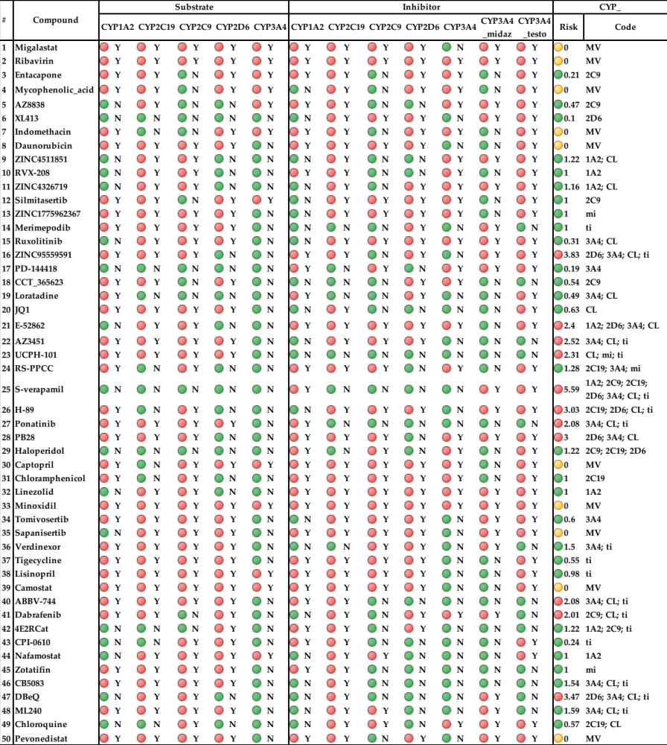

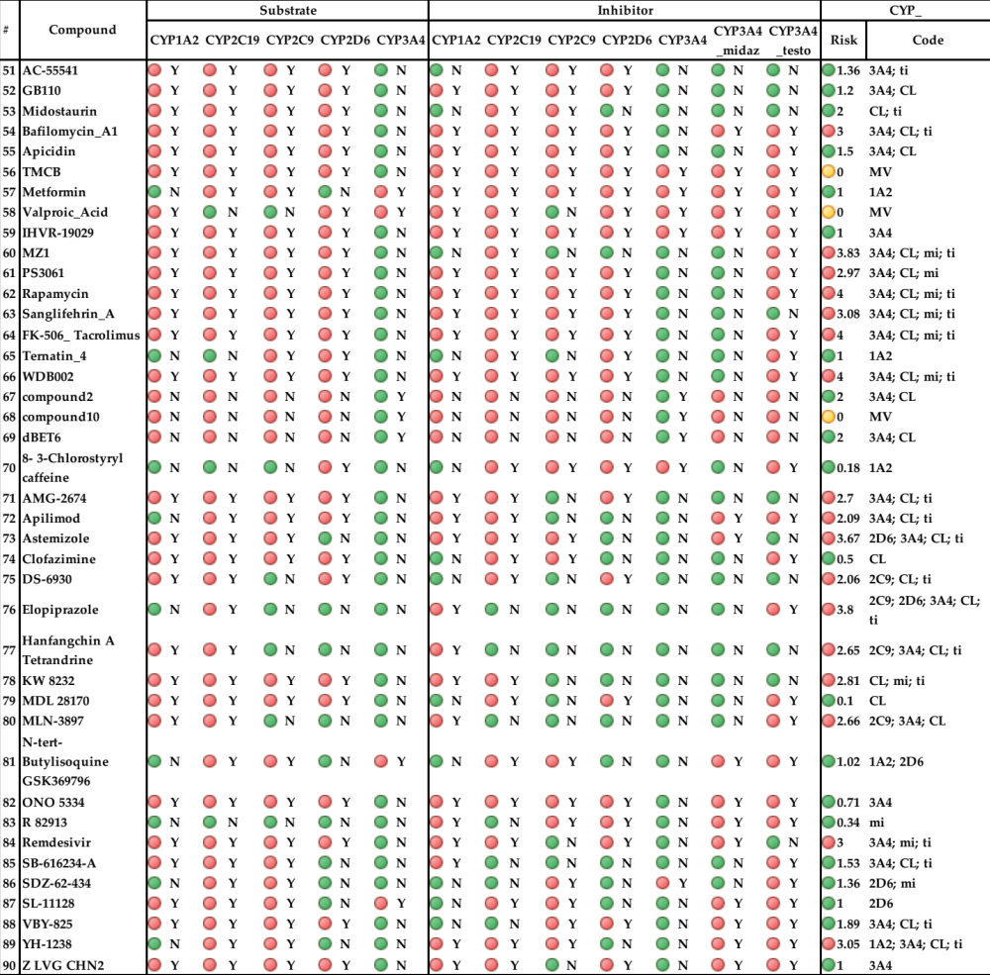

Table 4. Predicted affinity to the hERG potassium channel in human expressed as pIC50 in mol/L using our ML model. (Abbreviations: AD: Applicability domain, MST: Similarity matrix and MDT: Minimum Distance to Training). NA stands for not available.
