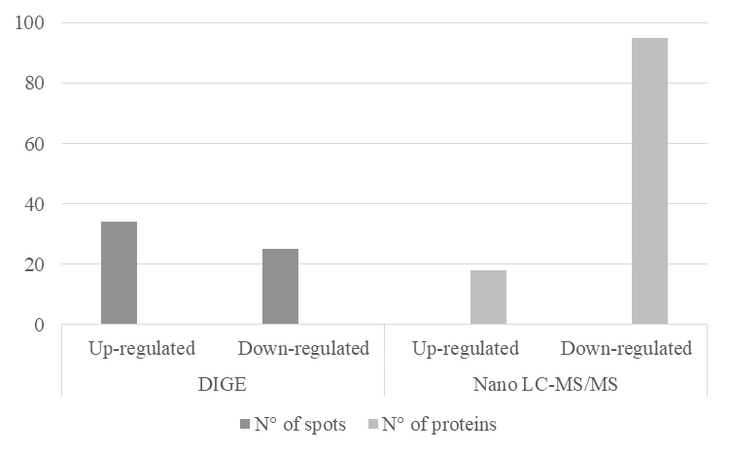
Figure S1. Number of spots/proteins identified on strain K. radicincitans UYSO10 that change its expression in the presence of sugarcane root exudates.

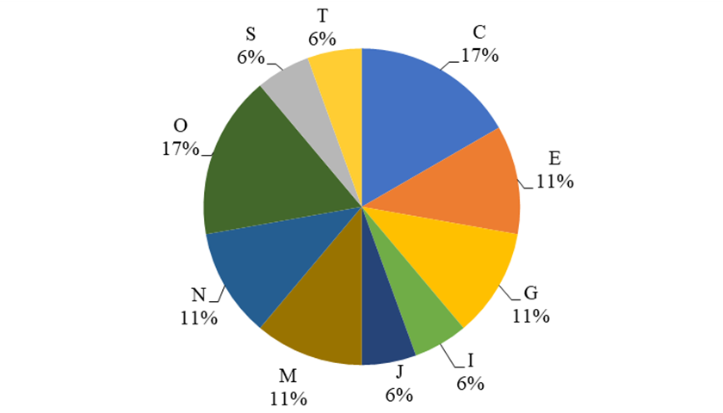
Figure S2. Classification into COG functional categories of proteins present as unique or up-regulated in the presence of exudates (n = 18). J- translation; O- chaperone molecules and related functions; M- biogenesis and structure of the outer membrane; N- secretion, mobility, and chemotaxis; T- signal transduction; C- energy production and conversion; G- carbohydrate transport and metabolism; E- transport and metabolism of amino acids; I- lipid metabolism; S- no functional prediction.

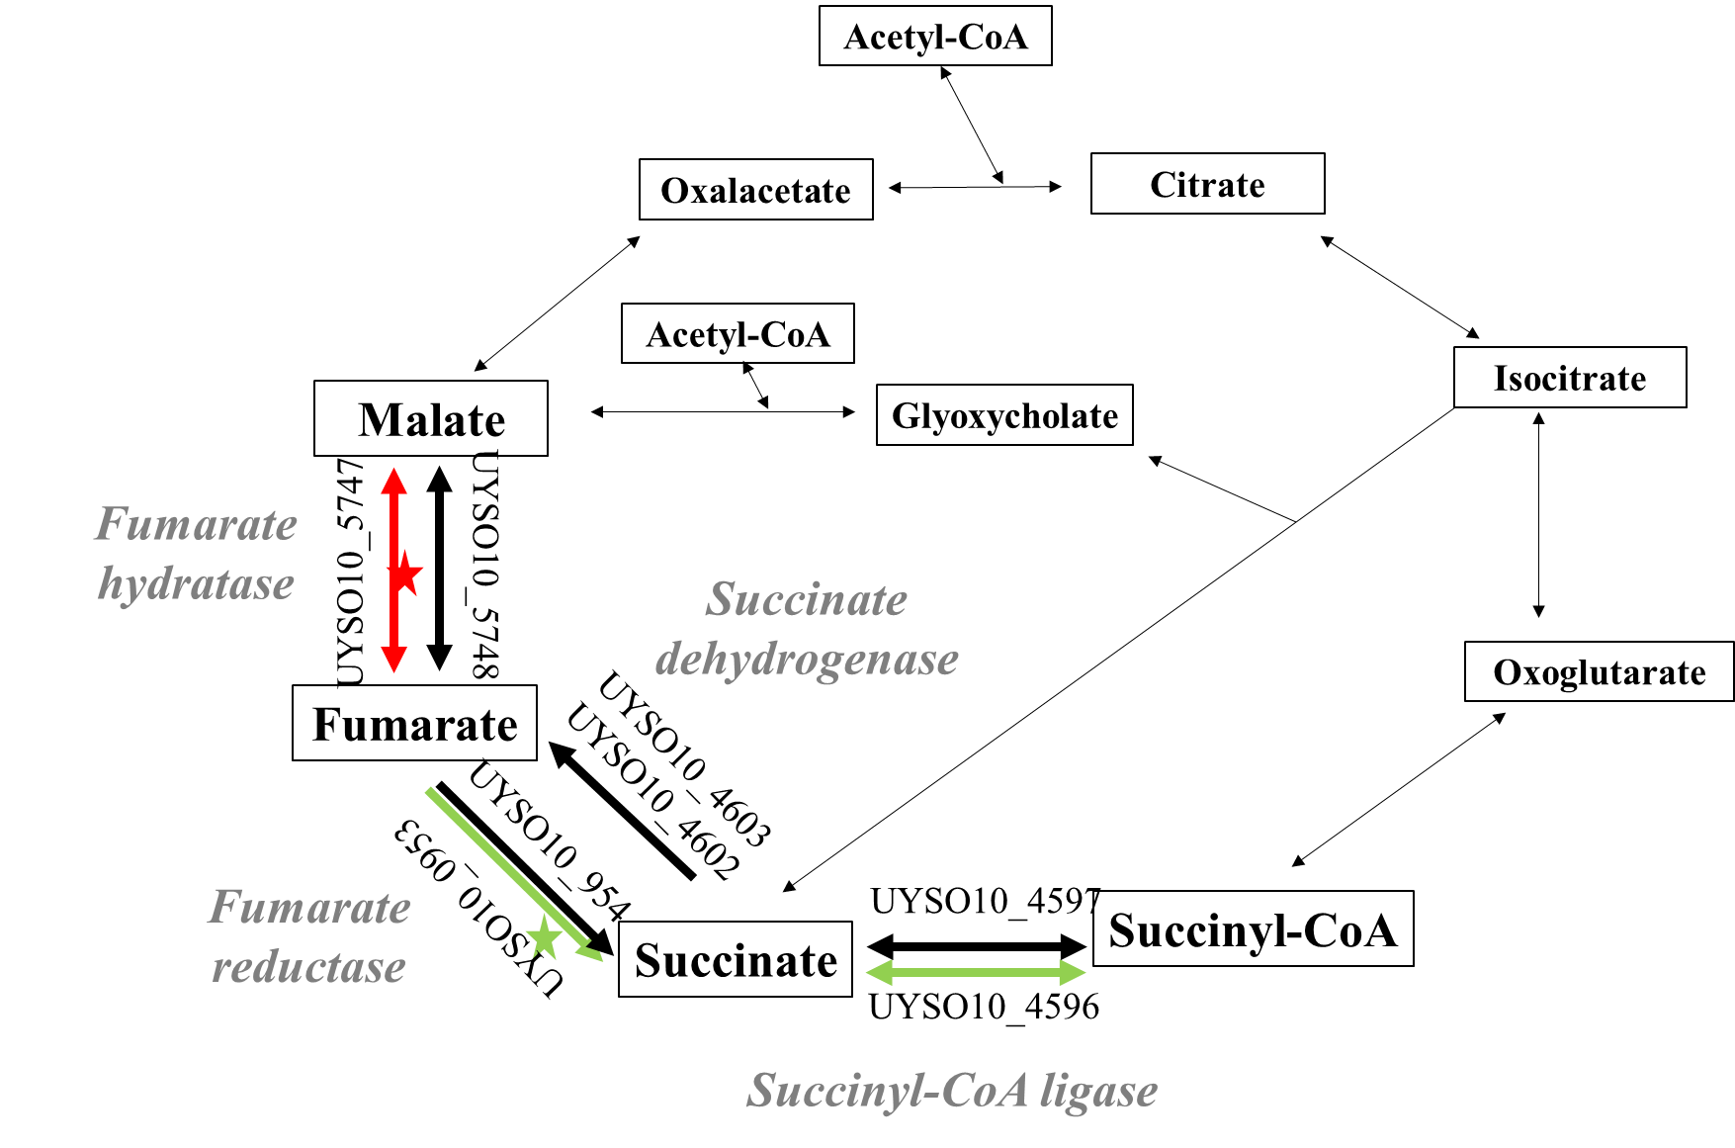

Figure S3. Schematic representation of the enzymes and their subunits that change their expression in the Krebs Cycle, identified in the strain UYSO10 exposed or not to root exudates.
The pathways marked with black: are constitutively expressed in both conditions, green: up-regulated, and red: down-regulated in the presence of toot exudates respectively. Asterisks: enzyme expressed only in the presence (green) or absence (red) of root exudates. When the same pathway is indicated with more than one indication, it refers to the fact that proteins or subunits with different tendencies were observed. The analysis of each subunit of the enzyme is represented.

Table S1. Ability of strain UYSO10 to grow in different C and N sources.
 | Compound |  |  | C or N utilization | Method
C sources | Sugars | Polysaccharide | Inulin | - | Hicarbohidrate kit
C sources | Sugars | Trisaccharide | Raffinose | - | Hicarbohidrate kit
C sources | Sugars | Trisaccharide | Melezitose | - | Hicarbohidrate kit
C sources | Sugars | Disaccharide | Sucrose (5, 100 y 200 g/l) | + | Hicarbohidrate kit, agar plate
C sources | Sugars | Disaccharide | Acnr (5, 100 y 200 g/l) | + | Agar plate
C sources | Sugars | Disaccharide | Trehalose | + | Hicarbohidrate kit
C sources | Sugars | Disaccharide | Lactose | - | Agar plate
C sources | Sugars | Disaccharide | Melibiose | - | Hicarbohidrate kit
C sources | Sugars | Disaccharide | Cellobiose | - | Hicarbohidrate kit
C sources | Sugars | Monosaccharide | Glucose | + | Agar plate
C sources | Sugars | Monosaccharide | Α-Methyl-D-glucoside | - | Hicarbohidrate kit
C sources | Sugars | Monosaccharide | Fructose | + | Hicarbohidrate kit
C sources | Sugars | Monosaccharide | Mannitol | + | Agar plate
C sources | Sugars | Monosaccharide | Xylose | + | Hicarbohidrate kit
C sources | Sugars | Monosaccharide | Maltose | + | Hicarbohidrate kit
C sources | Sugars | Monosaccharide | Dextrose | + | Hicarbohidrate kit
C sources | Sugars | Monosaccharide | L-arabinose | + | Hicarbohidrate kit
C sources | Sugars | Monosaccharide | D-arabinose | - | Hicarbohidrate kit
C sources | Sugars | Monosaccharide | Mannose | + | Hicarbohidrate kit
C sources | Sugars | Monosaccharide | Sorbose | + | Hicarbohidrate kit
C sources | Sugars | Monosaccharide | Rhamnose | - | Hicarbohidrate kit
C sources | Organic acids |  | Acetic acid | + | Agar plate
C sources |  |  | Citric acid | + | Hicarbohidrate kit
C sources |  |  | Malic acid | + | Agar plate
C sources |  |  | Purivic acid | + | Agar plate
C sources |  |  | Succinic acid | + | Agar plate
C sources |  |  | Fumaric acid | + | Agar plate
C sources |  |  | Gluconic acid | - | Hicarbohidrate kit
C sources |  |  | Malonic acid | - | Hicarbohidrate kit
C sources | Others |  | Α-Methyl-D-Mannoside | - | Hicarbohidrate kit
C sources |  |  | Inositol | - | Hicarbohidrate kit
C sources |  |  | Dulcitol | - | Hicarbohidrate kit
C sources |  |  | Sorbitol | - | Hicarbohidrate kit
C sources |  |  | Adonitol | - | Hicarbohidrate kit
C sources |  |  | Arabitol | - | Hicarbohidrate kit
C sources |  |  | Erythritol | - | Hicarbohidrate kit
C sources |  |  | Xylitol | - | Hicarbohidrate kit
C sources |  |  | Salicin | + | Hicarbohidrate kit
C sources | Plant extractions |  | Sugarcane root exudates | + | Agar plate
C sources |  |  | Sugarcane apoplast | + | Agar plate
N sources |  | Aminoacids | L-asparagine | + | Agar plate
 |  | Aminoacids | Aspartic acid | + | Agar plate
 |  | Aminoacids | Glutamic acid | + | Agar plate
 |  | Others | Ammonia | + | Agar plate
 |  | Others | Nitrate | + | Agar plate
 |  | Others | Urea | + | Agar plate
 |  | Plant extractions | Sugarcane root exudates | + | Agar plate
 |  | Plant extractions | Sugarcane apoplast | + | Agar plate

Table S2. Comparison of the results obtained by applying the DIGE and nano LC-MS/MS technique with spectral counting.

DIGE analysis |  |  | Nano LC MS/MS and spectrum counts analyses
Fold change | p value | Identified protein | Expression | Fold change | p-value
Up-regulated in the presence of exudates
2.51 | 0.01 | Aspartate ammonia-lyase (UYSO10_0935) | Up-regulated | 2.66 | 0.0082
2.21 | 0.00037 | Urea ABC transporter, substrate binding protein UrtA (UYSO10_3581) | Down-regulated | 2.75 | 0.042
1.89 | 0.022 | Uncharacterized protein conserved in bacteria (UYSO10_3373) | Unique in the presence of exudates
1.7 | 0.028 | Glucose-1-phosphatase (UYSO10_2573) | Without significative differences
1.45 | 0.04 | Phosphoglycerate kinase (UYSO10_0469) | Without significative differences
Down-regulated in the presence of exudates
1.77 | 0.0079 | FIG00955836: hypothetical protein (UYSO10_2505) | Without significative differences
1.69 | 0.0063 | Maltose operon periplasmic protein MalM (UYSO10_0266) | Unique in the presence of exudates
1.58 | 0.0075 | Outer membrane protein A precursor (UYSO10_2413) | Without significative differences
1.49 | 0.019 | Trehalase (UYSO10_3704) | Down-regulated | 2.88 | 0.017
1.37 | 0.039 | Heat shock protein 60 family chaperone GroEL (UYSO10_0940) | Without significative differences
1.37 | 0.039 | FIG00975563: hypothetical protein (UYSO10_1105) | Down-regulated | 2.66 | 0.021
1.3 | 0.016 | Ribose ABC transporter system, periplasmic ribose-binding protein Rbs (UYSO10_5888) | Without significative differences

