Supplementary Information

Supplementary Table 1: weight change over time

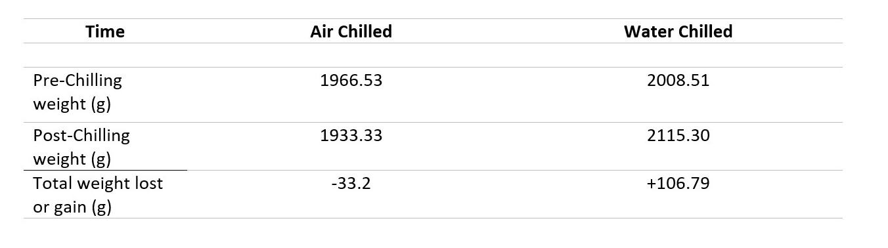
SI table 1. Average weight loss of chicken carcasses prior to and following chilling by either air chilling (AC) or water chilling (WC). On average the WC carcasses gained 5% of their pre-chilling weight while AC carcasses lost 1.6% of their pre-chill weight.

Supplementary Table 2: Mesophilic bacteria change over time
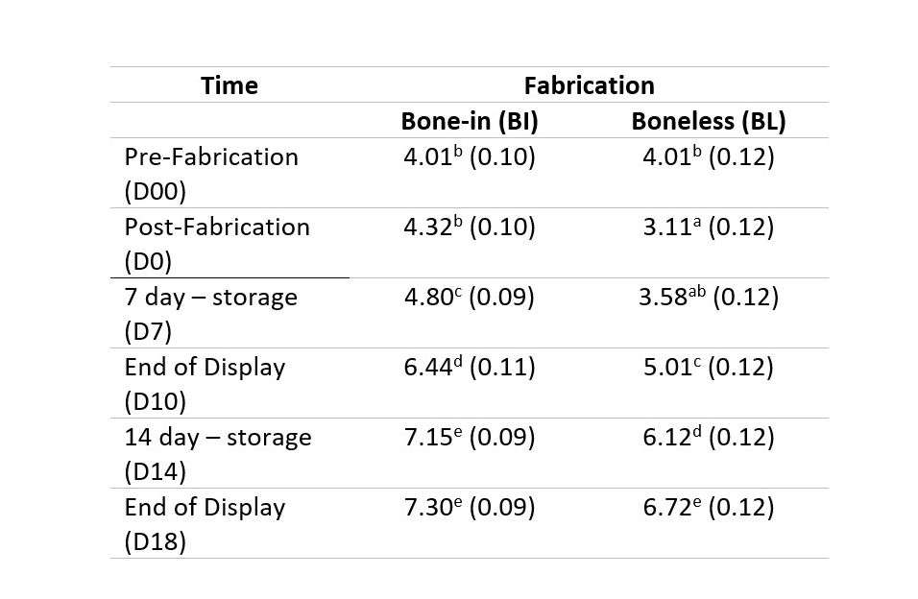
SI Table 2. Least square means of Mesophilic bacterial counts (log cfu/g) for bone-in and boneless chicken breast cooled by either air chilling or water chilling pre and post fabrication, pre and post chilling, during storage, during and after display.
^{a-e} Least square within a column with different superscripts differ (P<0.05)

Supplementary table 3: taste panel

SI Table 3. Trained panelists were asked to evaluate chicken breasts for texture and flavor attributes on a 100-point scale. Within a column, values with the same letter were not significantly different (P > 0.05).
 |  | Springiness | Cohesiveness of Mass | Moistness | Chicken Flavor Intensity | Off Flavor Intensity
AC | Bone-in | 54.8 (1.83)^{A} | 51.2 (2.01)^{A} | 52.9 (2.26)^{A} | 63.5 (1.58)^{A} | 3.04 (0.77)^{A}
 | Boneless | 53.3 (1.83)^{A} | 52.2 (2.01)^{A} | 46.0 (2.26)^{A} | 61.5 (1.58)^{A} | 3.33 (0.77)^{A}
WC | Bone-in | 56.6 (1.83)^{A} | 52.9 (2.01)^{A} | 51.7 (2.26)^{A} | 61.3 (1.58)^{A} | 2.17 (0.77)^{A}
 | Boneless | 53.7 (1.83)^{A} | 52.4 (2.01)^{A} | 47.2 (2.26)^{A} | 61.1 (1.58)^{A} | 3.08 (0.77)^{A}

Supplementary Table 4: proximate analysis

SI Table 4. Analysis of nutrient composition (proximate analysis) values. Data are organized first by chilling method, including hot carcass (HC), air chilled (AC) and water chilled (WC) samples. Within day, data are then organized by sampling day, which includes not stored (day 0), 7 or 14 days of dark storage, and 3 days of retail display after removal from dark storage (day 10 and day 17). Within day, data is organized by fabrication method, including unfabricated carcass, bone-in breasts, and boneless breasts. Values with the same letter within a column are not significantly different (P > 0.05).
 |  |  | Dry Matter | Moisture | Ash | Crude Fat | Crude Protein
HC | Day 0 | Carcass | 25.8 (0.337) A | 74.2 (0.337) B | 1.095 (0.061) AB | 1.270 (0.085) G | 5.23 (0.118) A
AC | Day 0 | Carcass | 25.8 (0.477) AB | 74.2 (0.477) AB | 0.965 (0.086) AB | 1.191 (0.120) EFG | 5.37 (0.167) ABC
 |  | Bone-in | 28.3 (0.477) AB | 71.7 (0.477) A | 1.140 (0.086) AB | 1.429 (0.121) G | 6.32 (0.167) CD
 |  | Boneless | 24.7 (0.477) A | 75.3 (0.477) B | 1.075 (0.086) AB | 0.481 (0.121) ABC | 5.65 (0.167) ABC
 | Day 7 | Bone-in | 27.0 (0.477) AB | 73.0 (0.477) AB | 1.195 (0.086) AB | 1.178 (0.121) DEFG | 6.06 (0.167) BCD
 |  | Boneless | 25.1 (0.477) A | 74.9 (0.477) B | 1.250 (0.086) AB | 0.506 (0.121) ABCD | 5.75 (0.167) ABCD
 | Day 10 | Bone-in | 26.9 (0.477) AB | 73.1 (0.477) AB | 1.078 (0.086) AB | 1.089 (0.121) BCDEFG | 6.10 (0.167) BCD
 |  | Boneless | 25.2 (0.477) A | 74.8 (0.477) B | 1.158 (0.086) AB | 0.445 (0.121) ABC | 5.82 (0.167) ABCD
 | Day 14 | Bone-in | 27.2 (0.502) AB | 72.8 (0.502) AB | 1.015 (0.091) AB | 1.201 (0.127) DEFG | 6.16 (0.176) BCD
 |  | Boneless | 25.4 (0.477) A | 74.6 (0.477) B | 1.126 (0.086) AB | 0.415 (0.120) AB | 5.85 (0.167) ABCD
 | Day 17 | Bone-in | 26.7 (0.477) AB | 73.3 (0.477) AB | 0.940 (0.086) A | 1.033 (0.121) ABCDEFG | 5.97 (0.167) ABCD
 |  | Boneless | 26.9 (0.477) AB | 73.1 (0.477) AB | 1.440 (0.086) AB | 0.589 (0.121) ABCDEF | 6.62 (0.167) D
WC | Day 0 | Carcass | 25.6 (0.477) AB | 74.4 (0.477) AB | 1.160 (0.086) AB | 1.109 (0.121) CDEFG | 5.31 (0.167) AB
 |  | Bone-in | 26.3 (0.502) AB | 73.7 (0.502) AB | 1.077 (0.091) AB | 1.131 (0.127) CDEFG | 5.77 (0.176) ABCD
 |  | Boneless | 25.0 (0.477) A | 75.0 (0.477) B | 1.366 (0.091) AB | 0.353 0.1207 A | 5.46 (0.167) ABC
 | Day 7 | Bone-in | 27.1 (0.477) AB | 72.9 (0.477) AB | 1.164 (0.086) AB | 1.260 (0.121) FG | 5.97 (0.167) ABCD
 |  | Boneless | 24.9 (0.477) A | 75.1 (0.477) B | 1.327 (0.086) AB | 0.543 (0.121) ABCDE | 5.71 (0.167) ABCD
 | Day 10 | Bone-in | 27.4 (0.502) AB | 72.6 (0.502) AB | 1.226 (0.091) AB | 1.188 (0.127) DEFG | 5.98 (0.176) ABCD
 |  | Boneless | 25.4 (0.502) A | 74.6 (0.502) B | 1.210 (0.091) AB | 0.426 (0.127) ABC | 5.89 (0.176) ABCD
 | Day 14 | Bone-in | 26.5 (0.477) AB | 73.5 (0.477) AB | 1.250 (0.086) AB | 1.092 (0.121) BCDEFG | 5.67 (0.167) ABC
 |  | Boneless | 25.5 (0.477) A | 74.5 (0.477) B | 1.223 (0.086) AB | 0.484 (0.121) ABC | 5.99 (0.167) ABCD
 | Day 17 | Bone-in | 26.8 (0.477) AB | 73.2 (0.477) AB | 1.062 (0.086) AB | 0.986 (0.1207) ABCDEFG | 5.75 (0.167) ABCD
 |  | Boneless | 25.4 (0.477) A | 74.6 (0.477) B | 1.347 (0.086) B | 0.412 (0.1207) AB | 5.86 (0.167) ABCD

Supplementary Table 5: Pseudomonas ASVs

SI Table 5. The most abundant Pseudomonas-associated ASVs associated with each chilling and storage group. The relative abundance of each ASV was averaged across samples within the group
Day | Chilling Method | ASV | Average Percent
10 | AC | ASV10 | 0.017998
10 | AC | ASV20 | 0.000684
10 | AC | ASV7 | 0.054059
10 | WC | ASV10 | 0.164519
10 | WC | ASV20 | 0.003918
10 | WC | ASV7 | 0.001833
14 | AC | ASV10 | 0.039777
14 | AC | ASV20 | 0.00117
14 | AC | ASV7 | 0.049584
14 | WC | ASV10 | 0.188287
14 | WC | ASV20 | 0.013212
14 | WC | ASV7 | 0
17 | AC | ASV10 | 0.035419
17 | AC | ASV20 | 0
17 | AC | ASV7 | 0.02821
17 | WC | ASV10 | 0.094772
17 | WC | ASV20 | 0.00855
17 | WC | ASV7 | 0.001355
7 | AC | ASV10 | 0.012105
7 | AC | ASV20 | 0
7 | AC | ASV7 | 0.146024
7 | WC | ASV10 | 0.076009
7 | WC | ASV20 | 0.001751
7 | WC | ASV7 | 0.0021
not stored | AC | ASV10 | 0.01177
not stored | AC | ASV20 | 0
not stored | AC | ASV7 | 0.002082
not stored | Hot Carcass | ASV10 | 0.005359
not stored | Hot Carcass | ASV20 | 0
not stored | Hot Carcass | ASV7 | 0.005298
not stored | WC | ASV10 | 0.002398
not stored | WC | ASV20 | 0
not stored | WC | ASV7 | 0.012768

Supplementary figure 1: Fatty Acids
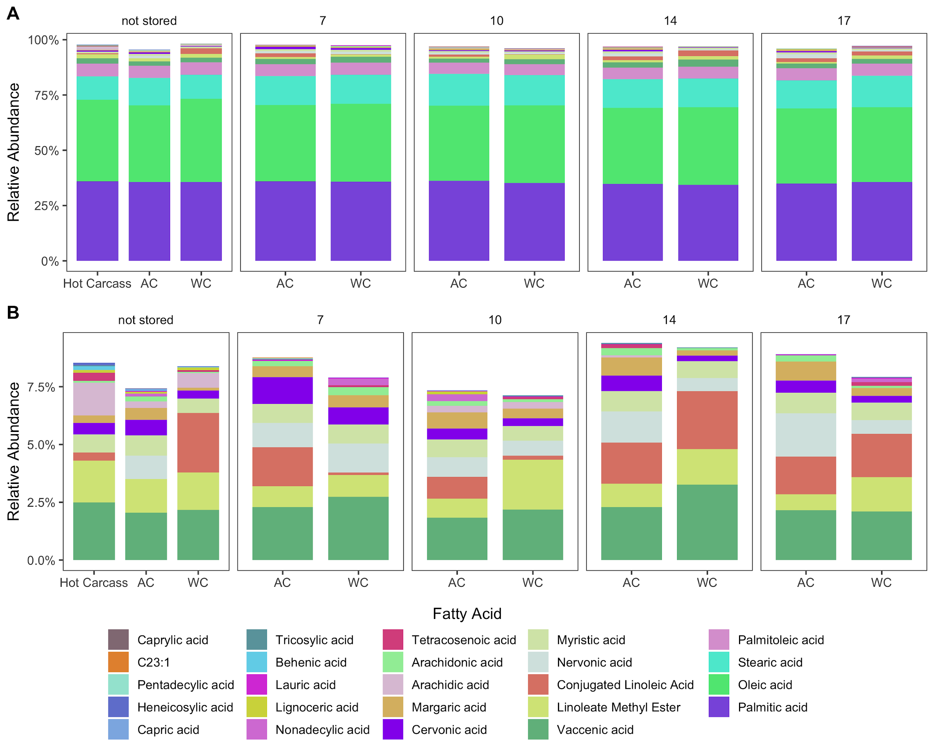
SI Figure 1. Relative abundances of fatty acids present in air (AC) and water chilled (WC) chicken meat. A) All fatty acids present in the samples. B) The ‘rare’ fatty acids present at <10% relative abundance.

Supplementary figure 2: Mock Community Composition

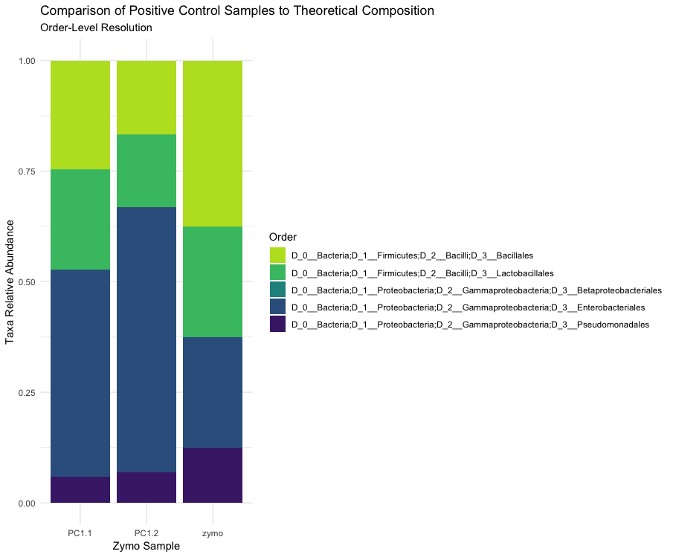SI Figure 2. A comparison of positive control samples (ZymoBIOMICS D6300) and the standard, expected composition as described by the company.

Supplementary Figure 3: Prediction Model

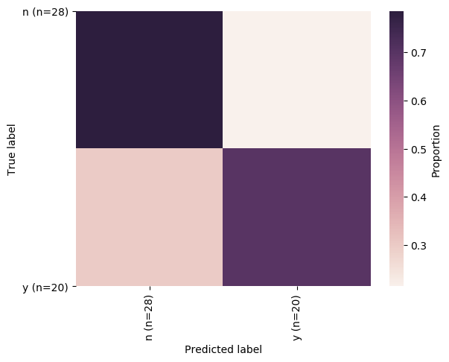
SI Figure 3. Model prediction errors using the microbiome data as a predictor and spoilage indicators as response variables. Model predicting whether the product has reached a spoilage state based on psychrotrophic bacterial counts. Model testing resulted in an accuracy score of 75%.

Supplementary figure 4: Pseudomonas tree
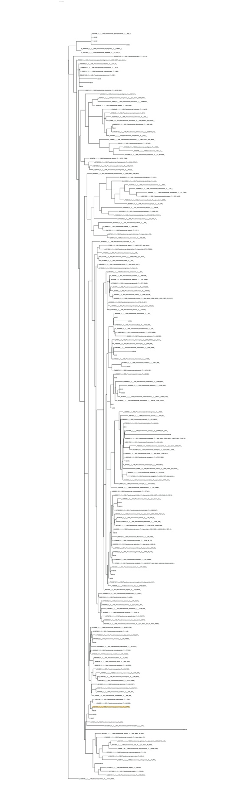
SI Figure4. Phylogenetic tree showing the evolutionary relationship between ASVs found in this study that assigned to the Pseudomonas genus.

Supplementary Figure 5: technoeconomics

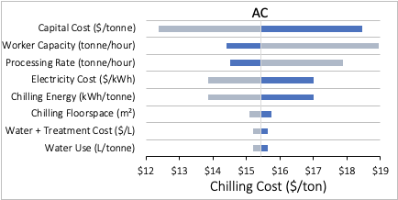
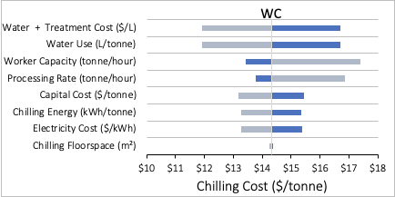

SI Figure 4. The sensitivity analyses varied the following model values by ±50%: capital cost ($/tonne), chilling floorspace (m²), processing rate (tonne/hour), chilling energy (kWh/tonne), worker capacity (tonne/hour), water use (L/tonne), water price plus water treatment cost ($/L), and electricity cost ($/kWh). The resulting levelized costs for AC (upper panel) and WC (lower panel) systems demonstrate which aspects of each system have the most influence over the total levelized cost of chilling. For AC systems capital costs and labor costs have the most impact on the total levelized chilling cost, while water and labor costs have the most impact on WC systems.

