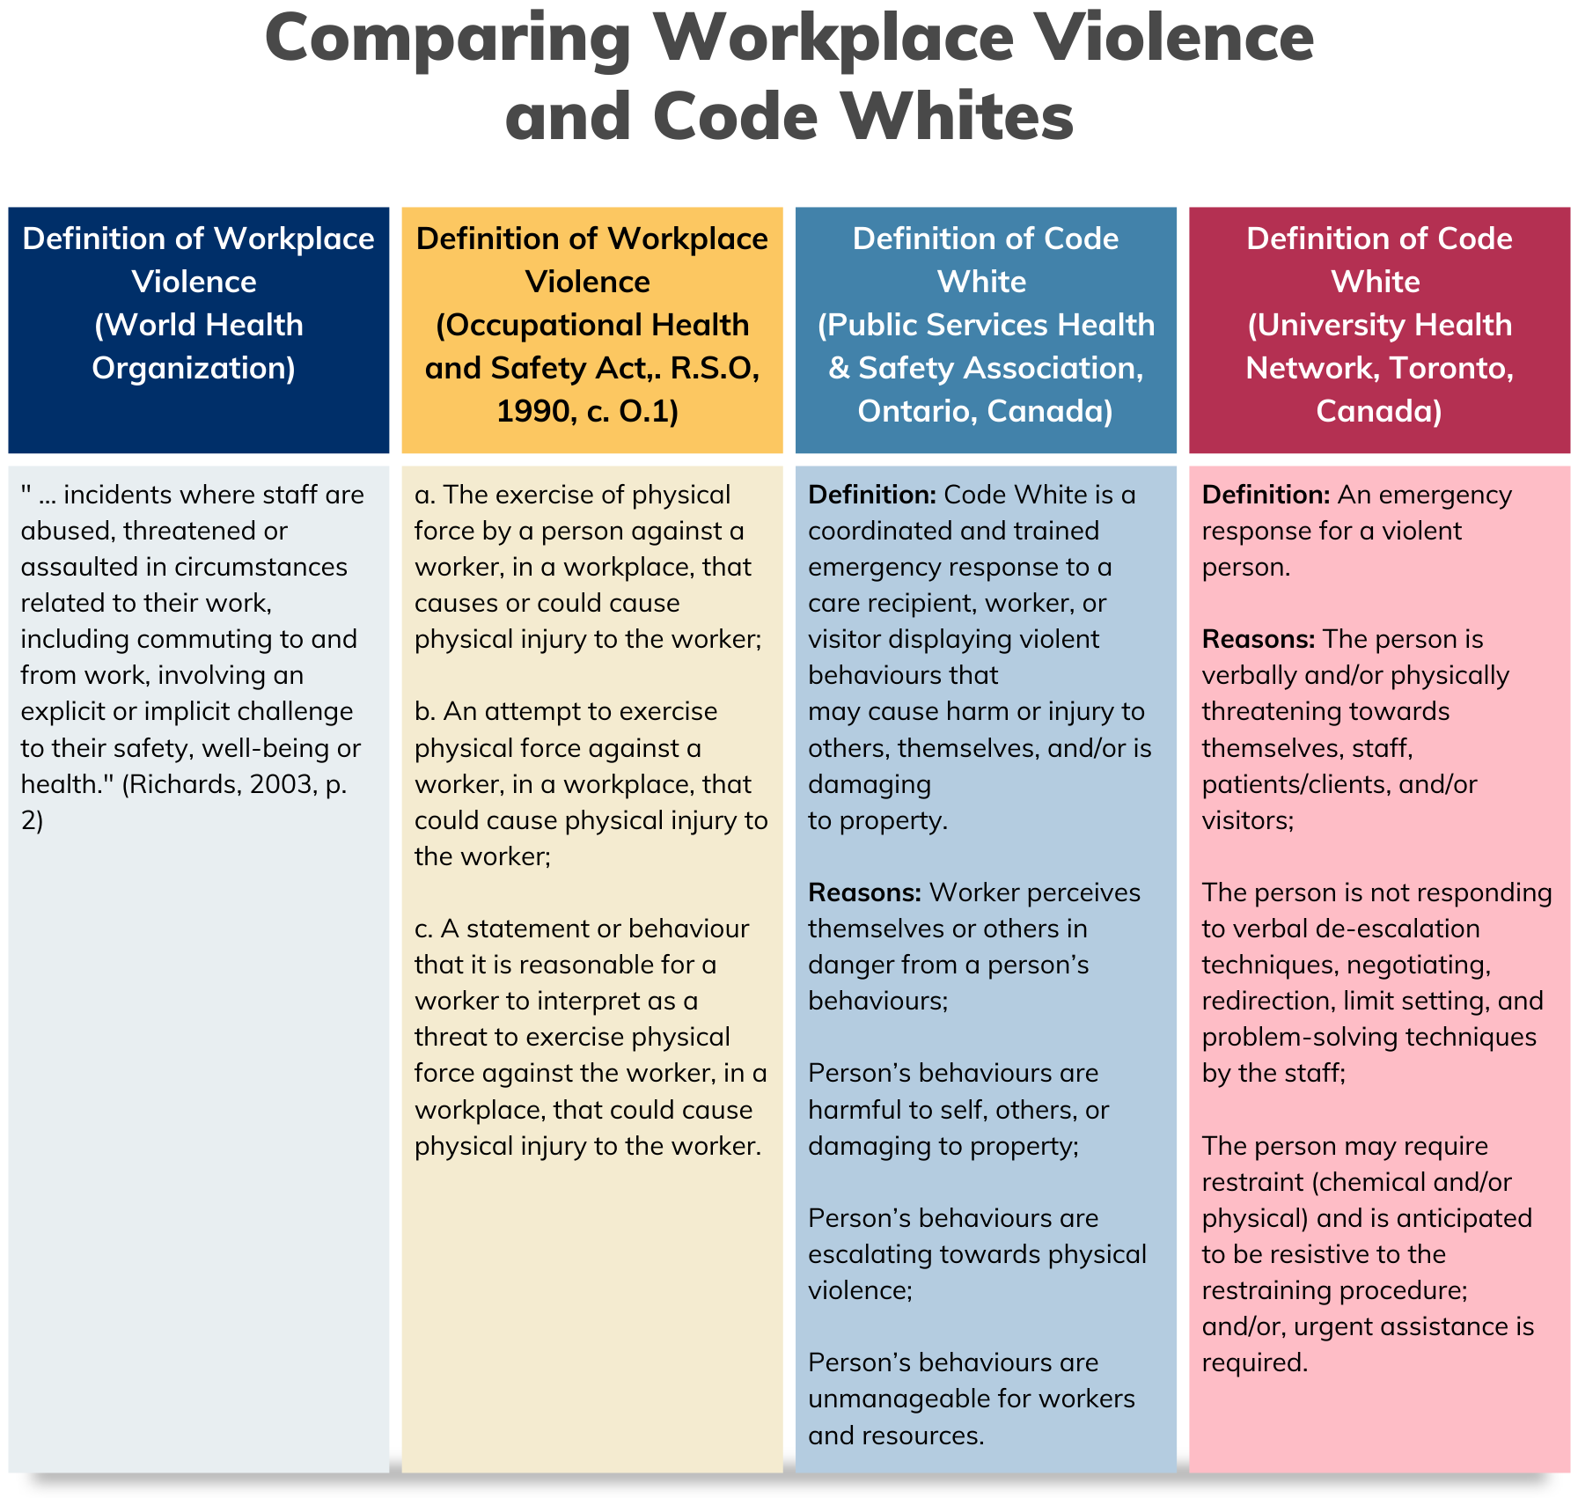 Table 1. Comparing Workplace Violence and Code Whites, [2].
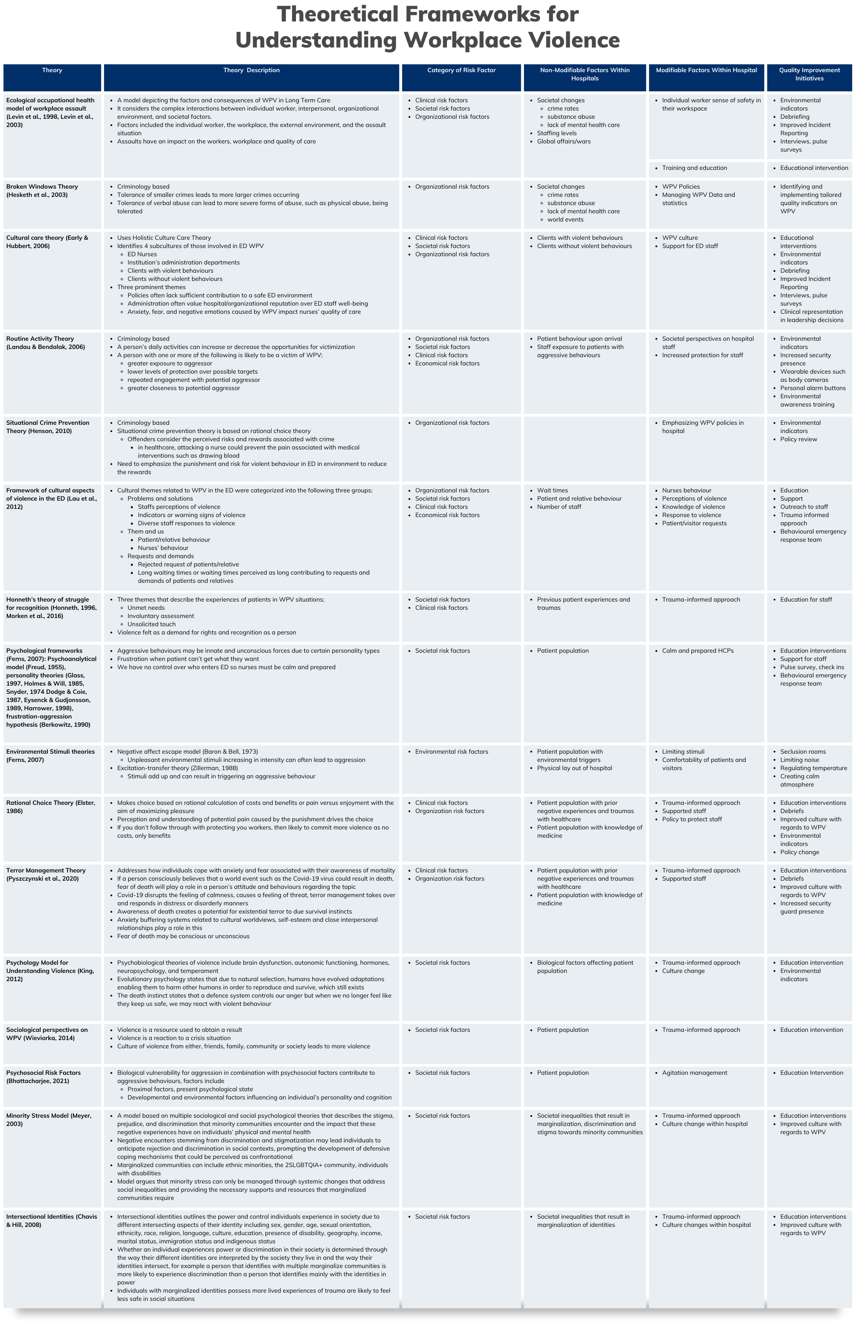
Table 2. Summary of theoretical frameworks for understanding WPV. References relating to 10-12, 91-114.
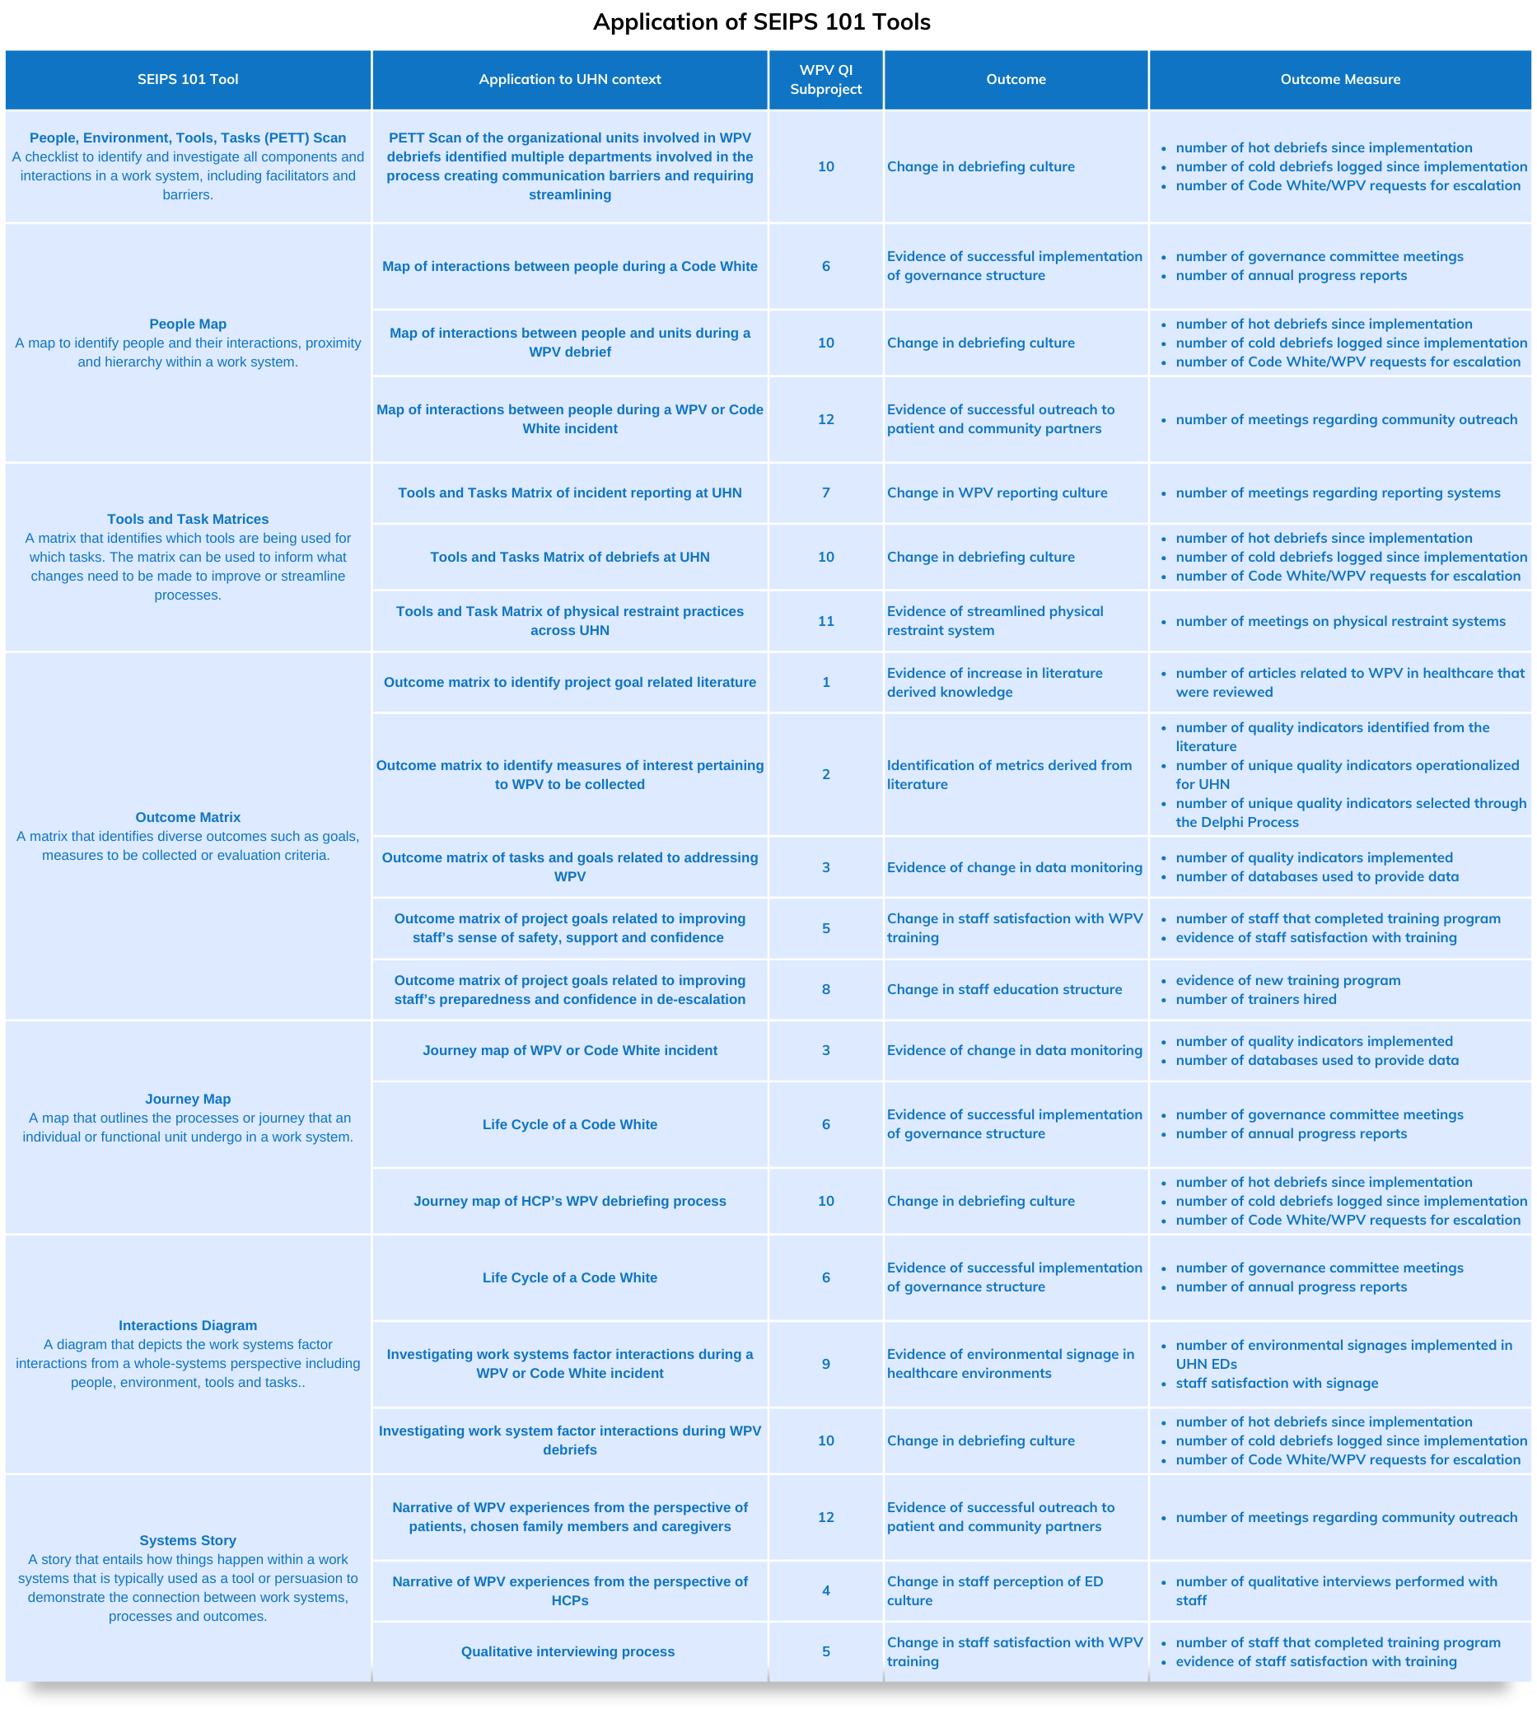 Table 3. Application of SEIPS 101 tools at UHN. Our QI project consisted of 12 subprojects which are further described in Table 4.
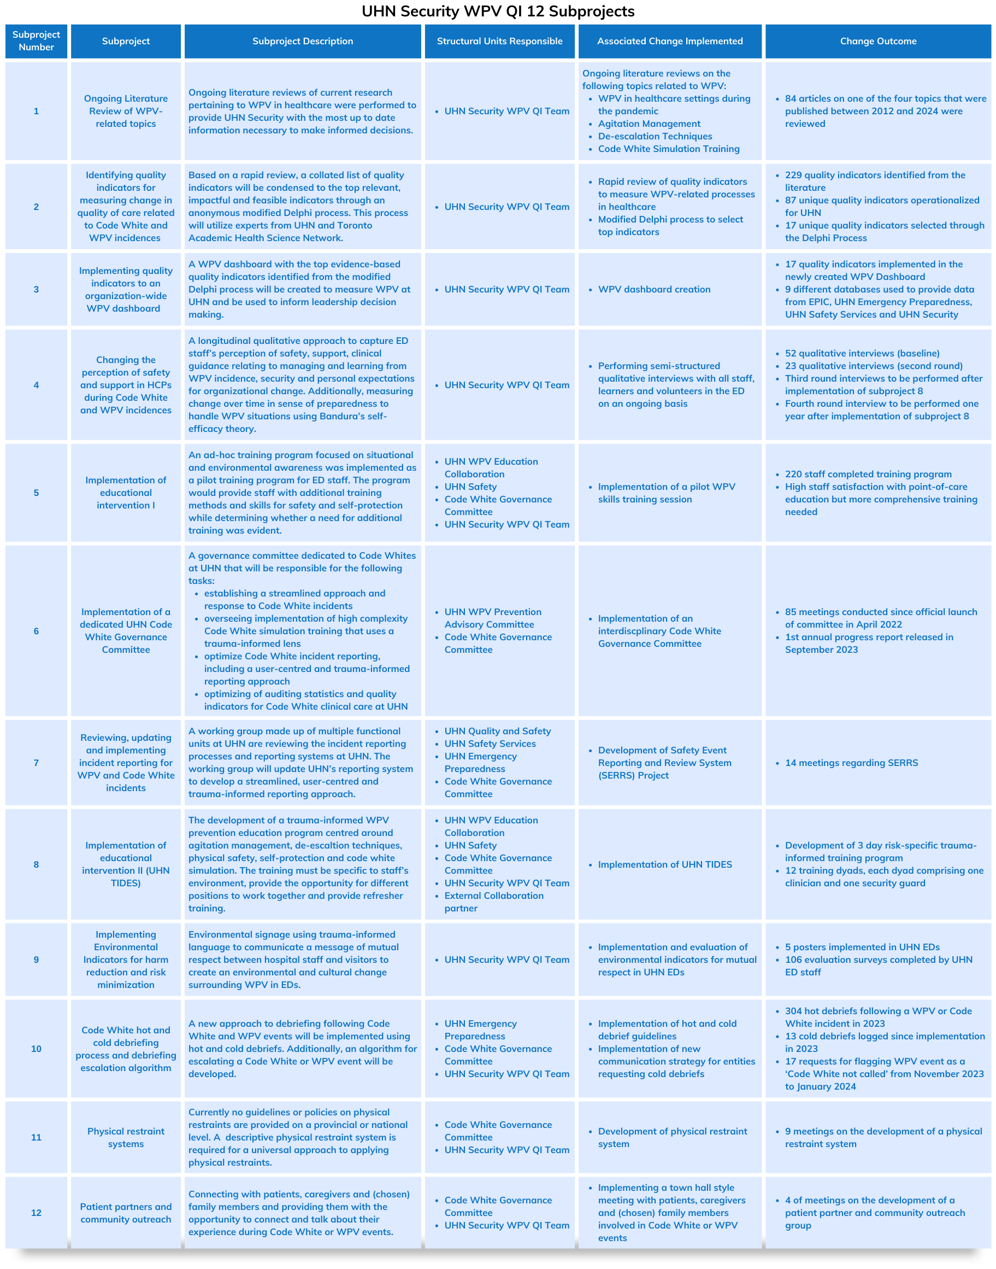 Table 4. A summary of the 12-subproject quality improvement initiative implemented at UHN to address WPV.
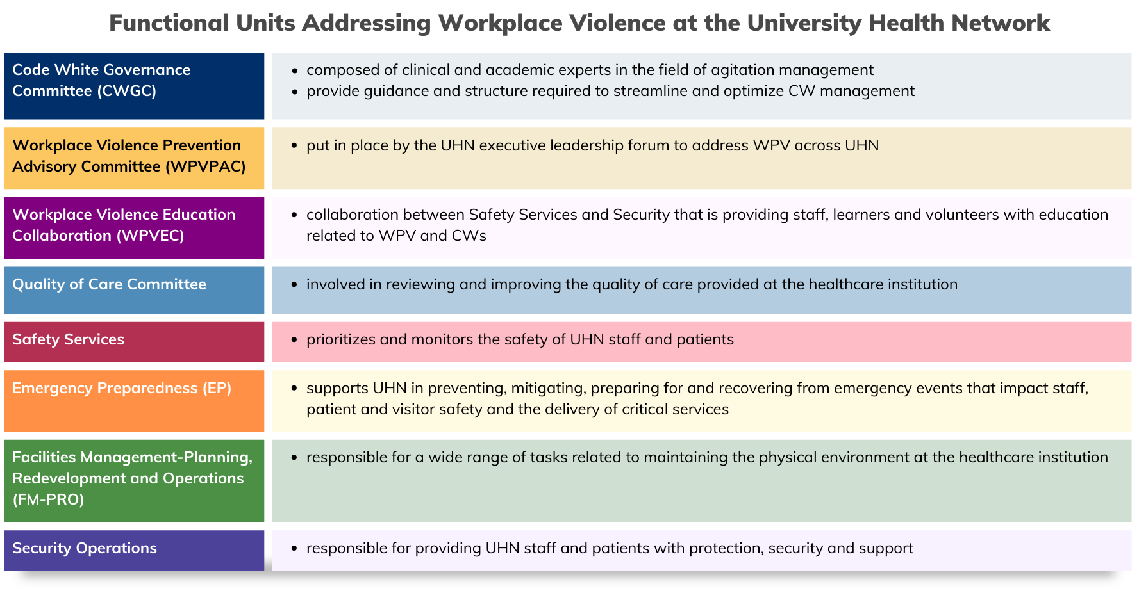 Table 5. Functional units at UHN addressing or involved in processes related to WPV within UHN.

