A
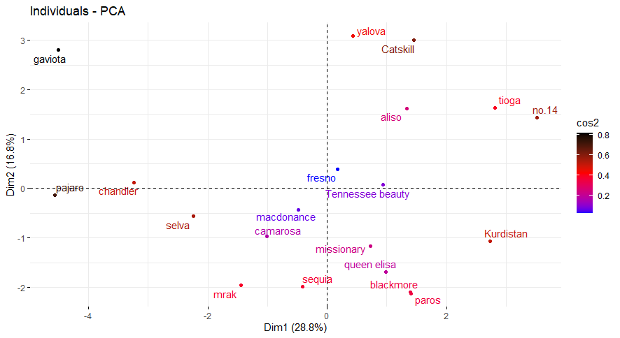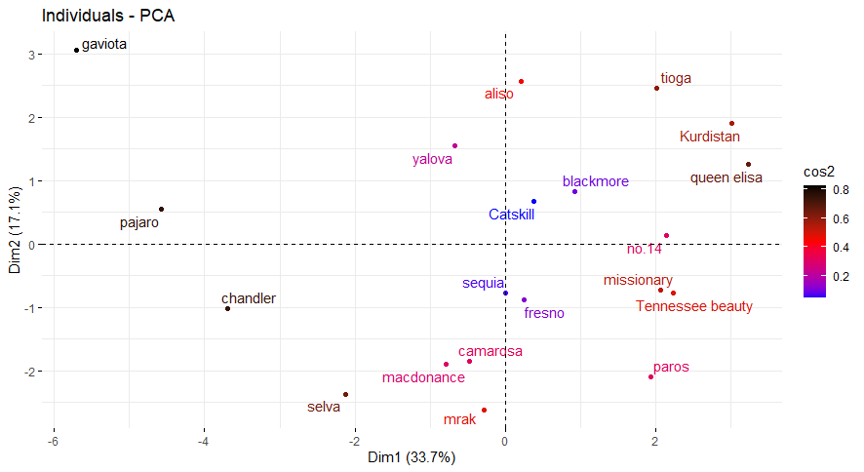
B
Figure S1. Loading plot of the features measured in strawbeery cultivars based on their values in first two principal components for first (A) and second (B) years.

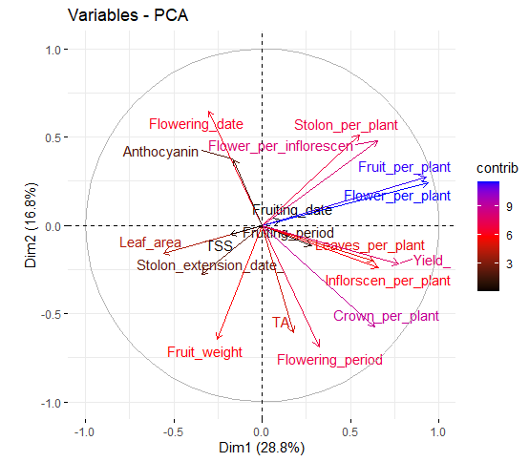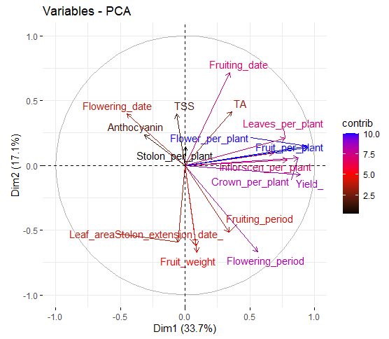
B
A
Figure S2. Scatter plot of the strawbeery cultivars based on their values in first two principal components for first (A) and second (B) years.

