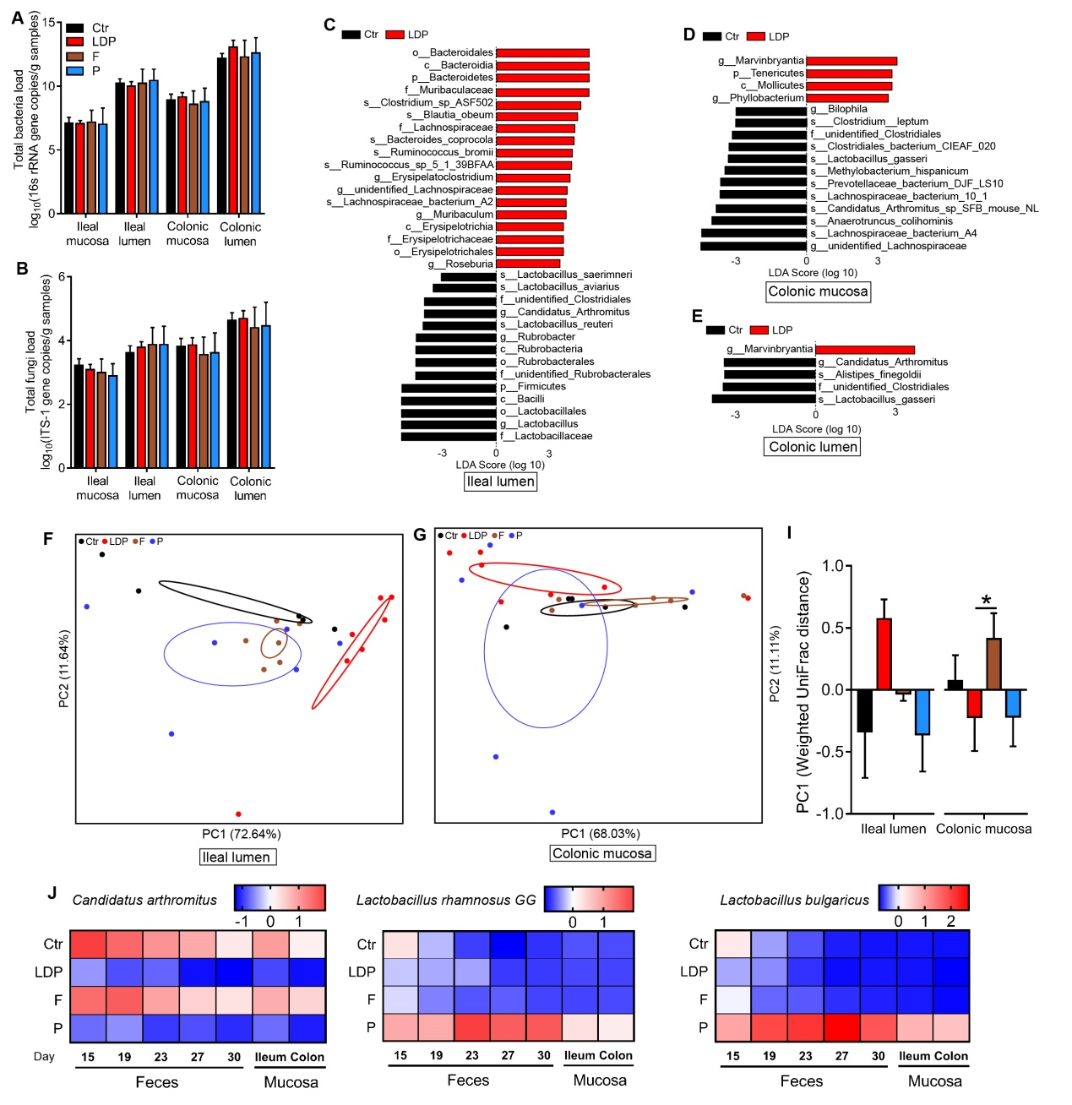
Figure S1 Effects of the LDP treatment on microbiota. (A and B) Total bacterial (A) and fungal loads (B), as determined by qPCR, in the mucosal and lumimal samples of the ileum and colon. Differences were determined by LSD posthoc tests of one-way ANOVA as compared to Dunnett’s (T3) test. (C–E) Discrepant bacterial species identification of different intestinal regions based on Linear discriminant analysis Effect Size (LEfSe) analysis. (F and G) The principal coordinate analysis (PCoA) based on the weighted UniFrac distance indicated the differences in the bacterial composition of ileal luminal (F) and colonic mucosal (G) samples among the four groups. (I) PC1 among the four groups, Differences were determined by LSD posthoc tests of one-way ANOVA as compared to Dunnett’s (T3) test. (J) Heatmaps show the relative abundances of Candidatus Arthromitus, Lactobacillus. rhamnosus GG and L. bulgaricus, as determined by qPCR, in the fecal and mucosal samples. For all figures, n = 5 for Ctr mice, n = 7 for LDP mice, and n = 6 for F and P mice.
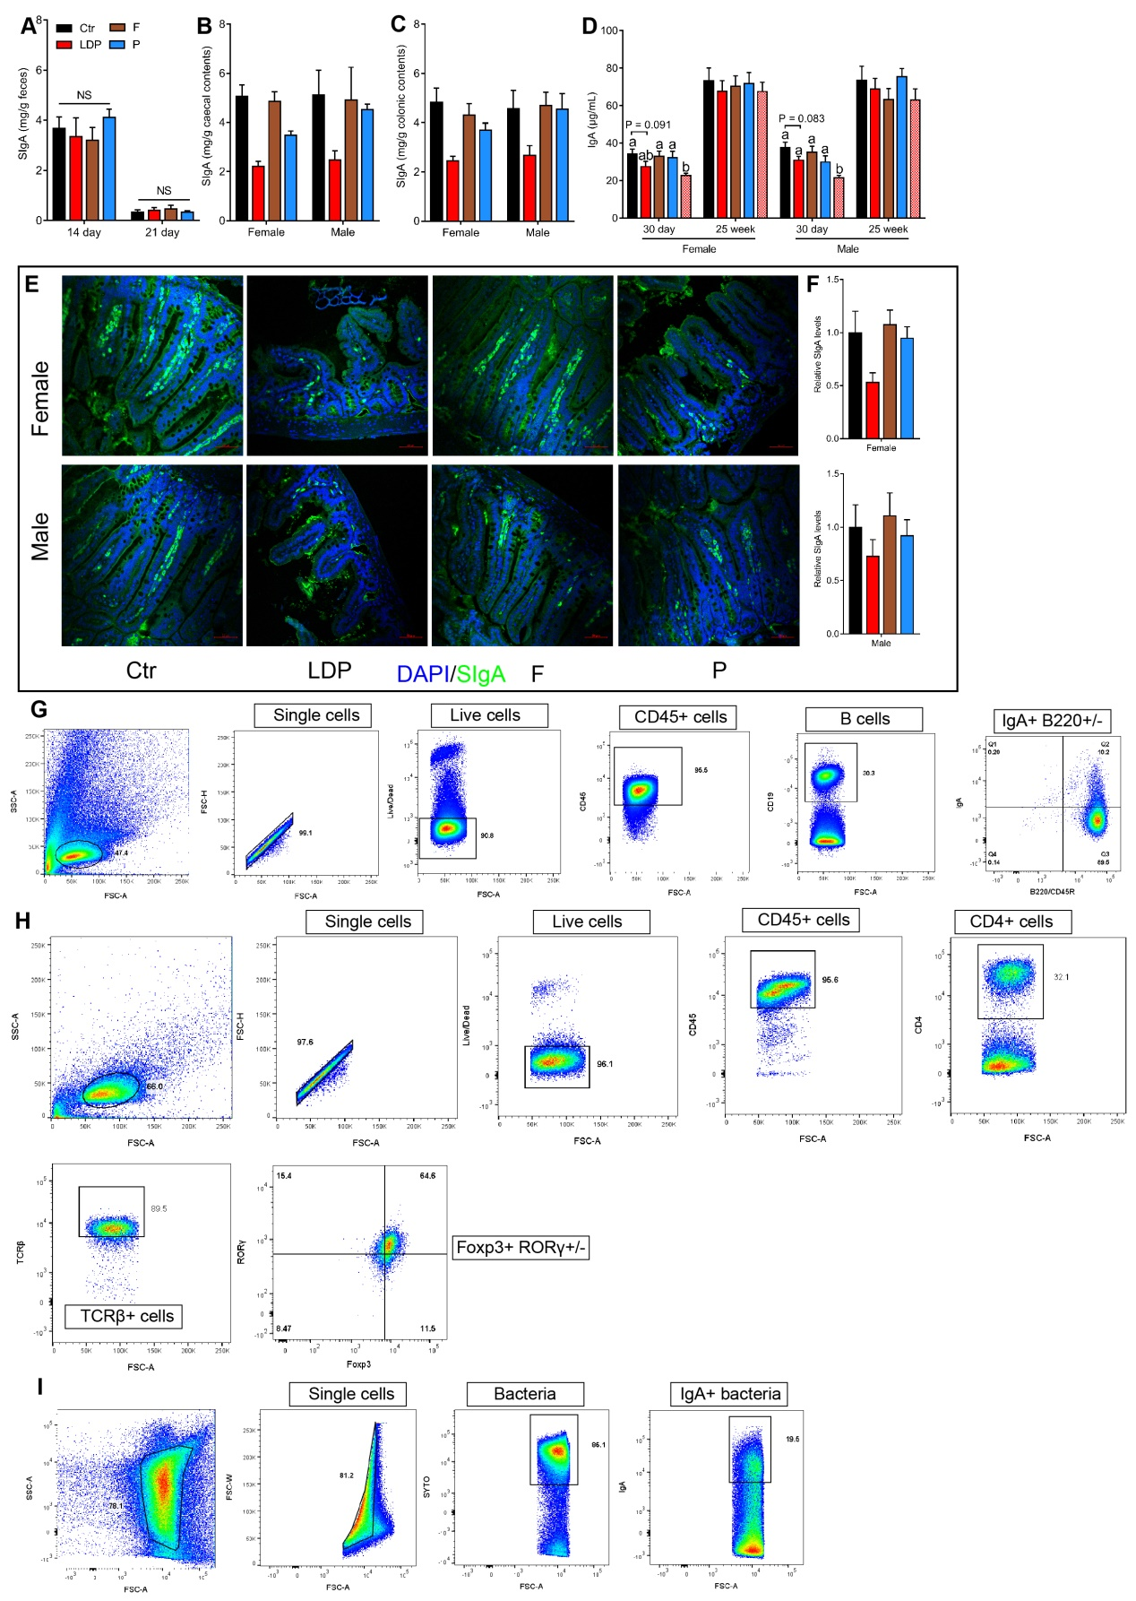
Figure S2 Influences of LDP on intestinal IgA response. (A–C) Fecal, caecal, and colonic levels of SIgA, as determined by ELISA. For A, n = 5 for Ctr mice, n = 7 for LDP mice, and n = 6 for F and P mice. For B and C, n = 2 for the female Ctr mice, n = 4 for male LDP mice, and n = 3 for all the remaining groups. (D) Serum concentration of IgA in Study 2; n = 5 for all 30 day mice, n = 5–8 for 25 week mice. (E and F) Immunofluorescence assays targeting the SIgA of the distal ileum in the 30-d-old females (top) and males (bottom), respectively. n = 2 for the female Ctr mice, and n = 3 for the remaining groups of females and males. (G – I) Gate strategies for IgA-producing plasma cells and B cells (G), regulatory T cells (Tregs) (H), and IgA+ bacteria (I).
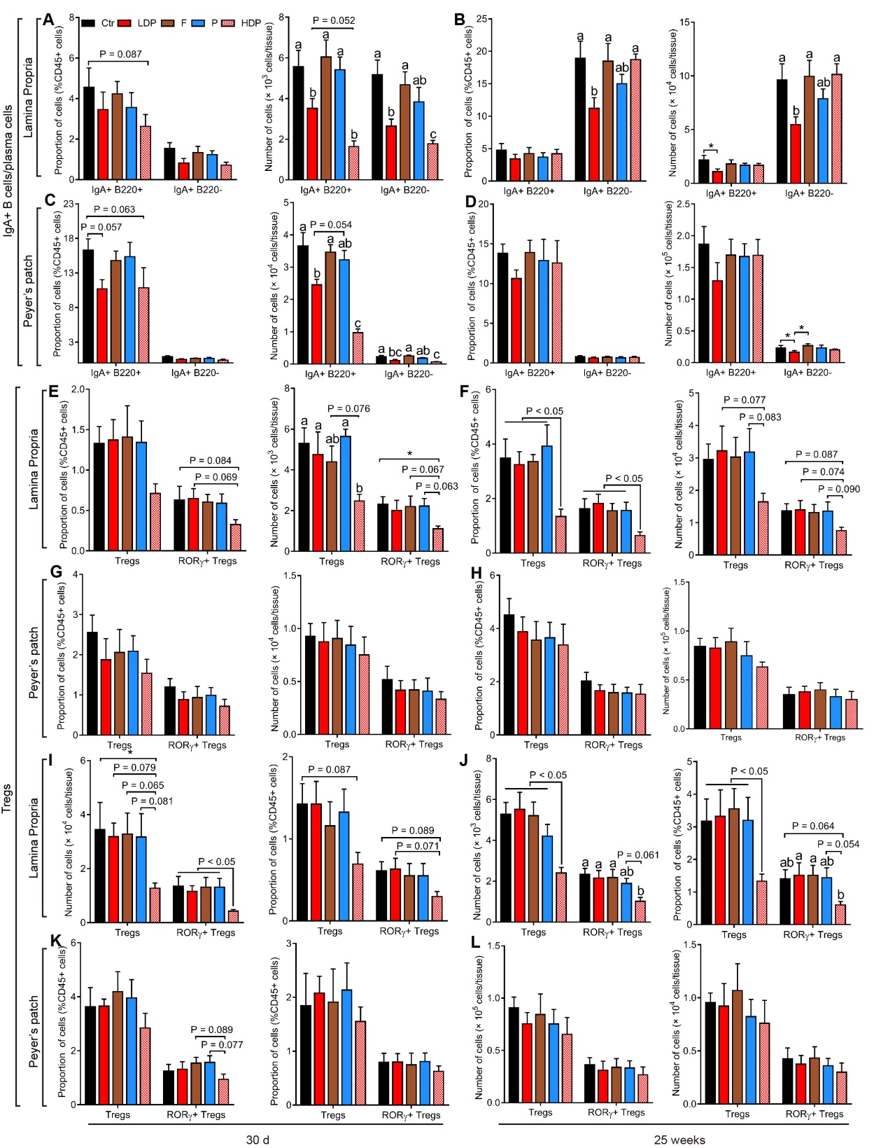
Figure S3 LDP persistently damped intestinal IgA response. (A–D) Frequency and absolute number of IgA-producing B cells (IgA+ B220+) and plasma cells (IgA+ B220-) within the distal small intestine lamina propira (A and B) and Peyer’s patches (C and D) in 30-d-old (A and C) and 25-week-old (B and D) male mice. (E–L) Frequency and absolute number of the total and RORγ+ regulatory T cells (Tregs) within the distal small intestine lamina propira (E, F, I, and J) and Peyer’s patches (G, H, K, and L) in 30-d-old and 25-week-old female (E–H) and male (I–L) mice. N = 5 for all 30 day mice, n = 5–8 for 25 week mice. Differences were determined by LSD posthoc tests of one-way ANOVA as compared to Dunnett’s (T3) test.
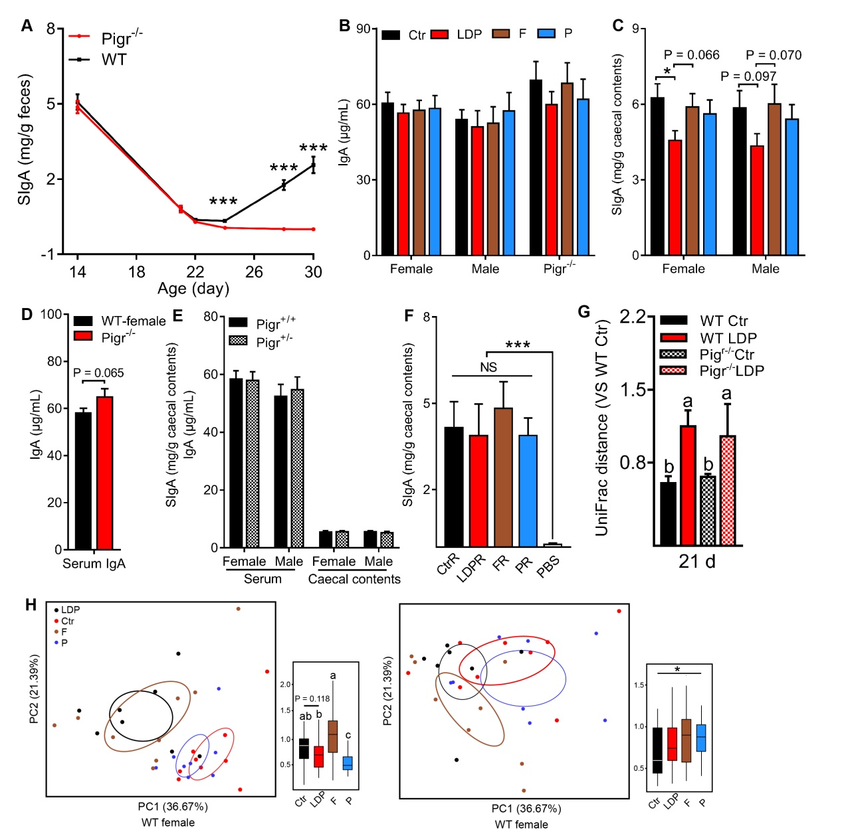
Figure S4 Changes in IgA and GM in Study 3 and 4. (A) Changes in the fecal SIgA of WT (n = 30) and Pigr^{-/-} (n = 10) mice in Study 3; differences were determined by Mann-Whitney U test. (B and C) Serum (B) and caecal (C) (S)IgA levels in 25-week-old mice in Study 3; n = 8–9 and differences were determined by LSD posthoc tests of one-way ANOVA as compared to Dunnett’s (T3) test. (D) Difference in serum IgA between 25-week-old WT (n = 34) and Pigr^{-/-} (n = 20) mice in Study 3; difference was determined by Mann-Whitney U test. (E) Difference in serum and caecal (S)IgA between 25-week-old Pigr^{+/+} and Pigr^{+/-} mice in Study 3; n = 16–18 and differences were determined by Mann-Whitney U test. (F) Caecal SIgA levels in mice from Study 4; n = 5 and ifferences were determined by LSD posthoc tests of one-way ANOVA as compared to Dunnett’s (T3) test. (G) Comparison of the weighted UniFrac distance showed the differences in fecal bacteria composition in 21-d-old mice; n = 16 for WT Ctr, n = 18 for WT LDP, and n = 10 for Pigr^{-/-} Ctr and LDP. Differences were determined by LSD posthoc tests of one-way ANOVA as compared to Dunnett’s (T3) test. (H) PCoA plots based on weighted UniFrac distance showed the differences in bacterial composition of colonic mucosa among 25-week-old WT mice. N = 8–9; differences were determined by Wilcox test.
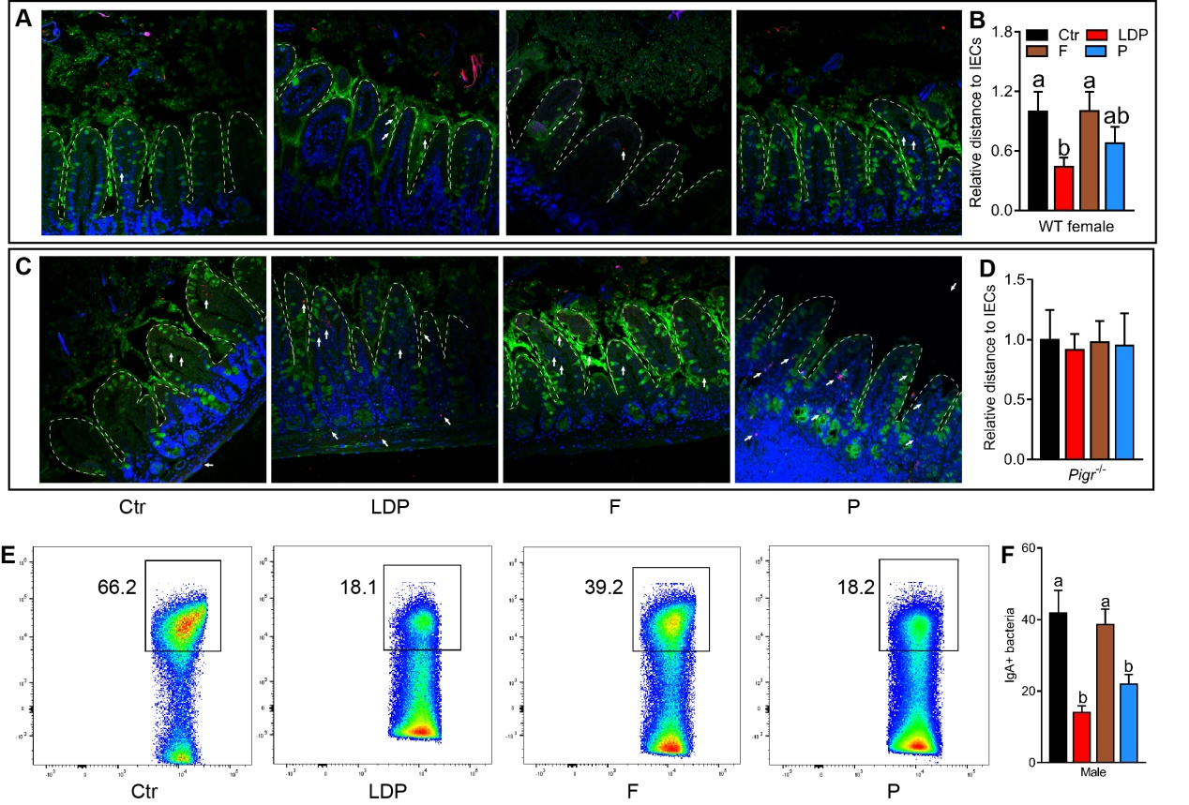
Figure S5 LDP increased ileal bacterial encroachment in mice from Study 3 (A and C) Representative confocal microscopy analysis of ileal bacterial localization in WT males (A) and Pigr^{-/-} females (C): MUC2, green; bacteria, red; and DNA, blue; white arrow, invasive bacteria. n = 3. Distances of bacteria that translocate into the villi are calculated as zero. (B and D) Relative distance of the closest bacteria to intestinal epithelial cells (IECs) over five high-powered fields per WT males (B) and Pigr^{-/-} females (D). (E and F) Proportion of ileal IgA+ bacteria in WT males; n = 8–9. Different letters indicate a significant difference between columns, p < 0.05; differences were determined by LSD post hoc test or one-way ANOVA as compared to Dunnett’s test (T3).
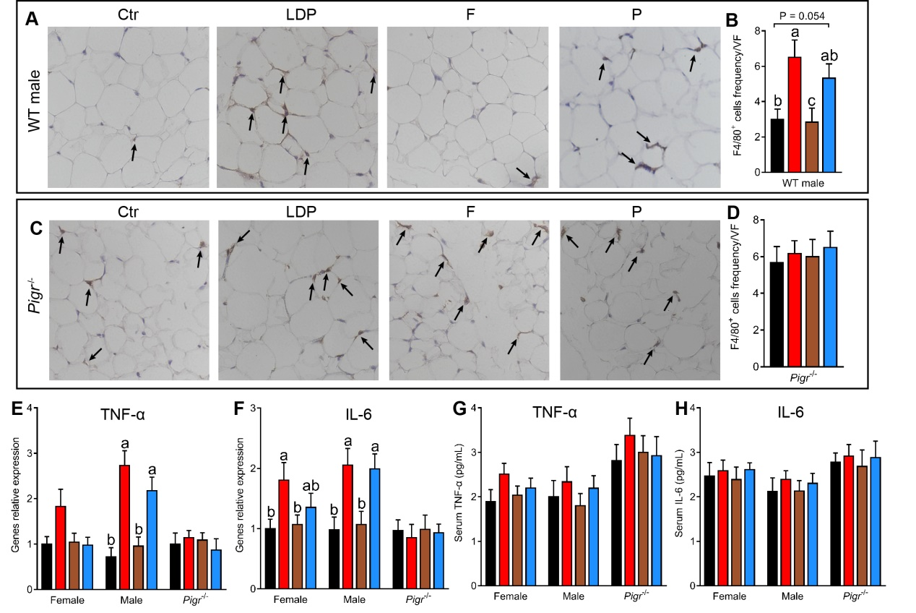
Figure S6 LDP increased adipose inflammation in mice from Study 3 (A–D) Representative immunohistochemical analysis targeting F4/80 in visceral adipose tissue of WT males (G and H) and Pigr^{-/-} females (I and J); n = 3. Black arrow, F4/80+ cells. (E and F) The relative mRNA expression of TNF-α (E) and IL-6 (F) in the visceral adipose tissue; n = 8–9. (G and H) Serum levels of lipopolysaccharide TNF-α (G), and IL-6 (H), n = 8–9. Different letters indicate a significant difference between columns, p < 0.05; differences were determined by LSD post hoc test or one-way ANOVA as compared to Dunnett’s test (T3).
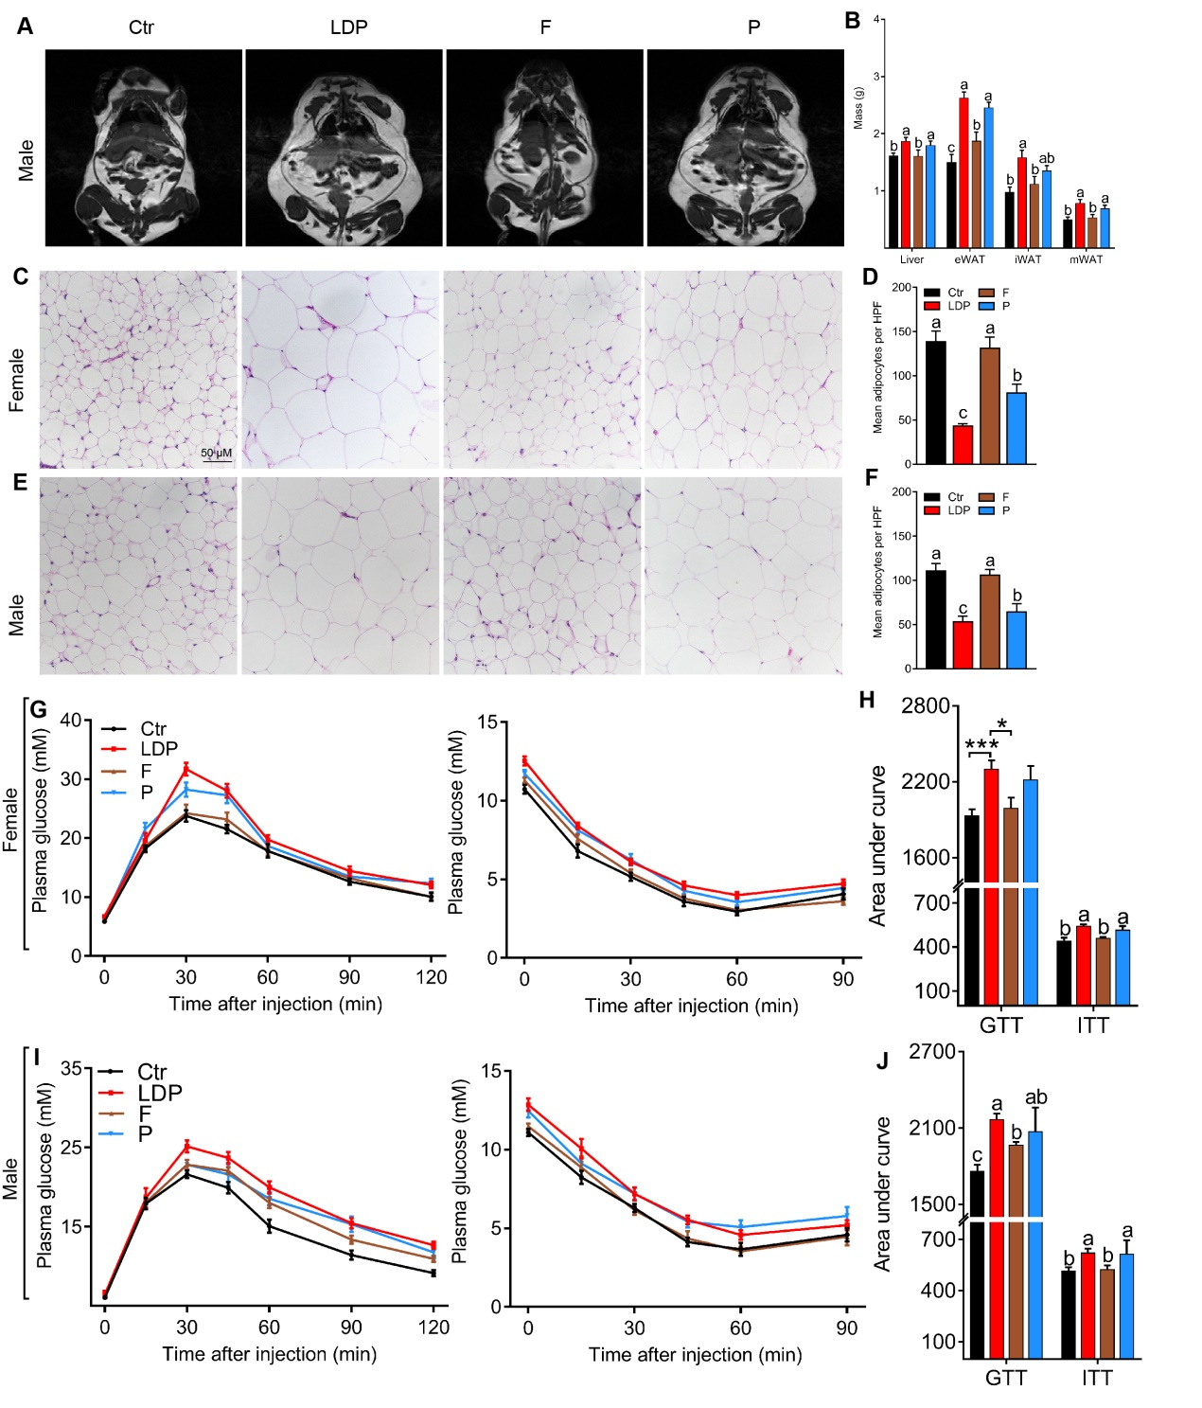
Figure S7 LDP enhanced diet-induced MetS. (A–I) Metabolic parameters of 25-week-old WT mice in Study 3. (A) Representative MRI images of the 25-week-old females; the white areas represent lipids, n = 3 for each group. (B) Tissue masses, n = 8–9. (C and E) Represented H&E stained adipose tissue sections for females (C) and males (E), n = 3 for all treatments. (D and F) The mean numbers of adipocytes per high-power field (HPF) of females (D) and males (F), n = 3. (G and I) Serum glucose levels after injection with glucose (G) or insulin (I), n = 8–9. (H and J) Area under curve (AUC) of figures G (H) and I (J). Different letters indicate a significant difference between columns, p < 0.05; *P < 0.05 and ***P < 0.001; differences were determined by LSD post hoc test or one-way ANOVA as compared to Dunnett’s test (T3).
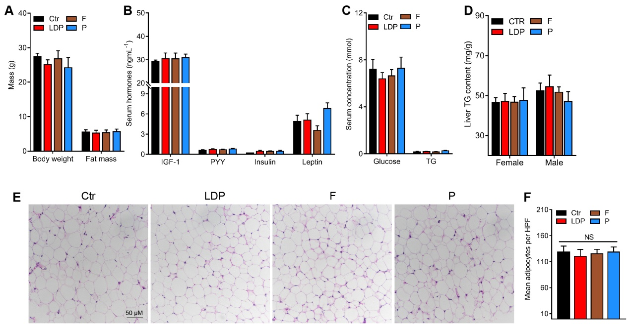
Figure S8 The LDP-effect on MetS was disappeared in Pigr^{-/-} mice. (A–F) Metabolic parameters of 25-week-old Pigr-/- mice in Study 3. (A) Bodyweight and fat mass. (B) Serum hormone levels. (C) Serum levels of glucose and triglyceride (TG). (D) Hepatic triglyceride levels. (E) Represented H&E stained adipose tissue sections, n = 3 for all treatments. (F) The mean numbers of adipocytes per high-power field (HPF) in figure F. Differences were determined by LSD post hoc test or one-way ANOVA as compared to Dunnett’s test (T3).

