The first complete T2T Assemblies of Cattle and Sheep Y-Chromosomes uncover remarkable divergence in structure and gene content

Supplementary materials

Supplementary tables
Table S1: Genome assembly statistics
Table S2: Repeat content on the cattle and the sheep T2T chromosomes
Table S3: Cattle T2T Y chromosome protein-coding genes annotation with homology search of protein sequences and Liftoff from the X-chromosome
Table S4: Sheep T2T Y chromosome protein-coding genes annotation with homology search of protein sequences and Liftoff from the X-chromosome
Table S5: NCBI annotation of the cattle T2T Y-chromosome
Table S6: NCBI annotation of the sheep T2T Y-chromosome
Table S7: Comparison of the protein-coding genes in the PARs on the X- and Y-chromosomes of cattle and sheep
Table S8: Ampliconic gene families on the cattle and the sheep Y-chromosomes
Table S9: Cattle Y-chromosome reads count table from RNA-Seq data indicating transcriptional activity
Table S10: Sheep Y-chromosome reads count table from RNA-Seq data indicating transcripts activity
Table S11: Abundance of the cattle-derived 73bp centromeric monomer on the cattle and sheep whole genome assemblies.
Table S12: Mashmap alignment between the BTAU5-Y and the T2T cattle Y-chromosome
Table S13: Mashmap alignment between the Hu-Sheep MSY and the T2T sheep Y-chromosome
Table S14: All publicly available cattle assemblies from male individuals on NCBI
Table S15: All publicly available assemblies from male sheep species on NCBI
Table S16: Centromeric repeat sequence on the cattle and the sheep Y-chromosomes
Table S17: Comparison of the T2T cattle Y-chromosome to the BTAU5-Y highlighting the missing protein-coding genes in BTAU5-Y relative to the T2T cattle Y-chromosome

Supplementary figures
Figure S1: Whole genome assembly visualization with Bandage
Figure S2: Genome quality assessment with Merqury k-mer spectra plots
Figure S3: The cattle Y-chromosome centromere
Figure S4: The sheep Y-chromosome centromere
Figure S5: Percentage identity of the centromeric HOR copies on the cattle Y-chromosome
Figure S6: The cattle Y chromosome-derived 73bp monomeric unit
Figure S7: Mashmap alignment between the BTAU5-Y (43.3Mbp) and the T2T cattle (59.4Mb)
Figure S8: Mashmap alignment dot plot between the Hu Sheep and the T2T sheep Y-chromosome (x-axis).
Figure S9: Definition of the PAR boundaries: IGV sequence coverage and alignment visualization of the female haplotype long reads mapping
Figure S10: Cross-species phylogeny of the protein-coding ampliconic genes
Figure S11: The loci of the ampliconic genes on the cattle (A) and the sheep (B) Y chromosomes

GENOME ASSEMBLY QUALITY ASSESSMENT

- Whole genome assembly visualization with Bandage

- (B)

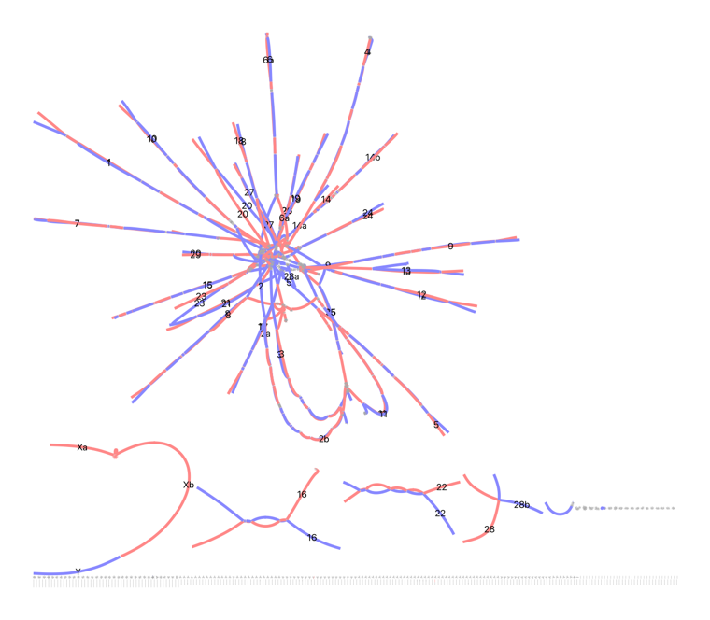
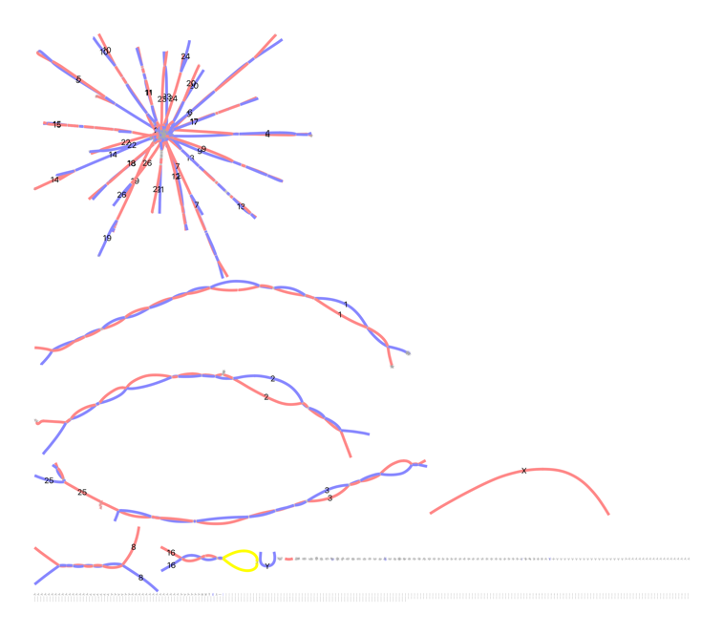

Figure S1: Whole genome assembly visualization with Bandage¹ showing the complete haplotype-resolved assemblies. The contigs of the paternal haplotypes are in blue color while those of the maternal haplotypes are colored in red. (A) For cattle, the sex chromosomes are highlighted in the red box showing a connection between the X- (red color in 2 contigs) and the Y-chromosome in a single contigs (blue) (B) The sheep sex chromosomes are both in single contigs and highlighted in green boxes with the Y chromosome in blue color.

A
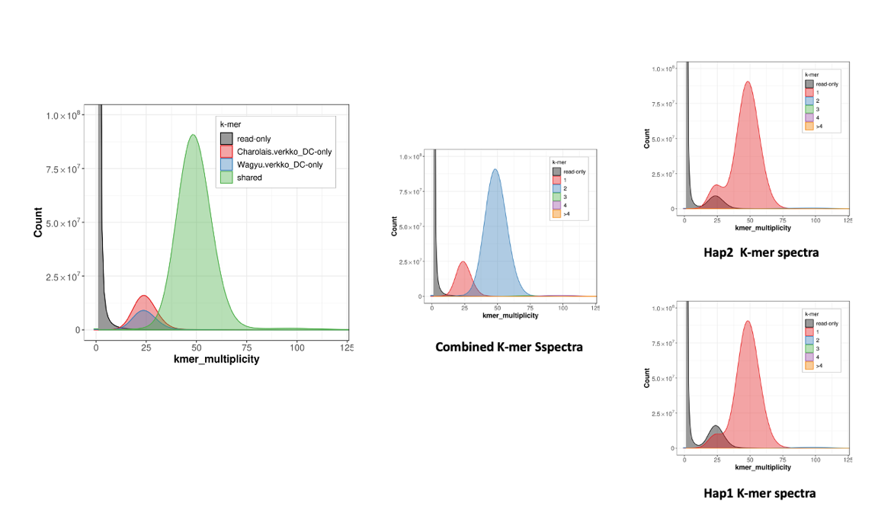

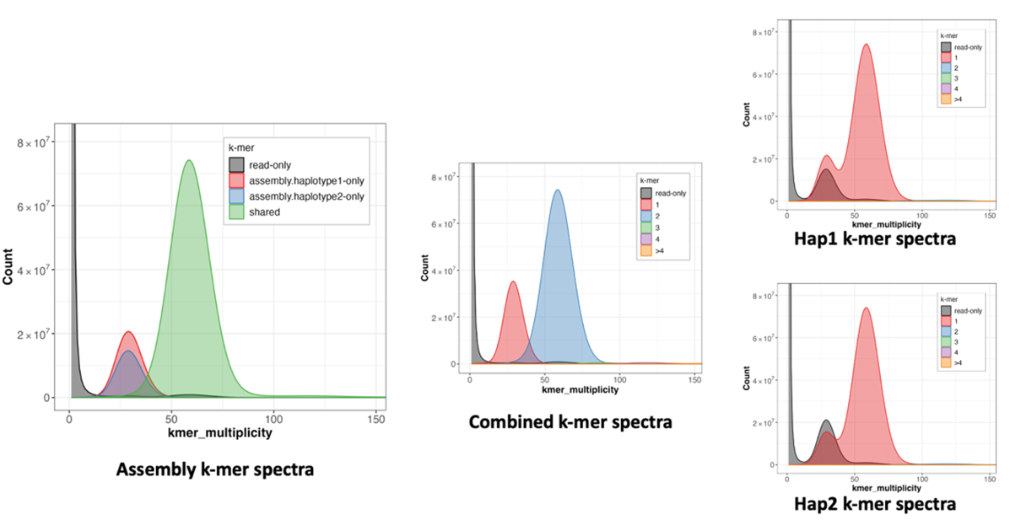
B

Figure S2: Genome quality assessment with Merqury k-mer spectra plots. Merqury² k-mer spectra plots of the genome assemblies of the F1 individuals from the (A) Wagyu_x_Charolais cattle and the (B) Churro_x_Friesian sheep crosses. The assembly k-mer spectra shows the distribution of the unique k-mers in the two haplotypes by highlighting the heterozygous regions (parental k-mers unique to either haplotype colored in red and blue) and the homozygous region (common to both haplotypes, colored in green). The survival of the reads k-mers in an assembly is an indication of the completeness of the assembly.

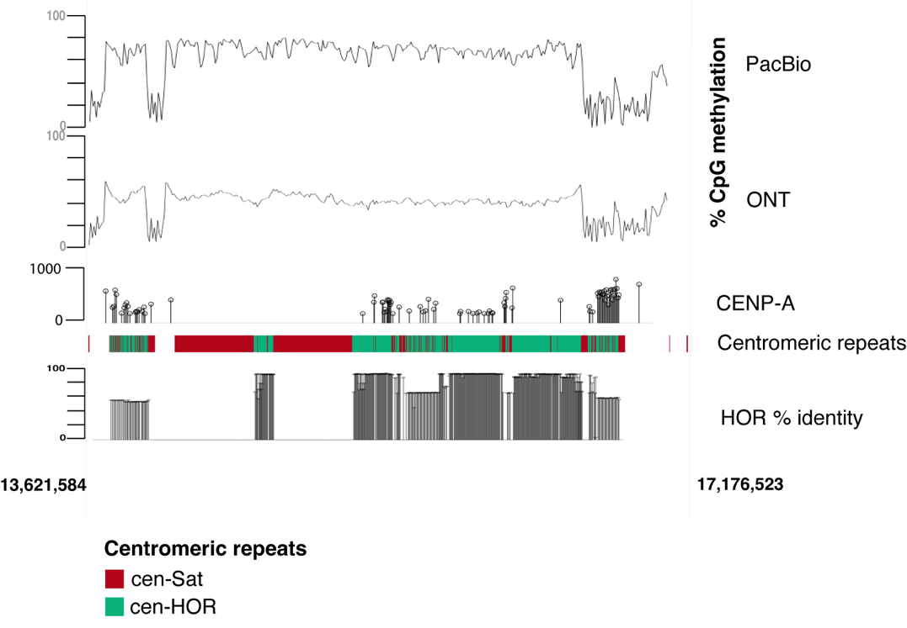

Figure S3: The cattle Y-chromosome centromere. The cattle centromere showing methylated cytosines residue frequency at 5kb bins from PacBio and ONT long reads sequencing technology, centromeric protein A (CENP-A) read depth track, centromeric satellite repeats organized into higher-order repeat (HORs) and the percentage identity of the HORs. The centromeric satellite comprised the cattle 73bp monomer (cen-Sat) which were organized into 3.7kb HORs (cen-HOR) in varying tandem configurations of the monomer. The consistently high CpG methylation pattern from the two long read technology across the centromeric satellite array dipped on the flanks of the HOR array. The right flank just after the high identity HOR array coincided with the region of CENP-A enrichment. This is thought to be the locus of the kinetochore assembly on the centromere as previously annotated on human centromeres³.
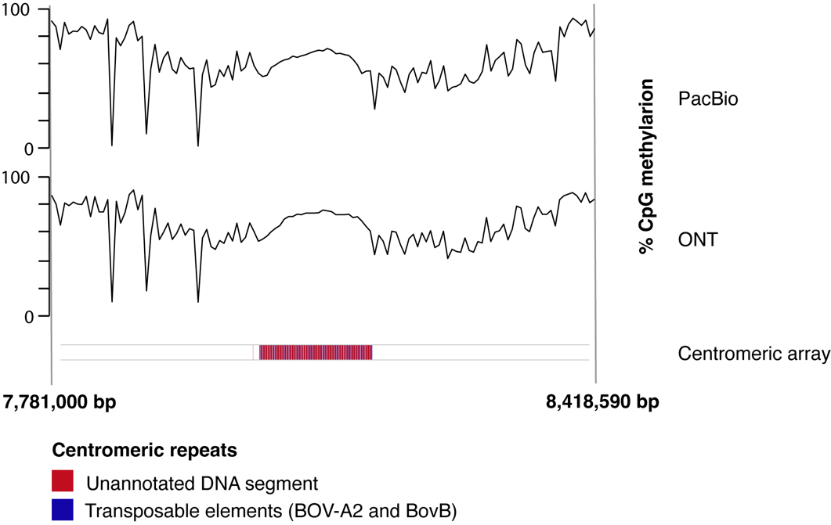

Figure S4: The sheep Y-chromosome centromere. The sheep centromere (8.03-8.15Mb) showing methylated cytosines residue frequency at 5kb bins obtained from PacBio and ONT long reads sequencing technology, and the centromeric array spanning about 112kb. The centromeric array comprised tandem copies of a unit containing the bovine transposable elements BOV-A2 and BovB separated by unannotated DNA. Sharp dips in the consistently high CpG methylation across the centromeric composite array were located at the flanks of the array

Figure S5: Percentage identity of the centromeric HOR copies on the cattle Y-chromosome. Sequence identity plot of the centromeric HOR repeat unit at the cattle centromere. The centromeric region is highlighted in light blue color. The HOR units flanking the centromere have lower sequence identity than the copies within the centromere.

A

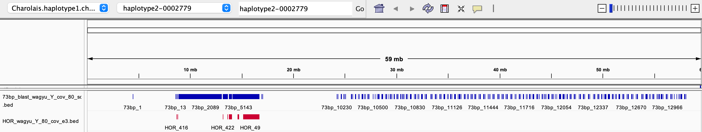

B
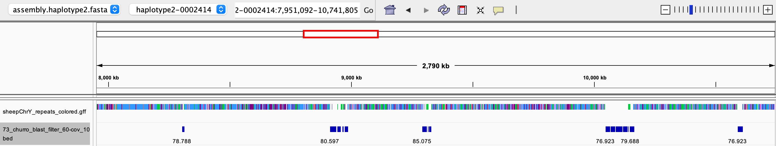

Figure S6: (A) The cattle Y chromosome-derived 73bp monomeric unit (blue track) spanning the length of the cattle Y-chromosome but enriched at the centromere, and the 3.7kb higher order repeat (HOR) (red track) also enriched at the centromere. (B) The 73bp monomeric unit on the sheep (second track) showing few diverged copies which are not proximal to the centromere locus.

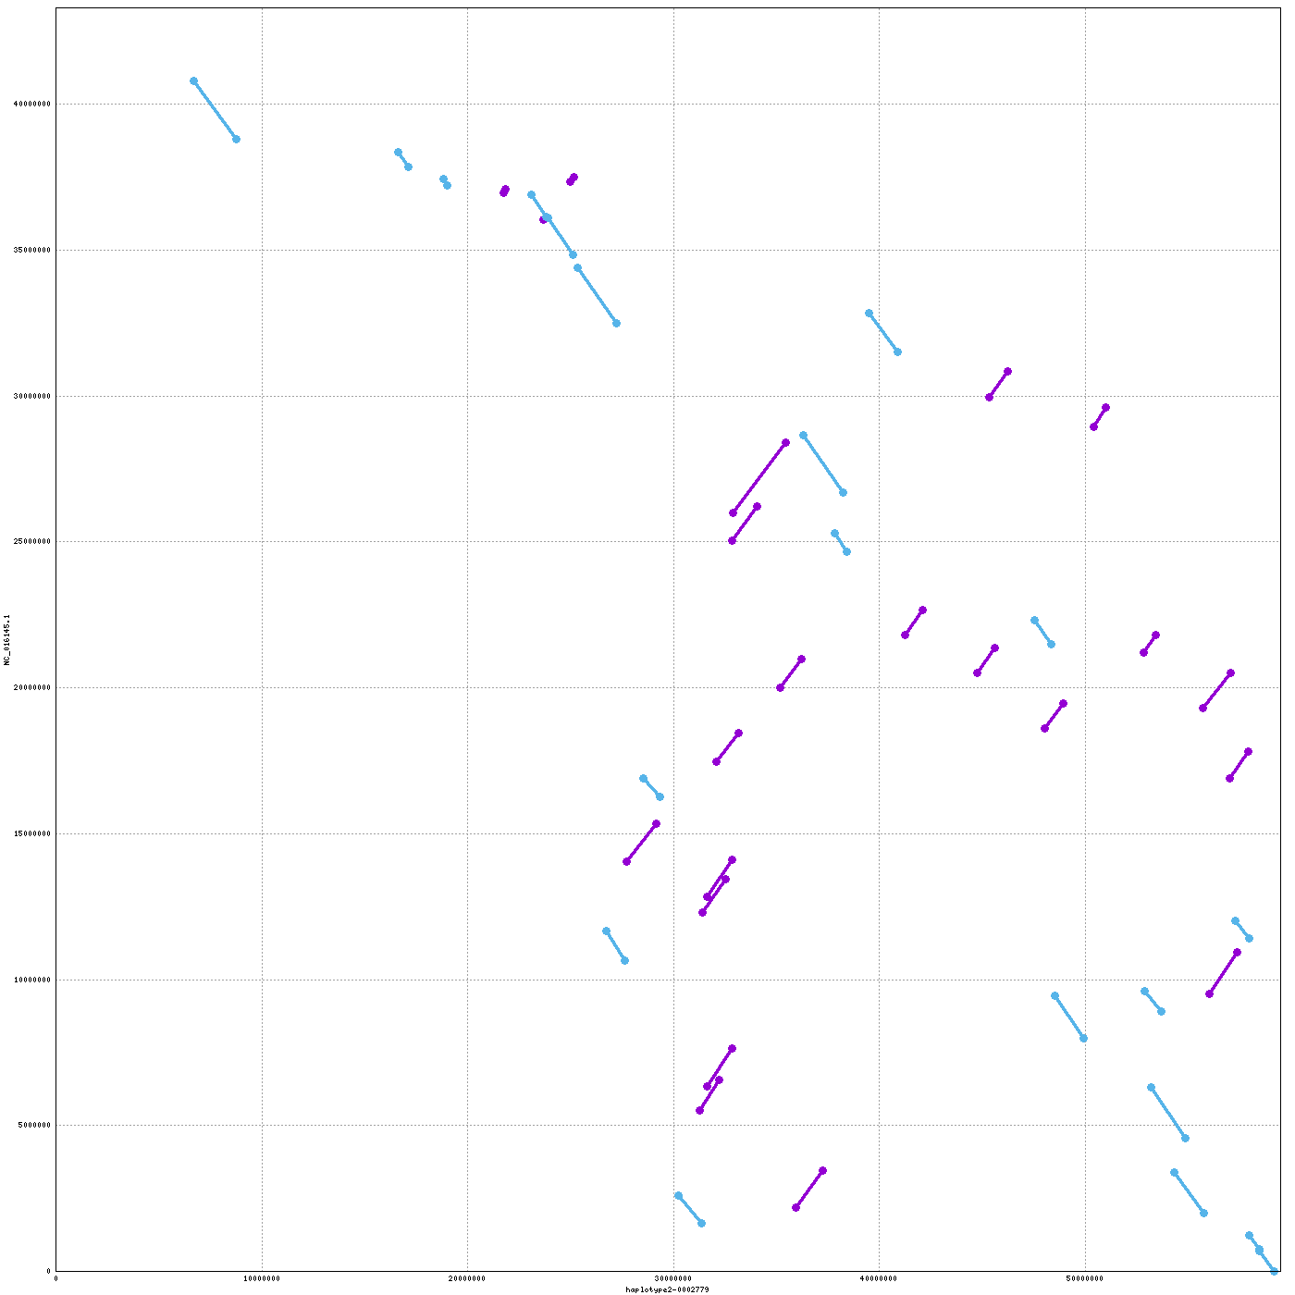
A

B

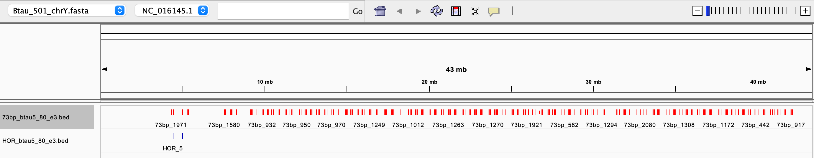

Figure S7: (A) Mashmap⁴ alignment between the BTAU5-Y (43.3Mbp) on the Y-axis and the T2T cattle (59.4Mb) chromosomes at 50kb minimum segment length for alignment. Forward orientation alignments are shown in purple color while inverted alignments are shown in light blue color. (B) The cattle 73bp centromeric repeat monomer (red track) and the higher order repeat (HOR) sequence (blue track) on the BTAU5-Y showing just four copies of the HOR around the locus where the centromere is missing from.

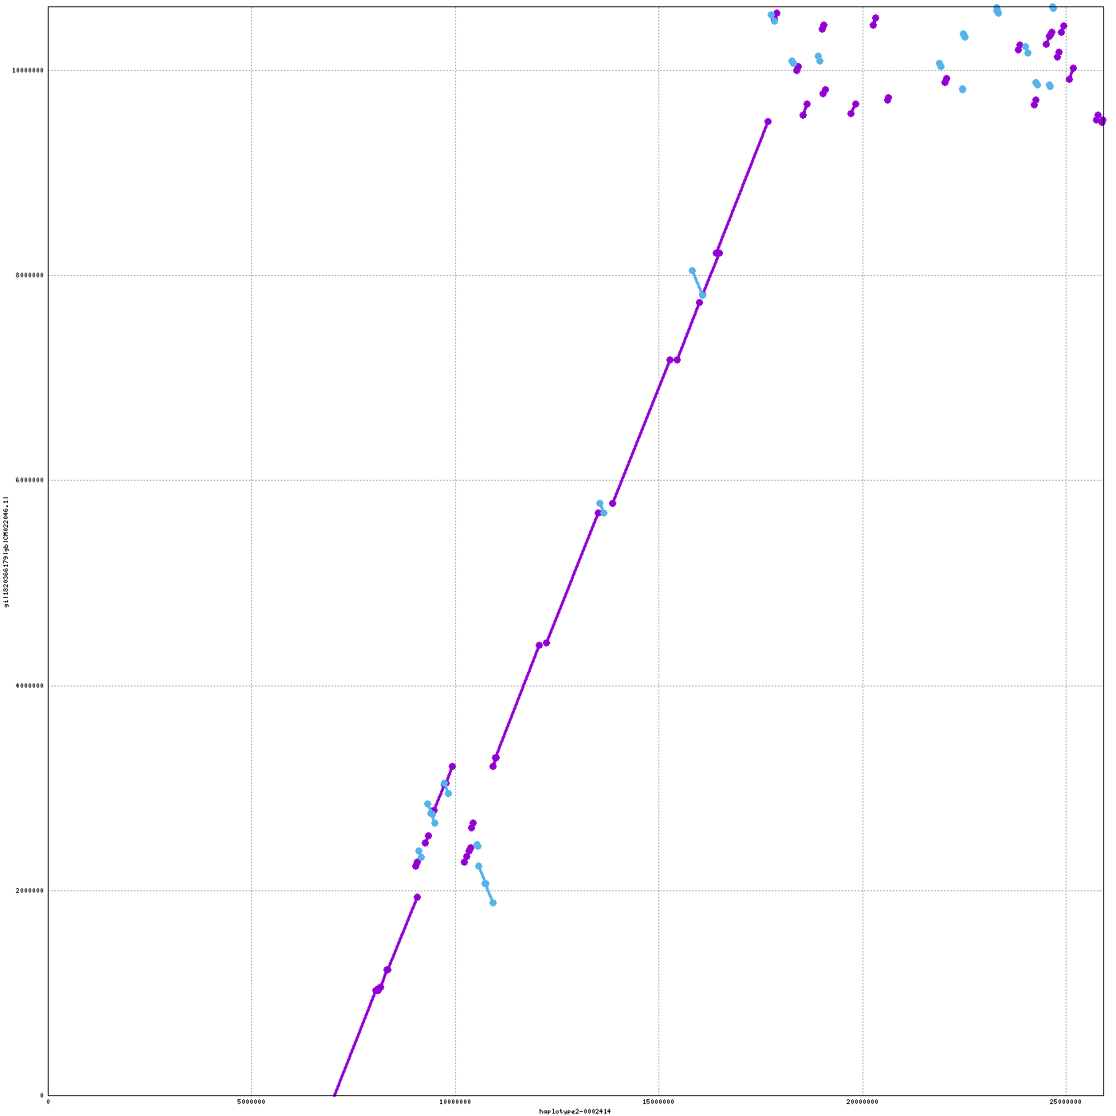
A.

B.
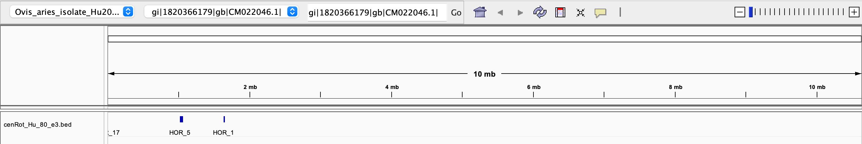

Figure S8: (A) Alignment dot plot between the Hu Sheep (y-axis) and the T2T sheep Y-chromosome (x-axis). Only the MSY was available for the Hu sheep⁵, and as such the PAR region spanning 7.01Mb on the T2T sheep (lower left corner) is missing from the alignment. (B) The T2T sheep-derived centromeric repeat on the Hu sheep at 1.02Mb from the beginning of the MSY comprising ten tandemly arrayed copies spanning 35.04kb.

Pseudo-autosomal region (PAR) boundary definition

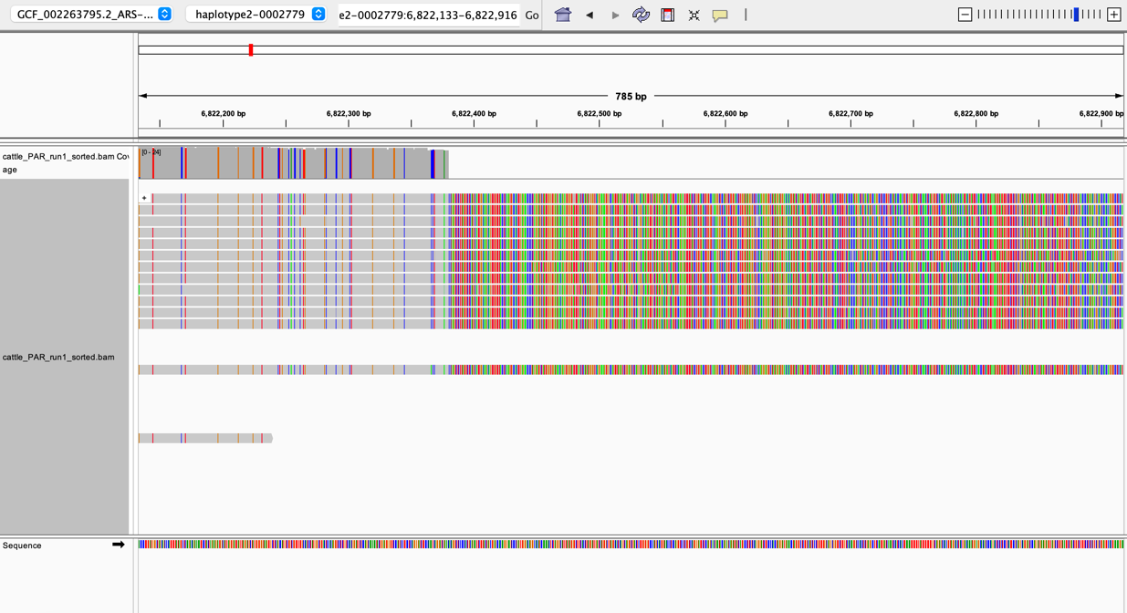

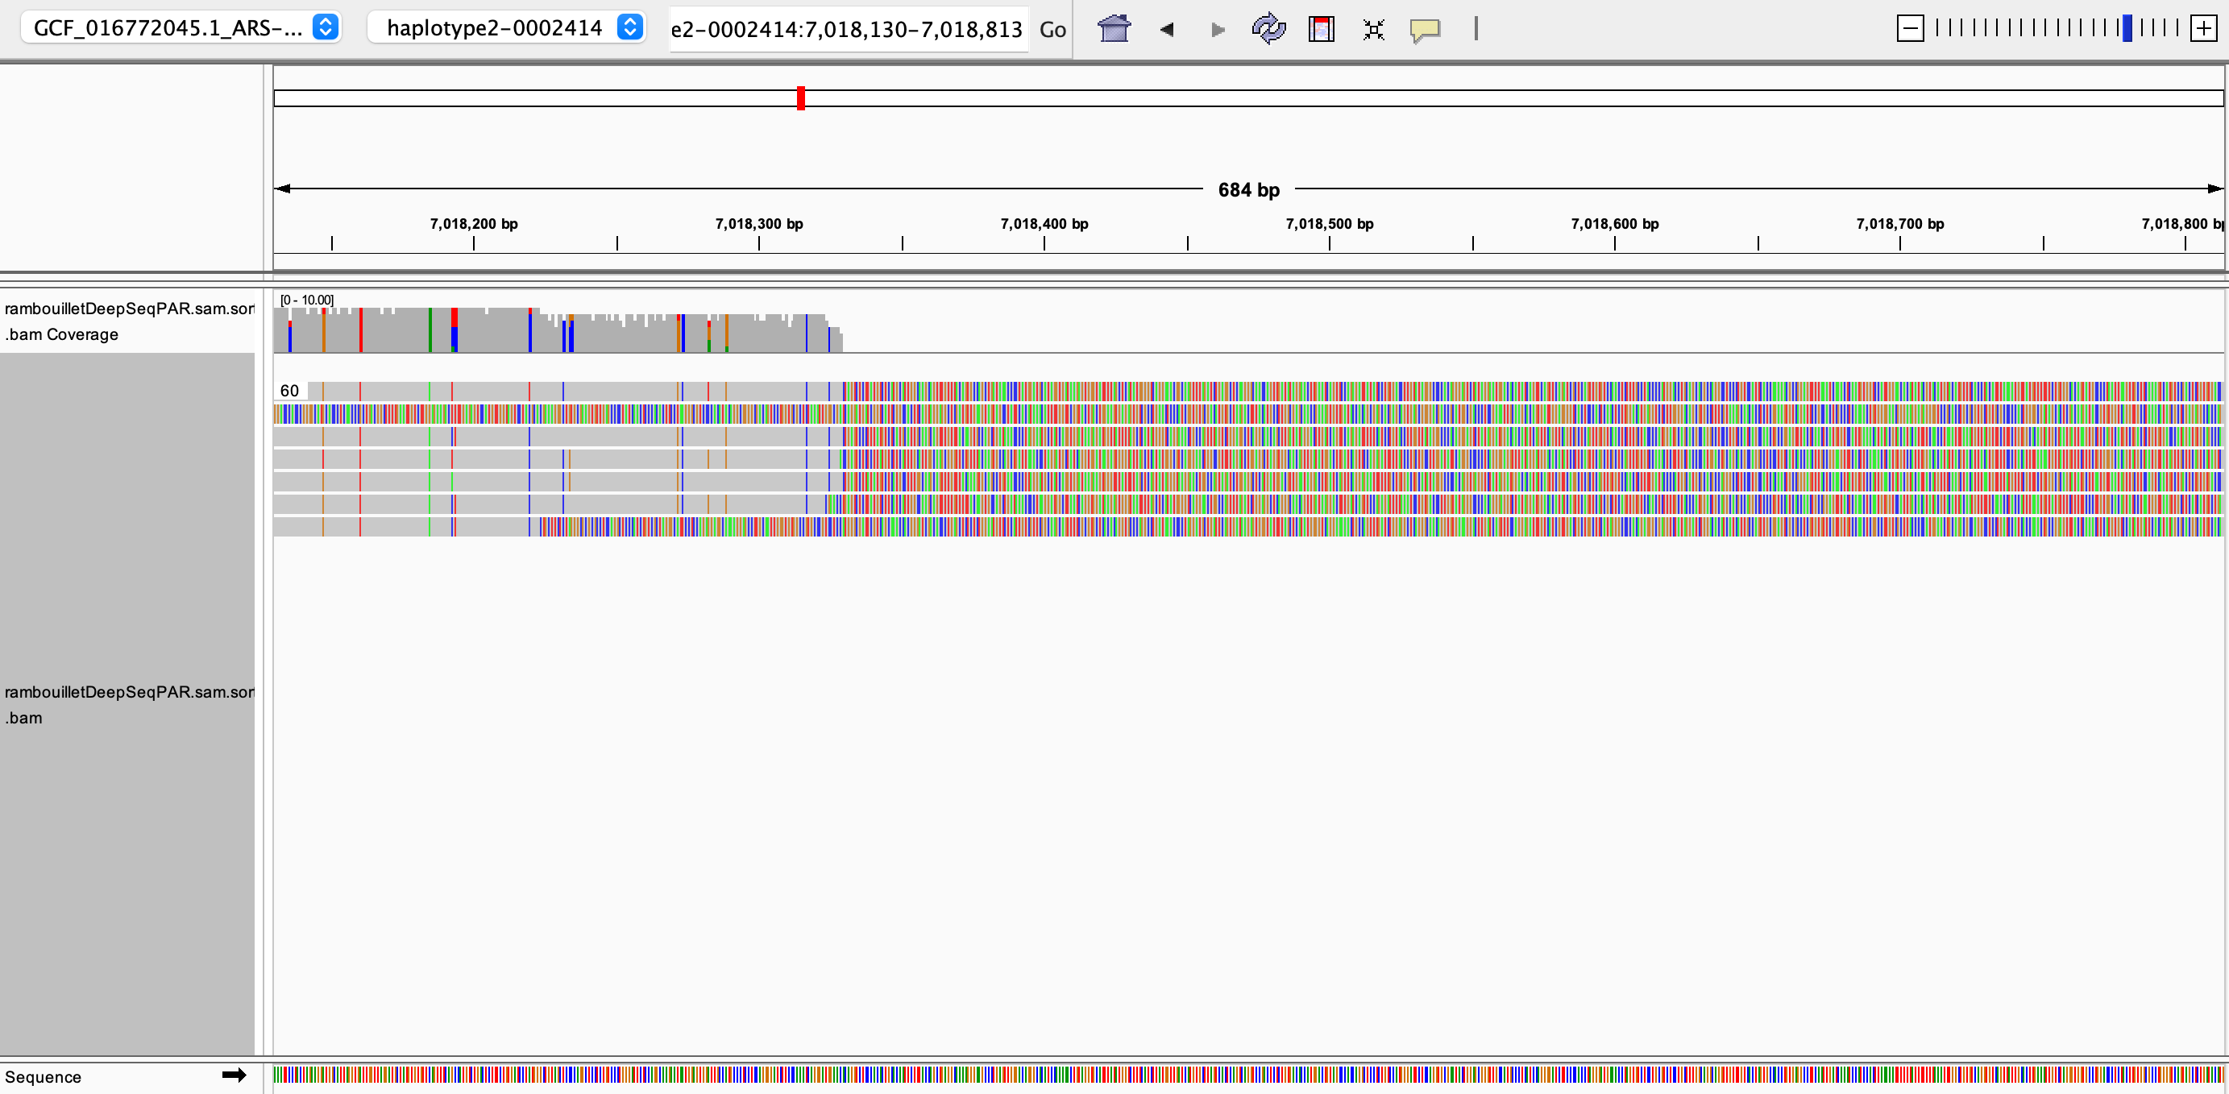
(B)

Figure S9: IGV⁶ sequence coverage and alignment visualization of the female haplotype long reads mapping to (A) the cattle and (B) the sheep Y-chromosomes. The highly colored regions of the alignment track show 3’ end soft clipping of the HiFi reads at the PAR boundaries due to non-alignment of the sequences to the Y-chromosomes. Homology between the Y-chromosome and the X-chromosome is lost at the PAR boundaries where the Y chromosome transitions into the X-degenerate region. The coverage tracks above also show a complete drop of sequence coverage to zero at the PAR boundaries.

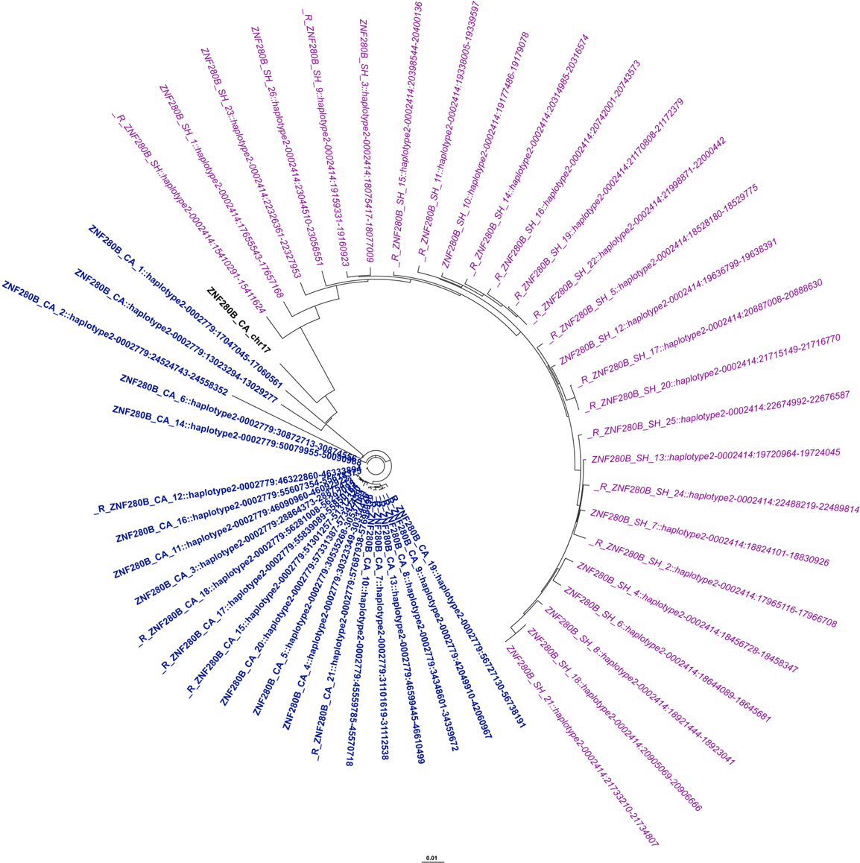
A

B
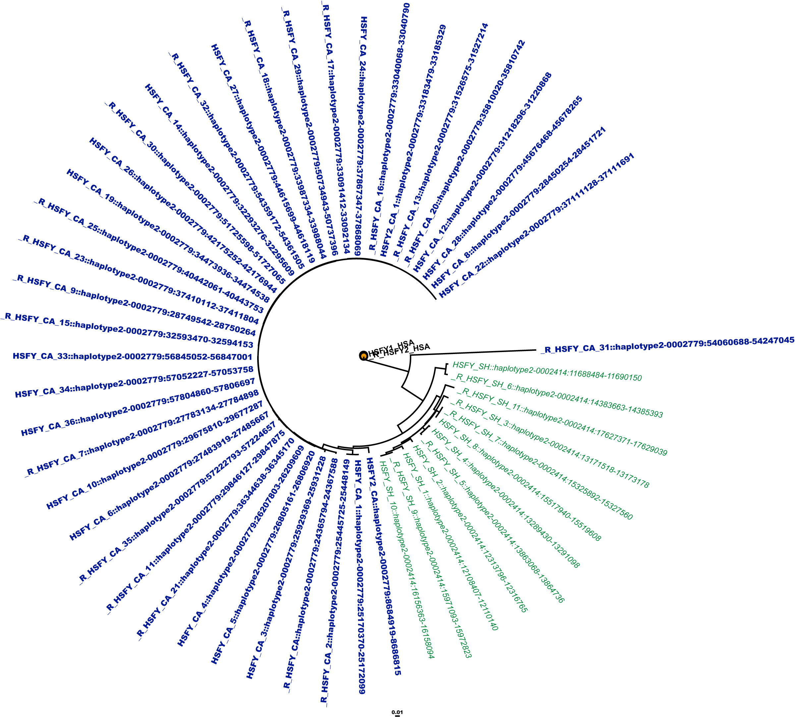
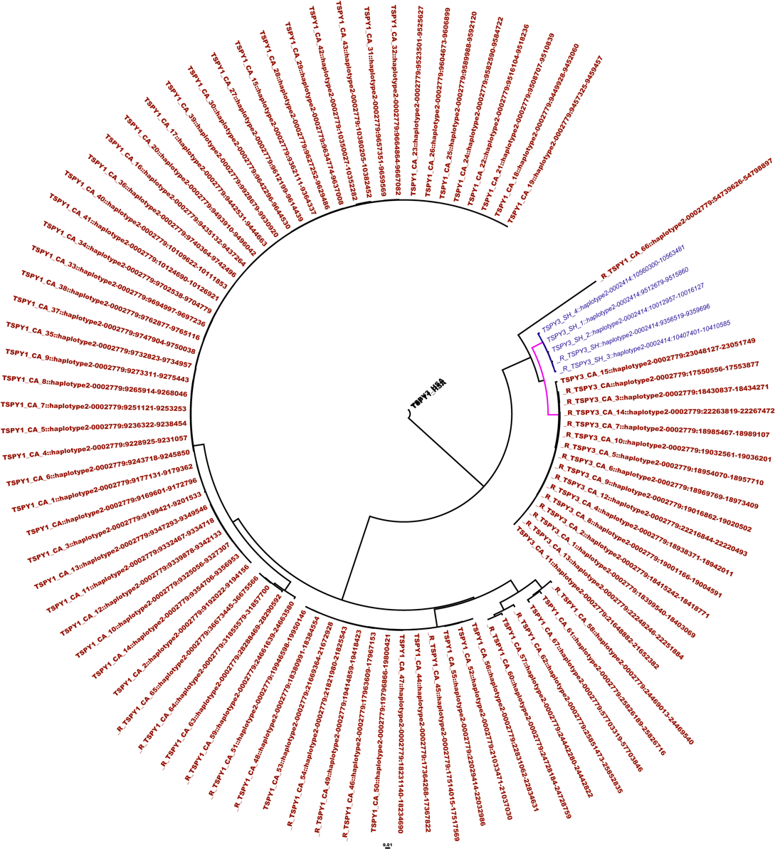
C

Figure S10: Inter-species clustering of the copies of the protein-coding ampliconic genes HSFY (A) ZNF280B (B) HSFY and (C) TSPY on the cattle and the sheep Y-chromosomes showing clear differentiation of the sheep copies from the cattle copies. RBMY and PRAME are not shown since only single copies were located on the sheep Y-chromosome. The genes in black font are the human copies used as outgroup for the tree construction. Since ZNF280B is bovine-specific, the copy in black font was obtained from cattle chromosome 17 from where it translocated to the Y-chromosome before amplification⁷. The sheep copies are in italicised normal font and have _SH appended to the gene name while the cattle copies are in bold with _CA appended to the gene name. The numbers between the name and the symbol “::” indicate the position of the copy on the chromosome relative to the end of the p-arm. The sheep copies are highligted in different colors for each gene family - ZNF280B (purple), HSFY (green), and TSPY (blue). The pink branch on panel (C) are all copies of TSPY3 while the rest of the copies are TSPY1; the TSPY3 copies were clearly separated from the TSPY1 and were differentiated between cattle and sheep.

(A)

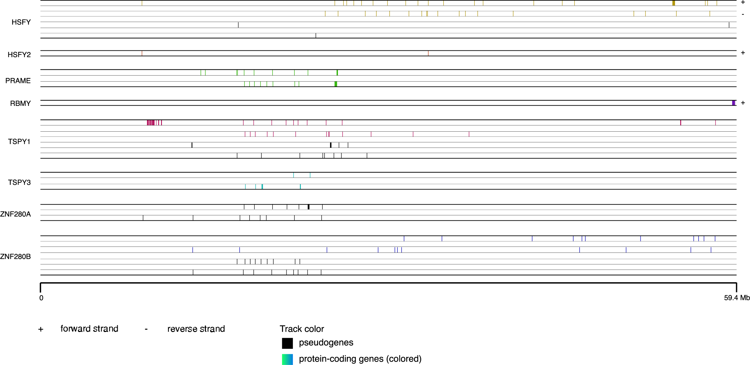

(B)

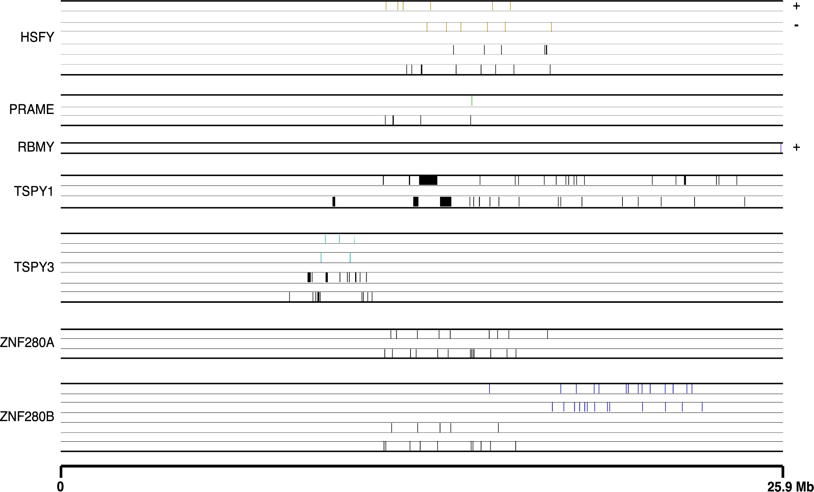

Figure S11: The loci of the ampliconic genes on the cattle (A) and the sheep (B) Y chromosomes rendered in four tracks for each gene; protein-coding genes (colored) on the positive and the negative strand are shown on tracks (from top) 1 and 2 respectively, while pseudogenes (black color) on the positive and negative strands are shown on tracks 3 and 4, respectively. Where there is only one track, its orientation is indicated with + or - sign. The TSPY1 island is located on the cattle-Y harboring a tandem array of 44 copies out of the total 68 protein-coding copies. Tandem arrays of protein-coding copies of HSFY, PRAME, and RBMY were also located on the Cattle-Y (thicker blocks on the tracks) but absent on the Sheep-Y. Both chromosomes did not have protein-coding copies of ZNF280A.

REFERENCES

1. Wick, R. R., Schultz, M. B., Zobel, J. & Holt, K. E. Bandage: Interactive visualization of de novo genome assemblies. Bioinformatics 31, 3350–3352 (2015).
2. Rhie, A., Walenz, B. P., Koren, S. & Phillippy, A. M. Merqury: Reference-free quality, completeness, and phasing assessment for genome assemblies. Genome Biol 21, 1–27 (2020).
3. Gershman, A. et al. Epigenetic patterns in a complete human genome. Science (1979) 376, (2022).
4. Jain, C., Koren, S., Dilthey, A., Phillippy, A. M. & Aluru, S. A fast adaptive algorithm for computing whole-genome homology maps. Bioinformatics 34, i748–i756 (2018).
5. Li, R. et al. A Hu sheep genome with the first ovine Y chromosome reveal introgression history after sheep domestication. 64, 1116–1130 (2021).
6. Robinson, J. T. et al. Integrative genomics viewer. (2011) doi:10.1038/nbt0111-24.
7. Yang, Y. et al. ZNF280BY and ZNF280AY: Autosome derived Y-chromosome gene families in Bovidae. BMC Genomics 12, 9–11 (2011).

