Divergent roles of abundant and diverse Aquificaceae of Pampinifervens gen. nov. in the nitrogen cycle in geothermal springs in Tengchong, China
Marike Palmer, Nancy O. Nou, Lara A. Turello, Carolyn E. Chang, John C. Ong, Dengxun Lai, Anna-Louise Reysenbach, Yan-Ling Qi, Jeremy A. Dodsworth, Jian-Yu Jiao, Lan Liu, Zhen-Han Lian, Brandon R. Briggs, Hongyan Zuo, Stephen R. Quake, Emiley A. Eloe-Fadrosh, Tanja Woyke, Ramunas Stepanauskas, Hailiang Dong, Wen-Jun Li, Zhengshuang Hua, Brian P. Hedlund

Supplementary Figures Page
1. Figure S1. Aquificaceae Bac120 phylogeny 1
2. Figure S2. OGRI and genealogical concordance 2
3. Figure S3. Conserved metabolism in Pampinifervens 3
4. Figure S4. Recruitment plots for Pampinifervens diazotrophicum 4
5. Figure S5. Recruitment plots for Pampinifervens sericum 5
6. Figure S6. Recruitment plots for Pampinifervens tengchongense 6
7. Figure S7. Recruitment plots for Pampinifervens florentissimum 7
8. Figure S8. Recruitment plots for Pampinifervens sinense 8
9. Figure S9. Recruitment plots for Pampinifervens yunnanense 9
10. Figure S10. 16S rRNA phylogeny of the Aquificaceae 10
11. Figure S11. Summary of ICE composition in T-8 11

Supplementary Notes
- Supplementary Note 1. Energy and carbon metabolism of Pampinifervens 12
- Supplementary Note 2. ICE and MGEs are spring specific 14

Supplementary Tables
1. Table S1. Metagenomes analyzed in this study
2. Table S2. Read classification using Kaiju v. 1.7.3
3. Table S3. Genomes analyzed in this study
4. Table S4. Genomes and conserved marker genes used for genealogical concordance
5. Table S5. Genome statistics of nomenclatural types
6. Table S6. KEGG annotations for high-completeness genomes compared in this study
7. Table S7. Genes for acid tolerance present in Pampinifervens
8. Table S8. EggNOG annotation results for Pampinifervens florentissimum T-8
9. Table S9. EggNOG annotation results for Pampinifervens diazotrophicum T-2
10. Table S10. Closest BLAST hits for genes on the ICE present in the T-8 genome
11. Table S11. Comparison of cultivated Pampinifervens strains and type species of other genera in the Aquificaceae

Supplementary Datasets
- File S1. Count ancestral character state reconstruction file
- File S2. Nitrogen metabolism marker phylogenies
- File S3. Acid tolerance marker phylogenies

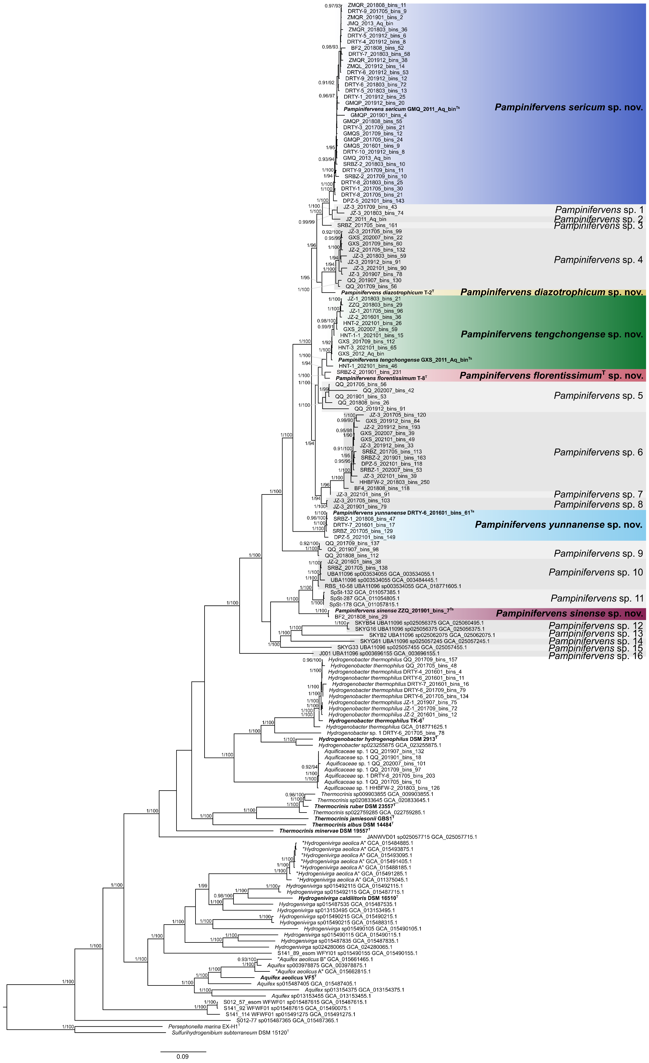
Figure S1. Phylogenomic species tree for Pampinifervens and other Aquificaceae analyzed in this study. A maximum-likelihood phylogeny from a concatenated matrix of 120 conserved bacterial markers (Bac120) constructed in IQ-Tree, with SH-aLRT > 0.9 and UFbootstrap values > 95% indicated at nodes, with independent optimal models of protein evolution applied to each partition. The scale bar indicates the number of amino acid changes per site. Nomenclatural types are indicated in bold, and superscript “T” denotes the genome of type strain under the ICNP, while superscript “Ts” denotes type genomes under the SeqCode.
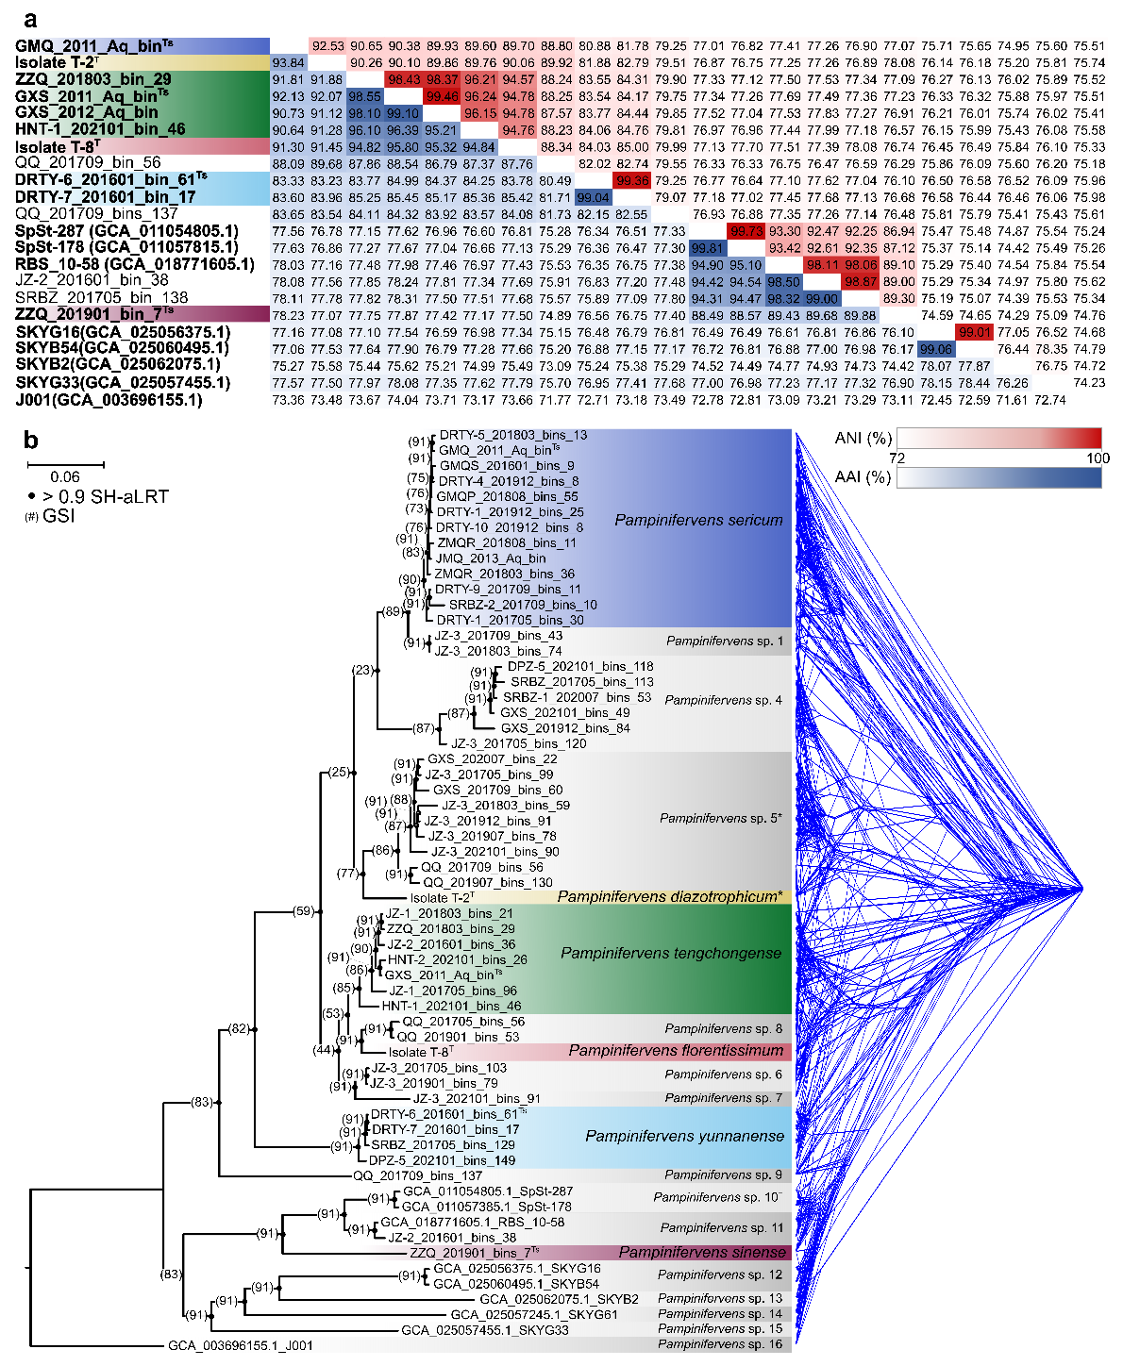
Figure S2. Genome-based evidence used for species delineation, including the overall-genome-relatedness-indices average nucleotide identity (ANI) and average amino acid identity (AAI) (A), and multi-locus (14 genes) genealogical concordance analysis (B). A) ANI and AAI values among genomes of Pampinifervens. High-quality genomes containing 16S rRNA genes are indicated in bold, while nomenclatural types are indicated either with superscript “T” for types under the ICNP, or superscript “Ts” for types under the SeqCode. Conspecific genomes had ANI values >96%, while all pairwise AAI within the genus were above 70%. B) Genealogical concordance analysis of 14 shared genes. Inconsistencies among individual phylogenies may be indicative of frequent gene sharing among sympatrically occurring species, e.g., Pampinifervens sp. 4 and Pampinifervens sp. 5. High quality genomes containing 16S rRNA genes are indicated in bold, while nomenclatural types are indicated either with superscript “T” for types under the ICNP, or superscript “Ts” for types under the SeqCode.
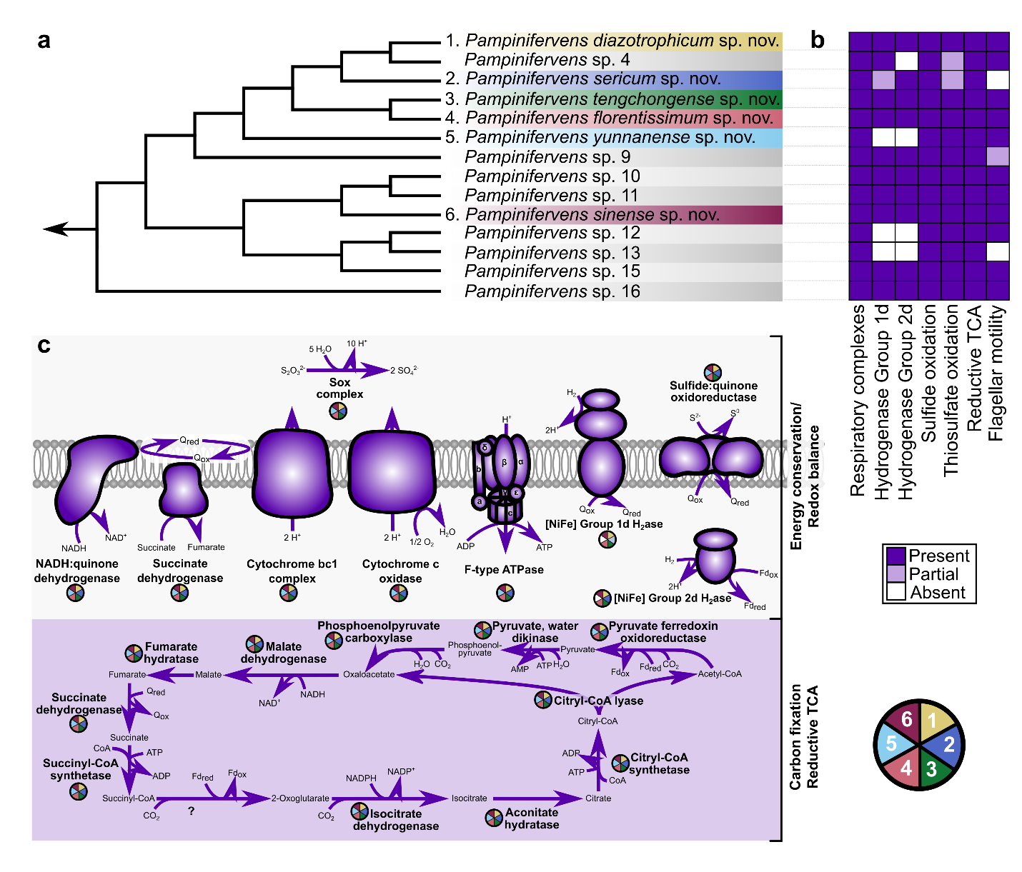
Figure S3. Cell model for conserved carbon fixation and energy metabolism pathways in Pampinifervens. A) Cladogram inferred from the species tree for the genus (Fig. S1) indicating all species represented by high-completeness, low-contamination genomes. B) Heatmap indicating the presence of central carbon and energy metabolism pathways along with flagellar motility. All species with high-completeness genomes of Pampinifervens encode all respiratory complexes, indicating that they can all likely use O₂ as terminal electron acceptor. Sulfide and thiosulfate oxidation also appears as conserved in the genus, although not all components of the Sox complex were annotated in P. sericum and Pampinifervens sp. 4. Group 1d and Group 2d [NiFe] hydrogenases were also frequently found in the high-quality genomes of the genus, except for P. yunnanense, Pampinifervens sp. 12, and Pampinifervens sp. 13 that lacked any identifiable hydrogenases, and Pampinifervens sp. 4 that lacked the Group 2d hydrogenase. The majority of the genomes in P. sericum lacked one subunit of the Group 1d hydrogenase. Genes encoding the reductive tricarboxylic acid cycle are conserved within the genus, although no homologs to the characterized 2-oxoglutarate ferredoxin oxidoreductases in Hydrogenobacter were found. As two putative pyruvate ferredoxin oxidoreductases are annotated in their genomes, we propose that one of these may in fact encode a 2-oxoglutarate ferredoxin oxidoreductase. Flagellar motility is also largely conserved in the genus with only the genomes of P. sericum and Pampinifervens sp. 13 lacking all flagellar genes. C) Cell model for the predicted energy and carbon metabolism of species described here belonging to Pampinifervens.
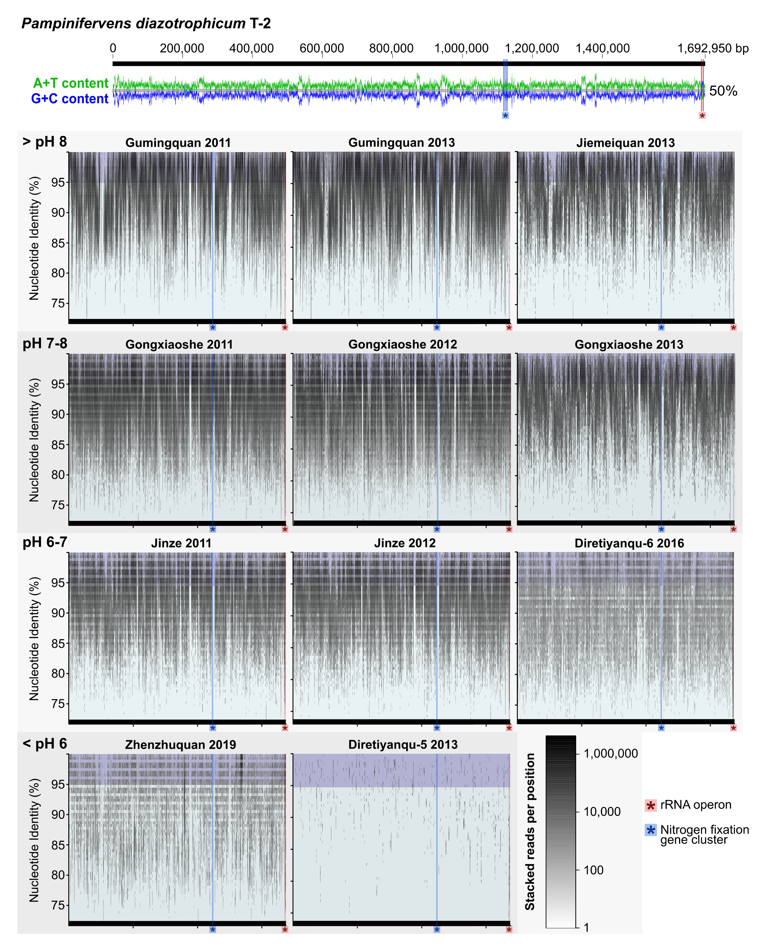
Figure S4. Recruitment plots for P. diazotrophicum with metagenomic reads from Tengchong hot springs. Mapped reads with nucleotide identity > 95% (dark blue section) indicate reads of conspecific populations to the reference genome. Mapped reads with nucleotide identity < 95% (light blue section) indicate reads of different species occurring in the spring. Shade intensity of the reads indicates the number of stacked reads per position in the genome. T-2 was isolated from Gumingquan hot spring, and nearly complete coverage of mapped reads across the genome is observed at high identity from metagenomes from Gumingquan. Many reads of different species than T-2 (P. diazotrophicum) are recovered from all circumneutral and basic hot springs, but gaps in high identity read mapping across several regions of the T-2 genome makes it unclear whether P. diazotrophicum is found in any other springs analyzed here.

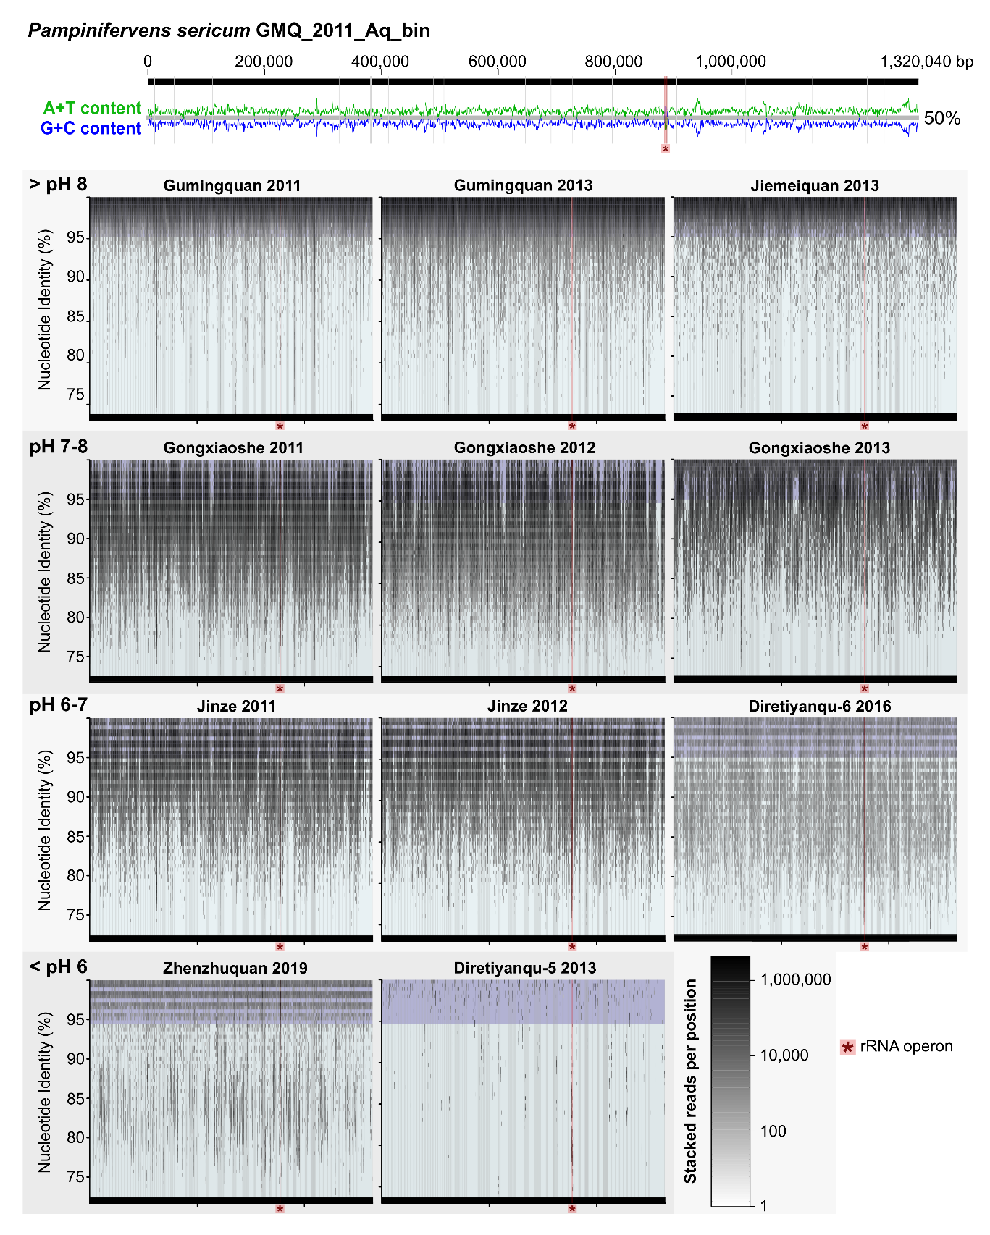
Figure S5. Recruitment plots for P. sericum with metagenomic reads from Tengchong hot springs. Mapped reads with nucleotide identity > 95% (dark blue section) indicate reads of conspecific populations to the reference genome. Mapped reads with nucleotide identity < 95% (light blue section) indicate reads of different species occurring in the spring. Shade intensity of the reads indicates the number of stacked reads per position in the genome. P. sericum MAGs are recovered from many different hot springs in Tengchong, and complete coverage of mapped reads across the genome is observed at high identity from all circumneutral and basic hot springs and Zhenzhuquan. The lower number of reads mapping to P. sericum at < 95% nucleotide identity in Gumingquan, is likely indicative of lower diversity in Pampinifervens populations in this spring.
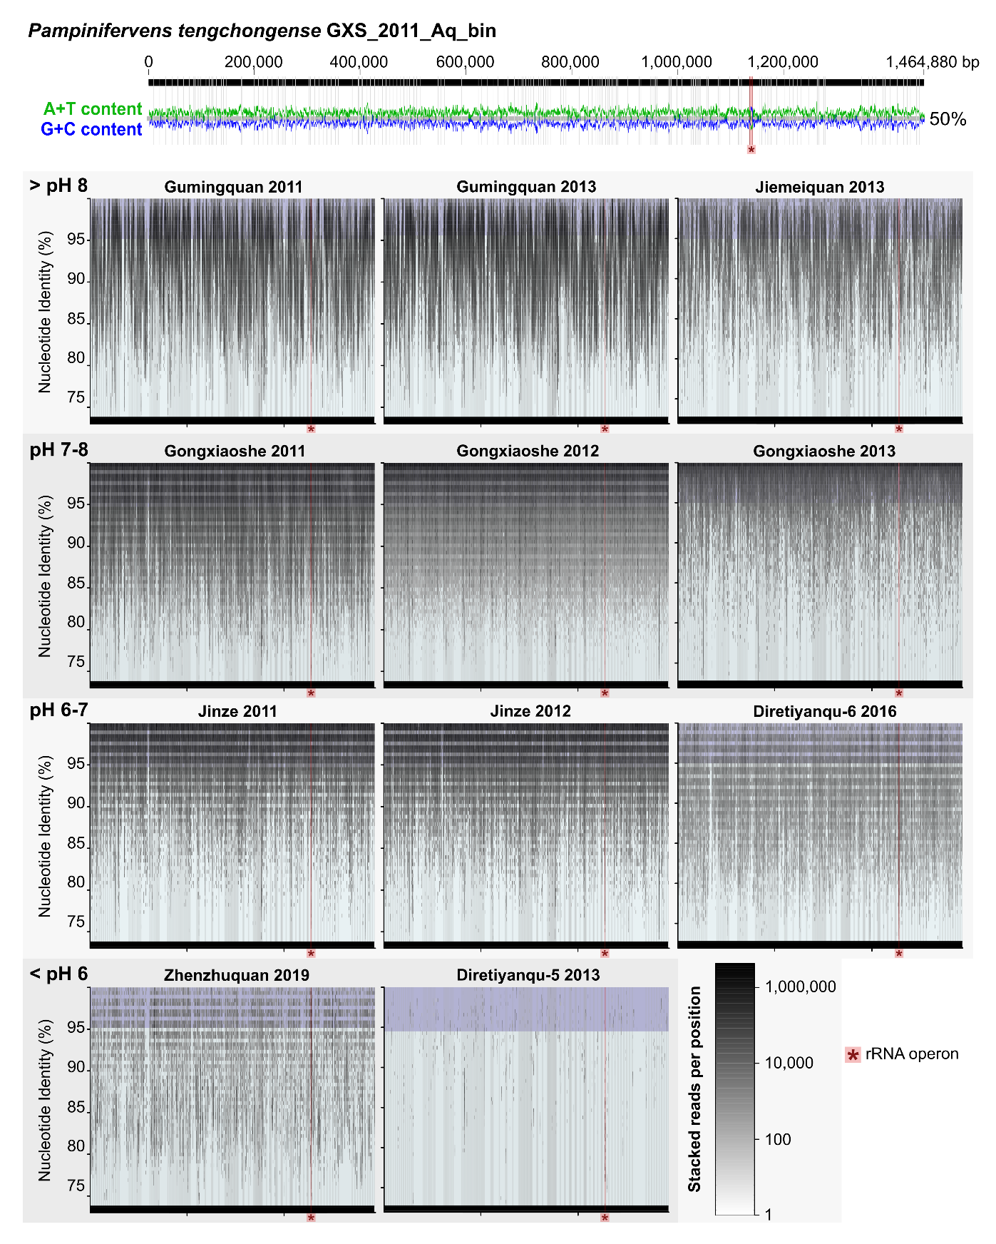
Figure S6. Recruitment plots for P. tengchongense with metagenomic reads from Tengchong hot springs. Mapped reads with nucleotide identity > 95% (dark blue section) indicate reads of conspecific populations to the reference genome. Mapped reads with nucleotide identity < 95% (light blue section) indicate reads of different species occurring in the spring. Shade intensity of the reads indicates the number of stacked reads per position in the genome. MAGs of P. tengchongense were recovered from circumneutral hot springs, and complete coverage of mapped reads across the genome is observed at high identity from all circumneutral hot springs. Many mapped reads at < 95% nucleotide identity indicate highly diverse Pampinifervens populations in these springs.
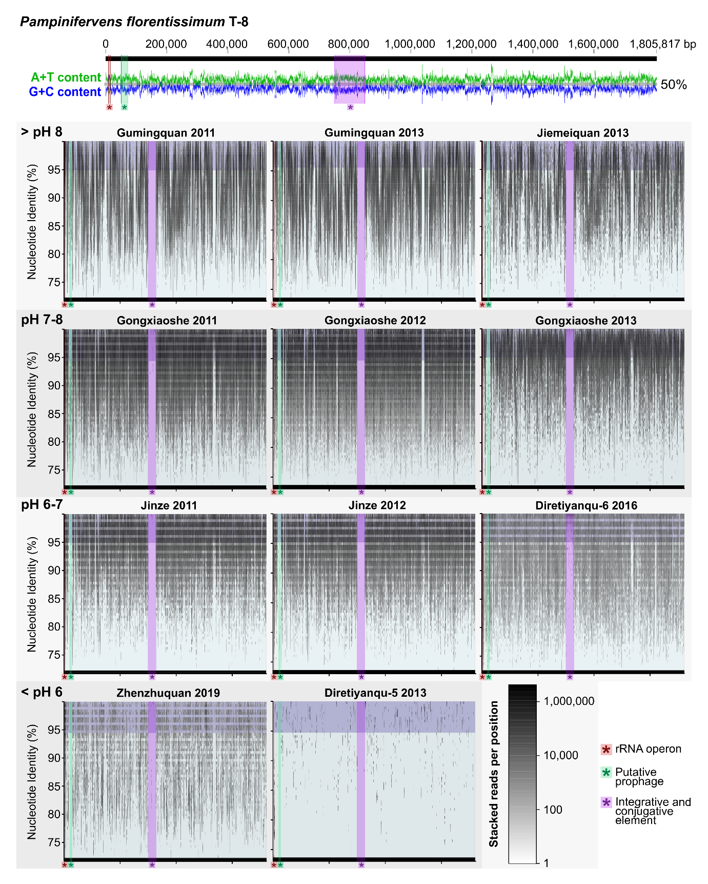
Figure S7. Recruitment plots for P. florentissimum with metagenomic reads from Tengchong hot springs. Mapped reads with nucleotide identity > 95% (dark blue section) indicate reads of conspecific populations to the reference genome. Mapped reads with nucleotide identity < 95% (light blue section) indicate reads of different species occurring in the spring. Shade intensity of the reads indicates the number of stacked reads per position in the genome. T-8 was isolated from Qiao Quan hot spring (metagenome not analyzed here), but complete coverage of mapped reads across the entire genome is observed at high identity from all circumneutral hot springs, with the exception of two genomic regions (green and purple section). Some reads are mapped to these regions from Diretiyanqu-6 sampled in 2016, and these regions are further analyzed (Fig. S11 and Note S2). Although numerous reads are recruited from circumneutral springs at > 95% nucleotide identity, only a single MAG of this species was recovered, likely due to the difficulty in binning metagenomic data from such diverse Aquificaceae populations in the circumneutral springs.
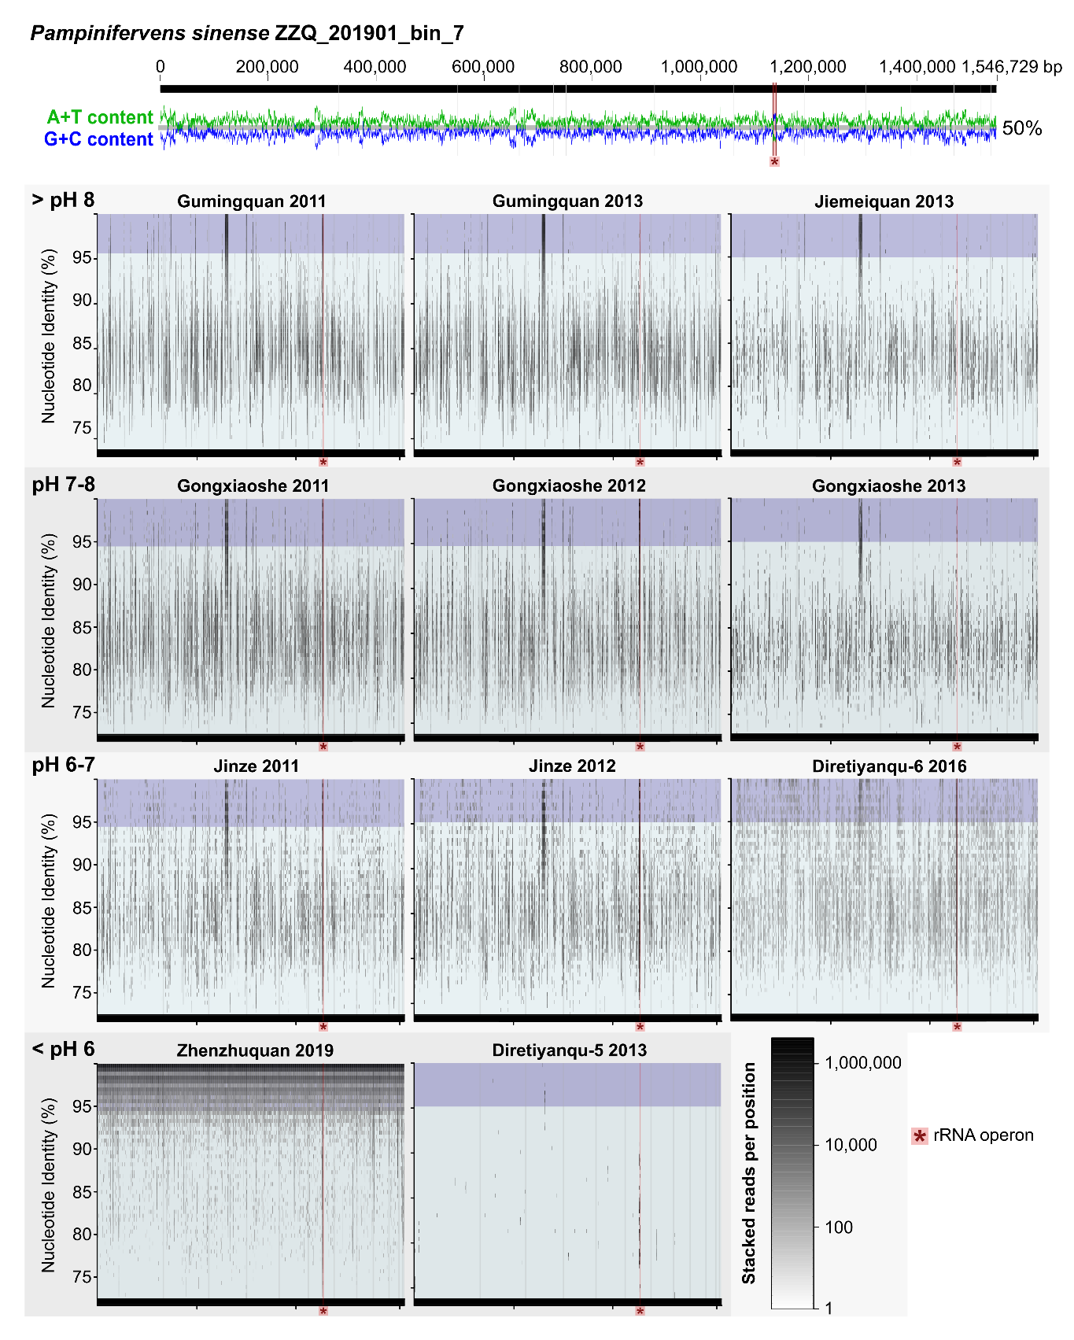
Figure S8. Recruitment plots for P. sinense with metagenomic reads from Tengchong hot springs. Mapped reads with nucleotide identity > 95% (dark blue section) indicate reads of conspecific populations to the reference genome. Mapped reads with nucleotide identity < 95% (light blue section) indicate reads of different species occurring in the spring. Shade intensity of the reads indicates the number of stacked reads per position in the genome. Complete coverage of mapped reads across the genome is only observed at high identity from Zhenzhuquan, where the MAG was recovered from. From this data, it appears that this species is only found in the high-temperature (91.7 °C ), low-pH (pH 4.4) Zhenzhuquan spring. In addition to the ribosomal RNA operon, one genomic region encoding largely poorly annotated genes appear conserved in populations in all springs.
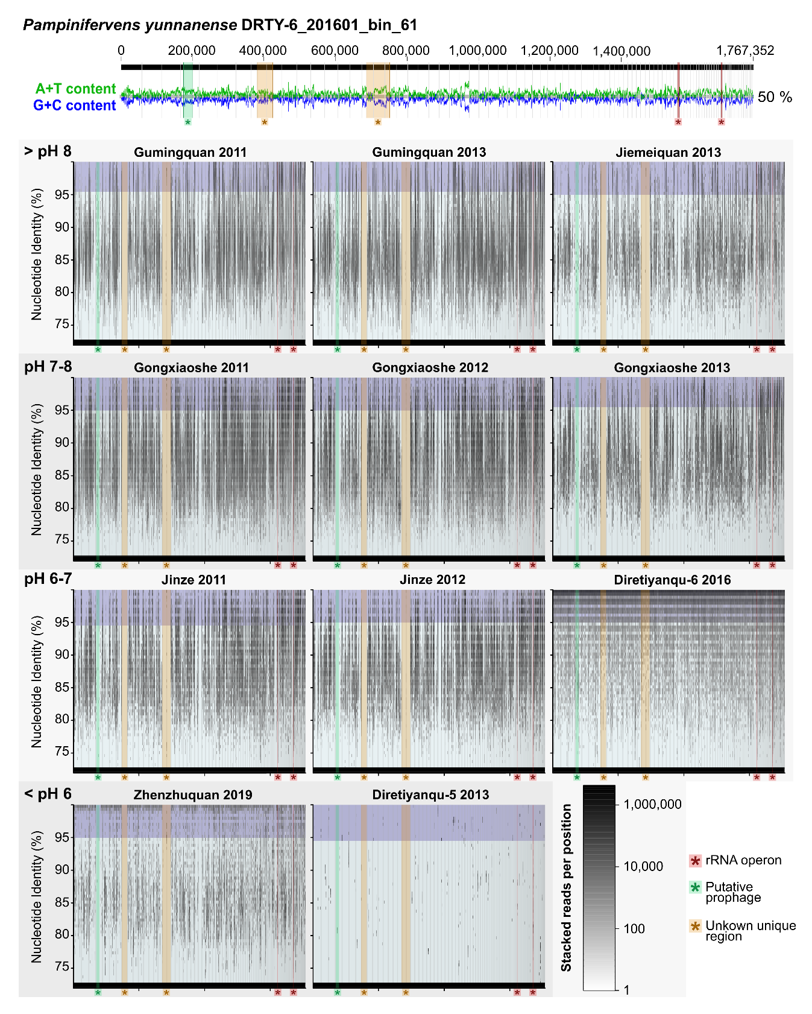
Figure S9. Recruitment plots for P. yunannense with metagenomic reads from Tengchong hot springs. Mapped reads with nucleotide identity > 95% (dark blue section) indicate reads of conspecific populations to the reference genome. Mapped reads with nucleotide identity < 95% (light blue section) indicate reads of different species occurring in the spring. Shade intensity of the reads indicates the number of stacked reads per position in the genome. Complete coverage of mapped reads across the genome is observed at high identity for the metagenome from which the MAG was recovered. Poor mapping at high nucleotide identity for reads from all other hot springs, except Zhenzhuquan, indicate that this species is likely not found in any other springs. Additionally, three genomic regions only had any reads mapped to it in the Diretiyanqu-6 metagenome (green and orange regions), indicating that this genomic region is unique to Diretiyanqu-6 of the metagenomes analyzed. One of these regions encode prophage-associated proteins.
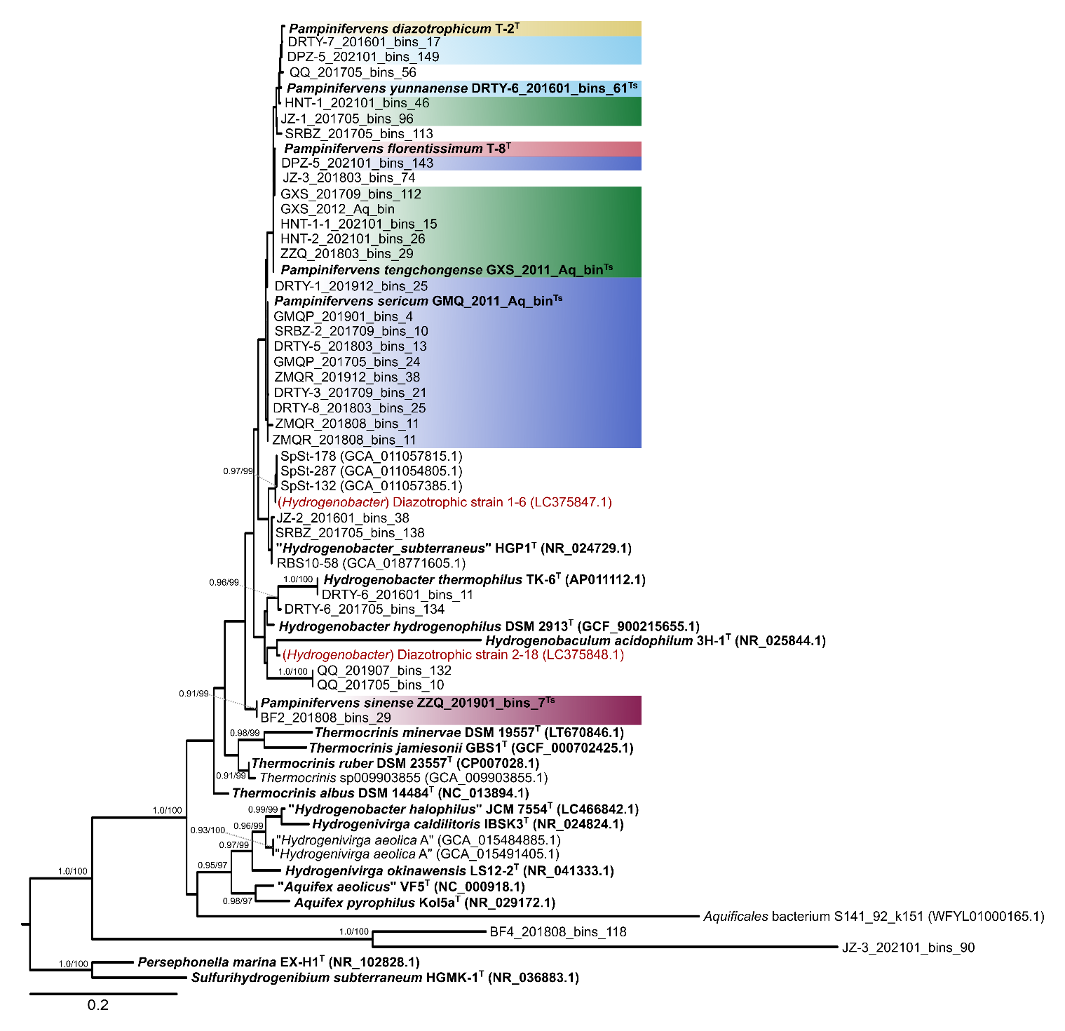
Figure S10. 16S rRNA gene phylogeny of the Aquificaceae. All Pampinifervens genomes with 16S rRNA gene sequences were analyzed in addition to all Aquificaceae 16S rRNA sequences from genomes of type and non-type organisms. Sequences were aligned with the SINA aligner and used for phylogenetic reconstruction using IQ-Tree. The best-fit evolutionary model was determined with the implemented model test in IQ-Tree, and Shimodaira-Hasegawa approximate likelihood ratio test (SH-aLRT) and ultrafast bootstrapping branch support was inferred from 1,000 pseudoreplicates each. Designated nomenclatural types are indicated with bold, and superscript “T” is used to denote types under the ICNP and superscript “Ts” is used to denote types under the SeqCode. Red text indicates previously confirmed diazotrophic strains.

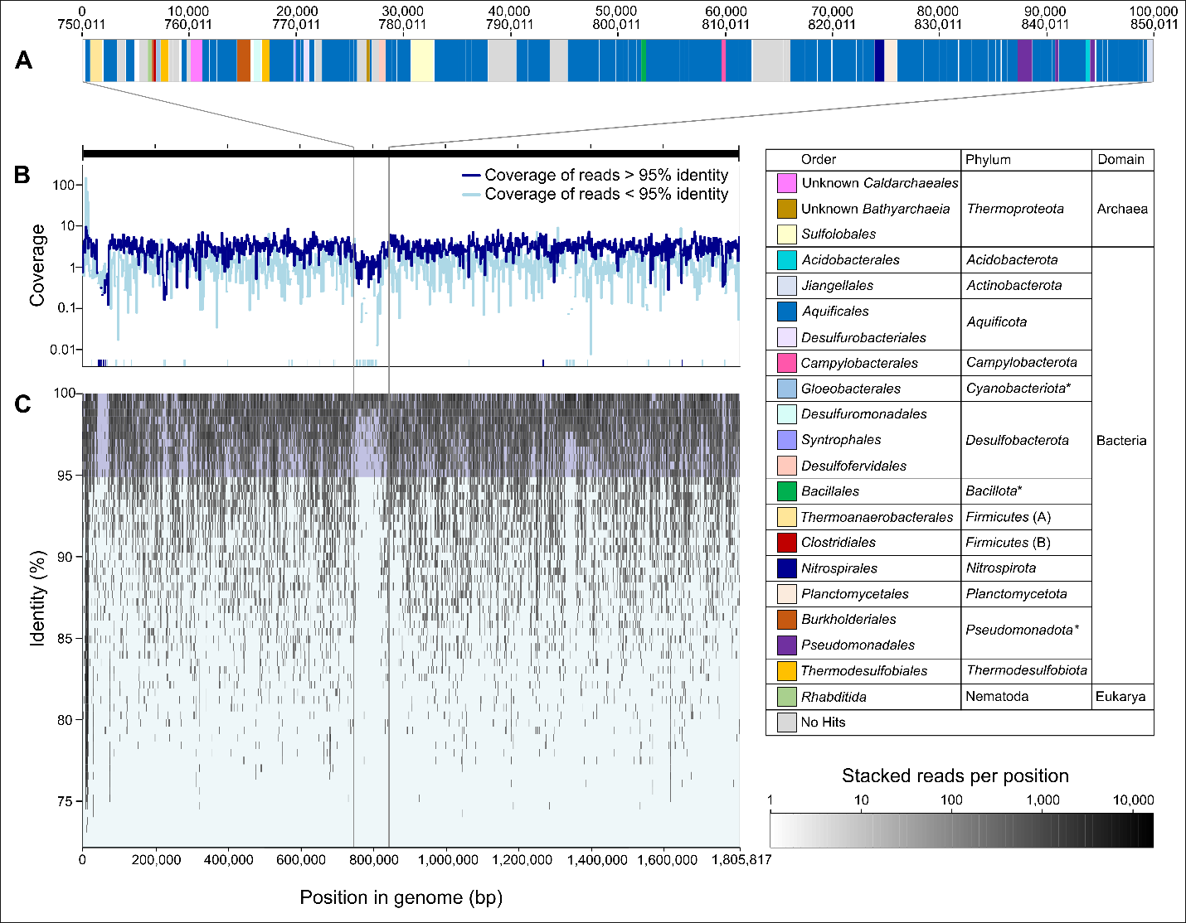
Figure S11. Summary of ICE composition in T-8. A) Genes were called and functionally annotated with Prokka and RASTtk, followed by HMMscan comparison to profiles of protein families in Pfam, TIGRFAM, Gene3D, Superfamily, PIRSF and TreeFam databases, all with default e-value thresholds. To further identify any closely related sequences in the non-redundant (nr) database, blastp searches were conducted with a minimum identity of 30% over at least 50% of the length coverage. The taxonomic affiliation of closest hits to genomes whose sequences are included in the nr database were based on GTDB classifications for prokaryotes. B) Sequence coverage across the genome of isolate T-8. Read coverage of > 95% identity to the T-8 genome is indicated in dark blue, while read coverage of reads with < 95% identity to the T-8 genome are indicated in light blue. C) Recruitment plot of the Qiao Quan metagenome to the genome of isolate T-8. The shade of the mapped reads are indicated as denoted in the stacked reads per position scale.
Supplementary Note 1: Energy and carbon metabolism of Pampinifervens
As with other Aquificales (1), sulfur metabolism features prominently in energy conservation in Pampinifervens, specifically through sulfur oxidation. All species of Pampinifervens encoded sulfide:quinone oxidoreductase (SQR) (Fig. S3 and Table S6), the enzyme responsible for the oxidation of sulfide (S²⁻) to elemental sulfur (S⁰) while reducing the quinone pool (2, 3). In “Aquifex aeolicus”, SQR is present as a homotrimeric protein that is embedded into the periplasmic face of the inner membrane (2-4), where polysulfide chains are taken into the cytoplasm and intracellular sulfur globules are formed (3, 5). However, it remains unclear whether any Pampinifervens spp. form intracellular sulfur deposits or whether elemental sulfur is deposited extracellularly as has been proposed for other Aquificae recently (6). Like all Aquificales compared here, all species of Pampinifervens also encoded a Sox complex (Fig. 3 and Table S6), which facilitates thiosulfate (S₂O₃²⁻) oxidation. This is consistent with the use of thiosulfate as electron donor by both T-2^{T} and T-8 (7), and with what has been reported for other Aquificales (1, 8). Additionally, although it was shown that T-2^{T} could use S⁰ as electron donor (7), no sulfur reductases were annotated in its genome, potentially due to poor functional annotation of many uncharacterized genes.
Most species of Pampinifervens encode a group 1d and/or group 2d hydrogenase. The exception to this was P. yunnanense, Pampinifervens sp. 12 and Pampinifervens sp. 13, which lacked any identifiable hydrogenases. As characterized in “Aquifex aeolicus”, group 1d hydrogenases are O₂-tolerant, membrane-bound uptake hydrogenases that are linked to the aerobic respiratory chain by transfer of electrons to cytochrome oxidases through the quinone pool (9-11) and contribution to the proton-motive force (11, 12) (Fig. 3). In contrast, very little is known about Group 2d hydrogenases, although it is likely cytosolic (13), and speculated to be involved in carbon fixation through the generation of reductants (5, 13, 14). Previously, the hypothesis that hydrogen that is produced as a by-product of nitrogen fixation is consumed by this hydrogenase in “A. aeolicus” (mbhSL3) was rejected due to the lack of genes for diazotrophy in Aquifex (13), however, we also believe this is an unlikely primary function for these group 2d hydrogenases, as the presence of these hydrogenases in Pampinifervens does not correspond to the presence of the nif gene cluster in the genus (Fig. 3 and S3). Rather, in line with the mechanism suggested for “A. aeolicus”, the group 2d hydrogenases of Pampinifervens may transfer electrons to ferredoxin, which can drive the tricarboxylic acid cycle in reverse for carbon fixation (5, 13).
All respiratory complexes for aerobic respiration are encoded by the HQ genomes of Pampinifervens species, consistent with observed growth of T-2^{T} and T-8 using O₂ as terminal electron acceptor. Subunits coding for NADH-quinone oxidoreductase (i.e., complex I, nuoABCDEFGHIJKLMN) are conserved within the genus (Fig. 3 and Table S6), and multiple copies of several of these genes were found in the genomes of most species, particularly nuoHIJKLMN (e.g., in T-8 and T-2, Table S7-8). This may be associated with distinct roles for different isozymes under different growth conditions (15), but as the second set of nuo genes are not complete in the genomes, the function of these additional copies is unclear. Genes coding for the low-affinity, high-velocity cytochrome c oxidase (complex IV; coxABC, including K02274, K02275, and K02276) is conserved within the genus, while subunits II and III of a cbb3-type cytochrome c oxidase (K00405 and K00406), and subunit I of the high-affinity cytochrome bd ubiquinol oxidase (K00425) is intermittently present within the genus (Table S6). Consistent with the rest of the Aquificaceae compared here, all Pampinifervens encode the F-type H⁺ translocating ATPase as complex V of their respiratory chain, whereas Persephonella marina in the Hydrogenothermaceae, also encode a A-type H+/NA+ transporting ATPase (Table S6) (16).
All known members of the Aquificaceae have the ability to fix CO₂ through the reverse tricarboxylic acid cycle (rTCA) with citrate cleavage facilitated through citryl-CoA synthetase and citryl-CoA lyase (17-19), and genes required for this pathway were conserved within Pampinifervens (Fig. 3 and Table S6). However, neither of the two alternate 2-oxoglutarate ferredoxin oxidoreductases (FOR and KOR) described in Hydrogenobacter thermophilus TK-6^{T} (20, 21) were found in genomes of Pampinifervens, although two putative pyruvate ferredoxin oxidoreductase (POR) gene clusters were predicted in the genomes, which is known to share high homology to FOR in H. thermophilus TK-6^{T} (20). As such, we propose that one of these copies may code for a 2-oxoglutarate ferredoxin oxidoreductase within Pampinifervens and is incorrectly annotated as a POR. Based on the data presented here, a sufficiently reduced quinone pool, as enhanced through the activity of the group 1d hydrogenase, and reduced ferredoxin, as facilitated by the group 2d hydrogenase, likely drive the rTCA in these microbes (13).

Supplementary Note 2: Unique genomic regions and mobile genetic elements are spring specific
During read recruitment of metagenomes to the nomenclatural types of the genus Pampinifervens, several genomic regions with no or low read coverage were recovered. These were particularly evident in P. florentissimum (Fig. S7) and P. yunnanense (Fig. S9), where mapping of reads from metagenomes of springs other than the source of the types generally lacked reads across several genomic regions. For P. florentissimum two genomic regions had little to no reads recruited from Gumingquan, Jiemeiquan, Gongxiaoshe, Jinze, Zhenzhuquan, and Diretiyanqu-5 (Fig. S7). In contrast, Diretiyanqu-6 and a metagenome from Qiao Quan (Fig. S11) where T-8 was isolated from, mostly had high similarity reads (>95% identity) mapping to one of the two regions (purple region in Fig. S7). Similarly, for P. yunnanense, metagenomes from all springs except Diretiyanqu-6 had little to no reads covering three genomic regions.
For both P. florentissimum and P. yunnanense, some of the unique regions found in their genomes may represent novel prophages (regions in green in Fig. S7 and S9). For P. florentissimum, the genomic region of T-8 between 42,000 and 72,000 bp encode roughly 44 proteins, of which several are phage associated. Among these are phage tail proteins (i.e., phage tail protein I [QID32292.1], phage tail sheath family protein [QID32327.1], phage major tail tube protein [QID32328.1], phage tail tape measure protein [QID32331.1], and phage tail protein [QID32332.1]), phage baseplate proteins (i.e., baseplate J/gp47 family protein [QID32293.1] and phage baseplate assembly protein V [QID32335.1]) and a N4-gp56 family major capsid protein [QID32321.1], which are all associated with virion structure and diagnostic of tailed phages (Büttner et al., 2016, Zinke et al., 2022). A recombinase [QID32302.1] and a Holliday junction resolvase [QID32312.1] are also encoded by this region, which may be associated with integration of phages into the host genome. Similarly, for P. yunnanense, the genomic region of DRTY-6_201601_bin_61 on scaffold 4 from approximately 6 200 to 31 200 bp, likely also encode a prophage, as roughly 40 proteins are encoded by this region, of which three functionally annotated genes code for a phage baseplate assembly protein [awaiting accession], a Mu-like prophage FluMu gp28 protein [awaiting accession], and a phage tail sheath protein [awaiting accession]. All other genes in this region are annotated as encoding hypothetical proteins. The lack in metagenomic read mapping across these putative prophages, especially at high sequence identity (>95%), likely indicate an environmental specificity for the phage populations, where only certain springs harbor specific phage populations. Additionally, large temporal fluctuations in the phage populations in these springs are also likely, as the putative prophage in the genome of T-8 recruited reads from Gongxiaoshe sampled in 2011 at nucleotide identity of 85-95%, but no reads were recruited to this region from Gongxiaoshe metagenomes sampled in 2012 or 2013, and the Qiao Quan metagenome sampled in July 2013 did not recruit reads across the prophage (Fig. S11), despite T-8 being isolated from this spring from samples taken in 2014 (7).
Other mobile genetic elements may also be responsible for the lateral transfer of unique genomic regions within the communities of different springs. The large genomic region in the genome of T-8 (indicated in purple in Fig. S7) that lacked recruited reads from most springs, may represent an integrative and conjugative element (ICE). This region represents approximately 100 kbp and is highly chimeric (Fig. S11). Closest matches to other organisms for the proteins encoded by genes in this region, were mostly to other Aquificales, including Aquifex, Hydrogenivirga, Hydrogenobacter, Hydrogenothermus, Persephonella, and Thermocrinis, however, matches to various other bacterial and archaeal phyla were also found, with one poor match to the nematode Caenorhabditis elegans (Table S10). Roughly 65% of genes predicted from this region represent hypothetical proteins, with only 14 of the roughly 120 genes having a consistent annotation with different annotation pipelines. Of these hypothetical protein-coding genes, those that have putative functions annotated based on HMM-profiles include genes for components of the Type IV conjugation machinery, along with various transposases, integrases and a relaxosome accessory protein (Table S10). Overall, this region is consistent with being a novel ICE as it conforms to the following key features: i) forms part of the chromosome of T-8 (22, 23), ii) contain genes associated with ICEs (22-24), iii) appears to be mosaic in nature (23, 24), and iv) is of a size typically associated with ICEs (22, 23).
Thermophilic organisms typically possess smaller genomes than their mesophilic counterparts (25-27), likely due to the inherent high maintenance energy and replication costs of large genomes (27, 28). This means that the adaptive potential of thermophiles is typically limited due to less genetic versatility (29), and lateral gene transfer may be key in maintaining adaptability of these populations (28-32). Thus, although larger genomes are typically considered more likely to harbor ICEs (22), the relatively small genome of T-8, harboring a ca. 100 kbp ICE, may be an example of where rapid lateral transfer of DNA is facilitated through an ICE, which may aid in adapting to environmental fluctuations, as has been noted before in Thermus species (28). It is thought that ICEs can potentially be maintained as conjugative plasmids and vice versa (22, 24), and that under strong selection pressures associated with capabilities conferred by the cargo genes (23), integration into the chromosome results in more stable maintenance of the element in the genome (22). However, further characterization of the cargo genes carried by this putative ICE, is necessary to understand the role of this and other ICEs in the evolution of these bacteria, as the potential benefits conferred by the cargo genes on this ICE are unclear at this moment.

References
1. Reysenbach A-L, Hamamura N, Podar M, Griffiths E, Ferreira S, Hochstein R, et al. Complete and draft genome sequences of six members of the Aquificales. J Bacteriol. 2009;191:1992-3.
2. Nübel T, Klughammer C, Huber R, Hauska G, Schütz M. Sulfide: quinone oxidoreductase in membranes of the hyperthermophilic bacterium "Aquifex aeolicus" (VF5). Arch Microbiol. 2000;173:233-44.
3. Marcia M, Ermler U, Peng G, Michel H. The structure of "Aquifex aeolicus" sulfide: quinone oxidoreductase, a basis to understand sulfide detoxification and respiration. Proc Natl Acad Sci USA. 2009;106:9625-30.
4. Sousa FM, Pereira JG, Marreiros BC, Pereira MM. Taxonomic distribution, structure/function relationship and metabolic context of the two families of sulfide dehydrogenases: SQR and FCSD. Biochim Biophys Acta Bioenerg. 2018;1859:742-53.
5. Guiral M, Tron P, Aubert C, Gloter A, Iobbi-Nivol C, Giudici-Orticoni M-T. A membrane-bound multienzyme, hydrogen-oxidizing, and sulfur-reducing complex from the hyperthermophilic bacterium "Aquifex aeolicus". J Biol Chem. 2005;280:42004-15.
6. Tamazawa S, Yamamoto K, Takasaki K, Mitani Y, Hanada S, Kamagata Y, et al. In situ gene expression responsible for sulfide oxidation and CO₂ fixation of an uncultured large sausage-shaped Aquificae bacterium in a sulfidic hot spring. Microbes Environ. 2016;31:194-8.
7. Hedlund BP, Reysenbach A-L, Huang L, Ong JC, Liu Z, Dodsworth JA, et al. Isolation of diverse members of the Aquificales from geothermal springs in Tengchong, China. Front Microbiol. 2015;6:157.
8. Reysenbach A-L. Aquificales in Yellowstone National Park. In: Inskeep W, McDermott T, editors. Geothermal Biology and Geochemistry in Yellowstone National Park. Bozeman, Montana, United States of America: Montana State University Publications; 2005. p. 129-42.
9. Guiral M, Tron P, Belle V, Aubert C, Léger C, Guigliarelli B, et al. Hyperthermostable and oxygen resistant hydrogenases from a hyperthermophilic bacterium "Aquifex aeolicus": physicochemical properties. Int J Hydrogen Energy. 2006;31:1424-31.
10. Pandelia M-E, Lubitz W, Nitschke W. Evolution and diversification of Group 1 [NiFe] hydrogenases. Is there a phylogenetic marker for O₂-tolerance? Biochim Biophys Acta Bioenerg. 2012;1817:1565-75.
11. Carere CR, Hards K, Houghton KM, Power JF, McDonald B, Collet C, et al. Mixotrophy drives niche expansion of verrucomicrobial methanotrophs. ISME J. 2017;11:2599-610.
12. Pinske C, McDowall JS, Sargent F, Sawers RG. Analysis of hydrogenase 1 levels reveals an intimate link between carbon and hydrogen metabolism in Escherichia coli K-12. Microbiology. 2012;158:856-68.
13. Brugna-Guiral M, Tron P, Nitschke W, Stetter K-O, Burlat B, Guigliarelli B, et al. [NiFe] hydrogenases from the hyperthermophilic bacterium Aquifex aeolicus: properties, function, and phylogenetics. Extremophiles. 2003;7:145-57.
14. Greening C, Biswas A, Carere CR, Jackson CJ, Taylor MC, Stott MB, et al. Genomic and metagenomic surveys of hydrogenase distribution indicate H₂ is a widely utilised energy source for microbial growth and survival. ISME J. 2016;10:761-77.
15. Spero MA, Brickner JR, Mollet JT, Pisithkul T, Amador-Noguez D, Donohue TJ. Different functions of phylogenetically distinct bacterial complex I isozymes. J Bacteriol. 2016;198:1268-80.
16. Dibrova DV, Galperin MY, Mulkidjanian AY. Characterization of the N-ATPase, a distinct, laterally transferred Na⁺-translocating form of the bacterial F-type membrane ATPase. Bioinformatics. 2010;26:1473-6.
17. Hügler M, Huber H, Molyneaux SJ, Vetriani C, Sievert SM. Autotrophic CO₂ fixation via the reductive tricarboxylic acid cycle in different lineages within the phylum Aquificae: evidence for two ways of citrate cleavage. Environ Microbiol. 2007;9:81-92.
18. Hügler M, Wirsen CO, Fuchs G, Taylor CD, Sievert SM. Evidence for autotrophic CO₂ fixation via the reductive tricarboxylic acid cycle by members of the ɛ subdivision of Proteobacteria. J Bacteriol. 2005;187:3020-7.
19. Ganji R, Murugapiran SK, Ong JC, Manoharan N, Huntemann M, Clum A, et al. High-quality draft genome sequence of Thermocrinis jamiesonii GBS1^{T} isolated from Great Boiling Spring, Nevada. Genome Announc. 2016;4:e01112-16.
20. Yamamoto M, Arai H, Ishii M, Igarashi Y. Characterization of two different 2-oxoglutarate:ferredoxin oxidoreductases from Hydrogenobacter thermophilus TK-6. Biochem Biophys Res Commun. 2003;312:1297-302.
21. Yamamoto M, Ikeda T, Arai H, Ishii M, Igarashi Y. Carboxylation reaction catalyzed by 2-oxoglutarate:ferredoxin oxidoreductases from Hydrogenobacter thermophilus. Extremophiles. 2010;14:79-85.
22. Guglielmini J, Quintais L, Garcillán-Barcia MP, de La Cruz F, Rocha EP. The repertoire of ICE in prokaryotes underscores the unity, diversity, and ubiquity of conjugation. PLoS Genet. 2011;7:e1002222.
23. Johnson CM, Grossman AD. Integrative and conjugative elements (ICEs): what they do and how they work. Annu Rev Genet. 2015;49:577-601.
24. Cury J, Touchon M, Rocha EP. Integrative and conjugative elements and their hosts: composition, distribution and organization. Nucleic Acids Res. 2017;45:8943-56.
25. Sabath N, Ferrada E, Barve A, Wagner A. Growth temperature and genome size in bacteria are negatively correlated, suggesting genomic streamlining during thermal adaptation. Genome Biol Evol. 2013;5:966-77.
26. Sorensen JW, Dunivin TK, Tobin TC, Shade A. Ecological selection for small microbial genomes along a temperate-to-thermal soil gradient. Nat Microbiol. 2019;4:55-61.
27. Hedlund BP, Thomas SC, Dodsworth JA, Zhang CL. Life in high‐temperature environments. In: Yates M, Nakatsu CH, Miller RV, Pillai SD, editors. Manual of Environmental Microbiology. 4th ed. Washington, DC: ASM Press; 2016. p. 4.3.4.1-4.3.4.15.
28. Blesa A, Averhoff B, Berenguer J. Horizontal gene transfer in Thermus spp. Curr Issues Mol Biol. 2018;29:23-36.
29. Fuchsman CA, Collins RE, Rocap G, Brazelton WJ. Effect of the environment on horizontal gene transfer between bacteria and archaea. PeerJ. 2017;5:e3865.
30. Rhodes ME, Spear JR, Oren A, House CH. Differences in lateral gene transfer in hypersaline versus thermal environments. BMC Evol Biol. 2011;11:199.
31. Blesa A, Berenguer J. Contribution of vesicle-protected extracellular DNA to horizontal gene transfer in Thermus spp. Int Microbiol. 2015;18:177-87.
32. Blesa A, Berenguer J. Methods to identify and analyze vesicle-protected DNA transfer. In: de la Cruz F, editor. Horizontal Gene Transfer Methods in Molecular Biology. 2075. Humana, New York, NY: Springer; 2020.

