Table 1. Attributes of Available and proposed emergency assembly points
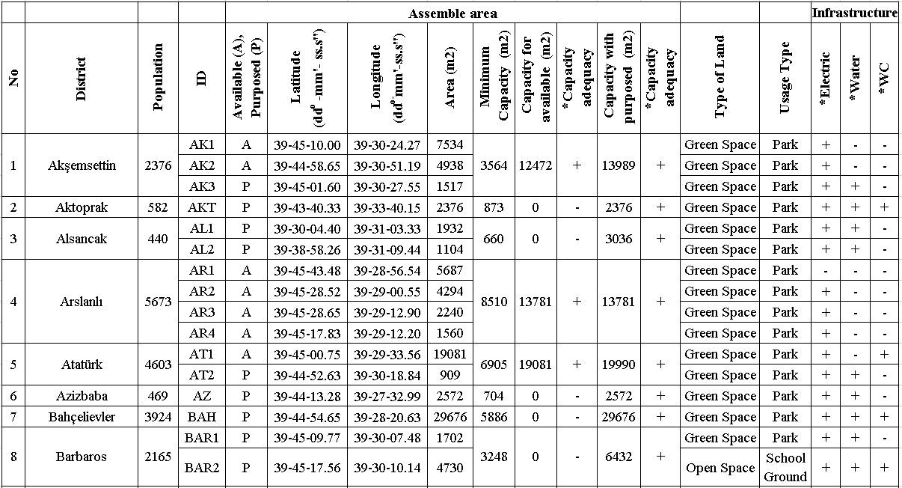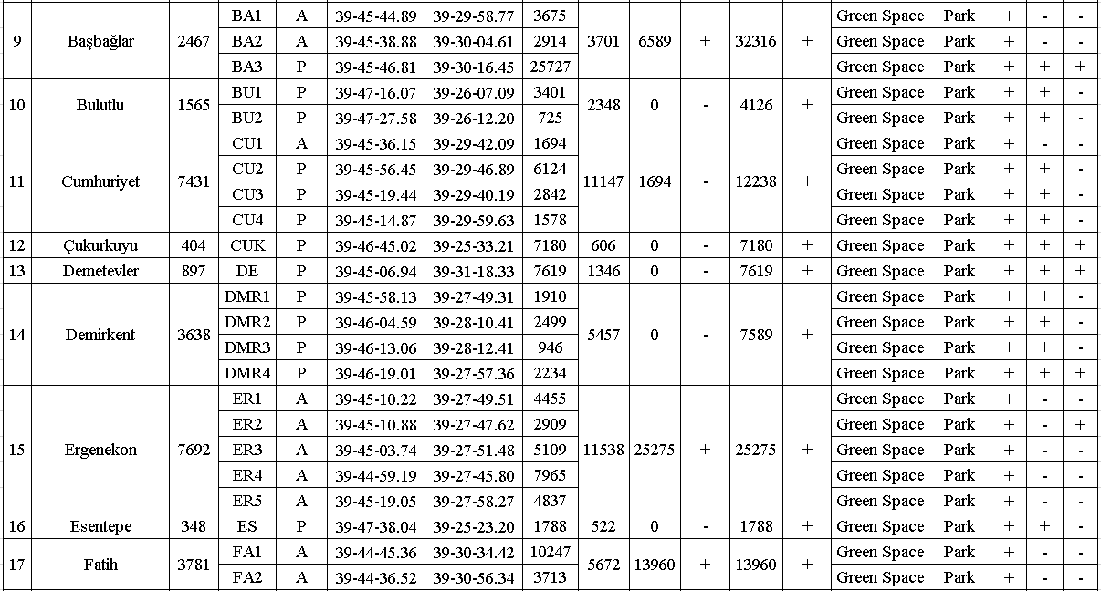
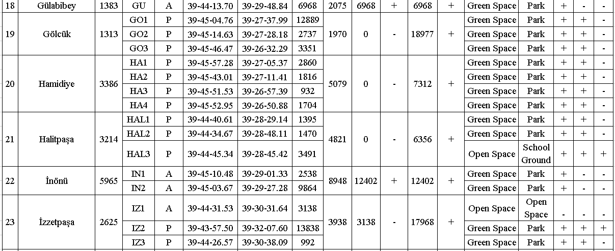
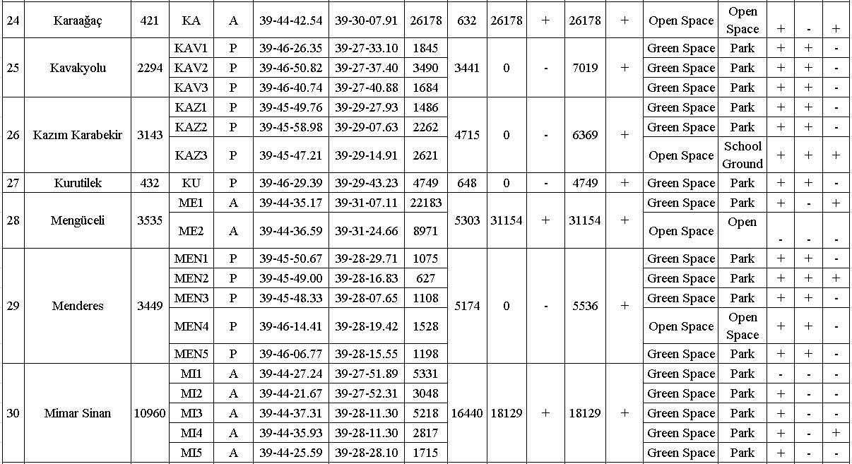
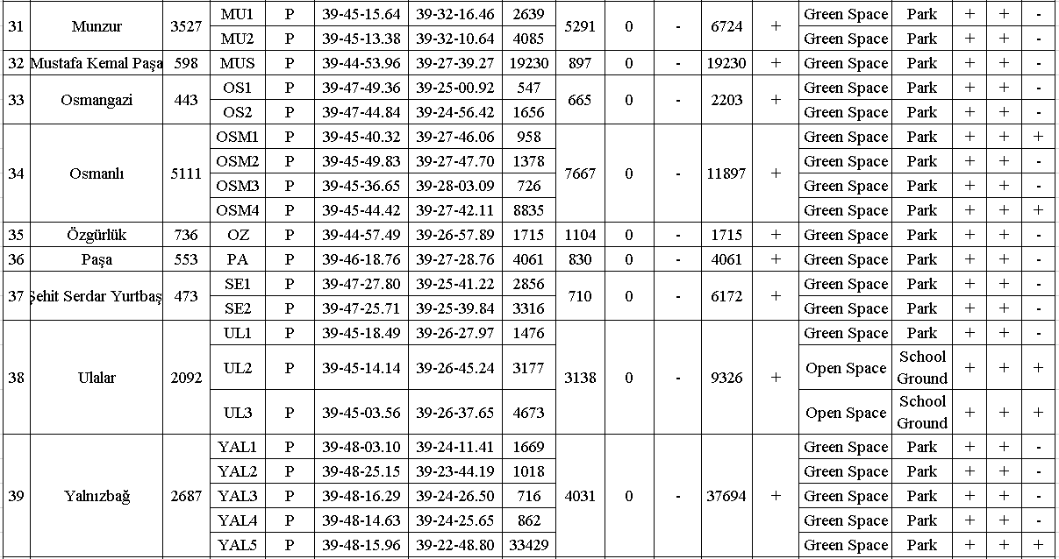
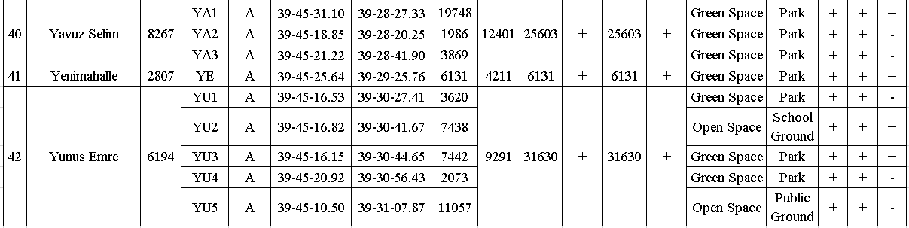
*Available(+), Not Available(-)

Table 2. Service areas of emergency assembly points in neighborhoods for 250m and 500m
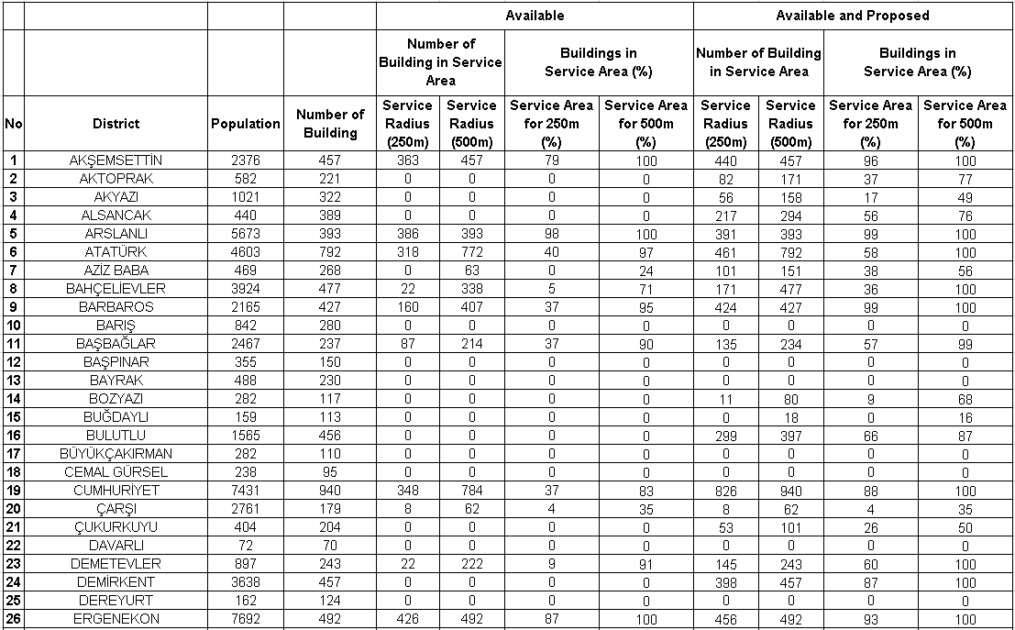
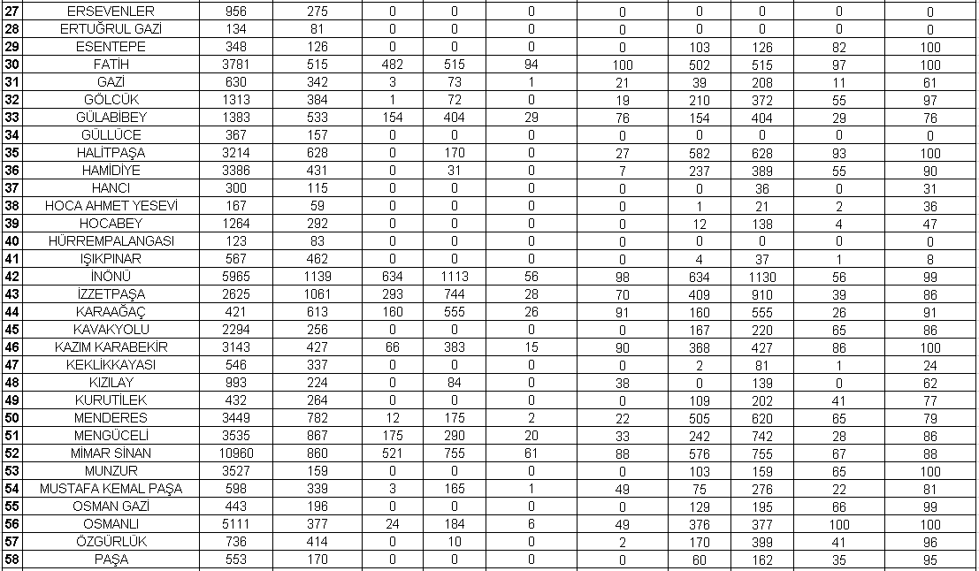
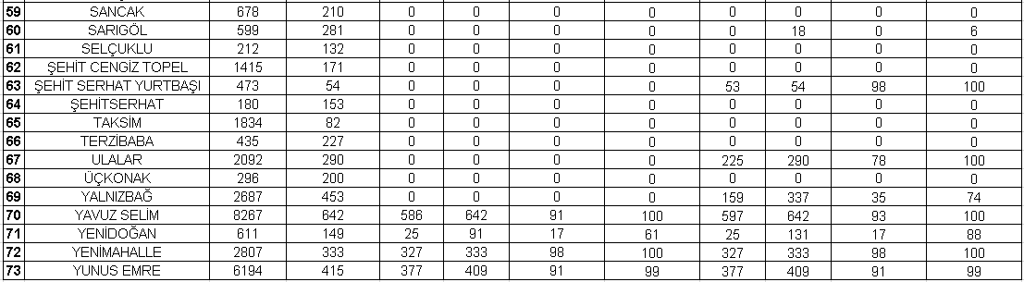
Table 3. Number (ƒ) of neighborhood for 250 m, and 500m service area
 | Available |  | Proposed
 | 250m service area  ƒ | 500m service area  ƒ | 250m service area  ƒ | 500m service area  ƒ
%0-24 | 57 | 47 | 32 | 22
%25-49 | 7 | 6 | 12 | 5
%50-74 | 2 | 3 | 13 | 6
%75-100 | 7 | 17 | 16 | 40

