SUPPLEMENTARY MATERIAL

 |  | Univariable logistic regression |  |  | Stepwise logistic regression
Variable |  | OR | 95% Confidence Interval | p-value | OR | 95% Confidence Interval | p-value
Duration of fishing | as continuous | 1,51 | 0,89 to 2,55 | 0,1222 | not entered
Depth of fishing net | as continuous | 1,018 | 0,998 to 1,038 | 0,0735 | not entered
CCL | as continuous | 0,977 | 0,93 to 1,03 | 0,3453 | not entered
CCW | as continuous | 0,973 | 0,921 to 1,027 | 0,3166 | not entered
Weight | as continuous | 0,977 | 0,945 to 1,01 | 0,1682 | not entered
Gender | F vs M | not estimable |  | 0,981 | not entered
Gender | J vs M | not estimable |  | 0,9775 | not entered
Temperature | as continuous | 1,037 0,863 to 1,246 |  | 0,6994 | not entered
Respiratory Rate | as continuous | 0.92 0,78 to 1,08 |  | 0,2894 | not entered
Peripheral edema | Yes vs No | 2 | 0,24 to 16,39 | 0,5193 | not entered
Cloacal prolapse | Yes vs No | 0,98 | 0,37 to 2,58 | 0,9694 | not entered
Hind limbs under carapace | Yes vs No | 11,63 | 2,16 to 62,5 | 0,0043 | 21,28 | 1,49 to 333,33 | 0,0242
Neurological deficit | Yes vs No | 24,39 | 6,76 to 90,91 | <0,0001 | 7,87 | 1,31 to 47,62 | 0,0243
Sensory | Comatose vs Alert | 29,78 | 6,13 to 144,76 | 0,0001 | 80,13 | 8,25 to 778,09 | 0,0003
Sensory | Depressed vs Alert | 1,67 | 0,65 to 4,3 | 0,0437 | 6,023 | 0,97 to 37,24 | 0,6019
PCV (reference value <0.29) | >0.35 | 1.78 | 0.45 to 7.13 | 0.6059 | not entered
 | 0.33 – 0.35 | 1.25 | 0.29 to 5.31 | 0.7511
 | 0.29 – 0.33 | 1.92 | 0.51 to 7.29 | 0.4640
Heart rate | <=12 bpm vs >12 bpm | 12.69 | 2.82 to 57.07 | 0.0009 | not entered

Table S1: Results of the univariable logistic regression and of the multivariable logistic regression. In the univariable model each factor was evaluated alone; in the multivariable all factors were analyzed together but a stepwise method selected the statistically significant factors. Not all significant factors in the univariable were statistically significant in the multivariable.

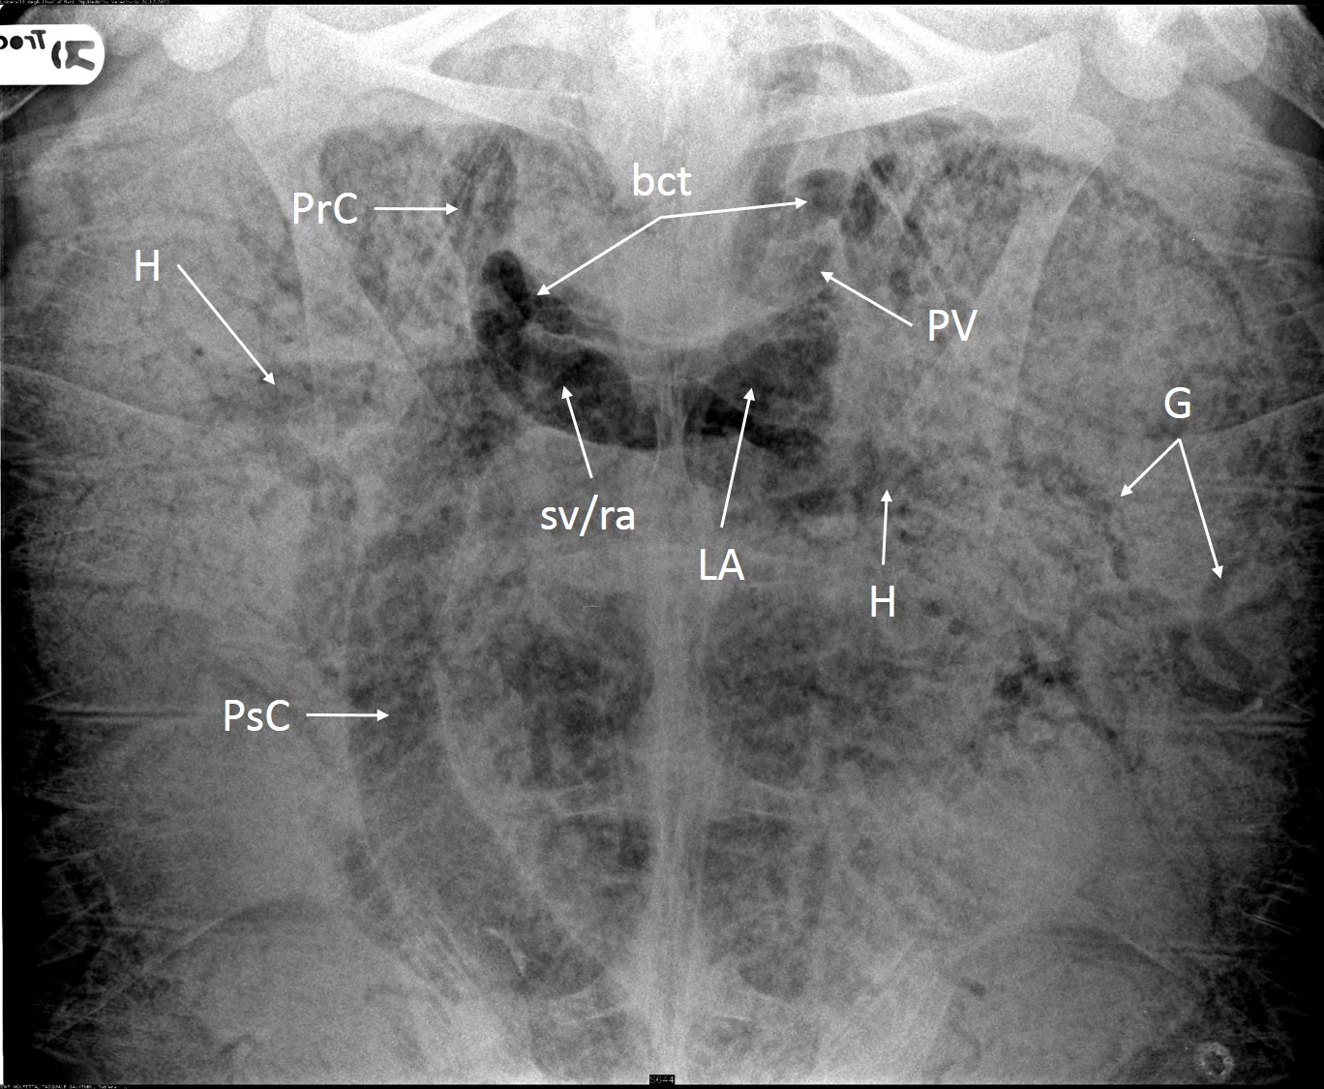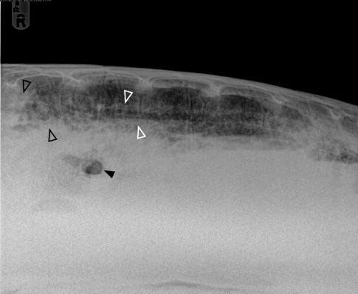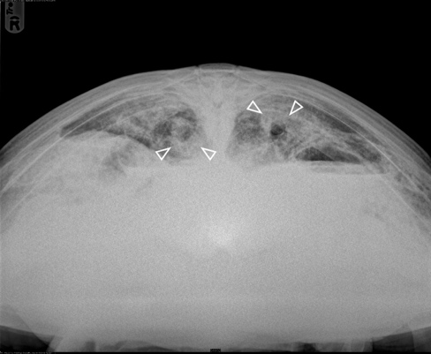
A B C

Fig. S1. Radiographic study of a Loggerhead turtle (Caretta caretta) with GE associated with drowning. A) Dorsoventral view shows presence of gas inside the sinus venosus/right atrium (sv/ra), left atrium (LA), brachiocephalic trunk (bct), pulmonary vessels (PV), precava (PrC) and postcava vein (PsC), hepatic vessels (H) and gastric vessels (G). The massive accumulation of gas in the heart chambers and in the brachiocephalic trunk (black arrow) is also evident in the lateral view (B). In the craniocaudal (C) and lateral projections is evident diffuse opacification of the pulmonary parenchyma, in the dorsal cranial area (empty black arrows) and around the bronchi (empty white arrows), due to the inspiration of sea water.

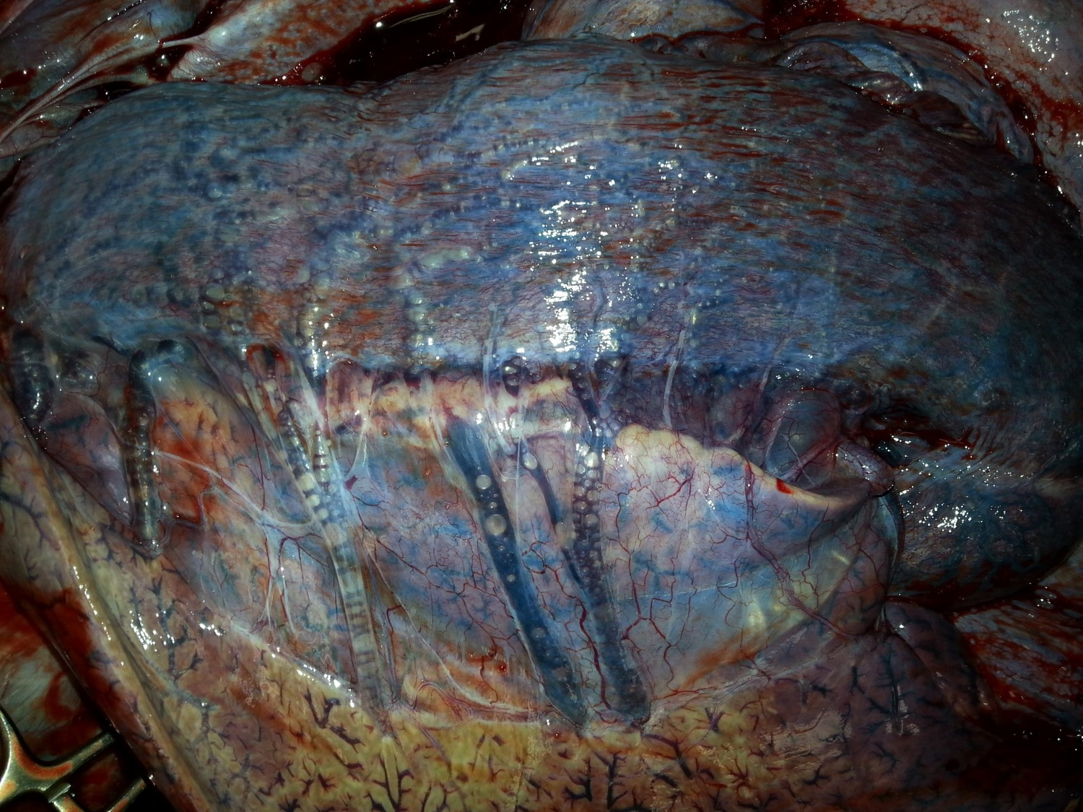

Fig. S2. Postmortem examination of a Loggherhead with severe GE: the vessels of the hepatogastric ligament show side by side serial macrobubbles with evident vascular obstruction.

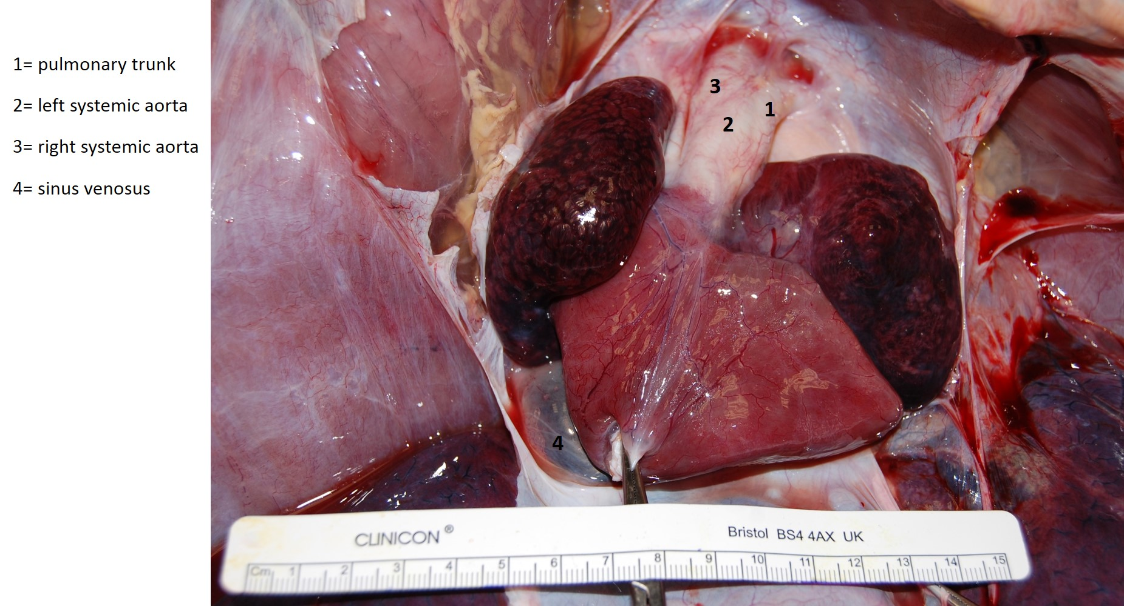
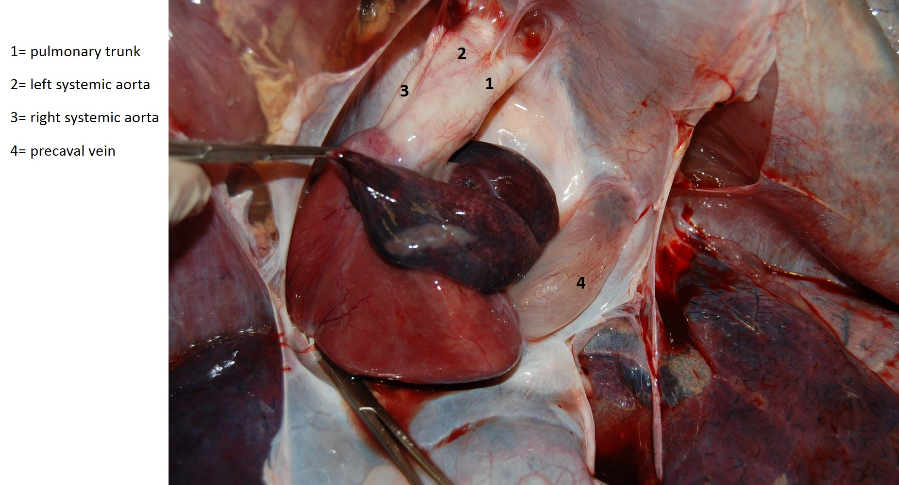
A B

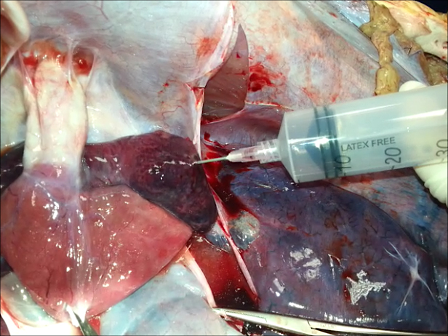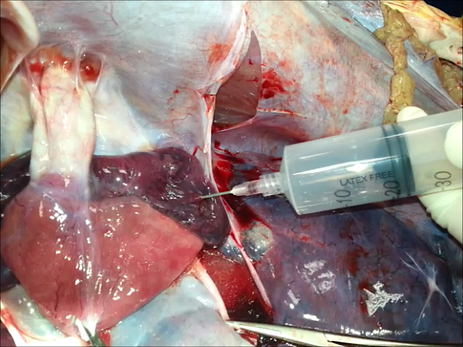
C D

Fig. S3. Postmortem examination of the heart of a turtle with severe GE after the opening the pericardial sac. (A) the right atrium is displaced with forceps to show the precaval vein below that is diffusely distended by gas that completely replaced the blood. B) The right and left atrium are markedly distended with intracameral gas. C) the gas was aspirated with a 60 ml syringe from the left atrium D) the atrium appearance after the air aspirated (20 ml) resembles a “deflated balloon”

