Supplementary material

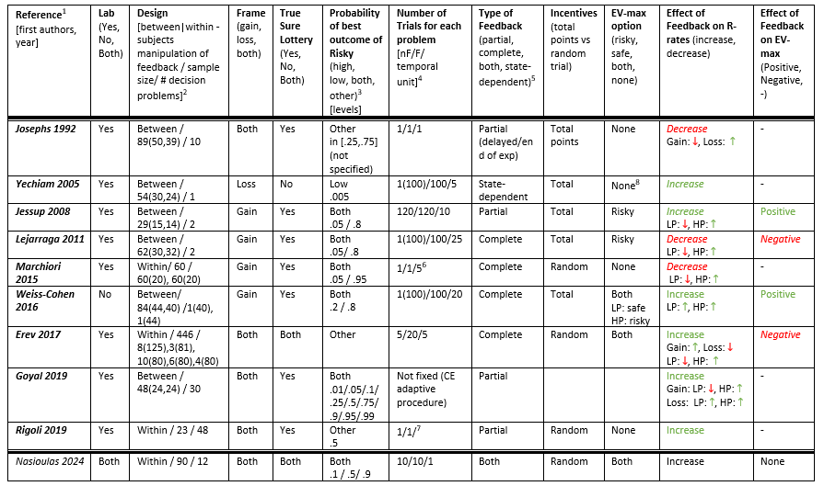

Table S1: details of the design of relevant literature.
¹ Josephs 1992 refers to Experiment 2 (“Study 2”) of the paper, which compares description-based decisions without feedback and with partial feedback. Yechiam 2005 refers to the “Experience” condition, which corresponds to the feedback case (Descriptions+Experience) and to the “D-Binary” condition, which is a description-only condition with one choice from the subject then repeated 100 times by the computer. Lejarraga 2011 refers to the “DS” condition (Description-only) and to the DES condition (Description+Experience). Marchiori 2015 refers to the condition of decision under risk in Experiment (“Study”) 1 & 3. We excluded the decision under risk condition of Experiment 2 as it is preceded by the condition of decision under estimated risk which creates a carryover effect (page 19, Marchiori et al., 2015). Weiss-Cohen 2016 refers to the conditions D and DES (description-only and description+experience, respectively) of Experiment 1. Erev 2017 refers to the problems mentioned in Supplementary Material/ Erev et al. (2017) re-analysis.
² In the between-subjects design the sample size field has the form [total(no-feedback, feedback)]. In case decision problems were manipulated between-subjects, the #decision problems field contains the different groups with the format #decisionProblems(#participants) mentioning in parentheses the number of participants in the relevant group of decision problems.
³ “Other” corresponds to the case that the risky option can give the best outcome with a medium-range probability as well. Note that some studies define the probability of the risky option as the probability of getting the best outcome in absolute value. This gives a different (in fact, opposite) classification of high/low probabilities and this is the reason why some problems that are classified as low(high)-probability in the initial studies are classified as high(low)-probability by us.
⁴ In the parentheses of the “nF” field we put the number of trials played/simulated by the computer (if any, otherwise omitted). The “temporal unit” field corresponds to the number of trials used as one data point in the reported results of the original paper.
⁵ In the “state-dependent” case, the outcomes of the options are correlated and determined by the (random) instantiation of the state of the world. It is similar to the complete feedback case, as we get to know the results of all options, but still, they are conceptually different.
⁶ Each decision problem is tested either with or without feedback for one trial (not in both conditions). For each participant, 5 out of the 60 problems were tested without feedback and then the rest 55 problems were tested with feedback. The order of the problems is randomized across participants, so in the aggregate data, most problems have been tested both with and without feedback. Yet, the problems differed only in the magnitudes, so to some extent this design is a hybrid between one-shot and repeated trials.
⁷ They do four runs of a batch of 96 trials in which each condition is repeated only once: essentially one-shot.
⁸ The expected values of the safe and the risky option of Yechiam 2005 are 2.03 and 1.995, respectively. Given the very small difference, we decided to treat them as equal.

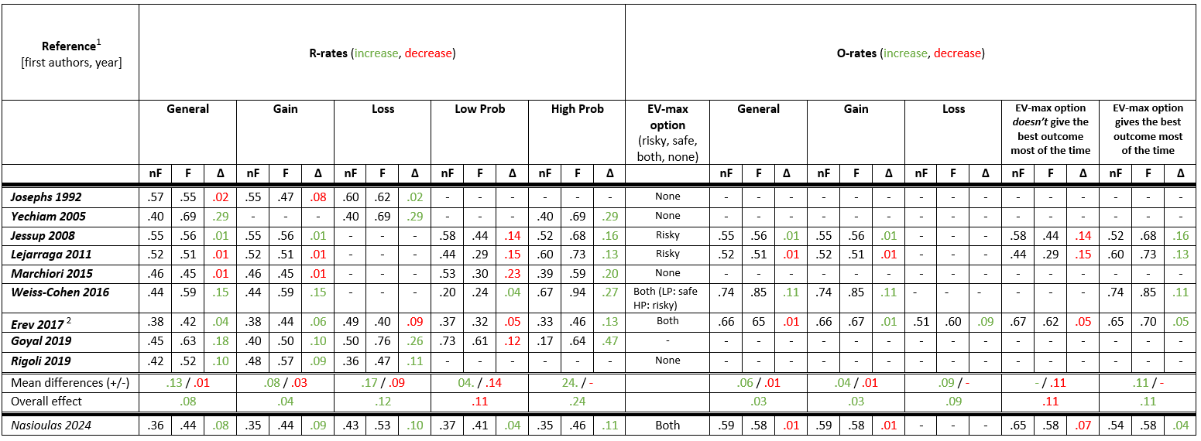

Table S2: Detailed Risky-rates and Optimal-rates in various conditions in the relevant literature.
¹ Many of the reported R-rates are not presented per se in the relevant publications. In these cases, the R-rates were obtained by averaging conditions in Table 2 (Josephs 1992); by re-analyzing the data kindly provided by the authors (Jessup 2008); extracted from Fig1(Lejarraga 2015); by re-analyzing the raw data available online (Erev 2017); by merging Table2 and Table3 (Goyal 2019). Note that R-rates in Goyal 2019 are not the typical Risky-rates, as this paper used a staircase procedure to compute the Certainty Equivalent of various risky gambles. R-rate here correspond to the percentage of risk seeking choices (choices where CE > EV(gamble)). Additionally, none of the reported O-rates are explicitely presented as such in the relevant publications. We obtained them by converting R-rates to O-rates depending on the condition.
² Only one decision problem in the loss domain (meaning with all the outcomes being non-positive). In this study there are also problems with outcomes in both domains -this explains why we see a positive effect on O-rates both in the gain and in the loss domain, but not in general case.

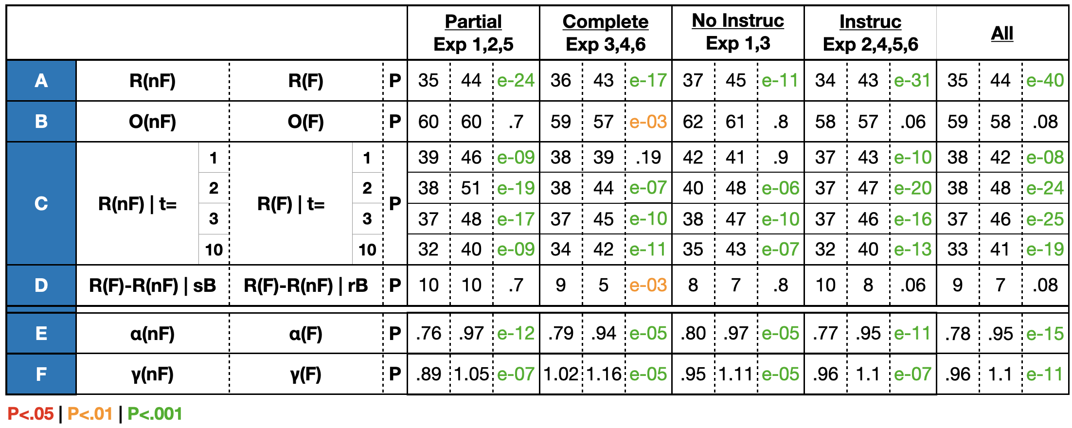
Table S3: mean percentages and fitted values when grouping experiments together. Upper part (sections A-D): it is the analogous of Table 3 but after grouping experiments with respect to type of feedback (partial or complete) or to block instructions availability, as well as when grouping Exps 1-6 together. O=optimal, R=risky, nF= no feedback, F = feedback, t=trial, sB=sure-better, rB=risky-better. A|B means that A is computed in the condition B. Lower part (sections E-F): fitted values of the utility parameter (alpha) and the probability weighting function (gamma) for the various groupings of the experiments. P-values are Wilcoxon Signed-Rank tests.

Erev et al. (2017) re-analysis
This is by far the most extensive study that includes description-only and description+experience choices, consisting of 150 decision problems and 446 participants. However, the main goal of the Erev et al. 2017 paper was not to compare these two paradigms. In an attempt to facilitate this comparison, we processed the raw data of the aforementioned paper and we examined whether we can replicate with their data our main results. In doing so, we focused on a subset of their decision problems, that enables us to answer the most important questions of our investigation.
First of all, we excluded from our analysis problems that involve ambiguity, more than two outcomes for one option, a correlation between the outcomes of the two lotteries, and decisions without lotteries (eg coin-toss). Additionally, to be able to assess the effect of feedback on EV-maximization and on risk propensity, we further excluded decision problems in which the two options had equal EVs, problems that did not have the form of a sure vs a risky lottery, trivial problems (problems in which one option dominates the other) and problems with extreme probabilities for the risky option (1% or 99%); this left us with 31 decision problems, which constitute the pool for the following discussion.
In the aforementioned pool of decision problems of Erev et al. 2017, as mentioned in the main text, there is an absence of an effect of feedback on the optimal choice, a significant effect of feedback on increasing risky choice rates, and a gambler’s fallacy pattern. Additionally, Erev, which features complete feedback, replicates the monotonic relationship between the effect of feedback on R-rates and the probability level of the best outcome of the risky option, which is also present in our complete feedback experiments. So, Erev et al. 2017 verifies and thus solidifies most of our main findings -with the first-trial effect being the only one remaining to be examined.
To do so, we first have to look into the ordering of the blocks/problems in Erev et al 2017. Erev used two order conditions tested between-subjects. In the “by-problem” order, all trials related to a decision problem were presented in a row, in a block of twenty-five trials, with five no-feedback trials in the beginning and twenty feedback trials following (Figure S1A). In the “by-feedback” order, subjects first faced all the no-feedback trials for all the problems (with the five no-feedback trials of each problem being consecutive, i.e. grouped in mini-blocks), and then they faced all the feedback trials for all the problems (again, grouped in mini-blocks of twenty trials each) (Figure S1B). Notably, between the two parts of the by-feedback order, namely the no-feedback and the feedback one, there were instructions explicitly informing the participants of the presence of feedback in the second (feedback) part. Hence, in the by-feedback condition subjects knew they would receive feedback before even receiving it -resembling the case in which our experiments feature block instructions. In contrast, in the by-problem order, not only the instructions were vaguer not revealing the exact structure of each block, but even if the subjects knew (or managed to discover throughout the task) the exact structure, they would still have to count precisely in each block the number of no-feedback trials, to know exactly when the feedback ones begin. While we cannot be sure about whether participants were dedicated enough to determine precisely the beginning of each feedback mini-block in the by-problem condition, we can probably speculate that many of them did not. If the latter is the case, then the by-problem condition resembles our experiments that did not feature block instructions: at the beginning of the first feedback trial (trial 6) subjects did not know whether they would receive feedback or not, and after receiving feedback in trial 6, they would know from trial 7 onwards that the rest of the block comprises of feedback trials.
According to our findings and interpretations, we thus expected that in the by-problem condition (resembling the case without block instructions), we would not see a difference in the R-rates between trial 5 and trial 6, and we would see a difference in the R-rates between trial 6 and trial 7. In contrast, in the by-feedback condition (resembling the case with block instructions), we would expect the increase of R-rates to appear immediately in the presence of feedback, namely between trial 5 and trial 6 (again, grouping all the twenty-five trials of each decision problem in one block, just for the sake of the analysis). This is exactly the pattern we observe in the behavioral results of Erev et al 2017 (Figure S1C & D).

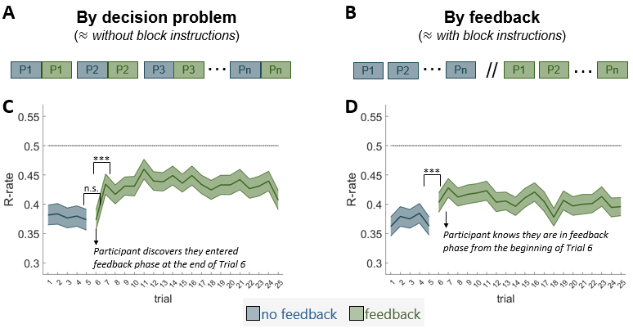
Figure S1: re-analysis of Erev et al. (2017). (A) Illustration of the ordering of the decision problems (P1,…, Pn) and no-feedback/feedback trials (blue/green, respectively) in the “by-decision” condition. All trials of a decision problem are grouped together in a block, with no-feedback trials always preceding the feedback ones in all blocks. The subtitle refers to the analogous condition in our experiments -here, the by-problem condition of Erev et al. 2017 corresponds to the case where we do not have block instructions in our experiments. (B) same as (A), but for the “by-feedback” condition. (C) The colored lines represent the risky choice rate as a function of the feedback condition and the trial number within a block. (D) same as (C) but for the “by-feedback” condition.
Wilcoxon signed-rank test: ***: p<0.001 | n.s.: p>0.05

Cognitive modeling

Results
Finally, we analyzed our main datasets (experiments 1-6) through the lens of descriptive behavioral modeling. More specifically we applied a two-parameters version of Cumulative Prospect Theory (CPT; (Tversky & Kahneman, 1992)) that we fitted separately per subject and per feedback condition (feedback / no feedback) (see also Supplementary Materials). After checking that they were correctly recoverable in simulated datasets, we found that both the utility curvature parameter and the probability distortion parameter increased with the presence of feedback (both P < 0.001; Figure S2A-B; Table S3.E-F). Of note, these (significant) differences between parameters should be interpreted in the light of their impact on the subjective decision variable that they control (respectively, on the utility value and on the subjective weighting). In fact, the parameter differences translated into radically separable utility curvature (Figure S2C), but only on marginal effects on the probability weighting function (Figure S2D). Thus, overall, these computational results suggest that between-condition differences are better captured by different subjective utilities of the outcomes, rather than by different perception of the involved probabilities.
Modelling discussion
Our descriptive modeling results suggest that both the utility parameter and the probability weighting parameters are affected by the feedback manipulations (Prelec, 1998; Tversky & Kahneman, 1992). However, despite the fact that the relative difference was comparable for both parameters, only the utility parameter induced sensible differences in the resulting psychometric function. As a matter of fact, we did not find strong evidence of probability weighting, such as overweighting or underweighting or rare events, in our data (Wulff et al., 2017). This is probably in part due to the fact that we did not use the very extreme probabilities supposed to elicit the possibility and certainty effects (Kahneman & Tversky, 1979), and future research should establish whether or not our results (both behavioral and computational) hold across a broader probability range (including both very low, 1%, and very high, 99%, probabilities). Nonetheless, our findings illustrate once again that a set of well-established decision anomalies (such as the possibility and certainly effect) may only arise in very narrow sub-spaces of decision problems, such that their role in building generally valid decision model should be reconsidered (see Erev et al., 2010, 2017 for similar considerations).

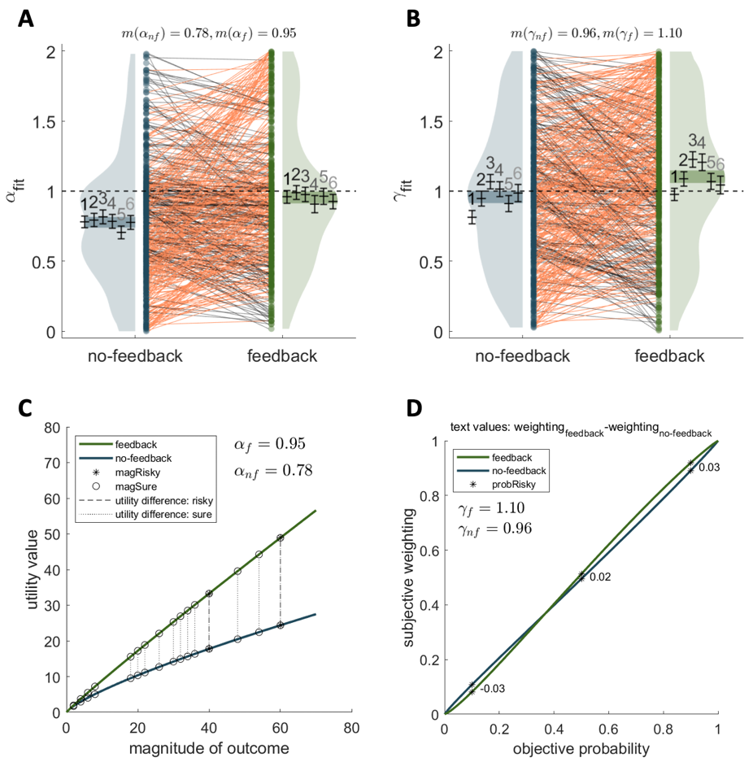
Figure S2: model-fitting results of Experiments 1-6. (A) Fitted values of the utility parameter (alpha) as a function of the feedback condition in Experiments 1-6. The numbers above the mean/error bars indicate the experiment being displayed. (B) Fitted values of the probability weighting function parameter (gamma) as a function of the feedback condition in Experiments 1-6. (C) The utility function in the two feedback conditions, using the mean value of parameter alpha in each case. (D) The probability weighting function in the two feedback conditions, using the mean value of parameter gamma in each case.
In (A), and (B) points indicate individual average, violin plots indicate probability density function, line segments connect the values of the participants in different conditions, orange lines have the direction of the means; black the opposite, shaded area indicate 95% confidence interval of the aggregate data, mean$±$errors bars (s.e.m.) correspond to single experiments with the small numbers at the top of it indicating the numbering of the experiment.
Modeling details
In this section, we present the details of the model-fitting analysis. The model we used is a two-parameter version of the Cumulative Prospect Theory model [Tversky and Kahneman, 1992]. Parameter alpha(α) controls for the curvature of the utility function and parameter gamma(γ) for the deformation of the probability weighting function -we excluded the rest parameters of the initial model as they concern the loss domain which we did not study in Experiments 1-6. The utility function was $u(x) = x^{α}$. Regarding the probability weighting function, we used an elegant version proposed by Prelec, namely $w(p) = exp(-{(-lnp)}^{γ})$ [Prelec, 1998]. Prelec proved that this function satisfies all the properties of the one proposed by Kahneman and Tversky. In the paradigm of one-shot description-based decisions (the one that Prospect Theory and Prelec used), both parameters are allowed to vary between 0 and 1 so that the utility function is increasing and concave and the probability weighting function has the characteristic inverse “s” shape, overweighting small and underweighting large probabilities. Previous research has shown different and even reversed behavior patterns when we use other paradigms. To allow the utility function to be convex (and still increasing), we let the parameter α vary between 0 and 2. Additionally, to allow the probability weighting function to capture reversed behavioral patterns (underweighting of small and overweighting of large probabilities), we let the parameter γ vary between 0 and 2.
The model-fitting was done by maximizing the fraction of correctly predicted choices (Stock & Watson, 2003). The function patternsearch of Matlab and specifically the version that implements the Mesh Adaptive Direct Search (MADS) algorithm combined with multiple random starting points were used to account for the fact that the search space is discontinuous.
We estimated four parameters for each participant, two for the feedback ($α_{f}$ and $γ_{f}$) and two for the no-feedback ($α_{nf}$ and $γ_{nf}$) blocks. We then used the Wilcoxon signed-rank test (hence, WSRT) to compare the corresponding parameters ($α_{f}$ vs $α_{nf}$, $γ_{f}$ vs $γ_{nf}$ ). To ensure that the results of the model-fitting analyses are meaningful, we ran simulations to verify that parameter recovery is of high quality. Specifically, we ran 2000 simulations with parameters randomly drawn as follows: $α∈\left[0,2\right], γ∈[0,2]$.
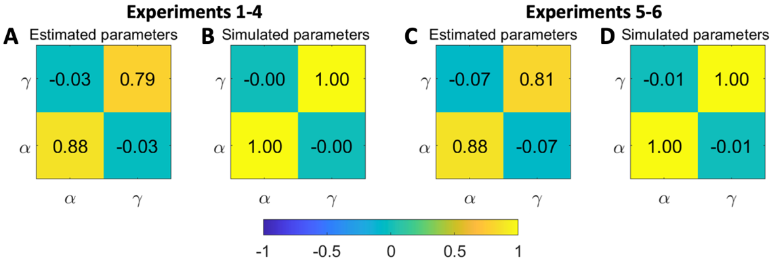
Parameter recovery of simulated parameters was of high quality (Figure S3). The Pearson correlation coefficient between simulated and estimated parameters was 0.88 for parameter α (for all experiments) and approximately 0.80 for parameter γ (0.79 for experiments 1-4 and 0.81 for experiments 5-6). This suggests that our model-fitting analysis provides meaningful results.

Figure S3: recovery of simulated parameters. (A) Main diagonal: correlations between simulated and estimated parameters. Off diagonal: cross correlations between estimated parameters. Experiment 1-4. (B) Correlations (diagonal) and cross correlations (off-diagonal) between simulated parameters. (C) & (D) are same as (A) & (B) respectively but for Experiments 5-6. Pearson correlation values are depicted inside the squares. The number of simulations was 2000.

References
Erev, I., Ert, E., Plonsky, O., Cohen, D., & Cohen, O. (2017). From anomalies to forecasts: Toward a descriptive model of decisions under risk, under ambiguity, and from experience. Psychological Review, 124(4), 369–409. https://doi.org/10.1037/rev0000062
Erev, I., Ert, E., Roth, A. E., Haruvy, E., Herzog, S. M., Hau, R., Hertwig, R., Stewart, T., West, R., & Lebiere, C. (2010). A choice prediction competition: Choices from experience and from description. Journal of Behavioral Decision Making, 23(1), 15–47. https://doi.org/10.1002/bdm.683
Kahneman, D., & Tversky, A. (1979). Prospect Theory: An Analysis of Decision under Risk. Econometrica, 47(2), 263–291. https://doi.org/10.2307/1914185
Prelec, D. (1998). The Probability Weighting Function. Econometrica, 66(3), 497–527. https://doi.org/10.2307/2998573
Stock, J., & Watson, M. (2003). Introduction to Econometrics. Prentice Hall.
Tversky, A., & Kahneman, D. (1992). Advances in prospect theory: Cumulative representation of uncertainty. Journal of Risk and Uncertainty, 5(4), 297–323. https://doi.org/10.1007/BF00122574
Wulff, D., Mergenthaler-Canseco, M., & Hertwig, R. (2017). A Meta-Analytic Review of Two Modes of Learning and the Description‒Experience Gap. Psychological Bulletin, 144. https://doi.org/10.1037/bul0000115

Instructions at the beginning of each block informing participants about whether there will be feedback or not in the upcoming block.
“Following some of the trials, there will appear on the selected button the outcome you obtained by selecting that option (this outcome will appear in black font). On the other button, there will appear the outcome you could have obtained had you selected the other option (the forgone outcome will appear in dull font).” (Appendix C, Erev et al 2017)

