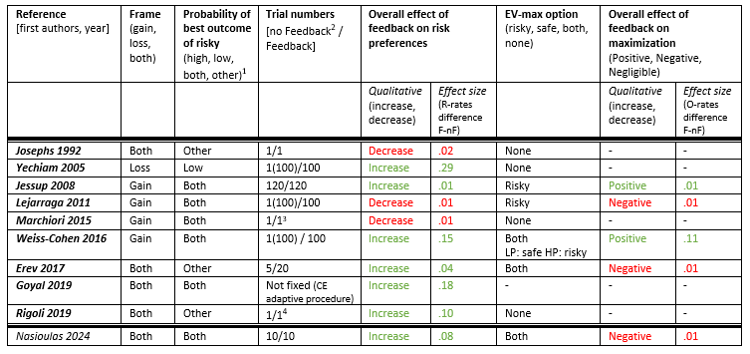
Table 1. Basic features of the design and main effects of feedback on Risky-rates and EV-maximization as derived by the literature.
¹ “Other” corresponds to the case that the risky option can give the best outcome with a medium-range probability as well.
² In parentheses we put the number of trials played/simulated by the computer (if any, otherwise omitted).
³ In this study, each decision problem is tested either with or without feedback for one trial (not in both conditions). The order of the problems (hence, the condition they belong) is randomized across participants, so in the aggregate data, most problems have been tested both with and without feedback.
⁴ They do four runs of a batch of 96 trials in which each condition is repeated only once: essentially one-shot.

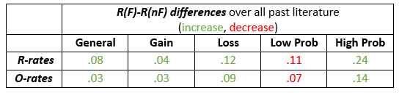
Table 2. Main effects of feedback on Risky-rates and EV-maximization as derived by the literature.

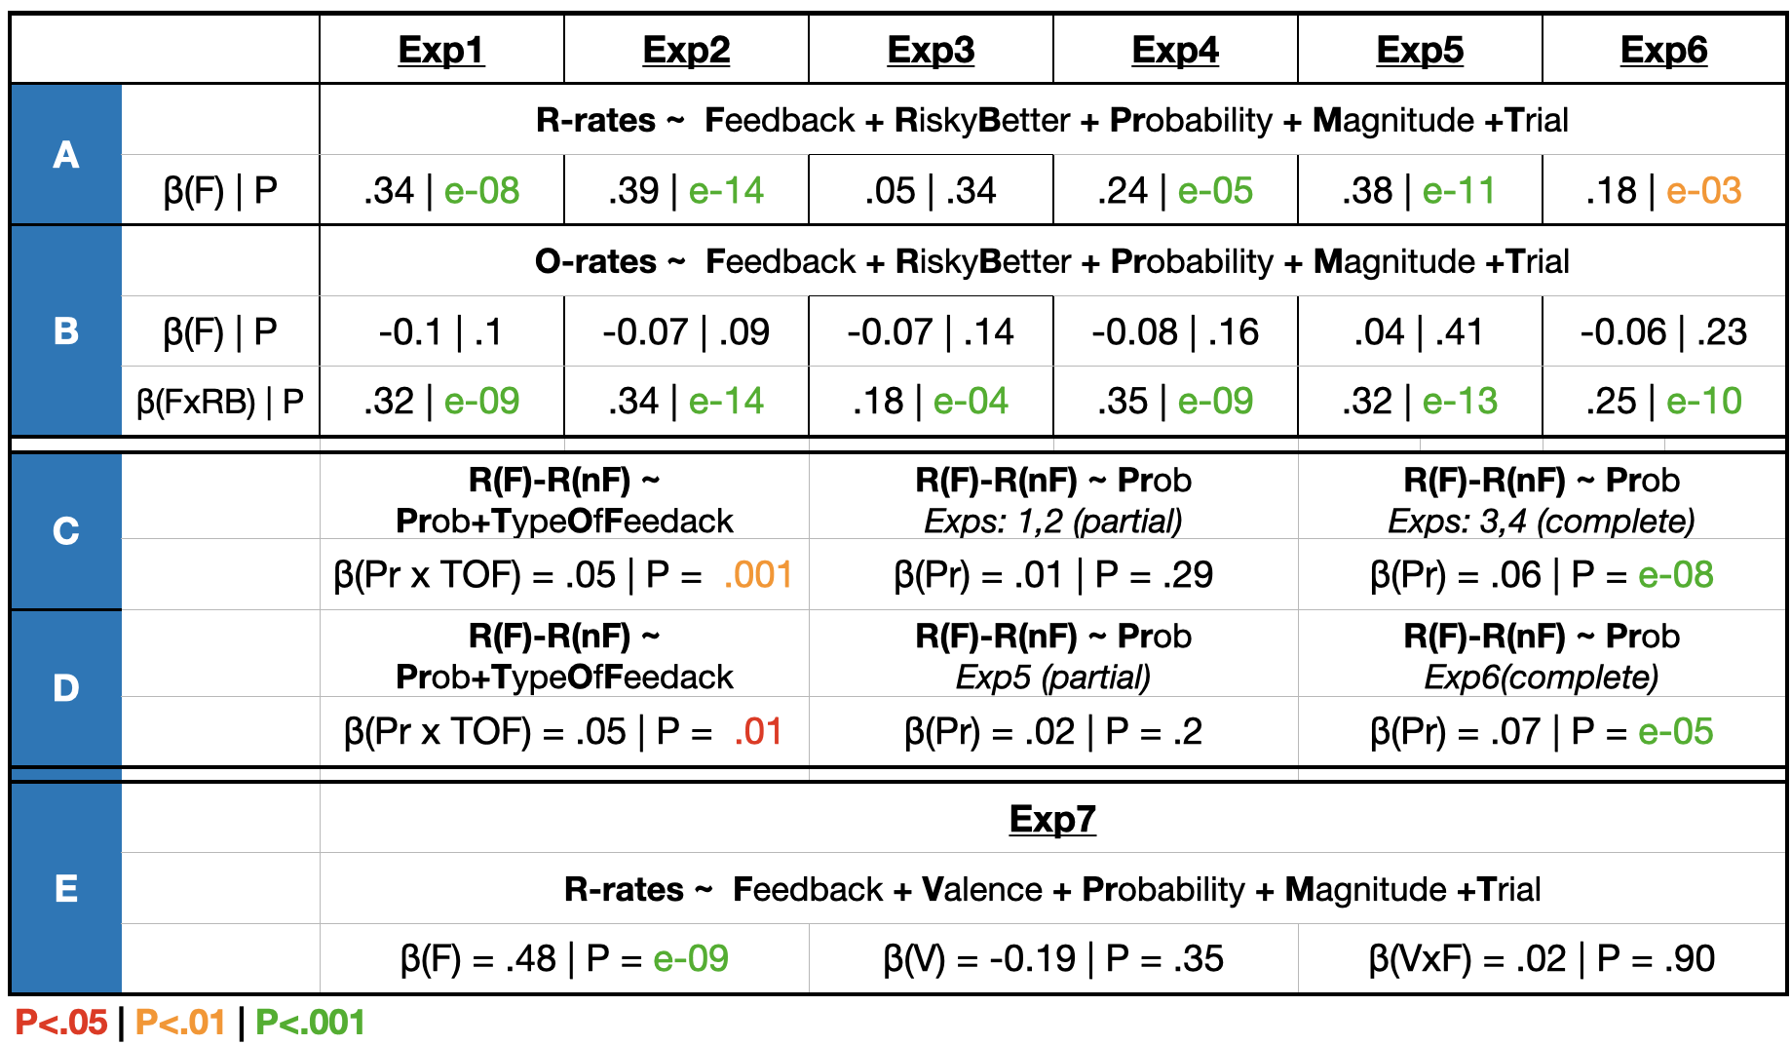
Table 3: main results of the regression analyses. The formulas show the factors involved in the corresponding regression analyses, but do not show the exact model we used. For more details, see the Statistical analysis section of the Methods. the β is the estimate and P the corresponding p-value. Bold letters in the formulas reveal the abbreviation of each factor in the results -for example F=feedback.

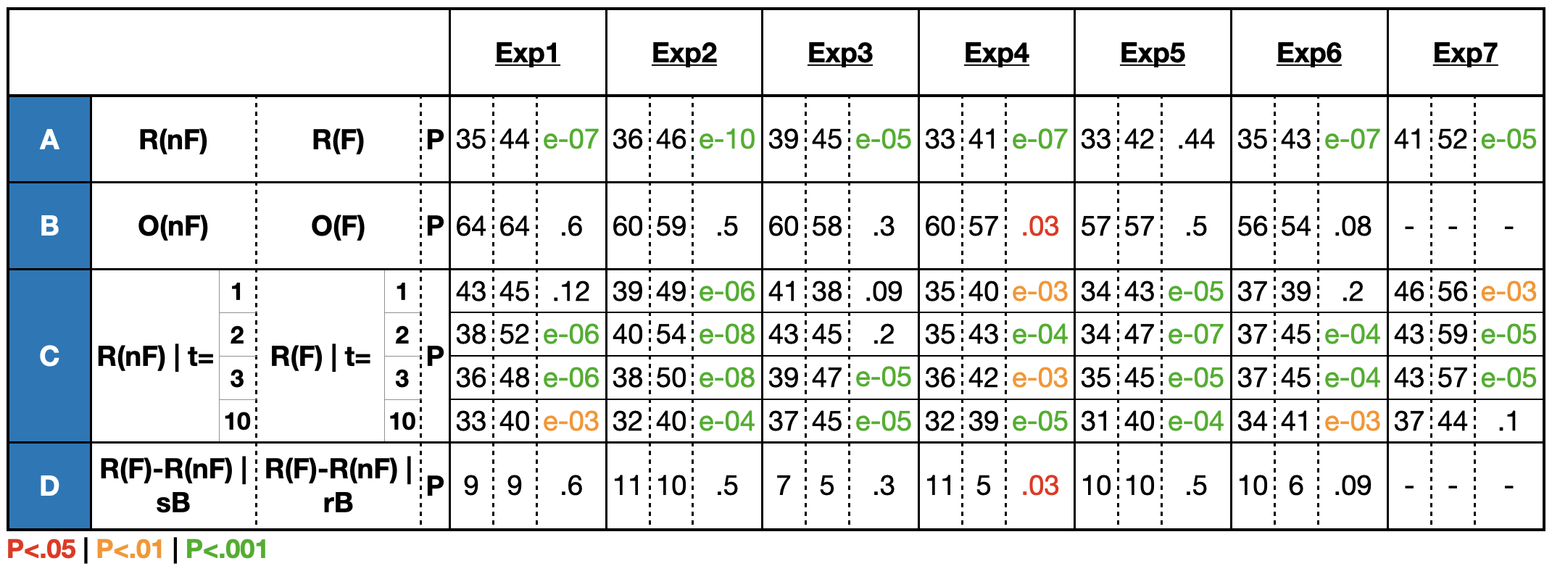
Table 4: mean percentages of Optimal and Risky choices in various conditions. O=optimal, R=risky, nF= no feedback, F = feedback, t=trial, sB=sure-better, rB=risky-better. A|B means that A is computed in the condition B. P-values are Wilcoxon Signed-Rank tests.

