Table 4 CpG islands and percent GC contents predicted in the promoter sequences of L. donovani BPK282A1 genes
Promoter region name | Possible CpG island(s) found | Number of CpG islands found | %GC content
Pro-LDBPK_141-460 |  | 1 | 60
Pro-LDBPK_230-300 | 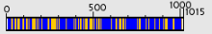 | 1 | 59
Pro-LDBPK_212-210 | 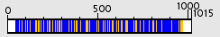 | 1 | 55
Pro-LDBPK_251-640 |  | 1 | 61
Pro-LDBPK_151-500 | 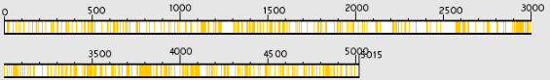 | - | -
Pro-LDBPK_340-900 | 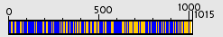 | 1 | 50
Pro-LDBPK_262-720 | 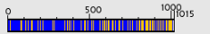 | 1 | 100
Pro-LDBPK_040-440 | 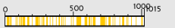 | - | -
Pro-LDBPK_171-020 | 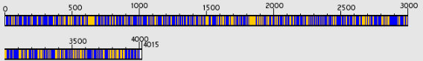 | 1 | 60
Pro-LDBPK_151-100 | 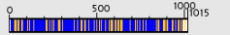 | 1 | 59
Pro-LDBPK_151-540 | 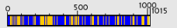 | 1 | 53
Pro-LDBPK_060-590 | 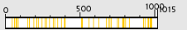 | - | -
Pro-LDBPK_030-760 | 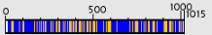 | 1 | 59
Pro-LDBPK_111-140 | 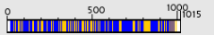 | 1 | 56
Pro-LDBPK_160-580 | 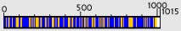 | 1 | 100
Pro-LDBPK_250-780 | 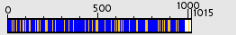 | 1 | 52
Pro-LDBPK_362-640 | 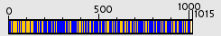 | 1 | 100
Pro-LDBPK_280-030 | 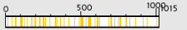 | - | -
Pro-LDBPK_131-090 | 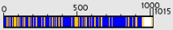 | 1 | 55
Pro-LDBPK_040-570 |  | - | -
Pro-LDBPK_303-160 | 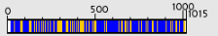 | 1 | 54
Pro-LDBPK_180-690 | 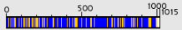 | 1 | 100
Pro-LDBPK_180-620 | 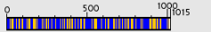 | 1 | 58
Pro-LDBPK_180-590 | 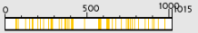 | - | -
Pro-LDBPK_180-480 |  | 1 | 57
Pro-LDBPK_180-460 | 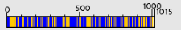 | 1 | 57
Pro-LDBPK_180-370 | 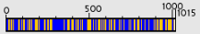 | 1 | 50
Pro-LDBPK_180-360 | 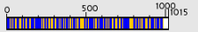 | 1 | 59
Pro-LDBPK_180-270 | 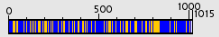 | 1 | 55
Pro-LDBPK_181-100 | 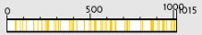 | - | -
Pro-LDBPK_181-080 | 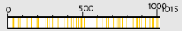 | - | -
Pro-LDBPK_180-920 |  | 1 | 61
Pro-LDBPK_180-810 |  | 1 | 100
Pro-LDBPK_180-790 | 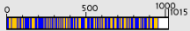 | 1 | 60
Pro-LDBPK_180-650 |  | 1 | 60
Pro-LDBPK_180-580 | 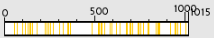 | - | -
Pro-LDBPK_180-510 |  | 1 | 56
Pro-LDBPK_170-660 | 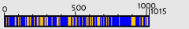 | 1 | 100
Pro-LDBPK_170-610 | 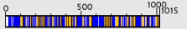 | 1 | 58
Pro-LDBPK_170-890 | 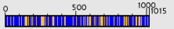 | 1 | 100

