Supporting material
For
Structural insight into Aeromonas hydrophila AHL synthase AhyI driving acyl-ACP selective recognition

Contents

Fig. S1 The biosynthetic process of E. coli acyl-ACP in this study.
Fig. S2 Urea-PAGE analysis of the various forms of ACP protein with C-terminal His-tags.
Fig. S3 The closeup view of acyl-chain binding pocket of AhyI in complex with acyl-4'-PP of C4-ACP and C14-ACP.
Fig. S4 The optimal 3D docking conformation of acyl-4'-PP of six acyl-ACP substrates inserts into the binding pocket of WT AhyI protein.

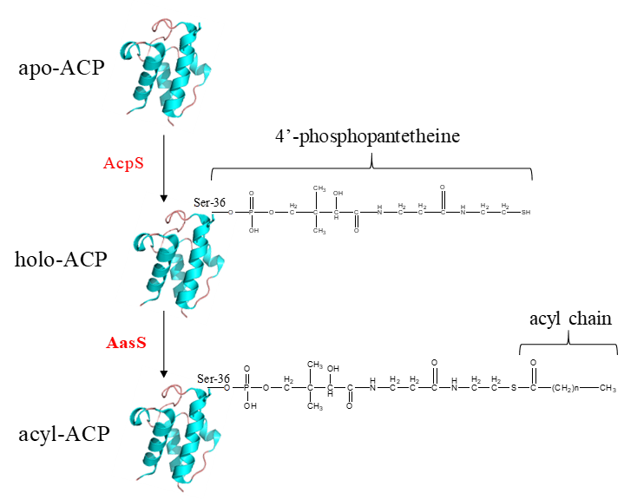
Fig. S1 The biosynthetic process of E. coli acyl-ACP in this study. The E. coli apo-ACP is modified with 4’-PP group in the position of Ser36 by AcpS reaction to form holo-ACP, and then acyl chain from fatty acid is attached as a thioester to 4’-PP group thiol using V. harveyi AasS.

Fig. S2 Urea-PAGE analysis of the various forms of ACP protein with C-terminal His-tags. Fifteen μl of each ACP was run on 17.5% polyacrylamide gels containing 2.5 M urea. A mixture of apo- and holo-ACP standards was used as a marker (lane Stds). Purified holo-ACP was loaded in lane 1. The C₄~C₁₄-ACP products of the AasS reaction were shown in Lanes 2~7, respectively.

Fig. S3 The closeup view of acyl-chain binding pocket of AhyI in complex with a native short-chain C4-ACP (in green) and a non-native long-chain C14-ACP (in bluish violet). The AhyI residues were shown in sticks and colored in green.

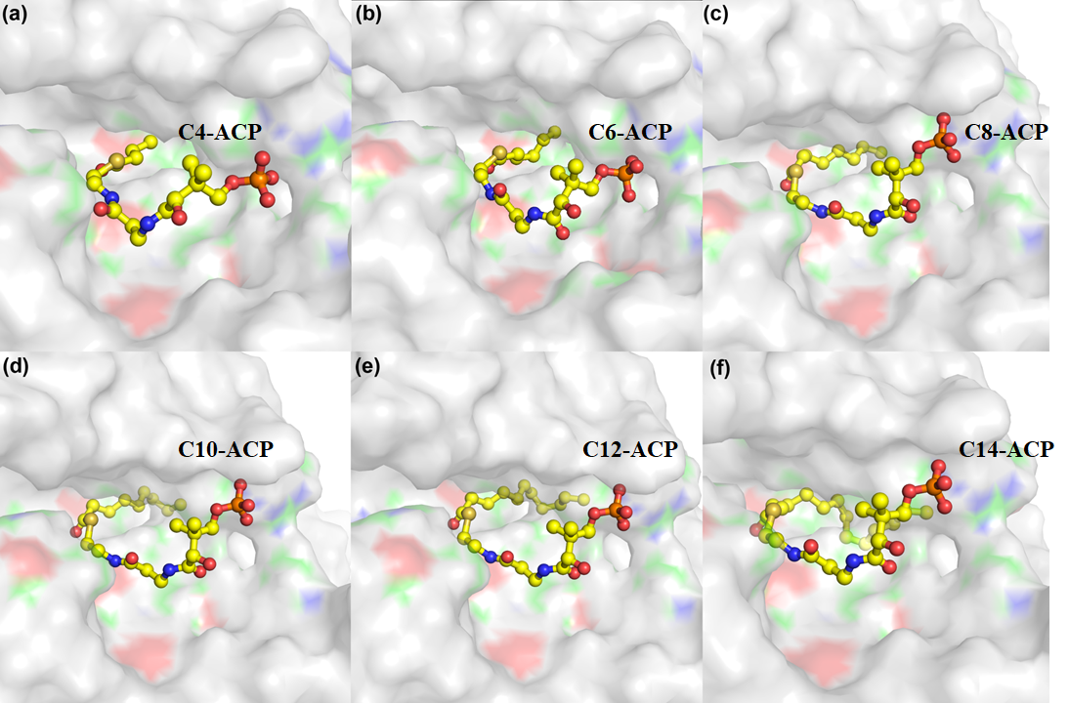
Fig. S4 The optimal 3D docking conformation of acyl-4'-PP of six acyl-ACP substrates inserts into the binding pocket of WT AhyI protein. Red, blue and green surfaces indicate the oxygen, nitrogen and carbon atoms of pocket residues surrounding the acyl-pantetheine group, respectively.

