Supplemental Information

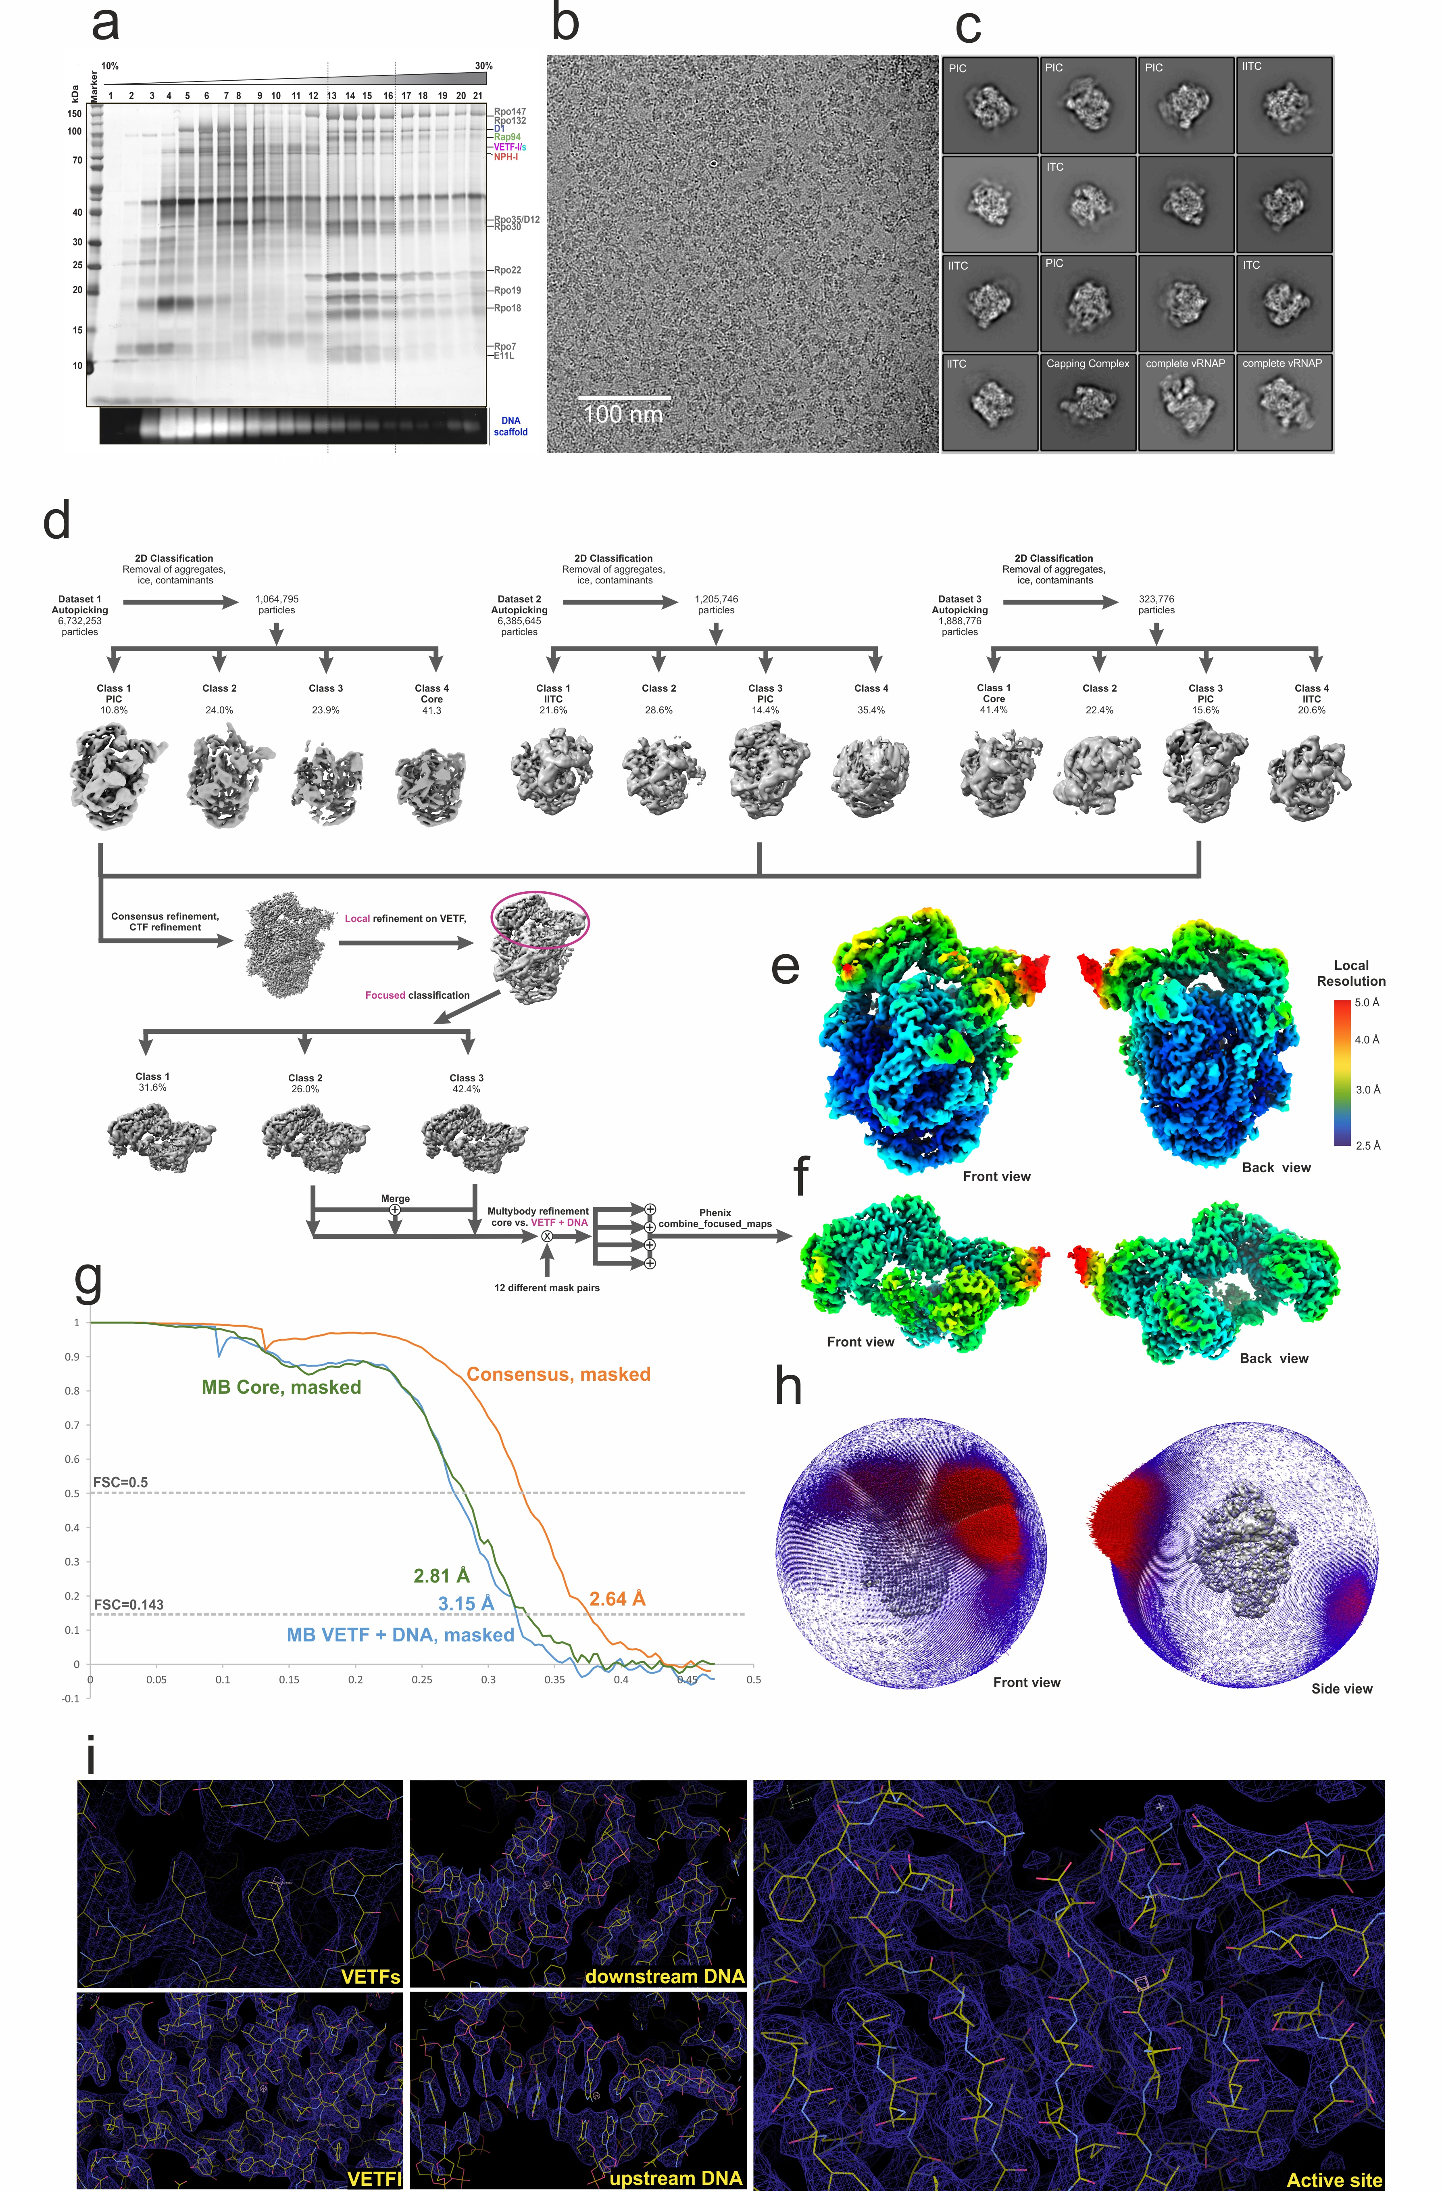
Supplemental Figure 1, related to Figures 1-3. (a) Reconstitution and preparative purification of vRNAP-promoter complexes. Approx. 400 µg affinity-purified complete vRNAP was incubated with a 60-fold molar excess of the synthetic DNA scaffold in the presence of 1mM NTPs and separated by gradient centrifugation. Fractions 13-16 were pooled and used for cryo-EM studies. (b) Representative micrograph and (c) representative 2D classes of the dataset. If applicable, the images are annotated with the names of the predominant particle type. (d) Classification and refinement scheme. (e) Local resolution mapped to the consensus reconstruction density iso-surface (only a mild B-factor sharpening of -10 Å² was applied). (f) Masked VETF and DNA region after multibody refinement. (g) FSC curves for consensus and multibody refinements. (h) Angular distribution plots referring to the consensus reconstruction in E. (i) Selected views of the final, B-factor sharpened (-60 Å²) cryo-EM density isosurface overlaid with the model.

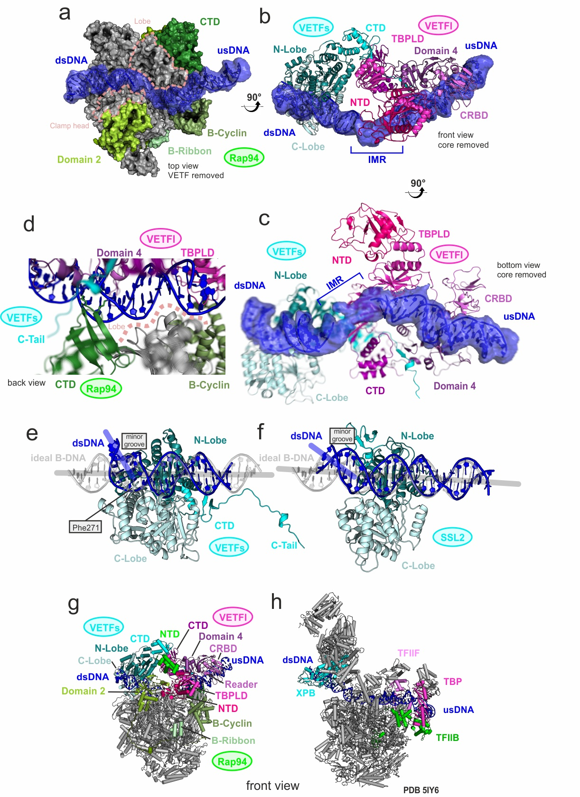
Supplemental Figure 2, related to Figures 1-3, color code as in Figure 1. (a) DNA contacts in the PIC. Transparent blue iso-surface of the cryo-EM density for the bound DNA, filtered by a Gaussian blur to 1.5σ standard deviation. The model is shown in cartoon style and the initially melted region (IMR) is indicated. Top view of the PIC with VETF removed (top view) and vRNAP core shown as solvent accessible surface. The clamp head and lobe are marked on the molecular surface by a rose dotted line, respectively. (b) Front view of the PIC with core removed (front view) and VETF shown in cartoon representation. (c) PIC with vRNAP removed shown in cartoon view turned by roughly 90° relative to B. and slightly optimized for clarity (d) Upstream promoter contacts to the core vRNAP. Detailed view of the upstream promoter contacts to the core vRNAP in cartoon representation. The lobe region contacting the DNA is indicated with a rose dotted line. (e) Cartoon model of VETFs and downstream DNA with superposed ideal B DNA in transparent grey is shown. The respective helix axes are indicated and Phe 271 is depicted in stick representation. (f) A depiction of the promoter-bound yeast XPB homologue SSL2 from the yeast PIC bound to TFIIH and core mediator (Schilbach et al., 2017) (PDB:5oqm) analogous to a. The axis of the bent, bound DNA (blue) is indicated. Both arms of the DNA helix axis bend angles in (e) and (f) lie approximately in the paper plane. (g) Vaccinia PIC model in cartoon representation as shown in Fig. 1a, front view. (h) Pol II core PIC model (PDB 5IY6) in cartoon representation and oriented by superposition of the Pol II core polymerase with the core vRNAP of the vaccinia PIC in (g). Elements identified as functionally, architecturally or structurally corresponding are colored according to the scheme used for the vaccinia PIC throughout this manuscript.

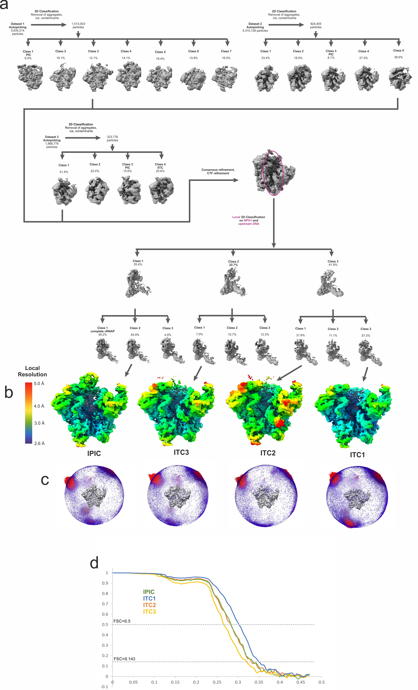
Supplemental Figure 3, related to Figures 4 and 5. Cryo EM reconstruction of lPIC and lITC. (a) classification and refinement scheme. Areas used for local classification is encircled in magenta. (b) Local resolution mapped to the reconstruction density isosurface. (c) FSC plots for consensus refinement and the separaty bodies of the multibody (MB) refinement. (d) Angular orientation plots referring to the reconstructions in (b).

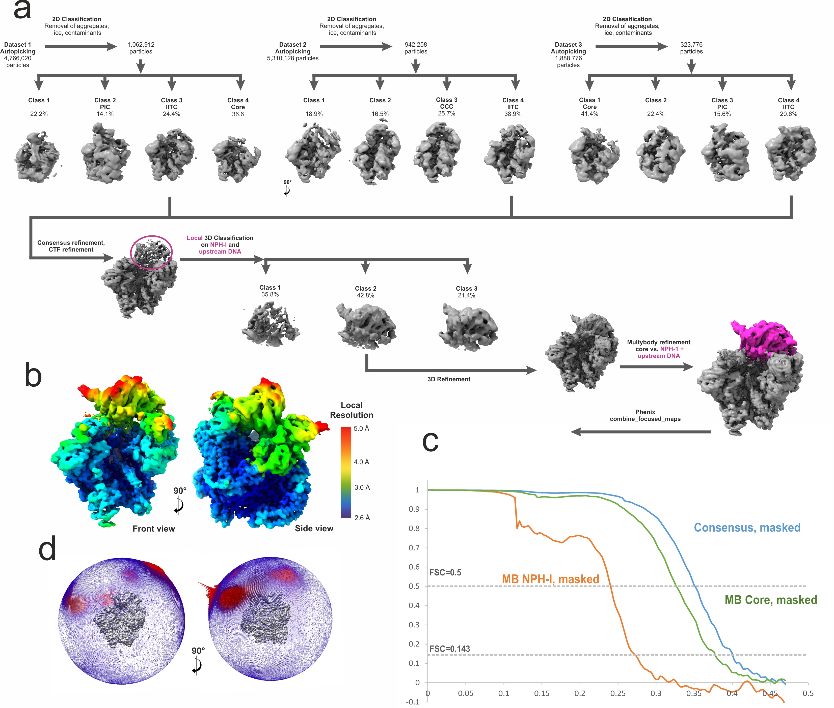

Supplemental Figure 4, related to Figure 6. Cryo EM reconstruction of the lITC. (a) classification and refinement scheme. (b) Local resolution mapped to the reconstruction density isosurface. (c) FSC plots for consensus refinement and the two-bogy MB refinement, respectively. (d) Orientation plot referring to the consensus reconstruction in (b).

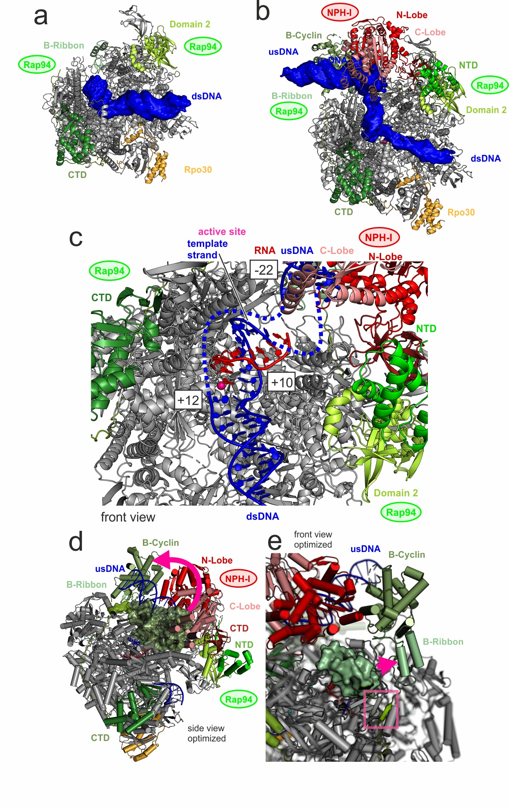
Supplemental Figure 5, related to Figure 6. (a) Cryo EM density for DNA in the ITC. (b) Cryo EM density for DNA in the lITC. The blunt ends of the synthetic DNA scaffold are recognizable in the density. Note that the position of the downstream end of the scaffold has advanced roughly 5bp when comparing the ITC (a) to the lITC (b) structure. The visible upstream blunt end indicates extensive promoter scrunching. (c) Transcription bubble in the lITC. A zoomed view into the active site region is depicted. Disordered regions of the template and non-template strand are shown as dotted lines. The start and end positions of the melted promoter and the base at the active site are numbered relative to the TSS. (d) illustration of major rearrngments during ITC formation. The lITC model is shown in carton representation. The B cyclin as in the lPIC structure is shown as a molecular surface. In this orientation it would obstruct the upstream DNA path. The domain rearrangement is indicated ba a magenta arrow. (e) Analogous to (d), the B ribbon as in the lPIC structure is shown as a molecular surface, its rearrangement indicated as a magenta arrow. The stabilization of transiently flexible regions of Rap94 in the lITC by formation of a β strand to the core vRNAP is highlighted with a magenta box.

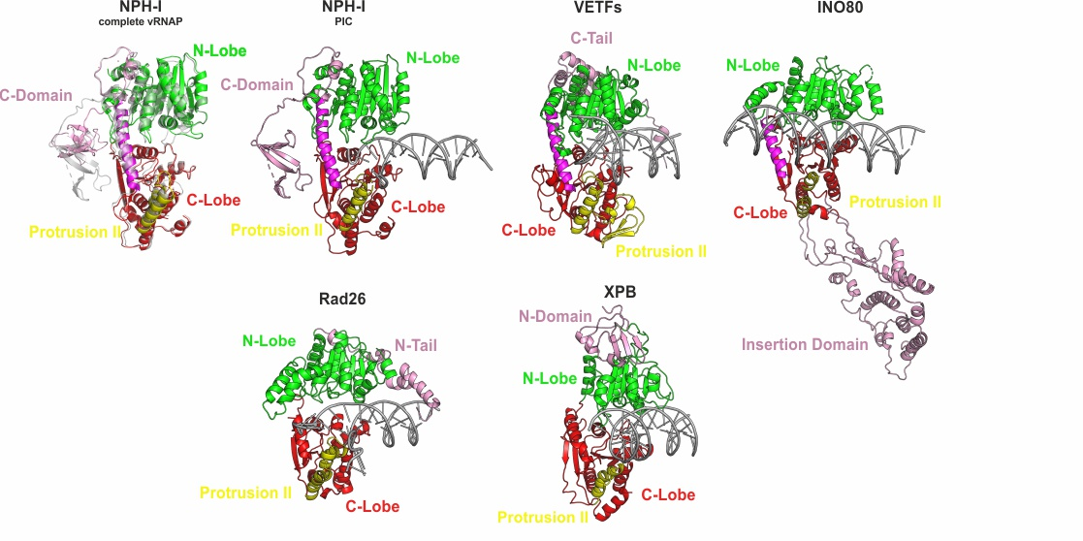

Supplemental Figure 6. Comparison of Vaccinia NPH-I and VETFs with structurally related helicases. Color code according to common structural elements. The helicase ATPase modules were extracted from structures with the following PDB ID codes: Complete vRNAP: 6RFL, INO80: 6HTS, Rad26: 5VVR, XPB: 6NMI.

Supplemental Table 1: Cryo-EM data collection, single-particle reconstruction and model refinement statistics of the PIC.

Data collection
Voltage (kV) | 300
Total electron dose (e⁻/Å²) | 77.5
Number of fractions | 47
Exposure time (s) | 75
Number of Movies per hole | 2
Number of Movies in dataset* | 10,816 / 9,878 / 3,640
Particles (automatically selected)* | 6,732,253 / 6,385,645 / 1,888,776
Particles (in final reconstruction) | 181,788
Pixel size (Å) | 1.0635
Defocus range (µm) | -1.0 to -2.2
Detector | Falcon III camera, counting mode
Reconstruction (Relion)#
Accuracy of rotations (°) | 0.53 (0.52)
Accuracy of translations (pixels) | 0.32 (0.35)
Resolution (Å) | 2.64 (3.15)
Map sharpening B-factor (Å²) | -60 (-60)
Model composition
Non-hydrogen atoms | 45175
Protein residues | 5348
Nucleic acid residues | 84
Ions | 1 Mg, 4Zn
Refinement (Phenix.real_space_refine)
Map CC (around atoms) | 0.79
RMS deviations
Bond lengths (Å) | 0.006
Bond angles (°) | 0.83
Validation
All-atom clashscore | 2.81
Rotamer outliers (%) | 0.41
C-beta deviations | 0
Ramachandran plot (%)
Outliers | 0.0
Allowed | 2.8
Favored | 97.2

*Values for dataset 1 / dataset 2 / dataset 3
# Values for consensus refinement. Values in parentheses for two-body multibody refinement, body 2 (VETF+DNA).
Supplemental Table 2: Cryo-EM data collection, single-particle reconstruction and model refinement statistics of lPIC.
 | lPIC
Data collection
Voltage (kV) | 300  77.5  47  75  2  10,816 / 9,878 / 3,640
Total electron dose (e⁻/Å²) | 300  77.5  47  75  2  10,816 / 9,878 / 3,640
Number of fractions | 300  77.5  47  75  2  10,816 / 9,878 / 3,640
Exposure time (s) | 300  77.5  47  75  2  10,816 / 9,878 / 3,640
Number of movies per hole | 300  77.5  47  75  2  10,816 / 9,878 / 3,640
Number of movies in dataset* | 300  77.5  47  75  2  10,816 / 9,878 / 3,640
Particles (automatically selected)* | 1,513,003 / 5,310,128 / 0
Particles (in final reconstruction) | 88828
Pixel size (Å) | 1.0635
Defocus range (µm) | -1.0 to -2.2
Detector | Falcon III camera, counting mode
Reconstruction (Relion)#
Accuracy of rotations (°) | 0.50
Accuracy of translations (pixels) | 0.30
Resolution (Å) | 3.0
Map sharpening B-factor (Å²) | -40 (-40)
Model composition
Non-hydrogen atoms | 32727
Protein residues | 4034
Nucleic acid residues | 0
Ions | 1 Mg, 4 Zn
Refinement (Phenix.real_space_refine)
Map CC (around atoms) | 0.87
RMS deviations
Bond lengths (Å) | 0.004
Bond angles (°) | 0.9
Validation
All-atom clashscore | 4.3
Rotamer outliers (%) | 1.8
C-beta outliers (%)
Ramachandran plot (%)
Outliers | 0.0
Allowed | 5.0
Favored | 95.0
*Values for dataset 1 / dataset 2 / dataset 3
Supplemental Table 3: Cryo-EM data collection, single-particle reconstruction and model refinement statistics of ITC complexes.
 | ITC1 | ITC2 | ITC3
Data collection
Voltage (kV) | 300  77.5  47  75  2  10,816 / 9,878 / 3,640
Total electron dose (e⁻/Å²)
Number of fractions
Exposure time (s)
Number of movies per hole
Number of movies in dataset*
Particles (automatically selected)* | 1,513,003 / 5,310,128 / 0 | 1,513,003 / 5,310,128 / 0 | 1,513,003 / 5,310,128 / 0
Particles (in final reconstruction) | 133467 | 73035 | 96165
Pixel size (Å) | 1.0635 | 1.0635 | 1.0635
Detector | Falcon III camera, counting mode
Reconstruction (Relion)#
Defocus range (µm) | -1.0 to -2.2 | -1.0 to -2.2 | -1.0 to -2.2
Accuracy of rotations (°) | 0.55 | 0.56
Accuracy of translations (pixels) | 0.34 | 0.35
Resolution (Å) | 2.9 | 3.2 | 3.0
Map sharpening B-factor (Å²) | -40 (-40) | -40 (-40) | -40 (-40)
Model composition
Non-hydrogen atoms | 31512 | 31399 | 30881
Protein residues | 3782 | 3782 | 3782
Nucleic acid residues | 42 | 77 | 11
Ions | 1 Mg, 4 Zn | 1 Mg, 4 Zn | 1 Mg, 4 Zn
Refinement (Phenix.real_space_refine)
Map CC (around atoms) | 0.87 | 0.82 | 0.88
RMS deviations
Bond lengths (Å) | 0.005 | 0.003 | 0.009
Bond angles (°) | 1.07 | 0.56 | 1.08
Validation
All-atom clashscore | 3.0 | 3.4 | 4.3
Rotamer outliers (%) | 2.4 | 1.8 | 2.9
C-beta outliers (%) | 0.0 | 0.0 | 0.0
Ramachandran plot (%)
Outliers | 0.0 | 0.0 | 0.0
Allowed | 5.8 | 5.4 | 6.9
Favored | 94.2 | 94.6 | 93.1

*Values for dataset 1 / dataset 2 / dataset 3
Supplemental Table 4: Cryo-EM data collection, single-particle reconstruction and model refinement statistics of lITC.
 | lITC
Data collection
Voltage (kV) | 300  77.5  47  75  2  10,816 / 9,878 / 3,640
Total electron dose (e⁻/Å²) | 300  77.5  47  75  2  10,816 / 9,878 / 3,640
Number of fractions | 300  77.5  47  75  2  10,816 / 9,878 / 3,640
Exposure time (s) | 300  77.5  47  75  2  10,816 / 9,878 / 3,640
Number of movies per hole | 300  77.5  47  75  2  10,816 / 9,878 / 3,640
Number of movies in dataset* | 300  77.5  47  75  2  10,816 / 9,878 / 3,640
Particles (automatically selected)* | 4,766,02 / 5,310,128 / 942,258
Particles (in final reconstruction) | 278260
Pixel size (Å) | 1.0635
Defocus range (µm) | -1.0 to -2.2
Detector | Falcon III camera, counting mode
Reconstruction (Relion)#
Accuracy of rotations (°) | 0.58 (1.20)
Accuracy of translations (pixels) | 0.39
Resolution (Å) | 2.5 (3.7)
Map sharpening B-factor (Å²) | -40 (-40)
Model composition
Non-hydrogen atoms | 39139
Protein residues | 4675
Nucleic acid residues | 77
Ions | 1 Mg, 4 Zn
Refinement (Phenix.real_space_refine)
Map CC (around atoms) | 0.84
RMS deviations
Bond lengths (Å) | 0.005
Bond angles (°) | 0.67
Validation
All-atom clashscore | 3.5
Rotamer outliers (%) | 1.6
C-beta outliers (%) | 0.0
Ramachandran plot (%)
Outliers | 0.0
Allowed | 3.1
Favored | 96.9
*Values for dataset 1 / dataset 2 / dataset 3
# Values for consensus refinement. Values in parentheses for two-body multibody refinement, body 2 (NPH-I+DNA).

Supplemental Video 1: Reconfiguration of complete vRNAP to the PIC, details of promoter binding and melting.

Supplemental Video 2: Remodelling of the vaccinia PIC, template strand capture mechanism and upstream promoter scrunching.

