Supplementary Materials

- Fig. S1. Accuracy of edge weights
- Fig. S2. Bootstrapped difference test for edge weights
- Fig. S3. Stability of node strengths
- Fig. S4. Bootstrapped difference test for node strengths
- Fig. S5. Stability of node bridge strengths
- Fig. S6. Bootstrapped difference test for node bridge strengths

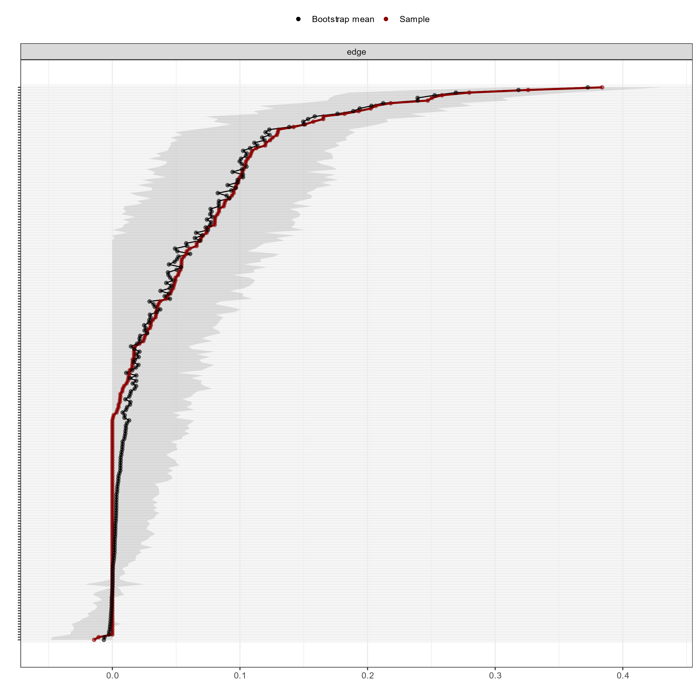
Fig. S1. Accuracy of edge weights
Note: The red line depicts the sample edge weights and the gray bar depicts the bootstrapped confidence interval.

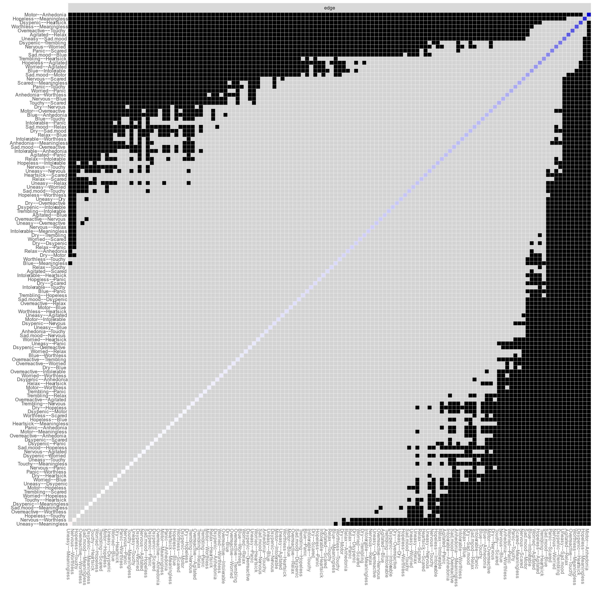
Fig. S2. Bootstrapped difference test for edge weights
Note: Gray boxes indicate edge weights that do not differ significantly from one another, while black boxes indicate edge weights that do differ significantly. Blue and red boxes on the diagonal correspond to edge weights with positive and negative correlations, respectively.

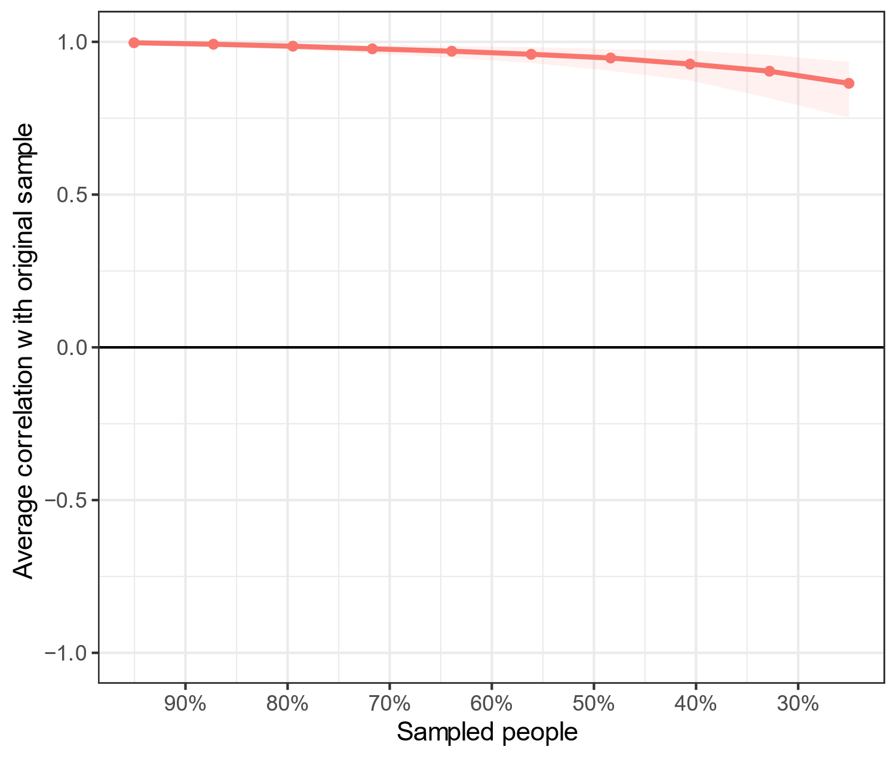
Fig. S3. Stability of node expected influence
Note: The red bar represents the average correlation between strength in the full sample and subsample with the red area depicting the 2.5th quantile to the 97.5th quantile.

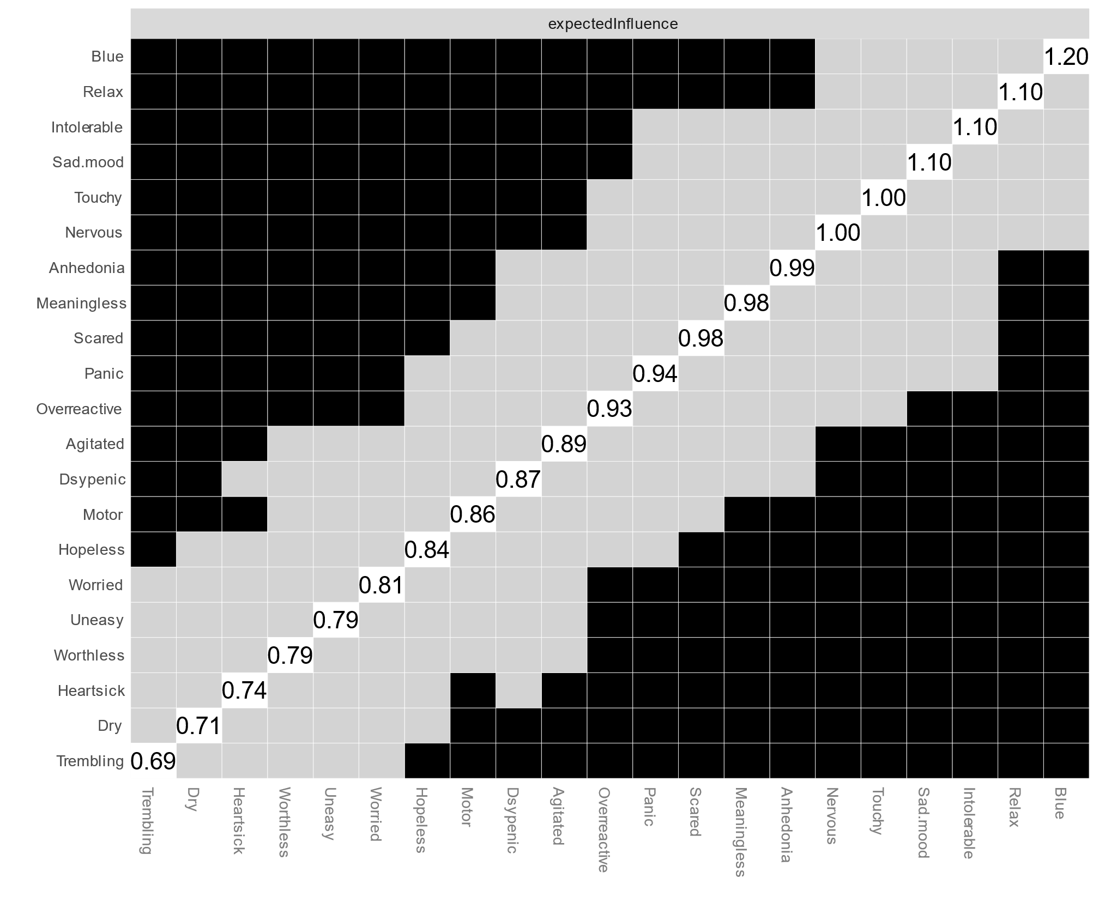
Fig. S4. Bootstrapped difference test for node expected influence
Note: Gray boxes indicate node expected influence that do not differ significantly from one another, while black boxes indicate node expected influence that do differ significantly. The number in the white boxes (i.e., diagonal line) represent the value of node expected influence.

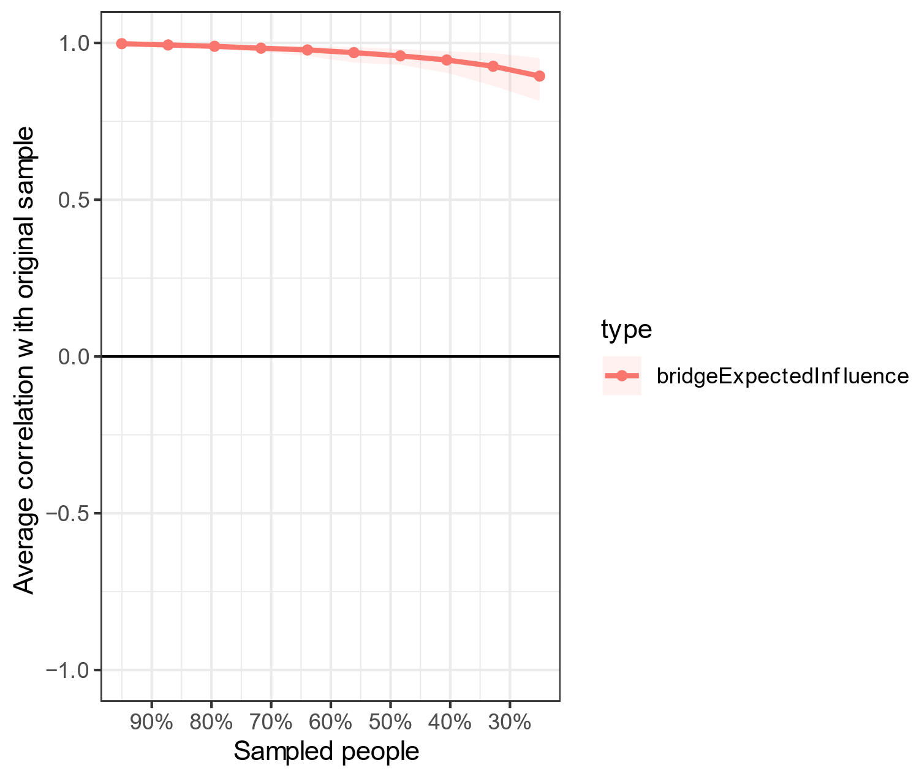
Fig. S5. Stability of node bridge expected influence
Note: The red bar represents the average correlation between bridge expected influence in the full sample and subsample with the red area depicting the 2.5th quantile to the 97.5th quantile.

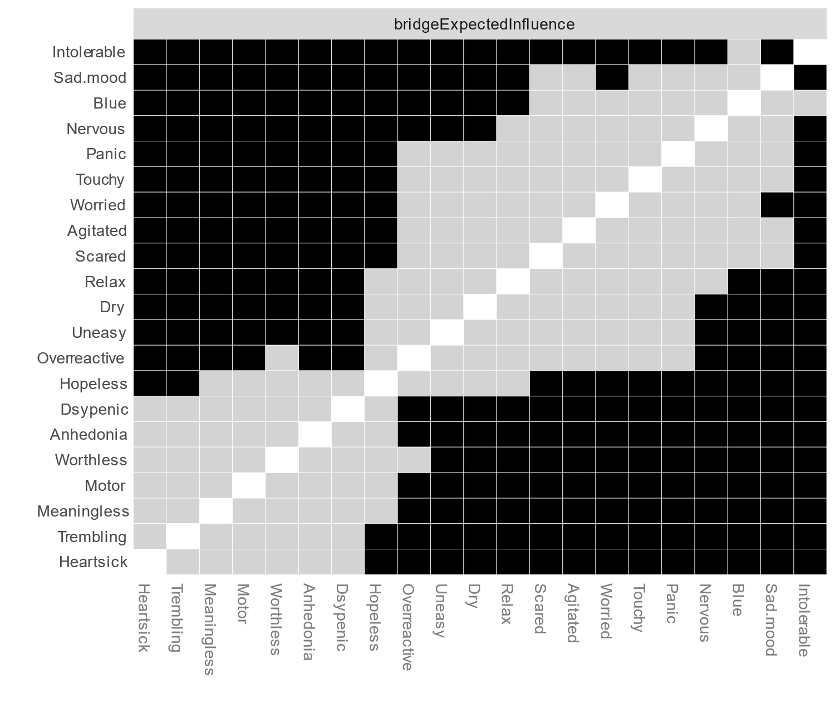
Fig. S6. Bootstrapped difference test for node bridge expected influence
Note: Gray boxes indicate node bridge expected influence that do not differ significantly from one another, while black boxes indicate node bridge expected influence that do differ significantly.

