Supplementary Information for

Removal of contaminants of emerging concern by Wolffia arrhiza and Lemna minor depending on the process conditions, pollutants concentration, and matrix type

Urszula Kotowska^{1*}, Janina Piekutin², Weronika Polińska³, Adam Kotowski⁴

¹Department of Analytical and Inorganic Chemistry, Faculty of Chemistry, University of Bialystok, Ciołkowskiego 1K Str., 15-245 Bialystok, Poland; ukrajew@uwb.edu.pl
²Department of Environmental Engineering Technology, Faculty of Civil Engineering and Environmental Sciences, Bialystok University of Technology, Wiejska 45E, 15-351 Bialystok, Poland; j.piekutin@pb.edu.pl
³Doctoral School of Exact and Natural Sciences, University of Bialystok, Ciolkowskiego 1K Str., 15-245 Bialystok, Poland; w.polinska@uwb.edu.pl
⁴Department of Automatic Control and Robotics, Faculty of Electrical Engineering, Bialystok University of Technology, Wiejska 45E, 15-351 Bialystok, Poland; a.kotowski@pb.edu.pl

Table S1. The values of pollution indicators characterizing raw and treated wastewater and landfill leachates used in the experiments
 | Raw  wasteater | Treated wastewater | Landfill leachates
Chemical oxygen demand (COD), mg/L | 315 | 31 | 2964
Biological oxygen demand (BOD₅), mg/L | 89 | 7 | 400
pH | 8.29 | 7.82 | 8.69
Electrolytic conductivity, mS/cm | 1,755 | 961 | 2,102
Total nitrogen concentration, mg/L | 46.5 | 10.2 | 307.7
Total phosphorus concentration, mg/L | 2.29 | 0.14 | 10.47

Table S2. The target CECs retention times, the ions selected for monitoring, and an overview of the USAEME-GC-MS concentration determination method's performance
 | Retention time (min) | Quantification and identifi-cation ions (m/z) | Linearity range (µg/L) | R² | LOD  (µg/L) | LOQ  (µg/L) | RSD  (%) | Recovery  (%)
DEET | 5.14 | 91, 119, 190 | 0.5-500 | 0.9954 | 0.01 | 0.03 | 11.8 | 96
TRC | 16.08 | 218, 288, 290 | 0.5-500 | 0.9987 | 0.01 | 0.03 | 6.4 | 109
BPA | 19.08 | 213, 228, 270 | 0.5-500 | 0.9971 | 0.01 | 0.03 | 9.5 | 108
DES | 21.23 | 268, 310, 352 | 0.5-500 | 0.9961 | 0.01 | 0.03 | 11.2 | 104
E1 | 24.16 | 185, 270, 272 | 0.5-500 | 0.9933 | 0.02 | 0.06 | 11.6 | 93
E2 | 24.40 | 43, 146, 272 | 0.5-500 | 0.9982 | 0.02 | 0.06 | 11.1 | 112

Table S3. The characteristics of the course of experiments and the values of removal efficiency of TRC, DES, and E2 obtained for successive sets of conditions
Run | pH | Light exposure time (h) | Amount of plant (g) | Removal efficiency (%)
 |  |  |  | DES | TRC | E2
1 | 8.2 | 14.8 | 2.1 | 98 | 94 | 82
2 | 8.2 | 14.8 | 0.9 | 93 | 96 | 88
3 | 8.2 | 11.2 | 2.1 | 97 | 95 | 84
4 | 8.2 | 11.2 | 0.9 | 92 | 97 | 93
5 | 5.8 | 14.8 | 2.1 | 97 | 97 | 90
6 | 5.8 | 14.8 | 0.9 | 93 | 89 | 88
7 | 5.8 | 11.2 | 2.1 | 98 | 97 | 90
8 | 5.8 | 11.2 | 0.9 | 96 | 90 | 90
9 | 9 | 13 | 1.5 | 100 | 99 | 95
10 | 5 | 13 | 1.5 | 96 | 93 | 74
11 | 7 | 16 | 1.5 | 100 | 96 | 95
12 | 7 | 10 | 1.5 | 98 | 86 | 89
13 | 7 | 13 | 2.5 | 100 | 98 | 96
14 | 7 | 13 | 0.5 | 90 | 85 | 92
15 | 7 | 13 | 1.5 | 99 | 98 | 96
16 | 7 | 13 | 1.5 | 99 | 98 | 97
17 | 7 | 13 | 1.5 | 99 | 98 | 97
18 | 7 | 13 | 1.5 | 99 | 98 | 97
19 | 7 | 13 | 1.5 | 99 | 99 | 98
20 | 7 | 13 | 1.5 | 99 | 98 | 98

Table S4. The ANOVA results of regression model generated for TRC
Source of variation | Sum of squares | DF | Mean square | F-value | p-value
pH (Linear) | 27.8639 | 1 | 27.86394 | 681.144 | 0.000002
pH (Square) | 2.5894 | 1 | 2.58940 | 63.299 | 0.000506
Light (Linear) | 18.1678 | 1 | 18.16784 | 444.119 | 0.000004
Light (Square) | 50.3161 | 1 | 50.31609 | 1229.994 | 0.000000
Amount of plant (Linear) | 78.5331 | 1 | 78.53314 | 1919.769 | 0.000000
Amount of plant (Square) | 57.3174 | 1 | 57.31743 | 1401.144 | 0.000000
pH-light Interactions | 0.3137 | 1 | 0.31369 | 7.668 | 0.039404
pH-amount of plant Interactions | 43.8795 | 1 | 43.87946 | 1072.648 | 0.000000
Light-amount of plant Interactions | 1.0915 | 1 | 1.09154 | 26.683 | 0.003568
Pure error | 0.2045 | 5 | 0.04091
Total | 349.7372 | 19
R2=0.75623 | R2 (Adjusted)=0.53684

Table S5. The ANOVA results of regression model generated for DES
Source of variation | Sum of squares | DF | Mean square | F-value | p-value
pH (Linear) | 0.4736 | 1 | 0.47361 | 36.064 | 0.001839
pH (Square) | 10.5396 | 1 | 10.53961 | 802.568 | 0.000001
Light (Linear) | 0.2901 | 1 | 0.29011 | 22.091 | 0.005336
Light (Square) | 4.1720 | 1 | 4.17197 | 317.686 | 0.000010
Amount of plant (Linear) | 77.1160 | 1 | 77.11599 | 5872.211 | 0.000000
Amount of plant (Square) | 47.6363 | 1 | 47.63627 | 3627.396 | 0.000000
pH-light Interactions | 3.1411 | 1 | 3.14111 | 239.188 | 0.000021
pH-amount of plant Interactions | 5.2090 | 1 | 5.20905 | 396.657 | 0.000006
Light-amount of plant Interactions | 0.5626 | 1 | 0.56264 | 42.844 | 0.001246
Pure error | 0.0657 | 5 | 0.01313
Total | 162.3961 | 14
R2=0.87931 | R2 (Adjusted)=0.77069

Table S6. The ANOVA results of regression model generated for E2
Source of variation | Sum of squares | DF | Mean square | F-value | p-value
pH (Linear) | 40.4872 | 1 | 40.4872 | 69.5319 | 0.000406
pH (Square) | 315.2594 | 1 | 315.2594 | 541.4196 | 0.000003
Light (Square) | 72.5001 | 1 | 72.5001 | 124.5101 | 0.000101
Amount of plant (Square) | 32.6211 | 1 | 32.6211 | 56.0228 | 0.000673
pH-amount of plant Interactions | 34.0776 | 1 | 34.0776 | 58.5242 | 0.000608
Pure error | 2.9114 | 5 | 0.5823
Total | 712.9060 | 19
R2=0.6318 | R2 (Adjusted)=0.5003

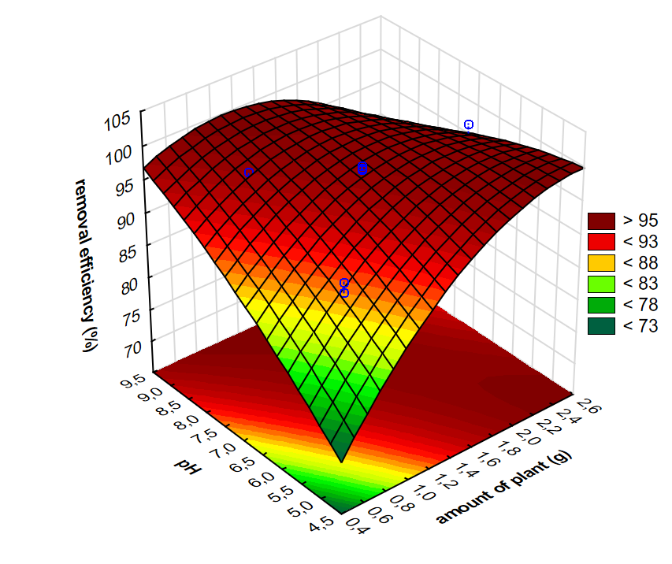
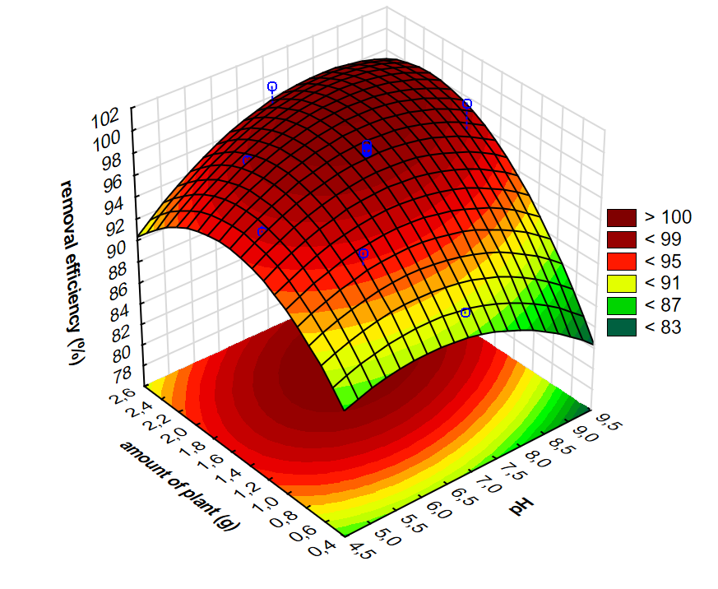
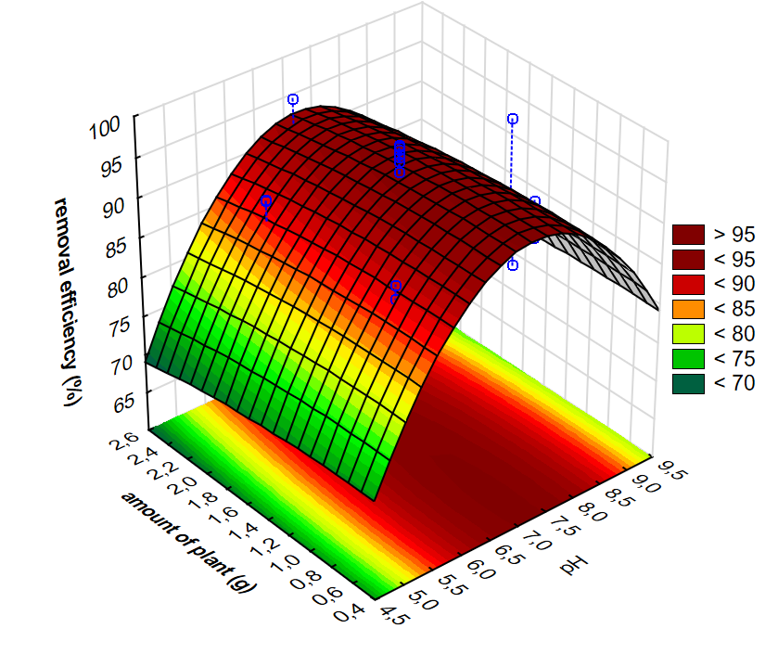

Figure S1. Effects of pH and mass of plant on EDCs removal rate by W. arrhiza
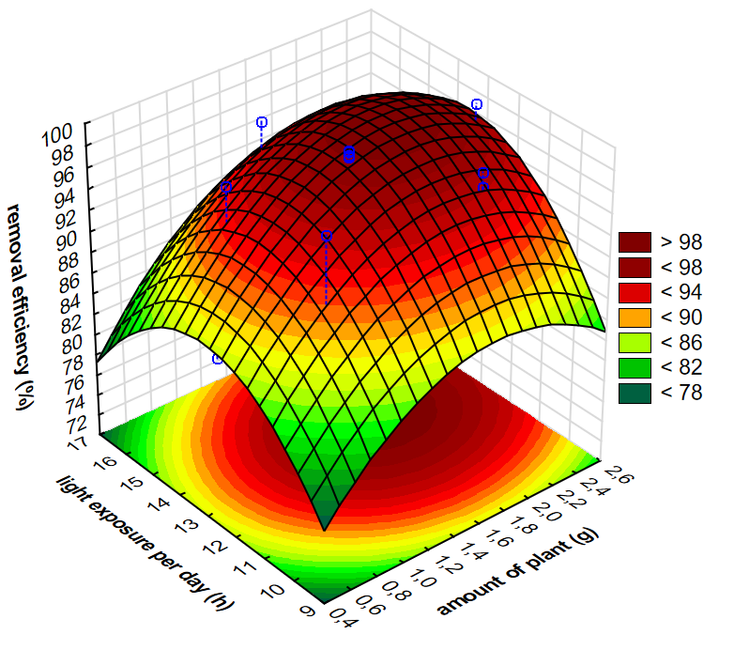
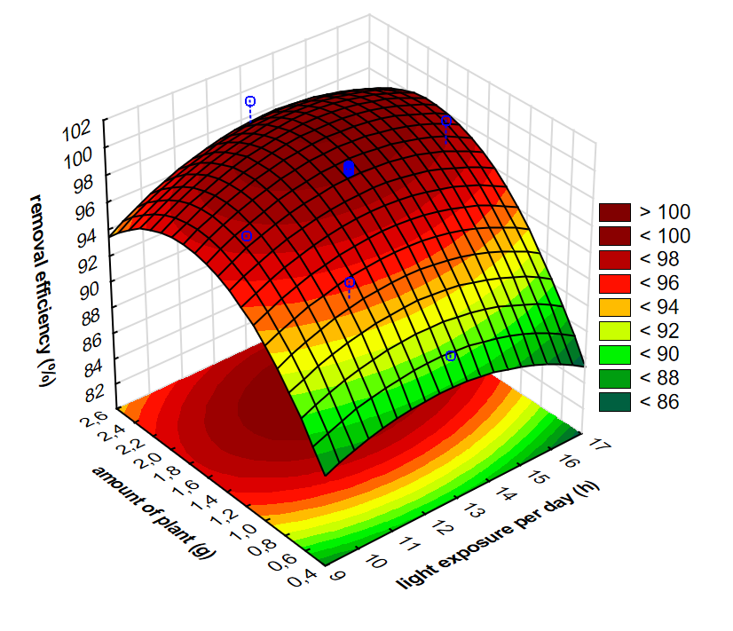
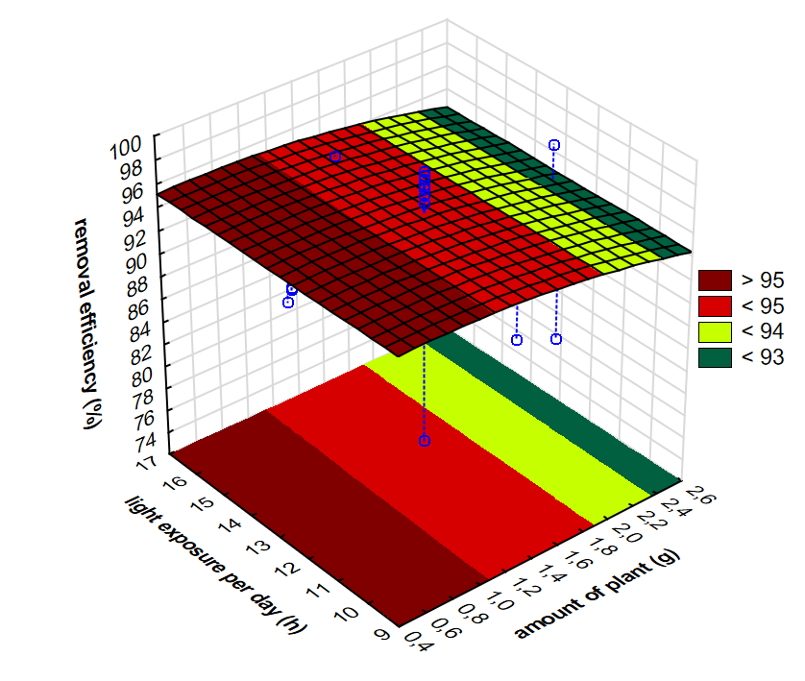

Figure S2. Effects of light exposure time, and mass of plant on EDCs removal rate by W. arrhiza
Table S7. The rate constant (k) values (day⁻¹) of CECs removal by W. arrhiza
 | k₁ | k₂ | k₃ | k₅ | k₇ | k₁₄ | k ₀₋₇ | k ₀₋₁₄
C = 100 µg/L
DEET | 0.67 | 0.50 | 0.12 | 0.26 | 0.15 | 0.07 | 0.30 | 0.19
TRC | 1.33 | 1.02 | 1.10 | 0.27 | 0.01 | 0.20 | 0.57 | 0.39
BPA | 1.67 | 0.30 | 0.55 | 0.58 | 0.14 | 0.23 | 0.57 | 0.40
DES | 0.59 | 1.33 | 0.02 | 0.68 | -0.05 | 0.53 | 0.46 | 0.49
E1 | 1.12 | 0.65 | 0.43 | 0.66 | 0.11 | 0.15 | 0.53 | 0.34
E2 | 1.44 | 0.62 | 0.44 | 0.11 | 0.36 | 0.14 | 0.49 | 0.32
C = 500 µg/L
TRC | 1.20 | -* | 0.23 | 0.92 | -0.14 | - | 0.46 | -
BPA | 1.05 | - | -0.04 | 0.78 | 0.14 | - | 0.40 | -
DES | 1.43 | - | 0.35 | 0.44 | 0.00 | - | 0.43 | -
E1 | 0.97 | - | 0.15 | 0.63 | 0.35 | - | 0.46 | -
* not determined

Table S8. The rate constant (k) values (day⁻¹) of CECs removal by L. minor
 | k₁ | k₂ | k₃ | k₅ | k₇ | k₁₄ | k ₀₋₇ | k ₀₋₁₄
C = 100 µg/L
DEET | 0.20 | 1.08 | 0.24 | 0.00 | 0.27 | 0.02 | 0.30 | 0.16
TRC | 1.20 | 1.13 | 0.28 | 0.12 | 0.53 | 0.01 | 0.56 | 0.28
BPA | 0.29 | 2.25 | -0.11 | 0.17 | 0.43 | 0.04 | 0.52 | 0.28
DES | 0.47 | 2.84 | 0.07 | 1.76 | 0.00 | 0.00 | 0.99 | 0.49
E1 | 0.48 | 1.92 | 0.17 | 0.18 | 0.30 | 0.06 | 0.50 | 0.28
E2 | 0.46 | 1.24 | 0.31 | 0.24 | 0.39 | 0.00 | 0.47 | 0.23
C = 500 µg/L
TRC | 0.84 | -* | 0.08 | 1.00 | -0.17 | - | 0.38 | -
BPA | 0.82 | - | 0.16 | 0.41 | 0.00 | - | 0.28 | -
DES | 0.13 | - | 0.61 | 0.31 | -0.07 | - | 0.26 | -
E1 | 0.25 | - | 0.24 | 0.69 | -0.08 | - | 0.28 | -
* not determined

Table S9. The CECs half-life (t_{1/2}, days) values in systems with W. arrhiza and L. minor
 | W. arrhiza |  | L. minor
 | C = 100 µg/L | C = 500 µg/L | C = 100 µg/L | C = 500 µg/L
DEET | 2.29 | - | 2.33 | -
TRC | 1.21 | 1.51 | 1.24 | 1.82
BPA | 1.22 | 1.72 | 1.33 | 2.47
DES | 1.52 | 1.62 | 0.70 | 2.65
E1 | 1.30 | 1.51 | 1.38 | 2.47
E2 | 1.41 | - | 1.48 | -

