Unraveling the Help-Seeking Process and Predictors of Mental Health Care Use among Individuals with Depressive Symptoms: A Machine Learning Approach - Supplementary Material

Content
S1 – Predictor Variables and Measurements
Table S1a. Overview of Predictors for Each Machine Learning Model
Table S1b. Overview of the Measures used in the Current Study: Help-Seeking Process, Well-Being Variables and Illness Beliefs
Table S1c. Overview of the Measures used in the Current Study: Other Potential Influencing Variables
S2 – Sample & Power
S3 - Analysis procedure
S4 - Results
Abbreviations for the predictors used in the study
Table S4a. Correlations of Important Predictors for the Three Models
Table S4b. Model-Based Feature Importance for Help-Seeking Attitudes
Figure S4c. Elastic Net Regression Model for Help-Seeking Attitudes
Table S4d. Model-Based Feature Importance for Help-Seeking Intention
Figure S4e. Elastic Net Regression Model for Help-seeking Intension
Table S4f. Model-based Feature Importance for Help-seeking Behaviour
Figure S4g. Confusion Matrix with Accuracy of the Logistic Regression Model with Help-Seeking Behaviour as Outcome
S1 – Predictor Variables and Measurements
Table S1a
Overview of Predictors for Each Machine Learning Model
Help-Seeking Attitudes | Help-Seeking Intention | Help-Seeking Behavior
 |  | Help-seeking attitudes
 | Help-seeking attitudes | Intention to seek professional help
 | Intention to seek help from other sources  Informal  Non-professional | Intention to seek help from other sources  Informal  Non-professional
Stigma | Stigma | Stigma
Self-Identification | Self-Identification | Self-Identification
TPB  Attitudes  subjective norms  perceived controllability  self-efficacy | TPB  Attitudes  subjective norms  perceived controllability  self-efficacy | TPB  Attitudes  subjective norms  perceived controllability  self-efficacy
Intrapsychic  mental health literacy  causal beliefs  continuum beliefs  Self-efficacy seek help  Self-efficacy self help | Intrapsychic  mental health literacy  causal beliefs  continuum beliefs  Self-efficacy seek help  Self-efficacy self help | Intrapsychic  mental health literacy  causal beliefs  continuum beliefs  Self-efficacy seek help  Self-efficacy self help
Motivation  autonomous  Controlled | Motivation  autonomous  Controlled | Motivation  autonomous  Controlled
illness-related  subjective sense of illness  depression severity  subjective health status  Quality of Life  Treatment experience | illness-related  subjective sense of illness  depression severity  subjective health status  Quality of Life  Treatment experience | illness-related  subjective sense of illness  depression severity  subjective health status  Quality of Life  Treatment experience
Structural &  Sociodemographic  Socioeconomic status  Age, Gender  education  income  occupation  service awareness  household size  personality traits | Structural &  Sociodemographic  Socioeconomic status  Age, Gender  education  income  occupation  service awareness  household size  personality traits | Structural &  Sociodemographic  Socioeconomic status  Age, Gender  education  income  occupation  service awareness  household size  personality traits
Covid-19  help-seeking despite  pandemic  Distress  Rule compliance  subjective restriction | Covid-19  help-seeking despite  pandemic  Distress  Rule compliance  subjective restriction | Covid-19  help-seeking despite  pandemic  Distress  Rule compliance  subjective restriction
Note. While we surveyed the attitude and intention of those seeking help using a metric measure, we surveyed behavior after 3 months with a binary measure (yes/no).

Table S1b
Overview of the Measures used in the Current Study: Help-Seeking Process, Well-Being Variables and Illness Beliefs
 | Variable [reference] |  |  | Study name |  |  | Measurement (number of items) |  |  | Scoring (range) |  | α
 | Help-seeking process
Help-seeking behavior after three or six months* [1] |  | Help-seeking  behavior |  |  | List-wise assessment (15)  Subscale:  Mental health  professionals (MHP) |  |  | 0=no; 1=yes |  |  |  | n.a.
 | Help-seeking intention*  [1] |  |  | Help-seeking intention (Mental health professionals/ General professionals/ Informal) |  |  | List-wise assessment (15); subscales |  |  | maximum scores (1-7)
 |  |  |  |  |  |  | Mental health professionals (MHP) |  |  |  |  | .91
 |  |  |  |  |  |  | General professionals |  |  |  |  | .81
 |  |  |  |  |  |  | Informal |  |  |  |  | .69
 | Attitude toward seeking professional psychological help*  [2] |  |  | Help-seeking attitudes |  |  | Attitude toward seeking professional psychological help-short form (10) |  |  | mean score  (1-4) |  | .83
 | Self-identification as having a mental illness [3] |  |  | Self-identification |  |  | SELF-I (5) |  |  | mean score  (1-5) |  | .90
 | Theory of planned behavior  [4] |  |  |  |  |  | Subscales
 |  |  |  | TPB - Attitudes towards treatment for personal situation |  |  | Attitudes towards treatment (3) |  |  | mean score  (1-2) |  | .72
 |  |  |  | TPB - Subjective norms |  |  | Subjective norms (4) |  |  | mean score  (1-7) |  | .90
 |  |  |  | TPB - Controllability |  |  | Perceived behavioral control - controllability (2) |  |  | mean score  (1-7) |  | .82
 |  |  |  | TPB - Self-efficacy |  |  | Perceived behavioral control - self-efficacy (1) |  |  | 1-7 |  | n.a.
 | Motivation to seek help [5] |  |  |  |  |  | Autonomous and controlled motivation questionnaire, ACMQ subscales |  |  | mean scores  (1-5)
 |  |  |  | Autonomous motivation |  |  | Autonomous motivation (3) |  |  |  |  | .84
 |  |  |  | Controlled motivation |  |  | Controlled motivation (3) |  |  |  |  | .73
 | Previous treatment experience |  |  | Treatment experience |  |  | 1-item question |  |  | 1=experience; 0=no exp. |  | n.a.
Symptoms and well-being
Subjective sense of illness  [6] |  |  | Subjective sense of illness |  |  | Brief illness perception questionnaire (8) |  |  | mean score  (1-7) |  | .66
Subjective health status  [7] |  |  | Subjective health status |  |  | SF-1 (1) |  |  | 1=bad - 5=excellent |  | n.a.
Quality of life [8] |  |  | Quality of life |  |  | EUROHIS Quality of life (QOL)-index (8) |  |  | mean score  (1-5) |  | .76
Depression severity [9] |  |  | Depression severity |  |  | Patient health questionnaire (9) |  |  | sum score  (0-27) |  | .70
Illness beliefs
Continuum beliefs |  |  | Continuum beliefs |  |  | Adapted from different instruments (9) |  |  | mean score,  (1-5) |  | .68
Mental health literacy  [10] |  |  | Mental health literacy |  |  | Depression literacy scale (12) |  |  | sum score of correct answers (range 0–12) |  | .72
Causal beliefs of mental illness [11] |  |  | Causal beliefs |  |  | Bio-psycho-social causal model (18) |  |  | index score (range 0–42.80) |  | .85
Self-efficacy to self-help  [12] |  |  | Self-efficacy to self help |  |  | Adapted items from the BRAHMS study (6) |  |  | mean score  (1-5) |  | .80
Self-efficacy to seek professional help [13] |  |  | Self-efficacy to seek professional help |  |  | Adapted items from healthcare use self-efficacy list (7) |  |  | mean score  (1-5) |  | .86
Notes. Ranges: higher scores indicate higher agreement to variables. α = internal consistency (baseline measures). n.a. = not applicable. We assessed all measures at baseline, except for behavior (at follow-up). * Variables and measurements explained in detail in the text.

Table S1c

Overview of the Measures Used in the Current Study: other Potential Influencing Variables

 | Variable [reference] |  | Study name |  | Measurement (number of items) |  | Scoring (range) |  | α
Stigmatizing attitudes
Stereotype awareness [14] |  | Stereotype awareness |  | Self-stigma of mental illness questionnaire, short-form (5) |  | mean score  (1-5) |  | .84
Stereotype agreement  [14] |  | Stereotype agreement |  | Self-stigma of mental illness questionnaire, short-form (5) |  | mean score  (1-5) |  | .80
Self-stigma of seeking help [15] |  | Self-stigma of seeking help |  | Short-form of the self-stigma for seeking help questionnaire (3) |  | mean score  (1-5) |  | .92
Desire of social distance from people with mental illness [16] |  | Social distance |  | Social distance scale, SDS (7) |  | mean score  (1-5) |  | .85
Agreement with the stereotype of blame [17] |  | Blame |  | Blame (3) |  | mean score  (1-5) |  | .79
Emotional reaction towards a person with a mental illness  [18] |  |  |  | ERMIS; subscales |  | mean scores  (1-5)
 |  | Fear |  | Fear (3) |  |  |  | .82
 |  | Anger |  | Anger (3) |  |  |  | .80
 |  | Pro-social reactions |  | Pro-social reactions (3) |  |  |  | .64
Support for discrimination of persons with mental illness [19] |  | Discrimination |  | Discrimination (3) |  | mean score  (1-5) |  | .73
Shame for being mentally ill and seeking help [17] |  | Shame |  | Shame (2) |  | mean score  (1-5) |  | .86
Sociodemography and biography
Age |  | Age |  | 1-item question |  | ≥18, continuous |  | n.a.
Sex |  | Sex |  | 1-item question |  | 1=female, 2=male |  | n.a.
Education |  | Education |  | years of schooling (1) |  | dummy-coded (9,10,12+ years, other) |  | n.a.
Monthly income |  | Income |  | 1-item question |  | dummy-coded (<1000€; -2500€;>2500€ |  | n.a.
Household size |  | Household size |  | number of 1-item question |  | 1=single person household; 0=more than one |  | n.a.
Socioeconomic status  [20] |  | SES |  | SES Index for education, profession, income (score from sociodem. variables) |  | 1=lowest; 6=highest |  | n.a.
Self-construal  [21] |  | Self-construal- |  | Subscales |  | mean scores  (1-5)
 |  | Decisions |  | Making decisions (6) |  |  |  | .82
 |  | Self |  | Looking after oneself (6) |  |  |  | .76
 |  | Communicating |  | Communicating with others (6) |  |  |  | .78
 |  | Conflicting interests |  | Dealing with conflicting interests (6) |  |  |  | .73
External factors
Covid-19 questions |  | Covid-19 |  | 4 items |  |  |  | n.a.
 |  | Rule compliance |  | Rule compliance |  | 1-5
 |  | Restriction |  | Restriction
 |  | Psychological stress |  | Psychological stress
 |  | Potential help-seeking despite current pandemic |  | Help-seeking despite pandemic (answers on item divided) |  | 1= yes despite Covid; 0= not at all
 |  | No current potential help-seeking because pandemic |  | Help-seeking despite pandemic (answers on item divided) |  | 1= no because of Covid; 0= not at all
Perceived availability and accessibility to the health care system  [3] |  | Service awareness |  | Local service awareness |  | 1=yes; 0=no |  | n.a.
Notes. Ranges: higher scores indicate higher agreement to variables. α = internal consistency (baseline measures). n.a. = not applicable. We assessed all measures at baseline.

We assessed help-seeking attitudes with the Attitudes toward seeking professional psychological help – Short form, ATSPPH-SF [2]. Participants rated their agreement on 10 items about seeking help from a mental health professional (e.g., “Emotional difficulties like many things, tend to work out by themselves”) on a 4-point Likert scale from 1 = “strongly disagree” to 4 = “strongly agree”. In contrast to the TPB Attitude Scale, the ATSPPH-SF refers more to general attitudes towards help-seeking and not, like the TPB Attitude Scale, to subjective use and feelings of help-seeking in relation to actual reported symptoms. We consider help-seeking attitudes on the one hand as a dependent variable as well as an independent variable to predict help-seeking intentions and behavior on the other hand.
We measured help-seeking intention with a list of 15 persons/institutions to potentially seek help from (adapted from 1). Participants rated the likelihood of help-seeking for their mental health problems respectively on a 7-point Likert scale from 1=“extremely unlikely” to 7=“extremely likely”. Three factors of sources of help emerged from an explorative factor analysis. We operationalized each factor as a maximum score of the highest rated help-seeking intention. Only one of the three factors was used as dependent variable, it is called intention to seek help from mental health professionals and contained the following persons/institutions: psychologist, psychotherapist, psychiatrist, counselling center, general practitioner, and neurologist. This approach conceptualizes a rather broad range of healthcare services for mental health problems, allowing to capture mental healthcare infrastructure emphasizing external validity [22]. The other two emerging factors were help-seeking intention from a general professional (as opposed to mental health professional) and contained the following persons/institutions: police, teacher, social worker, priest/pastor, fortune teller, alternative healer and informal sources, which contained the following persons: family, friends, colleagues. While help-seeking intention from mental health professionals will function as dependent variable, to be predicted, and as exogenous variable to predict help-seeking behavior, the other two forms of help-seeking intention (from general professionals and informal sources) will be considered as independent variables, as predictors for help-seeking intention from mental health professionals and for behavior.
We assessed help-seeking behavior three months and six months after the baseline with the same list described for help-seeking intention. Participants indicated whether they sought help in the past three months, respectively (0=“no”, 1=“yes”). If they answered affirmatively, they were asked whether the help sought was due to psychological complaints (1=“yes, exclusively”, 2=“yes, amongst other complaints”, 3=“no, because of other complaints). Thus, we coded answers as help-seeking behavior, if either “1” or “2” were stated. Questions for both follow-ups were collapsed into a dummy-coded variable of help-seeking within the last three or six months (N = 983) with 0=“did not seek help for their psychological complaints” and 1=“sought help for their psychological complaints by at least one of the follow-ups”.

S2 – Sample & Power

Exclusions
The following exclusions were made to comprise the final data: completion time under half the median study duration [23] monotone answer profiles (n=116), PHQ-9 score<8 in the second assessment 36 hours later (n = 362), conflicting information about an individual’s sex between the study points (n=12), and diverse sex, due to small sample (n=9).

Power
Large sample size is recommended because machine learning often involves multiple predictors. Precise sample size justification and power analysis for complex, high-dimensional, multivariable models from the machine learning field is still an open matter and no standards have been established [24]. A disputed simple suggestion is that N = 50 is required to start any meaningful machine learning-based data analysis [25]. Another suggestion is that 10 to 20 observations per degree of freedom (predictor) is reasonable [26]. Based on these considerations we estimated a sufficient N for predictions for help-seeking attitudes, intention and behavior. For attitudes, we calculated with 50 independent features a required N of 500 to 1000. For intention, we calculated with 55 independent features a required N of 505 to 1100. For the behavior, we calculated with 63 independent features a required sample size of N of 640-1260. We were able to perform machine learning models with N = 1368 participants from baseline survey for help-seeking attitudes and intention and with N = 983 from follow-up for behavior.
S3 - Analysis procedure
EN applies L1-norm as well as L2-norm regularization to perform variable selection and counter multicollinearity in data [27, 28]. The predictors of these analyses are listed in the supplement S1. We expect collinearity to some degree since we included related aspects of stigma of mental health and help-seeking.
LR models were chosen to perform the classification task of predicting if participants sought help within the last six month (0 = “did not seek help”; 1 = ”sought help”). LR was also used in a regularized form (L1 and L2 penalties). To assess the models’ performance to unknown data—the generalizability of the models’ prediction accuracy to new data—a nested cross-validation (CV) procedure was employed [29]. CV implements repeated splits of the data into training and testing sets. Nested CV is applied, to train a model where also the hyperparameters have to be optimized. The training data of the outer loop is used in an inner CV loop to do the hyperparameter evaluation. For help-seeking attitudes and help-seeking intentions we applied in the main (outer) CV loop a group-controlled shuffle-split scheme, grouping by participants (20% of the participants in the testing set, 80% of the participants in the training set, 100 repetitions). For help-seeking behavior we also applied in the main (outer) CV loop a group-controlled shuffle-split scheme, grouping by participant again, with regard to the time point (20% of the participants in the testing set, 80% of the participants in the training set, 100 repetitions).
During each repetition, we utilized the training set to standardize the data and optimize model complexity. For the nested (inner) CV procedure, we combined a shuffle-split scheme with a blended frugal cost optimization process (Microsoft FLAML, v1.0.0, 30) to identify the best performing complexity parameters. The complexity parameters that led to the highest prediction accuracy in the inner CV were subsequently used and all other parameters left at default settings, to train regressor models in the main CV loop. The models were subsequently tested on the respective testing set of the main CV loop. The testing set was explicitly not used in the inner CV loop.
Because the project on which this study is based contained interventions on illness beliefs that aimed to influence stigma and help-seeking, these interventions will be entered as control variables in a dummy-coded from (1=received intervention; 0=did not receive intervention). We do not expect them to have an influence on the connections assessed in this study, since all other variables entered are assessed pre-intervention.
Notably, the prediction R² will be smaller than R² values of conventional statistical models because the prediction R² measures prediction performance for unknown data and not post hoc model fit [28]. Classification performance was measured with weighted classification accuracy, meaning that the unbalanced class in our sample, was up weighted so that the total contribution of each class was equal [28]. Higher values indicate a better model fit. We assessed the importance of single predictors for the model’s performance of the linear regressions using the mean weights of the models [31]. The absolute value of the weights that the models use to compute the predictions directly reflects the predictor’s importance (Model feature importance). Hence the higher the absolute value of the weight of a predictor the more important it is. We assessed importance of single predictors for the model’s performance of the LR through calculating the odds ratio of the weights of the model [31].
Statistical significance of the prediction R² metric as well as of the independent variables importance’s was assessed using a modified t-test that takes the sample dependence due to CV into account [32, 33]. If necessary, t-test results were Bonferroni corrected for multiple comparisons.

S4 - Results
Abbreviations for the Predictors Used in the Study
Name | Abbreviation
Age | alter
Subjective health status | SF_1
SES Education | SES_Bildung
SES Occupation | SES_Beruf
SES Income | SES_Einkommen
Illness perception | IPQR_Sum_Score
Depression severity | PHQ_Sum_Score
Self-identification of having a mental illness | SELFI_Mean_Score
Continuum Beliefs | CB_Mean_Score
Depression Literacy | DLIT_Sum_Score
Causal Beliefs | Ursachen_Score
Self-efficacy self help | Selbsthilfe_Mean_Score
Self-efficacy seek help | HUSEL_Mean_Score
Attitudes towards seeking professional help | ATSPPH_Mean_Score
TPB Subjective Norms | tpb_sn_Mean_Score
TPB Attitudes | tpb_att_Mean_Score
TPB Perceived behavior control | tpb_pbcontrol_Mean_Score
TPB Self efficacy | tpb_pbse
Autonomous motivation | ACMQ_auto_Mean_Score
Controlled Motivation | ACMQ_control_Mean_Score
Stereotype Awareness | SSMI_public_Mean_Score
Stereotype Agreement | SSMI_self_Mean_Score
Discrimination | Diskr_Mean_Score
Shame | Scham_Mean_Score
Social distance | SDS_Mean_Score
Blame | Schuld_Mean_Score
Self-stigma of seeking help | SSOSH_Mean_Score
Emotional reactions - Fear | ERMIS_angst_Mean_Score
Emotional reactions - Anger | ERMIS_wut_Mean_Score
Emotional reactions - Pro-Social Behavior | ERMIS_positiv_Mean_Score
Help-seeking intention-Professional | Max_Intention_MentalHealth
Help-Seeking Intention - General Professionals | Max_Intention_GenProf
Help-seeking intention - Informal | Max_Intention_Informal
Covid-19 - Compliance | covid_1
Covid-19 - Restriction | covid_2
Covid-19 - Psychological Stress | covid_3
Quality of Life | QOL_Mean_Score
behav_alln | Help-Seeking Behavior

Table S4a
Correlations of Important Predictors for the Three Models
 | ACMQ auto  Mean  Score | ACMQ  control  Mean  Score | SSMI_  Public  Mean  Score | SSMI_self  Mean  Score | DiskrMean  Score | SDS  Mean  Score | Scham Mean  Score | Schuld Mean  Score | SSOSH  Mean  Score | ERMIS  angst  Mean  Score | ERMIS  wut  Mean  Score | ERMIS_  positiv  Mean  Score | Max_  Intention  MentalHealth | Max_  Intention  GenProf | Max_  Intention  Informal | covid_1 | covid_2 | Covid  _3 | QOL  Mean  Score | behav_all
alter | -.06 | .03 | .13 | -.09 | -.01 | -.04 | .15 | -.01 | -.01 | .15 | .04 | -.04 | .11 | .04 | -.29 | .14 | -.05 | -.06 | -.10 | .15
SF_1 | -.01 | -.03 | .00 | .06 | .07 | .06 | -.03 | .08 | .04 | .05 | .00 | .02 | .14 | .04 | .17 | -.17 | .12 | .03 | .49 | -.17
SES_Bildung | -.04 | -.04 | -.01 | -.02 | -.01 | .04 | .06 | .06 | .03 | .05 | .04 | -.01 | -.06 | -.05 | .02 | .00 | .00 | -.06 | .20 | -.08
SES_Beruf | .00 | .02 | -.02 | .05 | .03 | .06 | .06 | .11 | .11 | .05 | .08 | -.03 | -.01 | .02 | .07 | -.13 | .06 | .01 | .21 | .01
SES_Einkommen | .01 | .04 | .03 | .00 | .05 | .05 | .12 | .07 | .05 | .07 | .09 | -.05 | .06 | .05 | -.02 | -.05 | .07 | .01 | .24 | .06
IPQR_Sum_Score | .00 | .02 | .05 | .02 | -.05 | .02 | .03 | .06 | .01 | .07 | .02 | .06 | .05 | -.05 | -.13 | .05 | -.06 | .05 | -.51 | .12
PHQ_Sum_Score | .03 | .09 | .10 | .00 | -.06 | .05 | -.09 | .03 | .05 | -.02 | -.03 | .11 | .00 | -.03 | -.05 | .00 | -.04 | .10 | -.48 | .14
SELFI_Mean_Score | .27 | .06 | .08 | -.17 | -.30 | -.18 | -.29 | -.26 | -.25 | -.17 | -.18 | .21 | .16 | -.05 | .04 | .07 | -.07 | .09 | -.33 | .18
CB_Mean_Score | .16 | -.16 | .03 | -.38 | -.36 | -.24 | -.37 | -.35 | -.29 | -.29 | -.29 | .14 | .03 | -.12 | .11 | .09 | -.05 | -.02 | .08 | .03
DLIT_Sum_Score | .11 | -.16 | .01 | -.32 | -.33 | -.17 | -.25 | -.37 | -.22 | -.18 | -.19 | .08 | .00 | -.18 | .03 | .11 | -.07 | -.04 | -.12 | .05
Ursachen_Score | .09 | .17 | .07 | .19 | .12 | .06 | .06 | .14 | .04 | .13 | .17 | .04 | .09 | .11 | .01 | -.03 | -.03 | -.03 | -.04 | .03
Selbsthilfe_Mean  _Score | .17 | .13 | -.11 | -.07 | .06 | -.12 | -.06 | .02 | -.15 | -.05 | .01 | .02 | .15 | .13 | .10 | .04 | .03 | .01 | .24 | .07
HUSEL_Mean_  Score | .22 | .16 | .04 | -.05 | .11 | .23 | -.08 | -.01 | -.26 | -.07 | -.02 | .06 | .26 | .16 | .16 | .03 | .02 | -.02 | .29 | .11
ATSPPH_Mean_  Score | .68 | .29 | .01 | -.27 | -.19 | -.36 | -.24 | .34 | -.55 | -.14 | -.18 | .17 | .49 | .12 | .25 | .13 | .02 | .09 | .06 | .25
tpb_sn_Mean_Score | .32 | .54 | .05 | .03 | .01 | -.02 | -.13 | .02 | -.02 | .02 | .05 | .16 | .38 | .22 | .23 | .00 | .02 | .12 | -.18 | .23
tpb_att_Mean_  Score | .62 | .31 | .00 | -.18 | -.11 | -.15 | -.16 | -.16 | -.30 | -.05 | -.08 | .11 | .41 | .16 | .19 | .04 | .03 | .07 | .05 | .18
tpb_pbcontrol_  Mean_Score | .05 | -.09 | -.06 | -.13 | -.04 | -.09 | -.09 | -.07 | -.06 | -.14 | -.14 | .00 | .02 | -.01 | .00 | -.01 | .03 | .04 | .16 | .03
Notes. Reduced condensed variant of the most important predictors and their relationships to other predictors taken from the correlation matrix. Pearson correlation coefficients r. in bold: coefficients ≥ .30. Abbreviations of the variables can be found in the legend.

Table S4b
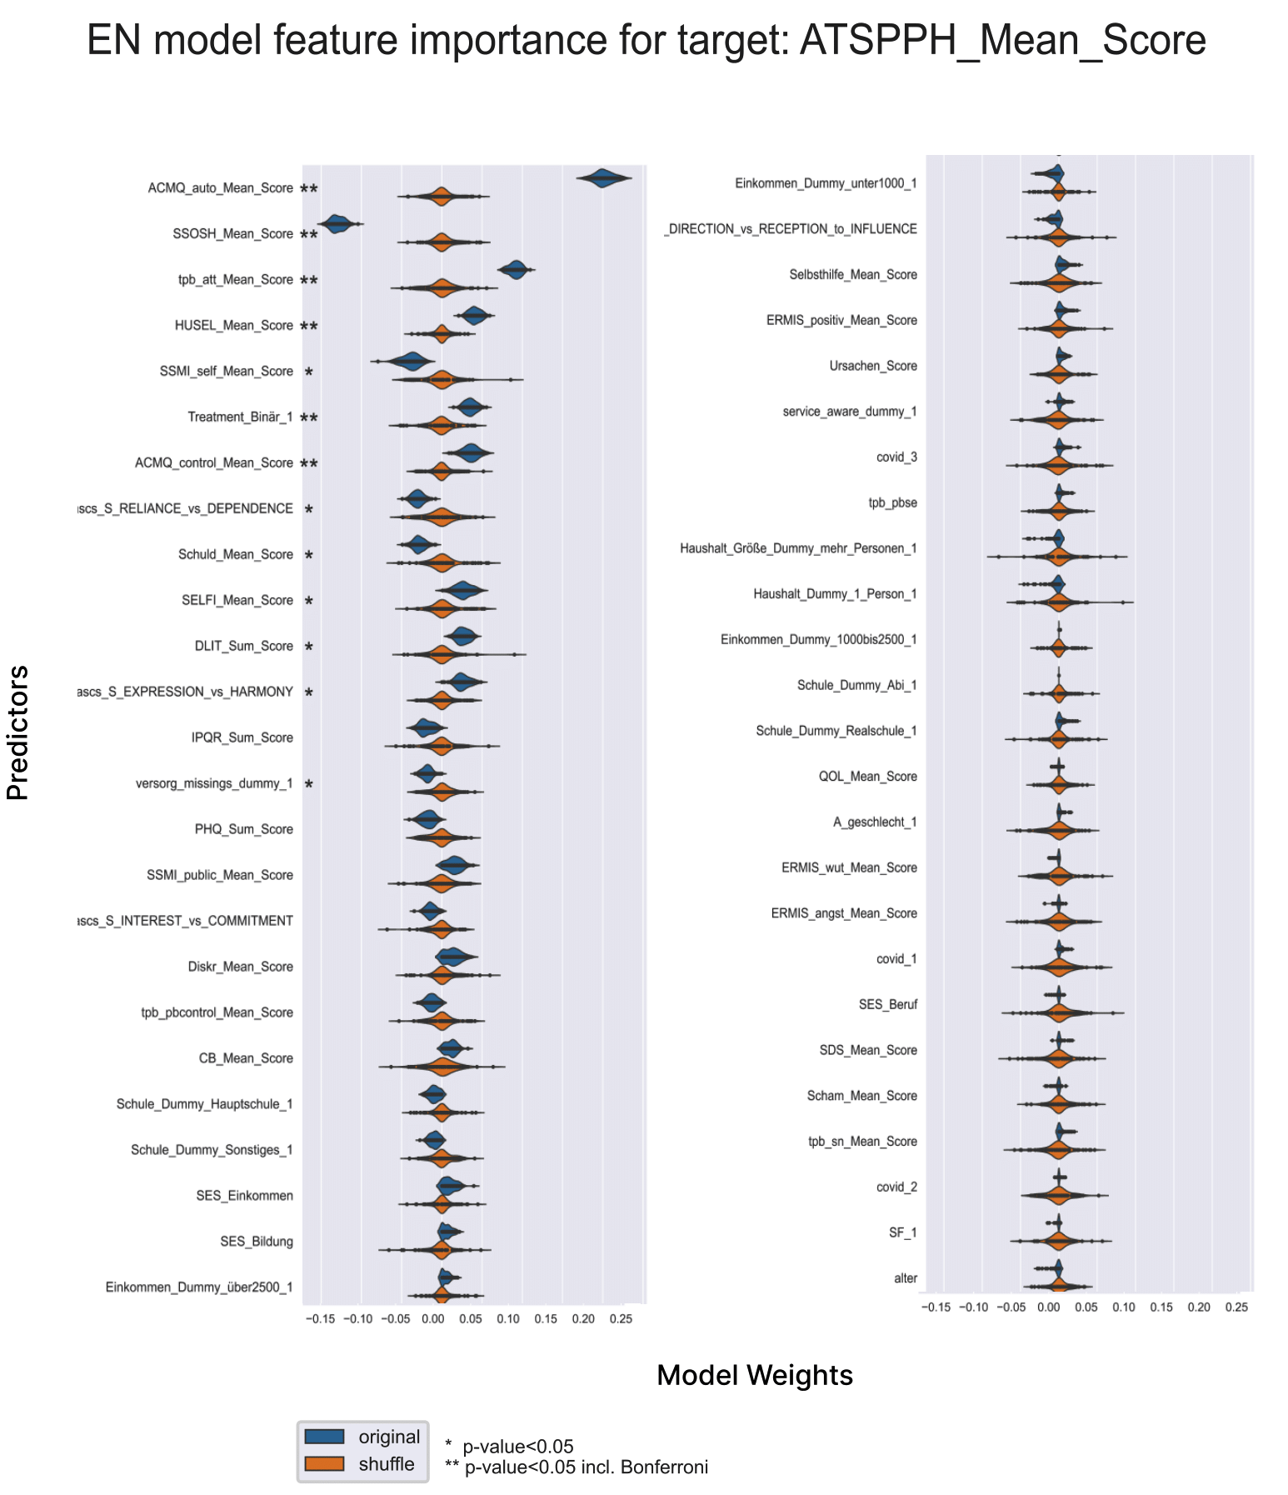
Model-Based Feature Importance for Help-Seeking Attitudes
Note. EN = Elastic Net. ATSPPH_Mean_Score = Attitudes towards seeking professional help. p-value of significance.
Figure S4c
Elastic Net Regression Model for Help-Seeking Attitudes
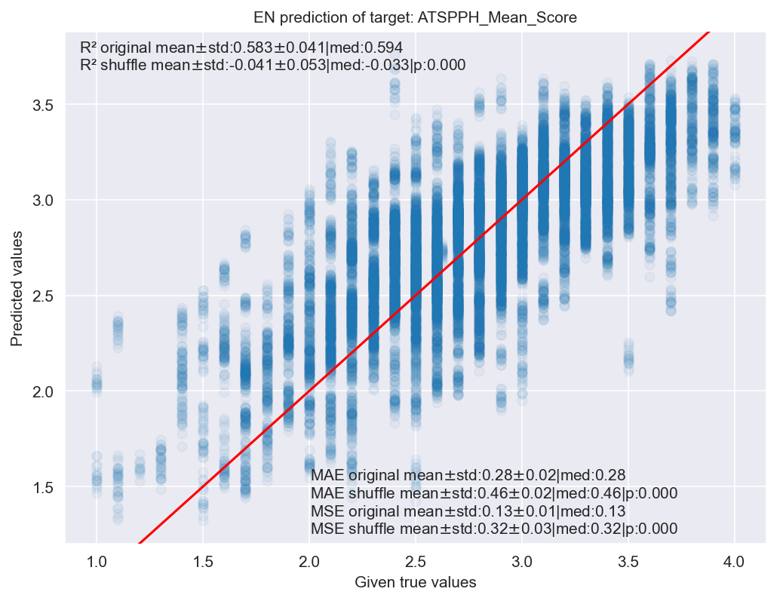

Note. EN = Elastic Net. ATSPPH_Mean_Score = Attitudes towards seeking professional help. R² = coefficient of determination. MAE = mean absolute error. MSE = mean standardized error. Std = standard deviation. med = median p = p-value of significance.
Table S4d
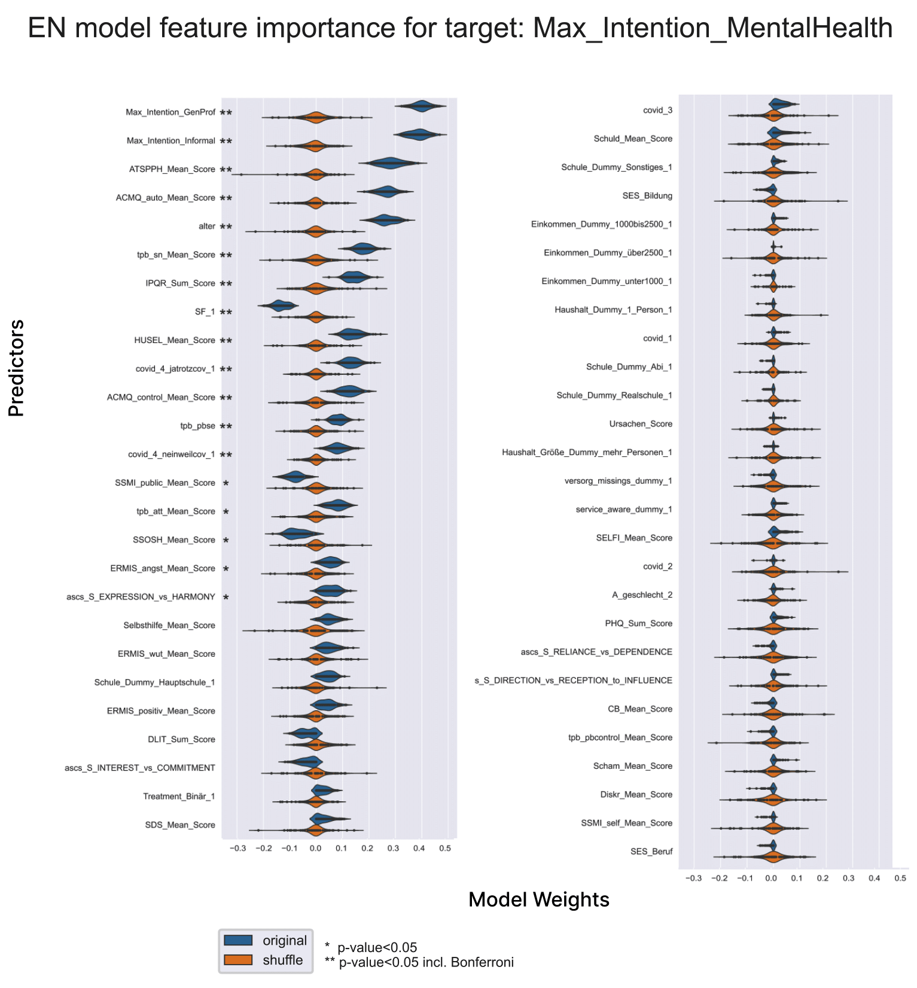
Model-Based Feature Importance for Help-Seeking Intention

Note. EN = Elastic Net. p-value of significance.
Figure S4e
Elastic Net Regression Model for Help-seeking Intention
. 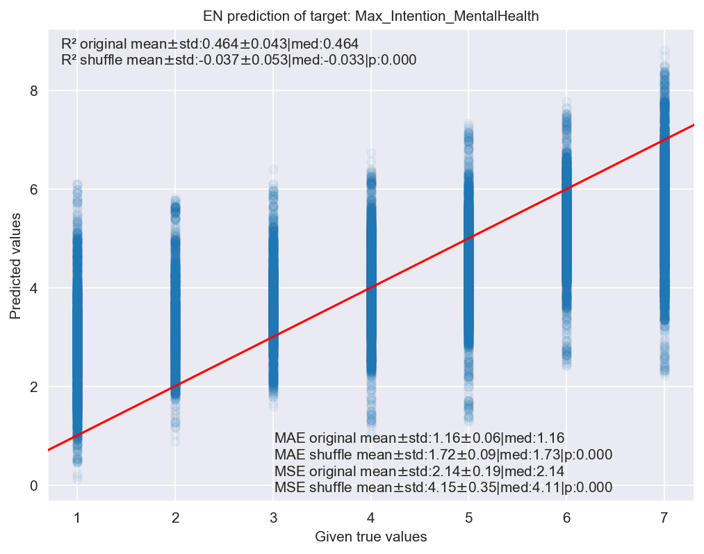
Note. EN = Elastic Net. R² = coefficient of determination. MAE = mean absolute error. MSE = mean standardized error. Std = standard deviation. med = median p = p-value of significance.
Table S4f
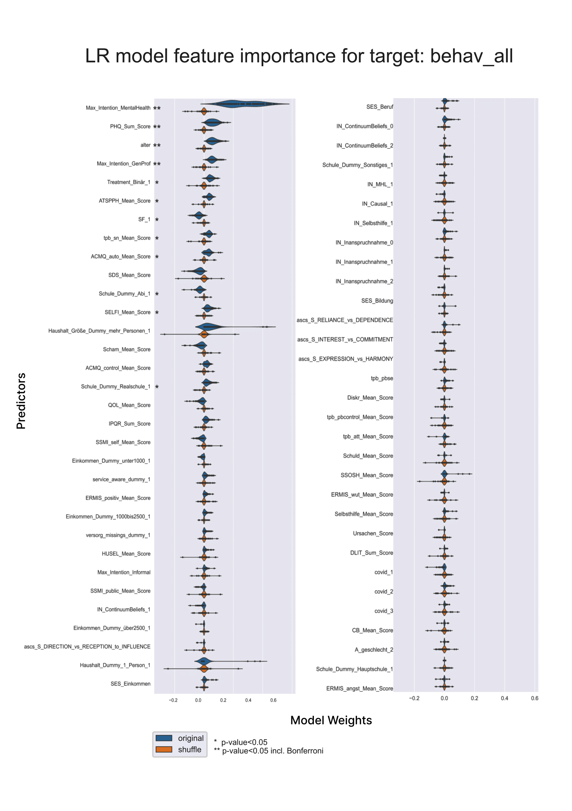
Model-based Feature Importance for Help-seeking Behaviour
Note. LR = Logistic Regression. p-value of significance.
Figure S4g
Confusion Matrix with Accuracy of the Logistic Regression Model with Help-Seeking Behaviour as Outcome

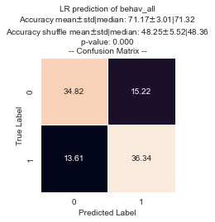
Note. LR = Logistic Regression Model. Bevah_all = Help-Seeking Behaviour. 0 = No help sought within the last three or six months from mental health professionals. 1 = Help sought within the last three or six months from mental health professionals. Std = standard deviation. p-value of significance.

References
1. Pescosolido BA, Boyer CA (2010) Understanding the context and dynamic social processes of mental health treatment. In: Scheid TL, Brown TN (eds) A handbook for the study of mental health: Social contexts, theories, and systems, Second edition. Cambridge University Press, Cambridge, pp 420–438
2. Fischer EH, Farina A (1995) Attitudes toward seeking professional psychologial help: A shortened form and considerations for research. Journal of College Student Development
3. Schomerus G, Muehlan H, Auer C et al. (2019) Validity and psychometric properties of the Self-Identification as Having a Mental Illness Scale (SELF-I) among currently untreated persons with mental health problems. Psychiatry Res 273:303–308. https://doi.org/10.1016/j.psychres.2019.01.054
4. Tomczyk S, Schomerus G, Stolzenburg S et al. (2020) Ready, Willing and Able? An Investigation of the Theory of Planned Behaviour in Help-Seeking for a Community Sample with Current Untreated Depressive Symptoms. Prev Sci 21:749–760. https://doi.org/10.1007/s11121-020-01099-2
5. Keleher B (2020) Evaluating the Effect of Basic Psychological Needs Support and Thwarting on Motivation for Emotionally Demanding Behaviour Change. UW Space
6. Broadbent E, Petrie KJ, Main J et al. (2006) The brief illness perception questionnaire. J Psychosom Res 60:631–637. https://doi.org/10.1016/j.jpsychores.2005.10.020
7. Morfeld M, Bullinger M, Kirchberger I (2011) Fragebogen zum Gesundheitszustand: SF-36 ; deutsche Version des Short Form-36 Health Survey, 2., erg. u. überarb. Aufl. Hogrefe, Göttingen, Wien u.a.
8. Brähler E, Muehlan H, Albani C et al. (2007) Teststatistische Prüfung und Normierung der deutschen Versionen des EUROHIS-QOL Lebensqualität-Index und des WHO-5 Wohlbefindens-Index. Diagnostica 53:83–96. https://doi.org/10.1026/0012-1924.53.2.83
9. Kroenke K, Spitzer RL, Williams JBW et al. (2010) The Patient Health Questionnaire Somatic, Anxiety, and Depressive Symptom Scales: a systematic review. Gen Hosp Psychiatry 32:345–359. https://doi.org/10.1016/j.genhosppsych.2010.03.006
10. Freitag S, Stolzenburg S, Schomerus G et al. (2018) Depressionswissen – Deutsche Übersetzung und Testung der Depression Literacy Scale (Depression Literacy - German Translation and Testing of the Depression Literacy Scale). Psychiatr Prax 45:412–419. https://doi.org/10.1055/s-0043-119245
11. Stolzenburg S, Freitag S, Schmidt S et al. (2018) Associations between causal attributions and personal stigmatizing attitudes in untreated persons with current mental health problems. Psychiatry Res 260:24–29. https://doi.org/10.1016/j.psychres.2017.11.014
12. Renner B, Hahn A, Schwarzer R (1996) Berlin Risk Appraisal and Health Motivation Study - Messinstrumente
13. Israel JI (2017) Healthcare use self-efficacy in adults who are homeless. Dissertation Abstracts International: Section B: The Sciences and Engineering
14. Corrigan PW, Michaels PJ, Vega E et al. (2012) Self-stigma of mental illness scale—short form: reliability and validity. Psychiatry Res 199:65–69. https://doi.org/10.1016/j.psychres.2012.04.009
15. Brenner RE, Colvin KF, Hammer JH et al. (2020) Using Item Response Theory to Develop Revised (SSOSH-7) and Ultra-Brief (SSOSH-3) Self-Stigma of Seeking Help Scales. Assessment:1073191120958496. https://doi.org/10.1177/1073191120958496
16. Angermeyer MC, Matschinger H (1997) Social distance towards the mentally ill: results of representative surveys in the Federal Republic of Germany. Psychol Med 27:131–141. https://doi.org/10.1017/S0033291796004205
17. Schomerus G, Angermeyer MC, Baumeister SE et al. (2016) An online intervention using information on the mental health-mental illness continuum to reduce stigma. Eur Psychiatry 32:21–27. https://doi.org/10.1016/j.eurpsy.2015.11.006
18. Angermeyer MC, Holzinger A, Matschinger H (2010) Emotional reactions to people with mental illness. Epidemiol Psichiatr Soc 19:26–32. https://doi.org/10.1017/s1121189x00001573
19. Schomerus G, Stolzenburg S, Freitag S et al. (2019) Stigma as a barrier to recognizing personal mental illness and seeking help: a prospective study among untreated persons with mental illness. Eur Arch Psychiatry Clin Neurosci 269:469–479. https://doi.org/10.1007/s00406-018-0896-0
20. Lampert T, Kroll L, Müters S et al. (2013) Messung des sozioökonomischen Status in der Studie zur Gesundheit Erwachsener in Deutschland (DEGS1) (Measurement of socioeconomic status in the German Health Interview and Examination Survey for Adults (DEGS1)). Bundesgesundheitsblatt Gesundheitsforschung Gesundheitsschutz 56:631–636. https://doi.org/10.1007/s00103-012-1663-4
21. Vignoles VL, Owe E, Becker M et al. (2016) Beyond the ‚east-west‘ dichotomy: Global variation in cultural models of selfhood. Journal of Experimental Psychology: General:966–1000. https://doi.org/10.1037/xge0000175
22. Nübel J, Müllender S, Hapke U et al. (2019) Epidemie der Depression? : Prävalenzentwicklung und Inanspruchnahme von Hilfs- und Versorgungsangeboten (Epidemic of depression? : Development of prevalence and help-seeking behaviour). Nervenarzt 90:1177–1186. https://doi.org/10.1007/s00115-019-0681-y
23. Rössler P (2017) Kumulierte Evidenzen: Replikationsstudien in der empirischen Kommunikationsforschung. Springer Fachmedien Wiesbaden, Wiesbaden
24. Rosenbusch H, Soldner F, Evans AM et al. (2021) Supervised machine learning methods in psychology: A practical introduction with annotated R code. Social and Personality Psychology Compass 15. https://doi.org/10.1111/spc3.12579
25. Lakens D (2021) Sample Size Justification
26. Vittinghoff E, McCulloch CE (2007) Relaxing the rule of ten events per variable in logistic and Cox regression. Am J Epidemiol 165:710–718
27. Friedman J, Hastie T, Tibshirani R (2010) Regularization Paths for Generalized Linear Models via Coordinate Descent. J Stat Soft 33:1–22
28. Hastie T, Tibshirani R, Friedman JH (2009) The elements of statistical learning: data mining, inference, and prediction, 2nd edn. Springer, New York
29. Cawley GC, Talbot N (2010) On Over-fitting in Model Selection and Subsequent Selection Bias in Performance Evaluation. Journal of Machine Learning Research:2079–2107
30. Wang C, Wu Q, Weimer M et al. (2021) Flaml: A fast and lightweight automl library. Proceedings of Machine Learning and Systems:434–447
31. Molnar C (2019) Interpretable machine learning: A guide for making black box models explainable. Leanpub
32. Nadeau C, Bengio Y (2003) Inference for the Generalization Error. Machine Learning 52:239–281. https://doi.org/10.1023/A:1024068626366
33. Bouckaert RR, Frank E (2004) Evaluating the Replicability of Significance Tests for Comparing Learning Algorithms. In: Kanade T, Kittler J, Kleinberg JM et al. (eds) Advances in Knowledge Discovery and Data Mining, vol 3056. Springer Berlin Heidelberg, Berlin, Heidelberg, pp 3–12

