Supplemental Materials

An efficient variant phasing utilizing a replication cycle reaction system

Supplementary Methods 1. pBR322 plasmid with oriC cassette sequence.
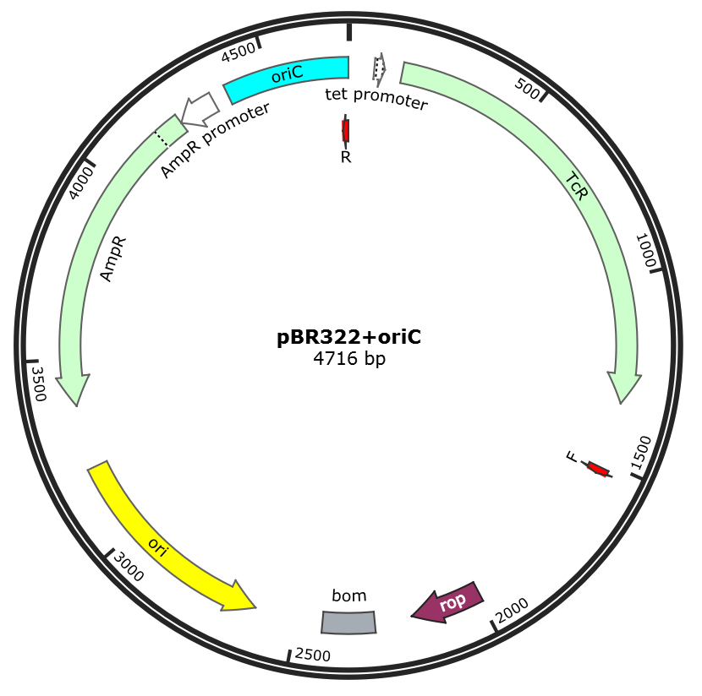
oriC cassette contained in OriCiro Cell-Free Cloning System (OriCiro Genomics, Tokyo, Japan) was subcloned into pBR322 downstream of the ampicillin resistance gene.
With the vector as a template, the region containing rop, ori, AmpR, and oriC cassette (oriC-AmpR cassette) was amplified by PCR. The sequence of primer used in this PCR amplification is as follows:
F 5’-CTGCTCTGATGCCGCATAG -3’
R 5’-GTGTCGGGGCTGGCTTAAC-3’
This PCR product was used as oriC-AmpR cassette in this paper.

Supplementary Methods 2. PCR amplification of oriC-AmpR cassette
oriC-AmpR cassette was amplified by PCR using primer pairs containing 60 nt overlapping sequences with the target sequence located at the 5’-side. PCR reaction was conducted as follows; initial denaturation at 94°C for 1 min, followed by 35 cycles of 94 °C for 30 s, 57 °C for 30 s, and 68 °C for 2 min. A final elongation step was 68 °C for 8 min. Afterward, electrophoresis on a 1% agarose gel at 100 V for 30 minutes was performed, and gel extraction was conducted using the QIAquick Gel Extraction Kit (QIAGEN).
The primers used in each experiment is as follows:
[chr5:149,503,216–149,513,393]
Forward Primer:
5’-AGGTTGGGCAGGCCCCCCAAATCAGGAGGGGCCGGGGAGAAATCAGCCTGCAAGCC
AGATCTGCTCTGATGCCGCATAG-3’
Reverse Primer:
5’-TACATAGACTTATTCACGTTTGCAATGATCGCTCATTTCAACATTTTCGTTTGTGTAGAT
GTGTCGGGGCTGGCTTAAC-3’
[chr10:79,309,011–79,336,568]
Forward Primer:
5’-GTTTTTCGGATGATTTTTTTCCTGGCTTGTCCACAACTTCTGGAAGCATCTTACTCAGA
TCTGCTCTGATGCCGCATAG-3’
Reverse Primer:
5’-AGCAACAGATCAAAATTATTATTAAGACTGAAGTTACAATAAACAAAGCAAACAAAAG
ATGTGTCGGGGCTGGCTTAAC-3’
[chr14:88,450,095–88,455,957]
Forward Primer:
5’-AAACCATAAACTTGGGCCACCTTTTGTCCAAACTTCCCATGTACCCTCAGTCACCAAG
ATCTGCTCTGATGCCGCATAG-3’
Reverse Primer:
5’- TCACCTGTCACAAACTGTTAGTTAACACCTTTTAAGGATTTGAAAAGTATGAAAAATG
ATGTGTCGGGGCTGGCTTAAC-3’
[chr2: 219,674,341–219,680,561]
Forward Primer:
5’-ACGGTCCTGGAGCTGGCTTTCTGTGAGCAATATTACCATGTGATCTAAATTTGCCCAGG
TCTGCTCTGATGCCGCATAG-3’
Reverse Primer:
5’-CCCAACAAAGTAAAGTCTAATAAGACTGTCTAAGCTATGAATTCTGATTAATGACCAG
TAGTGTCGGGGCTGGCTTAAC-3’
[chr6: 152,527,031–152,546,879]
Forward Primer:
5’-TGACCCCCATCCTGTCTCTCAATACCCATGAAGCCAGCAGTAACTGGACTTGGACCTC
TGGCATGATCGTGCTCCTGTCG-3’
Reverse Primer:
5’-CGCATCACTTGCTCCAAGAGCGGGGCACTGGCCAGGTTCACGTGCATCTGAGGCCCT
AAGGTGTCGGGGCTGGCTTAAC-3’
157
[chr6: 152,545,700–152,558,998]
Forward Primer:
5’-TTTATTTTATTTAAAACTGGAAAACACTTTTTAAAAGATCAGTTGAAGTCTTTTCCAGT
ACTGCTCTGATGCCGCATAG-3’
Reverse Primer:
5’-AATGGAGTAGTCACAAAGTGGCCTTTGACAAGATAAACAGTTACCTCATGGAGGCCA
GATGTGTCGGGGCTGGCTTAAC-3’
[chr13: 52,506,042–52,586,194]
Forward Primer:
5’-CGGCAAGAGTGAACTCCGCACCTGGAAAATCGATCCGCTGTGCGCAAAGGCCAGCCA
ATGCTGCTCTGATGCCGCATAG-3’
Reverse Primer:
5’-ATAGGTTCCAGAGACATGCTGGTGGCATAGTCCGTTATCATATTTCAAGGTTCTCCCCC
AGTGTCGGGGCTGGCTTAAC-3’
[chr6:152,599,149–152,671,977]
Forward Primer:
5’-AAAAAAAAATGAGCCTGCTCATCTCCGTGGACAAGATGAATACATACATATTCCCATG
CTGCTCTGATGCCGCATAG-3’
Reverse Primer:
5’-GCTGGCCCACAGCTGAAAGTTGGCACACTGTTCACGTGCTCCTTCTAAGGTTTGCCA
GGTGTGTCGGGGCTGGCTTAAC-3’
[chr6:152670346–152754123]
Forward Primer:
5’-GATGATCTGCACAGCGGGTAATCTTATCTGAGCAACATTGCACCCTCCCACCCTCCACA
TCTGCTCTGATGCCGCATAG-3’
Reverse Primer:
5’-TTAAATCTATCAAGATAAGAACTTAATAATATGTATTTTTAGTAATCGTGTTTACCACGT
GTGTCGGGGCTGGCTTAAC-3’
[chr3:184,074,010-184,081,131]
Forward Primer:
5’- GGACGGAAGTTAAGTAGCCCCGAGCGGGAGGCTGTGGCGGAAGTGGTCGCGTTAC
CGCTTCTGCTCTGATGCCGCATAG-3’
Reverse Primer:
5’- GACTTCCCTTGGGACTGACATCCTTCAGAGAGAGGGCAGCCAGCTGAACCTGCTCC
CTACGTGTCGGGGCTGGCTTAAC-3’

Supplementary Methods 3.
[Patient 1]
Variant 1
5’-ATGATGTCTCCATTTGGTAA-3’
Variant 2
5’-GGGCAAAAGTTAGGGCCATT-3’
[Patient 2]
Variant 1
5’-AGACCATCAGGCTCAGAGGA-3’
Variant 2
5’-GAGCCTGAAAGCTTCCAGCC-3’
[Patient 3]
Variant 1
5’-TTCTAGACGTGGTCCCATCTG-3’
Variant 2
5’-TTCAGGATCTGGAAGATTTG-3’
[Patient 4]
Variant 1
5’-TCCCATGGTCTTGGTGTTTT-3’
Variant 2
5’-CAAGCACATCTCCCAGACAG-3’
[Patient 5]
Variant 1
5’-AAGCTCAGCAGCATTGTAGGA-3’
Variant 2
5’-AGAACTGTCAGTCCACAATG-3’
SNP
5’-TCCTATGCTGCACAGGTCCT-3’
Patient 6
Variant 1
5’-ATTAGGGTAGGCCCCTGGT-3’
Variant 2
5’-AAGGGAAGAGGCACCTGAGT-3’

