Delocalizing Electron Distribution in Thermally Activated Delayed Fluorophors for High-efficiency, Long-Lifetime Blue Electroluminescence
Tianyu Huang¹, Qi Wang¹, Hai Zhang¹, Yangyang Xin¹, Yuewei Zhang^{1,2}, Dongdong Zhang¹*, Lian Duan^{1,2}*

¹ Key Laboratory of Organic Optoelectronics and Molecular Engineering of Ministry of Education, Department of Chemistry, Department of Chemistry, Tsinghua University, Beijing 100084, China
² Laboratory of Flexible Electronics Technology, Tsinghua University, Beijing, 100084, China
E-mail: ddzhang@mail.tsinghua.edu.cn; duanl@mail.tsinghua.edu.cn

Supplementary Notes

1. Materials synthesis and characterization
Synthesis of 4CzBN-PhCN. 4CzBN-PhCN was synthesized through a two-step process from 4-bromo-2,3,5,6-tetrafluorobenzonitrile and (4-cyanophenyl)boronic acid. The stepwise synthetic methods are shown in Scheme S1 and the general process is given below.
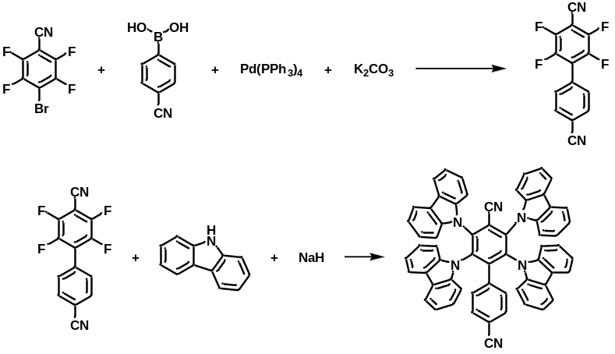

Scheme S1 Synthesis of 4CzBN-PhCN

Synthesis of 2,3,5,6-tetrafluoro-[1,1'-biphenyl]-4,4'-dicarbonitrile. A mixture of 4-bromo-2,3,5,6-tetrafluorobenzonitrile (5.00 g, 19.69 mmol), (4-cyanophenyl)boronic acid (3.18 g, 21.66 mmol), Pd(PPh₃)₄ (1.14 g, 0.98 mmol), and potassium carbonate (5.44 g, 39.37 mmol) dissolved in 1,4-dioxane/H₂O in a 2-neck round bottle was refluxed for 12 hours under nitrogen. The water was separated, and the organic layer was extracted with chloroform. The combined organic extracts were dried over Na₂SO₄ and concentrated by rotary evaporation. The crude product was purified by column chromatography on silica gel using 1: 4 dichloromethane (DCM)/petroleum ether (PE) as eluent to afford a white solid (3.90 g, 72 % yield).

Synthesis of 4CzBN-PhCN. A mixture of carbazole (2.66 g, 15.93 mmol) and sodium hydride (60% in mineral oil, 0.87 g, 21.7 mmol) dissolved in dimethyl formaldehyde (DMF) was heated at 80℃ for 1 hour. Then, 2,3,5,6-tetrafluoro-[1,1'-biphenyl]-4,4'-dicarbonitrile (1.00 g, 3.62 mmol) was added to the reaction drop by drop and heated overnight. After cooling to room temperature, the solution was poured into ice water and the precipitation was filtered to get crude product. Afterwards, the product was purified by column chromatography on silica-gel (DCM: PE =5:1) to afford a yellow solid (2.50 g, 2.89 mmol, 80% yield).
¹H NMR (400 MHz, Chloroform-d) δ 7.76 – 7.69 (m, 4H), 7.61 – 7.54 (m, 4H), 7.24 – 7.20 (m, 4H), 7.12 – 7.06 (m, 8H), 6.95 (m, 12H), 6.73 – 6.62 (dd, J = 11.5, 8.3 Hz, 4H).
¹³C NMR (101 MHz, Chloroform-d) δ 139.3205, 138.9204, 131.2069, 128.1709, 125.5164, 125.2434, 124.1485, 123.3811, 121.2103, 120.7072, 120.2952, 120.1272, 112.2783, 110.0613, 109.6195.
MALDI-TOF-MS m/z: 864.37 [M]+
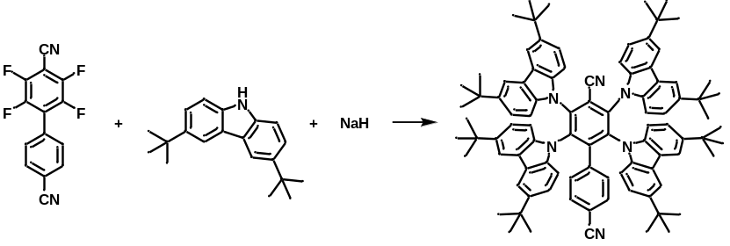
Scheme S2 Synthesis of 4tCzBN-PhCN

Synthesis of 4tCzBN-PhCN. As shown in Scheme S2, a mixture of 3,6-tert-butylcarbazole (4.45 g, 15.93 mmol) and sodium hydride (60% in mineral oil, 0.87 g, 21.7 mmol) dissolved in dimethyl formaldehyde (DMF) was heated at 80℃ for 1 hour. Then, 2,3,5,6-tetrafluoro-[1,1'-biphenyl]-4,4'-dicarbonitrile (1.00 g, 3.62 mmol) was added to the reaction drop by drop and heated overnight. After cooling to room temperature, the solution was poured into ice water and the precipitation was filtered to get crude product. Afterwards, the product was purified by column chromatography on silica-gel (DCM: PE =5:1) to afford a yellow solid (3.96 g, 3.01 mmol, 83% yield).
¹H NMR (400 MHz, Chloroform-d) δ 7.56 (d, J = 1.8 Hz, 4H), 7.45 (d, J = 1.8 Hz, 4H), 7.02 (d, J = 8.2 Hz, 2H), 6.95 (dd, J = 8.7, 1.8 Hz, 4H), 6.87 (d, J = 8.5 Hz, 4H), 6.83 (dt, J = 8.6, 2.1 Hz, 6H), 6.59 (d, J = 8.6 Hz, 4H), 1.34 (s, 36H), 1.30 (s, 36H).
¹³C NMR (101 MHz, Chloroform-d) δ 148.2400, 143.8188, 143.3146, 141.3521, 138.2856, 137.8515, 137.1944, 135.4780, 131.5297, 129.1458, 124.5381, 123.7244, 122.8810, 122.6045, 115.7702, 115.6259, 111.8658, 109.7246, 108.9686, 77.4102, 77.0917, 76.7764, 34.6014, 34.5275, 31.9593, 31.9105.
MALDI-TOF-MS m/z: 1313.47 [M]+

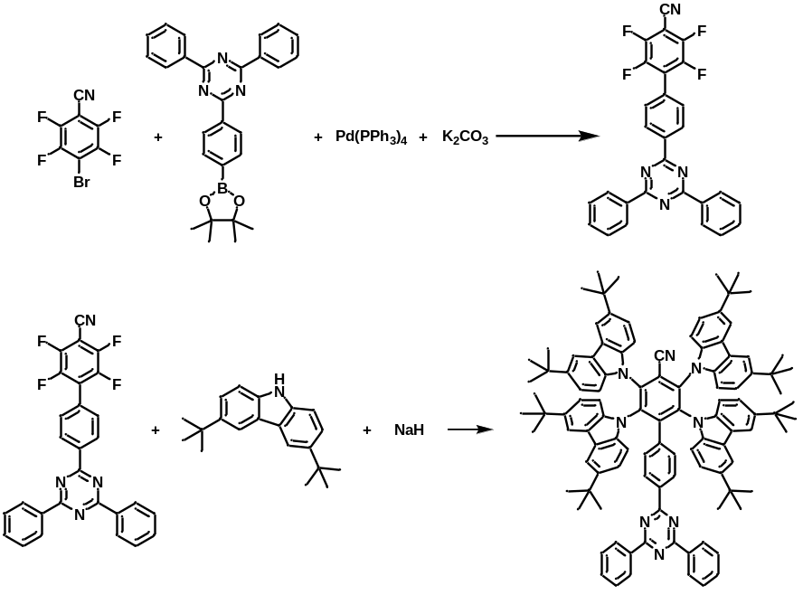
Scheme S3 Synthesis of 4tCzBN-TPTRZ

Synthesis of 4'-(4,6-diphenyl-1,3,5-triazin-2-yl)-2,3,5,6-tetrafluoro-[1,1'-biphenyl]-4-carbonitrile. A mixture of 4-bromo-2,3,5,6-tetrafluorobenzonitrile (5.00 g, 19.69 mmol), 2,4-diphenyl-6-(4-(4,4,5,5-tetramethyl-1,3,2-dioxaborolan-2-yl)phenyl)-1,3,5-triazine (9.43 g, 21.66 mmol), Pd(PPh₃)₄ (1.14 g, 0.98 mmol), and potassium carbonate (5.44 g, 39.37 mmol) dissolved in 1,4-dioxane/H₂O in a 2-neck round bottle was refluxed for 12 hours under nitrogen. The water was separated, and residue was filtered and washed by DCM. The crude product is a white solid and used directly without further purification due to the poor solubility (5.50 g, 58 % yield).

Synthesis of 4tCzBN-TPTRZ. A mixture of 3,6-tert-butylcarbazole (2.55 g, 9.12 mmol) and sodium hydride (60% in mineral oil, 0.50 g, 12.44 mmol) dissolved in dimethyl formaldehyde (DMF) was heated at 80℃ for 1 hour. Then, 4'-(4,6-diphenyl-1,3,5-triazin-2-yl)-2,3,5,6-tetrafluoro-[1,1'-biphenyl]-4-carbonitrile (1 g, 2.07 mmol) was added to the reaction drop by drop and heated overnight. After cooling to room temperature, the solution was poured into ice water and the precipitation was filtered to get crude product. Afterwards, the product was purified by column chromatography on silica-gel (DCM: PE =5:1) to afford a yellow solid (2.70 g, 1.78 mmol, 86% yield).
¹H NMR (400 MHz, Chloroform-d) δ 8.42 (dd, J = 7.1, 1.7 Hz, 4H), 8.07 – 7.97 (m, 2H), 7.57 (d, J = 1.9 Hz, 4H), 7.43 (q, J = 2.8 Hz, 6H), 7.36 (dd, J = 8.3, 6.8 Hz, 4H), 6.99 – 6.92 (m, 4H), 6.90 – 6.82 (m, 8H), 6.72 (d, J = 8.6 Hz, 4H), 1.36 (s, 36H), 1.28 (s, 36H).
¹³C NMR (101 MHz, Chloroform-d) δ 171.2924, 170.3967, 149.9348, 143.5338, 142.9249, 140.9966, 137.9551, 137.8878, 137.5745, 136.0042, 135.9179, 135.5608, 132.4428, 128.8857, 128.8067, 128.5086, 128.4539, 124.4151, 123.9086, 122.7961, 122.5552, 118.0665, 115.6843, 115.5563, 113.3240, 109.6899, 109.2051, 77.4071, 77.0909, 76.7744, 34.5991, 34.4956, 31.9996, 31.9352.
MALDI-TOF-MS m/z: 1520.02 [M]+

Supplementary Figures
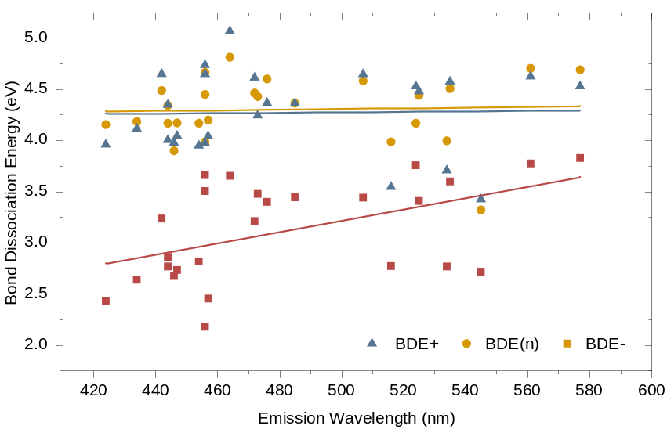
Supplementary Fig. 1 Cross-comparison of BDE values versus emission wavelength for reported TADF emitters with good performances.

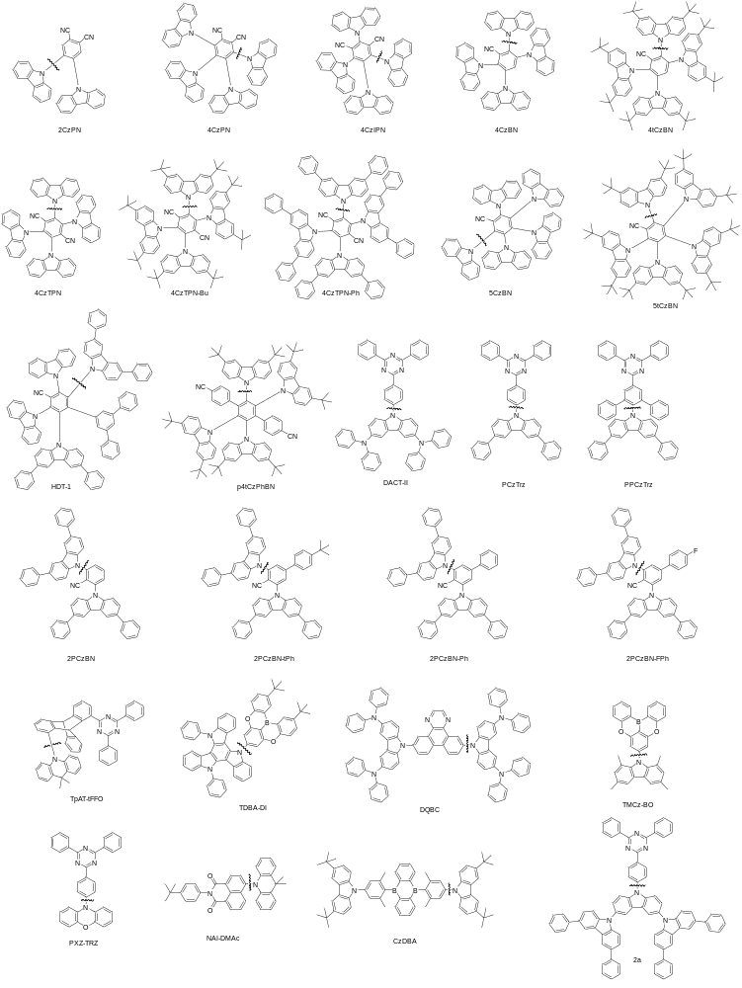
Supplementary Fig. 2 Chemical structures of the reported TADF emitters for cross-comparison of BDE values. The positions of the C-N bonds are marked by wavy line in each structure.

Supplementary Fig. 3 HOMO and LUMO distribution of the TADF molecules.
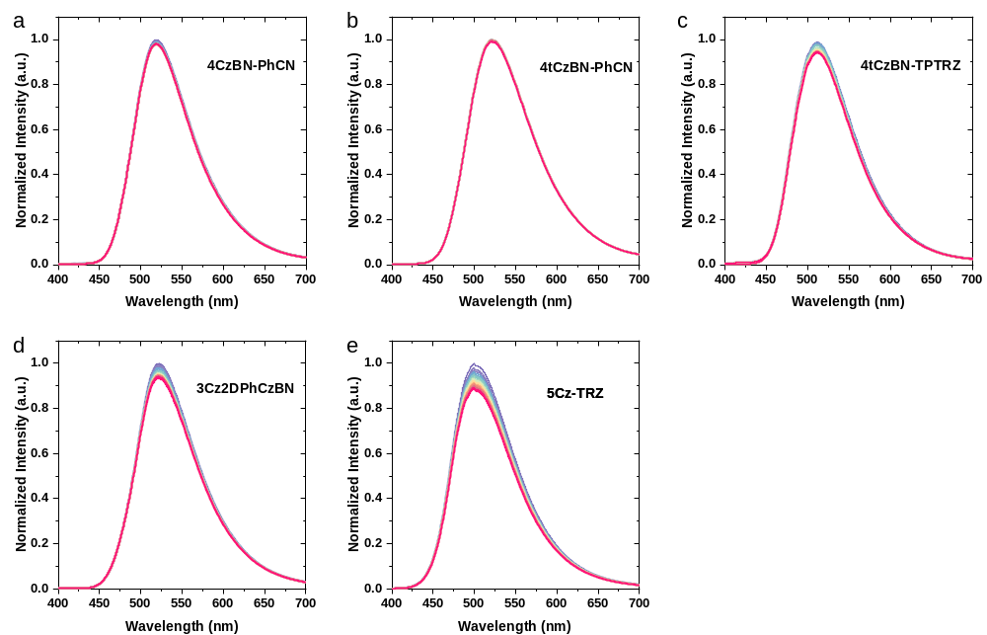
Supplementary Fig. 4 Photo-degradation spectra of the TADF-emitters.

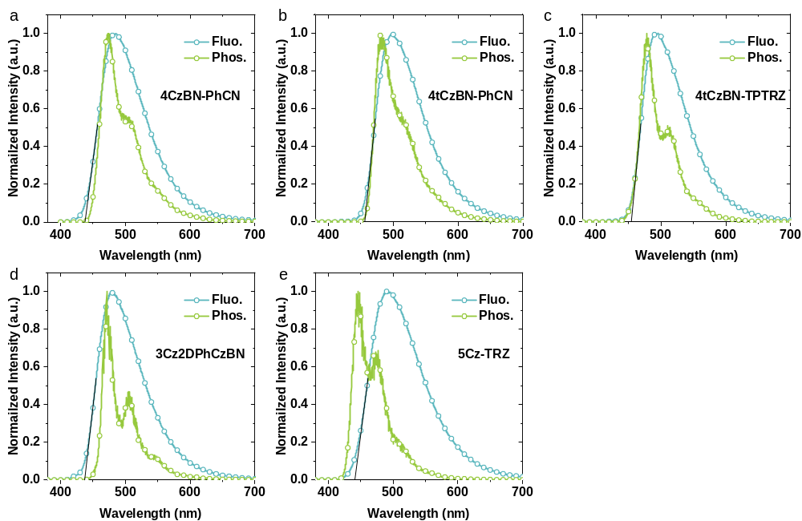
Supplementary Fig. 5 Fluorescence and phosphorescence spectra of the TADF-emitters.

Supplementary Fig. 6 Hole-electron analysis of the TADF molecules (Blue isovalue surface for hole distribution and green isovalue surface for electron distribution).

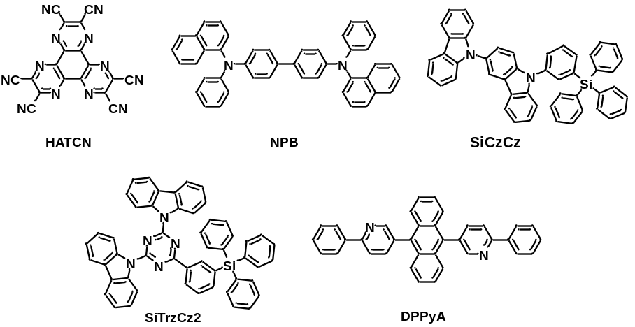
Supplementary Fig. 7 The functional materials employed in the devices.
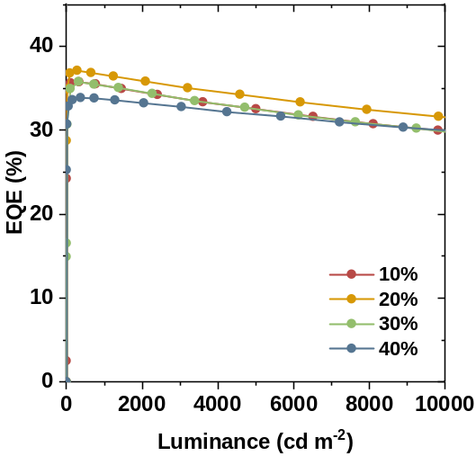
Supplementary Fig. 8 EQE-luminance characteristics of 4tCzBN-PhCN devices with different doping concentration.
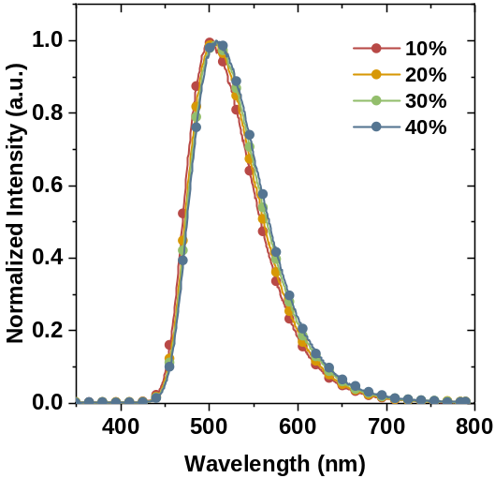
Supplementary Fig. 9 EL spectra of 4tCzBN-PhCN devices with different doping concentration.
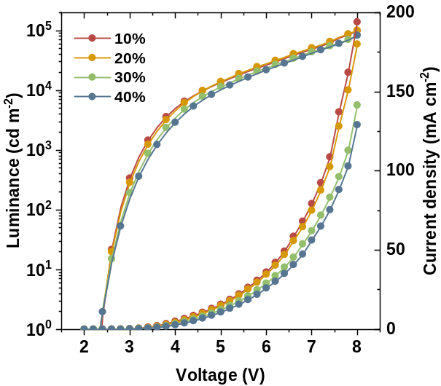
Supplementary Fig. 10 J-V-L characteristics of 4tCzBN-PhCN devices with different doping concentration.

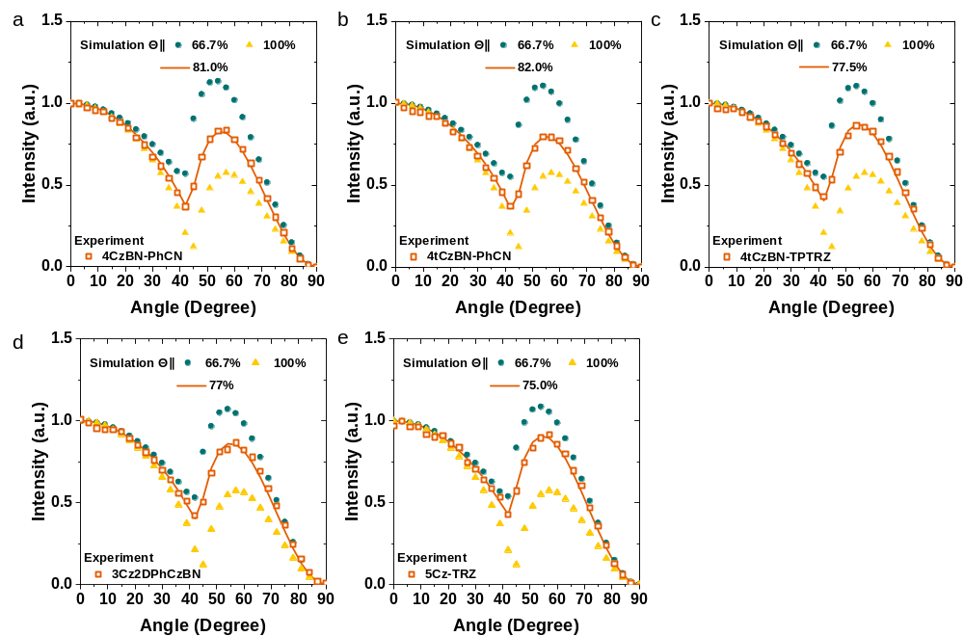
Supplementary Fig. 11 Angle-dependent PL spectra of the TADF emitters doped in SiCzCz: SiTrzCz2 films.

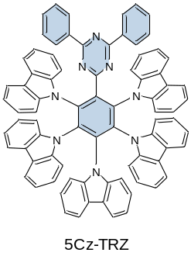
Supplementary Fig. 12 Chemical structure of 5Cz-TRZ.

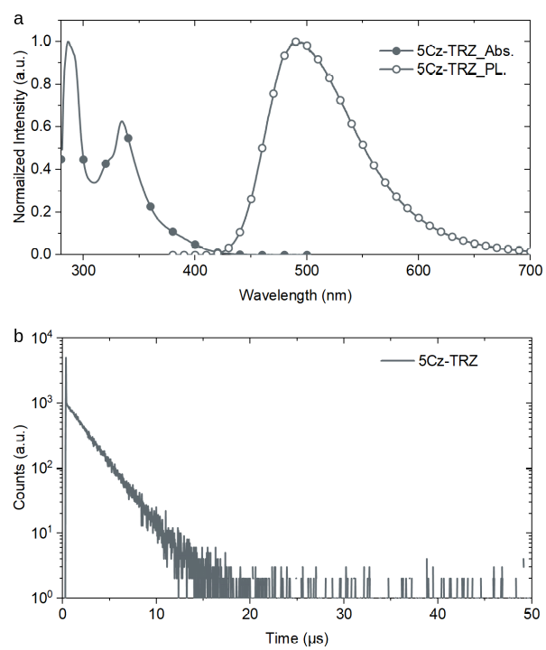
Supplementary Fig. 13 (a) UV-Vis absorption spectra and photoluminescence spectra of 5Cz-TRZ in dilute toluene solution. (b) Transient photoluminescence decay curves of 5Cz-TRZ in dilute oxygen-free toluene.

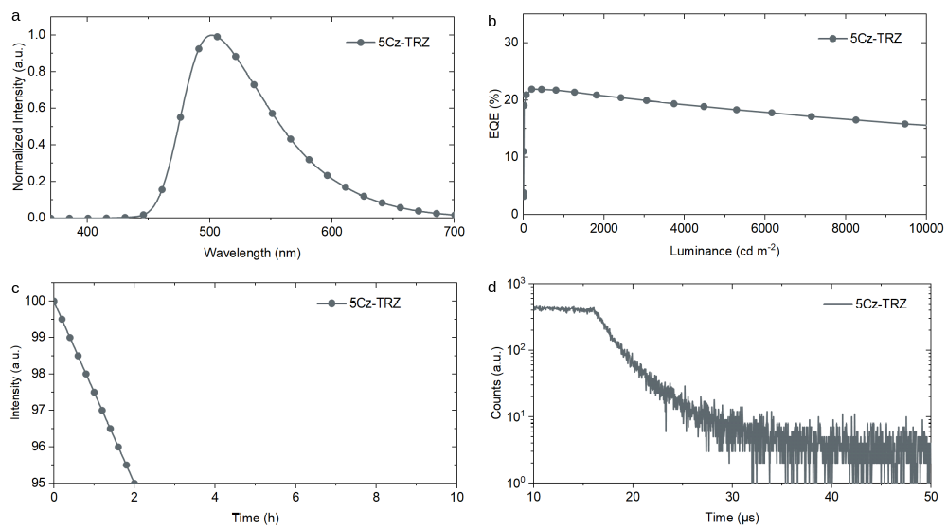
Supplementary Fig. 14 (a) EL spectra of 5Cz-TRZ device at 1,000 cd m⁻². (b) The EQE-Luminance characteristics of 5Cz-TRZ device at 1,000 cd m⁻². (c) Operational lifetimes of 5Cz-TRZ device at an initial luminance (L₀) of 5,000 cd m⁻². (d) Transient electroluminance decay curves of 5Cz-TRZ device at 1,000 cd m⁻².

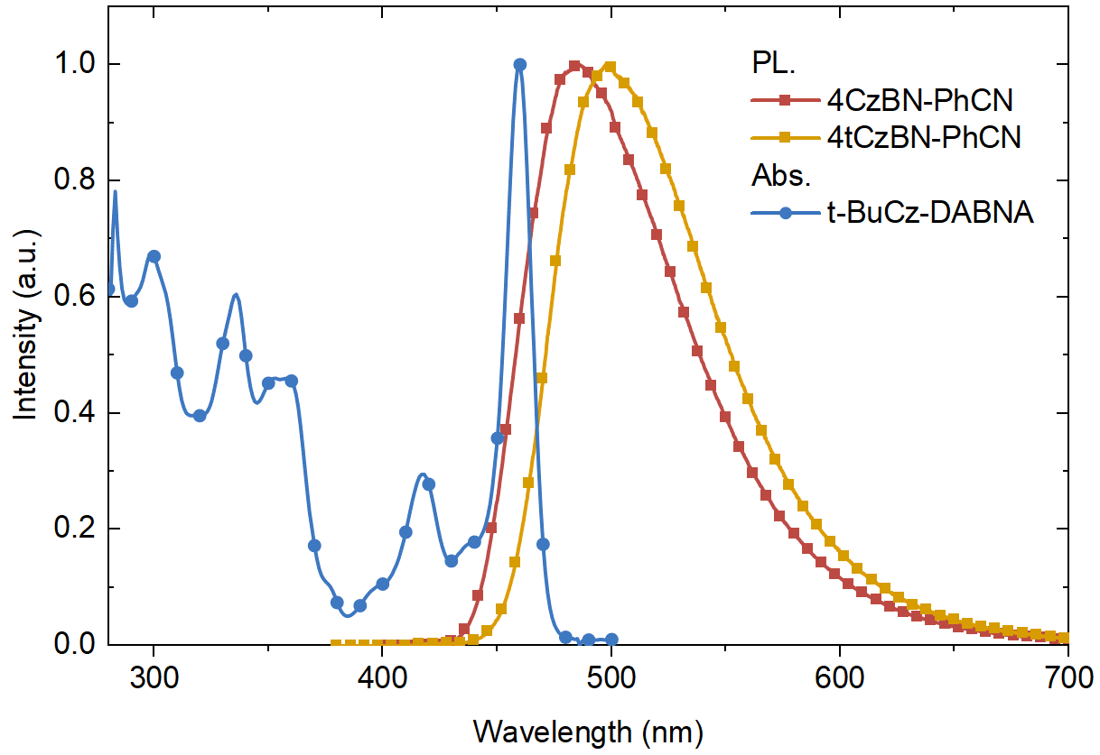
Supplementary Fig. 15 Absorption spectra of final emitters and emission spectra of the TADF sensitizers.

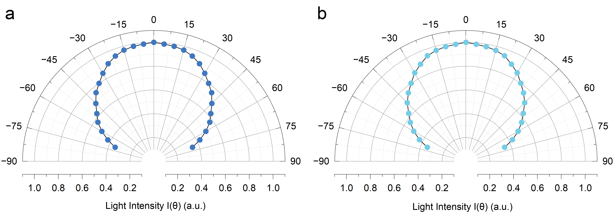
Supplementary Fig. 16 Angle-dependent EL intensities of (a) TSF-DB and (b) TSF-SB devices, compared to the Lambertian distribution.
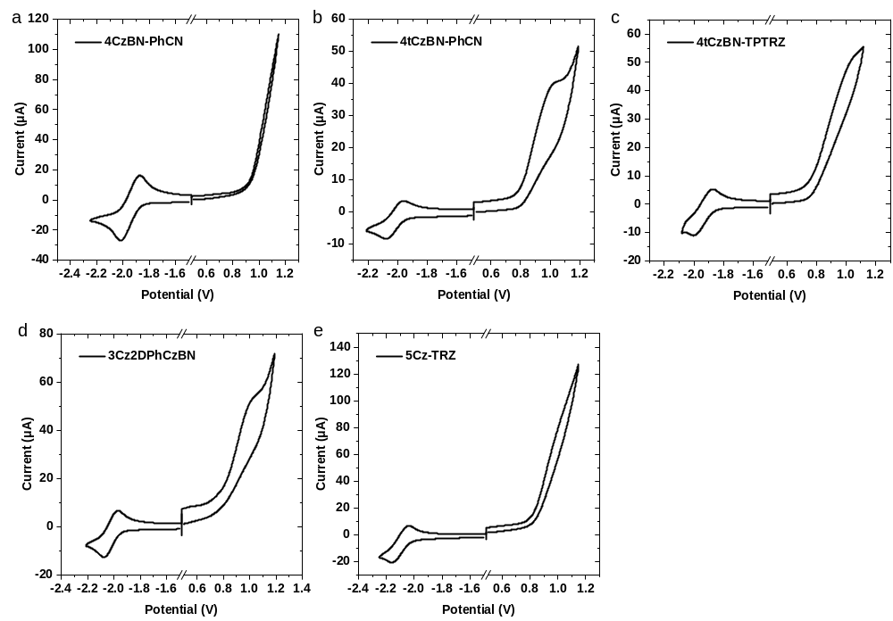
Supplementary Fig. 17 CV curves of the TADF emitters
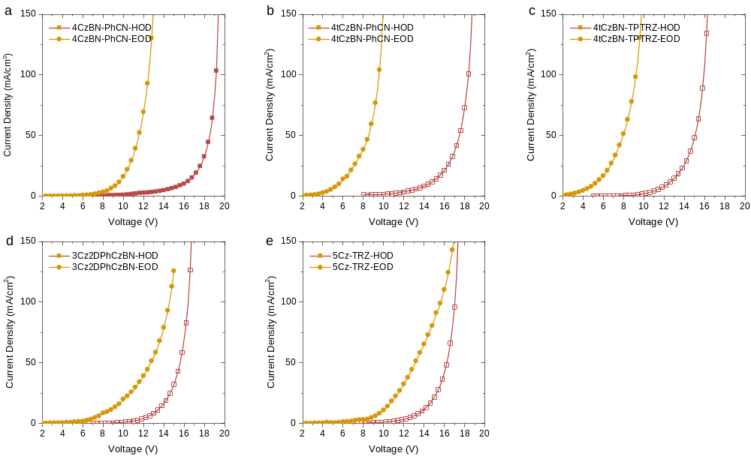
Supplementary Fig. 18 J-V curves of the single-carrier devices.

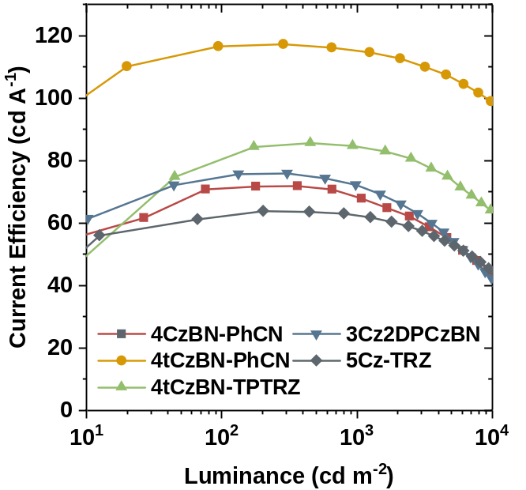
Supplementary Fig. 19 Current efficiency-luminance characteristics of the TADF-devices.
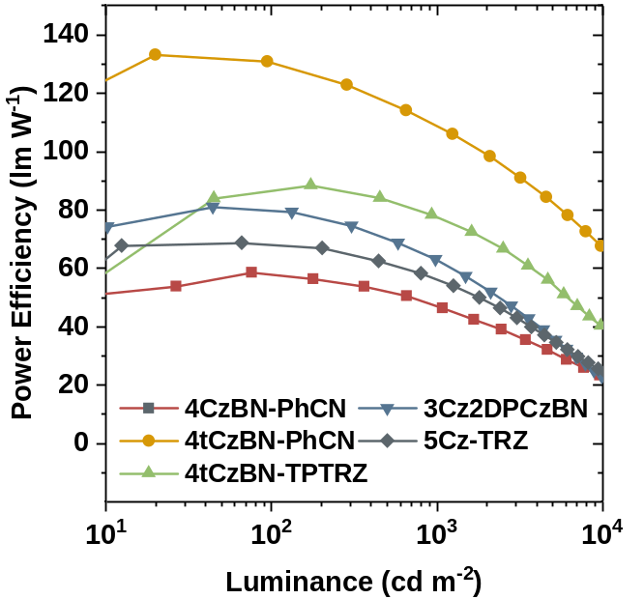
Supplementary Fig. 20 Power efficiency-luminance characteristics of the TADF-devices.
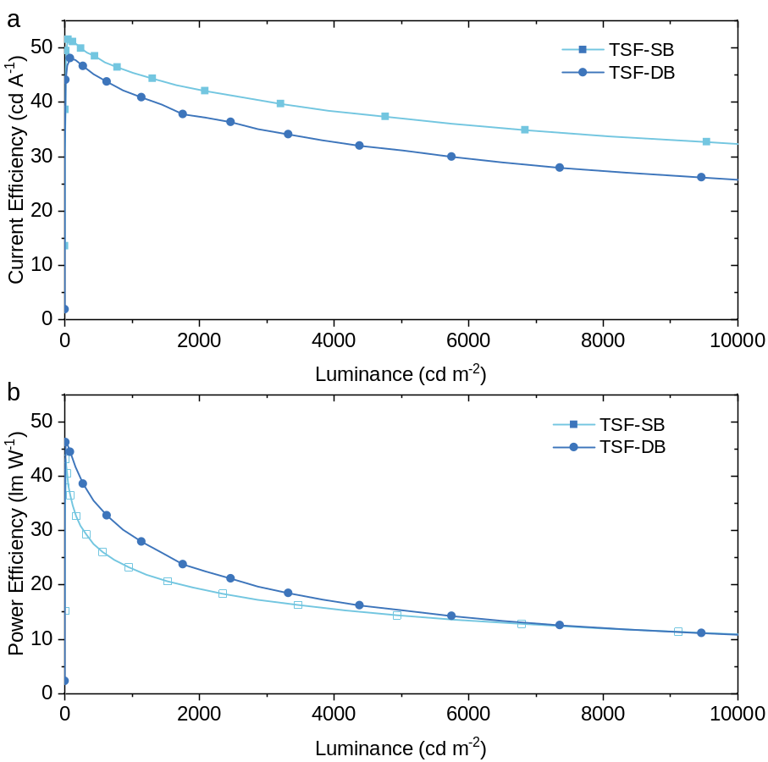
Supplementary Fig. 21 (a) Current efficiency-luminance characteristics and (b) Power efficiency-luminance characteristics of the TSF-devices.

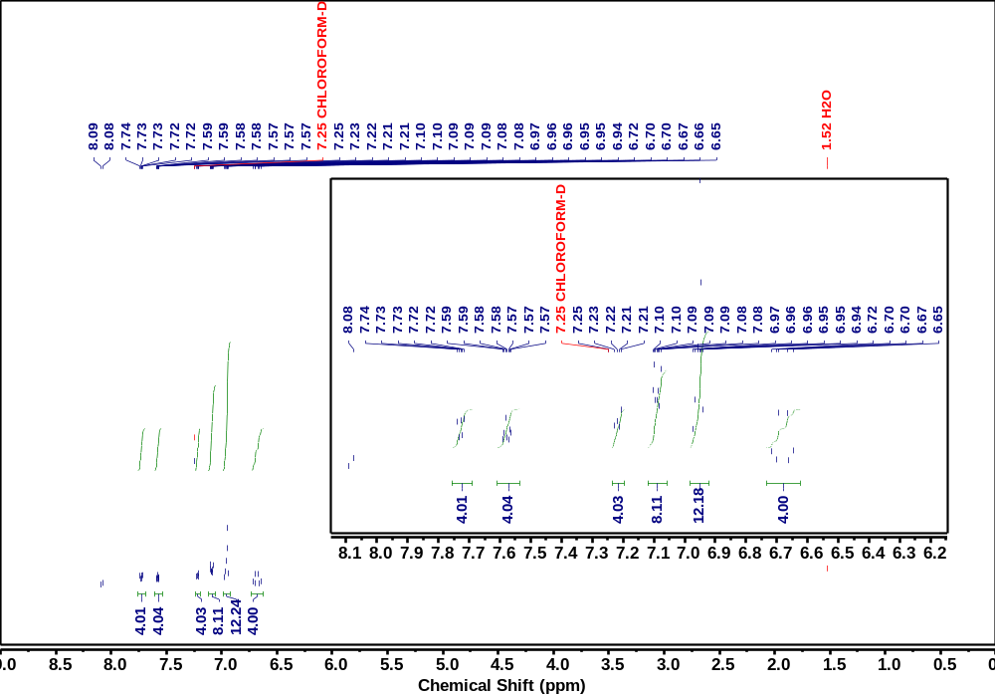
Supplementary Fig. 22 ¹H NMR of 4CzBN-PhCN

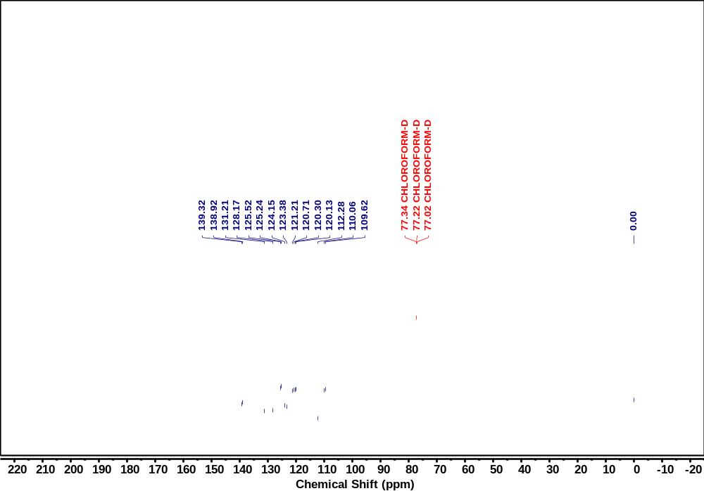
Supplementary Fig. 23 ¹³C NMR of 4CzBN-PhCN
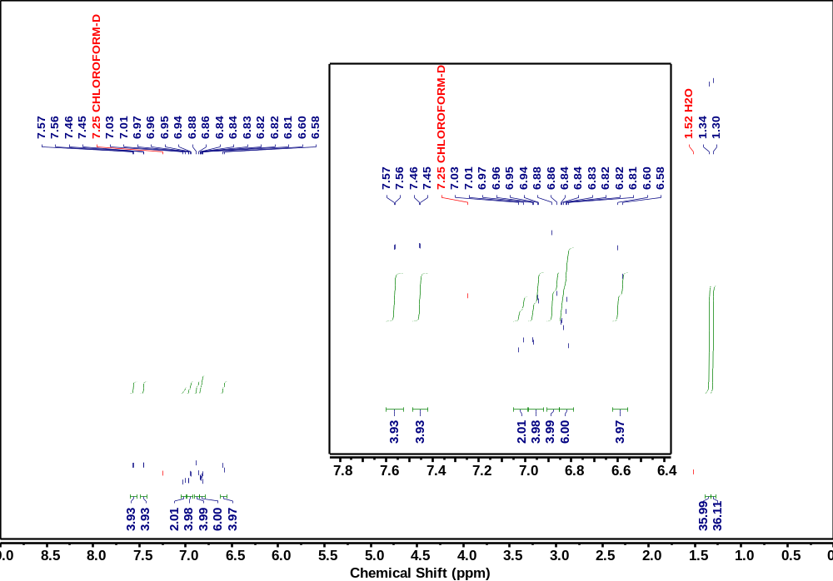
Supplementary Fig. 24 ¹H NMR of 4tCzBN-PhCN

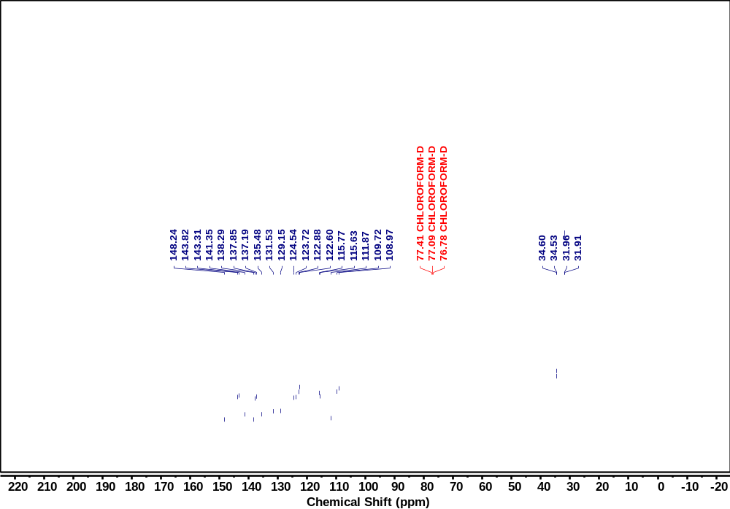
Supplementary Fig. 25 ¹³C NMR of 4tCzBN-PhCN
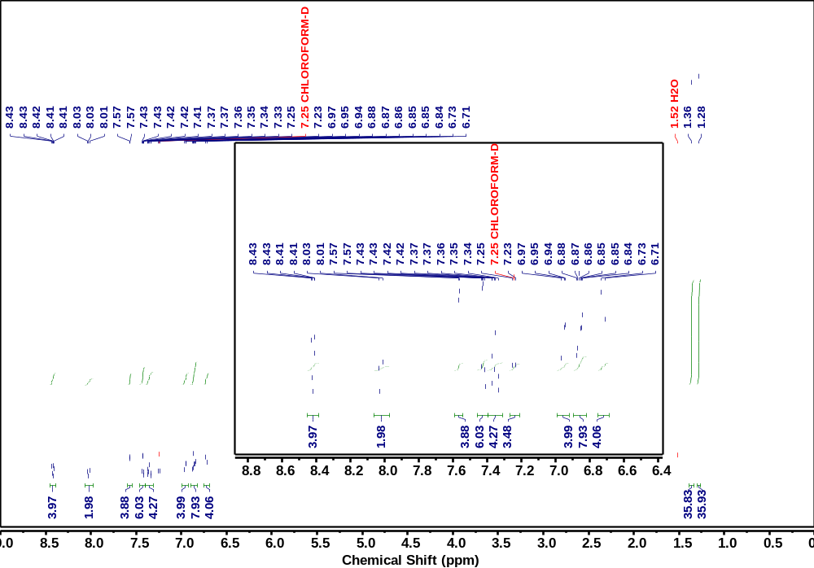
Supplementary Fig. 26 ¹H NMR of 4tCzBN-TPTRZ

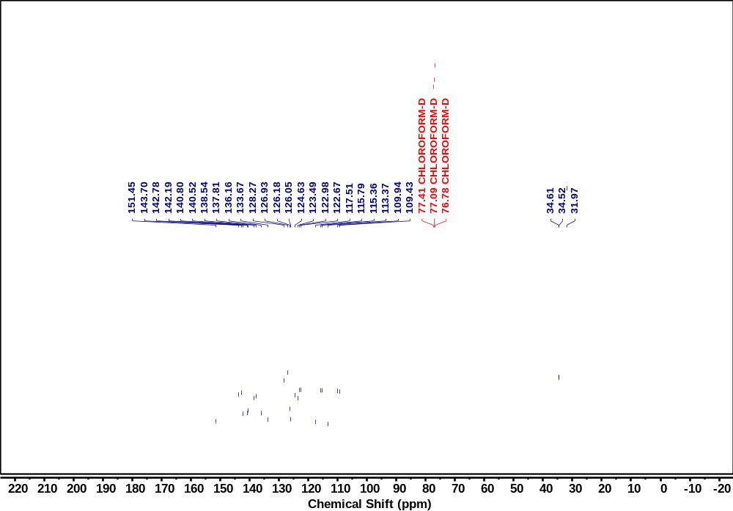
Supplementary Fig. 27 ¹³C NMR of 4tCzBN-TPTRZ
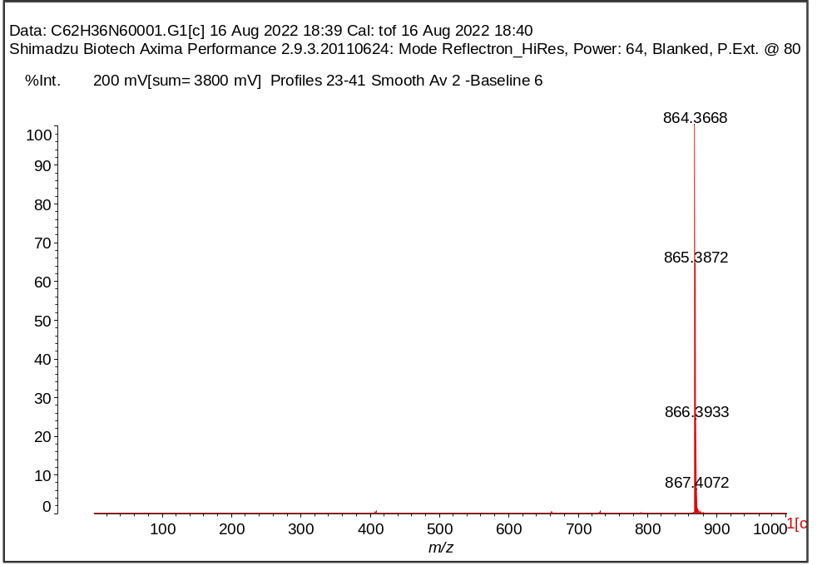
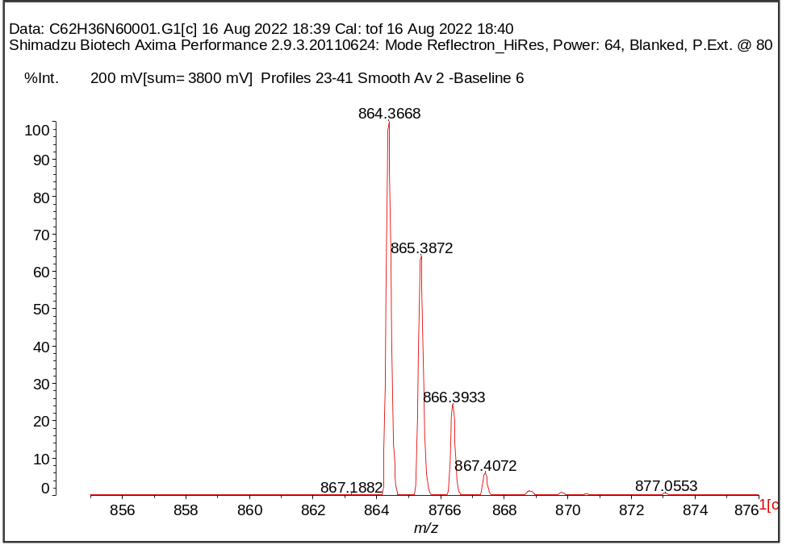
Supplementary Fig. 28 MALDI-TOF-MS of 4CzBN-PhCN
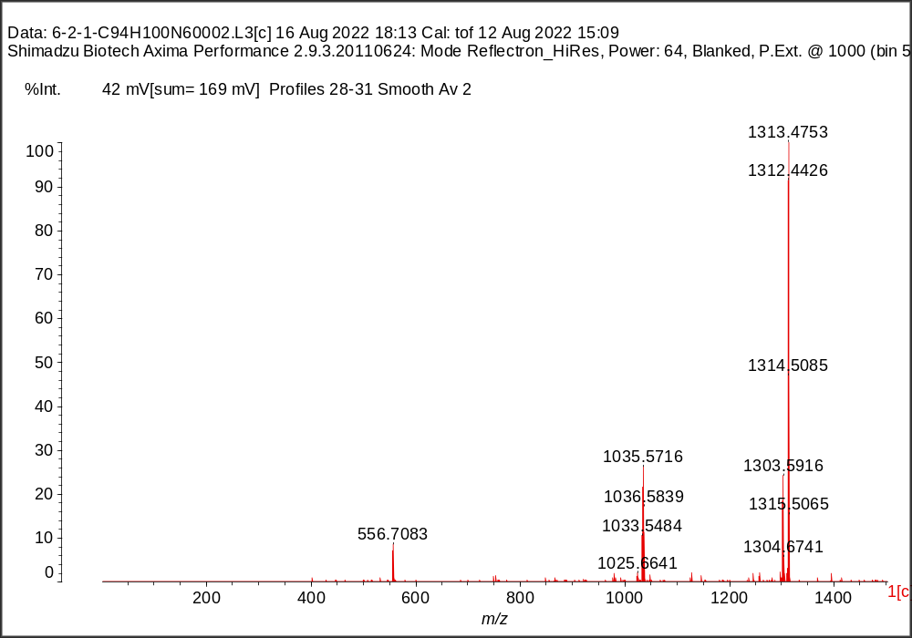
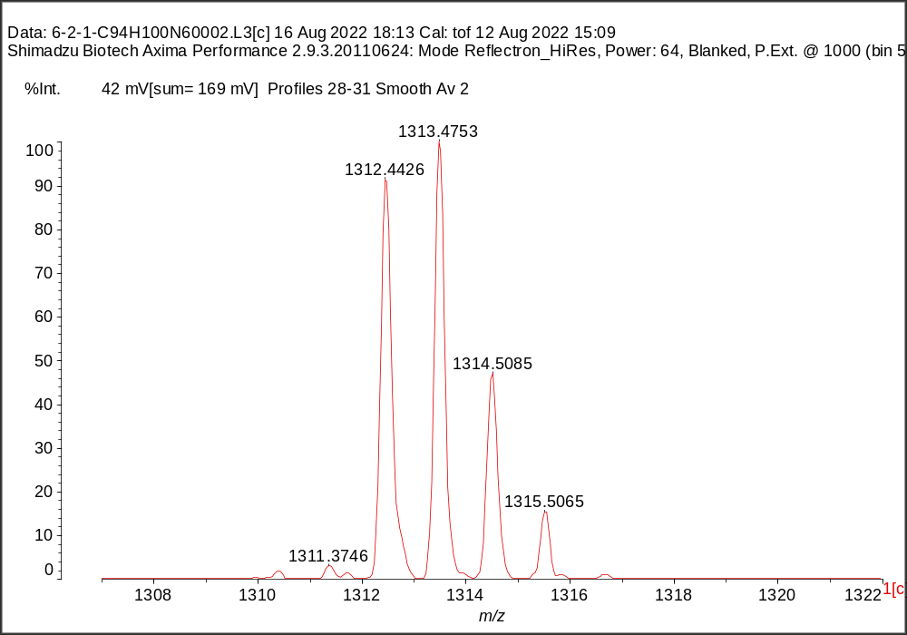
Supplementary Fig. 29 MALDI-TOF-MS of 4tCzBN-PhCN
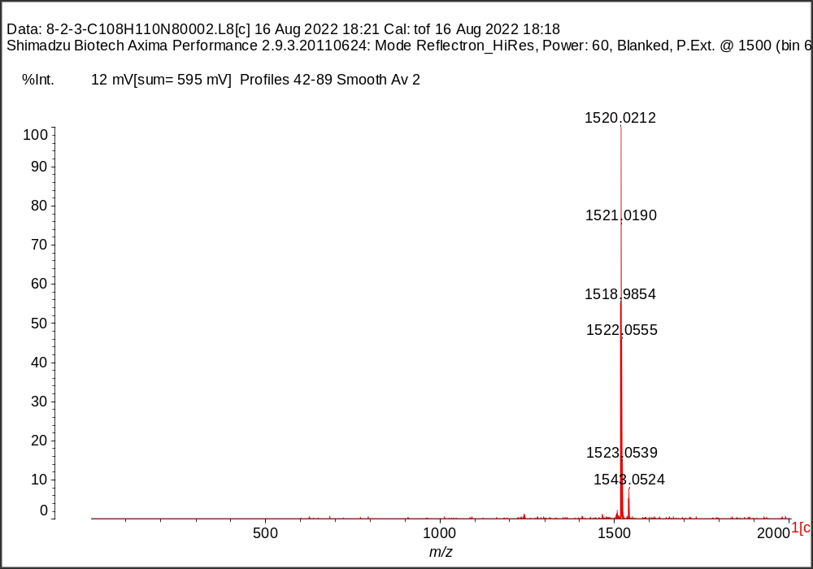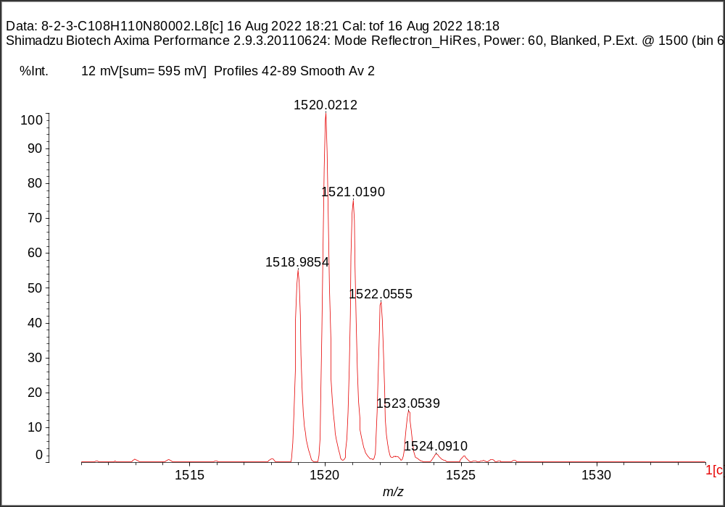
Supplementary Fig. 30 MALDI-TOF-MS of 4tCzBN-TPTRZ

Supplementary Tables
Supplementary Table 1 BDE values of the reported TADF emitters for cross-comparison
 | BDE(+) / eV | BDE / eV | BDE(-) / eV | Ref.
2CzPN | 4.24 | 4.43 | 3.48 | ¹
4CzPN | 4.48 | 4.44 | 3.41 | ²
4CzIPN | 4.65 | 4.58 | 3.44 | ²
4CzTPN | 4.57 | 4.51 | 3.60 | ²
4CzTPN-Bu | 4.62 | 4.70 | 3.77 | ²
4CzTPN-Ph | 4.53 | 4.69 | 3.83 | ²
4CzBN | 4.65 | 4.49 | 3.23 | ³
4tCzBN | 4.74 | 4.45 | 3.50 | ³
5CzBN | 5.07 | 4.81 | 3.65 | ³
5tCzBN | 4.61 | 4.46 | 3.21 | ³
HDT-1 | 4.36 | 4.60 | 3.40 | ⁴
p4tCzPhBN | 4.65 | 4.66 | 3.66 | ⁵
DACT-II | 3.54 | 3.98 | 2.77 | ⁶
PCzTrz | 4.11 | 4.18 | 2.64 | ⁷
PPCzTRZ | 4.35 | 4.34 | 2.86 | ⁷
2PCzBN | 3.96 | 4.15 | 2.43 | ⁸
2PCzBN-Ph | 4.00 | 4.17 | 2.77 | ⁸
2PCzBN-tPh | 4.04 | 4.17 | 2.73 | ⁸
2PCzBN-FPh | 3.95 | 4.17 | 2.82 | ⁸
TpAT-tFFO | 4.36 | 4.36 | 3.44 | ⁹
TDBA-DI | 3.97 | 3.98 | 2.18 | ¹⁰
DQBC | 3.70 | 3.99 | 2.77 | ¹¹
TMCz-BO | 3.97 | 3.90 | 2.67 | ¹²
PXZ-TRZ | 3.42 | 3.32 | 2.72 | ¹³
CzDBA | 4.53 | 4.17 | 3.76 | ¹⁴
2a | 4.04 | 4.20 | 2.45 | ¹⁵

Supplementary Table 2 BDE values of the TADF emitters studied in this work.
 | BDE(+) / eV | BDE / eV | BDE(-) / eV
4CzBN-PhCN | 4.89 | 4.48 | 3.04
4tCzBN-PhCN | 4.97 | 4.67 | 3.24
4tCzBN-TPTRZ | 5.00 | 4.55 | 3.20
3Cz2DPhCzBN | 5.21 | 4.43 | 2.75
5Cz-TRZ | 5.32 | 4.59 | 3.14

Supplementary Table 3 Spin-orbital coupling constants for the TADF emitters
 | S₁ | T₁ | T₂ | T₃ | ΔE_{S1-T1} | ΔE_{S1-T2} | ΔE_{S1-T3} | λ_{SOC}  (S₁-T₁) | λ_{SOC}  (S₁-T₂) | λ_{SOC}  (S₁-T₃)
 | [eV] |  |  |  |  |  |  | [cm⁻¹]
4CzBN  -PhCN | 2.6438 | 2.5347 | 2.5877 | 2.6565 | 0.1091 | 0.0561 | -0.0127 | 0.01 | 0.73 | 0.20
4tCzBN  -PhCN | 2.5514 | 2.4643 | 2.4893 | 2.5598 | 0.0871 | 0.0621 | -0.0084 | 0.08 | 0.71 | 0.21
4tCzBN  -TRZ | 2.5751 | 2.4986 | 2.5158 | 2.5616 | 0.0765 | 0.0593 | 0.0135 | 0.05 | 0.66 | 0.28

Supplementary Table 4 HOMO, LUMO and E_{g} of the TADF emitters.
 | HOMO  [eV] | LUMO  [eV] | E_{g}  [eV]
4CzBN-PhCN | -5.90 | -2.81 | 3.09
4tCzBN-PhCN | -5.68 | -2.73 | 2.95
4tCzBN-TPTRZ | -5.68 | -2.74 | 2.94

Supplementary Table 5 Summarized CIE_{y}/LT95 of blue TADF/TSF-OLEDs with considerable device operational lifetime.
 | LT95@1000 cd m⁻²  (h) | CIE_{y} | Ref.
TSF-DB | 221 | 0.17 | This work
TSF-SB | 454 | 0.27 | This work
5tCzBN | ~20 | 0.4 | ³
HDT-1 (Tandem) | ~20 | 0.16 | ⁴
HDT-1 (Single Layer) | ~12 | 0.2 | ⁴
p4tCzPhBN | ~9 | 0.12 | ⁵
PPCzTrz (Top Emission) | ~6 | 0.09 | ⁷
3Ph2CzCzBN | ~10 | 0.36 | ¹⁶
3Cz2DPhCzBN | ~210 | 0.44 | ¹⁷
BD-02 | 150 | 0.195 | ¹⁸
BD-02(PSF) | 72.9 | 0.165 | ¹⁹
D-5CzBN | ~100 | 0.14 | ²⁰
D-5tCzBN | ~189 | 0.20 | ²⁰
Supplementary Table 6 X-ray structural information of the TADF materials.
 | 4CzBN-PhCN | 4tCzBN-PhCN | 4tCzBN-TPTRZ
CCDC Number | 2232729 | 2232730 | 2232731
Empirical formula | C₆₂H₃₆N₆ | C₉₄H₁₀₀N₆ | 2(C₁₀₈H₁₁₀N₈)
Formula weight | 864.97 | 1313.81 | 3040.07
Crystal system | Monoclinic | Triclinic | Triclinic
T (K) | 170 | 173 | 293
space group | P21/c | P-1 | P-1
a/Å | 12.3683(2) | 11.3892(4) | 17.5848(4)
b/Å | 9.5383(2) | 15.5799(6) | 18.0059(4)
c/Å | 37.6166(12) | 23.4822(10) | 33.6335(7)
α/ ° | 90 | 100.858(3) | 87.395(2)
β/ ° | 95.220(2) | 91.212(3) | 84.576(2)
γ/ ° | 90 | 99.560(3) | 64.102(2)
V/Å³ | 4419.32(18) | 4029.4(3) | 9536.9(4)
Z | 4 | 2 | 2
density, g/cm³ | 1.300 | 1.083 | 1.059
F (000) | 1800 | 1412.0 | 3256.0
h,k,l_{max} | 14,10,42 | 14,19,29 | 22,22,42
N_{ref} | 6708 | 16004 | 38047
μ (mm⁻¹) | 0.601 | 0.474 | 0.468
R1 (all data) | 0.0727(5521) | 0.0590(13055) | 0.0850(29423)
wR2 (all data) | 0.2122(6708) | 0.1765(16004) | 0.2642(38047)

References
1. Masui, K., Nakanotani, H. & Adachi, C. Analysis of exciton annihilation in high-efficiency sky-blue organic light-emitting diodes with thermally activated delayed fluorescence. Org. Electron. 14, 2721–2726 (2013).
2. Uoyama, H., Goushi, K., Shizu, K., Nomura, H. & Adachi, C. Highly efficient organic light-emitting diodes from delayed fluorescence. Nature 492, 234–238 (2012).
3. Zhang, D., Cai, M., Zhang, Y., Zhang, D. & Duan, L. Sterically shielded blue thermally activated delayed fluorescence emitters with improved efficiency and stability. Mater. Horiz. 3, 145–151 (2016).
4. Chan, C.-Y. et al. Stable pure-blue hyperfluorescence organic light-emitting diodes with high-efficiency and narrow emission. Nat. Photonics 15, 203–207 (2021).
5. Zhang, D. et al. Efficient and Stable Deep‐Blue Fluorescent Organic Light‐Emitting Diodes Employing a Sensitizer with Fast Triplet Upconversion. Adv. Mater. 32, 1908355 (2020).
6. Kaji, H. et al. Purely organic electroluminescent material realizing 100% conversion from electricity to light. Nat. Commun. 6, 8476 (2015).
7. Jeon, S. O. et al. High-efficiency, long-lifetime deep-blue organic light-emitting diodes. Nat. Photonics 15, 208–215 (2021).
8. Hong, X. et al. TADF molecules with π-extended acceptors for simplified high-efficiency blue and white organic light-emitting diodes. Chem 8, 1705–1719 (2022).
9. Wada, Y., Nakagawa, H., Matsumoto, S., Wakisaka, Y. & Kaji, H. Organic light emitters exhibiting very fast reverse intersystem crossing. Nat. Photonics 14, 643–649 (2020).
10. Ahn, D. H. et al. Highly efficient blue thermally activated delayed fluorescence emitters based on symmetrical and rigid oxygen-bridged boron acceptors. Nat. Photonics 13, 540–546 (2019).
11. Chen, Y. et al. Approaching Nearly 40% External Quantum Efficiency in Organic Light Emitting Diodes Utilizing a Green Thermally Activated Delayed Fluorescence Emitter with an Extended Linear Donor–Acceptor–Donor Structure. Adv. Mater. 2103293 (2021).
12. Kim, J. U. et al. Nanosecond-time-scale delayed fluorescence molecule for deep-blue OLEDs with small efficiency rolloff. Nat Commun 11, 1765 (2020).
13. Tanaka, H., Shizu, K., Miyazaki, H. & Adachi, C. Efficient green thermally activated delayed fluorescence (TADF) from a phenoxazine–triphenyltriazine (PXZ–TRZ) derivative. Chem. Commun. 48, 11392 (2012).
14. Wu, T.-L. et al. Diboron compound-based organic light-emitting diodes with high efficiency and reduced efficiency roll-off. Nature Photon 12, 235–240 (2018).
15. Hirata, S. et al. Highly efficient blue electroluminescence based on thermally activated delayed fluorescence. Nat. Mater. 14, 330–336 (2015).
16. Chan, C.-Y., Tanaka, M., Nakanotani, H. & Adachi, C. Efficient and stable sky-blue delayed fluorescence organic light-emitting diodes with CIEy below 0.4. Nat. Commun. 9, 5036 (2018).
17. Noda, H., Nakanotani, H. & Adachi, C. Excited state engineering for efficient reverse intersystem crossing. Sci. Adv. 4, eaao6910 (2018).
18. Sun, J. et al. Exceptionally stable blue phosphorescent organic light-emitting diodes. Nat. Photonics 16, 212–218 (2022).
19. Kim, E. et al. Highly efficient and stable deep-blue organic light-emitting diode using phosphor-sensitized thermally activated delayed fluorescence. Sci. Adv. 8, eabq1641 (2022).
20. Huang, T. et al. Enhancing the efficiency and stability of blue thermally activated delayed fluorescence emitters by perdeuteration. Nat. Photonics (2024) doi:10.1038/s41566-024-01379-1.

