Supplementary Material

Supplementary Figure
Based on the species abundance, the species composition of the two groups of PLC patients was analyzed in terms of phylum, class, order, family, and genus classification levels (Supplementary Figure 1A–E). The composition of the intestinal flora in the two groups was similar at each classification level, but the abundance of intestinal flora was different. The differences in flora composition and abundance between the two groups of specimens are described at the phylum, family, and genus levels (Supplementary Figure1A, D, E).
In the two groups of samples, the phyla mainly included Firmicutes, Bacteroidota, Proteobacteria, Actinobacteriota, Desulfobacterota, Verrucomicrobiota, and Fusobacteriota (Supplementary Figure 1A). Among them, the relative abundance of Bacteroidota, Proteobacteria, Desulfobacterota, and Verrucomicrobiota was decreased in patients after treatment compared to before treatment. Firmicutes and Actinobacteriota had a higher relative abundance in the intestinal flora of patients in the post-medication group than the pre-medication group. At the family level, the relative abundance of Bacteroidaceae, Lachnospiraceae, Ruminococcaceae, Streptococcaceae, Selenomonadaceae, Bifidobacteriaceae, and Lactobacillaceae was higher in the PV2 group than in the PV1 group (Supplementary Figure1D). The relative abundance of Enterobacteriaceae, Veillonellacese, and Prevotellaceae was lower in the PV2 group than in the PV1 group. At the genus level (Supplementary Figure1E), the top ten species with the highest relative abundance in the two groups were Bacteroides, Veillonella, Escherichia, Shigella, Prevotella, Streptococcus, Megamonas, Faecalibacterium, Subdoligranulum, Bifidobacterium, and Eisenbergiella. Among them, the abundance of Bacteroides, Veillonella, Escherichia, Shigella, Prevotella, and Eisenbergiella was lower, and the abundance of Streptococcus, Megamonas, Faecalibacterium, Subdoligranulum, and Bifidobacterium, was higher in the PV2 group than the PV1 group.
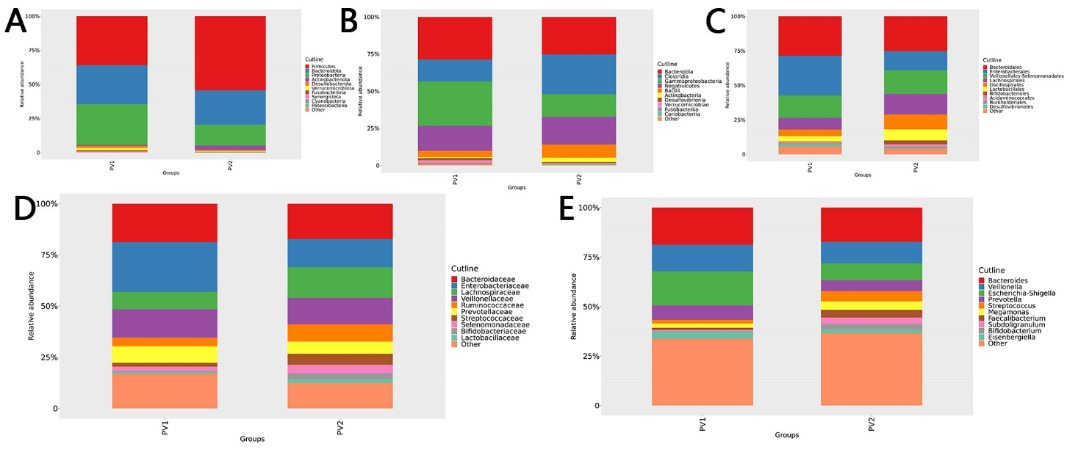
Supplementary Figure. Column diagram of species composition between the PLC groups. A–E are the column diagrams of species composition in the two PLC groups at the phylum, class, order, family, and genus classification levels, respectively. The top ten species with the highest relative abundance are described, whereas the rest are classified as others.

