Supplementary file
Lenvatinib Improves the Relative Abundance of Probiotics in Intestinal Flora of Patients with Primary Liver Cancer
Xin Chai ¹, Yue Tang¹, Ximeng Li¹, Shansi Zou², Xutao Guan², Wenqiao Zang^{3,}*, Tao Wang^{2,}*

Fig. 1 Distribution and diversity of intestinal flora in patients with PLC.
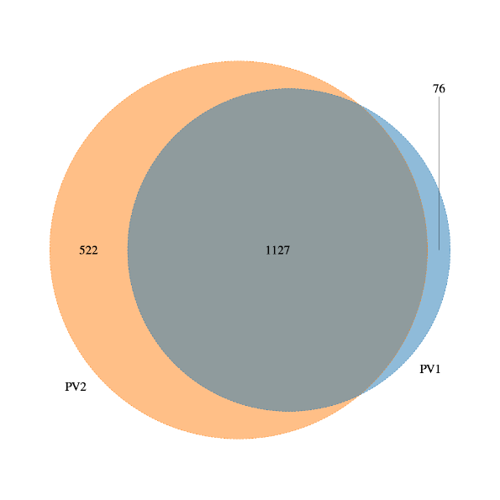
Fig. 1A Venn Diagram
Fig. 1B Alpha diversity reflects the heterogeneity of intestinal flora. Shannon index: P = 0.0929; Simpson index: P = 0.1843; Chao index: P = 0.2267.

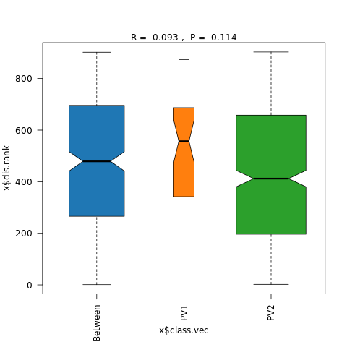
Fig. 1C Beta diversity. Non-weighted distance Anosim analysis results: R = 0.093, P = 0.114.

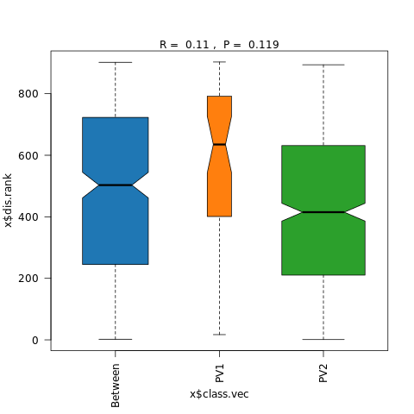
Fig. 1D Beta diversity. Weighted distance Anosim analysis results: R = 0.11, P = 0.119.

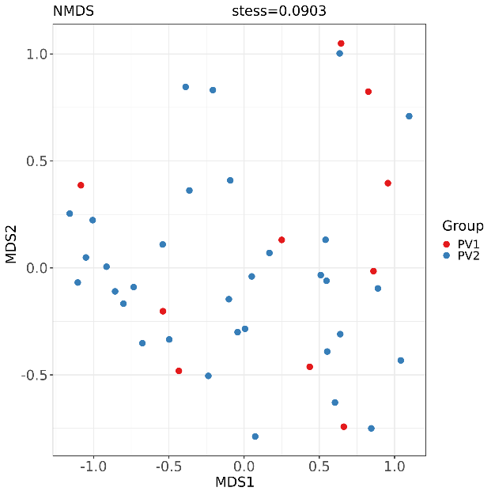
Fig. 1E Beta diversity. NMDS analysis.

Fig. 2 Column diagram of Species Composition between groups.
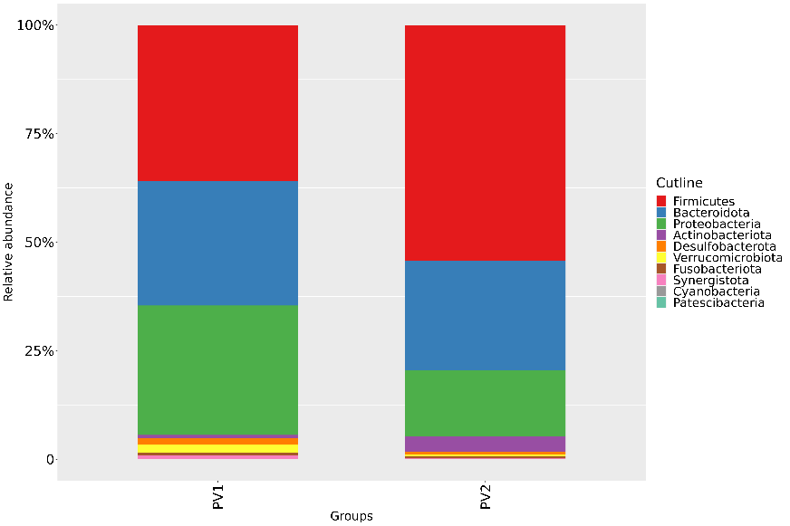
Fig. 2A Phylum

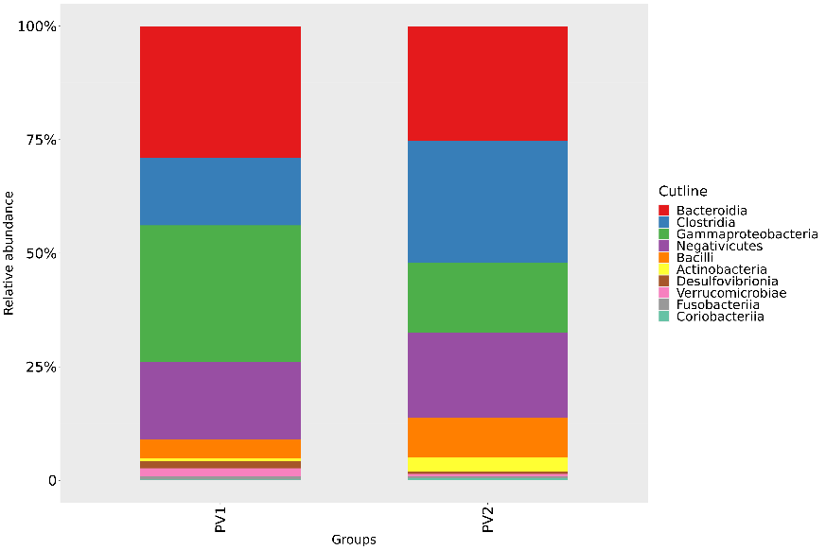
Fig. 2B Class

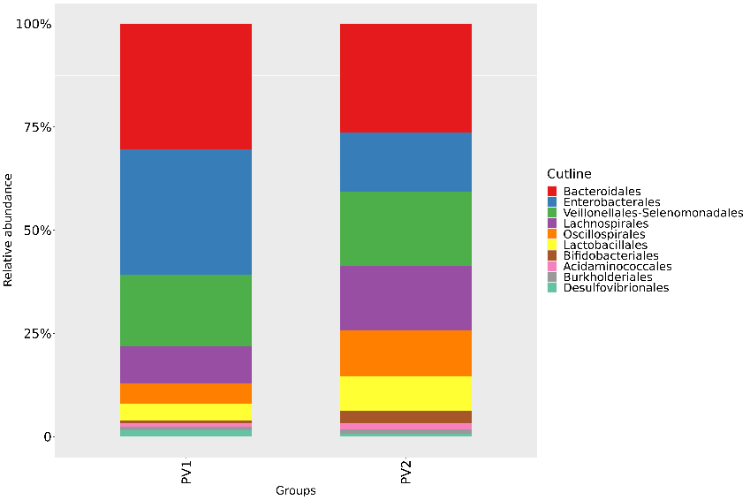
Fig. 2C Order

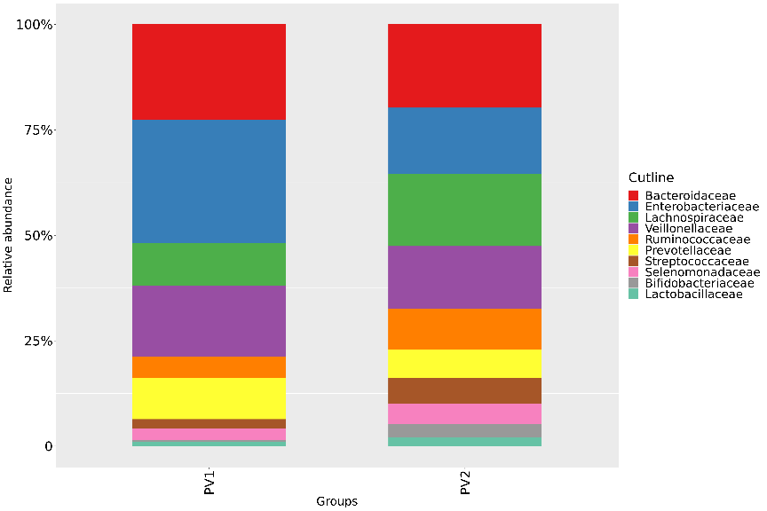
Fig. 2D Family

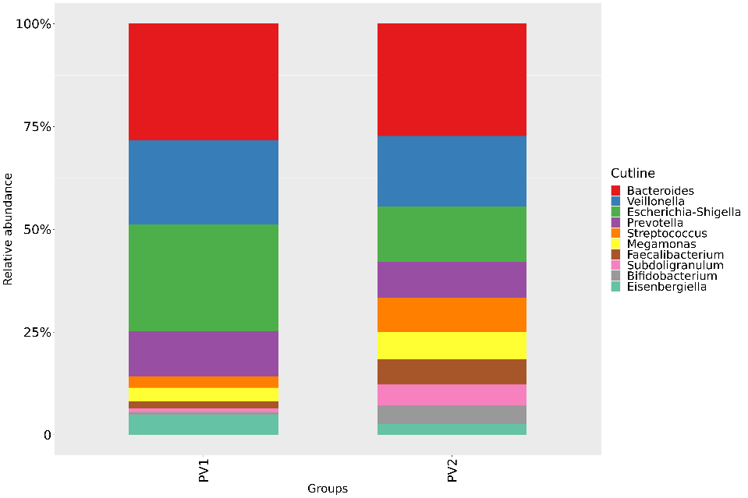
Fig. 2E Genus

Fig.3 Species difference analysis and biomarkers between PLC groups.
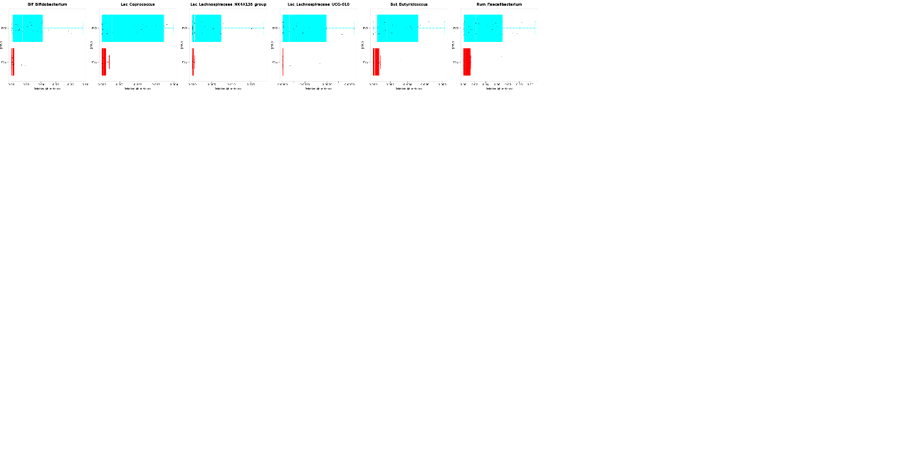
Fig.3A Box diagram of species difference between groups.

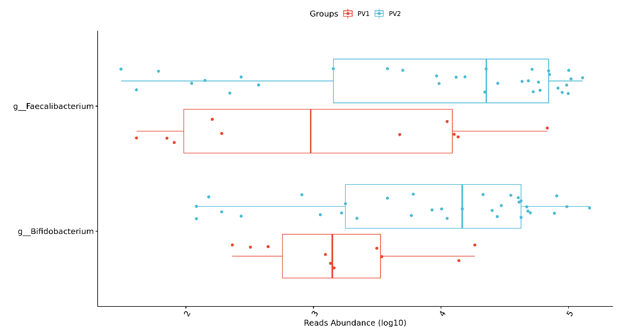
Fig.3B Box diagram of species difference between groups

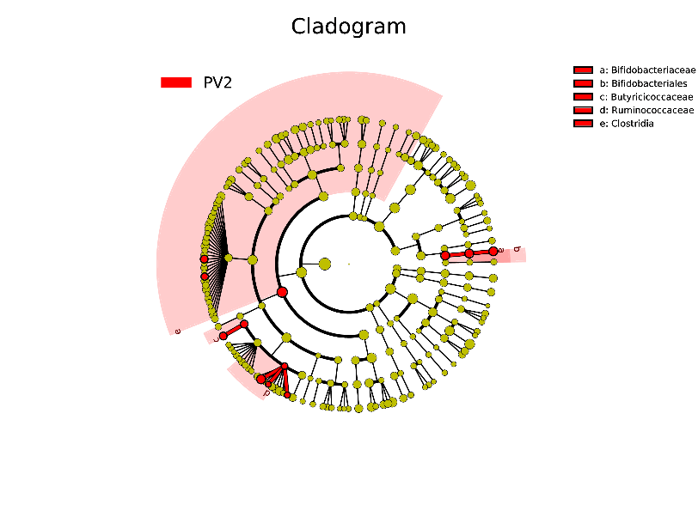
Fig.3C Evolutionary branch graph.

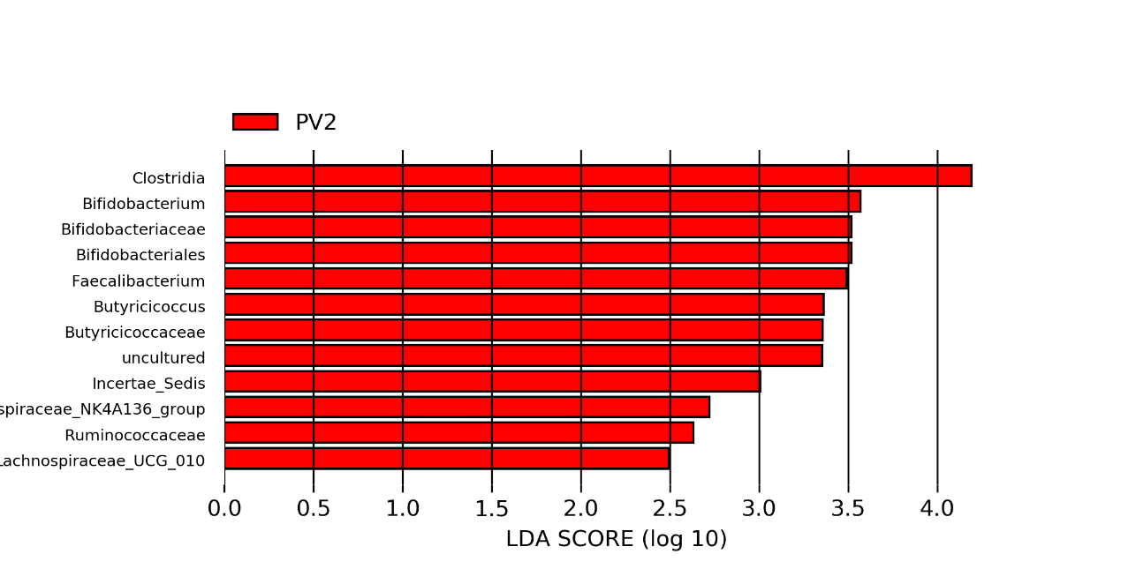
Fig.3D Histogram of LDA value distribution in PV2 group.

Fig.4 Picrust2 functional prediction analysis and random forest inter group prediction.
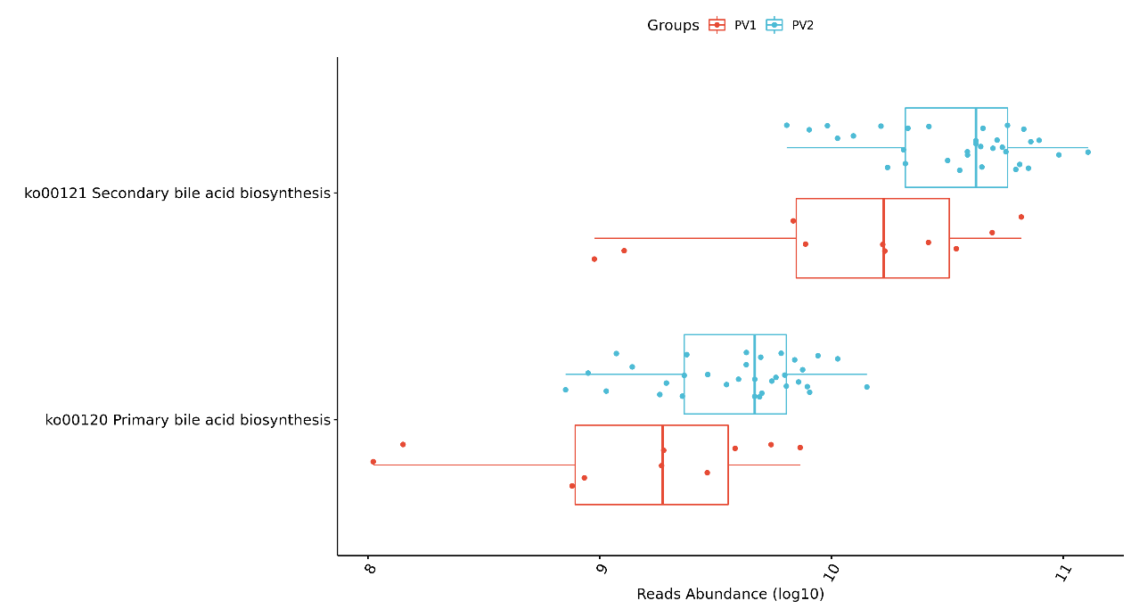
Fig.4A Differences between the two groups of samples in KEGG function.

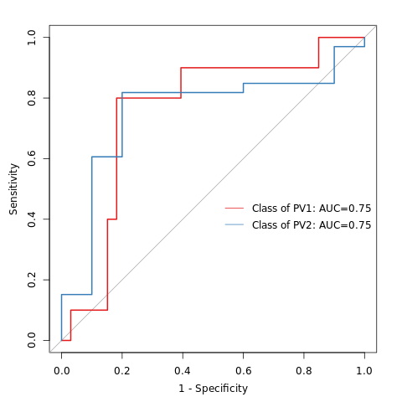
Fig.4B ROC curve.

Fig.5 Dynamic monitoring of intestinal flora changes in PLC patients treated with Lenvatinib
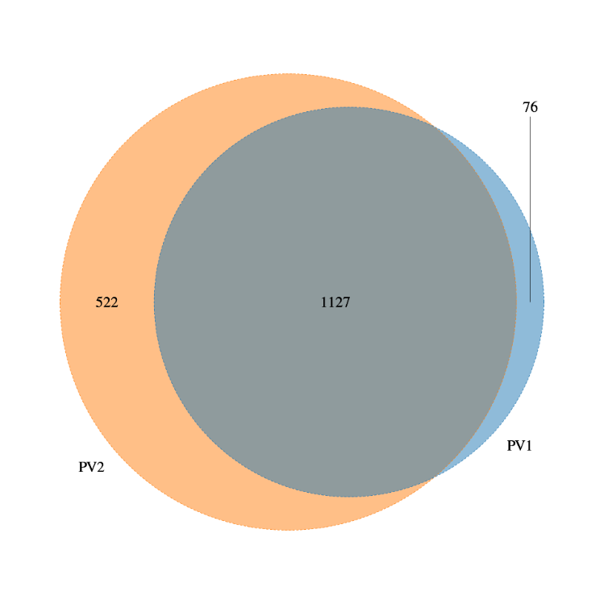
Fig.5A Venn Diagram.

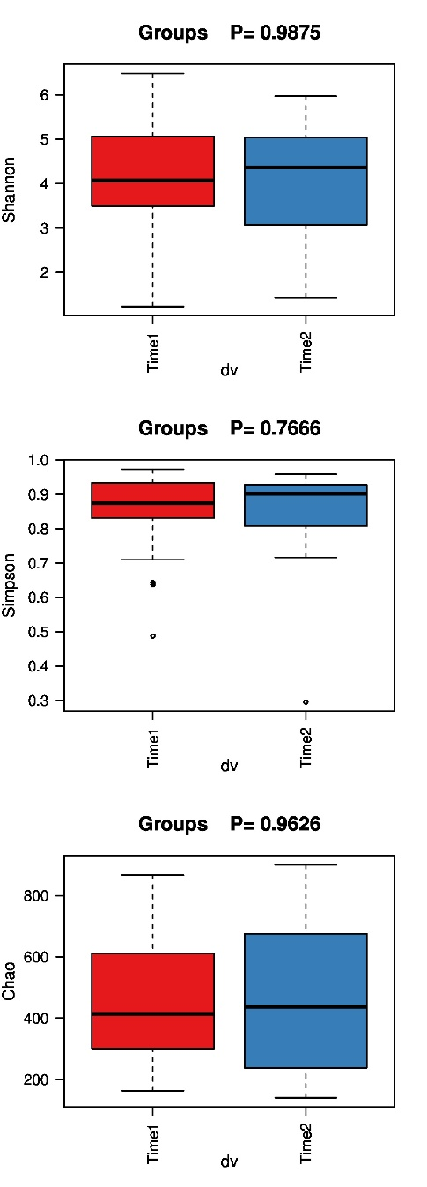
Fig.5B Alpha diversity. Shannon index: P = 0.9875; Simpson index: P = 0.7666; Chao index: P = 0.9626.

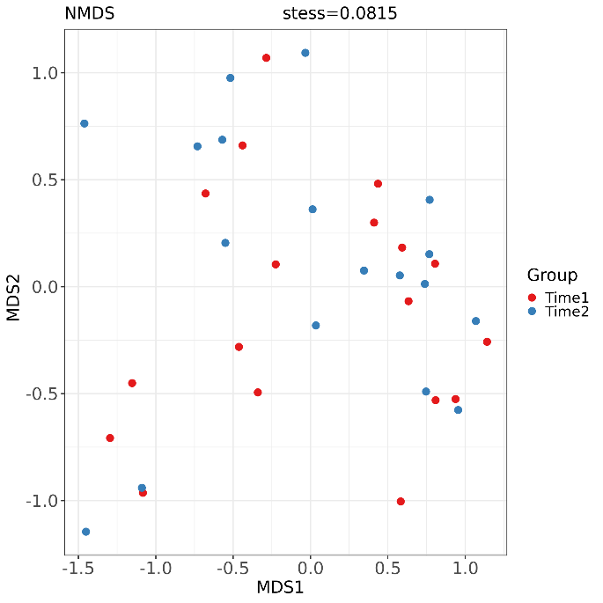
Fig.5C NMDS analysis. stess=0.0815.

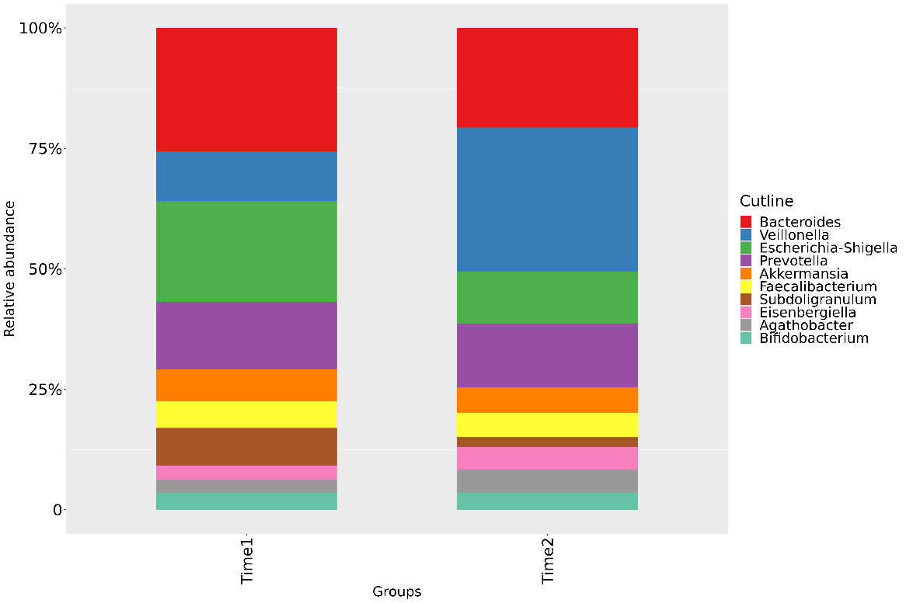
Fig.5D Column diagram of Species Composition.

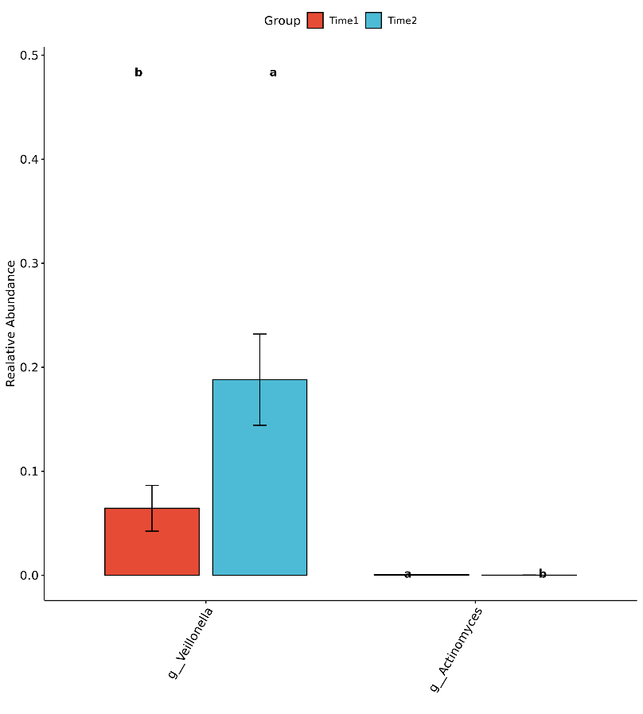
Fig.5E Tukey test.

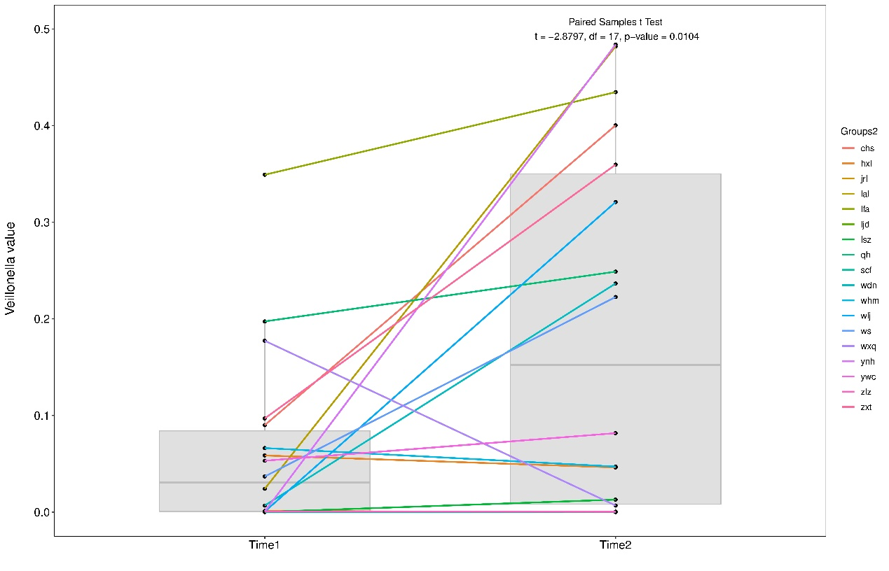
Fig.5F the relative abundance of Veillonella in two groups within the same patient.

Supplementary Figure
Based on the species abundance, the species composition of the two groups of PLC patients was analyzed in terms of phylum, class, order, family, and genus classification levels (Supplementary Figure 1A–E). The composition of the intestinal flora in the two groups was similar at each classification level, but the abundance of intestinal flora was different. The differences in flora composition and abundance between the two groups of specimens are described at the phylum, family, and genus levels (Supplementary Figure1A, D, E).
In the two groups of samples, the phyla mainly included Firmicutes, Bacteroidota, Proteobacteria, Actinobacteriota, Desulfobacterota, Verrucomicrobiota, and Fusobacteriota (Supplementary Figure 1A). Among them, the relative abundance of Bacteroidota, Proteobacteria, Desulfobacterota, and Verrucomicrobiota was decreased in patients after treatment compared to before treatment. Firmicutes and Actinobacteriota had a higher relative abundance in the intestinal flora of patients in the post-medication group than the pre-medication group. At the family level, the relative abundance of Bacteroidaceae, Lachnospiraceae, Ruminococcaceae, Streptococcaceae, Selenomonadaceae, Bifidobacteriaceae, and Lactobacillaceae was higher in the PV2 group than in the PV1 group (Supplementary Figure1D). The relative abundance of Enterobacteriaceae, Veillonellacese, and Prevotellaceae was lower in the PV2 group than in the PV1 group. At the genus level (Supplementary Figure1E), the top ten species with the highest relative abundance in the two groups were Bacteroides, Veillonella, Escherichia, Shigella, Prevotella, Streptococcus, Megamonas, Faecalibacterium, Subdoligranulum, Bifidobacterium, and Eisenbergiella. Among them, the abundance of Bacteroides, Veillonella, Escherichia, Shigella, Prevotella, and Eisenbergiella was lower, and the abundance of Streptococcus, Megamonas, Faecalibacterium, Subdoligranulum, and Bifidobacterium, was higher in the PV2 group than the PV1 group.
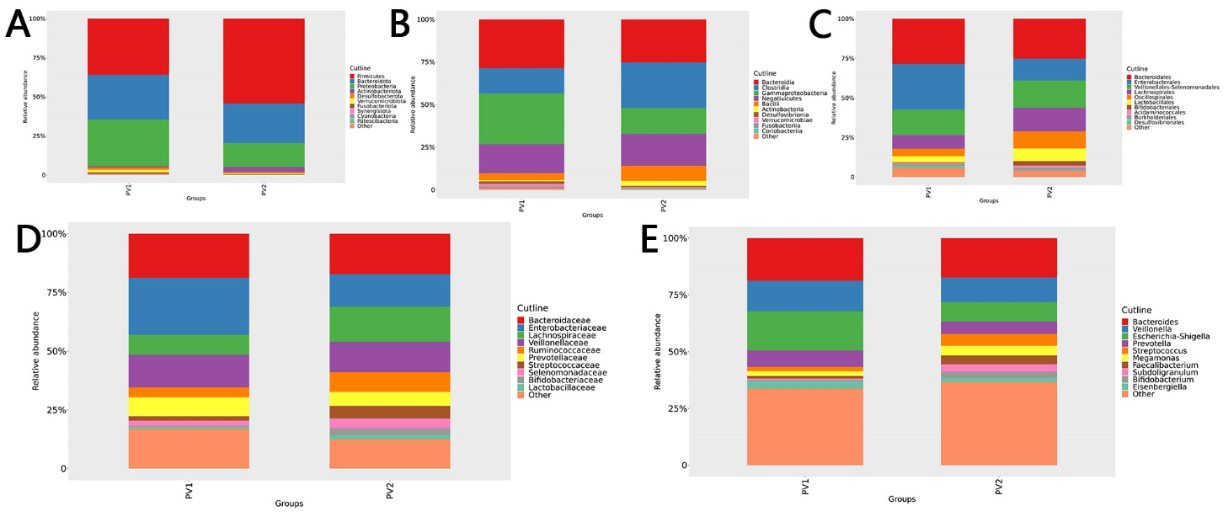
Supplementary Figure. Column diagram of species composition between the PLC groups. A–E are the column diagrams of species composition in the two PLC groups at the phylum, class, order, family, and genus classification levels, respectively. The top ten species with the highest relative abundance are described, whereas the rest are classified as others.

