Supplementary Information
The supplementary information contains additional materials and methods, supplementary figures, and supplementary tables.

MATERIALS AND METHODS
Coculture assays
Tumor cell culture supernatant (TSN) was prepared by culturing tumor cells in DMEM or RPMI-1640 containing 1% FBS for 48 h. The TSN was then centrifuged at 2000 rpm for 10 min and harvested. THP-1 cells were treated with 100 ng/mL PMA for 24 h for differentiating. To generate TSN-induced macrophages, PMA-induced THP-1 cells or BMDMs were cultured in a mixture of TSN and freshly complete DMEM (1:1) at a density of 2.5×10⁶ cells/mL for 48 h (57).
CD8⁺ T-cell isolation and activation
C57BL/6 mice aged 6-8 weeks were sacrificed under anesthesia. After being soaked in 75% ethanol, the spleen was isolated and cut into small pieces. Using 70 μM strainers (Cat No. 15-070, BIOLOGIX, USA), the pieces were ground and rinsed with PBS with 2% FBS and collected. After centrifugated at 350xg for 10 min, the cells were resuspended in PBS and adjust to 1×10⁸/mL. An EasySep Mouse CD8⁺ T-Cell Isolation Kit (Cat No. 19853, Stemcell, Canada) was used to sort CD8⁺ T cells according to the instruction manual. Separated T cells were seeded in a 6-well plate coated with 1 μg/mL CD3 (Cat No. 05112-25-500, BioGems, USA) in advance. The cells were cultured for 3-5 days.
Bone marrow-derived monocyte (BMDM) isolation and induction
C57BL/6 mice aged 6-8 weeks were sacrificed under anesthesia. The mice were soaked in 75% ethanol, and then limbs were washed in PBS and 75% ethanol successively. The marrow cavity was opened, and the bone marrow was rinsed using culture medium. Bone marrow was filtered using a 100 μM strainer (Cat No. 15-070, BIOLOGIX, USA), and cells were collected into 50 mL centrifuge tubes. Cells were centrifuged at 1500 rpm for 10 min. Red blood cell lysis buffer (Cat No. R1010, Solarbio, Beijing, China) was added to the centrifuge tube and mixed. The cells were then centrifuged at 1500 rpm for 10 min and washed in PBS. Fresh DMEM with 10% FBS containing L929 cell culture supernatant was added to resuspend the cells (DMEM: L929 cell culture supernatant = 5: 1). The cells were seeded in a 6-well plate and cultured for 7 days.
CCK8 assay
The procedure was followed the manul instruction of CCK-8 solution Kit (Cat No. CK04, DOJINDO, Japan). The plate was incubated for 2 h in the incubator, and then the absorbance at 450 nm was measured using a microplate reader.
Wound healing assay
Tumor cells were grown to confluency. A linear wound was made by the tip of a pipette across the confluent cell layer. Cells were washed twice using PBS to detach cells and debris. The size of the wounds was observed at the indicated times. Wounds were measured and analyzed using ImageJ.
5-Ethynyl-20-deoxyuridine (EdU)
Following the instruction manual to culture cells and stain using Cell-LightTM EdU Apollo567 In Vitro Kit (Cat No. C10310-1, RiboBio, GuangZhou, China, the same below). Apollo®567 was measured at 560 nm, and Hoechst 33342 was measured at 420 nm using OLYMPUS BX51.
Enzyme-linked immunosorbent assay (ELISA)
Following the instruction manual of ELISA kits (Cat No. MM-44779M1, MM-0689M1a and MM-0176M1, Meimian, Jiangsu, China). The mean O.D. values for each standard and sample were calculated. A standard curve was constructed to determine the concentration of the samples.
Immunohistochemistry
The sections were baked at 65°C for 2 h, dewaxed in 100% xylene and successively hydrated in 100%, 90%, 75% and 70% ethanol. The sections were soaked in citrate acid buffer solution (Cat No. ZLI-9065, ZSGB-BIO, Beijing, China) or EGTA (Cat No. MVS-0080, MXB, Fuzhou, China) and subjected to high-pressure heat repair for 10 min. After cooling naturally at room temperature, the tissues were circled by PAP pen (Cat No. BC004-1, Biosharp, Beijing, China). The sections were washed in PBS and incubated in Minute™ Peroxidase Suppressor (Cat No. WA-005, Invent, Beijing, China) for 20 min. Then, goat serum (Cat No. AR0009, Boster, Wuhan, China) was applied for a 20-min blocking. Then, the sections were probed with antibodies (Table S2) overnight at 4°C. The next day, the sections were washed in PBS and incubated with HRP for 1 h. Afterwards, the sections were exposed to DAB for 10-60 s using a MaxvisionTM2 HRP-Polymer anti-Mouse/Rabbit IHC Kit (Cat No. KIT-5920, MXB, Fuzhou, China). Hematoxylin (Cat No. BL702B, Biosharp, Beijing, China) was used to stain the nucleus, and 1% hydrogen ethanol was used to remove the color of the cytoplasm. The sections were washed to a proper shade of blue in water. Then, 70%, 75%, 90% and 100% ethanol were applied to dehydrate the tissues, and the sections were soaked in 100% xylene before being sealed using neutral gum (Cat no. BL704A, Biosharp, Beijing, China).
RNA extraction, reverse transcription, and qRT-PCR
RNA was extracted using AG RNAex Pro Reagent (Cat No. AG21102, Accurate Biology, Changsha, China) according to the instruction manual. RNA (2000 ng) from every sample was used to synthesize first-strand cDNA using HiScriptⓇ III All-in-one RT SuperMix Perfect for PCR (+gDNA wiper) (Cat no. R323-01, Vazyme, Nanjing, China). cDNA served as the template for quantitative real-time PCR analysis using Taq Pro Universal SYBR qPCR Master Mix (Cat no. Q712-02, Vazyme, Nanjing, China). GAPDH was used as the internal control for the detection of mRNA, and the relative mRNA expression level was calculated using the 2^{–ΔΔCT} method based on the Ct values (58). The primer sequences are listed in Table S3.
Western blot
RIPA lysis buffer (Cat no. P0013B, Beyotime, Shanghai, China) containing phenylmethylsulfonyl fluoride (PMSF) (Cat no. ST507, Beyotime) was used to extract protein from cells. The extracted proteins were transferred to a 7.5%-10% sodium dodecyl sulfate-polyacrylamide gel for electrophoretic separation, and then the proteins were transferred from the gel to PVDF membranes (Cat No. ISEQ00010, Millipore, USA). The membranes were blocked in Protein Free Rapid Blocking Buffer (1×) (Cat no. PS108P, Epizyme, Shanghai, China) for 20 min, followed by incubation in the corresponding primary antibody (Table S2) overnight at 4°C on a shaker. The membranes were incubated in horseradish peroxidase-conjugated secondary antibody (Cat no. FDR007 & Cat no. FDM007, Fudebio, Hangzhou, China) for 1 h. Protein bands were visualized by a chemiluminescence system (Cat No. GelView 6000 Pro, Boluteng Bio, Guangzhou, China). β-Tubulin or GAPDH served as the internal control as indicated in the figures.
Flow cytometry
Cells collected from culture dishes or transplanted tumors were centrifuged at 1500 rpm for 5 min and washed in HBSS. The cells were transferred to 1.5 mL EP tubes and centrifuged at 300xg for 8 minutes. Then, 100 μL of buffer II was added to the tube with antibodies (Table S4). The cells were incubated for 30 min at 4°C in the dark. Then the cells were then centrifuged at 300xg for 8 min and washed in buffer II. For intracellular protein, permeabilization buffer (Cat No. 554714, BD Biosciences, USA) was used before staining with antibodies. Samples were fixed in 1% paraformaldehyde and stored at 4°C in the dark. A BD Biosciences LSRFortessa (Special Order Research Product) was acquired to detect the samples. The flow cytometry data analysis was performed with FlowJo v10.4.
RNA sequencing (RNA-seq) and analysis
The cell samples were sent for RNA-seq analysis to Lc-Bio Technologies (Hangzhou) Co., Ltd. In this project, significant changes in gene expression were identified by setting a threshold of fold change greater than or equal to 2 (or absolute log2FC value greater than or equal to 1). The criterion for selecting differential genes was a q value less than 0.05.
Analysis of cytokine and chemokine levels by multiplex analysis
The cytoplasm of macrophages was collected and subjected to multiplex analysis of 31 chemokines and cytokines in accordance with the guidelines set forth by the manufacturer (LBX-MultiDTM-31-1, No. 64469922; Bio-Rad).
Targeted metabolomics Assay
Following the instruction manual, brief, the processes were divided into 4 stpes: 1) Metabolite extraction; 2) Standard solution preparation; 3) UHPLC-MRM-MS analysis; 4) Calibration curves making. The LODs and LOQs were defined as the analyte concentrations that led to peaks with signal-to-noise ratios (S/N) of 3 and 10.
HCC Tissue Microarray
A tissue microarray was obtained from Shanghai Outdo Biotech Co., Ltd. (Shanghai, China), comprising 180 paired liver cancer and corresponding adjacent non-tumor liver tissues. The above-described IHC approach was followed for conducting the IHC analysis. Primary antibodies against SMS (Thermo Fisher) or CD163 (Abcam) were used. The staining score was graded from 0 to 400, exhibiting no staining to strong staining.
TCGA and KEGG data collection
HCC transcriptome and clinical information were obtained from The Cancer Genome Atlas (TCGA) data portal (https://tcga-data.nci.nih.gov/tcga/). Based on the cutoff points calculated by X-Tile Software (59), the cases were divided into high and low expression groups of the indicated genes. Kaplan-Meier survival analysis and log-rank test were employed to assess the differences in overall survival between the high and low-expression groups. Metabolism-related data were downloaded from https://www.kegg.jp/.

Supplementary Figures
Fig. S1 Construct stable cell lines overexpressing or lacking SMS. a The expression correlation between SMS and different T-cell inhibitory receptors. b qPCR analysis (n = 3) and (c) protein level of SMS expression in normal hepatocyte MIHA and human hepatoma carcinoma cell LM3, MHCC-97H, Hep 3B, SNU387, Huh7 and Li7. d Assessment of the transfection efficiency of lentivirus-mediated SMS overexpression in SNU387 and MHCC-97H via qPCR analysis (n = 3) and (e) western blot. f Assessment of the transfection efficiency of lentivirus-mediated SMS knockdown in Huh7 via qPCR analysis (n = 3) and (g) western blot. h Assessment of the transfection efficiency of lentivirus-mediated Sms overexpression in Hepa 1-6, H22 and Hep 53.4 via qPCR analysis (n = 3). i Assessment of the transfection efficiency of lentivirus-mediated Sms knockout in Hepa 1-6 via qPCR analysis (n = 3) and (j) western blot. qPCR, quantitative real-time PCR. *p < 0.05, **p < 0.01, ***p < 0.001, ****p < 0.0001. Data are mean ± s.e.m. One-way ANOVA (b, f) or Student’s two-tailed unpaired t-test (d, h, i).

Fig. S2 Overexpressed SMS is not capable to enhance HCC in vitro or in immune-incompetent mice. a CCK8 assay in 5 days of indicated groups for Hepa 1-6 and MHCC-97H. 3000 of both cell lines are seeded in the well initially (n = 3). b Images of colony formation (left) and their quantification (right) of indicated groups for Hepa 1-6 and MHCC-97H after 9 days (n = 3). 1000 Hepa 1-6 or 2000 MHCC-97H are seeded in the well initially, respectively. c Images of wound healing test at 0h, 12h or 24h of indicated groups for Hepa 1-6 and MHCC-97H. 2×10⁶ Hepa 1-6 or MHCC-97H are seeded in the well initially, respectively (n = 3). d Images of EdU proliferation assay of indicated groups for Hepa 1-6 and MHCC-97H. 3000 Hepa 1-6 or MHCC-97H are seeded in the well initially, respectively (n = 3). e Gross appearance(left), tumors’ growth curves (right), (f) final volume and (g) tumor weight of subcutaneous tumors from balb/c nude mice in indicated groups(the NC group n = 6 and the SMS-OE group n = 5). Subcutaneous tumors are inoculated using MHCC-97H. h Gross appearance and (i) quantification of the ratio of liver weight to body weight for mice liver orthotropic tumors in the indicated groups (n = 4). Data are mean ± s.e.m. Two-way ANOVA (a, e) or Student’s two-tailed unpaired t-test (b-d, f-g, i).

Fig. S3 SMS is associated with increased macrophage infiltration in TME. a The correlation between SMS expression and different immune cell infiltration in TCGA-LIHC. b Immune filtration analysis for HCC using CYBERSORT (https://cibersortx.stanford.edu/) and EPIC (https://gfellerlab.shinyapps.io/EPIC_1-1/). Statistical significance is determined by one-way ANOVA. c The correlation between SMS expression and macrophage markers CD80 or CSF1R in TCGA-LIHC. d Gating strategy for CD11b+ F4/80+ cells or (e) CD3+ CD8+ cells in mice subcutaneous tumors by flow cytometry. f Representative images of Lv-con or Sms-OE liver orthotopic tumor evaluated by MRI. g Representative images of IHC staining with antibodies against CD206 and TGF-β from mice liver orthotopic tumors in indicated groups (n = 7-8). h qPCR analysis at the transcription level of chemokines and their receptors related to macrophage recruitment (Ccl25, Ccr2 and Ccl2) and CD8⁺ T recruitment (Cxcr3, Cxcr6, Cxcl9, Cxcl10) of mice orthotropic tumors in indicated groups (n = 3). i KEGG enrichment for whole tissue of mice liver orthotopic tumors. j Detailed information of NES and p-value of each pathway for Fig1. k GO enrichment for macrophages sorted out from mouse liver orthotopic tumors. *p < 0.05, **p < 0.01, ***p < 0.001, ****p < 0.0001. MRI, magnetic resonance imaging. IHC, Immunohistochemistry. Data are mean ± s.e.m. Student’s two-tailed unpaired t-test (g-h).

Fig. S4 SMS augments macrophages M2 polarization as well as the migration. a Evaluation of macrophage clearance efficacy by clodronate liposomes in vivo through flow cytometry. b qPCR analysis at the transcription level of M2 markers in Raw 264.7 after Hepa 1-6 TSN treatment in indicated groups for 2 days (n = 3). c Gating strategy of CD206+ F4/80+ cells and MHC-II+ F4/80+ cells of BMDM after different TSN treatment for 2 days in flow cytometry. d Representative images of macrophage migration and statistics of the cells count. Cells are stained and photographed after 24h cultivated in TSN of Hepa 1-6, SNU387 or Huh7 in indicated groups, respectively (n = 3). e Quantification using Luminex XMAP liquid chip to assess cytokines of BMDM in TSN of indicated groups for 2 days (n = 3). f Heatmap of the transcription of differentially expressed genes for M2 markers in BMDM after indicated groups of TSN treatment for 2 days (n = 3). g Schematic of polyamine metabolism pathway. h Using Targeted Metabolomics Assay to assess the concentration of arginine, ornithine, putrescine, spermidine in THP-1 after being treated in different Huh7 TSN for 2 days (n = 3). i Concentration of spermine in BMDM is assessed by ELISA after being treated in different Hepa 1-6 TSN, with or without AMXT-1501, for 2 days (n = 3). AMXT-1501 was used at the concentration of 5μM. j Evaluation of CD8⁺ T cells clearance efficacy by αCD8 in vivo through flow cytometry. *p < 0.05, **p < 0.01, ***p < 0.001, ****p < 0.0001. qPCR, quantitative real-time PCR. Data are mean ± s.e.m. One-way ANOVA (e, h) or Student’s two-tailed unpaired t-test (a, c-d, g).

Fig. S5 Blockade of spermine strengthened anti-PD-1 therapy efficacy for HCC in C57BL/6 mice. a Statistics of IHC staining with antibodies against CD163, Perforin, and TIGIT from mice tumor tissues (n = 5-7). b Gating strategy of CD206+, (c) GZMB+, (d) IFN-γ+ and (e) CTLA-4+ cells in indicated groups in flow cytometry. f Gating strategy of CD206+, (g) IFN-γ+, (h) TIM3+ and (i) CTLA-4+ in indicated groups in flow cytometry. j Concentrations of ALT, BUN and Cr in mouse serum of indicated groups are analyzed by ELISA (n = 6). *p < 0.05, **p < 0.01, ***p < 0.001, ****p < 0.0001. Data are mean ± s.e.m. One-way ANOVA (a, j).

Fig. S6 Blockade of spermine strengthened anti-PD-1 therapy efficacy for HCC in Ballb/c mice. a qPCR analysis of Sms in Hepa 1-6, H22 and Hep 53.4 cells (n = 3). b Generation of usage and dosage of DFMO and αPD-1 on Balb/c mice with liver orthotropic tumors. c Representative images (left) of mice livers from indicated groups with quantification of tumor volume (right) (n = 4). Scale bar, 1cm. d Gating strategy of CD206+, (e) CTLA-4+ and (f) TIM3+ in indicated groups in flow cytometry (n = 3). *p < 0.05, **p < 0.01, ***p < 0.001, ****p < 0.0001. Data are mean ± s.e.m. One-way ANOVA (a, c-f).

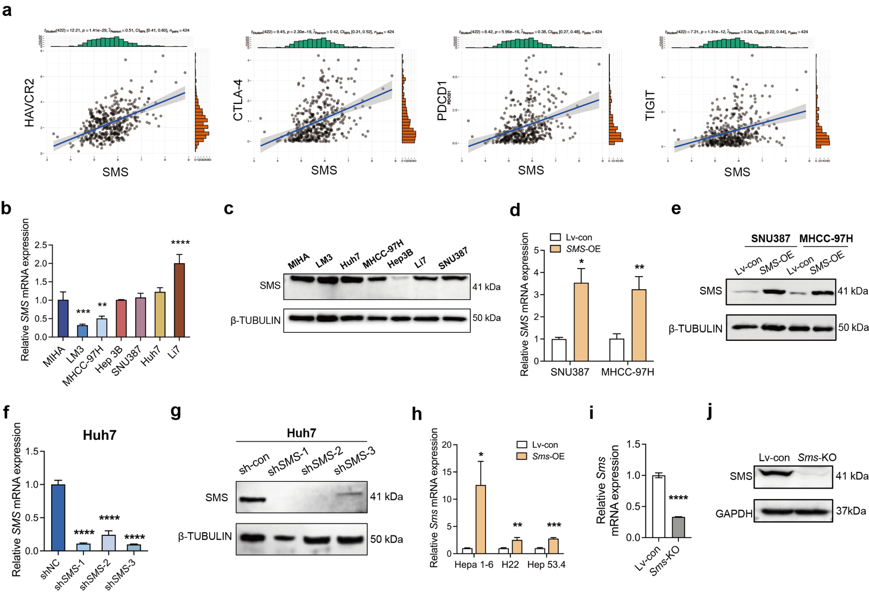
Supplementary Figure 1

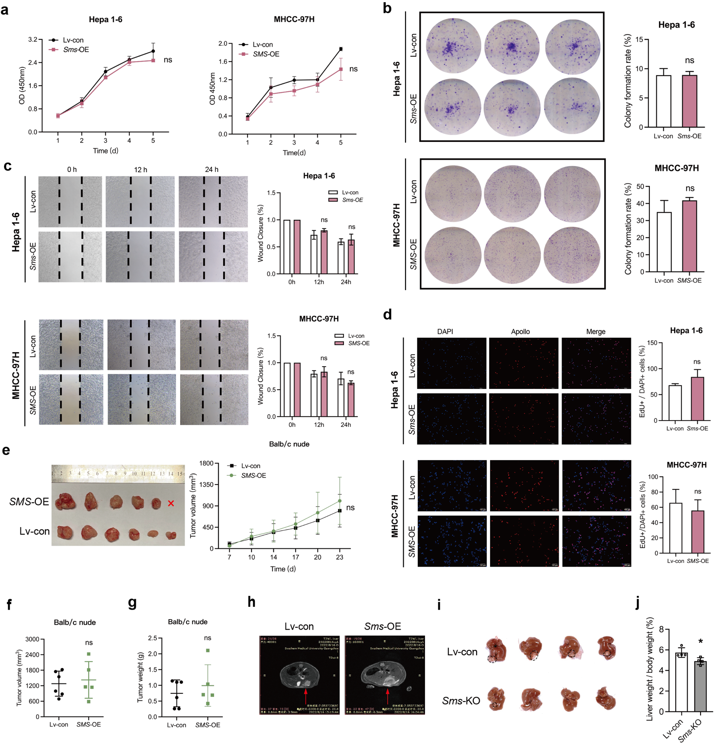
Supplementary Figure 2

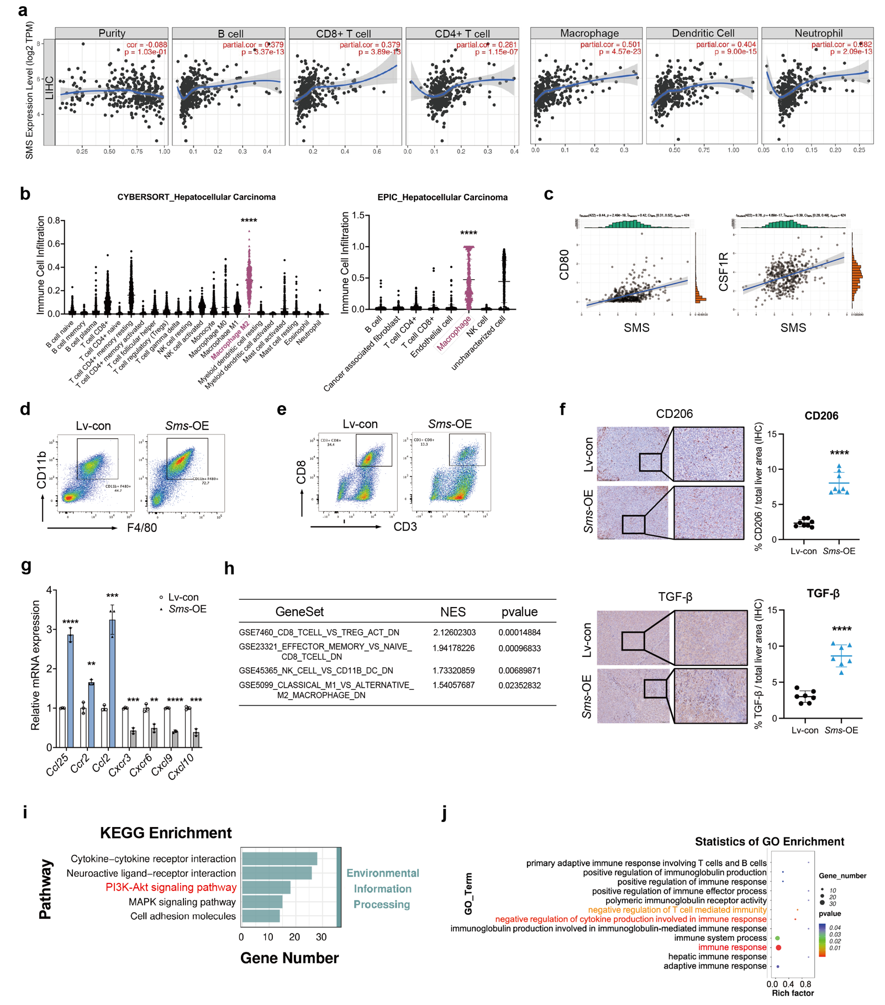
Supplementary Figure 3

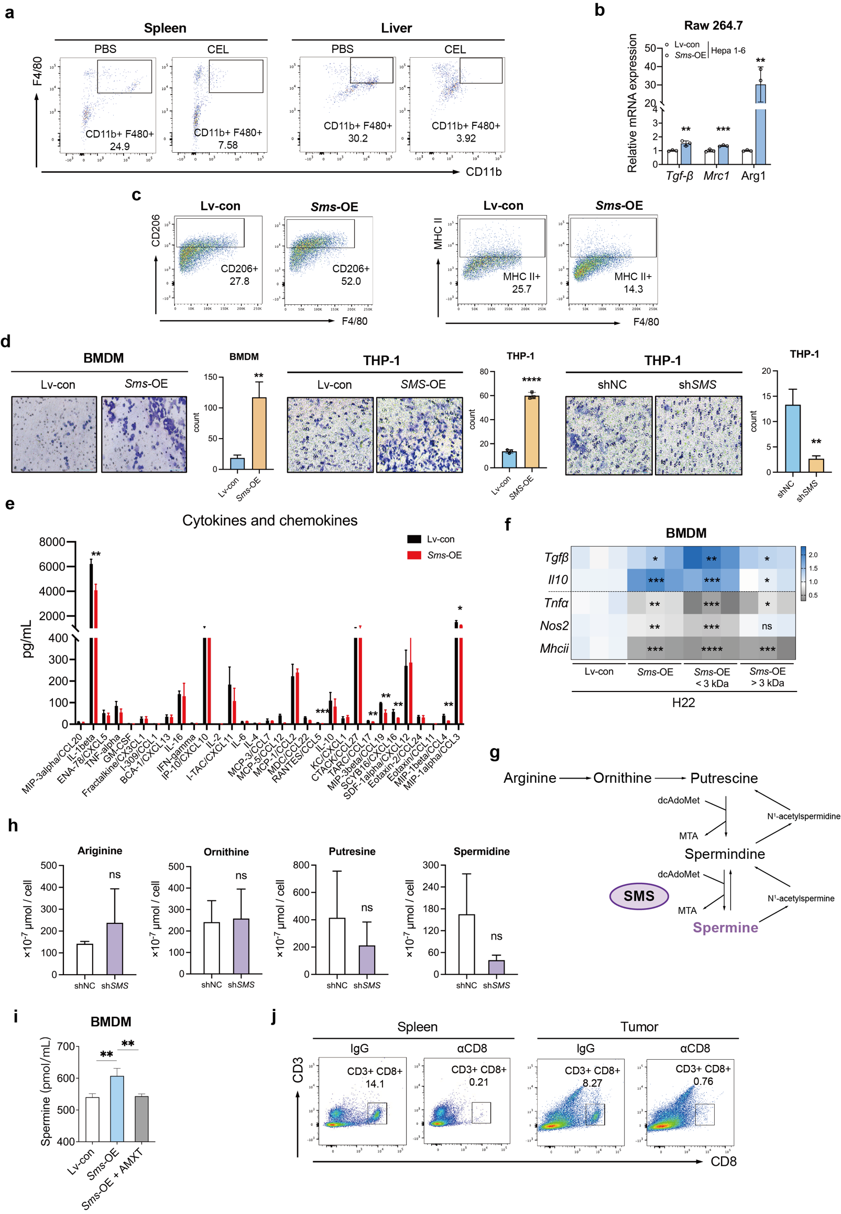
Supplementary Figure 4

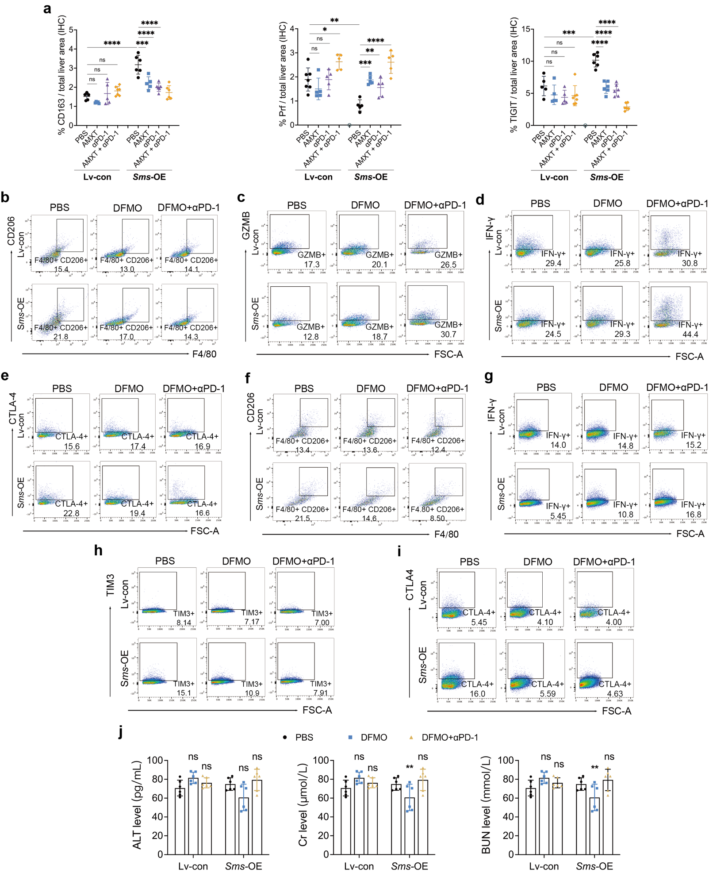
Supplementary Figure 5

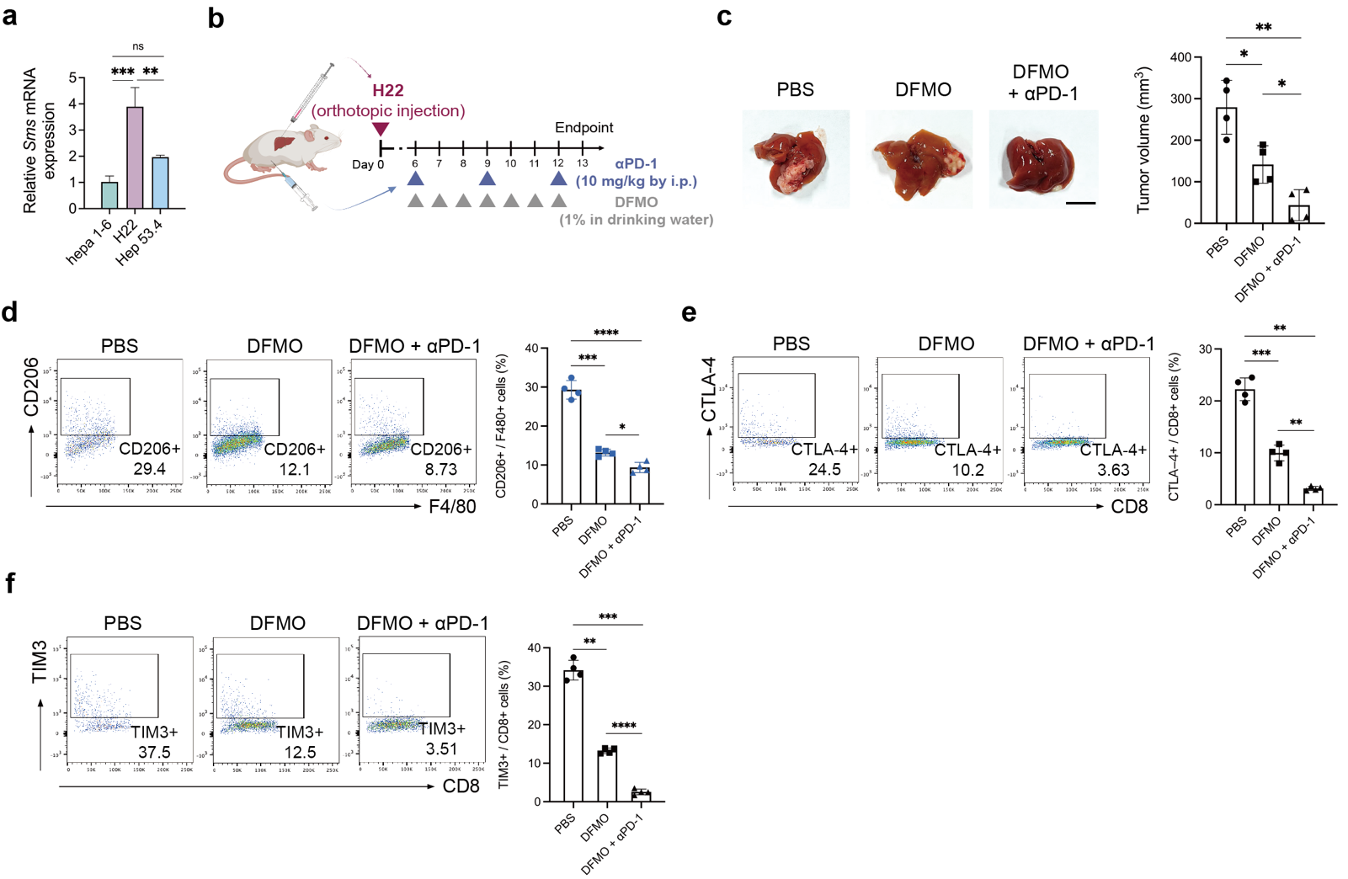
Supplementary Figure 6

Supplementary Tables
Table S1. Correlation between SMS expression and clinicopathological characteristics
 | variables | SMS expression  low high |  | total | p value | R value
Sex | male  female | 28  1 | 45  5 | 73  6 | 0.406 | 0.119
Age (year) | ≤59  >59 | 22  7 | 39  11 | 61  18 | 1 | -0.025
Grade | I/II  III | 24  5 | 27  23 | 51  28 | 0.014  0.071 | 0.29  0.234
Tumor size | ≤3.5cm  >3.5cm | 9  20 | 6  44 | 15  64
T stage | T1/T2  T3/T4 | 13  14 | 19  26 | 32  40 | 0.634 | 0.058
TNM stage | I/II  III/IV | 13  14 | 19  26 | 32  40 | 0.634 | 0.058

Table S2. Antibodies used in immunohistochemistry and western blot
Antibody | Supplier | Cat No. | Application | Dilution
SMS | Thermo fisher | MA525592 | IHC | 1:200
SMS | Abcam | ab156879 | WB | 1:1000
GAPDH | CST | 2118 | WB | 1:5000
β-TUBULIN | Fdbio | FD0064-100 | WB | 1:5000
F4/80 | abcam | ab111101 | IHC | 1:100
CD163 | abcam | ab182422 | IHC | 1:500
CD8 | abcam | ab209775 | IHC | 1:500
CD206 | CST | 24595S | IHC | 1:300
TGF-β | abcam | ab170874 | IHC | 1:100
Perforin | CST | E3W4I | IHC | 1:300
TIGIT | Abcam | ab300073 | IHC | 1:500
LAG3 | Proteintech | 16616-1-AP | IHC | 1:3000
PI3K | CST | 19H8 | WB | 1:1000
phospho-PI3K | CST | 4228T | WB | 1:1000
AKT | CST | C67E7 | WB | 1:1000
phospho-AKT | CST | S473 | WB | 1:1000
mTOR | CST | #2983 | WB | 1:1000
phospho-mTOR | CST | #5536 | WB | 1:1000
S6K | CST | #9208 | WB | 1:1000
phospho-S6K | CST | #9208 | WB | 1:1000
phospho-mTOR | CST | #5536 | WB | 1:1000
S6K | CST | #9208 | WB | 1:1000
phospho-S6K | CST | #9208 | WB | 1:1000
phospho-mTOR | CST | #5536 | WB | 1:1000
S6K | CST | #9208 | WB | 1:1000
phospho-S6K | CST | #9208 | WB | 1:1000
phospho-mTOR | CST | #5536 | WB | 1:1000
S6K | CST | #9208 | WB | 1:1000

Table S3. Sequence of qRT-PCR primers
Gene | Forward | Reverse
Mouse
Sms | GACCTTCAGAGTTACGACAGTG | GAACTATGGGTGGTAATCGCTTC
Gapdh | TGTGTCCGTCGTGGATCTGA | TTCGTGTTGAAGTCGCAGGAG
Arg1 | TGTCCCTAATGACAGCTCCTT | GCATCCACCCAAATGACACAT
Mrc1 | GCTTCCGTCACCCTGTATGC | TCATCCGTGGTTCCATAGACC
Tgfb | CCACCTGCAAGACCATCGAC | CTGGCGAGCCTTAGTTTGGAC
Il10 | GCTGGACAACATACTGCTAACC | ATTTCCGATAAGGCTTGGCAA
Tnfa | TCGTAGCAAACCACCAAGTG | AGATAGCAAATCGGCTGACG
Nos2 | CAAGCACCTTGGAAGAGGAG | AAGGCCAAACACAGCATACC
Mhcii | AAGGCATTTCGTGTACCAGTTC | CCTCCCGGTTGTAGATGTATCTG
Il1b | GAAATGCCACCTTTTGACAGTG | TGGATGCTCTCATCAGGACAG
Il6 | GCCACCGTTACCCTGATTTG | TCCTGTGGTAGTCCATTCTCTG
Cd8a | AAGAAAATGGACGCCGAACTT | AAGCCATATAGACAACGAAGGTG
Prf1 | AAAAACTCCCTAATGAGAGACGC | ACACGCCAGTCGTTATTGATATT
Gzmb | TCATGCTGCTAAAGCTGAAGAG | CCCGCACATATCTGATTGGTTT
Ifnγ | TGAGCTCATTGAATGCTTGG | ACAGCAAGGCGAAAAAGGAT
Lag3 | TCATCACAGTGACTCCCAAATC | GCCACACAAATCTTTCCTTTCC
Pdcd1 | CAGGCTGGGTAGAAGGTGAG | CATTCACTTGGGCTGTGCT
Tim3 | GCCCGGGAGGAGCTAAAGCTATCCCTACACA | GCCCGGGCCAATGAGGTTGCCAAGTGACATA
Ccl25 | CGTGCTGTGAGATTCTACTTCC | CTCCTCACGCTTGTACTGTTG
Ccr2 | CACGAAGTATCCAAGAGCTT | CATGCTCTTCAGCTTTTTAC
Ccl2 | GCATCCACGTGTTGGCTCAG | TTCTTGGGGTCAGCACAGAC
Cxcr3 | ATCAGCGCTTCAATGCCAC | TGGCTTTCTCGACCACAGTT
Cxcr6 | CCCTTTTGGGCCTATGCAG | ATGCCTCGAAGAGTTTTGCAC
Cxcl9 | CTGGAGCAGTGTGGAGTTCG | AGGCAGGTTTGATCTCCGTTC
Cxcl10 | TGTTGAGATCATGCACGAT | CTCTCTGCTGTCCATCCAT
Gapdh | TGTGTCCGTCGTGGATCTGA | TTCGTGTTGAAGTCGCAGGAG
Human
SMS | TAGTGGGGATGTTAATTTGGCAG | CCACACGTTTTTCGCATGTATTT
ARG1 | GTGGAAACTTGCATGGACAAC | AATCCTGGCACATCGGGAATC
MRC1 | CTACAAGGGATCGGGTTTATGGA | TTGGCATTGCCTAGTAGCGTA
IL10 | TCAAGGCGCATGTGAACTCC | GATGTCAAACTCACTCATGGCT
TGFB | CCACCTGCAAGACCATCGAC | TGGCGAGCCTTAGTTTGGAC
CD163 | TTTGTCAACTTGAGTCCCTTCAC | TCCCGCTACACTTGTTTTCAC
TNFA | GAGGCCAAGCCCTGGTATG | CGGGCCGATTGATCTCAGC
NOS2 | AGGCCACCTCTATGTTTGCG | TGATAGCGCTTCTGGCTCTTG
IL1B | TGGCAATGAGGATGACTTGT | TGGTGGTCGGAGATTCGTA
IL6 | CCTTCCAAAGATGGCTGAAA | GCTCTGGCTTGTTCCTCAC
GAPDH | CTGGGCTACACTGAGCACC | AAGTGGTCGTTGAGGGCAATG

Table S4. Antibodies used in flow cytometry
Antibody | Supplier | Cat No. | Clone
APC/Cyanine7 anti-mouse CD45 | BD | 103116 | 30-F11
FITC anti-mouse CD3 | Biolegend | 100204 | 17A2
PE/Cyanine7 anti-mouse CD8a | Biolegend | 100722 | 53-6.7
PE anti-mouse CD152 | Biolegend | 106305 | UC10-4B9
PerCP/Cyanine5.5 anti-mouse CD279 (PD-1) | BD | 109120 | RMP1-30
Brilliant Violet 605™ anti-mouse CD366 (Tim-3) | BD | 568890 | RMT3-23
eFluor™ 450 anti-mouse Granzyme B | ThemoFisher | 48-8898-82 | NGZB
APC anti-mouse IFN gamma | ThemoFisher | 17-7311-82 | XMG1.2
Brilliant Violet 510™ anti-mouse/human CD11b | Biolegend | 124308 | 10F.9G2
Brilliant Violet 650™ anti-mouse F4/80 | Biolegend | 123149 | BM8
Brilliant Violet 421™ anti-mouse I-A/I-E | Biolegend | 107631 | M5/114.15.2
APC anti-mouse CD206 (MMR) | Biolegend | 141708 | C068C2

