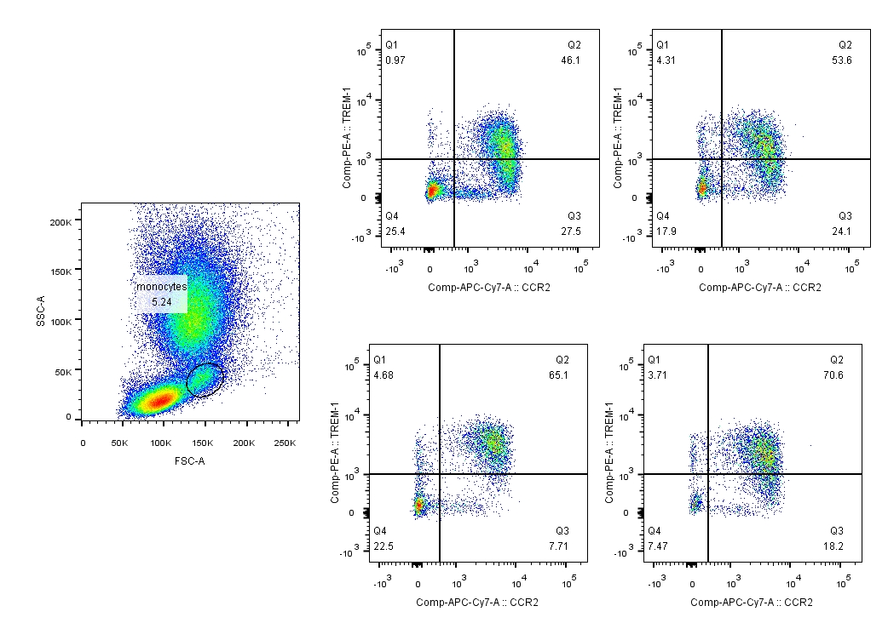
SFig1. The gating strategies for monocytes

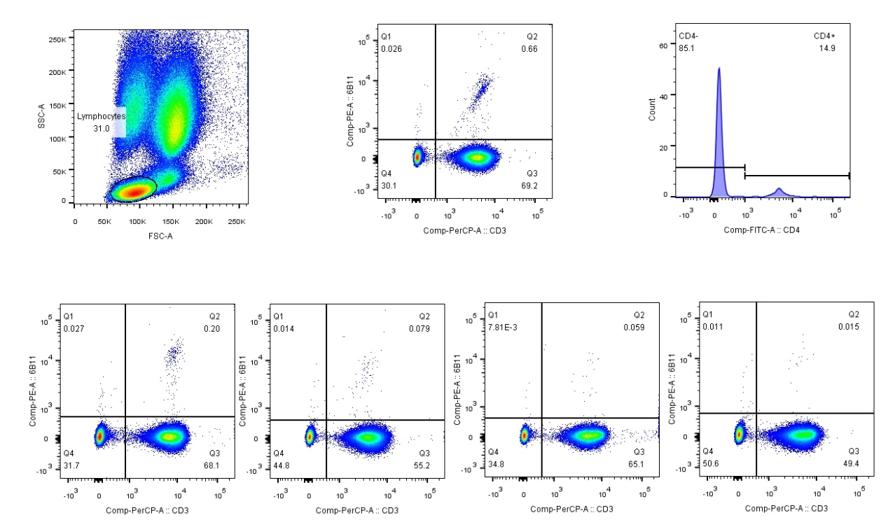
SFig2. The gating strategies for NKT cells

