Supplementary:

Supplementary Table 1: Clinical Characteristics of all Family Members:
(HTN-Hypertension, DM-Diabetes, CAD- Coronary Artery Disease, PTCA- Percutaneous transluminal coronary angioplasty, * - deceased, xanthomas present – III.5)
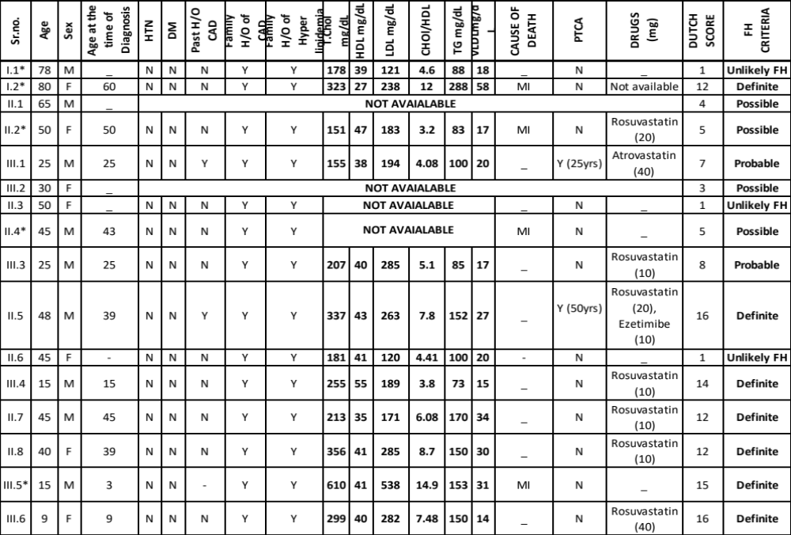

Supplementary Figure 1: Chromatogram of the novel mutation (c.743_744delinsAA – heterozygous) in exon 5 of LDLR gene
gene
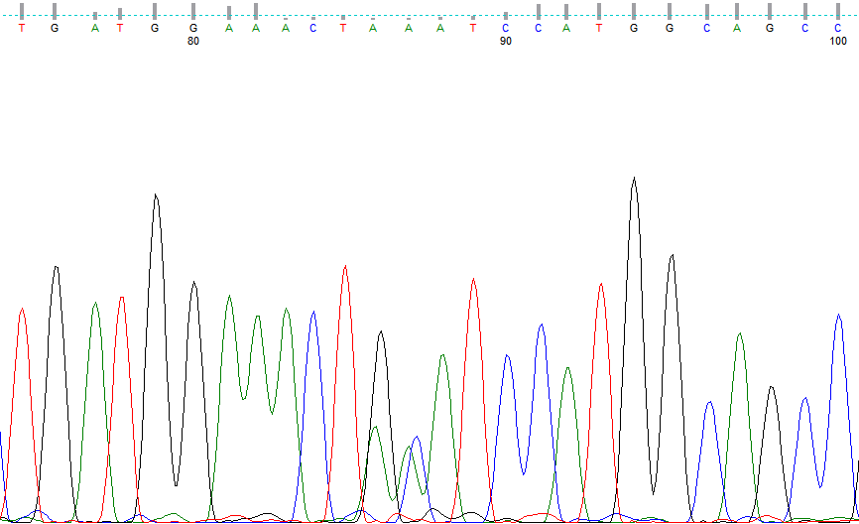
c.743_744delinsAA

