Supplementary Information A: Group Assignment Task

In both studies, each participant sat in front of a computer. On login, participants see the message in Figure A1. A circle A circle with some blue and red dots (see Figure A2.) was displayed on each participant’s computer screen for 20 seconds. Participants were asked to estimate the total number of dots on the circle, after which they were asked to estimate the number of blue dots.
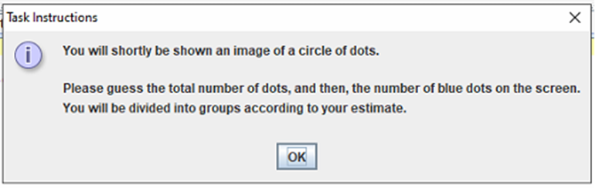

Figure SIA1. Assignment task instruction message


Fig. SIA2. The circle used for the dot estimation task.

Afterward, the following message was displayed on each participant’s screen: "Based on your estimate, you have been placed in a group with players who had similar estimates."

Supplementary Information B: Token Allocation
Once the players had been assigned to a group, each computer displayed all players represented with avatars, specifically, circles arranged on their screens. However, the participants were unaware of the presence of artificial agents. The participants were instructed to allocate a token every round to any one of the eight players, 4 per group. For each game, a trial run (Trial 1) was conducted where each player played for two rounds before the actual game. This was done to ensure that players understood what was required of them. Each player's token balance is displayed on the screen. Each participant allocates a token by clicking the avatar representing the target recipient. Each token allocation increased the recipient’s token balance by one and decreased the allocator's token balance by one. At the end of each round, the exchanges and the token balance of each player were displayed on the screen and made visible to all participants.

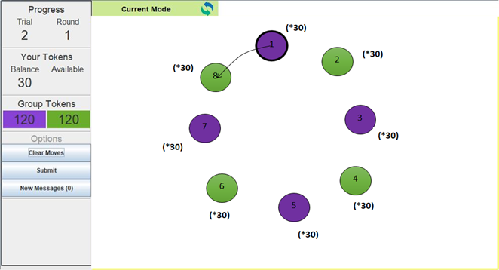

Fig. SIB1. VIAPPL interface showing a player as each player selects who to allocate a token to. the avatars (circles) represent the players where the thick outline indicates the player whose screen is shown, the player’s wealth (token balance), the wealth of each participant within the network, the accumulative wealth of each group, and the progress of the game indicated by the round number.

