Supplementary Materials

Figure S1: Ungradable Images from the Uk Biobank (A) and Moorfields External Validation (B) Datasets
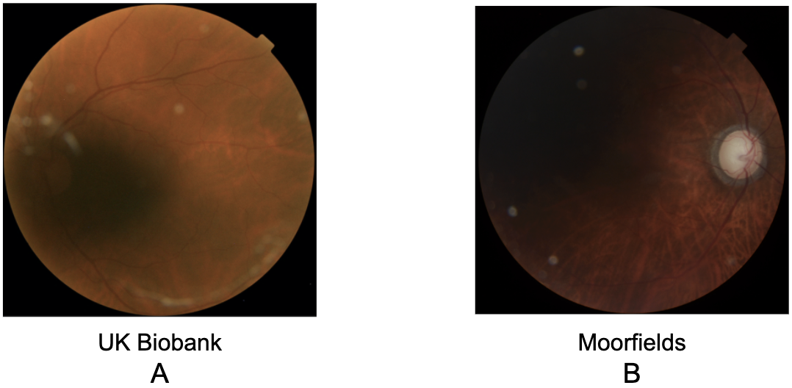

Table S1: Discordant Reported and Genetic Sex in UK Biobank Dataset

 | Number of Images | Percent of Dataset | Total
UK Biobank Train | 119 | 0.09% | 139,060
UK Biobank Tune | 13 | 0.04% | 34,764
UK Biobank Validation | 1 | 0.08% | 1,287

Table S2 Gradability Algorithm Details

Model Facts |  | Model name: Retinal Fundus Gradability
Summary
This model uses retinal fundus photos as input
which were labeled by retinal specialists for gradability,
to classify retinal fundus photos as gradable or ungradable.
Mechanism
 | Outcome | Whether a retinal fundus photo is gradable, defined as:  1. Field of view: Adequate visibility of retinal features (vascular arcades, macula, optic nerve);  2. Image quality: Ability to exclude features to the subtlety level of microaneurysms
 | Output | Binary classification of gradable or ungradable
 | Target Population | All adults with retinal photographs
 | Input data source | EyePACS public fundus dataset (Kaggle) diabetic screening
 | Input data type | Retinal fundus photographs, expert gradability labels to the same criteria as in Outcome section
 | Training data location | https://www.kaggle.com/tanlikesmath/diabetic-retinopathy-resized
 | Model type | Neural Network trained with Google Cloud AutoML
Datasets and Performance
 | Prevalence | AUPRC | PPV  @ 0.5 threshold | Sensitivity  @ 0.5 threshold | Cohort
Training set | 19.0% | *Not available in Auto ML | *Not available in Auto ML | *Not available in Auto ML | EyePACS Training/Tune:  convenience sampled  from source n=3984
Validation set | 20.9% | 0.934 | 0.897 | 0.872 | EyePACS test:  10% random sampled n=398

Table S3: Confusion Matrix of CFDL Sex Prediction Model Test Set: Rows Correspond to Predictions and Columns to Ground Truth

 | Female | Male
Female | 640 | 93
Male | 81 | 473

Table S4: Confusion Matrix of CFDL Sex Prediction Model External Validation Set: Rows Correspond to Predictions and Columns to Ground Truth

 | Female | Male
Female | 115 | 32
Male | 22 | 83

