APPENDIX
Cost-Effectiveness Analysis of a Large-Scale Crèche Intervention to Prevent Child Drowning in Rural Bangladesh
Contents
METHODS 1
Appendix Exhibit A. Detailed List of Creche Program Inputs 2
Appendix Exhibit B. Societal Cost Parameter Assumptions for Monte Carlo Simulation 3
RESULTS 3
Appendix Exhibit C. 10-Year Model of Annualized Program Cost, by Year 4
Appendix Exhibit D. Child Enrollment and Capacity by Month 4
Appendix Exhibit E. Program Cost by Study Area 5
Appendix Exhibit F1. Area 1 Monthly Expenditure Trend 6
Appendix Exhibit F2. Area 2 Monthly Expenditure Trend 6
SENSITIVITY ANALYSIS 7
Appendix Exhibit G1a. Effect of Changes to the Program Cost on the ICER 7
Appendix Exhibit G1b. Effect of Changes to the Societal Cost on the ICER 7
Appendix Exhibit G2a. Effect of Changes to the Number of DALYs Averted on the ICER 8
Appendix Exhibit G2b. Effect of Changes to the Number of Drowning Deaths Averted on the ICER 8
Appendix Exhibit H. Effect of Percentage Change of Inputs on the ICER 9
CONSOLIDATED HEALTH ECONOMIC EVALUATION REPORTING STANDARDS – CHEERS CHECKLIST 10

METHODS
Program ingredients included experts’ time designing the intervention and developing the creche manuals, equipment for central offices (CO) and field offices (FOs), trainings for crèche mothers and assistants, supervisors and monitoring officers, expenses for coordinating union, upazilla and village injury committee meetings, engaging the community in the program, manual printing (one per crèche), and logistic supplies for the creches (tiffin box, plastic jug, mug, paper basket, bowl, soap case, belcha, plastic pack, melamine glass, story book, poster chart, floor mat (12x 16 ft2), black board, electric fan, board, switch, cable and normal bulb). Other items included in the program cost included supplies provided more than once per year (e.g. registration book, towels, toys, door mat, soap, broom, colors and paper, chalks), stipend for crèche mothers and assistant, CO and FOs’ rent, wages, utilities, maintenance.

Appendix Exhibit A. Detailed List of Creche Program Inputs
Input Category |  | Input Description
Fixed Costs [life-time yrs.]
 | Start-up | Program design, manual development, initial stakeholder meetings (2-6 months of labor and operational costs) [10]
 | Equipment | Office furniture [10]
 | Equipment | Office computers [5]
 | Trainings | Crèche mother, mother assistant, trainer-of-trainers [5]
 | Crèche maintenance | Long lasting supplies: stationery, teaching and cleaning, equipment [5]
 | Crèche maintenance | Short lasting supplies: teaching and cleaning supplies [1]
 | Crèche maintenance | Repairs [2]
Variable Cost (VC)
 | Wages / stipend (field staff) | Crèche mother & assistant
 | Wages / stipend (field staff) | Supervisors
 | Wages / stipend (field staff) | Monitoring officers
 | Community engagement | Upazila committee advocacy meeting (CAM), Union CAM, village CAM
 | Community engagement | Village and Union injury Prevention Committees (VIPC, UIPC)
 | Transportation | Excludes trainings
 | Field overhead | Rent, utilities, maintenance
 | Administration | Rent
 | Administration | Wages: Upazila coordinators, team leaders, senior FAO, A/C officer
 | Administration | Wages: Deputy team leaders, office assistants
 | Administration | Wages: Human Resources and Admin
 | Administration | Wages: Communication officer
 | Administration | Wages: Accountants
 | Administration | Utilities expenditure
 | Administration | Maintenance expenditure
 | Administration | Communication expenditure

Appendix Exhibit B. Societal Cost Parameter Assumptions for Monte Carlo Simulation

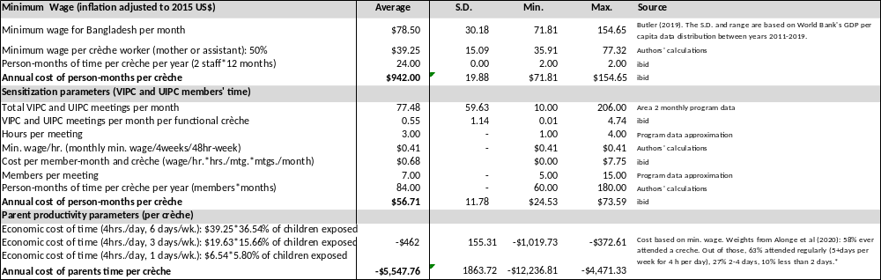Note: Negative values indicate savings. S.D. is the standard deviation. *S.D. for fixed data (without distributions) is approximated to one-fourth of the range of the data (e.g., maximum – minimum)/4).

RESULTS

Exhibits C shows the average monthly cost by input for the first three years of the program data and then the assumptions about the remaining 7 years in the 10-year projection model. We assumed that the annual program capacity for this annual expenditure level was the average of the mid. to full capacity reached during the 2nd year for study area 2 and both the 2nd and 3rd year for area 1. The total annual cost was divided by the total annual capacity to produce the average cost.

Appendix Exhibit C. 10-Year Model of Annualized Program Cost, by Year
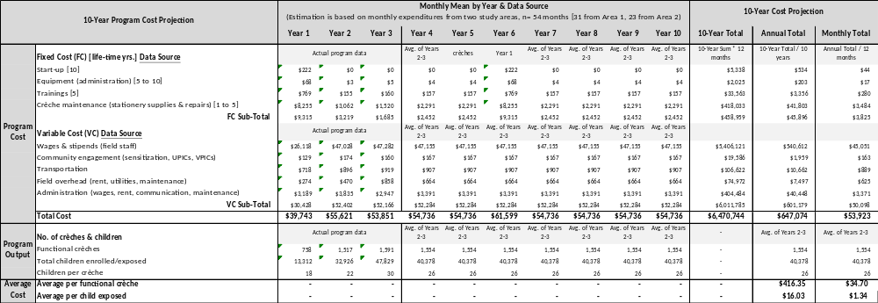

Appendix Exhibit D. Child Enrollment and Capacity by Month

Appendix Exhibit E. Program Cost by Study Area
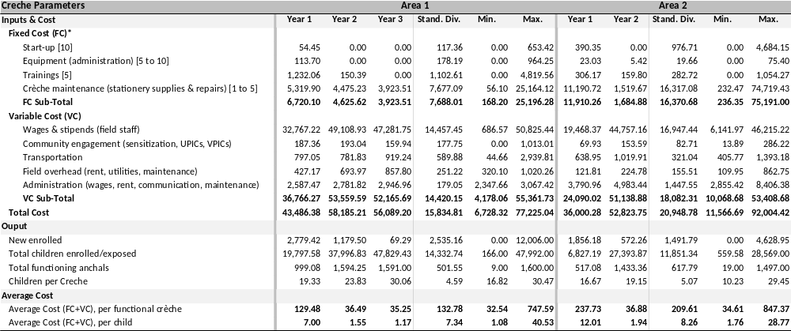

Appendix Exhibit F1. Area 1 Monthly Expenditure Trend

Appendix Exhibit F2. Area 2 Monthly Expenditure Trend

SENSITIVITY ANALYSIS

Appendix Exhibit G1a. Effect of Changes to the Program Cost on the ICER

DALYs: Disability-adjusted-life years. YLL: Years-of-Life Lost; ICER: Incremental-Cost-Effectiveness-Ratio.

Appendix Exhibit G1b. Effect of Changes to the Societal Cost on the ICER

DALYs: Disability-adjusted-life years. YLL: Years-of-Life Lost; ICER: Incremental-Cost-Effectiveness-Ratio.

Appendix Exhibit G2a. Effect of Changes to the Number of DALYs Averted on the ICER

DALYs: Disability-adjusted-life years. YLL: Years-of-Life Lost; ICER: Incremental-Cost-Effectiveness-Ratio.

Appendix Exhibit G2b. Effect of Changes to the Number of Drowning Deaths Averted on the ICER

DALYs: Disability-adjusted-life years. YLL: Years-of-Life Lost; ICER: Incremental-Cost-Effectiveness-Ratio.

Appendix Exhibit H. Effect of Percentage Change of Inputs on the ICER

CONSOLIDATED HEALTH ECONOMIC EVALUATION REPORTING STANDARDS – CHEERS CHECKLIST
