Supporting Information
Effect of Ionic Liquid [emim][OAc] on the Set Recovery Behavior of Densified Wood
Shiying Zhang, Halvar Meinhard, Steven Collins, Tainise V. Lourencon, Lauri Rautkari*
Department of Bioproducts and Biosystems, School of Chemical Engineering, Aalto University, 02150, Espoo, Finland
*Corresponding authors: Lauri Rautkari, Email: lauri.rautkari@aalto.fi
Table S1 Summary of sample groups subjected to set recovery analysis and mechanical test in terms of specimen normal dimensions and the number (n) of replicates
Sample | Set Recovery |  | 3-Point Bending
 | Size: L$×$T$×$R (mm³) * | n | Size: L$×$T$×$R (mm³) * | n
UC | - | - | 120$×$10$×$10 | 10
UCDW_1 | - | - | 120$×$10$×$10 | 10
UCDW_1w | 42$×$20$×$10 | 4 | 120$×$10$×$ 10 | 10
DW_0.5w | 42$×$20$×$10 | 4 | - | -
DW_1w | 42$×$20$×$10 | 4 | 120$×$10 $×$10 | 10
* L$×$T$×$R: Longitudinal ⋅ Tangential ⋅ Radial.
The compression ratio is calculated using equation S1.
$c (\%)=\frac{t_{o}-t_{d}}{t_{o}}×100$ (S1)
Where $c$ is the compression ratio of the densified wood. In the case of before-washing sample group, $t_{o}$ is the thickness of the IL-impregnated wood block in the dry state before densification, and $t_{d}$ is the thickness after densification. For the after-washing group, $t_{o}$ is the dry thickness of the wood block before IL impregnation, and $t_{d}$ is the dry thickness after densification, following the water washing and subsequent redrying process.
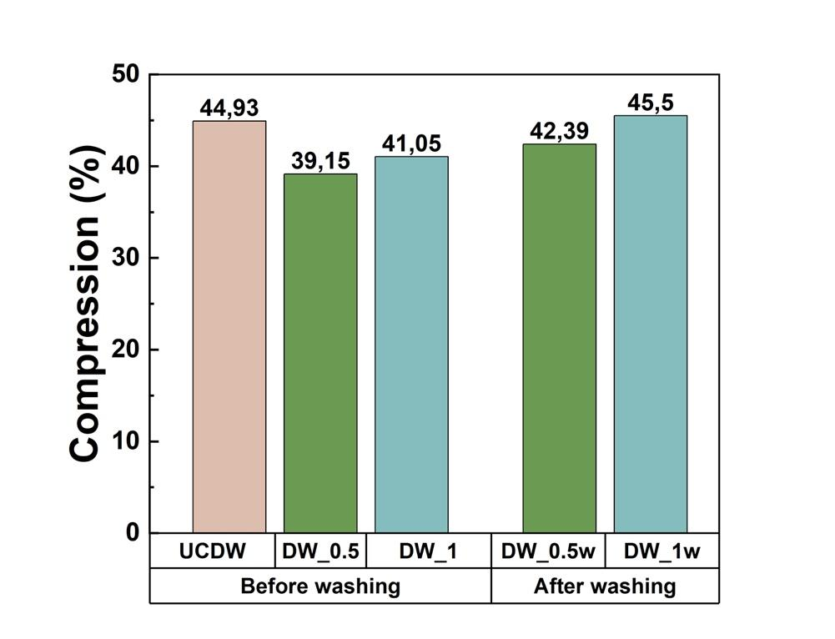
Fig. S1 The respective compression ratio of DW samples before washing and after washing with water in dry state
Ionic liquid recovery.
The DI water utilized in washing IL-treated densified wood (DW) was collected with the intention of recycling the ionic liquid (IL). This step was undertaken to validate our hypothesis regarding the feasibility of reusing the recycled IL for wood treatment. The IL recovery process involved vacuum filtration of the DI water obtained from the washing procedure, followed by subsequent evaporation of DI water at 100 °C. Following the same procedure as employed for the initial treatment method, the resulting residue of IL was then collected to undergo the wood impregnation and densification procedures. It is crucial to note that the precise determination of the purity and percentage of the recovered IL was not undertaken, as our primary objective was to assess the reusability potential of the IL.

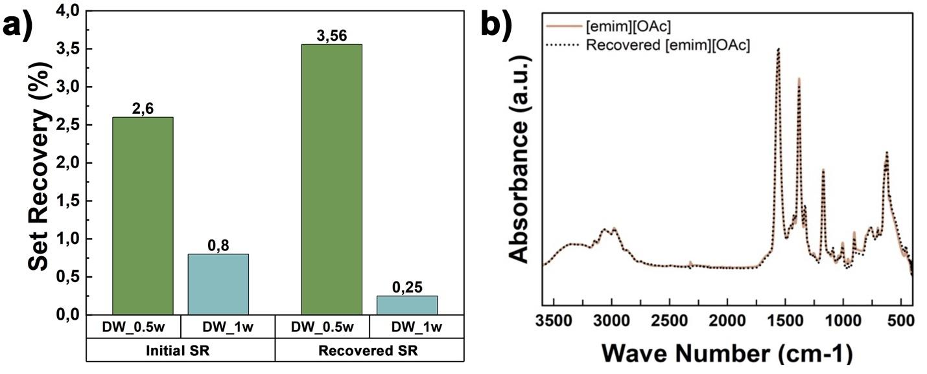
Fig. S2 The SR percentage of the DW samples and the chemical structure of the IL. a) the average SR values of the initial IL-treated DW and the recovered IL-treated DW. b) the FTIR spectra of the initial [emim][OAc] and the recovered [emim][OAc]

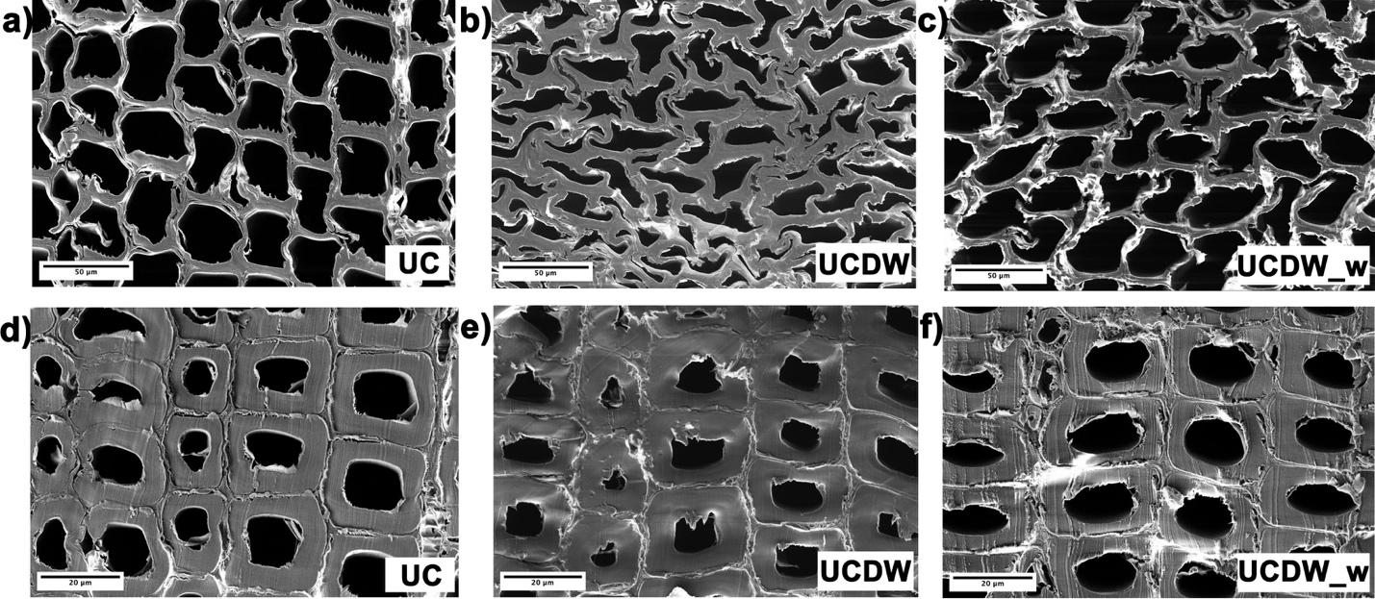
Fig. S3 SEM images of untreated wood samples: a), b) and c) are the respective earlywood morphologies of UC, UCDW, and UCDW_w; d), e), and f) are the respective latewood morphologies of UC, UCDW, and UCDW_w
Evidently, the latewood morphology of UCDW (Figure S3e) and UCDW_w (Figure S3f) has no significant deformation in comparison to that of UC (Figure S3d). This observation indicates that the current compression level of the wood sample has no impact on the latewood region.

Statements & Declarations
Funding
The authors declare that no funds, grants, or other support were received during the preparation of this manuscript.
Competing Interests
The authors have no relevant or non-financial interests to disclose.
Author Contributions
The manuscript was written through the contributions of all authors. The first draft of the manuscript was written by Shiying Zhang and all authors commented on the previous versions of the manuscript. All authors have read and approved the final manuscript.
Corresponding Authors
Lauri Rautkari - Department of Bioproducts and Biosystems, School of Chemical Engineering, Aalto University, FI-02150, Espoo, Finland; Email: Lauri.Rautkari@aalto.fi
Authors
Shiying Zhang - Department of Bioproducts and Biosystems, School of Chemical Engineering, Aalto University, FI-02150, Espoo, Finland; Email: shiying.zhang@aalto.fi
Halvar Meinhard - Department of Bioproducts and Biosystems, School of Chemical Engineering, Aalto University, FI-002150, Espoo, Finland
Steven Collins - Department of Bioproducts and Biosystems, School of Chemical Engineering, Aalto University, FI-02150, Espoo, Finland
Tainise Vergara Lourencon - Department of Bioproducts and Biosystems, School of Chemical Engineering, Aalto University, FI-02150, Espoo, Finland

