Supplementary Materials
RNA sequencing (RNA-seq)
Total RNA was extracted using TRIzol reagent (15596-018, Invitrogen, USA) and then we analyzed its concentration and purity by the RNA Nano 6000 Assay Kit of Bioanalyzer 2100 System (Agilent Technologies, USA). Global mRNA was purified by Oligo dT-Coated Magnetic Beads and then cleaved into small mRNA fragments. The mRNA-Seq sample preparation kit (Illumina, USA) was used to create the final cDNA library according to the instructions. NovaSeq 6000 200-cycle SP flow cell (Illumina, USA) was used to perform the paired-end sequencing (2X100). EdgeR software was used to examine differential expression of mRNA.
IHC
Paraffin sections (4 mm-thick) were deparaffinized in xylene and rehydrated through graded ethanol (100% I, 100% II, 90%, and 80%). For antigen retrieval, the sections were heated at 100 °C in a microwave in 1× citrate buffer, pH 6.0 or an EDTA solution, pH 9.0 for 2.5 min. To block the endogenous peroxidase activity, the slides were immersed in 3% hydrogen peroxide (H2O2) in methanol for 15 min and then washed three times with 1× phosphate-buffered saline (PBS) for 5 min. The slides were then incubated with the primary antibodies to CTSK (ab207086, Abcam, USA), overnight at 4 °C in a humidified chamber, and then washed with PBS. Biotinylated goat anti-polyvalent (ab6789, Abcam, USA), and streptavidin peroxidase were then added and incubated for 10 min at 20-25°C, in succession. After washing with PBS, the slides were treated with 3,3’-diaminobenzidine (DAB) substrate (ab64264, Abcam, USA), for 15 min at 20-25°C. The slides were then washed two times with water, lightly counterstained with hematoxylin, and finally, mounted with coverslips and DPX after dehydration through an ethanol gradient (80%, 90%, 100% II, and 100% II).
cell culture
GH3 cells were maintained in Ham’s F-12K (F12K) Nutrient Mixture (21127030, Gibco, USA) with 2.5% fetal bovine serum (FBS) and 15% horse serum (HS). GT1-1 cells were maintained in Dulbecco’s modified Eagle medium (DMEM, 11995065, Gibco, USA) with 8% FBS and 2% HS. 293T cells were maintained in DMEM with 10% FBS. MC3T3-E1 cells were maintained in minimum essential medium Alpha (Mem-α, 41061029, Gibco, USA) without acid containing 10% FBS. All cells were maintained at 37°C in a 5% CO2 incubator. All culture medium used was supplemented with penicillin (100 U/mL) and streptomycin (100 mg/mL).
Cell proliferation assay
For CCK8 assay, cell counting Kit-8 (CCK8, E606335-0500, BBI, China) was used. Cells (2×10³/well) were plated in 96-well plates at 37 °C with 3 duplicated wells in each group. Cell numbers were counted at 0h, 12h, 24h, 48h, 72h, and 96h after transfection to determine the cell growth curve. For colony formation assays, cells (5×10²/well) were seeded in the 6 cm dishes and incubate at 37 °C in humidified incubator. When growing to a certain extent, cells were fixed with formaldehyde and stained with crystal violet. Cell colonies more than 50 cells were counted and imaged. For EdU assays, BeyoClick™ EdU Cell Proliferation Kit with Alexa Fluor 488 (C0071L, Beyotime, China) was used. Cells (1×10⁴/well) were plated in 24-well plates and treated with EdU reagent for 1h. After washed, fixed, permeabilized, and blocked, cells were incubated with the Click Reaction Mixture for 30 min at room temperature darkly. Then the cells were incubated with Hoechst 33342 for 10 min and observed under a ﬂuorescence microscope (ECLIPSE Ni, Nikon, Japan). For cell cycle assay, ells (5×10²/well) were seeded in the 6 cm dishes and incubate at 37 °C in humidified incubator. When growing to a certain extent, cells were washed with PBS and fixed with -20^{◦C} ethanol at 4^{◦C} for 24 h. Then cells were centrifuged, resuspended with 1ml PBS, and centrifuged again. After washed, cells were stained with Cell Cycle and Apoptosis Analysis Kit (C1052, Beyotime, China) for 30 min at 37^{◦C} darkly. Cell Cycle was detected using a flow cytometry (CytoFLEX, Beckman, USA) within 24 h and data analysis was performed using FlowJo software (version 10.7, Tree Star, San Carlos, CA, USA).
Transwell invasion assay
Transwell co-culture system (8.0-µm pore polyester membrane) (3422, Corning, USA) was used. MC3T3-E1 cells (1×10⁴/well) were seeded in the upper chamber and induced by osteogenic induction medium containing L-ascorbic acid, β-glycerophosphatewhich, and dexamethasone. The culture medium was replaced every other day. Seven days later, cells were washed and lysed with Triton-NH4OH lysis Buffer. Then supernatant was removed and bone matrix was retained. Cells (1×10⁴/well) were seeded on the surface of bone matrix. Culture medium including 20% FBS was added to the lower chamber. Forty-eight hours later take out the transwell chamber and discard the culture medium. Then non-migrated cells were removed and migrated cells attached on the lower surface of the membrane were fixed with formaldehyde and stained with crystal violet. Three fields of each group were selected randomly to observe and count the migrated cells under a microscope.
Western blot
Radio immunoprecipitation assay (RIPA) buffer (P0013B, Beyotime, China) with Phenylmethanesulfonyl fluoride (PMSF), protease inhibitor cocktail, and sodium orthovanadate was used to extract protein. Enhanced BCA Protein Assay Kit (P0010, Beyotime, China) was used to quantified protein concentration. Sodium Dodecyl Sulfate PolyAcrylamide Gel Electrophoresis (SDS-PAGE) was used to separate proteins and then proteins were transferred to polyvinylidene fluoride (PVDF) membrane. The membrane was blocked with 5% skim milk in Tris Buffered Saline with Tween-20 (TBST) for 40 min at room temperature. Primary antibodies CTSK, S6K, p-S6K, 4E-BP1, p-4E-BP1, UCH-L1, TLR4, and GAPDH were incubated overnight at 4 °C. HRP labelled secondary antibodies (1:5000) (ab64264, Abcam, USA) were incubated for 2 hours at 37 °C. For exposure, excellent chemiluminescent (ECL) substrate Detection Kit (NCI5079, Thermo, USA), developing powder (500048-0001, Sangon Biotech, China), and fixing powder (500047-0001, Sangon Biotech, China) were used.
BMM isolation
Whole bone marrow cells were collected from the femora and tibiae of 6-8 weeks C57BL/6 mice and resuspended in ACK Lysis Buffer (T10105, Saint-Bio, China). Supernatant were discarded and cell were resuspended in Roswell Park Memorial Institute (RPMI) 1640 medium (R8758, Sigma-Aldrich, USA) containing 10% FBS, 1% penicillin/streptomycin, 100 μl M-CSF. Then cells were cultured on 60-mm culture dishes at a density of 3 × 10⁶ cells/well in the presence of M-CSF. The culture medium was replaced every other day and subsequent experiments were conducted on the sixth day.
Table S1 PCR primers of mRNAs used for qRT-PCR
 | Sequences (5'to3')
GAPDH-F | GCATCTTCTTGTGCAGTGCC
GAPDH-R | GATGGTGATGGGTTTCCCGT
RANKL-F | GATGAAAGGAGGGAGCACG
RANKL-R | GCAGGGAAGGGTTGGACAC
OPG-F | CAGAGAAGCCACGCAAAAGTG
OPG-R | AGCTGTGTCTCCGTTTTATCCT
CTSK-F | TCCTCAACAGTGCAAGCGAA
CTSK-R | CCAGCGTCTATCAGCACAGA
Table S2 CTSK siRNA sequences
RNA | Sequences (5'to3')
CTSK siRNA | CCAUAACCUUGAGGCUUCUTT
CTSK siRNA-NC | UUCUCCGAACGUGUCACGUTT

Supplementary Tables
Table S3 Clinical variable analyses of BIPAs
 | BIPAs  146 | Non-BIPAs  1291 | χ²/T | P
Age, y | 52.6±11.5 | 48.2±14.0 | 3.701 | ＜0.001
LTD, mm | 29.5±13.5 | 21.2±9.7 | 8.813 | ＜0.001
Volume of tumor, cm³ | 12.6 (3.4-31.1) | 4.9 (1.1-11.2) | 9.470 | ＜0.001
Apoplexy, n (%) | 45 (30.8) | 221 (17.1) | 16.329 | ＜0.001
NGTR, n (%) | 44 (30.1) | 111 (8.6) | 63.236 | ＜0.001
Headache, n (%) | 63 (43.2) | 404 (31.3) | 8.409 | 0.004
FPAs, n (%) | 36 (24.7) | 430 (33.3) | 4.479 | 0.034
Note: Skewed data are expressed as mean with SD or median (interquartile range) categorical data are expressed as n (%). Abbreviations: BIPAs: bone invasive pituitary adenomas, LTD: the largest tumor diameter, NGTR: not gross total resection, FPAs: functioning PAs.

Table S4 The characteristics of 137 recurrent patients
No | Age | Sex | BMI | DM | HTN | Invasion | Function | RFS | GTR | LTD
2 | 35 | F | 1 | No | No | IPAs no bone | FPAs | 14 | No | 10
10 | 45 | F | 2 | Yes | No | IPAs no bone | FPAs | 14 | Yes | 25
18 | 68 | F | 1 | No | No | BIPAs | FPAs | 10 | Yes | 10
25 | 48 | F | 3 | No | No | BIPAs | NFPAs | 11 | No | 55
30 | 26 | M | 2 | No | No | Non-IPAs | NFPAs | 11 | Yes | 28
32 | 55 | F | 2 | No | No | Non-IPAs | NFPAs | 12 | Yes | 24
40 | 67 | M | 4 | No | Yes | BIPAs | NFPAs | 22 | No | 32
51 | 72 | F | 2 | No | Yes | Non-IPAs | NFPAs | 13 | Yes | 17
54 | 66 | M | 2 | No | Yes | Non-IPAs | NFPAs | 12 | No | 42
55 | 47 | M | 1 | No | Yes | BIPAs | FPAs | 13 | Yes | 22
63 | 58 | F | 3 | No | No | BIPAs | NFPAs | 12 | No | 58
68 | 31 | M | 4 | No | No | BIPAs | FPAs | 14 | Yes | 20
72 | 62 | M | 1 | No | Yes | BIPAs | NFPAs | 15 | No | 42
86 | 74 | M | 2 | No | No | Non-IPAs | NFPAs | 15 | Yes | 27
94 | 70 | F | 2 | No | Yes | BIPAs | FPAs | 12 | Yes | 15
108 | 76 | F | 2 | Yes | Yes | IPAs no bone | NFPAs | 16 | Yes | 21
116 | 67 | F | 2 | Yes | Yes | BIPAs | NFPAs | 14 | No | 61
131 | 37 | M | 2 | No | No | BIPAs | NFPAs | 16 | Yes | 2
132 | 51 | M | 2 | No | No | BIPAs | FPAs | 15 | Yes | 18
156 | 38 | F | 3 | No | No | BIPAs | FPAs | 13 | Yes | 46
158 | 71 | M | 2 | No | No | Non-IPAs | NFPAs | 19 | Yes | 32
159 | 40 | F | 2 | No | No | IPAs no bone | FPAs | 18 | Yes | 36
165 | 58 | F | 4 | No | No | Non-IPAs | FPAs | 17 | Yes | 6
178 | 55 | F | 3 | No | No | IPAs no bone | NFPAs | 15 | Yes | 22
196 | 51 | M | 2 | Yes | No | Non-IPAs | NFPAs | 16 | Yes | 15
209 | 38 | F | 2 | No | No | IPAs no bone | FPAs | 20 | Yes | 26
219 | 63 | M | 2 | Yes | Yes | Non-IPAs | NFPAs | 16 | Yes | 8
242 | 40 | F | 2 | No | Yes | IPAs no bone | FPAs | 11 | Yes | 18
245 | 66 | F | 3 | No | Yes | BIPAs | FPAs | 16 | Yes | 10
254 | 62 | F | 2 | No | No | Non-IPAs | FPAs | 21 | Yes | 5
276 | 45 | F | 2 | No | Yes | Non-IPAs | NFPAs | 18 | Yes | 30
293 | 54 | F | 2 | No | No | BIPAs | NFPAs | 17 | No | 30
330 | 38 | M | 2 | No | No | BIPAs | NFPAs | 16 | Yes | 20
336 | 69 | F | 1 | No | No | IPAs no bone | NFPAs | 26 | Yes | 20
370 | 55 | M | 1 | No | No | Non-IPAs | NFPAs | 27 | Yes | 6
405 | 53 | M | 1 | No | No | Non-IPAs | NFPAs | 19 | Yes | 10
407 | 55 | M | 2 | No | No | IPAs no bone | NFPAs | 29 | No | 27
410 | 59 | F | 2 | No | No | IPAs no bone | NFPAs | 23 | Yes | 31
411 | 60 | M | 2 | Yes | No | Non-IPAs | NFPAs | 20 | Yes | 26
433 | 48 | F | 2 | No | No | BIPAs | NFPAs | 20 | No | 40
448 | 58 | M | 1 | No | Yes | IPAs no bone | NFPAs | 28 | Yes | 40
466 | 57 | F | 2 | No | No | IPAs no bone | NFPAs | 23 | Yes | 33
475 | 66 | M | 1 | No | No | Non-IPAs | NFPAs | 26 | Yes | 30
487 | 56 | F | 2 | No | No | BIPAs | FPAs | 25 | No | 75
501 | 55 | F | 1 | No | No | BIPAs | NFPAs | 36 | No | 50
517 | 62 | F | 2 | Yes | Yes | IPAs no bone | FPAs | 29 | Yes | 20
535 | 58 | F | 2 | No | Yes | IPAs no bone | NFPAs | 19 | No | 29
564 | 36 | F | 3 | No | Yes | IPAs no bone | FPAs | 37 | Yes | 26
567 | 43 | F | 2 | Yes | Yes | BIPAs | NFPAs | 40 | No | 31
609 | 15 | F | 3 | No | No | Non-IPAs | FPAs | 36 | Yes | 12
614 | 31 | M | 2 | No | Yes | Non-IPAs | FPAs | 32 | Yes | 2
620 | 53 | M | 1 | No | No | BIPAs | NFPAs | 32 | Yes | 20
644 | 45 | F | 2 | No | No | IPAs no bone | NFPAs | 18 | Yes | 5
663 | 31 | F | 1 | No | No | IPAs no bone | FPAs | 45 | No | 50
683 | 67 | M | 1 | No | No | Non-IPAs | NFPAs | 35 | Yes | 20
691 | 51 | F | 2 | No | No | Non-IPAs | FPAs | 45 | Yes | 10
715 | 53 | M | 4 | No | Yes | BIPAs | FPAs | 13 | Yes | 20
737 | 70 | M |  | No | Yes | Non-IPAs | NFPAs | 37 | Yes | 20
750 | 39 | M | 2 | No | No | Non-IPAs | NFPAs | 39 | Yes | 30
756 | 57 | F | 1 | No | No | BIPAs | NFPAs | 48 | No | 20
779 | 63 | F | 2 | Yes | No | IPAs no bone | FPAs | 30 | Yes | 10
790 | 69 | M | 1 | No | No | Non-IPAs | NFPAs | 40 | Yes | 18
822 | 48 | F | 1 | No | Yes | Non-IPAs | NFPAs | 36 | No | 20
829 | 34 | M | 2 | No | No | BIPAs | NFPAs | 29 | Yes | 33
831 | 58 | F | 2 | Yes | Yes | BIPAs | NFPAs | 16 | No | 61
832 | 57 | M | 2 | Yes | Yes | BIPAs | NFPAs | 23 | No | 29
834 | 64 | F | 1 | No | No | BIPAs | FPAs | 21 | No | 47
862 | 49 | M | 2 | No | No | Non-IPAs | NFPAs | 37 | Yes | 20
867 | 36 | M | 2 | No | No | IPAs no bone | FPAs | 47 | Yes | 11
901 | 38 | M | 2 | No | No | Non-IPAs | NFPAs | 44 | Yes | 15
917 | 47 | M | 1 | No | Yes | Non-IPAs | FPAs | 19 | Yes | 5
925 | 17 | F | 2 | No | Yes | Non-IPAs | FPAs | 31 | Yes | 5
926 | 18 | F | 2 | No | No | Non-IPAs | FPAs | 36 | Yes | 20
929 | 71 | M | 1 | No | Yes | Non-IPAs | NFPAs | 26 | Yes | 25
947 | 28 | F | 1 | No | No | Non-IPAs | NFPAs | 41 | No | 18
949 | 60 | M | 2 | No | Yes | IPAs no bone | NFPAs | 57 | No | 24
958 | 64 | F | 3 | No | No | IPAs no bone | NFPAs | 16 | No | 55
968 | 54 | F | 1 | No | No | IPAs no bone | NFPAs | 38 | No | 30
972 | 65 | F | 3 | No | Yes | Non-IPAs | NFPAs | 46 | Yes | 20
977 | 71 | F | 1 | No | No | Non-IPAs | NFPAs | 58 | Yes | 15
981 | 37 | M | 3 | No | No | IPAs no bone | FPAs | 28 | No | 20
984 | 21 | M | 4 | No | No | IPAs no bone | FPAs | 19 | Yes | 15
991 | 26 | F | 4 | No | Yes | Non-IPAs | FPAs | 53 | Yes | 10
1003 | 26 | M | 3 | No | No | Non-IPAs | NFPAs | 21 | No | 25
1004 | 77 | F | 3 | Yes | Yes | Non-IPAs | NFPAs | 24 | No | 20
1009 | 72 | F | 4 | No | No | BIPAs | NFPAs | 48 | No | 37
1075 | 73 | M | 2 | No | No | IPAs no bone | NFPAs | 34 | No | 16
1082 | 44 | M | 1 | No | No | BIPAs | NFPAs | 38 | Yes | 17
1087 | 71 | M | 2 | No | Yes | Non-IPAs | NFPAs | 28 | Yes | 20
1090 | 62 | F | 3 | Yes | Yes | IPAs no bone | FPAs | 58 | Yes | 5
1097 | 47 | F | 2 | No | No | IPAs no bone | FPAs | 24 | No | 45
2 | 63 | F | 2 | No | No | BIPAs | NFPAs | 56 | Yes | 30
1152 | 42 | F | 1 | No | No | Non-IPAs | FPAs | 47 | Yes | 18
1162 | 28 | F | 2 | No | No | Non-IPAs | FPAs | 23 | No | 9
1165 | 51 | M | 2 | No | No | Non-IPAs | NFPAs | 48 | Yes | 30
1172 | 44 | M | 4 | No | No | Non-IPAs | NFPAs | 48 | Yes | 20
1173 | 55 | F | 1 | No | Yes | BIPAs | NFPAs | 26 | No | 40
1174 | 42 | F | 2 | No | No | Non-IPAs | NFPAs | 51 | Yes | 22
1176 | 40 | M | 3 | No | No | BIPAs | FPAs | 35 | No | 20
1188 | 52 | F | 1 | Yes | Yes | Non-IPAs | FPAs | 22 | Yes | 14
1199 | 31 | M | 1 | No | No | Non-IPAs | FPAs | 22 | No | 55
1214 | 55 | F | 4 | Yes | Yes | Non-IPAs | NFPAs | 40 | Yes | 25
1215 | 49 | F | 2 | No | No | Non-IPAs | FPAs | 30 | No | 17
1240 | 44 | F | 1 | Yes | Yes | Non-IPAs | FPAs | 64 | No | 32
1243 | 15 | M | 1 | No | No | Non-IPAs | FPAs | 21 | No | 30
1247 | 45 | F | 4 | No | Yes | Non-IPAs | FPAs | 42 | Yes | 10
1249 | 38 | F | 3 | No | No | IPAs no bone | NFPAs | 50 | No | 31
1250 | 48 | F | 2 | No | Yes | Non-IPAs | FPAs | 21 | No | 15
1257 | 47 | M | 3 | No | No | BIPAs | NFPAs | 22 | No | 52
1258 | 53 | F | 3 | No | Yes | Non-IPAs | FPAs | 21 | Yes | 20
1271 | 50 | M | 3 | No | Yes | BIPAs | FPAs | 20 | No | 45
1273 | 59 | M | 2 | No | No | Non-IPAs | NFPAs | 54 | Yes | 25
1280 | 48 | M | 1 | No | Yes | IPAs no bone | FPAs | 44 | Yes | 25
1286 | 12 | F | 2 | No | No | Non-IPAs | FPAs | 36 | No | 13
1289 | 47 | F | 2 | Yes | Yes | Non-IPAs | FPAs | 55 | Yes | 14
1291 | 23 | F | 1 | No | No | Non-IPAs | FPAs | 68 | No | 46
1313 | 57 | M | 2 | No | No | BIPAs | FPAs | 15 | No | 39
1320 | 27 | M | 2 | No | Yes | IPAs no bone | FPAs | 20 | No | 38
1342 | 52 | F | 1 | No | No | IPAs no bone | NFPAs | 46 | Yes | 24
1346 | 68 | M | 2 | No | No | Non-IPAs | FPAs | 31 | Yes | 10
1356 | 68 | F | 4 | Yes | Yes | BIPAs | NFPAs | 26 | No | 45
1357 | 43 | F | 1 | No | No | Non-IPAs | NFPAs | 58 | Yes | 12
1364 | 46 | M | 2 | No | No | IPAs no bone | NFPAs | 26 | No | 39
1377 | 32 | M | 3 | No | No | Non-IPAs | NFPAs | 57 | Yes | 20
1387 | 70 | F | 3 | No | Yes | IPAs no bone | NFPAs | 42 | No | 33
1397 | 9 | F | 1 | No | No | Non-IPAs | FPAs | 21 | No | 30
1398 | 35 | F | 3 | No | No | Non-IPAs | FPAs | 54 | No | 20
1400 | 64 | F | 1 | No | No | BIPAs | NFPAs | 19 | Yes | 37
1411 | 61 | F | 2 | No | No | BIPAs | NFPAs | 40 | Yes | 13
1440 | 54 | F | 2 | No | Yes | IPAs no bone | NFPAs | 50 | Yes | 25
1446 | 56 | F | 2 | No | No | BIPAs | NFPAs | 28 | No | 26
1447 | 35 | M | 2 | No | No | Non-IPAs | FPAs | 37 | Yes | 15
1459 | 58 | F | 1 | No | No | BIPAs | FPAs | 15 | Yes | 34
1464 | 18 | F | 2 | No | No | Non-IPAs | FPAs | 18 | Yes | 18
1465 | 46 | F | 3 | No | Yes | Non-IPAs | FPAs | 19 | No | 45
1483 | 61 | M | 2 | No | Yes | Non-IPAs | FPAs | 22 | Yes | 18
1489 | 63 | M | 3 | No | No | BIPAs | NFPAs | 21 | No | 40
Note：RFS: recurrence free survival, HTN: hypertension, BMI:1: 18.5-23.9; 2: 24-28; 3: 28-32; 4: ≥32.

Supplementary Figures

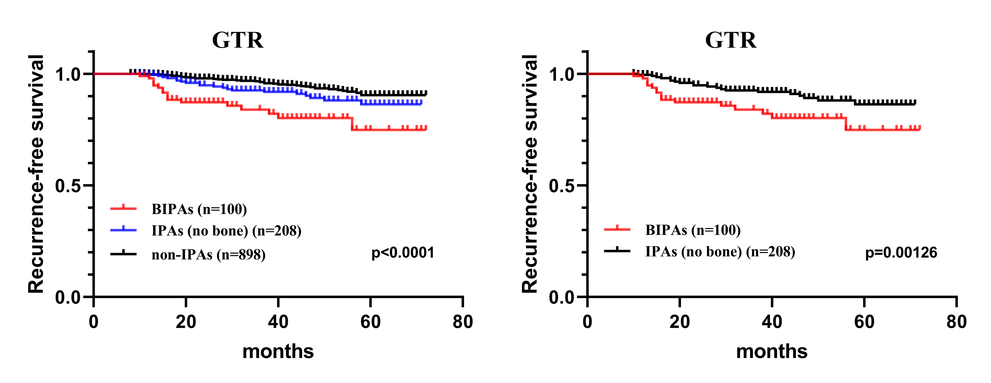
Fig S1. RFS analysis in patients with GTR.

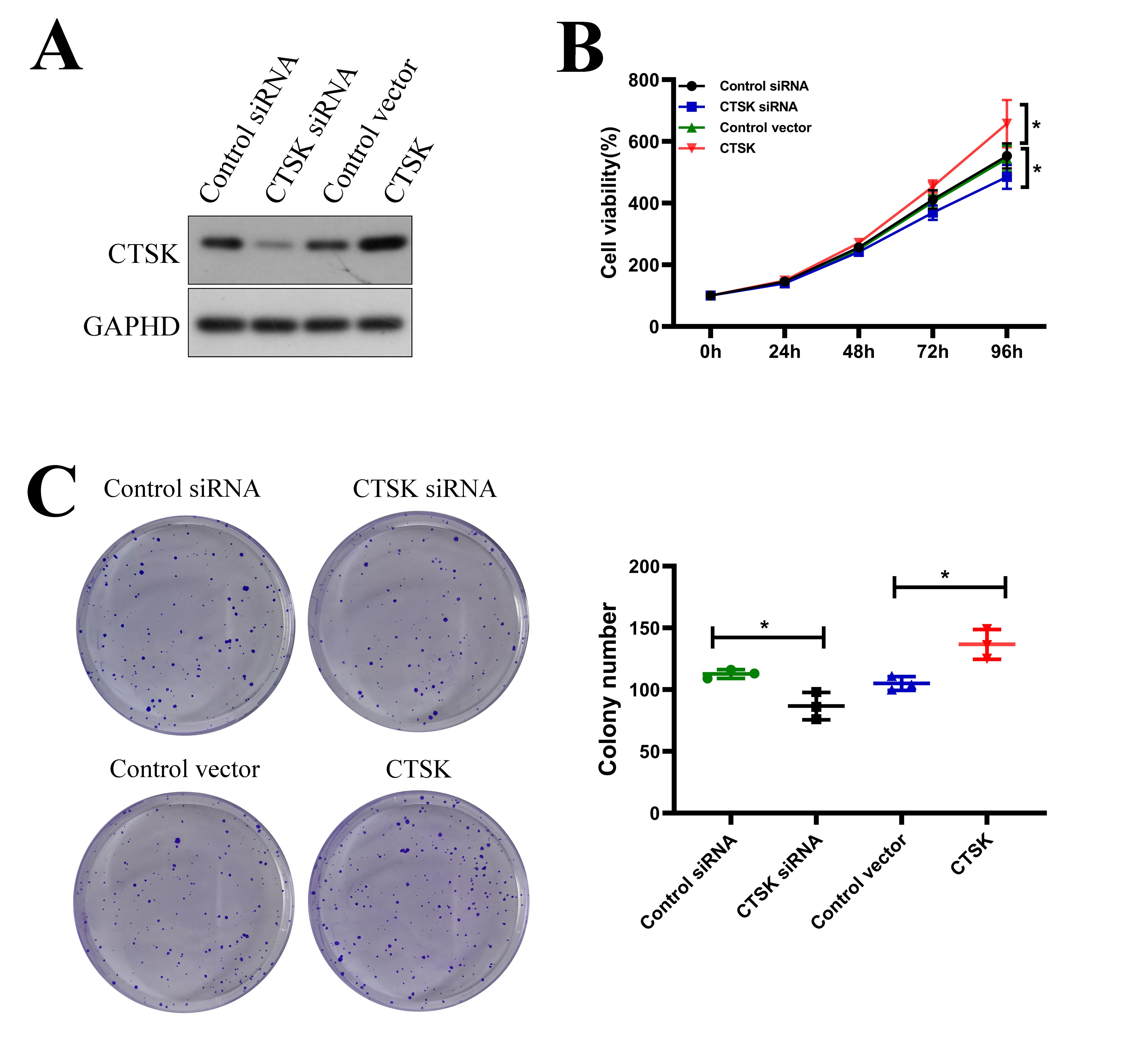
Fig S2 Elevated CTSK promoted pituitary adenoma cell proliferation in vitro. A: WB analysis showed that CTSK expression was decreased in CTSK knockout cells and increased in CTSK overexpression cells. B: CCK8 assays showed the effect of CTSK on proliferation of GT1-1 cells. C: Colony formation assay showed the effect of CTSK on the colony ability of GT1-1cells. Data are presented as the mean ± SD, **: p<0.01, ***: p<0.001.

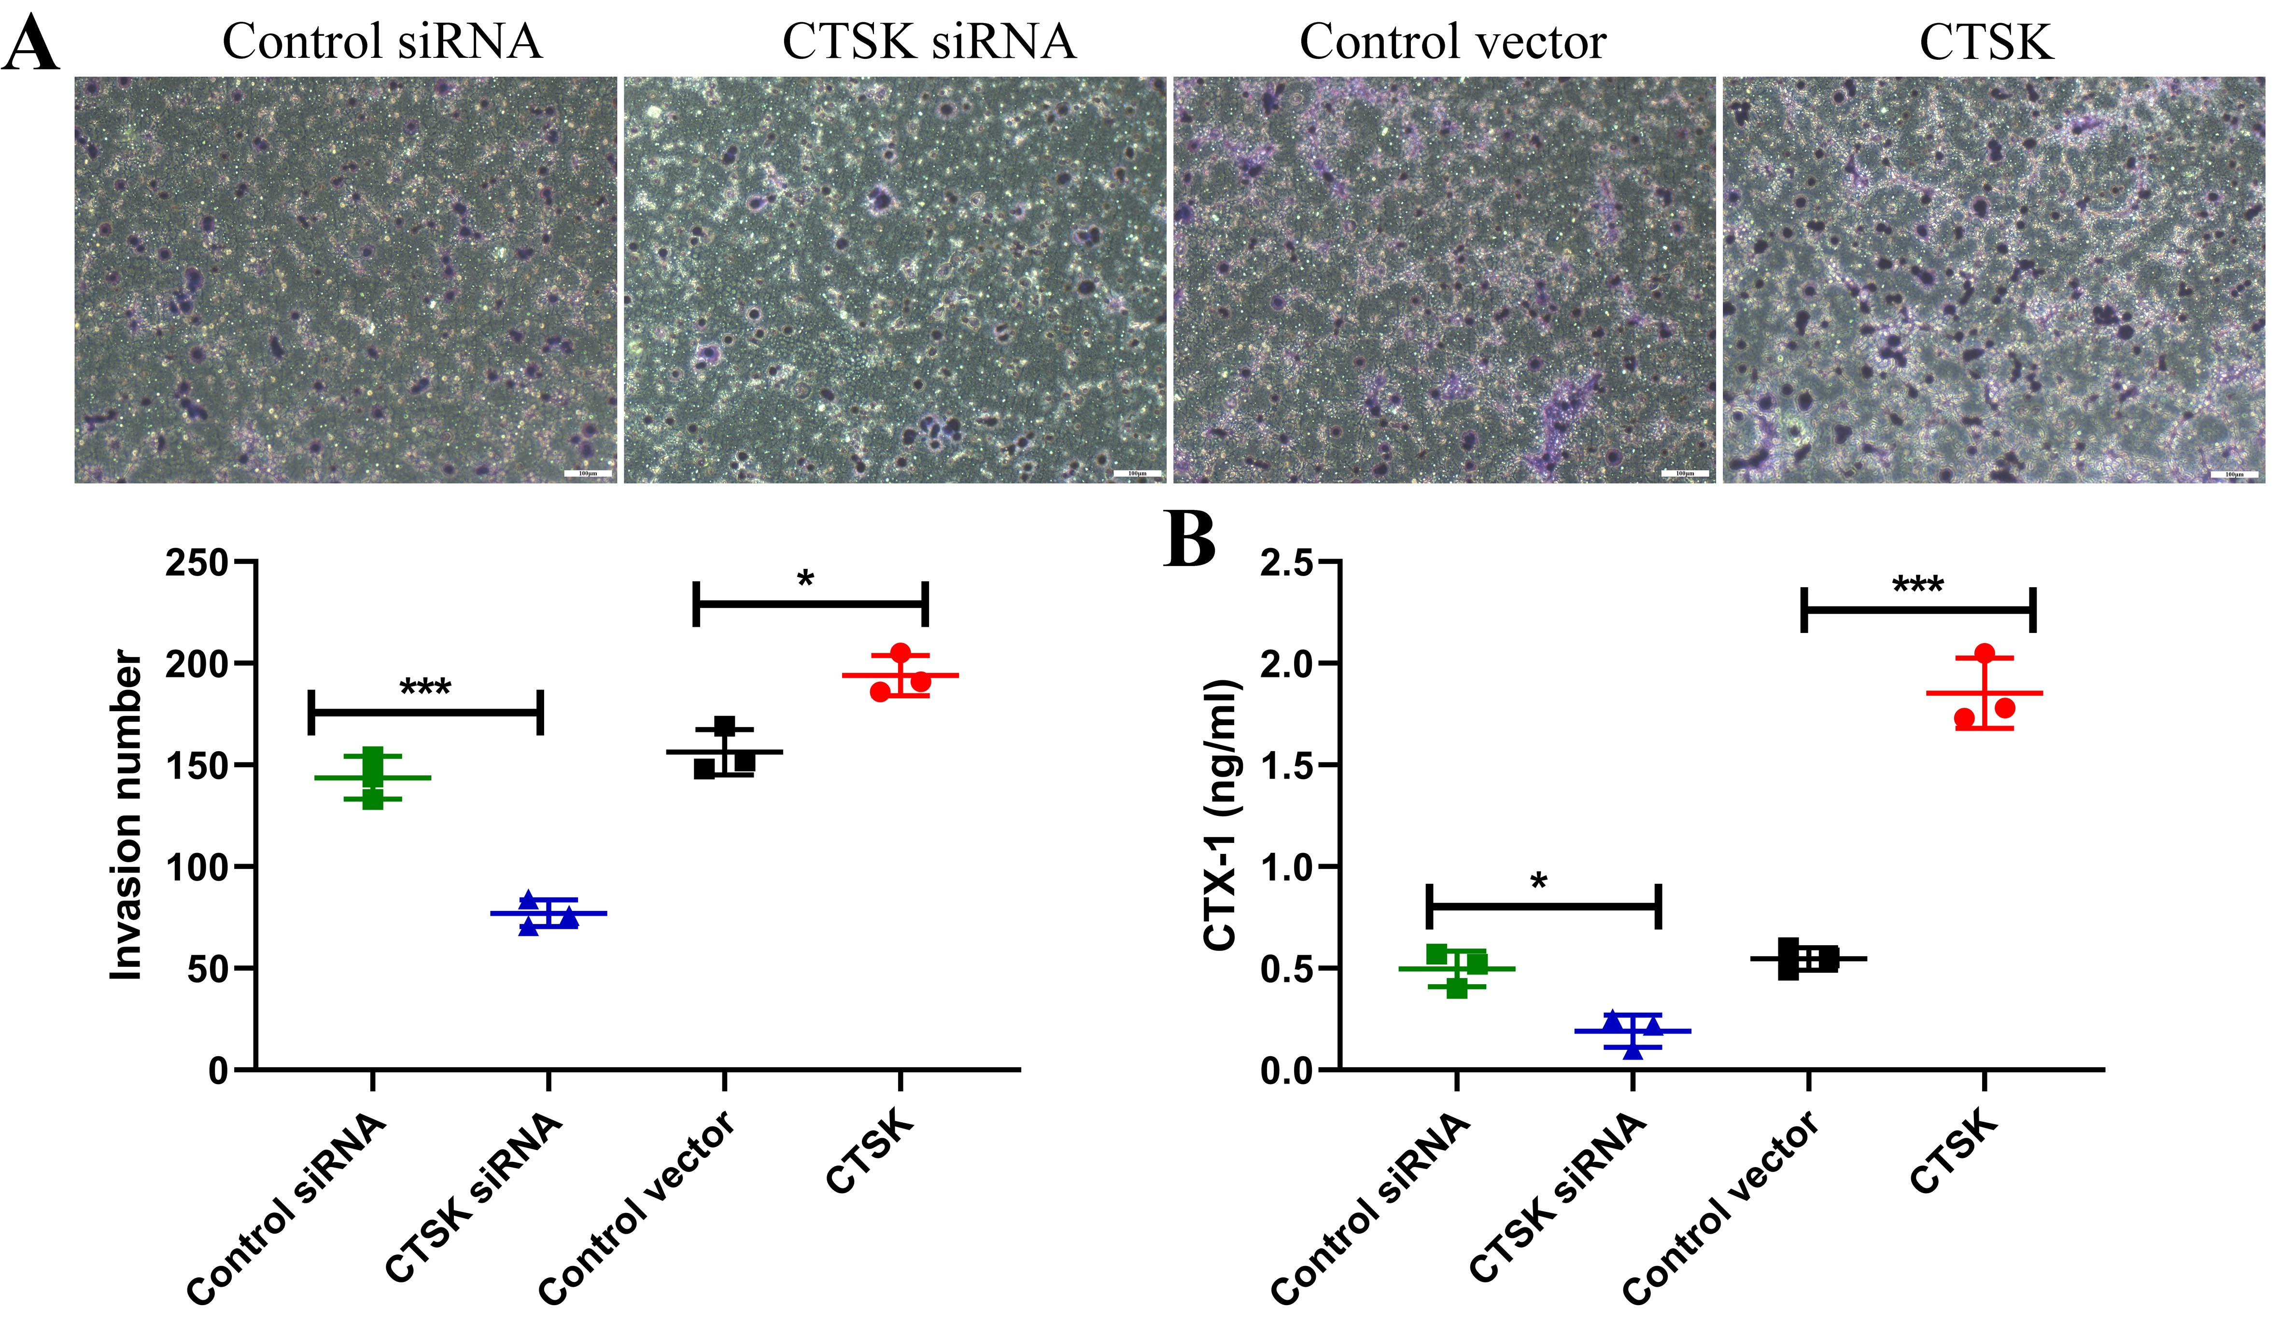

Fig S3. Elevated CTSK promoted pituitary adenoma cell invasion in vitro. A: Transwell invasion assay showed the effect of CTSK on invasion of GT1-1 cells. B: ELISA sassy was used to assess the level of CTX-1. Data are presented as the mean ± SD; *P < 0.05, **P < 0.01, ***P < 0.001.

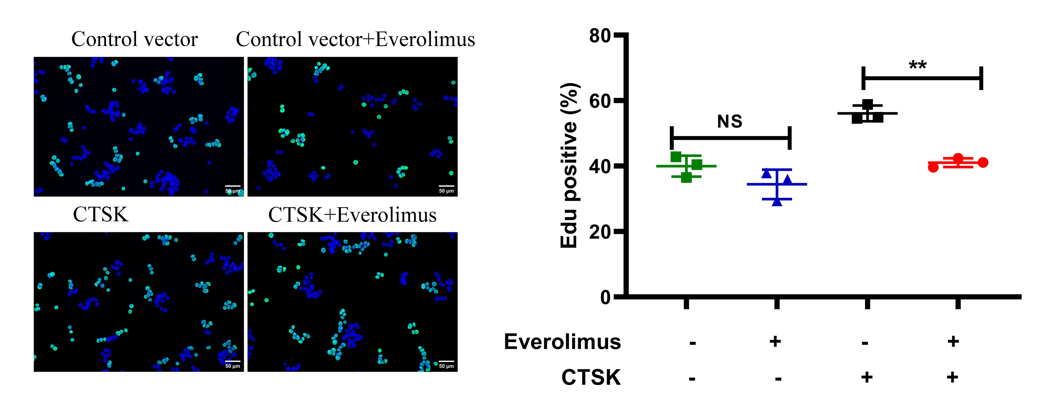

Fig S4. The effect of Everolimus on the proliferation ability of GH3 cells. A: EdU staining assays were used to assess proliferation of GH3 cells treated with or without Everolimus. (***: p<0.001, **: p<0.01)

