Deep Learning captures the effect of epistasis in multifactorial diseases
Vladislav Perelygin¹, Alexey Kamelin^{1,2}, Nikita Syzrantsev², Layal Shaheen^{2,3}, Anna Kim², Nikolay Plotnikov², Anna Ilinskaya⁴, Valery Ilinsky⁴, Alexander Rakitko^{2,}*, Maria Poptsova^{1,}*

¹Laboratory of Bioinformatics, Faculty of Computer Science, HSE University, Moscow, Russia
²Genotek Ltd., Moscow, Russia
³Phystech school of Biological and Medical Physics, Moscow Institute of Physics and Technology, Moscow, Russia
⁴Eligens SIA, Mārupe, Latvia

*corresponding authors (rakitko@genotek.ru; mpoptsova@hse.ru)

Supplemental Tables and Figures

Supplemental Table 1. Disease likelihood in additive, multiplicative and threshold types of epistasis. These schemes where supplied to PyTOXO to generate penetrance tables that were later used in GAMETES.

Genotype | Additive | Multiplicative | Threshold
AABB | x | x | x
AABb | x*(1+y) | x | x
AAbb | x*(1+y)² | x | x
AaBB | x*(1+y) | x | x
AaBb | x*(1+y)² | x*(1+y) | x*(1+y)
Aabb | x*(1+y)³ | x*(1+y)² | x*(1+y)
aaBB | x*(1+y)² | x | x
aaBb | x*(1+y)³ | x*(1+y)² | x*(1+y)
aabb | x*(1+y)⁴ | x*(1+y)⁴ | x*(1+y)

Supplemental Table 2. Penetrance table of 3-loci epistasis with heritability of 0.25 that was used in simulation with varying epistatic contribution.

 | SNP 2 (MAF = 0.25)
SNP 1  (MAF = 0.25) | Genotype | BB | Bb | bb | Marginal penetrance | SNP 3  (MAF = 0.25), CC
SNP 1  (MAF = 0.25) | AA | 0.643 | 0.258 | 0.542 | 0.492 | SNP 3  (MAF = 0.25), CC
SNP 1  (MAF = 0.25) | Aa | 0.281 | 0.812 | 0.473 | 0.492 | SNP 3  (MAF = 0.25), CC
SNP 1  (MAF = 0.25) | aa | 0.404 | 0.68 | 0.165 | 0.492 | SNP 3  (MAF = 0.25), CC
SNP 1  (MAF = 0.25) | Marginal penetrance | 0.492 | 0.492 | 0.492 |  | SNP 3  (MAF = 0.25), CC
 | SNP 2 (MAF = 0.25)
SNP 1  (MAF = 0.25) | Genotype | BB | Bb | bb | Marginal penetrance | SNP 3  (MAF = 0.25), Cc
SNP 1  (MAF = 0.25) | AA | 0.264 | 0.845 | 0.432 | 0.492 | SNP 3  (MAF = 0.25), Cc
SNP 1  (MAF = 0.25) | Aa | 0.81 | 0.014 | 0.501 | 0.492 | SNP 3  (MAF = 0.25), Cc
SNP 1  (MAF = 0.25) | aa | 0.64 | 0.188 | 0.986 | 0.492 | SNP 3  (MAF = 0.25), Cc
SNP 1  (MAF = 0.25) | Marginal penetrance | 0.492 | 0.492 | 0.492 |  | SNP 3  (MAF = 0.25), Cc
 | SNP 2 (MAF = 0.25)
SNP 1  (MAF = 0.25) | Genotype | BB | Bb | bb | Marginal penetrance | SNP 3  (MAF = 0.25), cc
SNP 1  (MAF = 0.25) | AA | 0.509 | 0.481 | 0.411 | 0.492 | SNP 3  (MAF = 0.25), cc
SNP 1  (MAF = 0.25) | Aa | 0.482 | 0.487 | 0.617 | 0.492 | SNP 3  (MAF = 0.25), cc
SNP 1  (MAF = 0.25) | aa | 0.404 | 0.627 | 0.481 | 0.492 | SNP 3  (MAF = 0.25), cc
SNP 1  (MAF = 0.25) | Marginal penetrance | 0.492 | 0.492 | 0.492 |  | SNP 3  (MAF = 0.25), cc

Supplemental Table 3. Penetrance table of the additive epistasis model.

 | SNP 2 (MAF = 0.25)
SNP 1  (MAF = 0.25) | Genotype | BB | Bb | bb | Marginal penetrance
SNP 1  (MAF = 0.25) | AA | 0.001 | 0.006 | 0.033 | 0.005
SNP 1  (MAF = 0.25) | Aa | 0.006 | 0.033 | 0.181 | 0.027
SNP 1  (MAF = 0.25) | aa | 0.033 | 0.181 | 1 | 0.149
SNP 1  (MAF = 0.25) | Marginal penetrance | 0.005 | 0.027 | 0.149

Supplemental Table 4. Penetrance table of the multiplicative epistasis model.
 | SNP 2 (MAF = 0.25)
SNP 1 (MAF = 0.25) | Genotype | BB | Bb | bb | Marginal penetrance
SNP 1 (MAF = 0.25) | AA | 0.007 | 0.007 | 0.007 | 0.007
SNP 1 (MAF = 0.25) | Aa | 0.007 | 0.025 | 0.085 | 0.019
SNP 1 (MAF = 0.25) | aa | 0.007 | 0.085 | 1 | 0.099
SNP 1 (MAF = 0.25) | Marginal penetrance | 0.007 | 0.019 | 0.099

Supplemental Table 5. Penetrance table of the multiplicative epistasis model.

 | SNP 2 (MAF = 0.25)
SNP 1 (MAF = 0.25) | Genotype | BB | Bb | bb | Marginal penetrance
SNP 1 (MAF = 0.25) | AA | 0.377 | 0.377 | 0.377 | 0.377
SNP 1 (MAF = 0.25) | Aa | 0.377 | 1 | 1 | 0.650
SNP 1 (MAF = 0.25) | aa | 0.377 | 1 | 1 | 0.650
SNP 1 (MAF = 0.25) | Marginal penetrance | 0.377 | 0.650 | 0.650

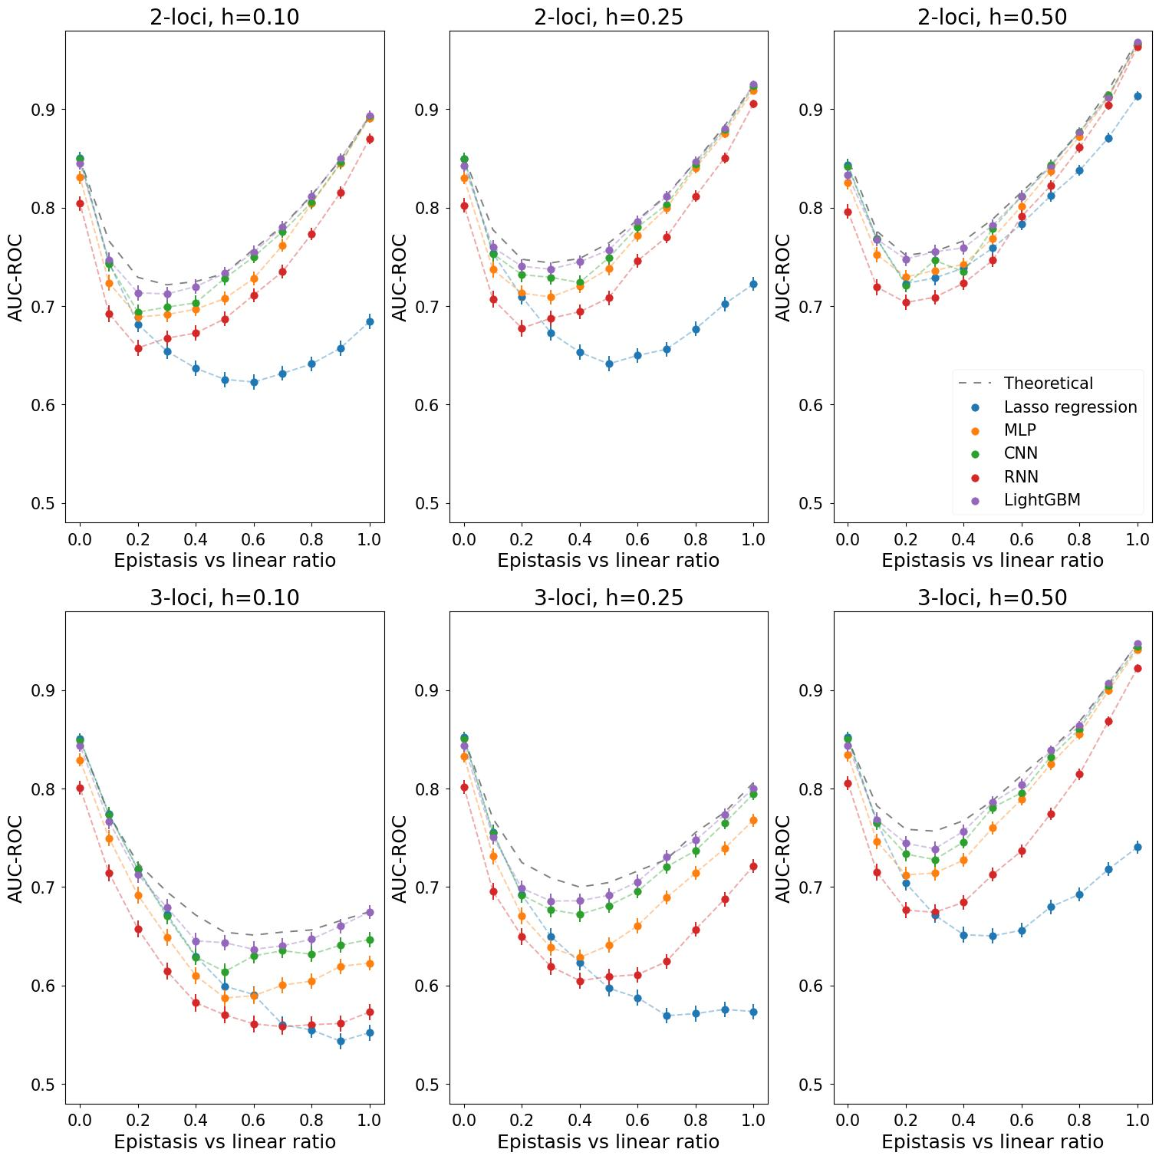
Supplemental Fig. 1. AUC-ROC values measured for different machine learning methods on simulated epistatic data. Simulation included 100,000 people with 100 SNPs, providing feature-to-instance ratio of 1:1,000. Each value on the abscissa axis corresponds to a phenotype with a certain contribution of epistasis (coefficient α). For each AUC-ROC value, the boundaries of the 95% confidence interval are indicated. Each figure corresponds to one of the epistasis models: 2- or 3-locus model with heritability equal to 0.1, 0.25 or 0.5.

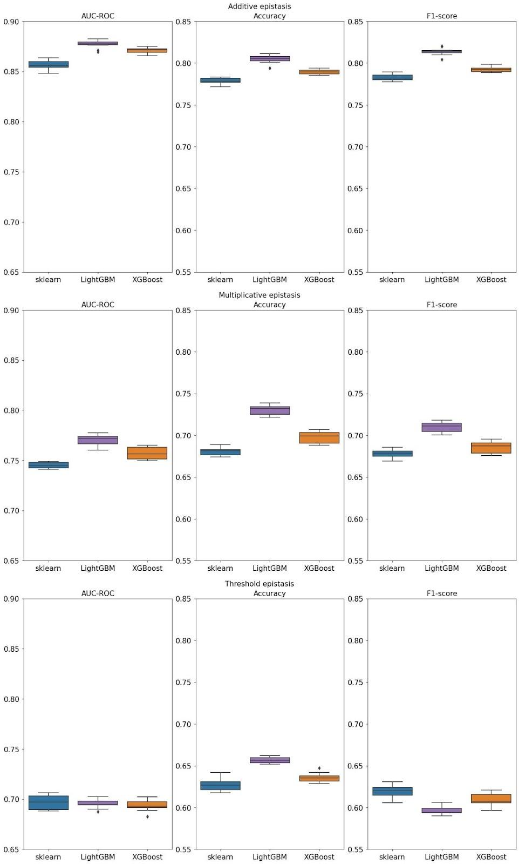Supplemental Fig. 2. Performance comparison of three variants of gradient boosting that were tested in this study: gradient boosting from sklearn library, LightGBM and XGBoost. Data corresponds to three types of simulated epistasis: additive, multiplicative and threshold.
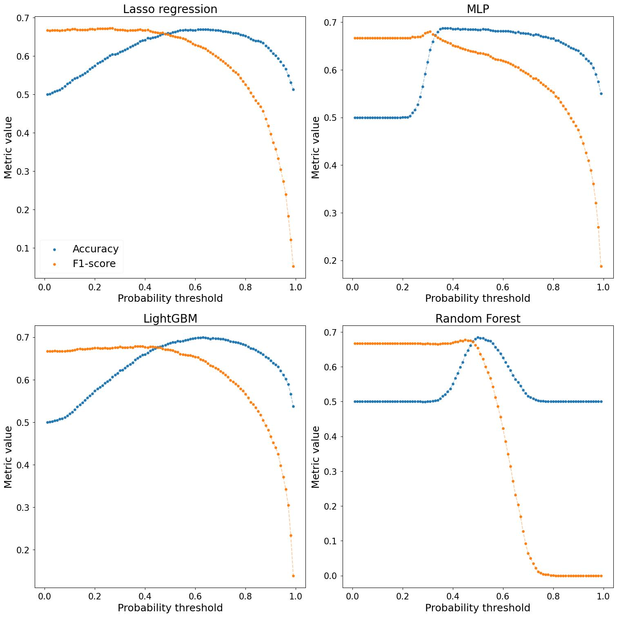
Supplemental Fig. 3. Metrics trade-off for different machine leering models on simulated dataset representing multiplicative epistasis. The X-axis indicates the values by which the result of model prediction is attributed to a disease.

