Supplementary Information
Microenvironment Regulation Breaks the Trade-Off between the Faradaic Efficiency and the Current Density for Electrocatalytic Deuteration Using D₂O
He et al.

Contents
Supplementary Fig. 1 Representative examples of drug molecules containing the aryl ethylamine backbones.
Supplementary Fig. 2 Time‒temperature/energy curve in AIMD.
Supplementary Fig. 3 The transport of 1a in solution without (a) and with BTAB (b).
Supplementary Fig. 4 Simulation calculations of nanotips.
Supplementary Fig. 5 Linear sweep voltammetry (LSV) curves of the Cu NTs and CuO NTs at a scan rate of 5 mV s⁻¹ in 0.5 M K₂CO₃ solution.
Supplementary Fig. 6 Synthesis and characterization of the Cu NTs.
Supplementary Fig. 7 Characterization of the Cu NTs.
Supplementary Fig. 8 Standard calibration curves for quantitative analysis of the model reaction with dodecane as an internal standard.
Supplementary Fig. 9 Structures of different quaternary ammonium surfactants.
Supplementary Fig. 10 Electrochemical performance of 2a under different conditions.
Supplementary Fig. 11 SEM and TEM images of Cu NRs and Cu NSs.
Supplementary Fig. 12 Active site tests of different Cu nanocatalysts.
Supplementary Fig. 13 Schematic illustration of the flow reactor used for the electrochemical deuteration of 1a using D₂O.
Supplementary Fig. 14 Characterization of the Cu NTs after the deuteration reaction.
Supplementary Fig. 15 In situ ATR-SEIRAS under various bias potentials.
Supplementary Fig. 16 Peak areas of the ATR-SEIRAS spectra under various bias potentials for the systems with and without BTAB.
Supplementary Fig. 17 In situ ATR-FTIR spectra under various bias potentials for the system with or without BTAB.
Supplementary Fig. 18 Contact angle test of Cu NTs with and without BTAB.
Supplementary Fig. 19 Interfacial properties from EIS.
Supplementary Fig. 20 Equivalent circuit diagram.
Supplementary Fig. 21 LSV curves of Cu NTs in 0.5 M D₂O solution of K₂CO₃ with and without BTAB.
Supplementary Fig. 22 CV curves of Cu NTs with 1a at a scan rate of 3 mV s⁻¹ in Diox/0.5 M K₂CO₃ with or without BTAB.
Supplementary Fig. 23 Interfacial properties from EIS.
Supplementary Fig. 24 Interfacial properties from EIS.
Supplementary Fig. 25 LSV curves of Cu NSs, NRs and NTs with 1a for activation energy analyses.
Supplementary Fig. 26 In situ Raman spectra of a mixed solution of Diox/0.5 M K₂CO_{3.}
Supplementary Fig. 27 Free-energy diagram for electrocatalytic hydrogenation of 1a over the Cu NTs.
Supplementary Fig. 28 EPR and HRMS tests.
Supplementary Fig. 29 H/D exchange experiment.
Supplementary Fig. 30 Comparison of methods for the synthesis of α,β-DAEPAs.
Supplementary Fig. 31 Electrochemical deuteration of different types of organics on different Cu electrocatalysts in D₂O.
Supplementary Fig. 32 Electrohydrogenation of 1a in a mixed solution of Diox and 0.5 M K₂CO₃ in H₂O (2:5 v/v, 7 mL) over Cu NTs with and without BTAB.
Supplementary Fig. 33 Comparison of electrocatalytic hydrogenation using H₂O and deuteration using D₂O of 1a over Cu NTs.
Supplementary Table 1-3.
Supplementary Notes 1-26.
NMR spectra.
Supplementary References (1-20).
Supplementary Figures and Notes
Supplementary Fig. 1 Representative examples of drug molecules containing aryl ethylamine backbones.

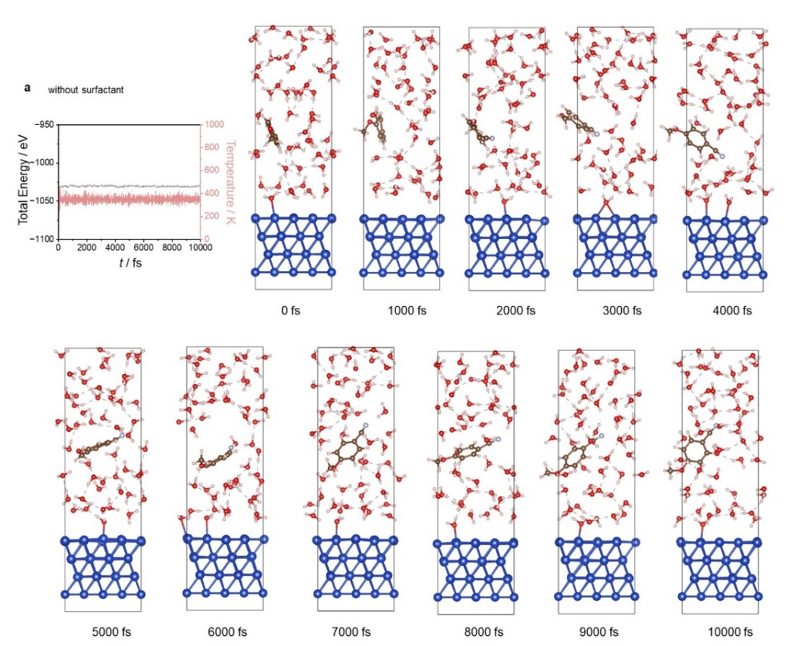
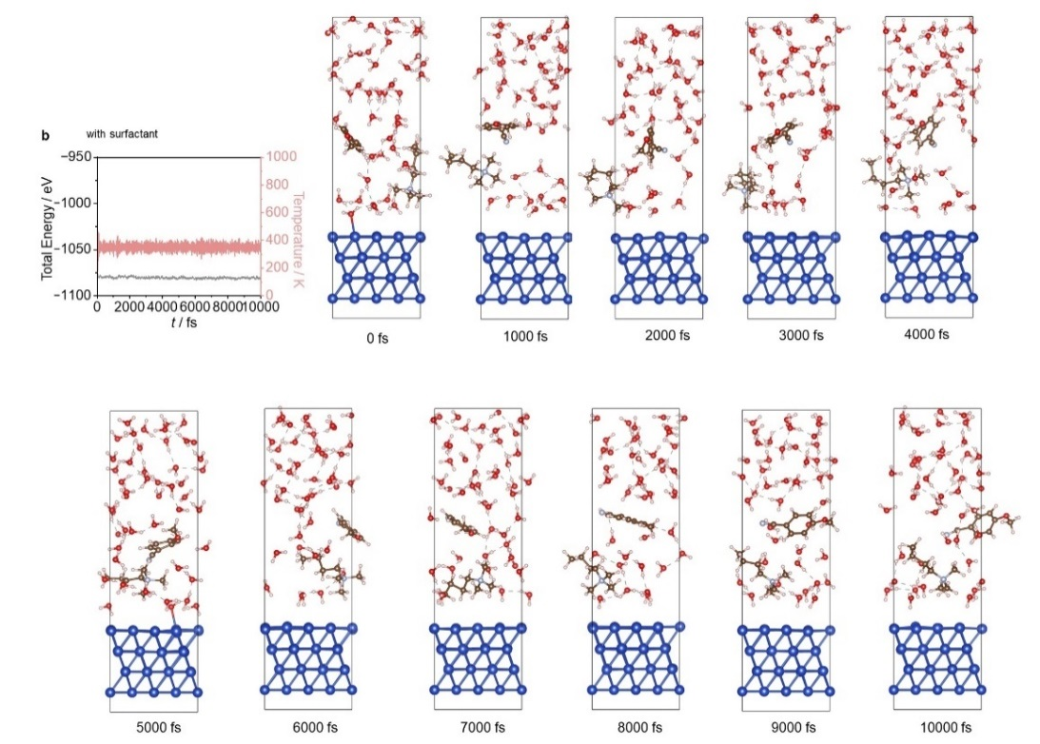
Supplementary Fig. 2 Time‒temperature/energy curve in AIMD.
Supplementary Note 1 To compare the effects of BTAB on the catalytic interface, (H₂O)₄ clusters were replaced by BTAB molecules. Although the number of H atoms and hydrogen bonds increased in the initial state, after 10000 fs of AIMD simulation, the hydrogen bonds between the H of the CH₃ group and H₂O are difficult to form, leading to the breakdown of the hydrogen bond network at the interface and a decrease in the number of hydrogen bonds.
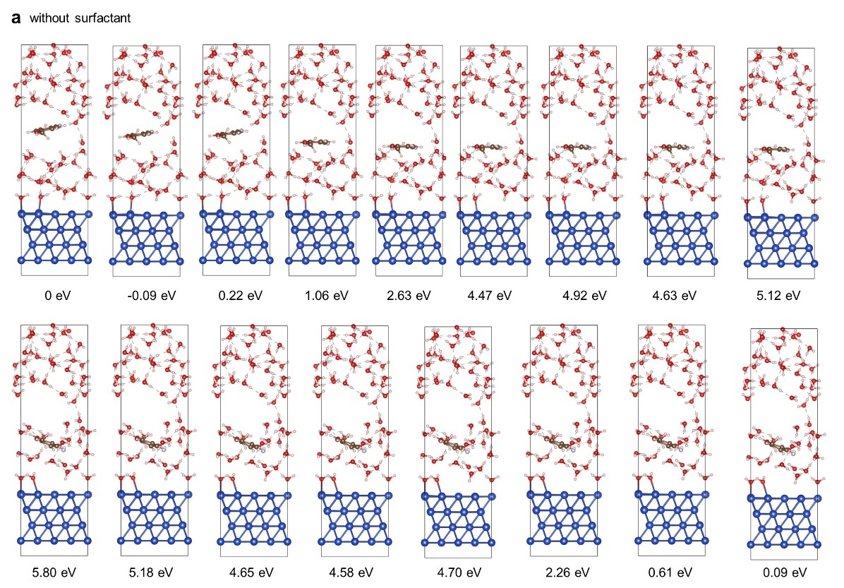
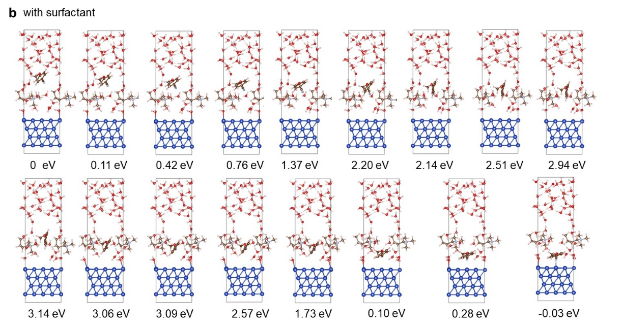
Supplementary Fig. 3 The transport of 1a in solution without (a) and with BTAB (b).
Supplementary Note 2 The AIMD simulation results revealed that the migration energy barrier of 1a molecules is reduced, and the migration rate is accelerated due to the disruption of the hydrogen bonding network by the BTAB molecules. This is favorable for the transfer of 1a to the electrode surface, thus enhancing the deuteration process.

Supplementary Fig. 4 Simulation calculations of nanotips. (a) Electrostatic field on the surface of Cu materials with different tip radii: 50 nm (left) and 5 nm (right). (b) Diagram of the atomic model of the nanotip structure.
Supplementary Note 3 For the nanotip structure formed by fcc metals such as Cu, the curvature of the needle-point leads to a large number of fine crystalline planes converging at the tips, and a large number of crystal prisms are formed. Due to the inherent nature of fcc, its (111) and (001) crystal planes are the crystal planes with the lowest surface energy, and its pinpoint structure is composed of a large number of (111) and (001) crystal planes, as shown in Fig. S4b. The blue atoms represent the (111) crystal planes, the yellow atoms represent the (001) crystal planes, and the red atoms represent the crystal prism sites.

Supplementary Fig. 5 Linear sweep voltammetry (LSV) curves of the Cu NTs and CuO NTs at a scan rate of 5 mV s⁻¹ in 0.5 M K₂CO₃ solution.
Supplementary Note 4 The thorough disappearance of the cathodic peaks corresponding to Cu(II) and Cu(I) in the LSV curves revealed the successful conversion of CuO to Cu NTs.
Supplementary Fig. 6 Synthesis and characterization of the Cu NTs. (a) The synthesis of self-supported Cu NTs via an electroreduction strategy. (b) TEM image of Cu NTs. (c) XRD patterns of CuO NTs and Cu NTs. (d) Cu 2p XPS spectra of CuO and Cu NTs. (e) In situ Raman spectra of the Cu NTs collected at −1.0 V in 0.5 M K₂CO₃.
Supplementary Note 5 The X-ray diffraction (XRD) pattern indicates that all the peaks of the electroreduced sample can be indexed to pure metallic Cu (JCPDS No. 04-0836). The peaks in the X-ray photoelectron spectroscopy (XPS) spectra located at 951.5 eV and 931.8 eV belong to Cu⁰ 2p_{1/2} and Cu⁰ 2p_{3/2}, respectively. In situ Raman spectroscopy revealed the electrochemical reduction conversion process of CuO→Cu₂O→Cu.

Supplementary Fig. 7 Characterization of the Cu NTs. (a) Cu K-edge XANES spectra. (b) 2D contour plots of the WT and (c) Fourier transform (FT) to R-space to isolate the EXAFS contributions from each coordination shell. (d) The χ(k) data are weighted by k³. The quantified fitting results are shown in Table S1.
Supplementary Note 6 To determine the electronic structure and coordination environment of the Cu NTs, X-ray absorption near-edge structure (XANES) and extended X-ray absorption fine structure (EXAFS) data were examined. The absorption edge position of the Cu NTs is located between that of the CuO NTs and the Cu foil (Supplementary Fig. 7a), indicating a higher valence state of the Cu NTs owing to the presence of low-coordination sites. The EXAFS spectra were subjected to continuous Cauchy Wavelet Transform (WT), and similar spectra for the Cu NTs and Cu foil further indicate the complete transformation of CuO to Cu (Supplementary Fig. 7b). The Fourier transformed k³-weighted Cu-K edge EXAFS spectra reveal the new appearance of the Cu−Cu path in the reduced sample (approximately 2.23 Å), while the average Cu−Cu coordination shell of the Cu NTs is much shorter than that of the Cu foil (Fig. 3b). The Fourier transform of the Cu K-edge in the R space plot was fitted with the least-squares method to precisely determine the average coordination number (CN). The fitting results (Supplementary Figs. 7c-d and Supplementary Table 1) show that the Cu−Cu CN of the Cu NTs is 7.3, which is much smaller than that of the Cu foil (CN = 12). The above results indicate the successful preparation of Cu NTs via electroreduction of CuO NTs.

Supplementary Fig. 8 Standard calibration curves for quantitative analysis of the model reaction with dodecane as an internal standard. (a) The reactant p-methoxyphenylacetonitrile, (b) the hydrogenated product p-methoxyphenethylamine.

Tetramethylammonium bromide (TMAB)
Butyl trimethyl ammonium bromide (BTAB)
Octyl trimethyl ammonium bromide (OTAB)
Supplementary Fig. 9 Structures of different quaternary ammonium surfactants (TMAB, BTAB, OTAB).
Supplementary Fig. 10 Electrochemical performance of 2a under different conditions. (a) Chronopentiometric curves of the electrochemical deuteration of 1a without surfactant and with different surfactants over Cu NTs at −100 mA cm⁻². (b) FEs and yield rates of 2a under various concentrations of BTAB at −100 mA cm⁻².

Supplementary Fig. 11 SEM and TEM images of Cu NRs and Cu NSs. SEM (left) and TEM (right) images of (a) Cu NRs and (b) Cu NSs.

Supplementary Fig. 12 Active site tests of different Cu nanocatalysts. CV curves of (a) Cu NTs, (b) Cu NRs, and (c) Cu NSs at scan rates 10 mV s⁻¹ in 0.5 M K₂CO₃ (D₂O).
Supplementary Note 7 Calculating the active sites by the redox peak area of a metal is a simple and convenient method.¹ Here, we measured the redox peak areas of the Cu NTs, NRs and NSs and calculated the number of active sites in the three samples (Supplementary Figs. 12a-c). To verify the intrinsic activity of the catalysts, the performances of the three Cu materials were normalized to the number of active sites.
The calculated area of active sites of Cu NTs, Cu NRs, and Cu NRs is 0.4325 × 1018 s, 1.2958 × 1018 s, and 1.8089 × 1018 s, respectively.

Supplementary Fig. 13 Schematic illustration of the flow reactor used for the electrochemical deuteration of 1a using D₂O.

Supplementary Fig. 14 Characterization of the Cu NTs after the deuteration reaction. (a) TEM image and (b) XRD pattern of the Cu NTs.
Supplementary Note 8 TEM images show that the tip structure of the Cu NTs maintains well and all the diffraction peaks in the XRD pattern can be indexed to the (111), (200), and (220) lattice planes of Cu (JCPDS No. 04-0836), revealing the good stability of the Cu NTs.

Supplementary Fig. 15 In situ ATR-SEIRAS under various bias potentials (a) with and (b) without Cu NTs. (c) XPS spectra after the Cu NTs were treaded with and without BTAB.
Supplementary Note 9 To exclude interactions between Au and the BTAB surfactant, we carried out ATR-FTIR experiments without loading Cu NTs under other identified conditions. As shown in Supplementary Fig. 15b, no obvious signal was observed under various bias potentials. This indicates that the observed signal in Supplementary Fig.15a is ascribed to the interaction between BTAB and Cu rather than Au.

Supplementary Fig. 16 Peak areas of the ATR-SEIRAS spectra under various bias potentials for the systems with and without BTAB.
Supplementary Note 10 The results show that the fitted peak area of D₂O increases even less after BTAB is added to the electrolyte. This demonstrates that there is less amount of D₂O near the electrode surface, benefiting the suppression of DER.

Supplementary Fig. 17 In situ ATR-FTIR spectra under various bias potentials for the system with or without BTAB.
Supplementary Note 11 The results show that after adopting a more negative potential of −1.4 V, we observe a smaller redshift of the ν_{O−D} mode (2478 vs. 2445 cm⁻¹) when BTAB was added to the electrolyte.

Supplementary Fig. 18 Contact angle test of Cu NTs with and without BTAB.

Supplementary Fig. 19 Interfacial properties from EIS. Comparison of (a) Nyquist plots and (b) Bode plots for the DER process with and without 0.1 mM BTAB over the Cu NTs at −1.15 V.

Supplementary Fig. 20 Equivalent circuit diagram. The equivalent circuit of all the systems.
Supplementary Note 12 ZView2 software was used to examine the data using the circuit shown above, where R_{s} is the solution resistance and R_{ct} is the charge transfer resistance. Constant-Phase Elements, or CPEs.

Supplementary Fig. 21 LSV curves of Cu NTs in 0.5 M D₂O solution of K₂CO₃ with and without BTAB.
Supplementary Note 13 A remarkable increase in the onset potential and a more negative potential are also needed to achieve a current density of −10 mA cm⁻² over Cu NTs after adding BTAB to the electrolyte, implying poor activity for D₂ formation.

Supplementary Fig. 22 CV curves of Cu NTs with 1a at a scan rate of 3 mV s⁻¹ in Diox/0.5 M K₂CO₃ with or without BTAB.
Supplementary Note 13 The reduction peak of 1a was larger with BTAB than that with BTAB, suggesting that more 1a was present near the electrode surface. The increased concentration of 1a may be ascribed to the breaking of the hydrogen bonding networks between D₂O molecules by BTAB, thus accelerating 1a migration to the electrode surface.

Supplementary Fig. 23 Interfacial properties from EIS. Comparison of (a) Nyquist plots and (b) Bode plots for the deuteration of 1a with and without 0.1 mM BTAB over the Cu NTs at −1.15 V.

Supplementary Fig. 24 Interfacial properties from EIS. EIS Nyquist plots at −1.3 V for the Cu NTs, Cu NRs and Cu NSs.

Supplementary Fig. 25 LSV curves of Cu NSs, NRs and NTs with 1a for activation energy analyses. Polarization curves of (a) Cu NSs, (b) Cu NRs and (c) Cu NTs in a 0.5 M K₂CO₃ aqueous electrolyte with BTAB at 10-25 °C.

Supplementary Fig. 26 In situ Raman spectra of a mixed solution of Diox/0.5 M K₂CO₃ with BTAB for the electrocatalytic deuteration of 1a over Cu NTs at −1.3 V.

Supplementary Fig. 27 Free-energy diagram for electrocatalytic hydrogenation of 1a over the Cu NTs.
Supplementary Note 14 According to our proposed mechanism, the process of 1a hydrogenation is simulated. The much lower hydrogenation barrier of imine than that of 1a implies easier hydrogenation.

Supplementary Fig. 28 EPR and HRMS tests. (a) EPR experiments for trapping deuterium (*) and carbon (#) radicals during the electrochemical experiments over Cu NTs. (b) HR-MS analysis of the spin-trapping experiment of deuterium radical.
Supplementary Fig. 29 H/D exchange experiment. The α-C−H to α-C−D exchange of 0.1 mmol of 1a is very quick and complete with the assistance of K₂CO₃ in D₂O.

Supplementary Fig. 30 Comparison of methods for the synthesis of α,β-DAEPAs. The structures of (a) the first approved deuterated drug, Austedo, and (b) the synthesized d₄-tetrabenazine in our work. (c) Typical methods and (d) our one-pot deuteration strategy for the synthesis of α,β-DAEPAs.
Supplementary Note 15 A comparison of the synthesis of α,β-deuterated arylethyl primary amines between the reported methods and ours is provided
(1) “Two-pot” in refs. and “one-pot” in our manuscript. Typically, two-pot reaction systems are adopted to synthesize α,β-deuterated arylethyl primary amines via H/D exchange of aryl acetonitrile followed by reductive deuteration of the nitrile group (C≡N) in different reactors.²⁻⁴ The requirement for such two-pot procedures may be due to the poor compatibility of the reaction conditions for the formation and subsequent deuteration of α-deuterio aryl acetonitrile for one-pot synthesis.
(2) “Expensive deuterated sources (e.g., NaBD₄, LiAlD₄, D₂)” in refs. and “inexpensive and safe D₂O” in our manuscript. Despite their dominance, expensive deuterated sources (e.g., NaBD₄, LiAlD₄, D₂) and strictly controlled anhydrous conditions are often needed. Moreover, the purification of α-deuterio aryl acetonitrile is always labor-consuming and time-consuming. These intrinsic factors cause operating complexities, safety risks, and environmental issues, restricting their practical application.
Supplementary Fig. 31 Electrochemical deuteration of different types of organics on different Cu electrocatalysts in D₂O.
Supplementary Note 16 The active site-normalized yields of different deuteration reactions over Cu NTs, Cu NRs, and Cu NSs. High yields of different deuteration reactions are obtained by using Cu NTs, suggesting good methodology generality.

Supplementary Fig. 32 Electrohydrogenation of 1a in a mixed solution of Diox and 0.5 M K₂CO₃ in H₂O (2:5 v/v, 7 mL) over Cu NTs with and without BTAB.
Supplementary Note 17 As shown in Supplementary Fig. 32a, the combined system can also promote the electrocatalytic hydrogenation of 1a at −100 mA cm⁻². The FE and yield rate obviously increase after the addition of BTAB. Additionally, benefiting from the combination of nanotip structure and surfactant, the highest turnover frequency (TOF) values are obtained under standard reaction conditions (Supplementary Fig. 32b). These results further demonstrate that promoting the mass transfer and establishing a hydrophobic interface microenvironment to inhibit the HER is also effective at improving the FE of hydrogenation reactions at high current densities.

Supplementary Fig. 33 Comparison of electrocatalytic hydrogenation using H₂O and deuteration using D₂O of 1a over Cu NTs. (a) Linear sweep voltammetry (LSV) curves of the Cu NTs cathode were recorded in 0.5 M K₂CO₃ in H₂O and D₂O at a scan rate of 10 mVs⁻¹. (b) Potential-dependent yield and FE of 4-methoxyphenethylamine over LC-Cu NTs obtained by using H₂O. (c) Potential-dependent yield and FE of 2a over LC-Cu NTs by using D₂O. (d) Comparison of FEs and yield rates of 4-methoxyphenethylamine obtained by using H₂O or D₂O at −100 mA cm⁻².
Supplementary Note 18 The slower kinetics of D* generation than of H* generation will lead to differences in the overpotential, activity, selectivity, FE, and reaction rate between deuteration reactions and hydrogenation reactions using H₂O. We have carried out several experiments to obtain a better understanding of the results. Linear sweep voltammetry (LSV) curves (Supplementary Fig. 33a) revealed that the overpotential of the hydrogen evolution reaction (HER) is much smaller than that of the DER for the same current density, such as the benchmark current density of −10 mA cm⁻², which implies sluggish kinetics of DER. In addition, potential-dependent experiments revealed optimal results at −1.15 V vs. Hg/HgO for the hydrogenation of 1a using H₂O (Supplementary Fig. 33b). In contrast, the deuteration of 1a using D₂O had the best performance when the potential reached −1.3 V vs. Hg/HgO (Supplementary Fig. 33c). Furthermore, the FE and yield rate of hydrogenation of 1a are greatly different from those of deuterated 1a under the same reaction conditions (Supplementary Fig. 33d).
Supplementary Table 1 EXAFS fitting parameters at the Cu K-edge for various samples (Ѕ₀² = 0.86)
Sample | Path | C.N. | R (Å) | σ² (Å²) | ΔE (eV) | R factor
Cu foil | Cu-Cu | 12* | 2.54±0.01 | 0.0087 | 4.4±0.6 | 0.0042
Cu NTs | Cu-O | 0.6±0.1 | 1.84±0.02 | 0.0036 | 3.1±1.0 | 0.0040
Cu NTs | Cu-Cu | 7.3±0.2 | 2.54±0.01 | 0.0090 | 3.1±1.0 | 0.0040
Cu NTs | Cu-O-Cu | 1.5±0.6 | 3.01±0.03 | 0.0130 | 3.1±1.0 | 0.0040
C.N.: coordination number; R: bond distance; σ²: Debye–Waller factor; ΔE: inner potential correction; R factor: goodness of fit. * Fitting with fixed parameters.
The k-range of 3-14 Å⁻¹ and R-range of 1-3 Å were used for the fitting of Cu foil; the k-range of 3-13 Å⁻¹ and R-range of 1-3 Å were used for the fitting of Cu NTs.

Supplementary Table 2 Simulated impedance parameters of the Nyquist plots over the Cu NTs electrode at −1.15 V.

Systems | R_{ct} (Ω) | CPE-T | CPE-P | R_{s} (Ω)
0.5 M K₂CO₃ | 7.227 | 0.030507 | 0.81347 | 1.443
0.5 M K₂CO₃+  BTAB | 28.62 | 0.040278 | 0.72931 | 0.72931
0.5 M K₂CO₃+  1a | 30.33 | 0.010981 | 0.73072 | 1.972
0.5 M K₂CO₃+  BTAB+1a | 10.63 | 0.017749 | 0.77940 | 1.685

Supplementary Table 3 Methodology universality.
Electrochemical deuteration of other functionalized AANs using D₂O over the Cu NTs with BTAB (isolated yields of the hydrochloride of deuterated primary amines are reported in parentheses, and deuterium ratios are presented in brackets).

Supplementary Note 19
Reagents and chemicals. All chemicals used in experiments are analytical pure and without further purification.
Synthesis of CuO nanorods (NRs). The self-supported CuO NRs were synthesized according to previous methods.⁵ First, commercial Cu foam was treated with acetone, 3.0 M HCl solution, and deionized water (DIW). Then, the cleaned copper foam was immersed in an aqueous solution containing 10 M NaOH (7.5 mL), 1 M (NH₄)₂S₂O₈ (3 mL), and DIW (19.5 mL) for 3 h at 0 °C. After that, the blue Cu(OH)₂ NRs/Cu foam was removed from the solution, washed with DIW and absolute ethanol, and dried at room temperature. Finally, the Cu(OH)₂ NR/Cu foam was put into a porcelain boat and heated through a 3-stage annealing process (2 h at 60 °C, 4 h at 120 °C, and 6 h at 180 °C) in an Ar environment to form the CuO NRs structure.
Synthesis of CuO nanosheets (NSs). The self-supported CuO NSs were synthesized according to the reported literature.⁶ The fully cleaned Cu foam was submerged in a solution containing 0.133 M (NH₄)₂S₂O₈ and 2.667 M NaOH for 4 h without interruption, followed by thermal annealing at 250 °C in air for 2 h to synthesize CuO NSs.
In situ electrochemical synthesis of Cu NRs and NSs. The Cu NRs and NSs were synthesized by a method similar to that used for the synthesis of Cu NTs. However, Cu NRs and NSs were obtained by electroreduction of CuO at −1.0 V vs. Hg/HgO for 45 min to ensure complete reduction.
Supplementary Note 20
Electrochemical measurements. The electrochemical deuterium measurements were carried out in a divided three-electrode electrochemical cell separated by a membrane. The as-prepared catalyst was used as the working electrode, a carbon rod was used as the counter electrode, and Hg/HgO was used as the reference electrode. A 0.5 M D₂O solution of K₂CO₃ (5.0 mL) was added to the cathodic and anodic cells. Then, a certain amount of surfactant solution and 0.4 mmol of reactants dissolved in 2.0 mL of Diox were added to the cathodic cell under stirring (600 rpm) to form a homogeneous solution, and chronoamperometry was carried out at −100 mA cm⁻². (All the potentials in this work were referred to as Hg/HgO without iR correction unless otherwise stated.) After the reaction was complete, 0.05 mmol of dodecane was added to the reaction mixture as an internal standard. Then, the solution at the cathodic cell was extracted with dichloromethane (DCM) and dried with anhydrous Na₂SO₄. The DCM was removed, and the products were tested by GC to calculate the yield of the amine products. In addition, the organic phase was treated with 3.0 M cyclopentyl methyl ether hydrochloric acid solution, and the precipitated solid product was filtered to calculate the isolated yields of the products, which were further subjected to NMR spectroscopy. The yield and FE, yield rate and TOF (2a as examples) were determined using dodecane as an internal standard and calculated using equations (1) - (4) below. The deuterated ratios of the products were determined by ¹H NMR according to equations (5) - (6).
$$\text{Yield} \text{(}\text{\%}\text{) = }\frac{\text{n}\text{ (obtained products)}}{\text{n}\text{ (theoretically formed products)}}\text{×100\% (1)}$$
$$\text{FE (\%) = }\frac{\text{4} \text{×} \text{n} \text{×} \text{96480}}{\text{Q}\text{ (actual values)}}\text{×100\% } \text{ (2)}$$
$$\text{Yield} \text{rate} \text{(\%)} \text{= }\frac{\text{n}\text{ (obtained products)}}{\text{t}\text{ (}\text{t}\text{ime required for }\text{the}\text{ reaction)}}\text{×100\% } \text{ (3)}$$
$$\text{TOF (}{\text{s}}^{\text{-}\text{1}}\text{) = }\frac{\text{The amount of produced am}\text{ine}\text{ molecules per s}\text{ite}}{\text{The amount of Cu sites}} \text{(4)}$$
$$\text{Deuterium incorporation at }\text{α}\text{-position (\%) }$$
$$\text{= 100\% – }\frac{\text{area (R-CH}\text{2}\text{-CD}\text{2}\text{-NH}\text{2}\text{·HCl)}}{\text{2}}\text{ × 100\% (5)}$$
$$\text{Deuterium incorporation at }\text{β}\text{-position (\%) }$$
$$\text{= 100\% –}\frac{\text{area (R-CD}\text{2}\text{-CH}\text{2}\text{-NH}\text{2}\text{·HCl)}}{\text{2}}\text{ × 100\% } \text{(}\text{6}\text{)}$$
The NMR spectra and data for the hydrochloride groups of the amine products are provided. When DMSO-d₆ was used as the solvent for the NMR tests, the peaks located at 2.5 ppm and 3.3 ppm in the ¹H NMR spectra were assigned to the hydrogen signals of d₆-DMSO and H₂O, respectively. Seven peaks centered at 39.52 ppm in the ¹³C NMR spectra were assigned to the carbon signals of DMSO-d₆. When using CDCl₃ as the solvent for NMR tests, the peak at 7.26 ppm in the ¹H NMR spectra was assigned to the hydrogen signal of CDCl₃. The three peaks centered at 77 ppm in the ¹³C NMR spectra were assigned to the carbon signals of CDCl₃. Additionally, some carbon atoms are missing in the ¹³C spectra of the deuterated products due to the presence of D, which is consistent with the reported literature.⁷⁻⁹

Supplementary Note 21
Electrochemical stability measurement in a flow cell. The electrochemical stability was measured in a typical flow cell that was separated by a Nafion 117 proton exchange membrane consisting of Cu NTs as the working electrode, CP as the counter electrode, and Hg/HgO as the reference electrode. 30 mL of a 0.5 M D₂O solution of K₂CO₃ was added to the anodic cell, and a mixed solution of 20 mL Diox and 15 mL 0.5 M D₂O solution of K₂CO₃ that contained 1.0 mM BTAB was added to the cathodic cell. 1a was added to the cathodic cell at 30-hour intervals (for a total of 1a). Chronoamperometry was carried out at −100 mA cm⁻². A peristaltic pump was used to achieve liquid-phase circulation, and the flow rate was 1 mL/min. Figure S13 shows a schematic diagram of the flow cell. The working electrode was held in the cathodic cell by conductive copper tape before performance testing.
Supplementary Note 22
Electrochemical in situ ATR-FTIR tests. Electrochemical in situ ATR-FTIR measurements were performed on a Linglu Instruments ECIR-II cell mounted on a Pike Veemax III ATR with a single bounce silicon crystal covered with an Au membrane in internal reflection mode. Spectra were recorded on a Thermo Nicolet Nexus 670 spectrometer. The electrolyte was degassed by bubbling N₂ for 20 min before the measurement.
Supplementary Note 23
EPR experiments for the electrochemical deuteration of nitriles. Electron paramagnetic resonance (EPR) measurements were performed in a divided three-electrode electrochemical cell by using the trapping agent 5,5-dimethyl-1-pyrroline-N-oxide (DMPO). After chronoamperometry was performed with and without 1a at −1.3 V for 10 min, 0.5 mL of reaction solution close to the working electrode was removed, and the solution was added to an ampoule bottle. Then, 0.1 mM DMPO was quickly added to the bottle, and the mixture was stirred to form a homogeneous solution. After that, the solution was removed for the EPR test.
Supplementary Note 24
XAS adsorption spectroscopy. X-ray absorption near-edge structure (XANES) and extended X-ray absorption fine structure (EXAFS) were used to determine the electronic structure and coordination environment of the Cu electrode. The Cu NT samples were ultrasonicated from the Cu foam and then loaded on the carbon paper substrate for synchrotron radiation tests using transmission mode.
Supplementary Note 25
The procedure for the gram-level synthesis of 2b. The gram-level synthesis of 2b was carried out by using a flow cell, as shown in Figure S13. The Cu NTs, CP, and Hg/HgO were used as the working electrode, counter electrode and reference electrode, respectively. For the synthesis of 2b, a mixed solution of Diox/0.5 M K₂CO₃ in D₂O (3:4 v/v, 35 mL) was used as the electrolyte, and then 1b was added to the electrolyte. The chronoamperometric measurements were carried out at −100 mA cm⁻² until the starting substrates vanished. After the reaction was complete, the solution was extracted with DCM. The DCM phase was dried over anhydrous sodium sulfate and removed under vacuum. The residue was analyzed by GC to determine the yield.
The synthetic procedure of d₄-tetrabenazine. Formic acid (1.38 mmol) was slowly added to the as-prepared 2b (1 mmol) in an ice bath, after which the pale yellow substance was heated to reflux (190 °C) until the reaction finished. After the solution was cooled, the yellow-colored reactant was diluted with toluene (2 mL). Then, 2 mmol of POCl₃ was added to the mixed solution, which was heated to reflux until the end of the reaction. Excess toluene and POCl₃ were removed by distillation, and the residue was washed with petroleum ether and dissolved in Diox. The solution was then poured into ice, and the resulting solution was washed with ether 3 times. The pH of the solution was adjusted to 12, and the solution was extracted with ether and dried over anhydrous sodium sulfate to give amber-colored oil. The amber oil was treated with 3.0 M cyclopentyl methyl ether hydrochloric acid solution, and the precipitated solid product was filtered. The crude product was mixed with acetone, and an equal amount of 3-(N,N-dimethylaminomethyl)-5-methyl-2-hexanone was added dropwise while stirring at room temperature. The precipitated solid was extracted and washed with water to obtain a light yellow crude product, which was purified by thin-layer chromatography (TLC) plates to give the pure product.^{10,11}
Supplementary Note 26
Finite element method simulations. Nernst‒Planck–Poisson (NPP) calculations of the Gouy–Chapman model were employed to elucidate the underlying mechanisms of charge transfer and storage, as well as of ion diffusion, governed by the Poisson equation and the Nernst–Plank equation¹²⁻¹⁴, where ε₀ is the permittivity of vacuum, ε_{r} is the relative permittivity of the medium, φ is the electrostatic potential, D_{i} is the diffusivity of chemical species i, C_{i} is the density of the species, z_{i} is the valency of the species, e is the elementary charge, k_{B} is Boltzmann’s constant, and T is the temperature. We used the ‘Electrostatics’ and ‘Transport of Diluted Species’ physics of COMSOL to obtain the electrochemical behavior of all the species. The tip radius of the structure in the panel is 5 nm. The thickness of the Helmholtz layer was taken as the radius of a hydrated potassium ion (0.33 nm),¹⁵ and the absolute temperature T was taken as 297.3 K. The diffusion coefficients D of the potassium ion and the hydroxide ion were taken to be 2.14 × 10⁻⁹ m² s⁻¹ and 5.30 × 10⁻⁹ m² s^{−1, respectively,} in water.¹⁶ This indicates a 600000-fold increase in the surface-adsorbed TMA⁺ ion concentration at the Cu needle tip due to a locally enhanced electrostatic field.
$$∇∙\left(ε_{0}ε_{r}∇φ\right)=-\sum_{i}{z_{i}eC_{i}}$$
$$\frac{∂C_{i}}{∂t}=∇∙\left[D_{i}∇C_{i}+\frac{D_{i}C_{i}}{k_{B}T}z_{i}e∇φ\right]$$
Computational details. All the DFT calculations were performed using the Vienna ab initio simulation package (VASP).¹⁷ The projector augmented wave (PAW)¹⁸ pseudopotential with the PBE¹⁹ generalized gradient approximation (GGA) exchange-correlation function was utilized in the computations. The cutoff energy of the plane wave basis set was 500 eV, and a Monkhorst-Pack mesh of 3 × 3 × 1 and 7 × 7 × 1 was used in K-sampling in the calculation of adsorption energy and density of states (DOS). The long-range dispersion interaction was described by the DFT-D3 method. The electrolyte was incorporated implicitly with the Poisson-Boltzmann model implemented in VASPsol.²⁰ The relative permittivity of the media was chosen as ϵr = 78.4, corresponding to that of water. All the structures were spin-polarized, all the atoms were fully relaxed with an energy convergence tolerance of 10⁻⁵ eV per atom, and the final force on each atom was < 0.05 eV Å⁻¹. The transition state (TS) searches were performed using the dimer method in the VTST package. The final force on each atom was < 0.05 eV Å⁻¹. The TS search was conducted by using the climbing-image nudged elastic band (CI-NEB) method to generate initial guess geometries, followed by the dimer method to converge to the saddle points.
In this work, facecentered cubic (fcc) phase copper (Cu) was used (a = b = c = 3.621 Å, α = β = γ = 90.000°, Fm-3m). The bulk model of the sample was built by a 4 × 4 supercell of Cu (111) with four layers of Cu. For the Cu model with low coordination, 3 Cu atoms need to be removed from the surface of the Cu (111) model. All periodic slabs have a vacuum layer of at least 15 Å. The adsorption energy of reaction intermediates can be computed using equations (7) - (8):
$$\text{∆}\text{E}\text{ = }{\text{E}}_{\text{(ads/slab)}}\text{ – }{\text{E}}_{\text{ads}}\text{ – }{\text{E}}_{\text{slab}}\text{ (7)}$$
$$\text{∆}\text{G}\text{ = ∆}\text{E}\text{ + }{\text{∆}\text{E}}_{\text{ZPE}}\text{ - }\text{T}\text{∆}\text{S}\text{ (8)}$$
where $\text{∆}{\text{E}}_{\text{ZPE}}$ is the zero-point energy change and $\text{∆}\text{S}$ is the entropy change. In this work, the values of $\text{∆}{\text{E}}_{\text{ZPE}}$and $\text{∆}\text{S}$ were obtained via vibration frequency calculations. The energy of the reaction can be calculated by the following fourteen equations (9) - (19):
*+H₂O——*H₂O | (9)
*H₂O+e⁻——*H+OH⁻ | (10)
*H+*H——*+H₂ | (11)
*+CH₃CN——*CH₃CN | (12)
*CH₃CH₂NH₂——*+ CH₃CH₂NH₂ | (13)
*+C₉H₉NO——*C₉H₉NO | (14)
*C₉H₉NO+H₂O+e⁻——*C₉H₉NHO+OH⁻ | (15)
*C₉H₉NHO+H₂O+e⁻——*C₉H₁₀NHO+OH⁻ | (16)
*C₉H₁₀NHO+H₂O+e⁻——*C₉H₁₀NH₂O+OH⁻ | (17)
*C₉H₁₀NH₂O+H₂O+e⁻——* C₉H₁₁NH₂O+OH⁻ | (18)
*C₉H₁₁NH₂O——*+ C₉H₁₁NH₂O | (19)

NMR spectra
¹H NMR (400 MHz, DMSO-d₆) δ [ppm] 8.20 (s, 2.28H), 7.16 (d, J = 8.0 Hz, 2H), 6.88 (d, J = 4.0 Hz, 2H), 3.72 (s, 3H), 2.92 (s, 0.09H); ¹³C NMR (101 MHz, DMSO-d₆) δ [ppm] 158.58, 129.70 (2C), 129.20, 114.03 (2C), 55.07.
¹H NMR (400 MHz, DMSO-d₆) δ [ppm] 8.20 (s, 2.37H), 6.87 (d, J = 8.0 Hz, 2H), 6.75 (d, J = 8.0, 1H), 3.74 (s, 3H), 3.71 (s, 3H), 3.13 (s, 0.01H), 2.95 (s, 0.08H); ¹³C NMR (101 MHz, DMSO-d₆) δ [ppm] 149.42, 148.25, 130.33, 121.18, 113.11, 112.59, 56.09 (2C).

¹H NMR (400 MHz, DMSO-d₆) δ [ppm] 11.01 (s, 0.79H), 8.18 (s, 2.11H), 7.55 (d, J = 4.0 Hz, 1H), 7.35 (d, J = 8.0 Hz, 1H), 7.22 (d, J = 4.0 Hz, 1H), 7.07 (t, J = 8.0 Hz, 1H), 6.98 (t, J = 8.0 Hz, 1H), 2.99 (s, 0.20H); ¹³C NMR (101 MHz, DMSO-d₆) δ [ppm] 136.95, 132.65, 127.46, 124.01, 121.81, 119.11, 118.73, 112.18.

¹H NMR (400 MHz, DMSO-d₆) δ [ppm] 8.50 (s, 2.08H), 7.43 (d, J = 4.0 Hz, 1H), 7.29-7.21 (m, 3H), 3.97 (s, 0.13H), 2.35 (s, 3H); ¹³C NMR (101 MHz, DMSO-d₆) δ [ppm] 137.31, 132.84, 130.90, 129.83, 129.09, 126.64, 19.42.

¹H NMR (400 MHz, DMSO-d₆) δ [ppm] 7.94 (s, 2.43H), 3.39 (t, J₁ = 4.0 Hz, J₂ = 12.0 Hz, 3H), 1.77 (t, J₁ = 8.0 Hz, J₂ = 4.0 Hz 0.39H), 1.51 – 1.45 (m, 2H), 1.35 – 1.28 (m, 2H), 0.87 (t, J = 8.0 Hz, 3H); ¹³C NMR (101 MHz, DMSO-d₆) δ [ppm] 69.95, 66.95, 31.44, 19.06, 13.99.

¹H NMR (400 MHz, DMSO-d₆) δ [ppm] 9.34 (s, 0.49H), 7.97 (s, 2.75H), 7.01 (d, J = 12.0 Hz, 2H), 6.70 (d, J = 8.0 Hz, 2H); ¹³C NMR (101 MHz, DMSO-d₆) δ [ppm] 156.31, 129.68 (2C), 127.30, 115.51 (2C).
¹H NMR (400 MHz, DMSO-d₆) δ [ppm] 8.20 (s, 2.20H), 7.38 (dd, J₁ = 28.0, J₂ = 8.0 Hz, 2H), 7.23 (dd, J₁ = 36.0, J₂ = 8.0 Hz, 2H), 1.26 (s, 9H); ¹³C NMR (101 MHz, DMSO-d₆) δ [ppm] 149.31, 134.65, 128.64, 128.15, 126.04, 125.66, 31.48, 31.50 (2C), 31.41.
¹H NMR (400 MHz, DMSO-d₆) δ [ppm] 8.15 (s, 2.6H), 7.14 (s, 4H), 2.94 (s, 0.15H), 2.28 (s, 3H); ¹³C NMR (101 MHz, DMSO-d₆) δ [ppm] 136.32, 134.83, 129.77 (2C), 129.12 (2C), 21.26.
¹H NMR (400 MHz, DMSO-d₆) δ [ppm] 8.10 (s, 2.79H), 7.33 (t, J = 8.0 Hz, 2H), 7.25 (t, J = 8.0 Hz, 3H), 2.98 (s, 0.15H); ¹³C NMR (101 MHz, DMSO-d₆) δ [ppm] 137.53, 128.85 (2C), 128.82 (2C), 126.92.
¹H NMR (400 MHz, DMSO-d₆) δ [ppm] 8.04 (s, 2.88H), 7.33 – 7.29 (m, 2H), 7.18 – 7.14 (m, 2H), 3.73 (s, 0.04H); ¹³C NMR (101 MHz, DMSO-d₆) δ [ppm] 161.19 (d, J = 243.41 Hz), 133.63, 130.64 (d, J = 8.08 Hz, 2C), 115.35 (d, J = 21.21 Hz, 2C).
¹H NMR (400 MHz, DMSO-d₆) δ [ppm] 8.07 (s, 2.90H), 7.39 (d, J = 12.0 Hz, 2H), 7.31 (d, J = 8.0 Hz, 2H); ¹³C NMR (101 MHz, DMSO-d₆) δ [ppm] 136.53, 131.60, 130.85 (2C), 128.72 (2C).

¹H NMR (400 MHz, DMSO-d₆) δ [ppm] 8.21 (s, 2.26H), 7.21 – 7.10 (m, 4H), 3.70 (s, 0.11H), 2.24 (s, 3H); ¹³C NMR (101 MHz, DMSO-d₆) δ [ppm] 136.48, 136.03, 130.79, 129.48, 127.22, 126.56, 19.29.

¹H NMR (400 MHz, DMSO-d₆) δ [ppm] 8.24 (s, 2.77H), 7.24 (t, J = 8.0 Hz, 1H), 7.17 (d, J = 4.0 Hz, 1H), 6.98 (d, J = 8.0 Hz, 2H), 6.90 (t, J₁ = 4.0 Hz, J₂ = 8.0 Hz, 1H), 3.82 (s, 3H), 2.93 (s, 0.16H); ¹³C NMR (101 MHz, DMSO-d₆) δ [ppm] 157.20, 129.98, 128.27, 125.09, 120.48, 110.82, 55.34.

¹H NMR (400 MHz, DMSO-d₆) δ [ppm] 8.30 (s, 2.41H), 6.80 (s, 2H), 2.88 (s, 0.17H), 2.25 (s, 6H), 2.17 (s, 3H); ¹³C NMR (101 MHz, DMSO-d₆) δ [ppm] 136.62 (2C), 135.69, 131.28, 129.16 (2C), 20.92, 19.78 (2C).

¹H NMR (400 MHz, DMSO-d₆) δ [ppm] 8.12 (s, 2.33H), 6.86 (d, J = 8.0 Hz, 2H), 6.71 (d, J = 8.0 Hz, 1H), 5.98 (s, 2H), 2.93 (s, 0.21H); ¹³C NMR (101 MHz, DMSO-d₆) δ [ppm] 147.78, 146.37, 131.39, 122.11, 109.47, 108.72, 101.21.

¹H NMR (400 MHz, CD₃CN-d₃) δ [ppm] 8.11 (s, 2.12H), 7.36 – 7.23 (m, 5H), 3.72 (s, 0.07H), 1.25 (s, 3H); ¹³C NMR (101 MHz, CD₃CN-d₃) δ [ppm] 143.33, 129.06 (2C), 127.54 (2C), 127.27, 19.58.

¹H NMR (400 MHz, DMSO-d₆) δ [ppm] 10.52 (s, 1.68H), 8.19 (s, 2H), 7.44 – 7.29 (m, 4H), 3.39 (s, 0.08H), 2.97 (s, 0.09H); ¹³C NMR (101 MHz, DMSO-d₆) δ [ppm] 137.96, 131.04, 130.52 (2C), 124.12 (2C).

¹H NMR (400 MHz, DMSO-d₆) δ [ppm] 8.54 (s, 1.91H), 7.59 (d, J = 8.0 Hz, 2H), 7.41 (d, J = 12.0 Hz, 2H), 3.98 (s, 0.32H); ¹³C NMR (101 MHz, DMSO-d₆) δ [ppm] 134.09, 131.02, 123.80 (2C), 114.47 (2C).
¹H NMR (400 MHz, DMSO-d₆) δ [ppm] 8.29 (s, 1.94H), 7.41 (d, J = 8.0 Hz, 2H), 7.30 (d, J = 8.0 Hz, 2H), 3.96, (s, 0.08H), 2.48 (s, 3H); ¹³C NMR (101 MHz, DMSO-d₆) δ [ppm] 138.97, 133.98, 129.83 (2C), 126.05 (2C), 14.81.

¹H NMR (400 MHz, CDCl₃) δ [ppm] 6.61 (d, J = 8.0 Hz, 1H), 6.55 (d, J = 4.0 Hz, 1H), 3.85 – 3.81 (m, 6H), 3.51 – 3.48, (m, 1H), 3.29 – 3.26 (m, 1H), 3.10 (s, 0.08H), 2.91 – 2.86 (m, 1H), 2.75 – 2.72 (m, 1H), 2.55 – 2.52 (m, 0.28H), 2.37 – 2.34 (m, 1H), 1.80-1.77 (m, 1H), 1.64 (s, 2H), 1.05-1.00 (m, 1H), 0.92 – 0.88 (m, 1H); ¹³C NMR (101 MHz, CDCl₃) δ [ppm] 210.40, 147.80, 128.89, 126.24, 111.80, 108.18, 62.70, 61.74, 56.27, 56.19, 47.87, 47.82, 35.35, 25.69, 23.48, 22.37.
Supporting References
- Andreiadis, E. S. et al. Molecular Engineering of a Cobalt-Based Electrocatalytic Nanomaterial for H₂ Evolution under Fully Aqueous Conditions. Nat. Chem. 5, 48-53 (2013).
- Xia, G.; Benmohamed, R.; Morimoto, R. I.; Kirsch, D. R.; Silverman, R. B. Deuteration and Fluorination of 1,3-Bis(2-Phenylethyl)Pyrimidine-2,4,6(1h,3h,5h)-Trione to Improve Its Pharmacokinetic Properties. Bioorg. Med. Chem. Lett. 24, 5098-5101 (2014).
- Tsukinoki, T. et al. Preparation of deuteriated benzylamines and phenethylamine with raney alloys in an alkaline deuterium oxide solution. J. Label. Comp. Radiopharm. 34, 839-844 (1994).
- Mándity, I. M.; Martinek, T. A.; Darvas, F.; Fülöp, F. A Simple, Efficient, and Selective Deuteration Via a Flow Chemistry Approach. Tetrahedron Lett. 50, 4372-4374 (2009).
- Pulagara, N.V., Kaur, G., and Lahiri, I. Enhanced field emission performance of growth-optimized CuO nanorods. Appl. Phys. A 127 (2021).
- Zhang, D. et al. Highly efficient electrochemical hydrogenation of acetonitrile to ethylamine for primary amine synthesis and promising hydrogen storage. Chem Catal. 1, 393-406 (2021).
- Wang, X. et al. General and practical potassium methoxide/disilane-mediated dehalogenative deuteration of (hetero)arylhalides. J. Am. Chem. Soc. 140, 10970-10974 (2018).
- Yu, R. P., Hesk, D., Rivera, N., Pelczer, I. & Chirik, P. J. Iron-catalysed tritiation of pharmaceuticals. Nature 529, 195-199 (2016).
- Loh, Y. Y. et al. Photoredox-catalyzed deuteration and tritiation of pharmaceutical compounds. Science 358, 1182-1187 (2017).
- Sumii, Y. et al. 3-(phenethylamino)demethyl(oxy)aaptamine as an anti-dormant mycobacterial substance: Isolation, evaluation and total synthesis. Tetrahedron Lett. 61 (2020).
- Yu, Q. S. et al. Preparation and characterization of tetrabenazine enantiomers against vesicular monoamine transporter 2. ACS Medicinal Chem. Lett. 1, 105-109 (2010).
- Fu, K., Han, D., Ma, C. & Bohn, P. W. Ion selective redox cycling in zero-dimensional nanopore electrode arrays at low ionic strength. Nanoscale 9, 5164-5171 (2017).
- Gao, F. Y. et al. High‐curvature transition‐metal chalcogenide nanostructures with a pronounced proximity effect enable fast and selective CO₂ electroreduction. Angew. Chem. Int. Ed. 59, 8706-8712 (2020).
- Xiong, G. et al. Bioinspired leaves-on-branchlet hybrid carbon nanostructure for supercapacitors. Nat. Commun. 9, 790 (2018).
- Nairan, A. et al. Proton selective adsorption on Pt–Ni nano-thorn array electrodes for superior hydrogen evolution activity. Energy Environ. Sci. 14, 1594-1601 (2021).
- Lee, S. H. & Rasaiah, J. C. Proton transfer and the mobilities of the H⁺ and OH⁻ ions from studies of a dissociating model for water. J. Chem. Phys. 135, 124505 (2011).
- Kresse, G. & Furthmüller, J. Efficient iterative schemes for ab initio total-energy calculations using a plane-wave basis set. Phys. Rev. B 54, 11169-11186 (1996).
- Blochl, P. E. Projector augmented-wave method. Phys. Rev., B Condens. Matter 50, 17953-17979 (1994).
- Perdew, J. P., Burke, K. & Ernzerhof, M. Generalized gradient approximation made simple. Phys. Rev. Lett. 77, 3865-3868 (1996).
- Mathew, K., Sundararaman, R., Letchworth-Weaver, K., Arias, T. A. & Hennig, R. G. Implicit solvation model for density-functional study of nanocrystal surfaces and reaction pathways. J. Chem. Phys. 140, 084106 (2014).

