CTAB-assisted AgBr -bismuth oxybromide based novel SERS substrate for label-free, non-invasivequantitative detection of detrimental synthetic food colorants
Arti Saroj1, Venkatnarayan Ramanathan1*
1 Department of Chemistry, Indian Institute of Technology (BHU) Varanasi 221005, Uttar Pradesh, India
*author to whom correspondence must be addressed at vraman.chy@iitbhu.ac.in

Supporting Information

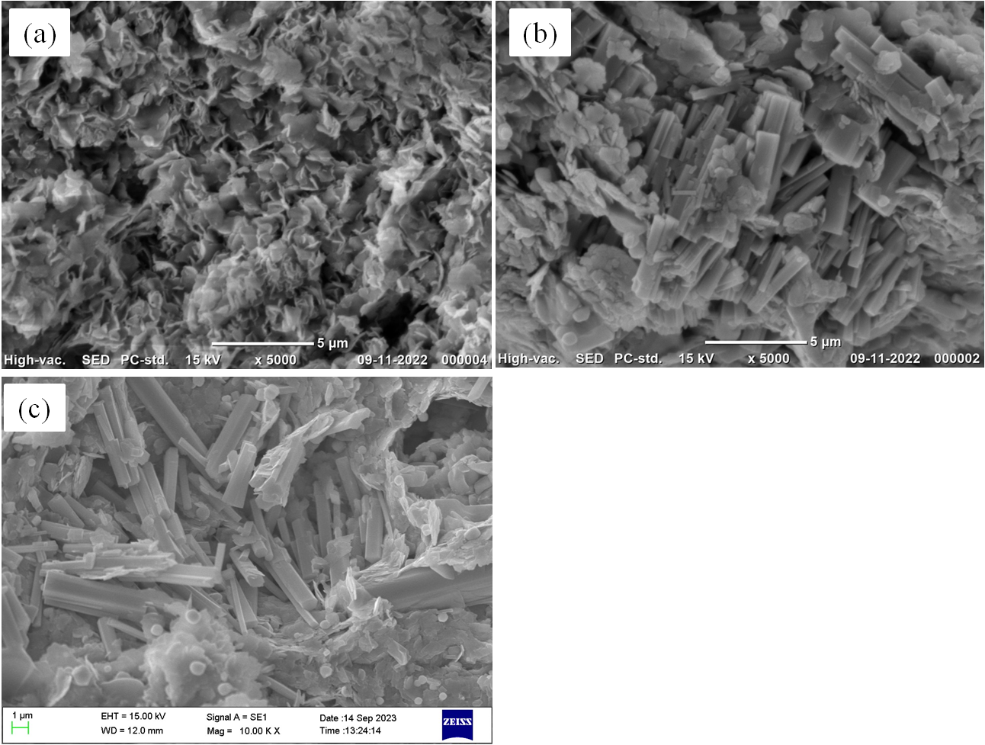
Figure S1. BT-SEM image of (a) BOB (b) Ag_{0.09}BOB (c) Ag_{0.15}BOB

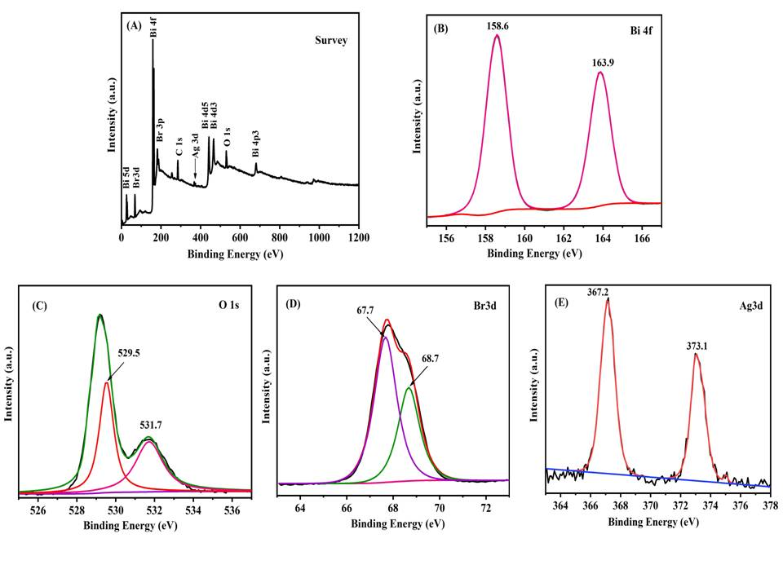
Figure S2 XPS spectrum of Ag_{0.15}BOB(CTAB- AgBr- Bi₃O₄Br/BiOBr) (A) survey spectrum and high resolution spectrum for (B) Bi 4f, (C) O 1s, (D) Br 3d, (E) Ag 3d.
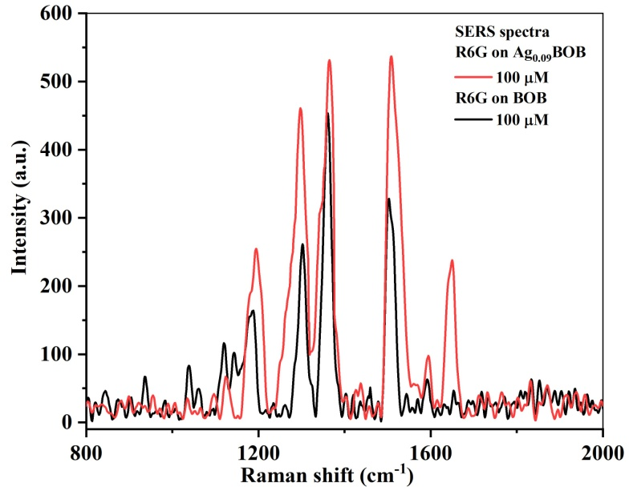
Figure S3 SERS spectra of 100 µM ethanolic solution of R6G on BOB and Ag_{0.09}BOB.
Table ST1. Tentative assignment for the vibrational Raman modes of Rhodamin 6G, Allura red, Amaranth, Tartrazine and Sunset yellow.
Analytes | Raman Peak ( cm⁻¹) | Tentative Assignment
Rhodamin 6G | 607  768  1117/1179  1302  1360/1504/1593/1644 | ipδ(C-C-C) ring  op δ(C-H)  ip δ(C-H)  ipδ(N-H)  ν (C-C) (36, 37)
Allura red | 751  974  1129/1578  1188  1223  1266  1383/1496  1407  1604 | ω(R₁)  ω(C-H)R₂  ν_{as}(R₁)  ν_{as}(SO₂)  ρ (C-H- R₁)  ν(O-C- R₁)  ω(C-H)  ρ (C-H)  ν_{as}( R₂)(15)
Amaranth | 738  1052  1138/1175  1231  1363  1405/1434  1478  1572 | ρ(C-H)  ν_{as} (SO₂)  ω(C-H)  ω(O-S)  ν(C-C)  ω(C-H)  ν (N-N)  ν_{as} (ring)(38-39)
Tartrazine | 623  802  1044  1132  1177  1217  1361  1414  1499  1597 | def(R1)  ν(C-O)  op (C – H); def. (R2)  op def(C-H-R1); δ(R1)  τ(R1)  ν(R1)  ν(C-N=N-C); νs(COO);wagg(R1)  ν(R1)  δ(R1); δ(C=C)  δ(R1);ipdef(C-H-R1); δ(O-H); νs(COO) (40)
Sunset yellow | 986  1123  1178  1231  1336  1384  1496  1545  1594 | ω(C-H-R₂)  ν (N=N); ω(C-H- R₁)  ν (N=N); ρ(C-H-R₁); ρ(R₁)  δ(C-C-R₁); ν (C-N); ν (C-C- R₂);  ν (C-N); ν_{as}(H-C-C-H-R₁); ρ(R₁)  ν_{s}(C-C-R₂);ip δ(R₁,R₂)  ν (C-N); ν (C-O); ρ(N-H)  δ(C-C-R₂); ρ(N-H); ρ(C-H)  ν_{s}(C-C-R₁); ω(C-H-R₁) (16)
ν=stretching; δ=bending; ρ=rocking; τ=twisting; ω=wagging; s=symmetric; as=asymmetric; def=deformation;ip=in-plane; op=out-plane; R₁=benzene ring;R₂ =naphthalene ring

Table ST2: Comparison of the detection limits foranalytes with the previous report on different SERS substrates
Substrate | Analytes | LOD (M) | Ref
Bi thin films  Au−BiOI  Ag/BR/Ag NPs  Gold nanodumbells  Ag_{0.15} BOB | R6G  R6G  TR  SY  R6G  TR  SY | 1× 10⁻²M  0.5 × 10⁻⁵M  2.1 × 10⁻⁵ M  1.1 × 10⁻⁵ M  1.0 × 10⁻⁵M  4.0 × 10⁻⁵M  4.0 × 10⁻⁵M | (21)  (26)  (*)  (**)  This work

References
* Liu, H. et al. based sandwich type SERS sensor based on silver nanoparticles and biomimetic recognizer. Sensors Actuators B Chem.2020, 313, 127989.
** Meng, J.; Qin, S.; Zhang, L.; Yang, L. Designing of a novel gold nanodumbbells SERS substrate for detection of prohibited colorants in drinks. Appl. Surf. Sci. 2016, 366, 181–186.

