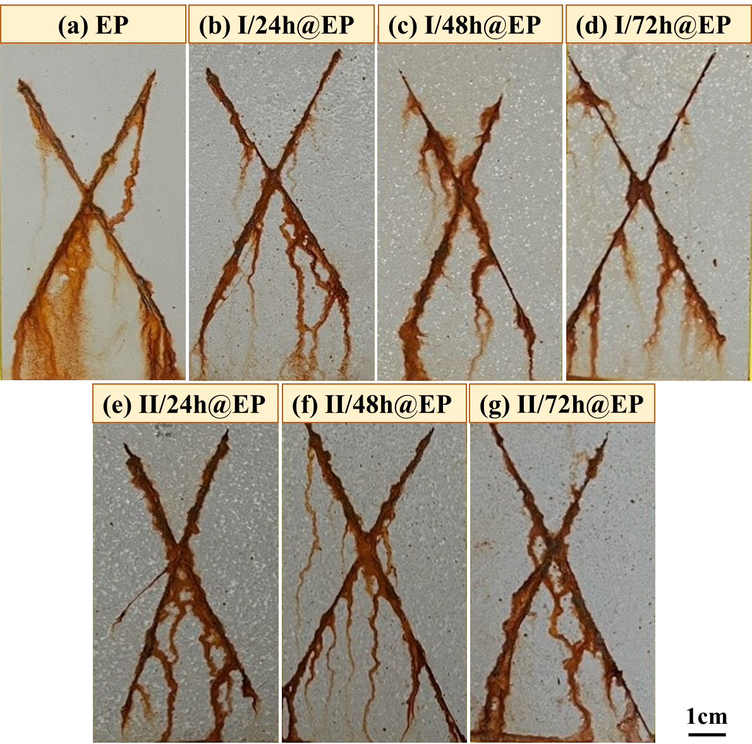
Fig. S1 Digital images of (a) EP, (b) rGO-SiO₂-I/24h@EP, (c) rGO-SiO₂-I/48h@EP, (c) rGO-SiO₂-I/72h@EP, (e) rGO-SiO₂-II/24h@EP, (f) rGO-SiO₂-II/48h@EP and (g) rGO-SiO₂-II/72h@EP coatings after salt spray test
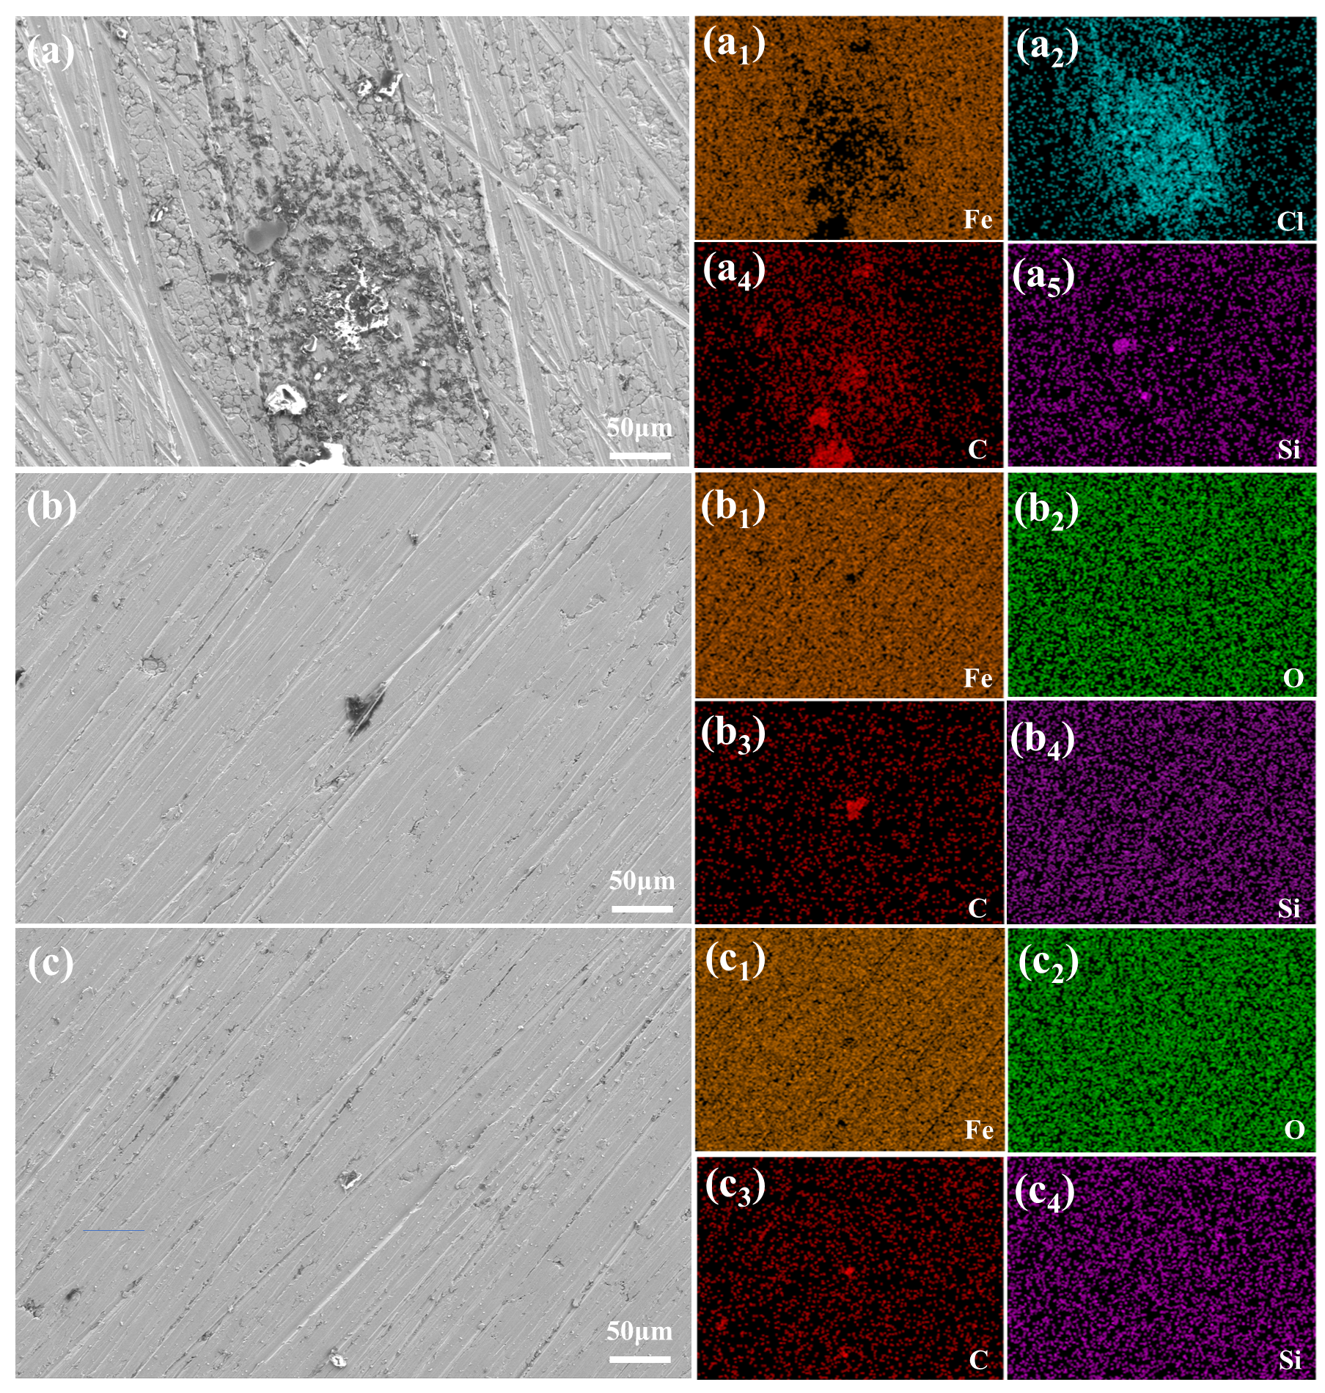
Fig. S2 Microstructure and element distribution of (a) EP, (b) rGO-SiO₂-I/48h@EP, (c) rGO-SiO2-II/48h@EP coatings after salt spray test

