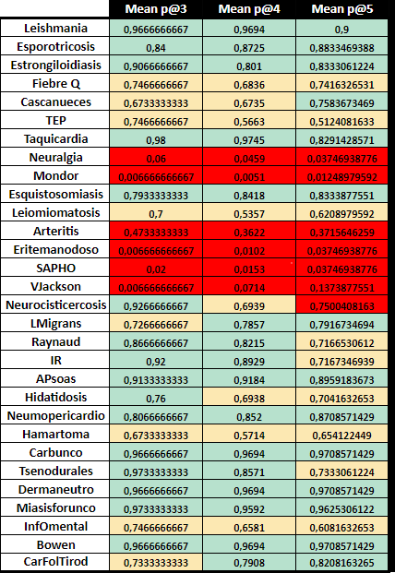
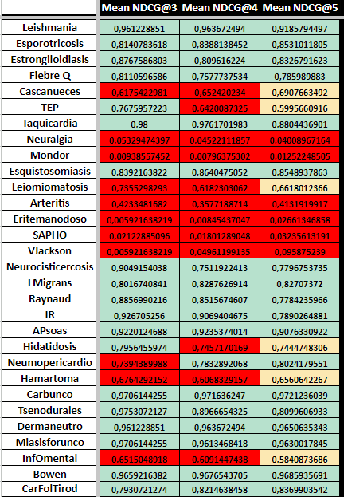
Table 3. Mean of the results for precision@3, precision@4 and precision@4 & Mean of the results for NDGC@3, NDGC@4 and NDGC@5

