Supplementary Information (SI)

Detailed methods:
Study design. This is a Phase I/II pilot feasibility randomized controlled trial (RCT) pre-registered at clinicaltrials.gov (NCT03021174) to assess the feasibility and preliminary efficacy exercise vs. behavioral placebo control on CIPN and the interoceptive brain system. We obtained ethical approval (RSRB 66046) and collected data at University of Rochester Medical Center in Rochester, NY, USA from 2017-2018. All participants provided written informed consent before participation.
Our methods follow the 11-item PEDro scale for assessing rigor in RCTs using exercise [50]. (1) Eligibility criteria: participants must: (i) have cancer, (ii) have at least six months life expectancy according to the participant’s referring oncologist or designee, (iii) be scheduled to receive neurotoxic chemotherapy (taxanes, platinums, vinca alkaloids, thalidomide, or bortezomib), (iv) be safe to perform the exercise intervention and study assessments, (v) be able to read English, (vi) be at least 18 years old (no upper limit on age), (vii) not be receiving concurrent surgery or radiation therapy, (viii) not be exercising more than two days per week (exercise was defined as aerobic or strength training for at least 20 min/session at an intensity that increases heart rate, breathing, and causes sweating), (ix) be safe for MRI. (2) Subjects were randomized to exercise or control using a random numbers table prepared by a biostatistician with random block sizes of 2 and 4 stratified by severity of baseline numbness/tingling in the hands/feet (rated 0-4 vs. 5-10) and type of neurotoxic chemotherapy (taxane vs. other). (3) Allocation was concealed. (4) The groups were similar in nearly all outcomes except that control participants were older due to random chance. (5-6) Subjects and interventionists could not be blinded to the participant’s intervention. (7) All pre-intervention assessments were blinded, but after randomization the assessments could not be blinded due to our small team. (8) Data on our primary outcome were available from 89% of the randomized participants. (9-11) All data were analyzed using intention to treat (participants were treated in the group they were randomly assigned to), with raw data shown in Table 2.
Outcome measures and study schema (Supplementary Figure 1). There were three assessment time points: pre-intervention was typically 1 week before neurotoxic chemotherapy, mid-intervention was 6-7 weeks after starting neurotoxic chemotherapy and the intervention, and post-intervention was 12-13 weeks after starting neurotoxic chemotherapy. Each time point included several assessments: (1) Patient-reported questionnaires conducted, such as the primary outcome, the CIPN-20 [18], which is recommended by the National Cancer Institute [51] given its reliability (α=0.88), validity [52], and sensitivity (d = 0.5-0.8) [53]; we scaled each subscale’s full range to 0-100 (higher is worse) for men and women separately due to a question about erectile dysfunction, which only applies to men [19]. The scaling equations are as follows: CIPN-20 Total Men = 1.67 × Raw – 33.33, CIPN-20 Total Women = 1.75 × Raw – 33.33, CIPN-20 Sensory = 3.70 × Raw – 33.33, CIPN-20 Motor = 4.17 × Raw – 33.33, CIPN-20 Autonomic Men = 11.11 × Raw – 33.33, and CIPN-20 Autonomic Women = 16.67 × Raw – 33.33. We also used a symptom inventory and 10 other symptom and health behavior questionnaires. (2) Clinical signs/symptoms, including a monofilament tactile sensitivity test on the pointer finger and great toe using a forced-choice staircase method by Testworks software by WR Medical Electronics Co. (Maplewood, MN) across 9 possible monofilaments spanning 0.05 g to 148 g; we collected other assessments that will be reported elsewhere such as cold sensitivity, cardiac interoceptive sensitivity using heartbeat detection [54], and affective reactivity using evocative photos (e.g., [24]). (3) Physical function tests including 6-min walk test in a 15-m linear space, handgrip dynamometry (Jamar), isokinetic leg strength using the Biodex System 4 (Biodex Medical Systems, Inc., Shirley, NY). (4) We collected and stored blood samples for serum, plasma, and nucleic acid analyses. (5) Data on physical activity and daily steps using a Garmin Vivofit wrist-worn activity tracker for 3-14 days at pre-, mid-, and post-intervention (exercisers wore the device every day of the study). (6) Brain MRI scans were conducted only at pre- and post-intervention on a Siemens 3T MRI MAGNETOM PrismaFit whole-body scanner (software VE11c) using a 64-channel head coil. The scans included (1) T1-weighted structural scan with a 1 mm isotropic grid, FOV=256 mm, TR=2,530 ms, TE=2.32 ms (2) 7.5-min “resting” T2-weighted functional MRI scan with a 4×4 mm in-plane grid and 3 mm slice thickness, FOV=256 mm, TR=3 sec, and TE=30 ms, and (3) a novel 8-min bodily attention task (results reported in [55]). (7) Near the end of the study, we conducted a semi-structured debriefing interview to assess study feasibility and acceptability.
Exercise intervention. The 12-week EXCAP©® intervention is a moderate-intensity home-based walking and resistance exercise program described previously [13]. Briefly, it includes a 1-hour face-to-face instructional session by an ACSM-certified exercise professional, a book on the exercise program including 16 upper- and lower-body exercises, 3 TheraBand resistance bands (red, green, and blue), and a wrist-worn activity tracker (Garmin Vivofit). The walking exercise is to be performed daily, at moderate intensity (rating of perceived exertion; RPE 5-8 out of 10), with total daily steps goal based on pre-intervention average daily steps with weekly progression of 5-20% (participant’s choice) for the 12-week intervention. The resistance exercise is to be performed daily, at moderate intensity (RPE 5-8), with 10 resistance band exercises including overhead press, toe raise, biceps curl, side bend, squat, triceps extension, leg extension, leg curl, row, chests press, plus 6 optional exercises including lateral raise, front raise, internal rotation, external rotation, horizontal adduction, and horizontal abduction with 8-15 repetitions per set ranging from 1-4 sets. The exercise progresses in reps (up to 15 per set), then sets (up to 4 sets), and then resistance level (band color) in a manner chosen by the participant per their abilities. We called or visited participants every 1-2 weeks to help identify and address barriers to adherence, and for psychological support. Adherence was assessed using a Daily Diary of steps, minutes of resistance training, and RPE, results reported elsewhere [37].
Behavioral placebo control intervention. The 12-week behavioral placebo control intervention is a nutrition education program designed to match the exercise intervention in time, attention, and expectation of benefit. The intervention includes a 1-hour face-to-face instructional session by the principal investigator (IRK) and a book by the National Cancer Institute called Eating Hints: Before, During, and After Cancer Treatment. The intervention starts with a discussion of the participant’s eating habits (quantity, composition, timing, tastes/preferences, and changes since cancer diagnosis). The Eating Hints book includes how to choose foods to manage chemotherapy toxicities including taste changes, weight gain/loss, diarrhea, nausea, vomiting, and distress. Daily homework includes attempting to eat 5 servings of fruits or vegetables each day if that is safe and feasible (e.g., 3 fruits plus 2 vegetables), and to choose foods that help manage their symptoms. We called or visited participants every 1-2 weeks to help address barriers to adherence and for psychological support. Adherence was assessed using a Daily Diary of the number of servings of fruit and vegetables consumed.
Matching interventions. We designed nutrition education to match the exercise intervention in several ways: (1) similar time and effort (1 hour initial meeting and daily homework with follow-up calls every 1-2 weeks to improve adherence), (2) both may alleviate non-CIPN symptoms (e.g., nausea), (3) both may have psychosocial benefits (e.g., increasing self-efficacy), and (4) we presented both with similar expectation of benefit using standardized talking points. We did not expect eating more fruits and vegetables would have large effects on CIPN based on prior work [21]. We assessed adherence and contamination using a Daily Diary of steps, minutes of resistance training, RPE, and servings of fruits and vegetables (Supplementary Figure 2).
Adverse event monitoring. We talked with participants and checked their medical records every 1-2 weeks. The participant’s physician graded the adverse events using CTCAE v4.0 and determined whether it was related to the intervention or our participation. We report all grade 3-5 events.
Sample size determination. We recruited as many participants as possible (up to 40) from summer 2017 to fall 2018, yielding 21 consents (2 withdrew before baseline assessments, yielding 19 participants). We did not perform interim analyses.
Brain MRI data processing. All brain MRI data were processed using standard procedures in the program AFNI [22], including skull-stripping and non-linear warping to standard Talairach space (TTN27). Resting fMRI data additionally utilized despiking, removing the first 2 time points, slice time correction, spatial smoothing, motion correction (motion censor threshold 0.5, outlier censor threshold 0.2), and ANATICOR to adjust for physiological noise [56] using masks of ventricles, white matter, and gray matter from FreeSurfer parcellation (recon-all [23]); we did not use global signal regression [57]. From there, for each of the 16 regions of interest (below), we computed voxel-wise temporal correlation values (Pearson’s r, Fisher transformed z values), with one brain map for each seed for each participant’s time point. The regions of interest (ROIs) were extracted from the Destrieux atlas [58] implemented in AFNI as DD Desai MPM, and included the following regions: DLPFC, S1, anterior insula, posterior insula, amygdala, thalamus, ACC, and precuneus, with separate ROIs on the left and right hemispheres (Supplemental Figure 4). The final dataset contained 27 resting fMRI scans, and one of those scans had to be removed due to excessive head motion (49% of data censored). All other scans passed visual and inspection for quality control in registration, motion correction, parcellation, and functional connectivity analyses.
Statistical analyses. All participants were analyzed in the group assigned via randomization. Analyses were performed using JMP (SAS Institute, Inc.; Cary, NC, USA) and MATLAB (Mathworks; Natick, MA). Due to the pilot nature of this work, we focused on standardized effect sizes (ES; not p-values). We calculated ES as Cohen’s d = (Mean difference) / (Pooled SD_{pre}). To test the effects of exercise vs. control on an outcome, we used linear regression to model the outcome at mid- or post-intervention as a function of study arm, pre-intervention value of that outcome, and age, because controls were older than exercisers due to random chance. To assess associations between brain measures and CIPN severity, we used linear regression to model CIPN-20 total score as a function of brain measure and age and subtracted that R² by that of a null model of CIPN-20 as a function of age only; we only ran these analyses at post-intervention (after exposure to neurotoxic chemotherapy). For brain analyses, we imputed two missing values of CIPN-20 using a linear regression model across all participants: CIPN-20(post) = CIPN-20(pre) + Arm + Age.

Supplementary results
Study safety. There were 16 adverse events across 9 participants (6 exercise, 3 control, with 1-5 events per participant). The adverse events included fever (5), diarrhea (3), abdominal pain (4), shortness of breath (2; with 1 pulmonary embolism), gastrointestinal issues (2; bleeding and pancreatitis). All participants recovered without sequelae. All adverse events were deemed unrelated to study participation by the participant’s medical oncologist. There were no incidental findings from our brain MRI data.

Supplementary discussion
The monofilament touch test data proved to be highly variable due to the methodology used; we found certain test sites easier to assess (e.g., back of the finger was easier and more ergonomic for participants and researchers compared to the finger pad).
During the conduct of this feasibility study, we overcame several logistical challenges. First, we found it most feasible to recruit participants with breast or gastrointestinal cancers due to their high prevalence and often the significant lead time before the start of neurotoxic chemotherapy. Other cancer types such as cervical and lymphoma had chemotherapy starting so quickly that we did not have time for pre-intervention assessments. Second, it was helpful to prioritize questionnaire data collection (email, paper, etc.), conduct assessments before or after existing medical appointments, and find assessment rooms near those appointments. Third, we observed four degrees of participant engagement in roughly equal proportions: some participants who easily did every study activity, some who did only the minimally required study activities, some who were borderline lost-to-follow up, and some who refused to participant in any additional research studies regardless of their details (they did not consent). Many participants felt frustrated and confused navigating the healthcare system in general, especially if they did not have a caregiver to help. Addressing those issues might reduce barriers for participants to participate in clinical trials.

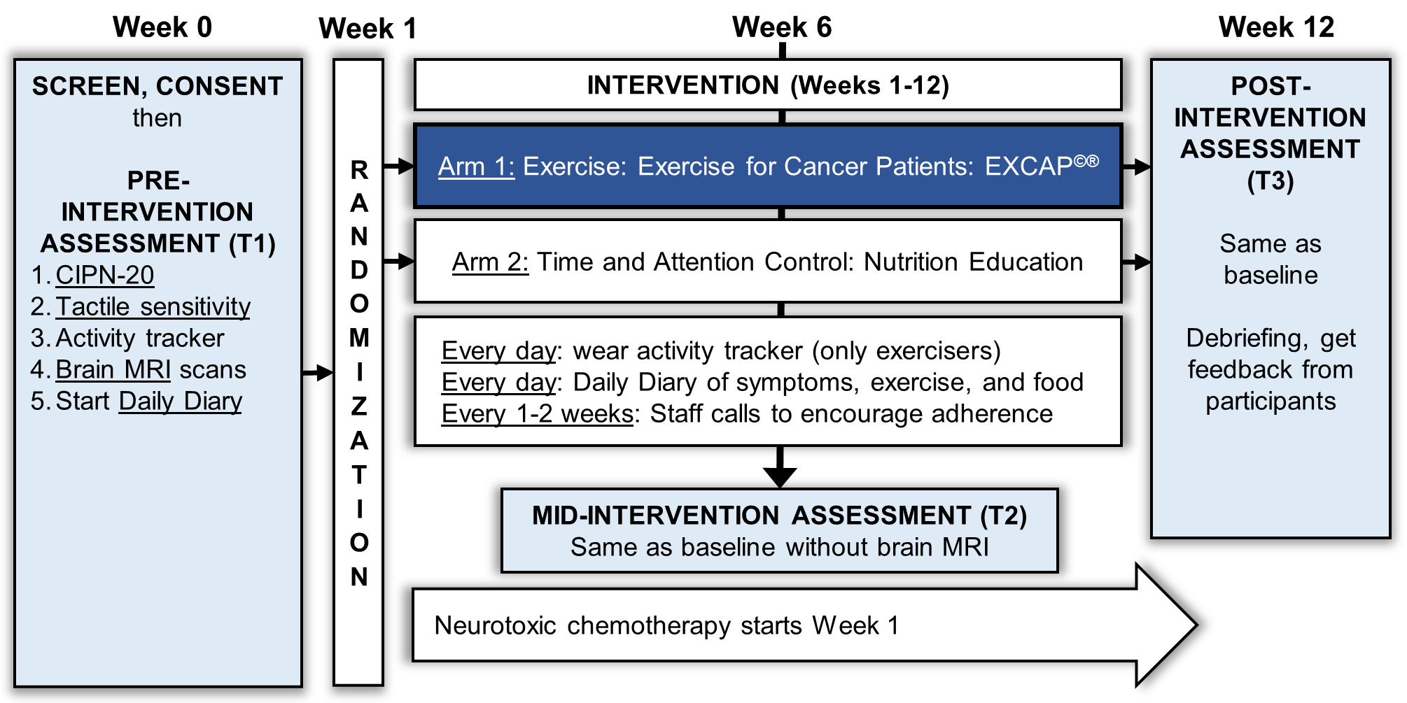
Supplementary Figure 1. Study schema.

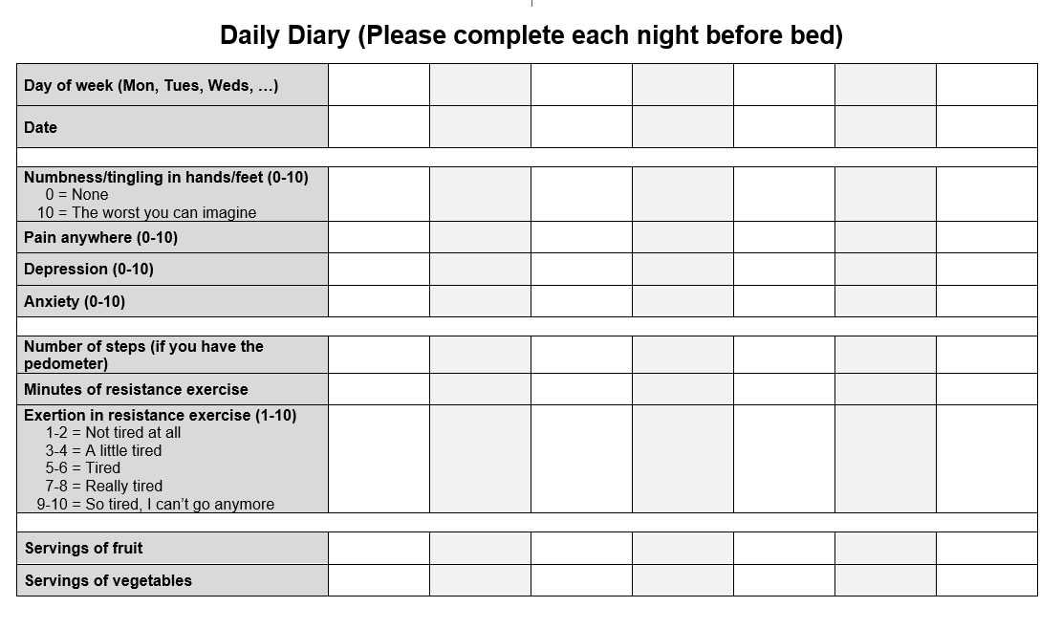
Supplementary Figure 2. The daily diary was a brief paper questionnaire designed to track daily exercise, selected symptoms, and mood. The participants were instructed to complete the diary each night immediately prior to sleeping.

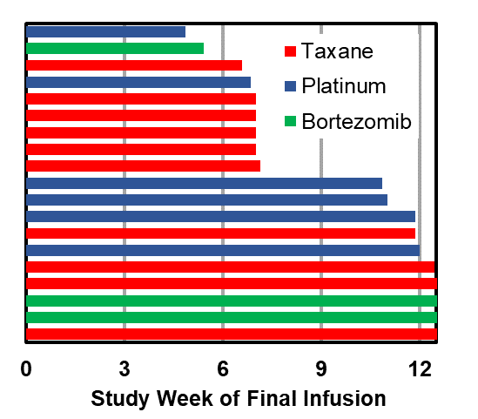
Supplemental Figure 3. Timing of final infusion by study participant and chemotherapy class.

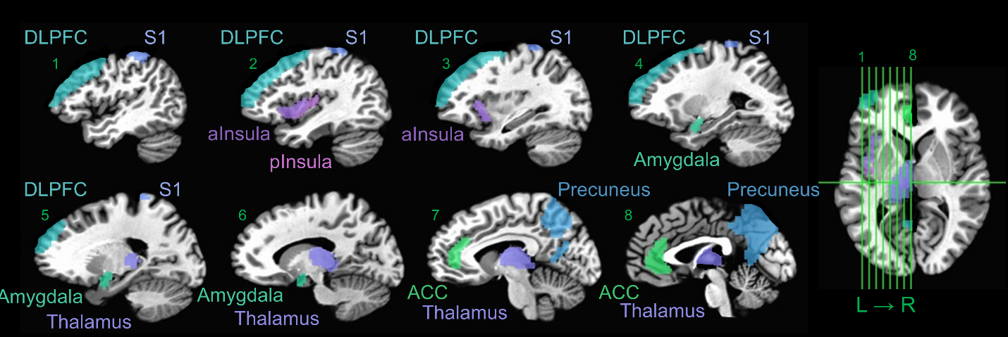
Supplemental Figure 4. Regions of interest used for brain connectivity analyses. Regions are from the Destrieux atlas [58] implemented in AFNI as DD Desai MPM. We also used the same regions on the right side of the brain (not shown in the image for simplicity).

