eAppendix 1. List of NIVAS Trial Investigators

Independent Data and Safety Monitoring Committee: K. Asehnoune, CHU Nantes,
France; X. Capdevila, CHU Montpellier, France

Participating sites and investigators:

Saint Eloi Hospital, Montpellier, France: Samir Jaber, Fouad Belafia, Daniel Verzilli,
Audrey De Jong, Gerald Chanques,
Lapeyronie Hospital, Montpellier, France. Nicolas Molinari

Estaing Hospital, Clermont-Ferrand, France: Emmanuel Futier, Jean-Michel Constantin,
Mathieu Jabaudon

Beaujon Hospital, AP-HP, Paris, France: Catherine Paugam-Burtz, Paër-Sélim Abback

Rennes Hospital, France: Philippe Seguin,

Tours, France: Martine Ferrandiere

Angers, France: Sigismond Lasocki, Soizic Gergaud

Institut Paoli Calmettes, Marseille, France: Antoine Sannini, Djamel Mokart

Strasbourg, France: Julien Pottecher

Purpan Hospital, Toulouse, France: Beatrice Riu, Olivier Fourcade

Avignon, France: Florent Montini, Pierre Courant

Bordeaux, France: Alexandre Ouattara

Nîmes, France: Laurent Muller

eAppendix 2. Definitions of Health-care associated infections

Health-Care associated infections:
Diagnostic criteria for health-care associated infections were adapted from CDC criteria.
The sites and dates of diagnosis of all healthcare associated infections were recorded as
well as antibiotic regimens given during the ICU stay within 30 days after inclusion in
the study.
Pneumonia, urinary tract infection, central venous catheter-related infection, bacteremia
and surgical-site infection, occurring both at least 48 hours after ICU admission and after
inclusion in the study were collected according to the following definitions.

Pneumonia was suspected in patients with a combination of new and persistent lung
infiltrates on chest X-ray, a temperature greater than 38°C, and macroscopically purulent
tracheal secretions while receiving either standard oxygen therapy, noninvasive
ventilation or invasive mechanical ventilation. Pneumonia was ascertained by the
positivity of a quantitative respiratory culture, defined as at least 1 microorganism
recovered at concentration of at least 1000 colony forming units per mL for blinded
protected telescoping catheter, of at least 10000 colony forming units per mL for
broncho-alveolar lavage and of at least 1000000 colony forming units per mL for tracheal
aspirates. In patients clinically suspected of having pneumonia but treated with
noninvasive ventilation, the positivity of a blinded protected telescoping catheter culture
at the same significant threshold, when available, or the sole administration of new antibiotics
in the absence of other sites of infection was used to characterize the presence of
pneumonia. The modified Clinical Pulmonary Infection Score (CPIS) at suspected
pneumonia was calculated from the first five variables (see table CPIS). The CPIS
gram/culture was calculated from the CPIS score by adding two more points when gram
stains or culture were positive. A score of more than six at baseline or after incorporating the
gram stains (CPIS gram) or culture (CPIS culture) results was considered suggestive of
pneumonia.

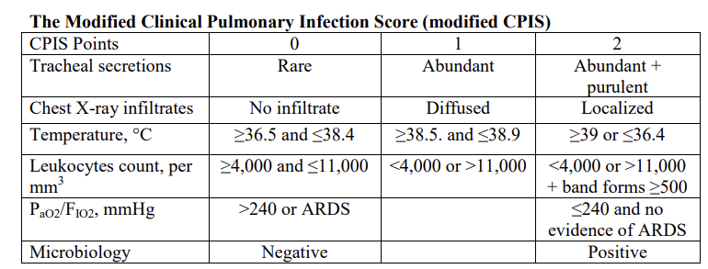

Urinary tract infection was defined by the association of fever (body temperature greater than
38°C) and a urine culture with no more than two species of organisms, at least one of which
is a bacteria of at least 100000 colony forming units per ml, in patients with no other evident
source of infection.

Catheter-related infection was defined as a combination of fever (body
temperature greater than 38°C), a quantitative catheter-tip culture eluate in broth showing at
least one microorganism in a concentration of at least 1000 colony forming units per mL, and
resolution of fever within 48 h after catheter removal and without any change in antimicrobial
therapy, and no other evident source of infection identified.

Primary bacteremia was defined as a combination of fever (body temperature greater than
38°C), at least 1 positive blood culture (two or more blood cultures drawn on separate
occasions when coagulase-negative staphylococci were isolated) not related to an infection
at another site.

Surgical-site infection diagnostic was performed according standard CDC definitions
(Mangram AJ, Horan TC, Pearson ML, Silver LC, Jarvis WR. Guideline for prevention
of surgical site infection, 1999: Hospital Infection Control Practices Advisory Committee. Infect
Control Hosp Epidemiol 1999;20:250-78). An independent infectious disease specialist
reviewed all clinical and microbiological information for each patient.
