Electronic Supporting Information
Magnetic BiFeO₃ Nanoparticles: A Robust and Efficient Nanocatalyst for the Green One-Pot Three-Component Synthesis of Highly Substituted 3,4-Dihydropyrimidine-2(1H)-one/thione Derivatives
Safa Hanifi, Mohammad G. Dekamin*, Mohammad Eslami
Pharmaceutical and Biologically-Active Compounds Research Laboratory, Department of Chemistry, Iran University of Science and Technology, Tehran 16846-13114, Iran
Tel: +98-21-77240640-50; fax: +98-21-73021584; e-mail: mdekamin@iust.ac.ir
Page | Contents
S1 | Title page
S4 | Figure S1. Typical examples of biologically active 3,4-dihydropyrimidine-2(1H)-one/thione derivatives (DHPMs/DHPMTs)
S4 | Figure S2. Synthesis of diverse 3,4-dihydropyrimidine-2(1H)-one/thione derivatives using the magnetic bismuth ferrite nanoparticles (BFO MNPs) in H₂O: EtOH solvent system.
S4 | Figure S3. Schematic preparation of the BFO MNPs for the Green One-Pot Three-Component Synthesis of Highly Substituted 3,4-Dihydropyrimidine-2(1H)-one/thione Derivatives (DHPMs/DHPMTs)
S5 | Figure S4. ¹H NMR of ethyl-6-methoxy-4-(3-nitrophenyl)2-oxo-1,2,3,4-tetrahydropyrimidine-5-carboxylate (4b)
S6 | Figure S5. ^{1H NMR} ethyl 4-(3,4-dichlorophenyl)6-methyl-2-oxo-1,2,3,40tetrahydropyrimidine-5-carboxylate (4f)
S7 | Figure S6. ¹H NMR of ethyl 4-(3,4-dimethoxyphenyl)-6-methyl-2-oxo-1,2,3,4-tetrahydropyrimidine-5-carboxylate (4l)
S8 | Figure S7. ¹H NMR of ethyl 6-methoxy-2-oxo-4-(thiophen-2-yl)-1,2,3,4-tetrahydropyrimidine-5-carboxylate (4q)
S9 | Figure S8. ¹H NMR of ethyl 6-methyl-4-phenyl-2-thioxo-1,2,3,4-tetrahydropyrimidine-5-carboxylate (4v)
S9 | Preparation of the magnetic bismuth ferrite nanoparticles (BFO MNPs)
S10 | Figure S9. Fourier-transform infrared spectrum (FT-IR) of bismuth ferrite nanoparticles (BFO MNPs) (a). FTIR spectrum of the as-synthesized spherical monodisperse Bi2O3 nanoparticles(b). FTIR graph of α-Fe₂O₃ calcined at 300ºC.
S10 | Figure S10. SEM images of BiFeO₃ nanoparticles; a) scale of 3 μm, b) scale of 500 nm.
S11 | Figure S11: EDS elemental mapping analysis of BFO MNPs.
S11 | Figure S112: Elemental analysis by energy-dispersive X-ray spectroscopy (EDS) for BFO MNPs.
S12 | Figure S13: X-ray diffraction pattern of BFO MNPs.
S12 | Figure S14: Hysteresis diagram of magnetic bismuth ferrite nanoparticles (BFO MNPs).
S12 | Table S1: Nitrogen adsorption-desorption isotherms of BFO MNPs.
S13 | Table S2. Exploring optimal conditions for the one-pot three-component Biginelli reaction involving benzaldehyde (1h), ethyl acetoacetate (2), and urea (3a).ª
S14 | Table S3. Expanding the optimized method: synthesis of ethyl 4-(aryl/heteroaryl)-6-methyl-2-oxo-4,3,2,1-tetrahydropyrimidine-5-carboxylate using BiFeO₃ magnetic nanoparticles for various aromatic and heteroaromatic carbonyl compounds.ª
S17 | Figure S15. Proposed mechanism for the synthesis of 3,4 dihydropyrimidine-2(1H)-one/thione derivatives in the presence of magnetic bismuth ferrite nano catalyst (BFO MNPs).
S17 | Figure S16: The results of recyclability and reusability of the BFO MNPs nanoparticles in the model reaction.
S18 | Table S4. Comparison of the model reaction for the synthesis of Ethyl 6-methyl-2-oxo-4-phenyl-1,2,3,4-tetrahydropyrimidine-5-carboxylate (4h) in the presence of BiFeO₃ in terms of time and product yield with recent reports.

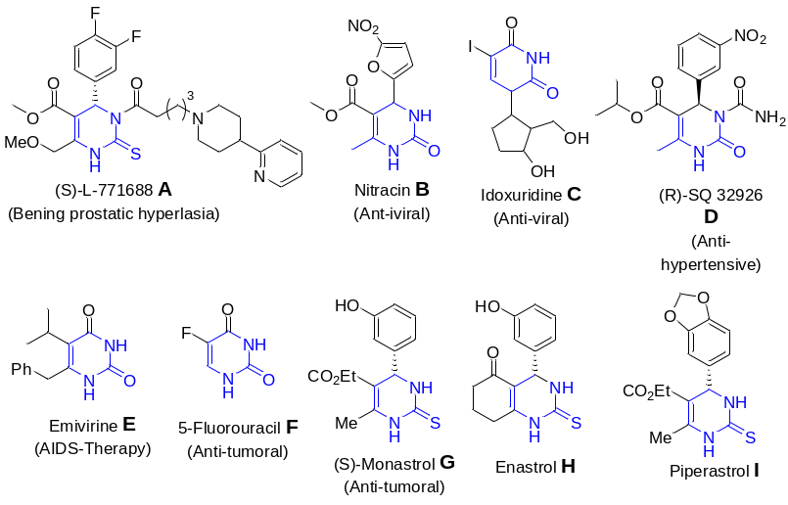
Figure S1. Typical examples of biologically active 3,4-dihydropyrimidine-2(1H)-one/thione derivatives (DHPMs/DHPMTs).
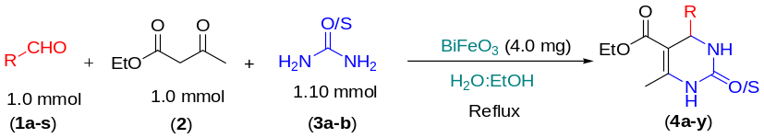

Figure. S2. Synthesis of diverse 3,4-dihydropyrimidine-2(1H)-one/thione derivatives using the magnetic bismuth ferrite nanoparticles (BFO MNPs) in H₂O: EtOH solvent system.
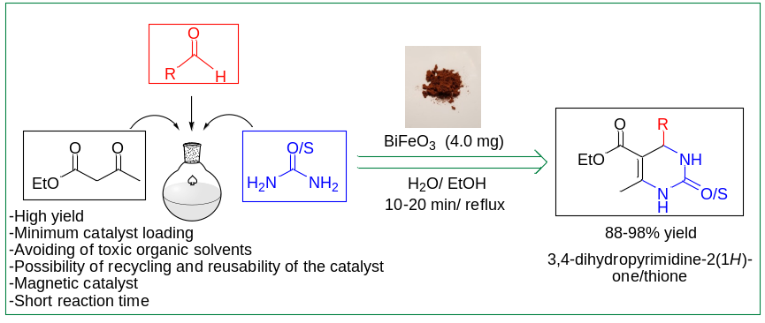
Figure S3. Schematic preparation of the Magnetic BiFeO₃ Nanoparticles for the Green One-Pot Three-Component Synthesis of Highly Substituted 3,4-Dihydropyrimidine-2(1H)-one/thione Derivatives (DHPMs).

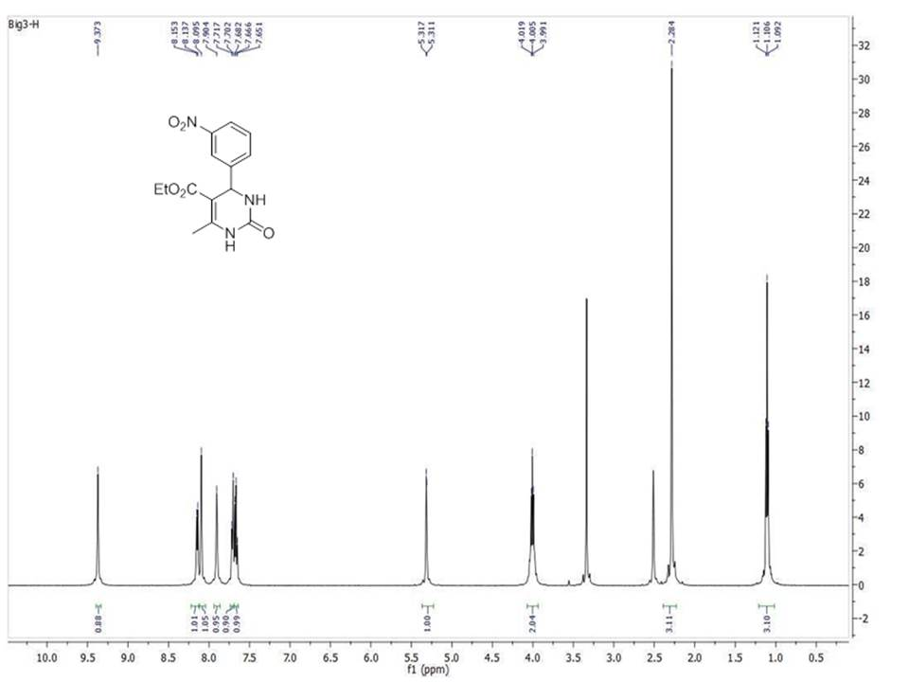
Figure S4: ¹H NMR of ethyl-6-methoxy-4-(3-nitrophenyl)2-oxo-1,2,3,4-tetrahydropyrimidine-5-carboxylate (4b).
Ethyl 6-methyl-4-(3-nitrophenyl)-2-oxo-1,2,3,4-tetrahydropyrimidine-5-carboxylate; White solid, M.P: 220-221 ºC, ¹H NMR (500 MHz, d₆-DMSO, δ = ppm) δ: 1.10 (t, J = 7.5 Hz, 3H, CH₃), 2.28 (s, 3H, CH₃), 4.00 (q, J = 7.0 Hz, 2H, CH₂), 5.31 (d, J = 3.0 Hz, 1H, CH), 7.66 (t, J = 8.0 Hz, 1H, Ar-H), 7.70 (d, J = 7.5 Hz, 1H, Ar-H), 7.90 (brs, 1H, NH), 8.09 (s, 1H, Ar-H), 8.14 (d, J = 8.0 Hz, 1H, Ar-H), 9.37 (s, 1H, NH).

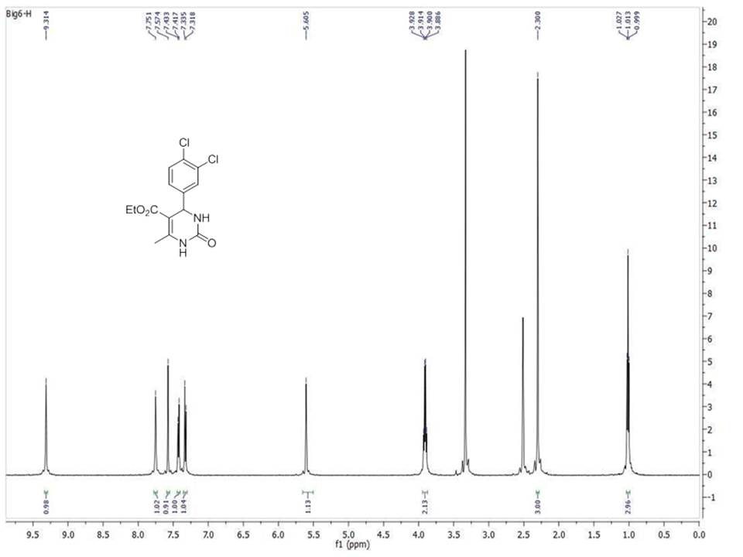
Figure S5: ¹H NMR ethyl 4-(3,4-dichlorophenyl)6-methyl-2-oxo-1,2,3,40tetrahydropyrimidine-5-carboxylate (4f).
Ethyl 4-(3,4-dichlorophenyl)-6-methyl-2-oxo-1,2,3,4-tetrahydropyrimidine-5-carboxylate; White solid, M.P: 228-230 ºC, ¹H NMR (500 MHz, d₆-DMSO, δ = ppm) δ: 1.01 (t, J = 7.0 Hz, 3H, CH₃), 2.30 (s, 3H, CH₃), 3.90 (q, J = 7.0 Hz, 2H, CH₂), 5.60 (s, 1H, CH), 7.32 (d, J = 8.5 Hz, 2H, Ar-H), 7.42 (d, J = 8.0 Hz, 2H, Ar-H), 7.57 (s, 1H, Ar-H), 7.57 (s, 1H, NH), 9.34 (s, 1H, NH).

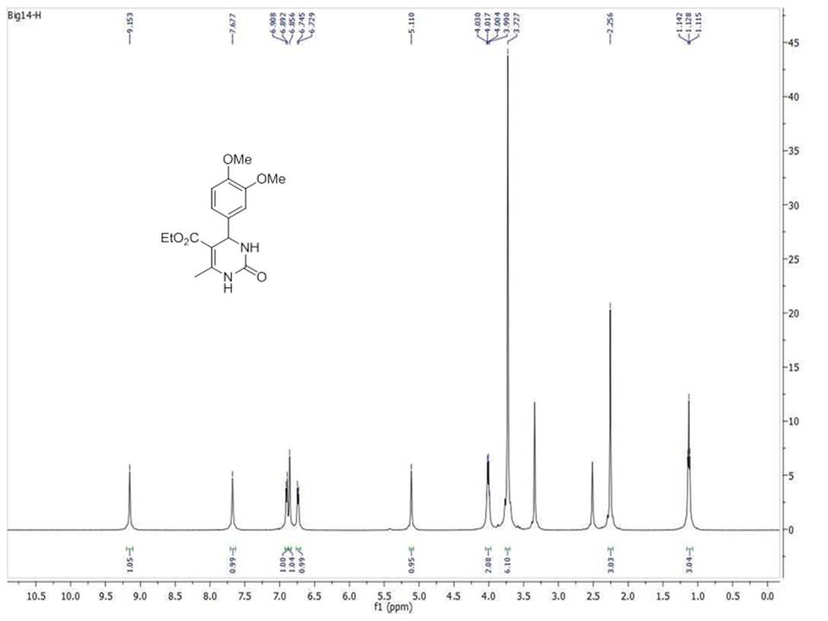
Figure S6: ¹H NMR of ethyl 4-(3,4-dimethoxyphenyl)-6-methyl-2-oxo-1,2,3,4-tetrahydropyrimidine-5-carboxylate (4l).
Ethyl 4-(3,4-dimethoxyphenyl)-6-methyl-2-oxo-1,2,3,4-tetrahydropyrimidine-5-carboxylate; White solid, M.P: 173-175 ºC, ¹H NMR (500 MHz, d₆-DMSO, δ = ppm) δ: 1.12 (t, J = 7.0 Hz, 3H, CH₃), 2.25 (s, 3H, CH₃), 3.77 (s, 6H, 2 OCH₃), 4.00 (q, J = 6.5 Hz, 2H, CH₂), 5.11 (s, 1H, CH), 6.73 (d, J = 8.0 Hz, 1H, Ar-H), 6.85 (s, 1H, Ar-H), 6.90 (d, J = 8.0 Hz, 1H, Ar-H), 7.67 (s, 1H, NH), 9.15 (s, 1H, NH).

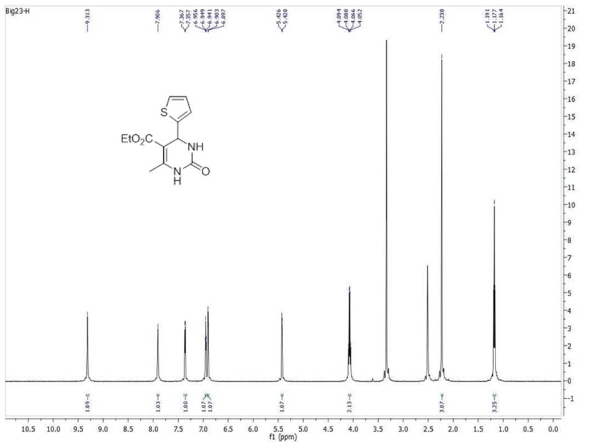
Figure S7: ¹H NMR of ethyl 6-methoxy-2-oxo-4-(thiophen-2-yl)-1,2,3,4-tetrahydropyrimidine-5-carboxylate (4q).
Ethyl 6-methyl-2-oxo-4-(thiophen-2-yl)-1,2,3,4-tetrahydropyrimidine-5-carboxylate; White solid, M.P: 214-216 ºC, ¹H NMR (500 MHz, d₆-DMSO, δ = ppm) δ: 1.17 (t, J = 7.0 Hz, 3H, CH₃), 2.23 (s, 3H, CH₃), 4.07 (q, J = 7.0 Hz, 2H, CH₂), 5.42 (d, J = 3.0 Hz, 1H, CH), 6.89 (m, 1H, Het Ar-H), 6.94 (t, J = 4.0 Hz, 1H, Het Ar-H), 7.33 (d, J = 5.0 Hz, 1H, Ar-H), 7.90 (s, 1H, NH), 9.31 (s, 1H, NH).

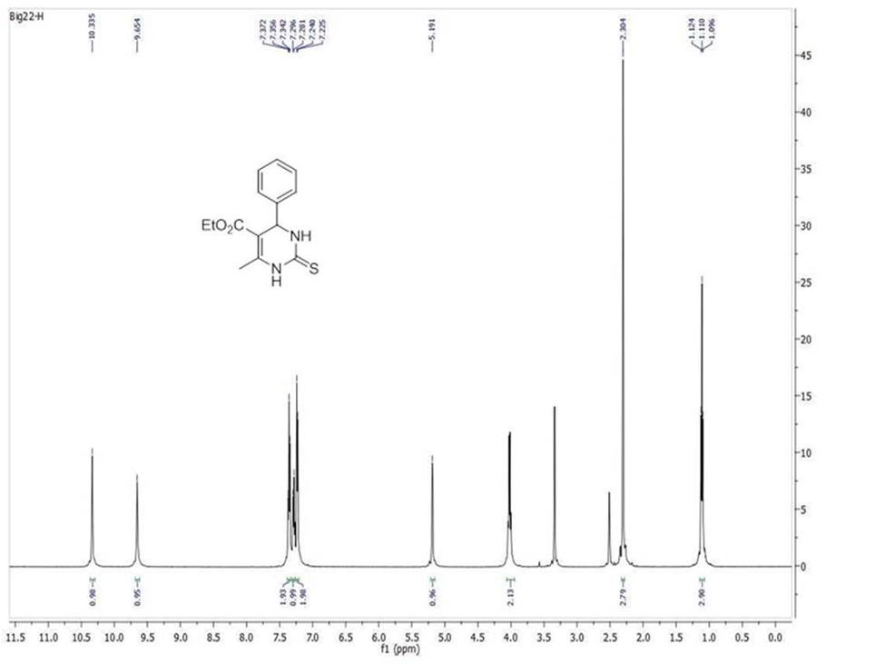
Figure S8: ¹H NMR of ethyl 6-methyl-4-phenyl-2-thioxo-1,2,3,4-tetrahydropyrimidine-5-carboxylate (4v).
Ethyl 6-methyl-4-phenyl-2-thioxo-1,2,3,4-tetrahydropyrimidine-5-carboxylate; White solid, M.P: 211-213 ºC, ¹H NMR (500 MHz, d₆-DMSO, δ = ppm) δ: 1.10 (t, J = 7.0 Hz, 3H, CH₃), 2.30 (s, 3H, CH₃), 4.00 (q, J = 7.0 Hz, 2H, CH2), 5.19 (s, H, CH), 7.23 (d, J = 7.0 Hz, 2H, Ar-H), 7.28 (t, J = 7.5 Hz, 1H, Ar-H), 7.35 (t, J = 8.0 Hz, 2H, Ar-H), 9.65 (s, 1H, NH), 10.33 (s, 1H, NH).

Preparation of the magnetic bismuth ferrite nanoparticles (BFO MNPs)
Preparation of BFO MNPs was carried out through the solid-state thermal decomposition method^{33,34}. Initially, a 100 ml round-bottom flask was charged with glycine (8.0 mmol), Fe(NO₃)₃ (4.0 mmol), Bi(NO₃)₃ (4.0 mmol), and deionized water (40.0 ml) and the obtained mixture was heated at 120 ºC for one h. Subsequently, HNO₃ (2.80 ml) was added dropwise to the reaction mixture. The reaction mixture was subjected to heating at 120 °C, resulting in the formation of a brown solid. Finally, the brown solid was placed in the oven for one h at 350 ºC and further one h at 550 ºC to prepare bismuth ferrite nanoparticles (BFO MNPs).

Figure S9: Fourier-Transform infrared spectrum (FT-IR) of BFO MNPs.

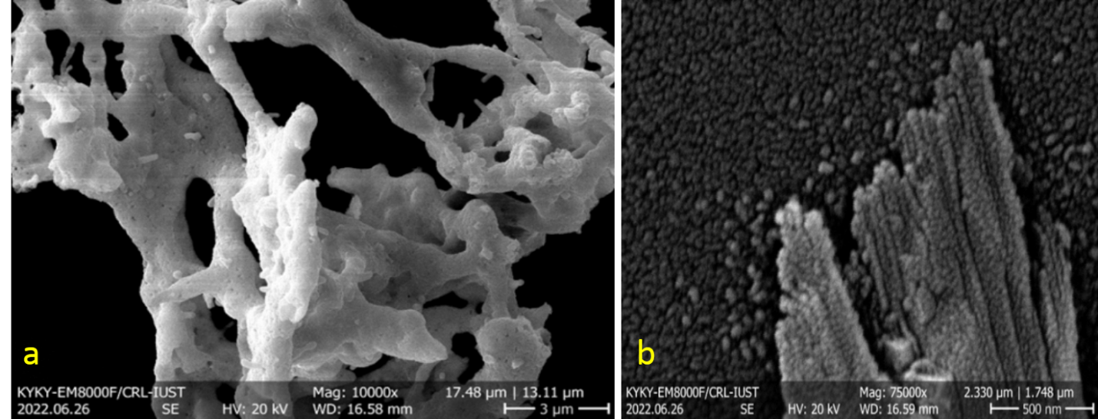
Figure S10: FESEM images of BiFeO₃ nanoparticles; a) 3 μm and b) 500 nm scales.
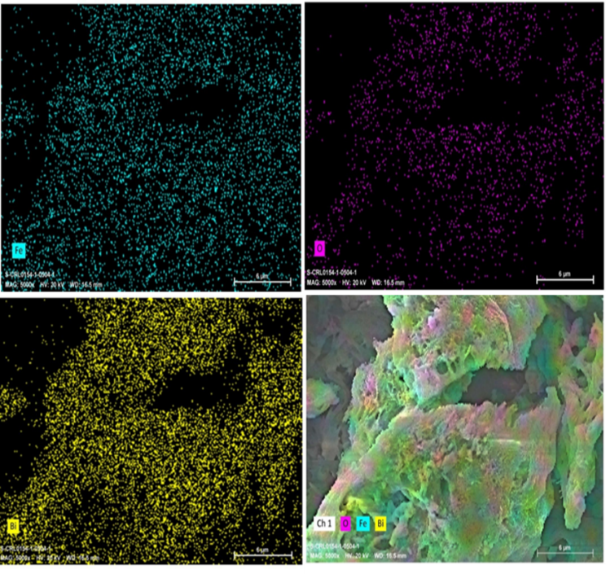
Figure S11: EDS elemental mapping analysis of BFO MNPs.
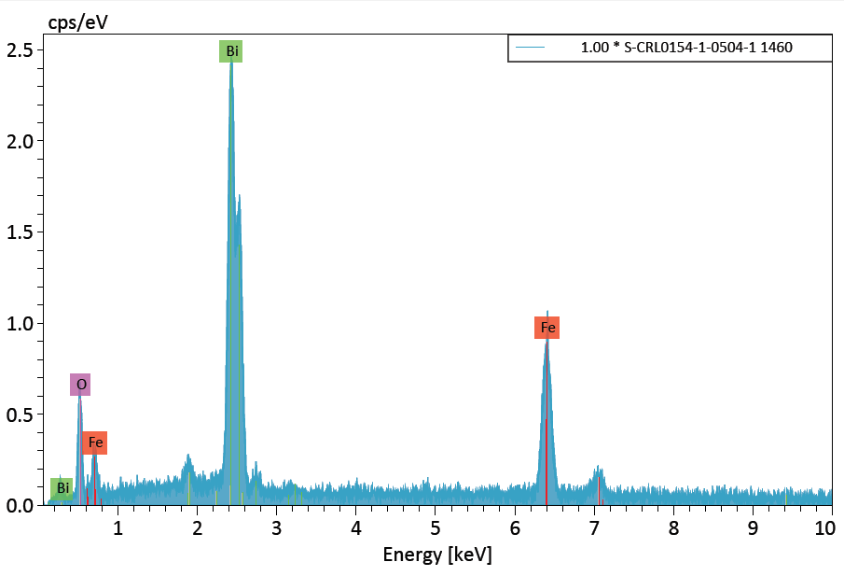
Figure S112: Elemental analysis by energy-dispersive X-ray spectroscopy (EDS) of the BFO MNPs.

Figure S13: X-Ray diffraction pattern of BFO MNPs.

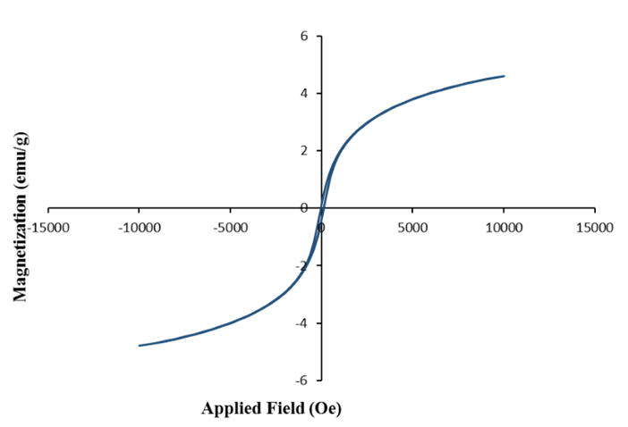

Figure S14: Hysteresis diagram of the magnetic bismuth ferrite nanoparticles (BFO MNPs).

BET Plot
BET Surface Area | 24.8109 [m²g⁻¹]
Table S1: The result of nitrogen adsorption-desorption isotherms of BFO MNPs.

Table 1. Exploring optimal conditions for the one-pot three-component Biginelli reaction involving benzaldehyde (1h), ethyl acetoacetate (2), and urea (3a).ª
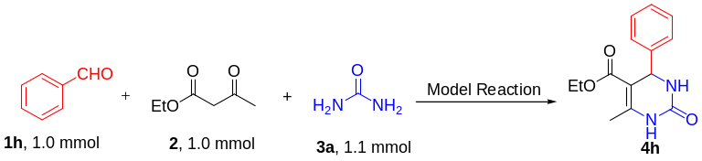
Entry. | Catalyst loading  (mg) | Solvent | Temperature  (ºC) | Time  (min) | Yield  (%)^{b} | TON
1 | - | H₂O | r.t | 360 | Trace | -
2 | - | H₂O | Reflux | 360 | Trace | -
3 | Fe₃O₄ (2.0 mg) | H₂O | r.t | 45 | Trace | -
4 | MnFe₂O₄ (2.0 mg) | H₂O | r.t | 45 | 30 | 34.6
5 | CuFe₂O₄ (2.0 mg) | H₂O | r.t | 45 | 27 | 32.3
6 | ZnFe₂O₄ (2.0 mg) | H₂O | r.t | 45 | 31 | 37.4
7 | NiFe₂O₄ (2.0 mg) | H₂O | r.t | 45 | 25 | 29.3
8 | BiFeO₃ (2.0 mg) | H₂O | r.t | 45 | 40 | 62.6
9 | BiFeO₃ (2.0 mg) | MeOH | r.t | 45 | 44 | 68.9
10 | BiFeO₃ (2.0 mg) | EtOH | r.t | 45 | 59 | 92.3
11 | BiFeO₃ (2.0 mg) | EtOAc | r.t | 45 | 53 | 82.9
12 | BiFeO₃ (2.0 mg) | CH₃CN | r.t | 45 | 50 | 78.2
13 | BiFeO₃ (2.0 mg) | H₂O: EtOH | r.t | 45 | 60 | 93.9
14 | BiFeO₃ (2.0 mg) | H₂O: EtOH | r.t | 45 | 67 | 104.9
15 | BiFeO₃ (4.0 mg) | H₂O:EtOH | r.t | 20 | 84 | 68.9
16 | BiFeO₃ (4.0 mg) | H₂O:EtOH | Reflux | 10 | 93 | 72.8
ªReaction conditions: aldehyde (1a, 1.0 mmol), ethyl acetoacetate (2, 1.0 mmol), urea (3a, 1.1 mmol) and 3 mL of H₂O: EtOH mixture (4.0 ml, 3:1) as a solvent. ^{b}The yield of the products is related to the isolated yield.

Table 2. Synthesis of diverse ethyl 4-(aryl/heteroaryl)-6-methyl-2-oxo-4,3,2,1-tetrahydropyrimidine-5-carboxylate using BFO MNPs nanocatalyst and various aromatic and heteroaromatic carbonyl compounds.ª
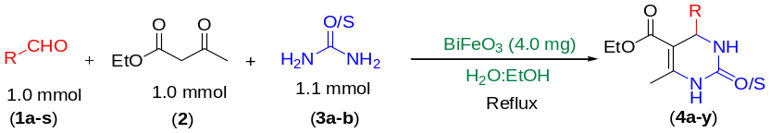
Entry. | Aldehyde  (1a-s) | Urea/Thiourea  (3a-b) | Product  (4a-y) | Time  (min) | Yield ^{b}  (%) | M.p  (ºC)
1 | 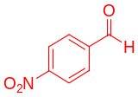1a | Urea  3a | 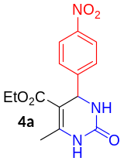 | 10 | 96 | 211-213⁹
2 | 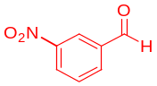  1b | Urea  3a | 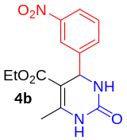 | 10 | 91 | 220-221⁹
3 | 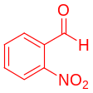  1c | Urea  3a | 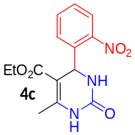 | 15 | 90 | 205-207⁵⁰
4 | 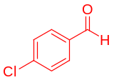  1d | Urea  3a | 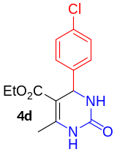 | 10 | 93 | 219-221⁵¹
5 | 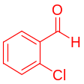  1e | Urea  3a | 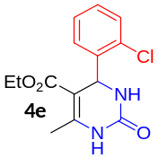 | 15 | 90 | 209-210⁹
6 | 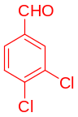  1f | Urea  3a | 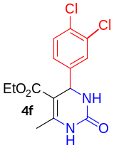 | 10 | 97 | 228-230⁵¹
7 | 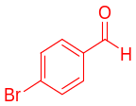  1g | Urea  3a | 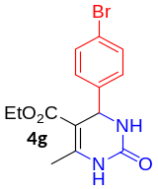 | 10 | 94 | 210-213⁵²
8 | 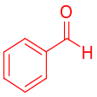  1h | Urea  3a | 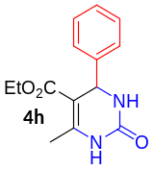 | 10 | 93 | 201-203⁵³
9 | 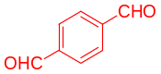  1i | Urea  3a | 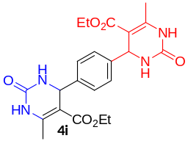 | 15 | 90 | 231-233⁵⁴
10 | 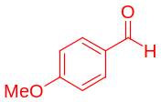  1j | Urea  3a | 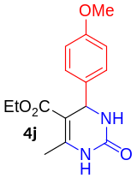 | 15 | 95 | 200-201⁵¹
11 | 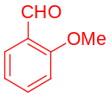  1k | Urea  3a | 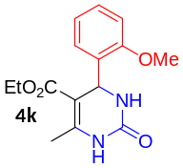 | 20 | 94 | 258-260⁵⁵
12 | 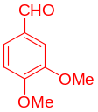  1l | Urea  3a | 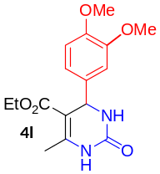 | 15 | 92 | 173-175⁵¹
13 | 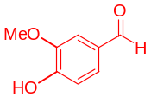  1m | Urea  3a | 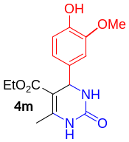 | 15 | 90 | 205-207⁵⁶
14 | 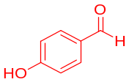  1n | Urea  3a | 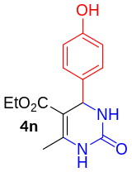 | 10 | 88 | 232-233⁵¹
15 | 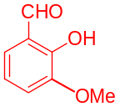  1o | Urea  3a | 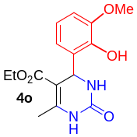 | 20 | 90 | 241-243⁵⁷
16 | 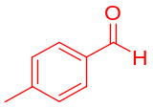  1p | Urea  3a | 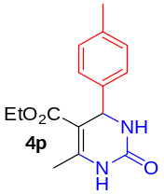 | 15 | 88 | 205-207⁵⁸
17 | 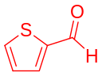  1q | Urea  3a | 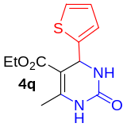 | 15 | 93 | 214-216⁹
18 | 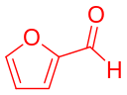  1r | Urea  3a | 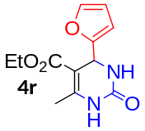 | 15 | 90 | 199-201⁹
19 | 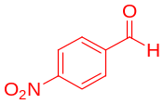  1a | Urea  3a | 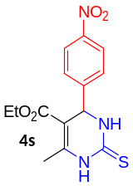 | 15 | 95 | 207-209⁵⁹
20 | 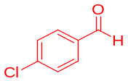  1d | Thiourea  3b | 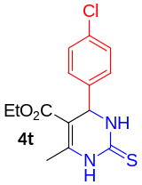 | 15 | 91 | 181-183⁶⁰
21 | 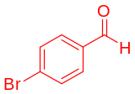  1g | Thiourea  3b | 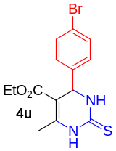 | 15 | 89 | 189-190⁶¹
22 | 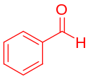  1h | Thiourea  3b | 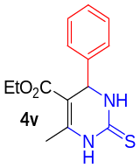 | 20 | 98 | 211-213⁶²
23 | 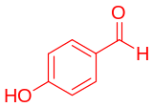  1n | Thiourea  3b | 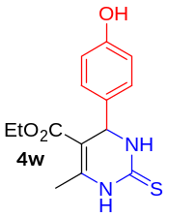 | 15 | 90 | 217-218⁶²
24 | 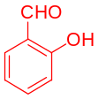  1s | Thiourea  3b | 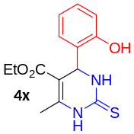 | 20 | 94 | 208-210⁶³
25 | 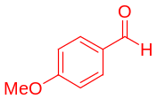  1j | Thiourea  3b | 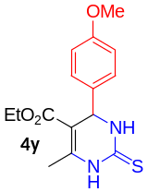 | 20 | 92 | 207-208⁶⁴
ª Reaction conditions: aromatic or heteroaromatic aldehyde (1a-s, 1.0 mmol), ethyl acetoacetate (2, 1.0 mmol), urea/thiourea (3a-b, 1.1 mmol), BiFeO₃ (4.0 mg), 3.0 ml of H₂O: EtOH (4.0 ml, 3:1) under reflux conditions. ^{b} The yield of products is related to the purified product.

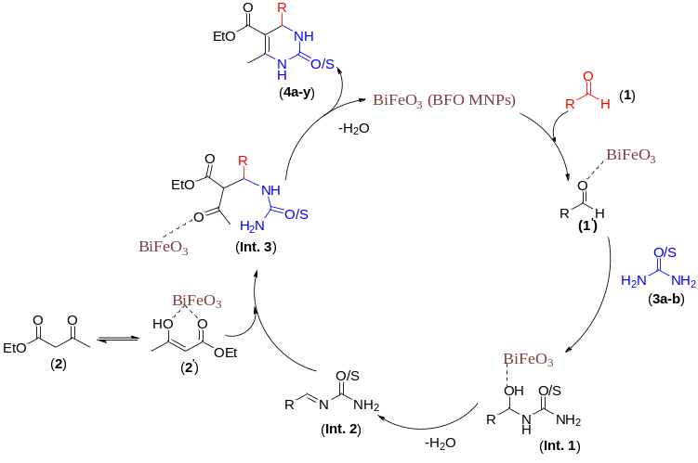
Figure S15: Proposed mechanism for the synthesis of 3,4 dihydropyrimidine-2(1H)-one/thione derivatives in the presence of magnetic BFO MNPs nanocatalyst.

Figure S16: The results of recyclability and reusability of the BFO MNPs nanoparticles in the model reaction.

Table 4. Comparison of the model reaction for the synthesis of Ethyl 6-methyl-2-oxo-4-phenyl-1,2,3,4-tetrahydropyrimidine-5-carboxylate (4h) in the presence of BiFeO3 in terms of time and product yield with recent reports.
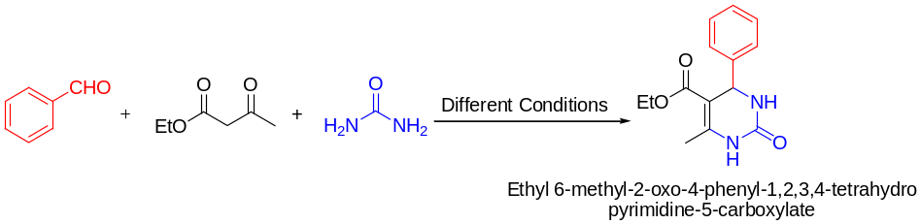.
Entry | Catalyst  (loading) | Solvent | Temperature  (ºC) | Time  (min) | Yield  (%) | Ref.
1 | 5-Hf(OTf)₄, 1.0 mol | - | 80 | 20 | 95 | ⁵⁷
2 | Zwitterionic MSI and TRIP, 10 mol% | Solvent-Free | 30 | 72 | 99 | ³²
3 | Niobium/Fe₃O₄, 1.5 mg | EtOH | 80 | 720 | 99 | ²⁴
4 | Polyanilin-FeCl₃, 200.0 mg | CH₃CN |  | 24 | 90 | ⁵⁸
5 | Bead-CDNS, 30.0 mg | H₂O | Ultrasonic, 120 W | 15 | 100 | ⁵⁹
6 | Coconut husk ash twisted graphene, 100.0 mg | Solvent-Free | 130 | 14 | 94 | ²¹
7 | IRMOF-3, 4.0 mol | Solvent-Free | Reflux | 300 | 90 | ⁶⁰
8 | Coordination polymer Zn, 5.0 mol% | Solvent-Free | 100 | 5 | 99 | ³⁵
9 | Wng Resin-Supported Sulfonic Acid, 30.0 mg | EtOH | 100 | 30 | 96 | ⁶¹
10 | Fe₃O₄@Nb₂O₅-0.1mol% | EtOH | 80 | 12 | 99 | ²⁴
11 | Nb₂O₅/T, 5.0 mol% | Solvent-Free | 130 | 1 | 94 | ⁶²
12 | BiFeO₃ NPs, 4.0 mg | H₂O:EtOH | Reflux | 10 | 93 | This Work

