5.7. Modeling with ANN using SPSS software:
The ANN model was also developed by SPSS statistics 25 software V2017, indeed the suggested model by SPSS software was analogous to the previous model we calculate using excel Microsoft office and Origin Pro v2018, the proposed model by the software comprises also five input nodes in the first layer, five hidden neurons in the second layer and one output, besides the linear (Purelin/ Identify) function was utilized by the software for the neurons in the input and the output with hyperbolic tangent as the transfer function of the hidden nodes, the results are summarized in figures N°18.a, N°18.b, N°18.c, and N°18.d.

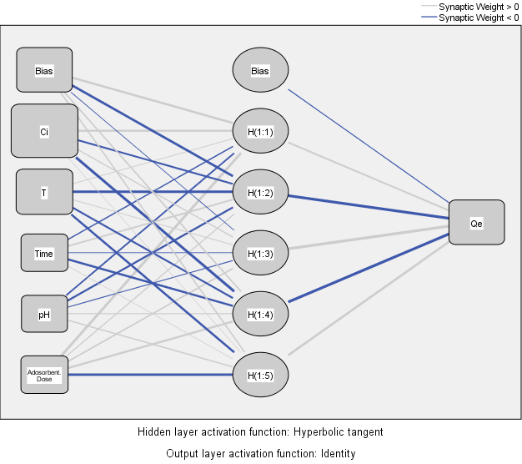
Figure N°18.a: ANN by SPSS for Cobalt (II) removal.
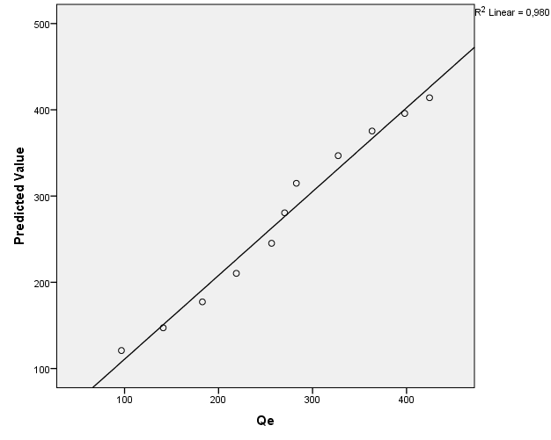
Figure N°18.b: Plot of Predicted values vs experimental values for cobalt (II) removal.

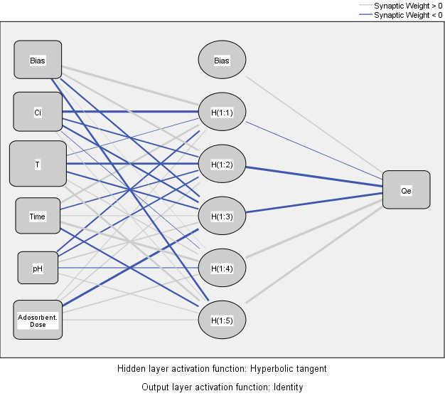
Figure N°18.c: ANN by SPSS for chromium (VI) removal.
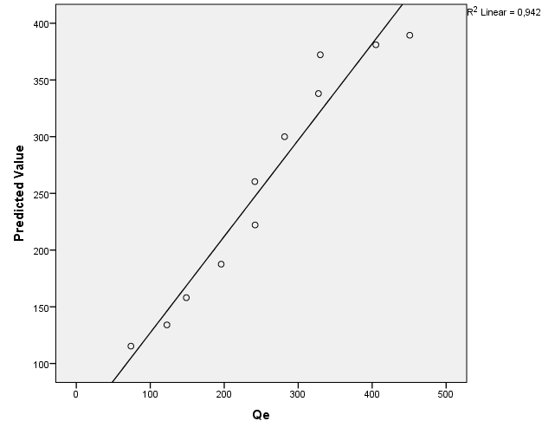
Figure N°18.d: Plot of Predicted values vs experimental values for chromium (VI) removal.

