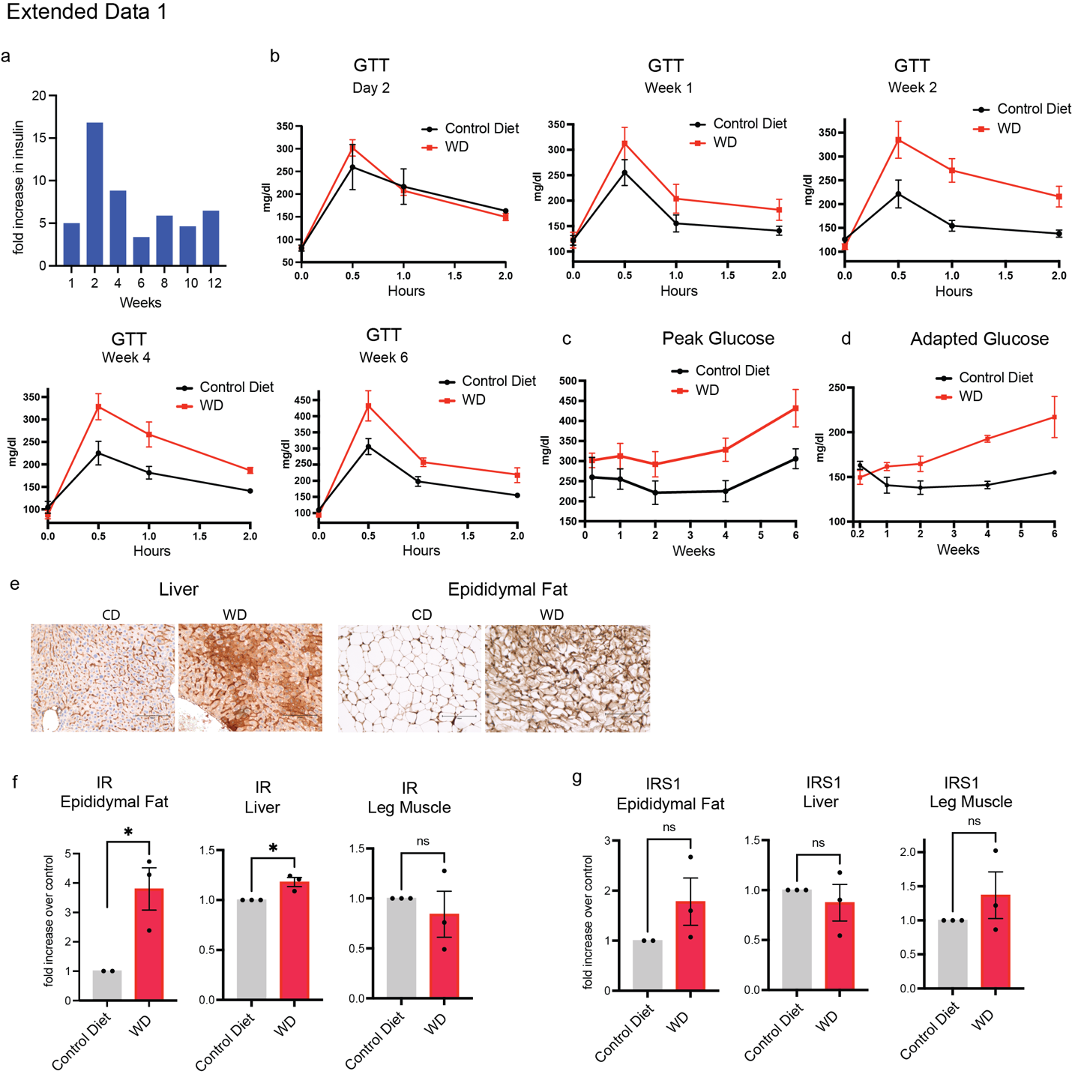

Extended Data 1 Western Diet increases PTEN expression
a. Fold increase in insulin of C57BL/6J mice fed with western diet over mice fed with regular diet for 12 weeks (n=3). b. GTT test was performed 2 days, 1, 2, 4 and 6 weeks after start of the diet (n=3) c. Glucose levels at 30 min (peak glucose) of GTT from b was plotted over time for mice on control or western diet d. Glucose levels at 2 hours (adapted glucose) of the GTT from b was plotted over time for mice on control or western diet e. Liver and eWAT tissues from mice fed on CD or WD were immunostained for PTEN and representative images shown (images from replicate mice from Fig 1i) (n=3) f-g. IR and IRS1 from Fig 1g was quantified and normalized with Actin and the mean and S.E.M represented (n=3). p value was calculated using unpaired student’s t test

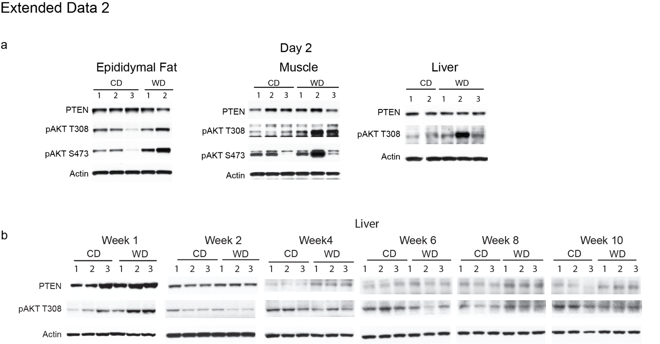

Extended Data 2 PTEN increases while AKT activity declines over 12 weeks in western diet
a. Mice were fed with regular (CD) or western diet (WD) for 2 days and protein from eWAT, muscle and liver were extracted and analyzed by western blotting for PTEN and PI3K pathway activity. b. Mice were fed with regular (CD) or western diet (WD) for 10 weeks and protein from liver extracted and analyzed by western blotting for PTEN expression and AKT activation (n=3 for every time point). Note; Week 1 of liver tissue are the same as used in Figure 1 since they were part of the same long term kinetics study that was done in Figure 2

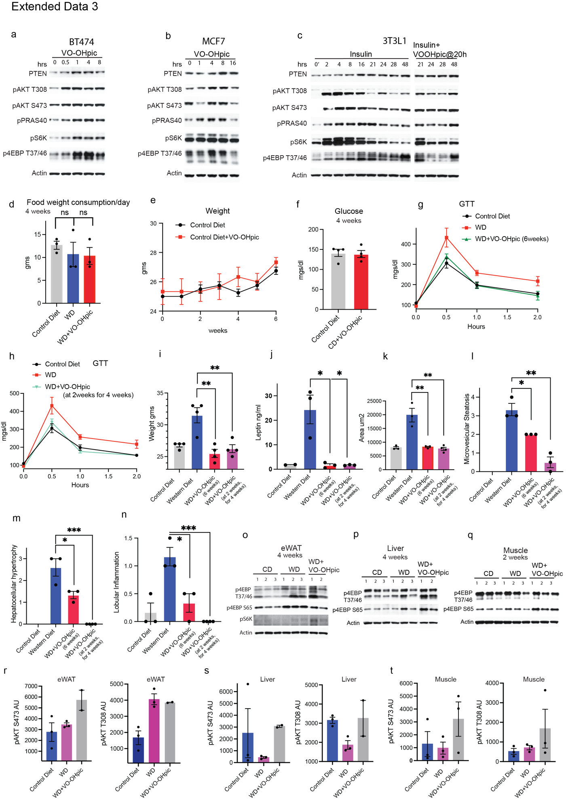
Extended Data 3 Inhibiting PTEN activity prevents and reverses insulin resistance
a-b. BT474 and MCF7 cells were treated with 1uM VO-OHpic for the indicated times, protein extracted and immunoblotted for PTEN and PI3K pathway activity c. 3T3L1 cells were treated with insulin alone or with insulin and VO-OHpic added at 20 hours of insulin treatment and immunoblotted for PTEN and PI3K pathway activity. d. Weight of food eaten by mice for the indicated conditions was measured each day for 3 days, mean and SEM represented (n=3) e-f. Mean and SEM of weight and glucose measured of mice for the indicated times and conditions (n=3). g-h. GTT measured for the indicated times and treatment conditions (n=3). i-j. Mice weight and leptin was measured for the indicated times and treatment conditions, mean and SEM represented (n=3). k. Mean and SEM of area of eWAT adipocyte cells from Fig 3l-m was measured in the above dietary and treatment conditions (n=3) l-n. The mean and SEM represented of liver parameters microvesicular steatosis, hepatocellular hypertrophy, and lobular inflammation scores (n=3). p value was calculated using unpaired student’s t test in i-n. o-q. Proteins from eWAT, muscle and liver of mice fed and treated with indicated conditions analyzed by immunoblotting (Refer Fig 3r-t). r-t. Quantification of pAKT normalized to actin from figure 3r-t.

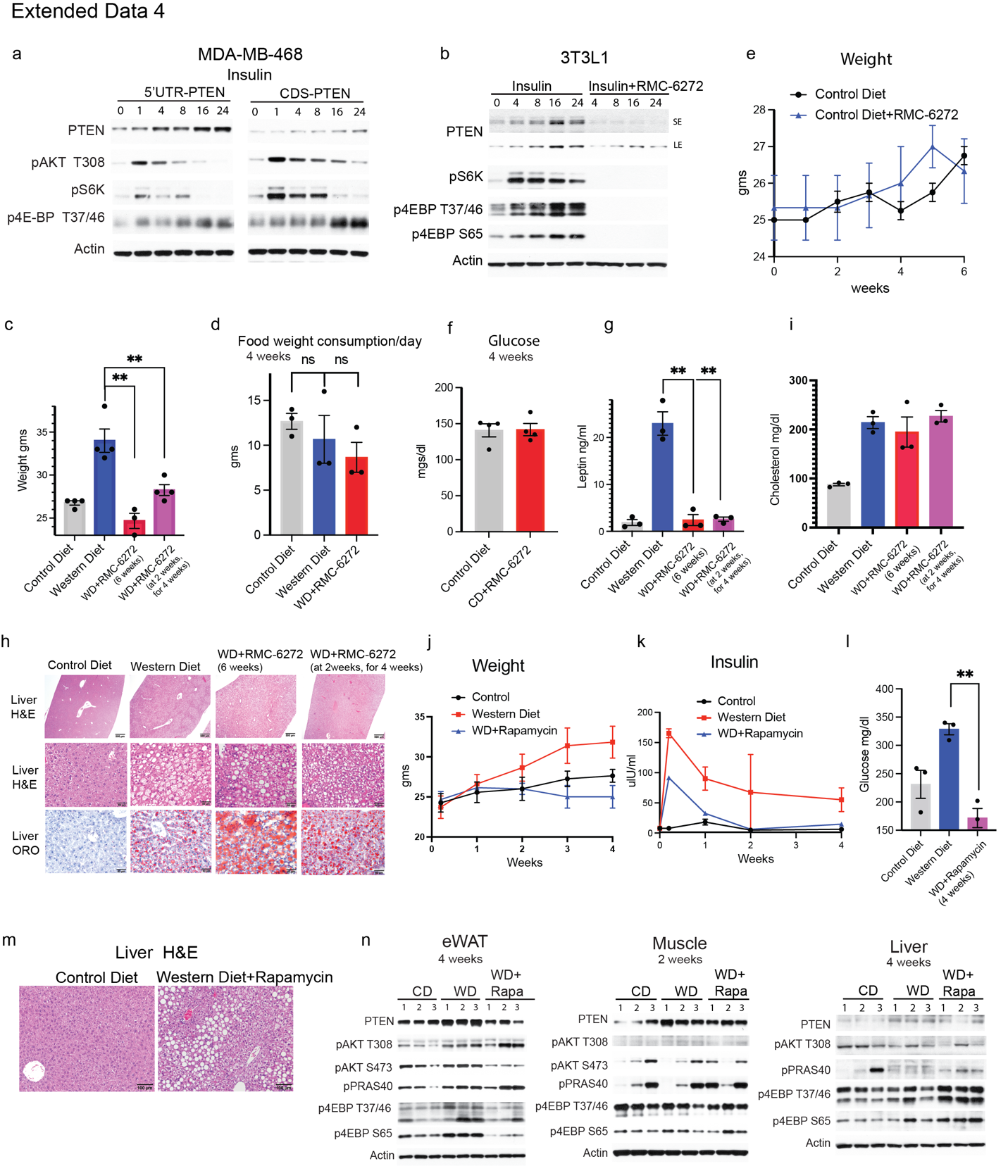

Extended Data 4 Inhibiting mTORC1 prevents and reverses obesity and insulin resistance
a. MDA-MB-468 cell expressing an inducible PTEN with or without its 5’UTR was treated with 100ng/ml of doxycycline for the indicated times and analyzed for PTEN and 4E-BP1 expression. b. 3T3L-1 cells were treated insulin alone or in combination with RMC-6272 (0.5nM) for the indicated times and immunoblotted for PTEN and PI3K pathway activity c. Mean and SEM of weight was measured in mice fed with control or western diet or treated with RMC-6272 (3mg/kg) at the start of the western diet or treated with the RMC-6272 after 2 weeks of western diet, for 4 weeks (n=3) d. Weight of food eaten by mice for the indicated time and conditions was measured each day for 3 days, mean and SEM represented (n=3) e-f. Mean and SEM of weight and glucose measured of mice for the indicated times and conditions (n=3) g. Mean and SEM of leptin was measured for the indicated times and treatments (n=3) h. Livers from mice with indicated diet and treatment stained for H&E and lipid OilRedO (n=3). Representative images are shown. i. Mean and SEM of cholesterol was measured for the indicated times and treatments (n=3). j-l. Weight, insulin and glucose was measured in mice fed with control diet, western diet or western diet with Rapamycin treatment (10mg/kg) for the indicated times (n=3). p value was calculated using unpaired student’s t test in c-i and l. m. Livers from mice fed with control diet or western diet with rapamycin treatment were stained for H&E. Representative images are displayed (n=3). n. Proteins from eWAT, muscle and liver of mice fed and treated with indicated conditions analyzed by immunoblotting. Note; In n. CD, WD same as Fig 2a-b, Extended Data 2b 3(r-t), 4q since the indicated experimental arms were run together on the same gels.

